SREEHARI S

RESEARCH SCHOLAR

@ Centre for Sustainable Technologies, Belfast School of Architecture and the Built Environment, ULSTER UNIVERSITY

**SKILLS AND ABILITIES**

**PROFILE**

Self-motivated, well disciplined, knowledge seeking, thorough and resourceful professional who can harness creativity and utilize sound technical knowledge to come up with solutions for time critical problems.

* Innovative and confident with high level of communication and team building skills
* Ambitious and enthusiastic, able to learn and adapt quickly and provide results under pressure
* Enthusiastic and technically, I am passionate about managing projects from inception to completion
* Able to adapt and make adjustments in the ever-changing world, adaptation to new trends, technology, products, and management strategies

**EDUCATION**

**2020 - Present**

**PhD**

**University: Ulster University**

**Department: Centre for Sustainable Technologies**

**MASTER OF TECHNOLOGY IN ENERGY ENGINEERING AND MANAGEMENT**

**UNIVERSITY:** **NATIONAL INSTITUTE OF TECHNOLOGY CALICUT**

**Grade: Distinction**

**CGPA: 8.32/10**

**BACHELOR OF TECHNOLOGY IN MECHANICAL ENGINEERING**

**UNIVERSITY: COCHIN UNIVERSITY OF SCIENCE AND TECHNOLOGY**

**Grade: First Class**

**CGPA: 7.31**

**12th INDIAN SCHOOL CERTIFICATE**

**BOARD: COUNCIL FOR THE INDIAN SCHOOL CERTIFICATE EXAMINATIONS**

**Grade: Distinction**

**Percentage: 89.2%**

**2nd Rank in School**

**10th INDIAN CERTIFICATE OF SECONDARY EDUCATION**

**BOARD: COUNCIL FOR THE INDIAN SCHOOL CERTIFICATE EXAMINATIONS**

**Grade: Distinction**

**Percentage: 90.4%**

**CONTACT**

**Mobile:**

+44-07473975735 (UK)

+91-9497530449 (India)

**Mail:** [sreeharisreekumar72@gmail.com](mailto:sreeharisreekumar72@gmail.com)

[Sreekumar-S@ulster.ac.uk](mailto:sreeharisapru@gmail.com)

skype id: sreeharisreekumar72

**Current City**:

Jordanstown,

Northern Ireland, The UK.

Post code: BT38 8ST

**2017 - 2019**

**2012 - 2016**

**Web Profile**

**Researchgate** **LinkedIn**

****  

**Google Scholar**



**2011 - 2012**

**2009 - 2010**

**SOFTWARE**

**RESEARCH EXPERIENCE**

**Master’s Thesis Title:** ***“Performance investigation of nanofluid applied parabolic trough direct absorption solar collector”***

**Summary:** Experimental investigation on the performance of hybrid nanofluid based direct absorption solar collector was performed. In comparison to surface absorption in a conventional collector, a direct absorption solar collector employs volumetric absorption process using nanofluid for photothermal energy conversion. A spectral selective hybrid nanofluid was synthesized and tested in the above-mentioned collector.

**Duration:** 2018-2019

**Achievements: 3 International Journal Papers**

**2 Conference Papers**

**SOLIDWORKS**

**ANSYS FLUENT**

**MATLAB**

**C/C++ **

**ORIGIN**

**PUBLICATION DETAILS**

**SKILLS ACQUIRED**

* CFD simulation of Energy Systems
* Experimentation on Thermal Energy Systems
* Energy/Exergy Analysis of solar thermal energy systems
* Synthesis of novel nanocomposites
* Characterization of nanomaterials
* Research content writing

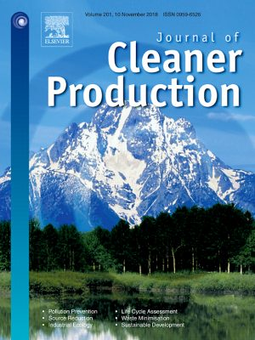

**Impact Factor**

**7.10**

**Journals**

* **Sreehari Sreekumar**, Albin Joseph, Sujith Kumar C S, Shijo Thomas, ***“Investigation on influence of antimony tin oxide/silver nanofluid on direct absorption parabolic solar collector”***in *Journal of Cleaner Productions*.

[***https://doi.org/10.1016/j.jclepro.2019.119378***](https://doi.org/10.1016/j.jclepro.2019.119378)

* Albin Joseph, **Sreehari Sreekumar**, Sujith Kumar C S, Shijo Thomas, “***Optimization of Thermo-Optical Properties of SiO2/Ag Nanofluid for Direct Absorption Solar collectors***”, in*Journal of Molecular Liquids*.

[***https://doi.org/10.1016/j.molliq.2019.111986***](https://doi.org/10.1016/j.molliq.2019.111986)

* Albin Joseph, **Sreehari Sreekumar**, Shijo Thomas, **“**Energy and exergy analysis of SiO2/Ag-CuO plasmonic nanofluid on direct absorption parabolic solar collector”, in Renewable Energy. ***[https](https://doi.org/10.1016/j.renene.2020.09.139" \o "Persistent link using digital object identifier" \t "_blank)***[***://doi.org/10.1016/j.renene.2020.09.139***](https://doi.org/10.1016/j.renene.2020.09.139)

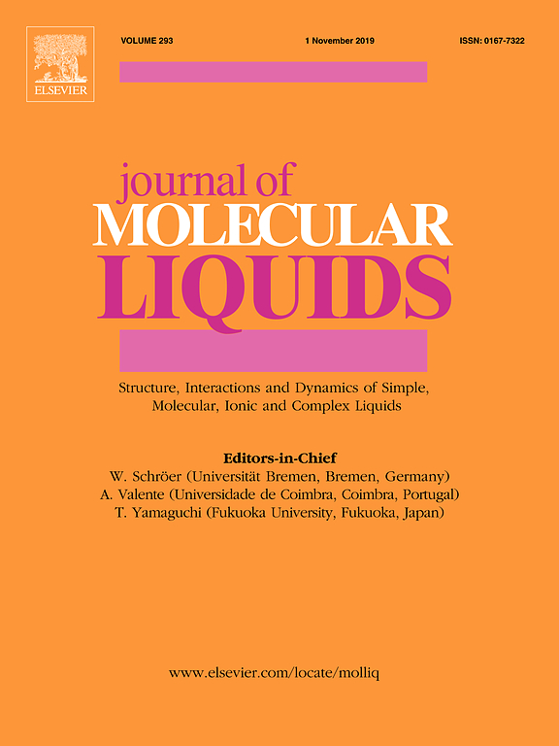

**Impact Factor**

**5.065**

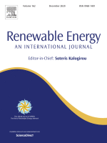

**Impact Factor**

**5.43**

**AREA OF INTEREST**

* Smart Nanomaterial for energy conversion
* Energy application oriented property tuning of nanomaterials
* Innovative Fuel cell technology for electric mobility
* Solid state Lithium-ion battery for electric vehicles
* Radiative heat transfer (in participating media)
* Applied Thermodynamics
* CFD analysis of thermal energy systems

**Conference papers**

* **Sreehari S**, Albin Joseph, Shijo Thomas, “Development of a low cost nanofluid based direct absorption solar collector”, **(accepted and presented)** 2nd International Conference on Materials Manufacturing and Modelling (ICMMM – 2019) Publisher: **Materials Today**: **Proceedings**.
* **Sreehari S**, Albin Joseph, Shijo Thomas, “Broadband Spectral Absorbing Al2O3/ATO Binary Nanofluid for Low-Temperature Direct Absorption Solar Collectors”, **(accepted and presented)** International Conference on Advances in Renewable Energy and Green Technology (ICARE 2019).

**ENGLISH LANGUAGE PROFICIENCY**

**OVERALL INTEREST**

**IELTS: Overall Band- 7.5**

**Listening – 8.5 Reading – 8.5**

**Speaking – 7 Writing – 6.5**

**OTHER ACADEMIC ACHEIVEMENTS**

**Qualified GRADUATE APTITUDE TEST IN ENGINEERING (GATE)**

**GATE SCORE: 596 (2019)**

**STREAM: ENGINEERING SCIENCE (XE)**

**SUBJECTS: Thermodynamics, Fluid Mechanics, Mathematics**

**All India Rank: 68**

**ACADEMIC EXPOSURE**

**LAB EXPOSURE**

* Scanning Electron Microscopy
* UV-Vis-NIR Spectroscopy
* X-Ray Diffractometer
* Thermal Conductivity Analyser
* Rheometer

**Title: “*Indo-Swiss Workshop on Building Integrated Solar Energy Systems”***

@CSIR- NATIONAL INSTITUTE OF INTERDISCIPLINARY SCIENCE AND TECHNOLOGY

**Title: *“Design of experiments and Optimization technique”.***

@SREE BUDDHA COLLEGE OF ENGINEERING

**Title: *“Recent Advances in Solar Systems”***

@NATIONAL INSTITUE OF TECHNOLOGY CALICUT

**Topic:** ***“Solar energy and its future scope”***

@NATIONAL INSTITUE OF TECHNOLOGY CALICUT

**INTERNATIONAL WORKSHOP**

**NATIONAL WORKSHOP**

**FACULTY DEVELOPMENT PROGRAMME**

**LECTURE PARTICIPATION**

**ACADEMIC EXPERIENCE**

**Subject: Thermal Engineering**

**Laboratory:**

**1) Fluid Mechanics and Hydraulics Machinery**

**2) IC Engines**

**FACULTY ASSISTANTSHIP**

**TEACHING ASSISTANTSHIP**

**MEMBERSHIP**

**REFERENCE**

Dr. Shijo Thomas

Assistant Professor

School of Materials Science and Engineering

National Institute of Technology

Calicut, Kerala, India

[shijo@nitc.ac.in](mailto:shijo@nitc.ac.in)

+919446276409

Dr. Sujith Kumar C. S

Assistant Professor

Department of Mechanical Engineering

National Institute of Technology

Calicut, Kerala, India

[sujithcs@nitc.ac.in](mailto:sujithcs@nitc.ac.in)

+917593001552

* **MEMBER OF SOLAR ENERGY SOCIETY OF INDIA (SESI)**

**THE SOCIETY IS INTERDISCIPLINARY IN NATURE, WITH MOST OF THE LEADING ENERGY RESEARCHERS AND MANUFACTURERS OF RENEWABLE ENERGY SYSTEMS AND DEVICES OF THE COUNTRY AS ITS MEMBERS.**

* **MEMBER OF EUROSCIENCE**

**EUROSCIENCE IS THE EUROPEAN GRASSROOTS ORGANIZATION FOR THE ADVANCEMENT OF SCIENCE.** **EUROSCIENCE MEMBERS ARE FOR THE MOST PART RESEARCHERS AND ENGINEERS FROM ALL SCIENTIFIC DISCIPLINES.**

* **Professional Member of INSTITUTE OF SCHOLARS (InSc)**

**INSTITUTE OF SCHOLARS (INSC) IS AN EMERGING TECHNICAL PROFESSIONAL ORGANIZATION ESTABLISHED WHICH AIMS TO CONNECT THE SCHOLARS, ACADEMICIANS AND PROFESSIONALS FROM INDUSTRIES.**

* **REVIEWER of InSc- INTERNATIONAL JOURNAL OF BASIC AND APPLIED SCIENCES**

**I hereby declare that the information given above is correct to the best of my knowledge and belief.**

**Place: United Kingdom 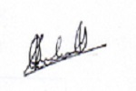 SREEHARI S**

**Date: Jan, 2021**

* **Title: Young Researcher Award 2020**

**Awarded for the research paper titled, “*Investigation on influence of antimony tin oxide/silver nanofluid on direct absorption parabolic solar collector”***

**Awarding Body:** **INSTITUTE OF SCHOLARS (InSc)**

**Awards**

**DECLARATION**