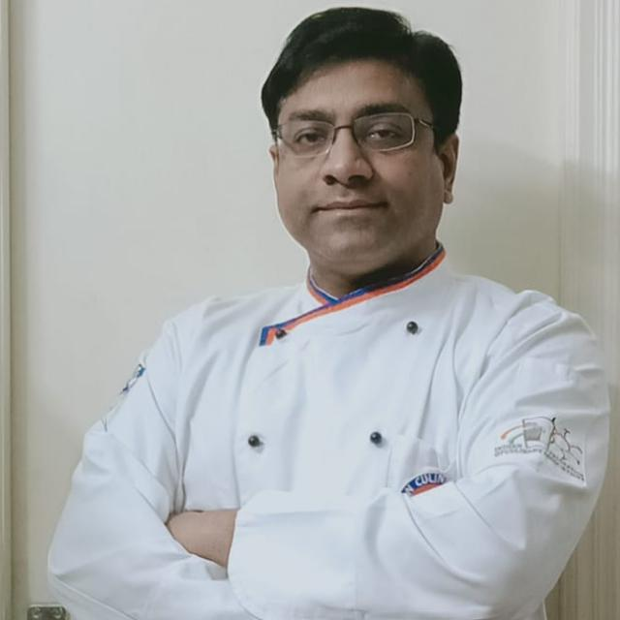
Brief Profile,
Chef Vikas Singh is an alumnus of IHM Bhubaneswar, with over 23 years of experience, including rich industry experience in Luxury brands like The Park, Hyatt regency and Carnival cruise lines, Miami Florida. He is having More than 16 years of academic experience in reputed Institutions like Banarsidas Chandiwala Institute of Hotel Management affiliated with Guru Govind Singh Indraprastha University, RIG Institute of Hotel Management, Galgotias University . Currently he is associated with Manav Rachna International Institute of Research and Studies (MRIIRS), Faculty of Hotel Manageemnt as Professor and Program Director since June 2022
He has completed his Masters in Hotel Management, MBA (HRM) and is pursuing his PhD in Hospitality (Thesis Submitted). Has Studied fellowship in Southern American Cuisine at Chef John Folse Culinary Institute, Thibodaux, New Orleans. He also did a reality cookery show named "Seedhe Rasoi Se". Has vast experience in creating recipes, preparation of elaborate meals and organizing food festivals.
He has also published more than 30 research papers in various journals, national and international journals, and has attended more than 40 FDPs and workshops.
He has also the author of a textbook book on Food Production named " Textbook of Food Production - Basic Training Kitchen (BTK)"
Published an edited book “Tourism and Hospitality: Perspectives, Patterns and Practices”
Published an edited book “Operational Transformations in
Tourism and Hospitality”
He is a lifetime member of the Prestigious Indian Culinary Forum, Member of the Chefs Guild of India
Proud Member of the World Association of Chefs Societies, Member of the Indian Federation of Culinary Associations and Member of World Chef Choice Federation.

He is also the recipient of various awards to his credit:

- National award for Academic Achievement Award -2016 (Food Production) by ISHE- International Society for Hospitality Education

- He is the recipient of the Global Hospitality Award 2019 in the area of Hospitality Education (Food Production)
- Was awarded Hospitality Education Award-Culinary at First International Hospitality Conclave and Awards held on 12.02.20.

- He is also the recipient of the Global Hospitality & Leadership Award for Best Associate Professor (Food Production) Year 2020

- Awarded Global Hospitality & Tourism Leadership Award by Shubharti University on 10th -11th April 2021

- Recognized as International Ambassador of Peace by World Literary forum for peace and human rights on 21st February 2021.

- Received Certificate of appreciation for its integration in supporting unity, hospitality, fraternity and tourism as a whole through Gastronomy in the World by I.C.C.(International Chefs Confraternity) on 13th January 2021

- Academic Excellence Award 2022 (Higher Educational Level) by InSc Institute of Scholars

