Dr.Rakesh Dani
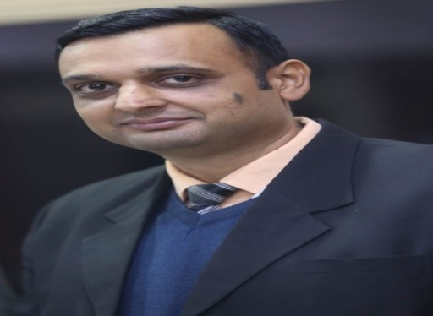
Dr.Rakesh Dani is currently associated with the Department of Hospitality Management at Graphic Era Deemed to be University, Dehradun (U.K) as an Associate Professor and holds a Ph.D. in Tourism and Hotel Management. In addition he also holds Masters in Travel & Tourism Management as well as in Hotel Management. Having a valuable experience in the academics and hospitality industry in India and abroad, he is quite familiar with the international standards as well. Not only does he provide quality teaching with professional and career advice to students pursuing careers in the hospitality industry, and even guides research scholars in Ph.D.
He has published and reviewed various research papers in international, national, and journal conferences of international repute, including Scopus, WOS, and UGC, etc., and also published his inventions in IP.India.
He has conducted and attended International Conferences, Faculty development programs and Seminars as a resource person and session chair.
He received the Best Faculty Award in 2021, the Award of Excellence in 2020, and the Best National Assistant Professor in Hotel Management of the Year in 2019 and was recognized for outstanding research contribution at Graphic Era (Deemed to be University) for the academic year 2019-20.
He has successfully attempted two Limca Books of Record with students at Graphic Era Deemed to be University, Dehradun.
Google Scholar ID:
https://scholar.google.com/citations?user=d26iOuoAAAAJ&hl=en
ORCID:
https://orcid.org/0000-0002-5589-0181

