Name | Dr. A. Kanaka Durga |  |  |  | 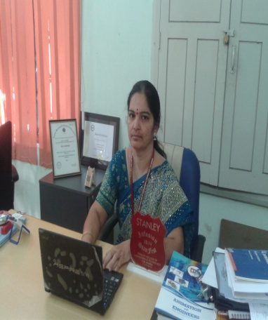
E Mail ID | durgapallavi@gmail.com
Contact No | 9849384247
Designation | Director Academics & Audit,  Professor in IT  IQAC Coordinator  Former HOD – IT |  | Experience in Engineering Colleges:  20 + Yrs
DOB | 27th April 1965
Degree | University |  |  | Specialization
Ph D | JNTUH, HYD |  |  | CSE
M. Tech | BIT, Ranchi |  |  | CSE
Memberships | CSI Life Member, APSMS Life Member, Governing Body and Fonder Member in CCICI, Planning & Reporting Officer SIG Cyber Security – ISoC,  Executive Member – ISoC Hyderabad Chapter
Courses Handled | - IRS, Data Warehousing & Data Mining, DC, CO and MP, OR, IPR.  - Semantic Web, SE, Cryptography and Network Security, AI, SPM.  - ISM, SRA and E, TA, NLP, IS, OR, Fundamentals of IoT, Cloud Computing.  - Signals and Systems, Wireless and Mobile Communications.
Projects Guided | - 100 Projects in UG level  - 2 in PG Level
Areas of Interest | NLP, Semantic Web, Machine Learning, Information Retrieval Systems, Data Warehousing and Data Mining, AI and Mathematical Modeling Fundamentals of IoT, OR.
Research Profile
- Recognized Research Supervisor and guiding 2 research scholars
- Patents Published: 2
- Published a Chapter on “Tools for Design Thinking” - Design Thinking: A Forefront Insight" ISBN 9781032039053 Published August 23, 2022 by CRC Press, Taylor & Francis Group.
- Published a Chapter on “Digital Marketing and MSMEs: Handbook on Enterpreneurship on Development of MSMEs”, 10th Jan, 2023.

National Journals / International Journals / International Conferences / National Conferences: 32
Project |  | - “Named Entity Error Detection On English – Telugu Cross Lingual Text” – JNTU for IT &C Dept. of A.P. cost of project 5 lakhs in 2011.  - “TOUR PLANNER COMPONENT FOR A.P.TOURISM” with CMC,Ltd.,( A Govt. India Enterprise) Hyderabad.
Recognition |  | - Best Engineer by Titan Lions, Hyd on 15th September, 2020  - Women Leadership Award from Dewang Mehta (Regional Round of Dewang Mehta Awards – Women in Education Award) presented at IPE, Shamirpet on 15th April, 17.  - Best Teacher and All Rounder from GNEC, HYD on 2004 & 2005.  - Got 2nd prize in HYSEA competition 2008
Other Achievements |  | - Reviewer for the book, “Veracity of Big Data” published by Apress / Springer.  - Reviewer for IGI Global Journals & for Equinocs Journals (Springer nature).  - Resource Person as a part of IIC Activities – Yogananda College of Engineering & Technology, J & K – Dept of CSE and delivered a seminar on “National Education Day (NEP – 20” for CSE & EEE Students in ONLINE mode on 26th Nov, 21.  - Resource Person as a part of IIC Activities – SELVAM College of Technology, Namakkal, Chennai as a part of Impact Lecture Series – II, Lecture 3 and delivered a seminar on “Identifying Intellectual Property Component at the early stage of Innovation” Students in ONLINE mode on 30th Aug, 2022.  - Resource Person in many Workshops and FDPs  - Coordinator for a six day workshop on “Advanced Workshop on Dynamical Models in Ecological, Epidemiological Sciences and Engineering – Theory, Computations, and Real World Applications” in association with NPDE, IIT – B.  - Coordinator for FDPs E&ICT, NIT,W and IIITDM, Jabalpur  - NSS Program Officer  - Academic and Administrative responsibilities – Invitee in BoS, OUCE, Paper Setter and Evaluator for both UG & PG (BE, ME/M Tech, MBA).  - Panel Member/Examiner for M. Tech and Ph D Viva Voce  - Session Chair for National & International Conferences  - Submitted thesis on “Bio Mathematics” at M.Sc. Level.

