CURRICULUM-VITAE
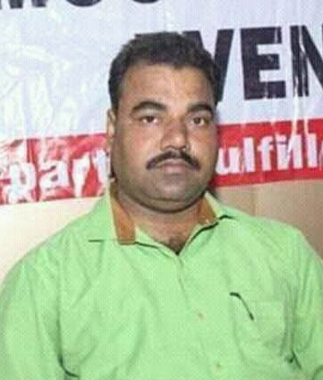
DR. GIRISH CHANDRA RAI
ADDRESS: -
House No. B37/153 A-1, Birdopur
Mahmoorganj, Varanasi
UP-221010
Mob. : 7800207246
Email.Id : rai.girishvns@gmail.com
Academic Qualification: -
- DOCTOR OF PHILOSOPHY (Awarded Ph.D.) from Tilka Manjhi Bhagalpur University Bhagalpur, Bihar in 2009 Topic “Crime Against Women in India: An analytical study of constitutional & Legal safe guard.”
- Master of Laws (LL.M.) from M.G.K.V.P. Varanasi in 2003.
- Bachelor of Laws (LL.B.) from M.G.K.V. Varanasi in 2001.
- Bachelor of Commerce (B. Com Hons) from M.G.K.V.P. Varanasi in 1998 with 1st Div.
- Intermediate from UP Board in 1995 with 1st Div.
- High School from UP Board in 1993 with 2nd Div.
Teaching Experience: -
- Lecture in Law at Narheji Law College, Ballia afficiated VBSPU Jaunpur from 01.08.2003 to 30.06.2004.
- Lecturer in Laws at Tilka Manjhi Bhagalpur University, Bhagalpur, Bihar from 01.07.2004 to 30.06.2009.
- Lecturer in Law at Veer Kunwar Singh University, Ara Bihar from 01.07.2009 to 30.06.2012.
- Lecturer in Law at Harishankar Prasad Vidhi Mahavidyalaya, Chitvaragaon, Ballia from 01.07.2012 to 20.08.2013.
- Princlpal in law at Lok Bandhu Rajnarayan Law College Gangapur Varanasi afficiated MGKVP from 12-09-2013 to till date.
Personal Details:
- Father’s Name : Shri Krishna Nand Rai
- Date of Birth : 05.10.1978
- Nationality : Indian
- Religion : Hindu
- Sex : Male
- Marital Status : Married
- Language Known : Hindi & English
Declaration
I hereby declare that above written information is true to the best of my knowledge.
Date:..................
Place : Varanasi (Dr. Girish Chandra Rai)

