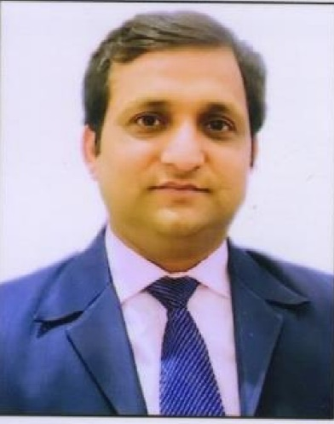
Dr. Nitish Pathak has done Ph.D. (Computer Science and Engineering) from Uttarakhand Technical University, Dehradun in 2017. He is an alumnus of Dr. A.P.J. Abdul Kalam Technical University; Lucknow and he obtained his Master degree in Computer Science and Engineering in the year 2010.
He is a Postdoctoral Fellow (17th February 2023 onwards), Big Data and Machine Learning Lab, South Ural State University (National Research University), Chelyabinsk, Russian Federation.

Currently, he is working as an Associate Professor in the Department of Information Technology at Bhagwan Parshuram Institute of Technology (BPIT), Guru Gobind Singh Indraprastha University (GGSIPU), Delhi, India.
He has more than 18 years of experience in Engineering Education, Corporate, and Research. He has worked for almost a decade in various capacities with Bharati Vidyapeeth, GGSIPU, Delhi. He has also worked for HCL Technologies, Noida. He has also served in reputed educational institutions such as KIET Group of Institutions and ABES Engineering College (Delhi-NCR campus, Ghaziabad).
He is actively engaged in teaching and research in areas of Computer Science since 2005. He is the recipient of the prestigious Directorate Award (2008 and 2009) for best teaching performance at ABES Engineering College, Ghaziabad. He got the best research paper publication award (2017, 2018 and 2019) by Bharati Vidyapeeth, GGSIPU, Delhi. He Received the INDIACom outstanding contribution award (2016, 2017, 2018, and 2019) & CSI outstanding contribution award-2015, for organizing the IEEE/Springer International conference, by Bharati Vidyapeeth, GGSIPU, Delhi. Original results have been published in more than 95 papers in international journals, proceedings of international conferences, patents, and book chapters.
He is Guest Editor, Lead Guest Editor, in various SCI & other reputed journals of Elsevier, Springer, Wiley & MDPI, etc. His research interests are Intelligent Computing Techniques, Empirical Software Engineering, Trusted Operating Systems, Cloud Computing, WAN, IoT, and Artificial Intelligence.
He actively reviews articles in various journals and conferences. He has been associated with various conferences as a Session Chair / Reviewer/ Conference Advisory Committee member etc. He has been pro-actively involved with professional associations and is a Life Member of Computer Society of India (CSI) and Indian Society for Technical Education (ISTE).

