Dr. Pradnya K. Ingle
~Contact: 098209 81052, 087797 54869 ~E-Mail: kiranpradnya@gmail.com

~Alumina of Institute of Chemical Technology, Mumbai ~
Industry Preference: Research and Development, Process Engineering, Production Planning, Operation Management Location Preference: Mumbai

PROFILE SUMMARY

A dynamic professional with over 17 + years of experience in Academics and Research across multiple segments of Chemical Engineering

~ Enzymatic Reactions | ~ Biotechnology | ~ Process Simulation
~Process Equipment design | ~ Process Intensification | ~ Fluid Mechanics
~Heat and Mass Transfer Opern | ~ Environmental Engineering | ~ Accreditation (NBA & NAAC)
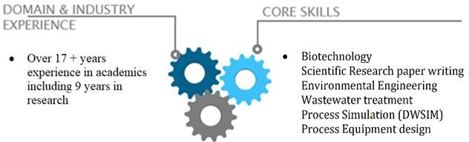

- Ph.D. Tech from Institute of Chemical Technology Mumbai in 2016
Thesis: Studies in Removal of Heavy Metals from Waste Water Using Bio-Sorbent
- M. Chem. Engg. from University Institute of Chemical Engineering, Mumbai (Formerly U.D.C.T) in 2010 with First Class and "A" Grade in research
Thesis: Studies in Enzymatic Reactions
- Bachelors in Chemical Engineering, University of Mumbai with Distinction.

Associate and Life time member of Indian Institute of Chemical Engineering, IIChE LM-51006
- Member of ISTE

- Trans-esterification reaction by immobilized enzymes
- Planning and outline the design of experiments for the identified problems
- Proficient in identifying adsorbents for removal of metals from Simulated waste water
- Developing appropriate Isotherms from the experimental data of Adsorption.
- Keeping abreast of developments in their field by reading current literature and participating in professional conferences
- Monitor key aspects and burning issues in broad spectrum of research like Extraction, Adsorption and Rubber Technology
- Initiate and facilitate Research Activities
- Planning, evaluating and revise curricula, course content, and course materials and methods of instruction timely as per the changing curriculum
- Expertise in organising work to prioritize tasks which is a blend of teaching and research
- Supervising and providing guidance to the students for developing their skills towards research and facilitating research publications to enhance their career

- Achievement oriented with excellent management of skills and an ability of students to focus on better results of research
- Leading a team for NAAC
- Successfully defended the NBA expert visit in 2018

KEY RESEARCH AREAS

- Studies in Enzymatic Reactions
- Waste water treatment using bio sorbents, activation and carbon
- Extraction of Caffeine from coffee beans
- Enhancing rubber characteristics using Coco peat as Bio fillers
- Process Simulation done on DWSIM

RESEARCH

Studies in Enzymatic Reactions:

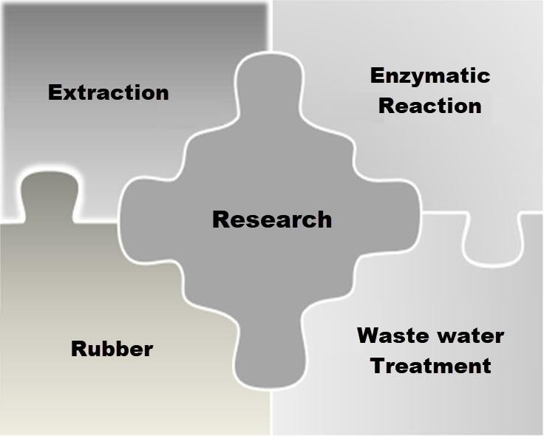
Increased environmental awareness and depletion of resources are driving industry to develop viable alternative fuels from renewable resources that are environmentally more acceptable. The interest is redirecting towards biomass based fuels, which currently seem to be the only logical alternative for sustainable development in the context of economical and environmental considerations. The use of oils has been recently looked upon as alternative fuels. Enzyme which is generally used for the production of methyl ester from vegetable oil is lipase. This lipase enzyme can be obtained from different sources like bacteria, fungi, yeast etc. Lipases are enzymes that catalyze both the hydrolysis and the synthesis of esters. These reactions usually proceed with high regio and enantio- selectivity making lipase an important group of biocatalysts. The reason for the economic biotechnological potential of microbial lipase include
the fact that they are stable in organic solvents, do not require cofactor, possess broad substrate specificity, exhibit a high enantio-selectivity. Lipolytic reactions occur at the lipid-water interface. 3-D structures of lipases provide an elegant explanation for interfacial activation. The active site of lipases was found to be covered by a surface loop, which is called a lid or flap. Upon binding to interface, this lid moves away, turning the closed form of the enzyme into open form, with the active site now accessible to the solvent, at the same time, a large hydrophobic surface is exposed, which is thought to facilitate binding of the lipase to interface .vegetable oil esters using process of transesterification. In the research work, vegetable oil is used as a raw material for transesterification reaction which contains 90% of the unsaturated fatty acids (linoleic acid and oleic acid) using enzyme as a catalyst.

Studies in Removal of Heavy Metals from Waste Water Using Bio-Sorbent:

Due to rapid industrialization and urbanization there is swift innovation in the field of science and technology. But on the other hand owing to technology advancement in various fields like pharmaceuticals, automobiles, refineries etc. pollution is becoming an issue of deep apprehension. The industrial toxic effluents generated by several industrial activities are dumped into water bodies leading to instability and distress to the ecosystem. This waste water contains various toxic materials like heavy metals, precious metals, hydrocarbons, soil etc. Therefore, the scientific research is being directed towards the implementation of novel approaches dealing with the efficient removal of toxic metals from waste water.

Within this context, the aim of the work is to compare the performance of bio sorbents prepared from agricultural waste for removal of metal and dye ions from dilute aqueous solutions, real wastewater with low toxic metal concentrations.

RESEARCH PUBLICATIONS

- Transesterification of Sunflower oil using Immobilized Enzymes presented in CHEMCON 2010 at Annamalai University Chennai.
- Ingle P.K., Gadipelly C. R., Rathod, V. K., Sorption of copper (II) from aqueous solution onto Arachis hypogaea husk, Desalination and water treatment, 2014, 1-9.
- Ingle P.K., Attarkar K., Rathod, V. K., Copper removal using acid activated peanut husk from aqueous solution, Journal of Environmental Engineering and Landscape, 2014, 1-7.
- Ingle P.K., Attarkar K., Rathod, V. K., Ultrasound assisted chemical activation of Peanut husk for copper removal, manuscript published in Green Processing and Synthesis on 11-06-2018.
- Rasika Shikare, Prathmesh Kale, Pradnya K. Ingle, Decolourization of Brown Sugar by Adsorption using Activated Charcoal, International Journal of Research and Analytical Reviews, 2018, VOLUME 5, (1): 135-146
- Ingle P.K., Rathod, V. K., Cationic Dye Removal by Chlorosulfonic Acid Treated Peanut Husk: Characterization, Equilibrium, Kinetics and Thermodynamics study, In communication with Journal of Environmental Chemical Engineering
- Aniket Chaugule, Hitesh Patil, Shreyans Pagariya, Pradnya K. Ingle, Extraction of Caffeine: A Review, Journal of Emerging Technology and Innovative Research, 2018, Volume 5, Issue 9.
- Riya Kejriwal, Manoj Mandke, Pradnya Ingle, Bio-Sorption of Heavy Metals: A Review, International Journal of Advanced Research in Chemical Science (IJARCS), 2018, Volume 5, Issue 11, 32-42
- Aniket Chaugule, Hitesh Patil, Shreyans Pagariya, Pradnya K. Ingle, Extraction of Caffeine International Journal of Advanced Research in Chemical Science (IJARCS) , 2019, Volume 6, Issue 9, 1-5
- Komal Patel, Namrata Panchal, Pradnya Ingle, Techniques Adopted for Extraction of Natural Products Extraction Methods: Maceration, Percolation, Soxhlet Extraction, Turbo distillation, Supercritical Fluid Extraction, etc., International Journal of Advanced Research in Chemical Science (IJARCS) 2019, Volume 6, Issue 2, , 1-6
- Ankush Singh, Madhura Suki, Ruchira Sharma, Pradnya Ingle, Applications of Nanotechnology: A Review, International Journal of Advanced Research in Chemical Science, 2020 Volume-7 Issue-2, 16-32
- “Bio sorption of copper (II) from aqueous solution onto Arachis hypogea husk” presented in CHEMCON 2012 at national Institute of Technology, Chandigarh.
- Acid activated Peanut husk for removal of heavy metal” presented in CHEMCON 2013 at Institute of Chemical
Technology, Mumbai.
- Characterization equilibrium, kinetics, isotherm and thermodynamics study of Cationic dye removal by Chlorosulfonic acid treated Peanut Husk presented in the International Conference on Sustainable Chemistry and Engineering at Hotel Lalit Mumbai in 2015.
- Ritesh A. Sakpal , Pradnya K. Ingle, Effective Utilization of Agricultural Waste for Removal of Heavy Metals from Waste Streams, International Journal of Environmental Chemistry, 2022, Volume 8, Issue 2, 1-11.
- Vrushali Kanade , Pradnya K. Ingle, Cotton Seed for Biodiesel: A Review, International Journal of Green Chemistry, 2022 , Volume 8, Issue 2, 39-46.
- Aovi Deshpande, Pradnya Ingle, In-Situ Product Recovery Methodologies Practiced in Pharmaceutical Industries: A Review, International Journal of Advanced Research in Chemical Science, Volume 9, Issue 1, 2022, 1-11.
- Gayatri Chaudhari, Akhlak Khan, Manthan Gavali, Pradnya Ingle, Hand Sanitizer Using Natural Ingredients: A Review, International Journal of Advanced Research in Chemical Science, Volume 9, Issue 1, 2022, 1-10
- Mitesh M Bhosle, Harshada P Chavan, Pradnya K Ingle, Girish Deshmukh, Chitosan Nanoparticles in
pulmonary drug delivery helpful for Covid-19 treatment: A Review, International Journal of Research Thoughts, 2021 Volume 9, Issue 7, 850-858

ACHIEVEMENTS

- Ph. D Guide Recognition under University of Mumbai since Feb 2023.
- Approved M.E Guide under University of Mumbai since 2013 and have guided 3 students at Kalyan Subcentre of University of Mumbai.
- Students working under me got 1st prize in the degree category in the Silver Jubilee celebration held at Institute of Engineers India Belapur center.
- Students guided by me secured first prize of Rs 50,000 in Story of Makers event held in Matunga for presenting the work of Cocopeat as Biofiller.

PROFESSIONAL EXPERIENCES

Shivajirao S. Jondhale College of Engineering, Dombivli
  - October 2013 - till date: Associate Professor, Chemical Engineering Department
  - June 2006 - October 2013: Assistant Professor , Chemical Engineering Department

University of Mumbai Kalyan Center School of Engineering and Applied Sciences
  - January 2020 - till date: Senior Faculty, Masters in Chemical Engineering Department

S.H. Jondhale Polytechnic Dombivli (West)
- June 2005 - May 2006: In-charge - Head of Department Chemical Engineering
- August 2004 - June 2005: Lecturer, Chemical Engineering department

ACADEMIC DETAILS
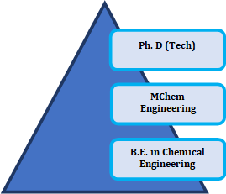
2016 | Ph. D (Tech) from ICT, Mumbai Formerly UDCT.
2010 | MChem Engg. (Chemical Engineering) from UICT, Mumbai Formerly UDCT
2003 | B.E. (Chemical Engineering) from Datta Meghe College of Engineering, Airoli, Navi Mumbai, Affiliated to University of Mumbai
2000 | Diploma in Chemical Engineering from VPM’s Polytechnic Thane, MSBTE

PERSONAL DETAILS

Date of Birth: 25th October 1980 Languages Known: English, Marathi and Hindi
Permanent Address: A-2402, Doris, Runwal Pearl, Dhokali,
Behind R mall, Ghod Bunder Road, Thane 400607, Maharashtra, India

