Dr. VIRUPAKSHA GOUDA H
Assistant Professor in R Y M Engineering College, Ballari
B.E., M.Tech., (VTU State 2nd Rank), Ph.D., (Bio- Composites)
8 Years of Experience in Teaching for UG & PG Students
 | 7th Cross Right Side,  “Sri Mahadeva Nilaya”  S.M.V Nagar, Kappagal Road,  Ballari- 583103. Karnataka. |  | virupaksha.rymec@gmail.com  - +91 9483066551.
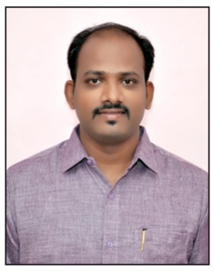
Achievements |  | Subjects Handled
Master of Technology |  | - Industrial Safety  - Theory of Metal Cutting  - Non-Traditional Machining  - Material Science  - Measurements & Metrology | - Composite Material  - Metal Casting & Welding  - Machine Tools & Operations  - Operations Management  - Operations Research
- Awarded First Place Academic Excellence in the Production Management for the year 2012-13.
- Awarded First Place Academic Excellence in the Production Management for the year 2013-14.
- Secured STATE SECOND RANK from VTU Belagavi in the Production Management for the year 2012-14.
 |  | Areas of Research
- Material Science
- Composite Material
- Tribology
Education
 | Ph.D. | Bio-Composite Materials | VTU Belagavi, Karnataka | Awarded 2022
 | M.Tech. | Production Management | RYMEC, Ballari | 2014 | 81.54% | Distinction
 | B.E. | Mechanical Engineering | RYMEC, Ballari | 2011 | 76.38% | Distinction
 | Diploma | Mechanical Engineering | VVS Polytechnic, Ballari | 2007 | 69.30% | First Class
Professional Experience & Accomplishments
Years of Experience | 08 Years (Feb 2015 – Present)
Students Handled | B. E (Mechanical Engg) & M. Tech (Production) Students
Present work | Assistant Professor, Dept of Mechanical Engineering, RYMEC, Ballari
Academic Related Activities | Involved in NBA & NAAC Accreditation Activities
Industry Experience
Company Name | JSW Steel Ltd, Vijayanagar Works, Ballari
Designation | Junior Manager
Number of Years | Oct 2007 to Feb 2015 - 08 Years
- Steel Melting Shop Capacity of 4MT having 130 Tons * 3 converters.
- Ladle heating furnace of 130 Tons * 3, RH Degasser of 130 * 1 & 4 slab casters.
- Handling 130T Ladle Heating Furnace properly to ensure Clean Steel.
- Tapping guidelines to BOF to ensure good input to Ladle Furnace.
- Efficiently managed to Save Aluminum, Power, Refractory & Tundish etc.
- Managing ISO related document, SOP’s and working instructions.

Soft Skills
Diploma Course in Computer Applications |  | Catia V5 R16
AutoCAD (Certified Course) |  | Ansys, Solid Edge V20
SAP PM/EAM |  | Kannada Nudi

Academic Activities
- Delivering lectures to the students and providing the study material to the students. Directing the students on how to use the study material for positive results in work.
- Organizing the workshops for the students and arranging the guest lecturers for the students in order to provide them the additional knowledge.
- Organizing the tests, seminars, technical & aptitude for the students in order to evaluate their progress.
- Providing the proper feedback to the students for the further development and helping students to accomplish the project work.
NBA Accreditation Activities
- Associate member of Criteria II and Criteria VIII.
- Actively involved in establishing the correlation between the CO’s, PO’s & PSO’s.
- Active PARTICIPANT in obtaining the attainment of CO’s, PO’s and PSO’s.
- Counseling for higher studies.
Professional Memberships
- Life Member of ISTE - LM111302 – 2016.
- Life Member of IFERP - PMIN25489760 – 2019.
- Senior Member of ISME (SMISME) - SMISME200424RYM - 2020
- Membership of the International Association of Engineers (IAENG) – 245239.
- Fellow Member of IRED (UAMAE) - SM101000601814 – 2019 to 2022.
- Associate Member of IRED (UAMAE) - AM101000584336– 2019 to 2022.
Reviewer
- Institute for Exploring Advances in Engineering (IEAE).
- International Journal of Creative Research Thoughts (IJCRT).
- International Journal of Engineering Research and Technology (IJERT).
- Institute of Scholars (InSc).
Editorial Board Member
- Journal of Automotive Mechanical & Aerospace Engineering Research ISSN: 2229-9270.

Faculty Development Program’s
- Successfully completed Four Days Faculty Development Program on “Process Quality through Optimization Techniques & Waste Utilization in Steel Manufacturing” Sponsored by VTU-VGST at BITM, Ballari from 20th to 23rd May 2015.
- Successfully completed Two Days Faculty Development Program on “System Dynamics” at RYMEC, Ballari from 18th to 19th Feb 2016.
- Successfully completed Three Days Faculty Development Program on “Industrial Automation & Computer Aided Engineering” at RYMEC, Ballari from 23rd to 25th July 2016.
- Successfully completed Four Days Faculty Development Program on “Outcome Based Education” at RYMEC, Ballari from 16th to 19th Jan 2017.
- Successfully completed Six Days Faculty Development Program on “Product Life Cycle Management & Thermo Acoustic Refrigeration” at RYMEC, Ballari from 11th to 16th Aug 2017.
- Successfully completed AICTE Approved Two Weeks FDP on “Foundation Program in ICT for Education (FDP101x)” Organized by IIT, Bombay, Under PMMMNMTT, MHRD and GOI from 08th March to 12th April 2018.
- Successfully completed AICTE Approved Two Weeks FDP on “Pedagogy for Online & Blended Teaching-Learning Process (FDP201x)” Organized by IIT, Bombay, Under PMMMNMTT, MHRD & GOI from 3rd May to 18th June 2018.
- Honor Code Certificate Issued for “SKANI101x: Basic 3D Animation using Blender”, a Certification course offered by IIT, Bombay. Online certification course conducted from 04th Apr to 11th July 2018.
- Honor Code Certificate Issued for “SKVIZ101x: Fundamentals of 3D Visualization”, a Certification course offered by IIT, Bombay. Online certification course conducted from 29th August to 07th October 2018.
- Successfully completed a One-day online FDP attended on “Contemporary tools & techniques for teachers and researchers in Higher Education Experience of using Virtual Classrooms” on 9th May 2020 Organized by Cambridge institute of technology, Bangalore.
- Successfully completed One Week Lecture Series on "Purely the fundamentals of Mechanical Engineering" from 01st to 05th June 2020 Organized by Chennai institute of technology, Chennai.
- Successfully completed Five Days FDP on "Mechanical Behaviour of Advanced Materials and Its Scope for Engineering Applications" from 10th to 14th June 2020 Organized by Sri Venkateshwara College of Engineering, Sriperumbudu.
- Successfully completed One Week Lecture Series on "Mechanical Behaviour of Materials" from 01st to 06th July 2020 Organized by Chennai institute of technology, Chennai.
- Successfully completed One Week FDP on "Optimization Techniques for Mechanical Engineers" from 27th July to 01st August 2020 Organized by Vignan institute of technology & science, Telangana.

- Successfully completed One Week ISTE Sponsored FDP on "Out Come Based Education and Accreditation" from 5th to 9th October 2020 Organized by ISTE, Telangana Section in Association with JNTU, Hyderabad.
- Successfully participated & completed AICTE Training and Learning (ATAL) Academy Online FDP on “The role of Additive Manufacturing in the Era of Industry 4.0” from 21st to 25th June 2021 organized by Chennai institute of technology, Chennai.
- Successfully participated & completed AICTE Training and Learning (ATAL) Academy Online FDP on “Industrial Automation using CNC and Intelligent Systems” from 16th to 20th August 2021 organized by Manipal Institute of Technology, Manipal.
- Successfully participated & completed AICTE Training and Learning (ATAL) Academy Online FDP on “Stress-Busting Meditation Sittings” from 20th to 24th September 2021 organized by Manipal Institute of Technology, Manipal.
Workshop’s
- Three days workshop attended on “Outcome Based Education” organized by Dept of CSE, RYMEC Ballari from 22nd to 24th November 2016.
- Two days workshop attended on “Research Methodology” organized by Dept of EEE at RYMEC, Ballari from 22nd to 23rd February 2018.
- One day Workshop attended on “Tableau: An Advanced Analytics Tool for Data Analysis” at Dept of ME BITM, Ballari on 10th March 2018.
- Two days Workshop organized on “Industrial Safety measures & Regulations” at RYMEC, Ballari on 21st & 22nd May 2018.
- Six days Workshop attended on “Research Methodology & Latex” organized by VTU e-Learning, Mysuru from 8th to 13th July 2019 at RYMEC, Ballari.
- One-day Workshop attended on “Research Scopes in Mechanical Engineering” organized by Dept of Mechanical Engineering, Chennai Institute of Technology, Chennai on 7th May 2020.
- One Week Workshop attended on "Composite Material and its Characterization" organized by Acharya institute of technology, Bangalore from 22nd to 26th June 2020.
- One Week Workshop attended on "Material Characterization using DMA" organized by Acharya institute of technology, Bangalore from 6th to 10th July 2020.
- One Week Workshop attended on "Tribology and its Applications" organized by Acharya institute of technology, Bangalore in association with DUCOM Instruments, Peenya, Bengaluru from 18th to 22nd January 2021.

Conference’s
- Presented a paper in the 3rd International Conference on “Computing, Engineering & Information Technology – 2014” on 25th August 2014 at The Solitaire Hotel, Bangalore.
- Participated in the KSTA National conference on “Impact of Science and Technology on Society and Economy” organized by KSTA, DST, GoK and VSKU, Ballari on 8th & 9th March 2017.
- Presented a paper in the International Conference on “Recent Innovation in Science, Engineering & Management – 2019 on 10th & 11th of May 2019 at RR Institute of Technology, Bangalore.
- Presented a paper in 4th International Conference on "Advanced Research in Mechanical, Materials and Manufacturing Engineering - 2020” on 10th and 11th July 2020 Organized by School of Mechanical Engg, REVA University, Bangalore.
- Presented Two papers in the 2nd International Conference on “Recent Developments in Material Science and Applications -2020" on 25th and 26th September 2020, Organized by Department Mechanical Engg, Chennai Institute of Technology, Chennai.

Webinar’s
- Successfully Completed One day online Workshop attended on “Research Scopes in Mechanical Engineering” organized by Department of Mechanical Engineering, Chennai Institute of Technology, Chennai on 7th May 2020.
- Successfully Completed One Day Webinar on “Contemporary tools & techniques for teachers and researchers in Higher Education Experience of using Virtual Classrooms” Department of Mechanical Engineering, Cambridge Institute of Technology, Bengaluru on 9th May 2020.
- Successfully Completed Online Quiz on “Research Methodology - 2020” organized by Internal Quality Assurance Cell (IQAC), Sri Krishna Institute of Technology, Bengaluru on 7th May 2020.
- Successfully Completed Two Day Webinar on “Design Thinking for Educators” organized by Allam Karibasappa Institute Management on 13th & 14th May 2020.
- Successfully Completed Faculty Program online on “NBA” organized Bharati Vidyapeeth College of Engineering, Navi Mumbai on 16th May 2020.
- Successfully Completed Online Quiz on “NAAC Awareness” organized by Internal Quality Assurance Cell (IQAC), AISSMS Institute of Information Technology, Pune, Maharashtra on 16th May 2020.
- Successfully Completed National Level Online Quiz on “Mechanical Systems Design (MSD)” organized by Internal Quality Assurance Cell (IQAC), AISSMS Institute of Information Technology, Pune, Maharashtra on 16th May 2020.

- Successfully Completed One Day Webinar on “Stress Management & Holistic Well Being” organized by Department Information Science & Engineering, Sri Krishna Institute of Technology, Bengaluru on 16th May 2020.
- Successfully Completed Online Quiz on “Teaching Aptitude” organized by PG Department of Commerce, Jamal Mohamed College, Tiruchirappalli, Tamil Nadu, on 17th May 2020.
- Successfully Completed Online Quiz on “Intellectual Property Rights (IPR)” organized by Internal Quality Assurance Cell (IQAC), RYMEC, Ballari, on 18th May 2020.
- Successfully Completed One Day Webinar on “GRAPHENE – The Future Material” organized by Department of Mechanical Engineering, Cambridge Institute of Technology, Bengaluru in association with VTU, Belagavi on 18th May 2020.
- Successfully Completed Online Quiz on “Theory of Machines” organized by Department of Mechanical Engineering, East West Institute of Technology, Bengaluru on 19th May 2020.
- Successfully Completed Online Quiz on “Mechathon” organized by Department of Mechanical Engineering, Mohamed Sathak A J College of Engineering, Chennai on 20th May 2020.
- Successfully Completed National Level Online Quiz on “Electrical Engineering” organized by Department of Electrical Engineering, Nitte Meenakshi Institute of Technology, Bengaluru on 20th May 2020.
- Successfully Completed One day online Workshop attended on “Fundamentals of Heat Transfer & Fluid Mechanics” organized by Department of Mechanical Engineering, Chennai Institute of Technology, Chennai on 20th May 2020.

Short Term Training Program’s
- Successful completed One Week (24th – 28th Oct 2018) STTP through ICT Mode on “Outcome Based Education & Accreditation” from NITTTR, Kolkata – Established by MHRD, Govt of India.
- Successful completed One Week (17th – 21st June 2019) STTP through ICT Mode on “NBA Accreditation” from NITTTR, Kolkata – Established by MHRD, Govt of India.
- Successful completed One Week (29th July – 02nd Aug 2019) STTP through ICT Mode on “Rural Development through Technical Institute” from NITTTR, Kolkata – Established by MHRD, Govt of India.
- Successful completed One Week STTP on "Innovative Approaches in Teaching Pedagogy" from 31st May to 05th June 2021 organised by NITTE Meenakshi Institute of Technology, Bangalore.
- Successful completed Five Days STTP on "Technology Enablers for Smart Manufacturing Using Industry 4.0" from 12th to 16th July 2021 organised by NITTE Meenakshi Institute of Technology, Bangalore.

Publication’s
- “Wear Study on Hybrid Natural Fiber Polymer Composite Materials Used as Orthopaedic Implants” in International Journal of Recent Development in Engineering and Technology (IJRDET), ISSN 2347-6435(Online) Volume 3, Issue 1, July 2014.
- “Characterization and Investigation of Mechanical Properties of Hybrid Natural Fiber Polymer Composite Materials Used as Orthopaedic Implants for Femur Bone Prosthesis” in IOSR Journal of Mechanical and Civil Engineering e-ISSN: 2278-1684, p-ISSN: 2320-334X, Vol-1, Issue 4 Ver. II, PP 40-52, Jul- Aug.-2014.
- “Ergonomic Analysis of Welding Operator Postures” in International Journal of Mechanical and Production Engineering, ISSN: 2320-2092 Volume- 4, Issue-6, June-2016.
- “Fabrication of Erosion Corrosion Equipment and Testing of Al 6063 Alloy” in International Journal of Engineering Research & Technology (IJERT) ISSN: 2278-0181 Vol. 5 Issue 11, November-2016.
- “Effect of Chemical Composition on Impact Strength of Steel” in International Journal for Research in Applied Science & Engineering Technology (IJRASET) ISSN: 2321-9653 Vol 5, Pg No 1556-1567, May 2017.
- “Hot Metal De-Sulphurisation by KR Process” in International Journal for Research in Applied Science & Engineering Technology (IJRASET) ISSN: 2321-9653 Volume 5, Page No 1827-1843, May 2017.
- "Design and Fabrication of Plantain (Banana) Fiber Extracting Mechanism" in International Journal of Science and Research (IJSR) ISSN: 2319-7064 Index Copernicus Value (2016): 79.57 | Impact Factor (2017): 7.296, Paper ID: ART20191808 DOI: 10.21275/ART20191808 Vol 7 Issue 10, Page No 520-523, Oct 2018.
- “Evaluation of Post Curing Effect on Mechanical Characterization of Polymer Matrix Composites” in Journal of Emerging Technologies and Innovative Research (JETIR) www.jetir.org (ISSN-2349-5162) © 2019 JETIR, Volume 6, Issue 4, April 2019.
- “Natural Fibers Reinforced Polymer Composite Materials – A Review” in International Journal of Scientific Research and Review UGC Journal No.: 64650, ISSN No.: 2279-543X, Volume 07, Issue 05, May 2019.
- “Process Optimization and Influence of Micro Structural Characterization by Friction Stir Welding of Various Materials” in International Journal of Engineering and Advanced Technology (IJEAT) ISSN: 2249 – 8958, Volume-9 Issue-2, December, 2019.
- “Investigations of Tensile Properties of Modified Epoxy-Based Composites Reinforced with Kenaf/Hemp Fibers for Orthopaedic Implants” in IOP Conf Series: Materials Science and Engineering, Scopus Indexed Journal, ISSN: 1757-899X, DOI:10.1088/1757-899X/988/1/012127, 988(1), 2020.
- “Experimental Investigation on Compression and Bending Properties of Epoxy Composites Reinforced with Al2O3, Kenaf/Hemp Fibers for Orthopaedic Implants” in IOP Conf Series: Materials Science and Engineering, Scopus Indexed Journal, ISSN: 1757-899X, DOI:10.1088/1757-899X/988/1/012001, 988(1), 2020.

Authored Book
- A Text Book on Non-Traditional Machining is published under INSC International Publishers, ISBN: 978-1-68576-135-6.
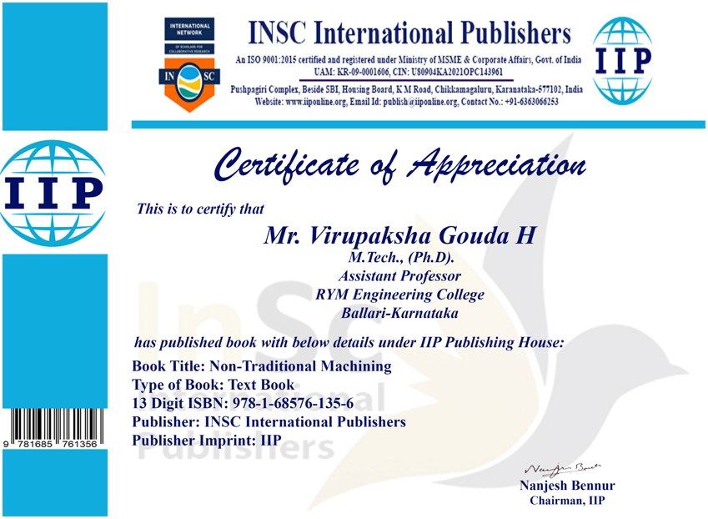

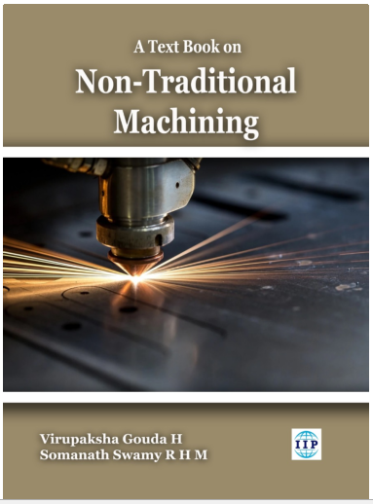

Personal Memorandum
Name | Dr. Virupaksha Gouda H
Father’s Name | Palakshi Gouda H
Mother’s Name | Ratanamma H
Spouse Name | Deepa N
Date of Birth | 25th March 1988.
Nationality | Indian.
Religion/caste | Hindu / Veerashiva Lingayath.
Marital Status | Married.
Languages known | Kannada, English, Hindi, Telugu.
Passport Number | M-2983390.
UIDAI Number | 9287-3419-1624.

Declaration
I hereby affirm that the information given above is true to the best of my knowledge.

Date: 15-08-2022
Place: Ballari (Dr. Virupaksha Gouda H)

