LOVELY SINGH 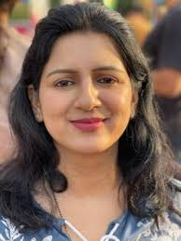
Mobile: +91-7389852020 / 9827512180
E-Mail: lovelyranjta@gmail.com, lovelyranjta@yahoo.co.uk

Area of Interest: Material Science (Nanocomposite Gel Polymer Electrolytes), Fiber Bragg Grating Sensors and Optical Amplifiers

Professional with 9 years of experience

Skills in synthesis, characterization and exploration of nanoparticles, operating & handling lectrochemical Analyser CH Instruments, X-ray Diffractometer (XRD), Scanning Electron Microscopy (SEM), Differential Scanning Calorimetry (DSC), Fourier Transmission Infra-red Spectroscopy (FTIR), Optical Microscope (OM) and fibre optic devices, fibre designs and applications; ensured up-to-date knowledge on technology; excellent time management skills; excellent organizational skills; proficient on various design software (Origin, Optiwave) applications

PROFILE SUMMARY

- Ph.D. (pursuing) in Physics on the topic “Studies on nanotubes embedded nano composite polymer electrolyte membrane for various device applications” from Deptt. of Physics, AKS University, Satna (M.P.) and a professional with 7 years of experience in teaching and 2 years exp. in corporate sector.
- Presented research papers in various international/national conferences.
- Research papers published in reputed international journals.
- Delivered many motivational lectures.
- Excellent hands-on experience in different characterization instruments, Fibre Optics instruments & Optical Communication kits.
- Excellent professional track record for positions assigned.
- Possess knowledge in Nanomaterials, Nanocomposite Polymer Gel Electrolytes, Fibre Optics & Optical Amplifiers
- Demonstrated skills in managing technical projects through all phases to completion.
- Superb background in process improvement and synthesis of nanocomposite polymer gel electrolytes, design for applications.
- Possess strong communication and interpersonal skills.

ORGANISATIONAL EXPERIENCE

Feb’09-Feb’11: Advanced Micronic Devices Ltd. (AMDL), New Delhi as Application Engineer

Jul’11-Sept’12: Vindhya Institute of Technology & Science, Satna (M.P.)

Aug’16- Currently : Asstt. Professor, Deptt. Of Physics, AKS University, Satna (M.P.)

Expertise in Origin & Optiwave Software (All modules) and various research characterization instruments

TECHNICAL SUBJECTS

- Polymer Electrolytes
- Nanomaterials
- Synthesis of Nanocomposite Gel polymer electrolytes
- Solution Cast Technique
- Optical Communication and Measurements
- Analog and Digital Communication
- Fibre Optics and Non Linear Optics
- Laser Physics
- Laser Applications
- Applied Optics
- Optical Networks
- Integrated Optics

EDUCATION
Scored first division throughout in studies
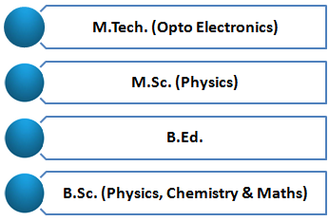
2019 Ph.D. (Pursuing) in Physics from Deptt. of Physics, AKS University, Satna (M.P.)
2008 M.Tech. (Opto Electronics) from Shri G.S. Institute of Technology &
Science, Indore; scored 75.14% marks & Ist division with distinction
Specialisation: Optical Communication
2006 M.Sc. (Physics) from Devi Ahilya Vishwavidyalaya, Indore (M.P.)
2004 B.Ed. from Himachal Pradesh University, Shimla (H.P.)
2003 B.Sc. (Physics, Chemistry & Maths) from Himachal Pradesh University,
Shimla (H.P.)
2000 H.S.C. from H.P. Board of School Education, Dharamshala
1998 S.S.C. from H.P. Board of School Education, Dharamshala

Academic Accolades:
- Attended many national/international conferences
- Delivered expert lectures in various govt. colleges in the field of science
- Won no. of certificates during B.Ed. Course in 2004
- Earned Scholarship in Graduation during 2000- 2003 tenure
- Received Certificate of the National Scholarship Scheme in 10th Standard in 1998

RESEARCH WORK (Ph.D.) in Physics

Title : Studies on nanotubes embedded nano composite polymer electrolyte membrane for various device applications” from Deptt. of Physics, AKS University, Satna (M.P.)
University : Deptt. of Physics, AKS University, Satna (M.P.)
Period : Pursuing since 2019

ACADEMIC PROJECT (M.Tech. Optoelectronics)

Title : Study of Fibre Bragg Grating (FBG) based Sensors for Strain and Pressure Measurements
Organisation : Central Scientific Instruments Organisation, Chandigarh
Period : May’07- Jun’08
Synopsis : Fibre optic sensor technology; Fabrication, writing and designing of Fiber Bragg Grating and its sensor applications.

MEMBERSHIPS

- Ex-IEEE Member
- Ex-IEEE Communications Society Member

RESEARCH PUBLICATIONS/PROFESSIONAL ENHANCEMENT PROGRAMS

Conference Attended:

- Paper presentation in International conference on Materials Science & Mathematics for advanced technology (MSMAT-2021) on the topic "Experimental Investigations on Nano-ferrite Embedded Nanocomposite Polymer Electrolytes for Proton-conducting Rechargeable Batteries Application” at NITTE, Karnataka from Nov 19-20, 2021. Published in Materials today: Proceedings, Nov 2021.
- Paper presented in National Conference in Materials and Devices (NCMD 2021) on the topic “Ion Transport behaviour in Nanotube Embedded Nanocomposite Polymer Electrolyte Membranes for Ionic Devices :[(PVA-NH₄CH₃COO):MWCNT] system” at Teerthanker Mahaveer University, Moradabad from Sept 16-17, 2021. Paper accepted in Macromolecular Symposia.
- Paper presentation in International Conference on Materials-Properties, Measurements and Applications (ICMPMA 2022) on the topic "Structural and electrical properties of Al₂O₃ nanoparticle soaked nanocomposite gel polymer electrolyte for device applications” at Fatima Mata National College, Kollam, Kerala from May 9-13, 2022.
- Paper accepted by American Journal of Nano Research entitled as “Structural, Thermal and electrical studies of Al₂O₃ nanoparticle soaked electrolyte gel films for novel proton conducting (H⁺ ion ) eco-friendly device applications.”
- Poster presented in the conference on Astronomy under Madhya Pradesh Vigyan Sammelan & Expo 2021 on the topic “Experimental Studies on Sol-Gel Derived Ni Doped BiNiFeO₃ Nanoparticle For Electrochemical Applications” organised by IIT Indore, MPCST and Vigyan Bharti at IIT Indore from Dec 22-25, 2021.
- Attended national webinar on “Solar Modulation of Cosmic Rays” organised by Govt. Model Science College, Rewa sponsored by Deptt. of Higher Education, RUSA & World Bank Scheme-MPHEQIP on Sept 25, 2021
- Represented AKS University, Satna at 13th International Conference on Fibre Optics & Photonics-Photonics 2016 at IIT Kanpur, from Dec 04-08, 2016
- Represented AMDL, New Delhi at 10th International Conference on Fibre Optics & Photonics-Photonics 2010 at IIT Guwahati, Assam from Dec 11-15, 2010
- Allocaded with many awards/certificates at university level.

Seminars Delivered:
- Nanotechnology: Materials & Applications in AKSU, Satna in Oct 2021
- Fibre Bragg Grating (FBG) based Sensors for Strain and Pressure Measurements at SGSITS, Indore in 2008
- Optical Amplifiers at SGSITS, Indore in 2007
- Optiwave at Indian Air Force Station, New Delhi
- ISTE sponsored STTP on Advances in Coding and Communication; Algorithms and Systems at Nagpur, MS
- Integrated Test Range, Balasore- A DRDO Lab
- National Institute of Technology, Hamirpur & Srinagar, etc.

Workshop Attended:
- Workshop at 13th International Conference on Fibre Optics & Photonics-Photonics 2016 at IIT Kanpur, from Dec 04-08, 2016
- National Workshop on Recent Trends in Nanotechnology RTN-2007 organised by SGSITS under TEQIP in Indore
- Participation and guidance of students of AKS University at IISER Bhopal in Technical fest.
- Workshop for Latex Software organised by Deptt. Of Mathematics, AKS University, Satna

LAB EQUIPMENT PURVIEW

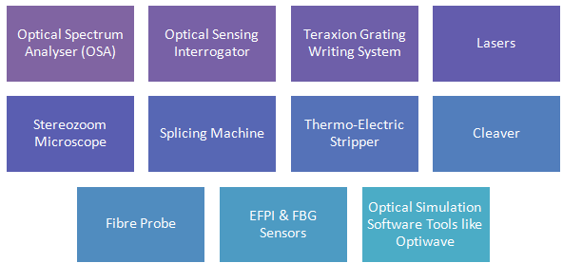
- FTIR
- XRD
- SEM
- OM
- Electrochemical Analyser
- Optical Spectrum Analyser (OSA)
- Optical Sensing Interrogator
- Teraxion Grating Writing System
- Lasers
- Stereozoom Microscope
- Splicing Machine
- Thermo-Electric Stripper
- Cleaver
- Fibre Probe
- EFPI & FBG Sensors
- ORIGIN
- Optical Simulation Software Tool (Optiwave)

CERTIFICATION
- Certificate of Proficiency in Airlines Management from Institute of Tourism & Future Management Trends (ITFT), Chandigarh

PERSONAL DETAILS

Date of Birth : 14th April 1983
Languages Known : English & Hindi
Address : HIG-62, Hinauta House, Bharhut Nagar, Satna - 485001 (M.P.) INDIA
Marital Status : Married
Nationality : Indian
Passport : Valid

