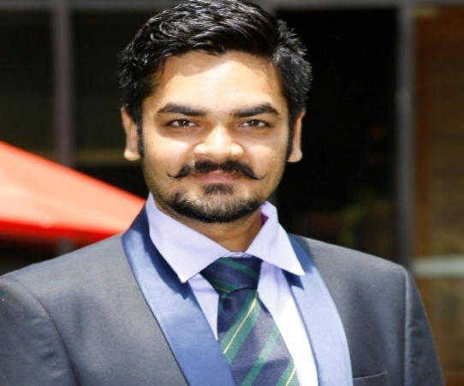
Experienced Assistant Professor with a demonstrated history of working in the higher education industry. Skilled in Intelligent Tutoring Systems, Business Planning, Operations Management, Analytical Skills, and Microsoft Office. Strong and euphoric portfolio of Commerce and Management from repute university of State of Gujarat PhD in Management & Commerce, MBA in Finance M.Com B.Com {Double Graduation with Major subject of Advance Accountancy and Advance Statistics-Currently working as an Assistant Professor in Faculty of Management, GLS University, Ahmedabad.
As well as When Education teaching area is concerned niche areas are Operation and Supply Chain Management, Security Analysis and Portfolio Management, Financial Services, Banking and Insurance, Research Methodology, Foreign Exchange Market, Entrepreneurship Development and many more in the area of General Management, Commerce and Finance.
Well acquainted with the research methodologies, using the existing scales and creating new scales for using in the research analysis. Comfortable and expert in using the SPSS tool, Microsoft Power BI and R Software to perform analysis. Published more than 30 Research papers in various national and international journals as repute. Co-authored 3 International books in the subject of Management and Commerce and invited as a Resource person, Keynote speaker, Panelist and Track moderator in various International and national symposium, conference, faculty development program in leading university and college. Dr.Devrshi also served as external examiner,paper setter and convener for various universities.
Also having diverse and deep research and consultancy interested areas are Behavior Finance, Financial Engineering, Managing technology & Innovation, Resources Management, Corporate Social Responsibility ,Ethics & Accountability, Business Strategy Development, Finance Optimization.
LinkedIn Profile:
https://www.linkedin.com/in/prof-dr-devrshi-upadhayay-7545225a

