Dalia Azmy Hosny Gharbiea 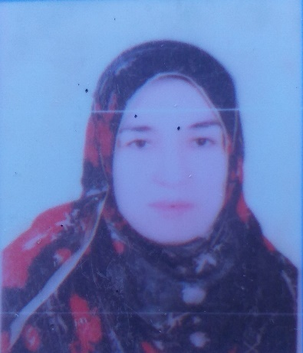

Personal information
- Date of birth: 21-6-1977
- Marital status: married
- Contact
- Address:32 Elsalam street-Elnagareen-ferescour-damietta-Egypt.

- Phone:
- 01286219838
- 057-3485673

- Email:
- Dalia_az1@hotmailcom
- Dalia-azmy@engmet.edu.eg
- Languaged
- Arabic
- English

Current jup
- Lecture of physics in misr high institution of engineering and technology.

Skill Highlights
- ICDL course in computer.
- Tofol course in English.
- Using fortran language in programming.
- Using Mathematica program in programing.

Certifications
- Bachelor of science in physics-physics depattment-faculty of physics-Damietta university.
- Master in theoretical physics (2004). Faculty of science – Damietta university.
- Ph.D. in physics (2011)-Faculty of science -Damietta university.
Published papers

1- Albedo problem in anisotropic semi-infinite medium

A. El-Depsy, D.A. Gharbiea and M.S. Abdel Krim.
JQSRT, Volume 94, Issues 3–4, 1 September 2005, Pages 491–506
http://www.sciencedirect.com/science/article/pii/S0022407304004169

2- Milne's problem for anisotropic scattering medium with specular reflecting boundary

A. EL-Depsy, D.A. Gharbiea and M.S. Abdel Krim
JQSRT, Vol 98, Issue 3, April 2006, Pages 379–393.
http://www.sciencedirect.com/science/article/pii/S0022407305002591

3- Two-region Milne problem with anisotropic scattering

M.H. Haggaga, A. El-Depsyb and D.A. Gharbieab.
Annal of nucl Energy, Vol 35, Issue 9, September 2008, Pages 1701–1707
http://www.sciencedirect.com/science/article/pii/S0306454908000571

4- Albedo problem in a semi-infinite medium with rayleigh scattering

A.R. Degheidya, A. El-Depsyb and D.A. Gharbieab,
Annal of nucl Energy, Vol 36, Issue 10, October 2009, Pages 1619–1623.
http://www.sciencedirect.com/science/article/pii/S0306454909001066

5- Albedo problem for pure–triplet scattering in finite planer media

A R Degheidy, A El-Depsy and D A Gharbiea
IndianJ.Phys, Vol.85,No.,pp575-585 (2011).
http://link.springer.com/article/10.1007%2Fs12648-011-0060-4

6- Albedo Problem in a semi-infinite medium with Pure-Triplet Scattering.
A.R. Degheidya, A. El-Depsyb, D.A. Gharbieab and M.Sallah.
IndianJ.Phys, December 2012, Volume 86, Issue 12, pp 1131-1137
http://link.springer.com/article/10.1007%2Fs12648-012-0145-8

7- Solution of radiative transfer equation in finite medium involving Fresnel reflection
Dalia A. Gharbiea, Eur. Phys. J. Plus (2020) 135:812.
https://doi.org/10.1140/epjp/s13360-020-00702-3

