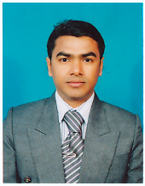

**Dr. Sanjoy Shil**