**Biography**

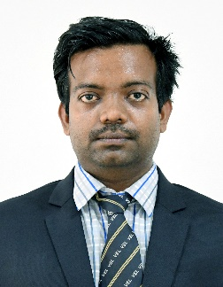

**Prof. R Sreedhar** received his bachelor degree in Electrical and Electronics Engineering from P.S.R Engineering College Sivakasi, in 2008 under Anna University Chennai, and a Master of Technology degree in Power Electronics and Drives from Kalasalingam University, Krishnankoil, Tamilnadu in 2013. He is currently working as an Assistant Professor also pursuing his doctorate degree in Department of Electrical and Electronics Engineering, Vel Tech Rangarajan Dr.Sagunthala R&D Institute of Science and Technology, Chennai. He published more than 20 research articles in various reputed journals and international conferences. He also acting as reviewer in various international Journals such as IEEE access, Electrical Engineering, IJPEDS and reviewed more than 100 articles. He has 11 years of teaching experience and 3 years of industrial experience. His areas of interests are Solar PV systems, MPPT controllers, Multilevel Inverters, Electric Vehicles, Battery Technology and Electrical Machines.