**Profile of Dr. Ashok Kumar Yadav**

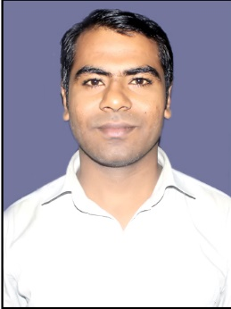

**Dr. Ashok Kumar Yadav** is Assistant Professor in Department of Food Technology at Rajiv Gandhi University (A Central University), Itanagar, Arunachal Pradeshis Ph.D. in Food Science and Technology from Banaras Hindu University, Varanasi. Dr. Yadav is Masters in two subjects one with Food Science and Technology and other with Chemistry as well. He had qualified ICAR NET in 2014. He had more than Eight years of experience in teaching and research. Prior to joining Rajiv Gandhi University, he had served Banaras Hindu University for more than seven years. At BHU he holds many administrative positions like Warden of Boys hostel for 7 Years, Member of Anti ragging squad and member of University Proctorial Board for 03 Years. He had research experience of 14 months in a UGC funded project at Indian Institute of Technology, Banaras Hindu University. He had participated and presented papers in many trainings, 13 national and 06 International conferences, workshops, organized one workshop and two national seminars. He is the life member of Association of Food Scientists and Technologists (India), Mysore and Indian Dairy Association, New Delhi. He had published 18 research papers in peer reviewed journals with national and International repute in high impact factors. He authored 28 book chapters in national and international level books. He is the co-editor of 07 national level books. He had developed the course curriculum for Vocational Course of Food Processing and M.Sc. Food Technology as per NEP 2020. His expertized research area includes nutraceutical and functional foods, fermented foods, food packaging, dairy technology and fruits and vegetables processing. He is honored with Young Scientist Award and Excellence Award in Teaching, Research and Extension from recognized societies.

**Dr. Ashok Kumar Yadav**

**Assistant Professor**

**Department of Food Technology**

**Rajiv Gandhi University (A Central University)**

**Rono Hills, Doimukh 791 112**

**Arunachal Pradesh**