Millet: A future leading grain – An Analytical study

Ms. Deepthi Shirahatti
Assistant Professor
Department of Management
Bangalore
Deepthimahantesh80@gmail.com

Ms.Sudha N
Department of Management
East West College of Management
Bangalore
Sudha.bims@gmail.com

Introduction
India is that the land of an agrarian society, where 55% of the population depends on agriculture. In these statistics, 86% of the farmers are identified as small and marginal farmers. This is often the major reason for increasing in the cost of cultivation and facing the crisis of sources of income and income security. CGIAR has estimated that the worldwide production of wheat, rice, and maize could decrease by 13-20% within the coming decades because of climate change. Moreover, India is one among the world's highest demographics of children suffering from malnutrition when compared to other countries. India's National Family Health Survey reveals that 55% of girls have iron deficiency and anemia. To deal with these issues of climate change, malnutrition, and poverty, special smart food should are given priority by the Government of India. Millets are often a potential smart food crop, which could eradicate of these issues as it fulfils the smart food criteria. a number of the smart food criteria are: 'Good for you, ‘Good for the plant' and 'Good for the Farmer'. These Smart food crops are highly nutritious and target the most important needs of women and children. It is a low carbon footprint and serves as a mitigation and adaptation strategy for climate change. They will survive in high temperatures and survive with very little water. Despite of extraordinary qualities of millets, their cultivations were decreased for several reasons. During this situation, it's important to enhance the production of these crops and increase awareness in the global market.

General Health Benefits of Millets

- It helps to guard against heart diseases.
- Control the cholesterol level.
- Helps in detoxifying the body.
- It prevents type 2 diabetes.
- It prevents carcinoma.
- It's effective in reducing blood pressure
- Helps to optimize the immune system

The Global Impact Economy of Millets

- Millets are being hailed as ‘super crops’ worldwide.
- Under the advice of India’s Food and Agriculture Organization (FAO), 2023, has been announced to be the "Year of the Millets".
- Countries like Africa and Asian countries are severely suffering from undernourishment and food security issues have been affecting all continents.
- With the assistance of millets' high nutritional profiles, address these deficiencies and evolve solutions towards establishing healthy dietary patterns.
- The US contributes to exports with 30% shares, and, 50 you look after the millets are imported to Indonesia, Iran, Belgium, Germany and South Kore, etc.. establishing a worldwide demand.
- Around 12 billion USD is that the projected growth of the global millet market by 2025.
- 20% of the worldwide export value of millets is contributed by India which is considered a key player in global demand.
- Millets are indicates an emerging market due to the 50% growth in export to UAE and Nepal.
- In India, Bangalore city is emerging as a millets hub by entrepreneurial chefs reinventing heritage cuisines.

Global Importance of Millets

- Elevation of millet-based recipes and new permutation precisely for health-conscious demographics. Promotion of divergence of diets to complement nutrients profile of food.
- Millet production yield and exports are increasing thanks to its reliability.
- For the enhancement of millet production, the government has promoted many research interventions.
- Revitalization of indigenous variations mixed cropping concepts. This crop is especially connected with the tradition and ethnicity of the local people and kinfolks in Africa.

Challenges of Millet Food Grains
- Product recognition is one among the most challenges, curbing the expected growth and expansion within the projected period by the various government agencies.
- FDA has been not recognized that the merchandise used for treating chronic diseases.
- Rigorous government regulations towards drug usage due to rising cases of enduring illness are likely to creel coenzyme industry growth.
- High product prices in contrast with largely consumed grains are acting as a disruption to dispersion in an urban food market.
- Photo-insensitive & sturdy to global climate change , millets are resistant, irrepressible crops that have a coffee carbon and water footprint, can survive high temperatures, and grow on deprived soils with little or no peripheral inputs.

Millet Type: Focus Areas for 2025

* Bulrush millet
* Ragi
* Proso millet
* Italian millet
* Others (Japanese barnyard millet, Kodo millet, etc.)
In 2018, pearl held the uppermost share in terms of product volume within the millets market and is likely to increase at more than 3% CAGR by 2025. The big demand share of pearl millets is due to their opulent nutritional value as it has 8 times more advanced iron content than rice. Finger millets are prevalent among several beliefs and have demand from processors. Foxtail, Proso, and other millets also are rich in fiber, calcium, and other minerals.

Approaches of Millets for healthy and sustainable agriculture

Table No.1
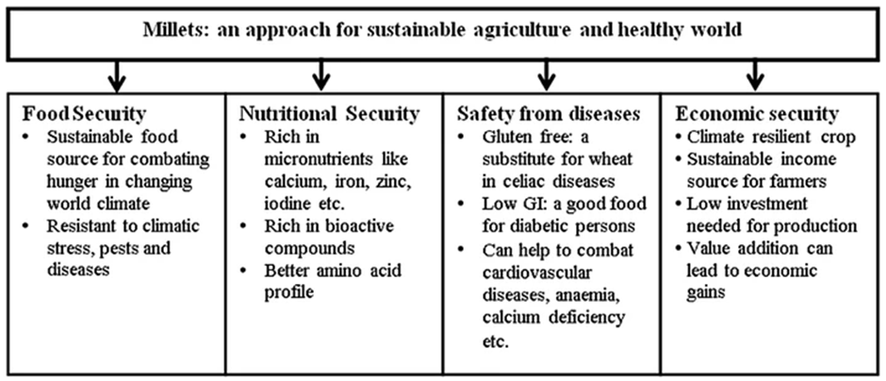

Market Share of Millet Productions

FAO estimated that millet production will reach around 28.4 million metric tons in 2019. The market share of India is 36.08 and represents as largest global producer followed by Niger at 11%, Mali at 7%, and Nigeria at 7%, and other production rates at 31% of the worldwide share.

Graph No.1

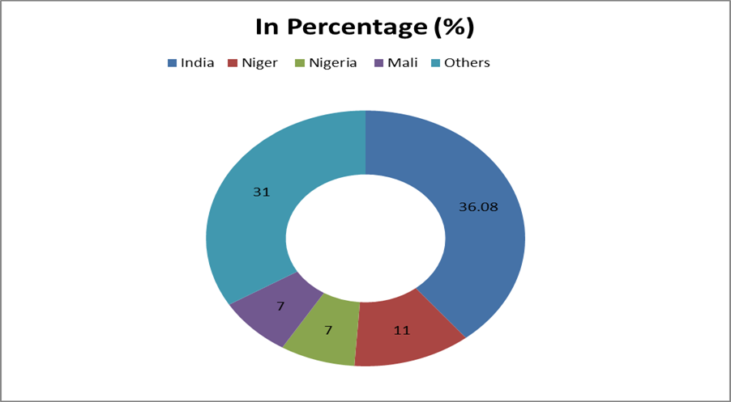

Case Study: How Slurrp Farm leveraged Digital Medium to extend its overall sales. Slurrp Farm may be a start-up that offers a wide range of healthy, millet-based packaged food products that are good for the nutritional needs of young children. the thought was to give parents a wide variety of yummy, healthy, and natural food options for his or her little ones which they could trust with their eyes closed. Founded in 2016, the Gurgaon-based early-stage company aims to revive the utilization of super grains such as ragi, jowar, and bajra by offering products within the kids’ food segment. The corporate offers as many as 20 products, which include puffed snacks, millet pancake mix, millet dosa mix, cereals, and cookies made with real butter. Their products have already made their debut on store shelves within the UAE and Singapore.

The objects, analysis, and outgrowth of the case in the digital crusade

The main ideal of the crusade is to help the business to grow five times in volume and help the business to vend its products directly from the websites. The target followership who was named is parents who are active druggies of e-commerce websites for baby- related products and especially high- value goods. Presently, these business products are available in Delhi, Mumbai, and Bangalore piecemeal from theecommerce platforms. Hence, the terrain was limited to league one metropolis only. Meanwhile opting the advertising platforms, the following digital platform was suggested Google display, Google Hunt, Facebook & YouTube. And this redounded in adding 5 times deals of the business. Crusade prosecution (creative) the brand came up with an intriguing and compelling banner and videotape advertisements.
This case study is the stylish illustration of showing the growing trends of millet and millet- grounded products by using digital platform to promote the products encyclopaedically and spreading mindfulness each over the globe.

Findings

- The study discloses numerous important factors of millets' consumption like high nutrition food, helpful in those who are suffering problems from malnutrition, iron insufficiency, and anemia, especially among women and children.
- It has gained global significance because of its multiple benefits like millet- grounded fashions, health-conscious demography, and government inauguration, and it's also a representation of numerous ethical values and traditions of a particular group.
- India is linked as the global leading patron gaining a request share of36.08 of global request share.
- It's estimated that the growth of the global millet request by 12 billion USD by 2025.
- The case study of Slurrp Farm substantiated the significance of the operation of e-commerce and digital Media to promote millet and milletgrounded foods concentrating on websites using women who are largely looking for value products.

Conclusion

This study has been noticed that there a need to change the image of millets and make it ultramodern by developing applicable consumer products which are matching for current request trends or changing scripts. These crops are largely nutritional and have health benefits by consuming them, and for formers friendly crop because it useless water and high failure forbearance. The government of India sets an docket of malnutrition-free India and adding the inflows of formers', the creation, product, and consumption of these cereals appears to be a strategy change in the veracious trend.

References
1] https://thelogicalindian.com/story-feed/awareness/millet/

2] https://www.drishtiias.com/daily-updates/daily-news-editorials/millets-superfood/print_manually

3] https://www.drishtiias.com/daily-updates/daily-news-editorials/millets-superfood/print_manually

4] https://impactentrepreneur.com/the-global-impact-economy-of-millets/

5] https://www.databridgemarketresearch.com/reports/global-millets-market
6] https://www.alliedmarketresearch.com/millet-market
7] https://blog.themediaant.com/case-study-how-slurrp-farm-leveraged-digital-medium-to-increase-its-overall-sales/

