Impact of COVID 19 Pandemic on Adoption of Quick Commerce
Piya Ghosh | Dr Asha Bhatia
Industrial and Management Engineering | Department of Research
Indian Institute of Technology, Kanpur, India | Universal Business School, Karjat, Maharashtra, India
piyagh@iitk.ac.in | asha.bhatia@ubs.org.in

ABSTRACT
Academics and industry practitioners are interested in the impact of digital transformation on organisational and industrial change. This may change how individuals and organisations see, capture, and transform digitalization's potential. Digital technology makes companies more successful, according to research. COVID-19 has increased the demand for digital transformation. Part of the working population must work from home because of government restrictions or volunteer actions against the epidemic. Due to the requirement for social separation, companies have changed how they engage with clients, leading many to resort to online means.
The Covid-19 outbreak helped create q-commerce, a business model that delivers items and services within 10-30 minutes of purchasing. It concentrates on lesser quantities of food, stationery, and over-the-counter drugs. Quick commerce's lightning-fast shipping service sets it different from other e-commerce sites. Traditional warehouses have been replaced by vendor-owned micro-warehouses. These efforts aim to reduce stock to 2,000 high-demand items. Q-Commerce systems make shopping faster than typical eCommerce sites. This means fewer steps, lighter carts, speedier checkout, and an overall better experience. This report will focus on the Indian market for quick commerce and academic views on quick commerce.

Keywords – Quick Commerce, E-Commerce, Indian Market, IT infrastructure, Digital transformation, COVID 19

I. Literature Review

If we talk about digital transformation, then Hanelt et al. [1] and Verhoef et al. [2] defined it as “organizational change that is triggered and shaped by the widespread diffusion of digital technologies” in order to “develop a new digital business model that helps to create and appropriate more value for the firm.”
The process of digital transformation is interdisciplinary in nature and has implications for a number of aspects of a business, including its IT infrastructure, corporate strategy, supply chain management, and marketing strategy. The way a firm interacts with its stakeholders has been transformed by new digital technology. Through vertical integration, customers, rivals, and suppliers may all become partners in the development of new goods and services. Cappa et al. [3] examine the effects of big data analytics on the performance of companies, including the use of mobile applications to acquire personal data from consumers. Big data should be dependable and rich enough to deliver useful information, according to the authors. Data collection, storage, and use costs and dangers may have a negative impact on a company's performance if they aren't minimized. Appio et al. [4] conducted for more theoretical and empirical study on how businesses innovate and compete in the digital age, as well as how digital technology have altered the process of developing new goods and services. Li [5] has identified three innovation techniques that are developing in top firms, and they are as follows: (1) experimental innovation, which utilizes experiments to review and recalibrate strategy and guide execution; (2) radical transformation, which entails carrying through a series of incremental linked stages; and (3) dynamic sustainable advantages, which are achieved via a changing portfolio of temporary advantages. The goal of achieving digital transformation is to create a more customer-centric business. In order to accomplish digital transformation, companies recognize that they must go through many phases. They must first establish the appropriate technological and social structures to acquire the essential capabilities, procedures, and routines to accommodate digital transformation. These structures must be developed before they can begin the process of digital transformation. As a direct consequence of the pandemic, there has been an unprecedented increase in the number of customers demanding rapid delivery of supermarket supplies. Because of this, the strain of delivery workers working for quick-commerce (q-commerce) businesses has increased tremendously. According to the findings of a study [6] that McKinsey carried out with customers in France, Germany, Italy, Spain, and the United Kingdom throughout the epidemic, there has been a continual rise in the desire from customers to purchase online. Researchers find out that about 15% of people have bought groceries on a website they had never used before. Of those people, more than 50% say they plan to keep buying groceries online for at least some of their needs, and 12% have switched to different grocery stores that offer home delivery or click-and-collect services. However, Elnahla and Neilson [7] found that COVID-19 has produced a previously unheard-of mismatch between the supply and demand of retail workers, since certain stores, such online food merchants, have been forced to close their doors due to an abnormal demand. The purpose of Nagel's [8] research is to determine if the COVID-19 epidemic has accelerated the digital transformation of the workplace. In response to the COVID-19 epidemic, the number of individuals working from home has increased, and many people think that the digital revolution of work has accelerated. People who saw this acceleration may see working totally digitally in the future. Due to the COVID-19 epidemic, the significance of conventional occupations as a secure source of money has declined, while the significance of digital forms of labour as a secure source of revenue has grown. Workers feel that digital employment will play a greater role in the future as a reliable source of income than conventional occupations. Traditional occupations will play a less future-proof source of income than alternative jobs. Eriksson and Stenius [9] observed that the demand for online grocery shopping was so great that clients had trouble finding a convenient time period for both self-pickup and home delivery. Researchers [10] studied that during the epidemic, food stores with home delivery services began to play a crucial role in society and its employees were classed as essential workers but also as "the neglected frontline." Even before the epidemic, a slew of new q-commerce food merchants had sprung up as a result of digitization. The requirement to obtain the highest return on experience while also growing the data organisation are all current preoccupations. Purcarea [11] expected a noticeable shift in e-commerce, and they have been preparing for it. The findings of the research showed that the quick-commerce retail space is expanding at a rapid pace, and that there is increased competition among vertically integrated instant-needs companies and third-party delivery platforms. A particular emphasis was placed on the economics of quick commerce, as well as the impact that delivery times have within this framework. COVID19 has advanced restaurant digitalization and food delivery growth. National lockdowns have made it hard to go to pubs and restaurants, so many people order online. Text-image retrieval for food and drink search engines is significant. Olóndriz et al. [12] introduce the FoDI-ML dataset. This dataset includes 1.5M unique photos and 9.5M Glovo shop names, product names, and collection sections. The data covers 37 nations in Europe, the Middle East, Africa, and Latin America. The collection includes 33 languages, including 870K samples of Eastern European and Western Asian languages like Ukrainian and Kazakh, which have been underrepresented in publicly accessible visio-linguistic datasets. The dataset comprises Spanish and English Latin America. This dataset opens the door to various applications previously inaccessible owing to a lack of public datasets. Multilingual picture-based search engines based on food and drink samples, and improved food image embeddings. Fast grocery delivery in Turkey was introduced by Getir in 2015, one of the earliest q-commerce grocery shops [13]. Another q-commerce shop, Spanish Glovo [14], was founded in 2015 and is presently active in 21 countries. Delivery Hero [15], a worldwide retailer, began using q-commerce in 2019 and has invested extensively in expanding its platform to include local stores as well as constructing Delivery Hero-owned local warehouses, dubbed Dmarts, around the United States. There are two major differences between Q-commerce grocery businesses and traditional grocery stores. Their lack of a brick-and-mortar storefront is the first thing to note. They offer apps for smartphones and tablets. Orders may be placed using the app, and customers can track the progress of their purchases at any given time. Secondly, their biggest difference is in the time they take to complete their tasks. According to Nierynck [16], "q-commerce" refers to the next-generation of e-commerce, which is all about speed. Customers may get thousands of daily products from Q-commerce grocery stores within minutes of placing an order. They deliver hundreds of often purchased items including milk, yogurt, bread, eggs, chocolate, chips, drinks, fruits and vegetables, baby diapers, shampoos and soaps, deodorants and deodorant creams, cat and dog food and batteries to their customers' homes in minutes. These shops. Because of their ease of use, these products quickly spread across the market. Young, tech-savvy shoppers choose Q-commerce grocery stores because they can save time and avoid the hassles of traditional brick-and-mortar stores. It is anticipated by Lange [17] that the worldwide market for Q-commerce would reach around 448 billion Euros in size by the year 2030. Q-commerce presents a substantial opportunity for future expansion. As a consequence, there is a need for greater research into q-commerce merchants.

II. Traditional E- commerce Vs Q- commerce

The speed of q-commerce is a significant advantage over more typical e-commerce methods. Cost-cutting is a top objective in conventional business models; corporations must handle enormous numbers of items, store them in big warehouses, and optimize their load. Companies in q-commerce deploy micro-hubs and depend on couriers specializing in last-mile deliveries since delivery time is a major concern for consumers when making purchasing choices. The on-demand economy and the ability to make quick deliveries have fuelled the rise of q-commerce, which is driven by urban lives, small families, and an aging population. In addition to speed, convenience, consistency, friendliness, and human touch, the most important characteristics of the customer experience have been recognized as friendliness, human touch, and consistency. For the most part, customer satisfaction is measured by how well a product or service meets these criteria.

Table 1: E- commerce Vs Q- commerce

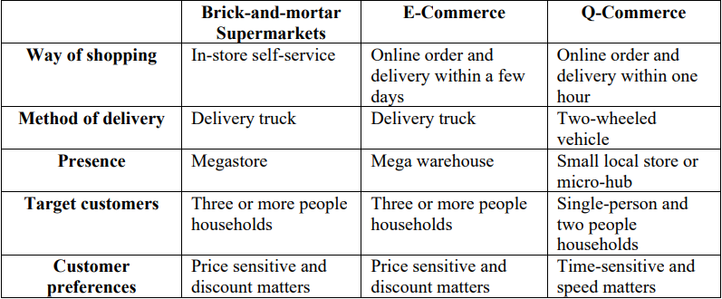

However, the growth of q-commerce has the same obstacles as urban e-commerce distribution, such as limited volumes, high replenishment frequency, complicated delivery locations, low stock levels, and timely deliveries. Consequently, corporations have implemented novel urban logistics strategies to minimize the number of cars as well as the number of trips and failed deliveries such as lockers, pickup locations, and mobile warehouses.

III. Indian Scenario

There has never been a better time to start a digital consumer company in India than now. From its present size of $0.3 billion, the Indian Q-commerce industry is expected to increase by a factor of 10 to 15 by 2025, reaching a value of $5 billion. This is the first time that people of all ages and geographic locations have taken use of internet shopping for a wide variety of goods, including daily necessities. Consumers who had previously relied on local kirana shops to purchase groceries and other convenience products now shop online. E-grocery platforms are expected to reach 130 million online transacting households by 2020 (those who have used or are likely to utilize e-grocery platforms) according to a previous report by RedSeer Consulting [18], grocery purchases are common in India for items in the home cleaning and personal care categories. As a result, Q-commerce businesses now have an excellent opportunity to expand their market share. Although online grocery penetration in the nation is still in the low single digits, this presents a huge possibility for development.
In decreasing order, the following players [19] are on their way to success:
Both Zomato and Swiggy, which provide shopping and meal delivery services, have vast fleets that are well-used. To retain consumers, they give membership advantages to their client base.
Ex-Grofers' warehouses: BigBasket and Blinkit (formerly Grofers) were early adopters of warehouse expansion. In certain cases, these hubs may be converted into mother hubs that connect to the dark store network. Because of this, they have a smaller fleet of drivers compared to other food delivery services like Swiggy and Zomato.

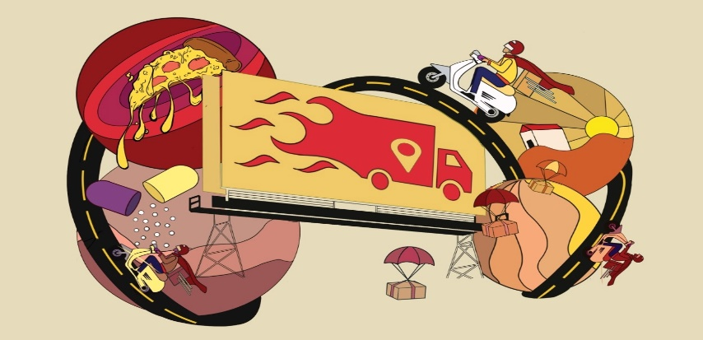
Figure 1: Delivery system

Data from AI platform Bobble shows Zepto has the fastest user growth (946 percent within 90 days). Dunzo outperformed all other q-commerce apps, including Zepto, in terms of time spent on the app.
Even while groceries are still the primary emphasis of rapid delivery, this is likely to change in the near future due to the introduction of electronics, stationery, and medicinal products. Companies like Netmeds, Apollo 247, and Tata 1mg are participating in the market.

IV. Q-Commerce in India: Where Are We Now?

Products like as grocery items and pet supplies as well as stationery, stationery supplies, and electrical goods are all well-suited to the Indian Q-commerce market's current status. Some of these items don't even have the option of being delivered in under 30 minutes, but brands are pushing for this option and will go to great lengths to please their customers. On the other hand, customers are more willing to accept lower delivery prices in exchange for faster delivery times.
At the moment, the Q-Commerce model can reach over 20 million Indian families in India, but that represents just 7% of the total market, according to the RedSeer [18] research. Q-development commerce's will be facilitated by the steady rise of online consumables in India. Metro and tier-I cities are estimated to contribute about half of this increase. A perfect window has opened for q-Commerce businesses to expand their reach and market share, as hyperlocal delivery is becoming more commonplace rather than an optional extra.
In spite of the low penetration of home goods and eCommerce, the ONDC [20] initiative has the potential to alter this. Previously offline vendors in neighbourhood kiranas may now record both scheduled and unexpected consumption online.

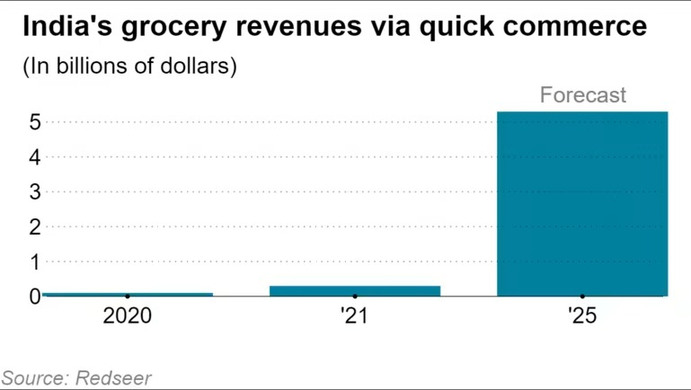
Figure 2: India’s grocery revenues via Q- commerce

Last year, "quick commerce," as it is called locally, became the talk of the town as some of India's top entrepreneurs [21] made strong advances into the supermarket delivery business, which delivers products to doorsteps in less than 20 minutes.
Swiggy, a food delivery business, has invested $700 million in its Blinkit service, while Zomato has invested $250 million in its Blinkit service. Reliance Industries purchased 25.8 percent of Dunzo for $200 million, a delivery firm, while Zepto obtained a $360 million investment on its way to a $900 million value. Flipkart, owned by Walmart, and BigBasket, operated by Tata Group, India's biggest online supermarket, are both expanding their market share. To compete with Amazon and Walmart's Flipkart, Warpli allows shoppers to choose items from retailers within 10 kilometres of their homes, as well as those kept in local fulfilment facilities. Additionally, Flipkart has launched Flipkart Quick, which promises groceries delivery in 45 minutes and home appliances, mobile phones, and fashion accessories in 60 minutes.

V. Conclusion
Logistics and online grocery companies should keep an eye on the quick commerce market, but the expectations are likely to stabilize at about 30 minutes or so. The 10-minute approach, according to industry insiders, will become obsolete in the future. There is a consensus among business leaders and academics that Q-commerce is unlikely to have a significant impact on consumer behaviour in the short term to make them willing to pay a premium for faster delivery. They also believe that it will have little long-term impact on consumer behaviour. It has been found in much of the research that there has been a rise in traffic and accidents as a result of q-commerce. Several drivers are tasked with picking up and delivering various items as quickly as feasible. With so many people on the roads and in businesses, there is an increase in traffic. An increasing number of incidents on the road might be blamed on irresponsible driving by truckers, who are always racing against time to meet their clients. Security on q-commerce websites is still a concern. Q-commerce is at a disadvantage since people are afraid to submit their credit card information because not every software is as safe as it sounds. Every order has the danger of compromising the safety of both drivers and customers. The q-commerce business will feel the impact of even a single incident that causes damage to a person. As a result of Q-unique commerce's and efficient solution, users may purchase food or other things and get them within an hour. Businesses may reach a new target market by offering products and services that are meant to be simple for customers to use. In all its facets, q-commerce has both benefits and drawbacks. Personal ties between driving agents and their customers are being put at risk by the rise of Q-commerce, as are companies that must work harder to meet their sales goals.

REFERENCES
[1] Hanelt, André, et al. "A systematic review of the literature on digital transformation: Insights and implications for strategy and organizational change." Journal of Management Studies 58.5 (2021): 1159-1197.

[2] Verhoef, Peter C., et al. "Digital transformation: A multidisciplinary reflection and research agenda." Journal of Business Research 122 (2021): 889-901.

[3] Cappa, Francesco, et al. "Big data for creating and capturing value in the digitalized environment: Unpacking the effects of volume, variety, and veracity on firm performance." Journal of Product Innovation Management 38.1 (2021): 49-67.

[4] Appio, Francesco Paolo, et al. "Digital transformation and innovation management: A synthesis of existing research and an agenda for future studies." Journal of Product Innovation Management 38.1 (2021): 4-20.

[5] Li, Feng. "Leading digital transformation: three emerging approaches for managing the transition." International Journal of Operations & Production Management (2020).

[6] Günday, G., et al. "How European shoppers will buy groceries in the next normal." McKinsey, December 2 (2020): 2020.

[7] Elnahla, Nada, and Leighann C. Neilson. "The stressors faced by retail workers during the COVID-19 pandemic." (2021).

[8] Nagel, Lisa. "The influence of the COVID-19 pandemic on the digital transformation of work." International Journal of Sociology and Social Policy (2020).

[9] Eriksson, Niklas, and Minna Stenius. "Changing behavioral patterns in grocery shopping in the initial phase of the COVID-19 crisis—A qualitative study of news articles." (2020).

[10] Pantano, Eleonora, et al. "Competing during a pandemic? Retailers’ ups and downs during the COVID-19 outbreak." Journal of Business research 116 (2020): 209-213.

[11] Purcarea, Ioan Matei. "E-commerce, Q-commerce, New Technologies and Omnichannel Consumers’ Personalized Experience." Romanian Distribution Committee Magazine 12.4 (2021): 38-51.

[12] Olóndriz, David Amat, Ponç Palau Puigdevall, and Adrià Salvador Palau. "FooDI-ML: a large multi-language dataset of food, drinks and groceries images and descriptions." arXiv preprint arXiv:2110.02035 (2021).

[13] Milliyet. Getir'e dev yatırım [online], Milliyet, https://www.milliyet.com.tr/ekonomi/getire-dev-yatirim-6466069. (2021).

[14] Glovo . About Glovo [online], Glovo, https://about.glovoapp.com/en/ . (2021).

[15] Delivery Hero. Delivery Hero significantly expands quick commerce and records 400,000 daily orders in April [online], Delivery Hero, https://www.deliveryhero.com/newsroom/delivery-hero-significantly-expands-quick-commerce/ . (2021).

[16] Nierynck, R. Quick commerce: pioneering the next generation of delivery [online], Delivery Hero, https://www.deliveryhero.com/blog/quick-commerce/ . (2020).

[17] Leng, Ho Keat. "The COVID-19 pandemic and its impact on grocery retailing: a Singapore case study." The Future of Service Post-COVID-19 Pandemic, Volume 2. Springer, Singapore, 2021. 49-63.

[18] Redsheer Strategy Consultant. Not just you, everybody is loving Q-commerce. https://redseer.com/newsletters/not-just-you-everybody-is-loving-q-commerce/ .(2021).

[19]Easycom. How is Quick Commerce Faring in India’s Instant Needs Economy? https://www.easyecom.io/blog/how-is-quick-commerce-faring-in-indias-instant-needs-economy/ .(2022).

[20] ET Retail.com . EXPLAINER-What is ONDC, India's project for an open e-commerce network? https://retail.economictimes.indiatimes.com/news/e-commerce/e-tailing/explainer-what-is-ondc-indias-project-for-an-open-e-commerce-network/91957977 .(2022).

[21] Nikkei Asia. India's 'quick commerce' delivery expands beyond groceries. https://asia.nikkei.com/Business/Startups/India-s-quick-commerce-delivery-expands-beyond-groceries . (2022).

