AN EXPERIMENTAL STUDY ON BACTERIAL CONCRETE WITH EFFECT OF DIFFERENT BACTERIA ON THE STRENGTH OF CONCRETE

ABSTRACT:
Cement is the second most widely used material in the world, behind water. As interest in concrete as a building material grows, so does interest in Portl& concrete. Concrete is a durable construction material made by combining Portl& concrete, water, totals, & other elements in large quantities. Changing the fixes & manufacturing procedure for normal concrete is critical for maximising the use of concrete as a construction material. This pattern depicts the results of a trial study that was conducted to evaluate the influence of Bacillus Subtilis with Bacillus Licheniformis on compressive strength, water retention, & self-recuperating capabilities. An effort is undertaken to recover these fractures by exp&ing the microorganisms in the significant & enhancing the durability of the substantial. Each tiny creature of fixation is included. The tests were carried out at the ages of 7, 28, & 56 days. The cracks in the material have been recovered, & the growth of calcite precipitation has been seen using Scanning Electron Microscopy (SEM). In the present endeavour, an attempt is being made to fill the gaps with the help of tiny organisms that have a self-mending property. Calcite formation of isolated microorganisms that can provide calcite hastens on suitable medium supplemented with a calcium source.

Keywords – Bacillus Subtilis, Bacillus Licheniformis, SEM.

I. Presentation

Bacterial concrete, otherwise called self-mending concrete, fills holes in structures by involving bacterial response in the material after it has cemented. The sorts of microorganisms, their parts, and the design of microscopic organisms concrete are talked about. In this day and age, the utilization of development has raised improvement st&ards to an unheard of level. Concrete, being the most frequently used improvement material, is supposed to assume a significant part in various ventures. It has been generally utilized in the improvement of plans, dams, capacity tanks, marine ports, expressways, ranges, burrows, trolleys, and different developments. Water, hard and fast (coarse and fine), as well as bond are normal fixings in concrete. Security fills in as the most principal part of serious areas of strength for the. It ties the totals and makes up for the distinctions between coarse and fine materials. Concrete is the favored decision for explicit applications on the grounds that to its high solidified properties, porosity, vigor, and likewise appropriate way of behaving of fortress bars, minimal expense, direct planning, and dependability of tossing in required shapes and sizes. Regardless of solid's ideal circumstances; it has a huge proclivity to move toward isolates, permitting strong engineered materials to enter the plan.

BENEFITS OFBACTERIALCONCRETE
• Self-fixing of breaks with no outside assistant.
• Huge expansion in strength when contrasted with typical cement.
• Obstruction towards freeze-defrost assaults.
• Decrease in penetrability of cement.

HISTORY OF MICROBIOLOGY
• Microorganisms ar little living creatures, single-celled prokaryotic creatures. Minute creatures come in different shapes & the sizes.
• Bacteria plays a major role in microbiology

SCOPE & WORK
- Foster bacterial cement by presenting the microscopic organisms' of bacillus family (Bacillus Subtilis).
- To find the ideal measurement of microorganisms expected for bacterial cement
- To decide the practical bacterial cells by sequential weakening technique.
- To know the presence of voids by ultrasonic heartbeat speed test.

II LITERATURE REVIEW
SakinaNajmuddinSaifee et .al1 distributed a paper on Critical examination on Bacterial Concrete. They investigated the numerous types of microorganisms & their uses in this research. Bacterial cement is quite useful in increasing the ruggedness of cemetous materials, repairing limestone l&marks, repairing considerable splits to incredibly strong breaks, & so on. It is also useful in the building of low-cost tough streets, high-strength facilities with seriously bearing limits, disintegration avoidance of free s&s, & low-cost tough residences. They have also told about the performance of concrete specimens as a service material. It was also discovered in the analysis that metabolic activities in microorganisms happening inside the significant result in increasing the overall appearance of cement, including its strength properties. This concentrate additionally clears up the substance interaction for remediate breaks.

III MATERIALS & METHODOLOGY
MATERIALS & METHODS
The materials used in the present study are,
Cement (OPC – 53 grade), Fine aggregate (s&), Coarse aggregate, Barite powder, Calcium Carbide, RTPP Fly ash, Water
Cement
53 grade OPC manufactured by Zuari Cement Company Conforming to IS. 12269 is used.

Table:1 Cement Properties
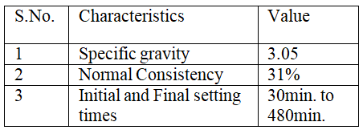

Fine Aggregate
Natural S& obtained from local river bed Cheyyeru is used in the present investigation
Table: 2 Properties of fine aggregate
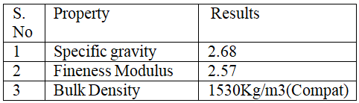

Coarse Aggregates
20mm crushed granite aggregate obtained from local stone crusher is used in the present investigation.
Table: 3 Coarse Aggregate Physical Properties
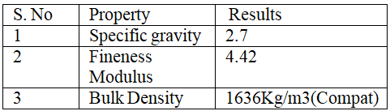

Microscopic organisms
Bacillus pasteurii microorganisms are used in this assessment. Sporosarcinapasteurii, formerly referred to as Bacillus pasteurii in other logical categories, is a bacterium capable of lateral calcite acceleration & s& consolidation in the involvement of a calcium source but also urea, using either microbiologically exacerbate existing precipitation or ordinary cementation. Bacillus pasteurii is a generally consistent organic improvement substance that has been recommended.
WATER
The most cost-effective component of cement, however, is water. The water used for blending cement should be excellent & free of harmful pollutants, for reference, oil, soluble base, corrosive, & so on. Convenient water was used for blending & alleviating work.
BACTERIAL CONCRETE OR SELF-HEALING CONCRETE
This widespread building issue of splitting has multiple remedies previously & a little while afterwards, thus the break. Bacteria Concrete or Self-Healing Concrete is one accommodating method. Self-Healing Concrete is plays key role in the repairs
BIOCONCRETE MECHANISM
When the solid is combined with bacteria (bacillus subtilus), the minute natural ingredients enter a slow express, a staggered plan similar to seeds. To effect their capacities, microbes require complete preamble to the air. Any aspects that should happen offer a big show. When the splits frame, microorganisms near the split, & flames accelerate calcite significant stones. When a solid growth is damaged & water begins to pour through the parts that appear in places of resilience for the, spores of microorganisms promote on impact with the water & enhancements.
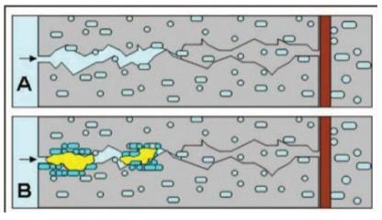
CULTIVATION OF BACTERIA
The unadulterated culture of microscopicorganisms i.e. Bacillus Subtilis is safeguarded onsupplement agar inclines.
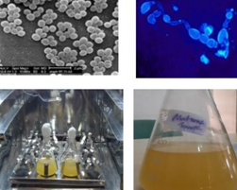
Fig.Bacteria in incubator MIXPROPORTIONING
MIXDESIGN
St&ard grade concrete (M40) Mixproportion1:1.76:2.71:0.45 Cement : 400 Kgs
Fine aggregate: 704 KgsCoarse aggregate: 1084 KgsWater:180 Lt
MIXING OF CONCRETE
Blend configuration may be defined as the process of selecting suitable cement ingredients, for reference, bond, totals, & water, & determining their proportional extents with the goal of producing cement with the least amount of quality, work ability, & toughness possible under the conditions.
First Set Phase
Second set phase

IV EXPERIMENTAL INVESTIGATION
Blend configuration may be defined as the most frequent method of selecting acceptable cement materials and determining their proportional extents with the goal of producing cement with the least amount of strength and toughness for the least amount of money. In our tests, we used cement of M40 grade. The blend proportion obtained following the blend plan as per IS 456: was stated in the previous section. Furthermore, we put the substance into 3D form moulds and created six separate instances, as seen below.
a. 40 grade Concrete
b. 15 with concrete in ml
c. 30 with concrete in ml
d. 45 with concrete in ml
e. 60 with concrete in ml
f. 75 with concrete in ml

METHODS OF MIXING BACTERIAL SOLUTION INTO CONCRETE
There ar various techniques for blending the bacterial arrangement in the substantial which ar viz.
Direct Mixing
Roundabout Mixing
Infusion strategy
Cubes & curing
When the substance is completely mixed, it is put into the 3D square, and compaction is completed by the vibration equipment. After this tested

Trial TEST ON BACTERIAL CONCRETE
Various tests are done on bacterial concrete to get results in various constructions; these exploratory procedures are grouped together as the Slump cone test.
Tests conducted for optimum content of mix chosen are:
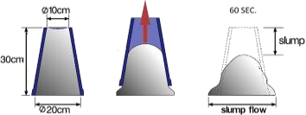
Slump Height.
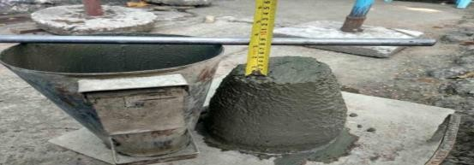
Fig: Slump Cone
Tests
- Compressive strength test
- Waterabsorption
- UPVtest
- Plate counttest
Experimental procedure to obtain plate count test of bacterial solution
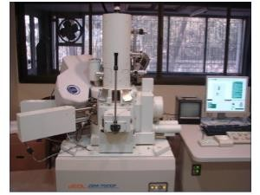
Fig: Scanning Electron Microscope Machine

V. RESULTS
Tests performed:
Compressive strength test
Water absorption
UPV test
Plate counttest

COMPRESSIVE STRENGTH TEST
Crushing strength was measured on concrete cubes 150mm 150mm 150mm. Compressive strength is affected by factors including w/c ratio, concrete strength, concrete material perfection, and quality control during the manufacturing process. These cubes are compressed tested during 7 days, 14 days, or 28 days of curing. The sample is put centrally on the machine's base plate, and the load must be applied progressively at a rate of 140kg/cm2 per minute until the specimen fails.

Table: COMPRESSION TEST RESULT @7 DAYS
Fig.: Compressive Strength test results

Table: COMPRESSION TEST RESULT
@28DAYS
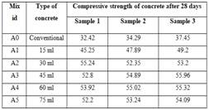
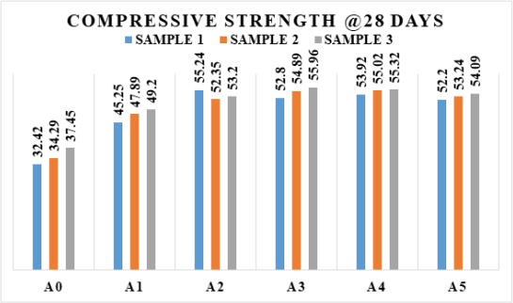
Fig: Compressive Strength test results

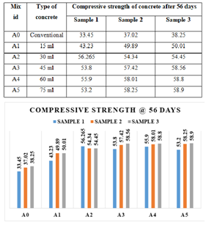
Fig: Compressive Strength test result

We can plainly observe from the graphs above that the mechanical properties of the cubes grows, as we can see between A0 to A1 the intensity of the cubes moves forward, implying that improvements in the quantity of bacteria solution increase in hardness of the cubes.
Strength got increasing with incorporation of bacteria.

Water Absorption:
After casting, the 150 mm x 150 mm x 150 mm cube was submerged in water for 28 days and cured for 60 days. These samples also were oven dried overnight at 110° C till the mass remained consistent and weighed again. The weight was recorded as the cylinder's dry weight (W1). The specimen was then immersed in hot water at 85°C over 3.5 hours. This weight was then recorded as the cylinder's wet weight (W2).
%water absorption = [(W2-W1)/W1] x 100
Where, W1 = Oven dry weight of cylinder in grams
W2 = after 3.5 hours wet weight of cylinder in grams.

Table: % WATER ABSORPTION TEST RESULT.

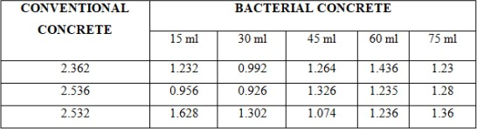

ULTRASONICPLUSEVELOCITYTEST
To determine the existence of cavities in the interior surface of the concrete cubes, a pulse velocity ultrasonic test was performed. The findings received following the test are given in the table below. This result reveals that of all specimens examined, the problem period of 30ml & 45ml cementitious materials is considerably shorter, & the velocity is also greater.
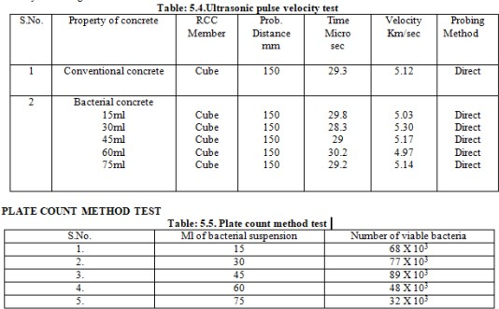
CONCLUSION
The microorganisms which are known to be dissolvable base safe, for instance they fill in standard living spaces portrayed by a genuinely high pH. Moreover, these strains can convey spores which are resting cells with extreme cell walls that safeguard them against senseless ecological mechanical-and substance stresses.
In this way these particular microorganisms could conflict with the high inside huge pH values (12-13 for Port l and cement based concrete), and stay reasonable for quite a while too, as spore sensibility for as long as 200 years is represented.
Compressive strength of the critical is begin reaching out while we convey creatures into the huge separation with show concrete
In this experience we worked with UPV test and plate load incorporate framework by how the speed and number of bacterial cell present in the critical was settled presumably Water support test is likewise done where from the assessment we can expect that we got additionally evolved accomplishes the microorganisms huge separation with regular cement.
By the way augmentation in microorganisms in the huge prompts improvement in the strength and additionally we can obviously see that no breaks thinking about piece of creatures.
FUTURE SCOPE
More review expected to decrease the expense of self-correcting concrete.
Further review expected to beat on the requirements of bacillus subtilis organic entities.
More work ought to be finished on the long impact of microorganisms on human existence.
Can be utilized in the headway of plane runways, stages and dams diminishing the assistance cost.
Holding wall headway.
REFERENCES
1) Chithra P, BaiShibi Varghese. An exploratory evaluation on the strength properties of fly garbage based bacterial huge Worldwide Diary of Creative Exploration in Cutting edge Designing (IJIRAE) ISSN: 2349-2763 Issue 08, Volume 3
2) V Srinivasa Reddy, M V SeshagiriRao, S Sushma. Likelihood Concentrate on Bacterial Concrete as an imaginative self break recuperating framework. Generally speaking Diary of Current Patterns in Designing and Exploration, e-ISSN No.:2349-9745, Volume 2, Issue 7, Unique Issue of ICRTET'2015, Date: 2-4 July, 2015, PP 642-647.
3) Ashish Babarao Gaw&e, Yash Suneel Kh&ekar and Ojas Pravin Rahate, Materialness of Cement Treated with Self-Recuperating Bacterial Specialists. By and large Diary of Structural Designing and Innovation, 7(5), 2016, pp.275-283.
4) Abhishek Thakur, AkshayPhogat and Khushpreet Singh, Bacterial Cement and Impact of Various Microorganisms on the Strength and Water Retention Qualities of Cement: A Survey. Generally speaking Diary of Structural Designing and Innovation, 7(5), 2016, pp.43-56.
5) MohitGoyal, P. Krishna Chaitanya. Direct of Bacterial Concrete as Self Recuperating Material, Global Diary of Arising Innovation and High level Designing, ISSN 2250-2459, Volume 5, Issue 1, January 2015,PP 100-103
6) N.GaneshBabu. An exploratory spotlight on strength and break properties of self recuperating concrete, All over the planet

