Automated Cricket Instructor

Sneh Modi
Dept. of Information Technology
St. Francis Institute of Technology
Mumbai, India
modisam2000@student.sfit.ac.in
Shruti Gupta
Dept. of Information Technology
St. Francis Institute of Technology
Mumbai, India
shnikk2000@student.sfit.ac.in
Abhishek Sunkale Information Technology
St. Francis Institute of Technology
Mumbai, India
sunkaleabhishek@student.sfit.ac.in
Jovita D’lima
Dept. of Information Technology
St. Francis Institute of Technology
Mumbai, India
rosalinddlima30@student.sfit.ac.in
Aruna Pavate
Dept. of Information Technology
St. Francis Institute of Technology
Mumbai, India
arunapavate@sfit.ac.in

Mrinmoyee Mukherjee
Dept. of Information Technology
St. Francis Institute of Technology
Mumbai, India
mrinmoyeemukherjee@sfit.ac.in

Abstract – Cricket is a very popular sport and growing in size, especially after the Indian Premier League (IPL). A prime challenge is to provide the players with a shot detection and judgmental model. Classifying cricket shots is usually a complex task. This paper presents a perspective of 3 shots of cricket into cut, drive and sweep from videos of shots played. The aims of this work is to classify shots by using images as input to the model as well as provide feedback about the quality of the shot played. The methodology used in this model is OpenPose Estimation which uses 18 key points on each image and the convolutional neural network for the classification of shots. The test model accomplished an f1 score of 0.8, which is good considering that the dataset consists of 120 images.

Keywords—OpenPose, Random Forest Classifier, Cricket Shot Prediction

Introduction
In today’s world, technology has a great impact on sports, especially cricket. Compared to the 1990’s era, cricket has come way too forward concerning technology. We have Ultra-Edge, highly sensitive cameras, hotspots, ball tracking, etc. However, there have been very few attempts at shot detection and comparative analysis of shots played. There are many researchers make use of machine learning algorithms in various fields[1-5].

Not many methods are present in today’s world which predict shots and also provide feedback on the shot played by the batsmen. Also, technology is developing in the current era of cricket and many new technologies such as Ultraedge, Hotspot, etc. are now very common. But we intend to develop a shot detection and prediction system that is not yet active in professional cricket and is only used for training or testing and is not very common.
The attempts in this field like [6] [7] use videos in combination with neural networks and available datasets to predict the shot played by batsmen. This work however try to make use of images to acquire data from batsmen like in [8] where a batsman plays a particular shot and tries to detect the shot played by batsmen and compare it with an ideal shot to produce the results bypassing the data collected into a model.
Our work includes the following:
- To apply the dataset of images to the model in the input phase.
- To train the model based on the classification of the shots data to the model in the analysis phase and to compare the shot played with the ideal shot.
- To produce the results with the shot played and the accuracy of the shot in the output phase.

Related Work
Automated Cricket Instructor aims to detect various cricket shots such as Straight shot, Cover shot, and pull shot and to improve the quality of shots played by batsmen.

To improve our analysis and to get a deeper understanding of the same, this work reviewed a few related papers as discussed below:

Semwal et al. [6] have presented a system for recognizing accurate cricket shots. This work presents a contemporary scheme to identify and categorize various types of shots played in the game. This system was developed using clipping from videos of live telecasts and highlights. This system uses Convolutional Neural Networks (CNN) and Support Vector Machines (SVM) to classify different shots. The model classifies the various shots with a precision of 83.098% for shots played by a right-handed batsman and 65.186% for shots played by a left-handed batsman, thus proving to be quantitatively reliable.

Zualkernan, et al. [7] described the outline and burgeoning of a sample electronic training system for cricket. The system is made up of a watch with an accelerometer that transmits real-time acceleration data. on all three axes from the watch using an exclusive wireless protocol and the performance of the player is recorded which utilizes a Learning Management System (LMS). The System is executed using Dynamic Time Warping (DTW). The accuracy of this system is estimated at 93%. The paper also mentions the use of the Minimum Absolute Distance Classifier (MADC) to classify different strokes. This technique uses statistical properties such as mean, standard deviation, skewness, and entropy. Both methods gave similar classification rates, but DTW proved to be more advantageous.
The work of Tevin Moodley et al. [8] “Cricket Automation and Stroke Recognition Model using OpenPose” uses LSTM architecture and gives an accuracy of 81%. Other works also include making use of sensors and sensor fusion algorithms as well as CNN models for the classification and detection of shots.
Sharma et al. [9] present to design a skeleton CommBox that utilizes sensors to automate cricket commentary.
This approach utilizing sensors outperforms previous video-based systems for some shots.
The framework uses wearable sensor MetaWear CPRO to collect data and sensor fusion algorithms are deployed. 5 shots namely cut, pull, straight drive, cover drive, and on the drive were tested in the experiment. Taking into account 3 shots, a comparative filter, and a gyroscope, the framework gives a promising accuracy of 90.69%.

Kumar et al. [10] have proposed a system to improve the performance of batsmen by computing the degree of the bat while rotating, shot timing, footwork, and so on. The system makes use of sensors that are fitted on the bat, arms, and knees. All values are measured by the sensors and are sent to the microcontroller. This data is sent to a laptop via BLE and can be viewed as graphs so that the performance of the shot played can be interpreted easily.

Khan et al. [11] have suggested a method based on Deep Convolutional Neural networks that deal with recognizing and grouping different batting strokes from cricket videos. 2D Neural Convolution is used on images to extract the features maps. LSTM neural network is used as it is proficient in capturing persistent dependencies in sequential data. 3D Neural convolution is used on the frames in spatial and temporal dimensions of the video to extract representations. The 3D model has an accuracy of 90% while the 2d model showed an 80% accuracy.

Tariq et al.[12] have suggested a paper in which they want to use MATLAB to develop a straight drive model. Biomechanics video analysis software was used to derive and examine the key aspects at each level of the model's development.. MATLAB SimMechanics is used to represent the four main elements of a straight drive. The pole-zero plot of the model is established to check system stability.
LQR Controller with feedforward compensator and LQR Controller with Integral Action (LQI) is used to control system design. The model with LQI was reliable and exhibited the same characteristics as the actual straight drive.

Karmaker et al.[13] have proposed a motion estimation perspective to classify strokes using a 3D MACH filter for recognizing actions. The project is based on motion vectors, which may be used to calculate the angle of any precise cricket hit. The MACH 3D was developed to detect specific action, in this case, a cricket shot. For this project, the MACH 3D of the video was made for specific shots.
To classify the shots, Laplacian of Gaussian (LoG) for each frame was computed using this formula. Using this approach 8 shots can be detected. The accuracy of different shots ie: Hook, Square Cut, Flick, Off Drive was 53.32%, 61.22%, 62.74, and 63.57% respectively.

Foysal et al. [14] have proposed an a new way to categorize different types of cricket shots using CNN and Deep Learning. A CNN-based model is proposed where images are input in three convolution layers, three max-pooling layers, two dense layers, and four dropout layers. This model allows for the classification of cricket shots using classifier algorithms. The dataset created consisted of 3600 images and 6 classes of cricket shots and the CNN model consisted of 13 layers.
The classification report shows a Precision average of 0.80, a Recall average of 0.79, and an average F1 score of 0.79. The model achieved a decent accuracy of 80%.

Nicholson et al. [15] have proposed an Activity recognition technology using Hierarchical Representation to assess the quality of cricket shots. Automated recognition of cricket shots is done using low-cost hardware and a simple setup that allows players to analyze the statistics of a shot played.

proposed system

Dataset
The dataset used for this model consists of images for each of these shots [16]. The dataset used 120 images of which 40 images were for the cut shot, 32 for the drive, and 42 for the sweep. The dataset will then be used by the model to generate 18 key points on both axes and then classify shots using the points generated by the dataset.

Methodology
Below is the proposed methodology of the system.
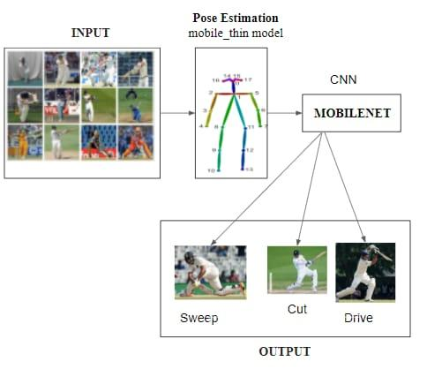
Fig. 3: Proposed Schematic diagram of the model

This system will be having an input phase where we will be collecting images of shots played by the player. This input will then be passed to the OpenPose estimation model phase where we use OpenCV to read and convert the image into an array for further processing. We then use HeatMats in other words Class Activation Mapping (CAM). CAM is used to collect each output of the convolution layer as an image and combine them in one shot, refer to Fig 4.
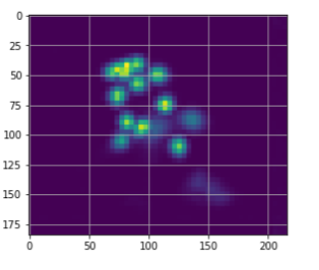
Fig 4: Heatmap of 18 key points.

Thereafter, the pixel of the image is analyzed, and we get the 18 key point coordinates of the body parts. Using these points, we can then plot them on the image respectively. The model uses OpenPose Estimation, which is a real-time multi-person human position detection library that can recognize important spots on an image for the human body, foot, hand, and face. Our model uses 18 key points on each image.Fig.5 shows an image of OpenPose using the 18 key points. The X-axis and Y-axis are generated from 18 key points respectively refer to Fig 5.
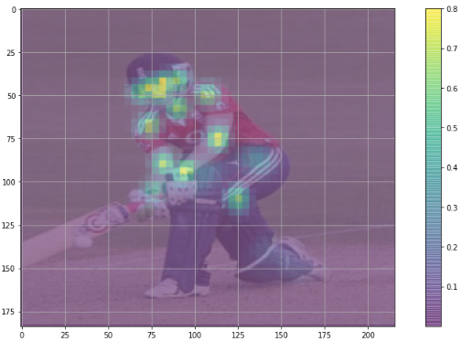
Fig 5: Pixel image of 18 key points while playing sweep.

The 18 key points that are considered are shown in the image below.
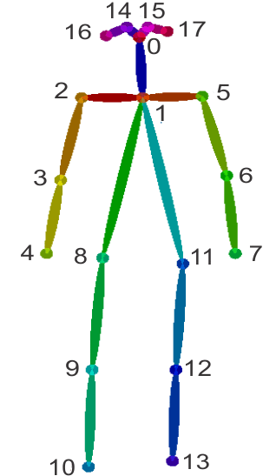
Fig 6: 18 key points for OpenPose estimation.

The model uses these key points for the classification of the shot into the cut shot, sweep shot, and drive shot. The trained model uses the mobile_net thin model which generates 18 key points. The model will then classify the image into the cut, drive or sweep shot using the mobile net and min-max normalization as per the 18 key points that will be generated by the player while playing the shot.
Once OpenPose is loaded in the model, each of the shot images is loaded as well, and features of the shot are extracted and the shots are loaded in a single data frame. We have then normalized all the x and y values from the data frame using the Min-Max Normalization technique [17]. For every feature, the minimum value of that particular feature gets transformed into a zero and the maximum value of that particular feature gets transformed into one.
The Min-Max Normalization formula is as follows: -
$x^{'}=\frac{x-min⁡(x)}{\left(x\right) -min⁡(x)}$ ------------ (1)

where x represents the normalized value, x is the original value, min(x) is the minimum value of x, and max(x) is the maximum value of x respectively.
The output will then be generated and accuracy will be displayed of the shot the player has played. The following dataset was used for training the model. The dataset was extracted from GitHub [16]. The results are then displayed for visual validation.
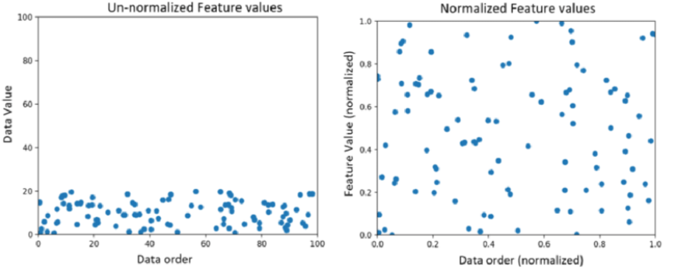
Fig 8: Illustration of Min-Max Normalization
Below are cricket shots that we have considered and their description.

Table 1: Description of shots used in the dataset.
Sr.no | Cricket Shot | Description
1. | Cut Shot | A cut shot is similar to a cross-court stroke, but the ball is struck at a much steeper angle. This shot is a batsman's cross-batted shot into the cricket field's offside, commonly the point area or backward of the point. (refer to Fig 10)
2. | Sweep Shot | The sweep is a cross-batted stroke delivered behind square on the leg side on or around the leg stump. When the bat makes contact with the ball, the goal is to go as low as possible and roll the wrists when the bat makes contact with the ball(represented in Fig 11).
3. | Drive Shot | A drive is a straight-batted shot made by driving the ball through the line of the ball in a straight arc, i.e. hitting the ball in front of the batting player along the ground. (represented in Fig 12).

Results And Anaylsis
On training the model and predicting the type of cricket shot played for the test split, the following values for precision, recall, f1-score, and support were obtained as shown in fig.9. With a train test split of 70/30, we obtained F1 scores around 0.8 on the test set. This is pretty good considering the data set consists of 120 images.
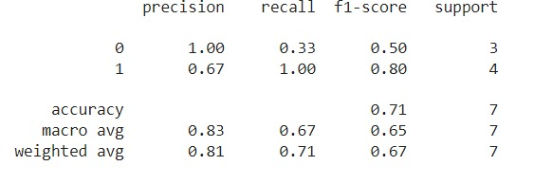
Fig. 9: Results
On testing the model, for prediction of the type of shot played and visual validation, the following results were displayed from the test set. Figure 10 demonstrates the forecast of a Cut shot and figure 11 demonstrates the forecast for a sweep shot.
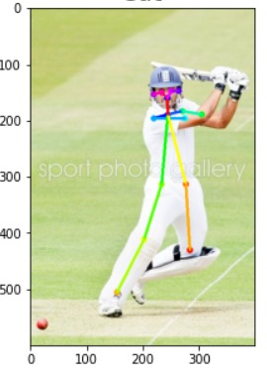
Fig. 10: OpenPose estimation for the cut shot.

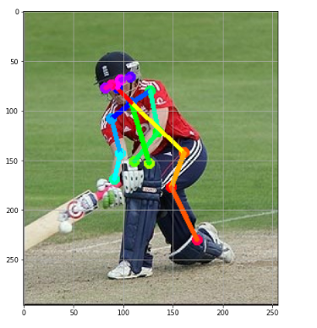
Fig. 11: OpenPose estimation for the sweep shot.
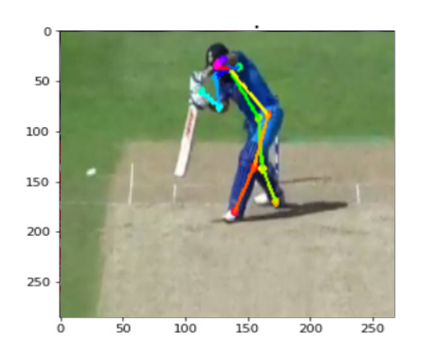
Fig. 12: OpenPose estimation for the drive shot.

Conclusion And Future Work
The paper aims to achieve and implement a model to accurately predict the shot played by the batsman and provide feedback based on the quality of the shot played. Currently, the model is used to predict the accuracy of three shots i.e. Cut, Sweep and Drive shot using OpenPose, which is a real-time multi-person human position detection library that can recognize crucial points on an image such as the human body, foot, hand, and face. The model then uses a neural network classifier for the classification of shots and testing.
This work uses images as inputs and predicts the shot played concerning the three shots considered as cut shot, sweep shot and drive.
In the future, we will plan to cover more shots and also develop a server and an online platform that takes in data and produces the required output in real-time.

References
- A. Pavate, A. Chaudhary, P. Nerurkar, P. Mishra and M. Shah, "Cuisine Recommendation, Classification and Review Analysis using Supervised Learning," 2020 International Conference on Convergence to Digital World - Quo Vadis (ICCDW), 2020, pp. 1-6, doi: 10.1109/ICCDW45521.2020.9318646.
- A. Pavate and N. Ansari, "Risk Prediction of Disease Complications in Type 2 Diabetes Patients Using Soft Computing Techniques," 2015 Fifth International Conference on Advances in Computing and Communications (ICACC), 2015, pp. 371-375, doi: 10.1109/ICACC.2015.61.
- Nerurkar, P., Pavate, A., Shah, M., Jacob, S. (2019). Analysis of Probabilistic Models for Influence Ranking in Social Networks. In: Iyer, B., Nalbalwar, S., Pathak, N. (eds) Computing, Communication and Signal Processing . Advances in Intelligent Systems and Computing, vol 810. Springer, Singapore. https://doi.org/10.1007/978-981-13-1513-8_23
- U. Rathod, A. Pavate and V. Patil, "Product Rank Based Search Engine for E-Commerce," 2018 3rd International Conference for Convergence in Technology (I2CT), 2018, pp. 1-5, doi: 10.1109/I2CT.2018.8529503.
- Aruna Pavate, Dr. Rajesh Bansode, Dr. A. Prasanth. (2021). Explore and Analysis of Methods to Train CNN in Machine Learning Environment. Annals of the Romanian Society for Cell Biology, 14750–14761.
- A. Semwal, D. Mishra, V. Raj, J. Sharma, and A. Mittal, "Cricket Shot Detection from Videos," 2018 9th International Conference on Computing, Communication and Networking Technologies (ICCCNT), Bangalore, 2018, pp. 1-6, DOI: 10.1109/ICCCNT.2018.8494081.
- A. Zualkernan, K. Assaleh, S. G. Dabrai, M. H. Hoque and H. Y. Pedhiwala, "A Wireless Electronic Training System for Cricket," 2013 IEEE 13th International Conference on Advanced Learning Technologies, Beijing, 2013, pp. 55-57, doi:10.1109/ICALT.2013.22
- S. Tariq and A. Mahmood, "Modeling and Control Design of a Straight Drive," 2019 22nd International Multitopic Conference (INMIC), Islamabad, Pakistan, 2019, pp. 1-7, doi: 10.1109/INMIC48123.2019.9022804.
- Ashish Sharma, Jatin Arora, Pritam Khan, Sidhartha Satapathy, Sumit Agarwal, Satadal Sengupta, Sankarshan Mridha and Niloy Ganguly, “CommBox: Utilizing Sensors for Real-Time Cricket Shot Identification and Commentary Generation”,2017 Department of Computer Science and Engineering Indian Institute of Technology Kharagpur Kharagpur, WB 721302, India.
- P.Marish Kumar, K.A.Indu Sailaja, G.Vignesh, K.S.Yashwanth, E.S.Yukesh, K.Murali Krishnan, “Threshold Monitoring System For Improving Batsman’s Performance”2017 Easwari Engineering College, Electrical and Electronics Engineering faculty, Chennai-89, India.
- M. Zeeshan Khan, M. A. Hassan, A. Farooq and M. U. Ghanni Khan, "Deep CNN Based Data-Driven Recognition of Cricket Batting Shots," 2018 International Conference on Applied and Engineering Mathematics (ICAEM), Taxila, 2018, pp. 67-71, DOI: 10.1109/ICAEM.2018.8536277.
- S. Tariq and A. Mahmood, "Modeling and Control Design of a Straight Drive," 2019 22nd International Multitopic Conference (INMIC), Islamabad, Pakistan, 2019, pp. 1-7, doi: 10.1109/INMIC48123.2019.9022804.
- D. Karmaker, A. Z. M. E. Chowdhury, M. S. U. Miah, M. A. Imran and M. H. Rahman, "Cricket shot classification using motion vector," 2015 Second International Conference on Computing Technology and Information Management (ICCTIM), Johor, 2015, pp. 125-129, doi: 10.1109/ICCTIM.2015.7224605.
- Md. Ferdouse Ahmed Foysal ID: 151-15-5274 AND Mohammad Shakirul Islam ID: 151-15-311, “Shot-Net: A Convolutional Neural Network for Classifying Different Cricket Shots” 2018 Partial Fulfillment of the Requirements for the Degree of Bachelor of Science in Computer Science and Engineering DAFFODIL INTERNATIONAL UNIVERSITY DHAKA, BANGLADESH.
- Khan, Aftab, Nicholson, James and Ploetz, Thomas (2017) Activity Recognition for Quality Assessment of Batting Shots in Cricket using a Hierarchical Representation. ACM Interactive, Mobile, Wearable and Ubiquitous Technologies (IMWUT), 1 (3). p. 62. ISSN 2474-9567
- https://github.com/muaz-urwa/Cricket-Shot-Classification-using-Computer-Vision/tree/master/cricket%20shot(Dated: 13th February 2022)
- Aditya C. (2022, February 15). Detecting Cricket Shots using Pose Estimation [Blog post]. Retrieved from:
https://blog.jovian.ai/detecting-cricket-shots-using-pose-estimation-8e69ed12fe98

