UNIVERSITY BENCHMARKING TOWARDS QUALITY PRACTICES IN INDIAN HIGHER EDUCATIONAL INSTITUTIONS

TABLE OF CONTENT
SR.NO. | PARTICULARS
1. | INTRODUCTION
2. | LITERATURE OF REVIEW
3. | OBJECTIVES & LIMITATIONS
4. | RESEARCH METHODOLOGY
5. | DATA ANALYSIS & INTERPRETATION
6 | SUGGESTIONS & FINDINGS
7 | CONCLUSION
 | Annexure-1-REFERENCES
 | Annexure-2-QUESTIONNAIRE

INTRODUCTION
In India, the demand for higher education is rapidly increasing along with the challenges of quality and sustenance. The focus of Indian higher education system for a long time was on establishing higher education institutions (HEIs) to give opportunity to the students to graduate themselves and seek jobs. This has lead to massive increase in number of institutions and the number of students going for higher education. But the system did not get required attention towards quality and fitness of purpose. Consequently, the system grew with several gaps like skill gaps, research gaps, relevance gaps etc. which got converted into issues like access, equity, quality and employability. The system underwent several reforms and passed through several stages of transformation in order to address these issues, but still they remain unresolved to a large extent. It is high time that the Indian higher education system gears up with appropriate measures to put the system on right track. Implementation of valuable recommendations given by the education commissions and committees set up time to time in real sense of term would help in the process in a big way. The HEIs should be ready with positive mindset as well as readiness to implement the recommendations of the New Education Policy as soon as it is launched. Institutions like National Assessment and Accreditation Council (NAAC), National Board of Accreditation (NBA) which are responsible for quality assurance and act as motivators to the institutions need to be strengthened.
In India, the demand for higher education is rapidly increasing, along with challenges to retain quality and sustenance, and to compete with higher education Institutions at the global level. Indian higher education has passed through several stages of transformation, in order to address the issues related to access, equity, quality and employability. Initially, the focus was on establishing higher education institutions (HEIs) to give opportunity to the students of both rural and urban areas to graduate themselves and seek jobs. This has lead to massive increase in the number of students going for graduate and postgraduate courses. The number of colleges and universities has significantly increased in the field of Science, Commerce and Management, Engineering and Medicine. But quality has become a crisis. Some of these colleges lack qualified staff, infrastructure and facilities. The designing of curricula, teaching learning and assessment are not as per the expectations of academic standards.

Development of skills such as soft skills, transversal skills, critical thinking skills and problem solving skills have not been given due importance. Research and innovation is another thrust area and essential component of higher education which failed to get required focus and attention

India has always been a source of inspiration in the field of Literature, Astronomy Art, Yoga, Sculpture, Monuments and great historical events. It had its own unique niche in the field of education and attracted many foreign scholars. During ancient period, India was popular for its contribution to higher education with existence of universities like Takshashila, Nalanda Vikramshila and many other universities. Modern education system which is now prevailing in India was started in 1857 under colonial regime with establishment of three universities – University of Bombay, University of Madras and University of Calcutta. Since the system has been growing with ups and downs. The massive increase has further lead to a lot of issues and challenges related to faculty, infrastructure, information and communication technology (ICT), quality, employability etc. Though some institutions like Indian Institutes of technology (IITs) and Indian Institutes of Management (IIMs) are doing well with well-established infrastructure and technological resources for effective teaching and learning, there are many higher education institutions without necessary facilities and resources and they find it difficult to provide good quality education. The main lacuna with Indian Higher Education System is callousness in implementation of recommendations of various committees’ commissions set up time to time. If all the recommendations have been implemented as and when recommended the system would have been in one the world-class ones.

LITERATURE REVIEW

The concept of quality has been defined differently in different contexts, and it is a much used and least understood term (Mishra, 2007). Trying to express the broad meaning of the term, Juran identifies quality as ‘fitness for use or purpose’, Crosby as ‘conformance to standards’, and Deming as ‘a predictable degree of uniformity and dependability at low cost and suited to market’ (Ali & Shastri, 2010). Assuming that students are both the customers and the ‘product’ in this newfangled industry, higher education institutions are challenged to cope with the non-standard human factor (Venkatraman, 2007) and there lies the intricacy. Thus, quality in higher education can be defined as “a multi-dimensional, multi-level, and dynamic concept that relates to the contextual settings of an educational model, to the institutional mission and 4 objectives, as well as to specific standards within a given system, institution, programme, or discipline” (Vlãsceanu et al., 2004). According to 1999’s Bologna Declaration, the enhancement of quality and the establishment of a common framework for European higher education institutions are basic objectives for quality assurance. The European Association for Quality Assurance in Higher Education (ENQA), which constitutes of public authorities, associations of higher education institutions and quality assurance agencies, is complied with the Bologna Process impetus for quality assurance reforms under the European Standards and Guidelines for Quality Assurance in Higher Education (ESG) (Unit, 2005; Vukasovic, 2014). ENQA promotes co-operation in the field of quality assurance, and disseminates information and expertise among its members and towards stakeholders in the European Higher Education Area (EHEA) to foster the European dimension of quality assurance (Kettunen, 2012). The International Association of Universities (IAU) is a worldwide organization with Member Institutions in over 130 countries, which cooperates with a vast network of international, regional and national bodies and provides a wide variety of enhancing services to the international higher education community at large (IAU, 2007). The rapidly changing forces that call for quality improvement and the ongoing upheaval in the higher education sector requires institutions recommence their strategic planning and implement effective practices for quality. In all respects, quality is relative to “whether one educational context has more or less quality than another, not whether it meets an absolute threshold standard so that it can be seen to be of adequate quality, nor whether it reaches a high threshold and can be viewed as outstanding and of exceptional quality, nor whether a context is perfect, with no defects” (Gibbs, 2010). According to many experts, there are considerable barriers in the applicability of the concept of Total Quality Management (TQM) in higher education institutions, though this philosophy has been transferred from industry to higher education due to rapidly changing forces that call for quality improvement in the higher education sector. Quality in the business of education is in need of change in the educational processes, as it is becoming important in the world of competitive environment (Venkatraman, 2007). Many researchers have compared industry to education and have pointed out conceptual and substantial obstacles in the implementation of TQM in tertiary institutions. Newby (1999) claims that barriers fall into three broad 5 categories: (a) the nature of the management culture in some institutions, regarding the inability to respond creatively to the pace of change which eventually leads to institutional atrophy and decline; (b) the traditional culture of higher education, as the barriers to introducing total quality approaches are more likely to lie in the prevailing culture of higher education and the tendency for organizations to ‘regress’ to the long standing and traditional; and, (c) the heritage of past quality initiatives, meaning that total quality introduces nothing new and that the responsibility for developing and delivering a curriculum is always devolved to course teams. Across the world, academic excellence is a much discussed topic among higher education organizations. According to various authors, excellence, like quality, is a rather vague term. In the European Union, promoting excellence is essential for creating and establishing a knowledge-based society and economy, and for accomplishing the goals of economic growth and job creation (Joosten, 2014). Adding up to the concept of excellence, academic research is another essential element that impacts on the continuous improvement and establishment of excellence in higher education institutions. In the UK, the Research Assessment Exercises (RAE), established by the UK University Grants Committee in 1985, constitutes an essential means for rationalising the stratification of universities and the concentration of research resources, and of maximising research output (Henkel, 1999). Arthur and Cox (2014) suggest the Research Excellence Framework (REF), which is in effect “a renewed version of judging research, notwithstanding the introduction of impact to the assessment criteria”. A multitude of educational institutions have acquired internal mechanisms for quality assurance and implement self-evaluation procedures for quality enhancement. However, a large number of them around the globe turn to quality assurance agencies to receive external assessment. In this case, the agencies determine the particular quality procedures to be practiced and prepare the guidelines and practicalities of any site visit (Ossiannilsson, 2012). Quality assurance agencies play an operative and effective role in the Bologna Process, specializing in quality assurance and accreditation (Unit, 2005). Except for the changing needs of the higher education environment, understanding the criteria and sticking to the best practices calls for the implementation of the following widespread framework of the way quality can be assured (Harman, 1998): • Self-evaluation; 6 • Peer review by a panel of experts, usually including at least some external panel members in one or more site visits; • Analysis of statistical information and/or use of performance indicators or the best practices benchmarking; • Surveys of students, graduates, employers, professional bodies; • Testing the knowledge, skills, and competencies of students. All processes require the use of specific tools and mechanisms, so that appropriateness for purpose is accomplished. Benchmarking is established as one of the most successful processes of assessment and improvement. Blackstock et al. (2012) define benchmarking as “the process of self-evaluation and self-improvement through the systematic and collaborative comparison of practice and performance with similar organizations in order to identify strengths and weaknesses, to learn to adapt and to set new targets to improve performance”. In the UNESCO-CEPES Glossary for Basic Terms and Definitions, benchmarking is identified as “a standardized method for collecting and reporting critical operational data in a way that enables relevant comparisons among the performances of different organizations or programmes, usually with a view to establishing good practice, diagnosing problems in performance, and identifying areas of strength” (Vlãsceanu et al., 2004). According to the contributing authors, benchmarking can also be defined as: (a) a diagnostic instrument; (b) a self-improvement tool (a quality assurance tool) allowing organizations and programmes to compare themselves with others regarding some aspects of performance, with a view to finding ways to improve current performance; (c) an open and collaborative evaluation of services and processes with the aim of learning from good practices; (d) a method of teaching an institution how to improve; and, (e) an on-going, systematically oriented process of continuously comparing and measuring the work processes of one organization with those of others by bringing an external focus on internal activities (Vlãsceanu et al., 2004) Vlãsceanu et al. (2004) refer to the historical development of benchmarking in the higher education sector. They identify the United States as the first country to introduce benchmarking processes in the early 1990’s and, also, establish NACUBO (National Association of Colleges and University Business Officers) Benchmarking Project for a long period of time. They also mention that benchmarking came to the forefront as a quality assurance tool in the UK, after the 1997 Dearing Committee 7 Report which included: (a) The History 2000 Project, led by Paul Hyland (School of Historical and Cultural Studies, Bath College of Higher Education); (b) The RMCS (Royal Military College of Science) Programme at Cranfield University (example of benchmarking in libraries); (c) The Higher Education Funding Council for Higher Education (HEFCHE) Value for Money Studies (VfM), launched in 1993; and, (d) The Commonwealth University International Benchmarking Club, launched in 1996, by CHEMS (Commonwealth Higher Education Management Service), as an example of international benchmarking (Vlãsceanu et al., 2004). The logic of benchmarking is sound and easy to follow as stability cannot bring improvement. Various authors suggest that continuous improvement and excellence can be achieved by higher education institutions that are empowered to take deliberate steps by using the benchmarking tool for optimization of their processes and programmes. One basic step is to choose a benchmark and the type of benchmarking that is going to be practiced. Typifying the concept of benchmarking in four broad categories, various literature recognize internal, competitive, functional and generic as the most common types. Jackson and Lund (2000) categorize benchmarking types with regard to processes that are implicit or explicit, independent or collaborative, internal or external, vertical or horizontal, quantitative and qualitative approach, and input-output focused. Achtemeier and Simpson (2005) recognize: (a) process benchmarking, which is about identifying the problem area within one’s institution, identifying another institution with impeccable performance in the same area, and sending a team of experts of the area to learn from the exemplar institution their success formula that brings outstanding results; (b) metric benchmarking, which means comparing data of selected performance indicators among several institutions (Smith et al., 1999); and, (c) goals and milestones, which represent another way to understand benchmarking by identifying internal targets to establish a process, without any external point of reference for measurement (Zairi, 1996). Yarrow and Prabu (1999) add up to the variety of benchmarking types by recognizing diagnostic benchmarking, which is more akin to the examination of an institution’s well-being in that it helps to identify the practices that need change and the nature and extend of performance improvements to be followed. The Consortium for Excellence in Higher Education (2003) identifies international benchmarking along with strategic, performance or competitive, process, functional and generic, external, and internal good practice 8 benchmarking. International benchmarking can be determined nationally and internationally and includes “a mix of all these approaches and organizational learning that is best done when it is carried out within a spirit or partnership and collaboration that enable both parties to learn from each other” (Lutfullayev, 2007). However, those who compete for excellence must make sure that they meet the criteria of powerful and progressive strategic management and governance, high standards of academic achievement, a strong track record with students destinations, an exceptional student experience, positive stakeholder satisfaction, high levels of student satisfaction, commitment to research and academic development, support for socio-economic and cultural development, recognition of the social benefit of education, commitment to internationalisation, promotion of equity and academic freedom (Brusoni et al., 2014). Considering the popularity of rankings worldwide, the main idea is linked to benchmarking and the acceptance of being compared to others in the sector. Ranking contributes to the improvement of institutions and programmes as universities are alerted to get better and better though processes of assessment and evaluation in order to elevate in the global ranking and gain reputation in the international scene. All universities that aspire to become renowned and attract more customers should be conscious of rankings and thus, establish benchmarking processes.
PURPOSE

The purpose of this paper is to investigate the extent to which higher education institutions can benefit from the implementation of benchmarking practices. Thus, the aim of this research is to point out the structure and applications of quality improvement, by providing evidence for understanding the implementation of benchmarking as a competing tool for excellence in higher education institutions.

OBJECTIVES

- To understand quality practices made by the university or business schools in seven important excellence.
- To understand the facilities infrastructure required for the students of business school in Indian context.
- The courses are aligned with industry needs or not, whether this alignment or content regularly checked for alignment or not.
- To understand the importance of the curriculum as per the industry fitness.
- To understand the requirement faculty excellent in teaching in Indian context.
- To understand the facilities infrastructure required for the students of business school in Indian context.
- To understand whether CRM or Marketing automation tools in support of the recruitment.

LIMITATIONS

The findings of this action research are highly important provided that it bases on reliable papers and high-impact educational organizations. However, this project may be identified with one particular constraint with potential impact on the findings. For all the practical purposes, the research sample is limited including an aggregate of 10 universities. Nevertheless, the degree to which this reduces the quality of our findings is a matter of debate. Given the fact that all research suffers from limitations, whether it is performed by undergraduate and master's level dissertation students, or seasoned academics, the limited number of the research specimen is not viewed by this thesis as a weakness. The researcher collected 60 participations, but selected studies of universities due to their quality features and their commitment to excellence. This particular attitude explains the low variances attributed by some of the findings, as the N/A element affected the induction of high percentages in some areas of the quantitative analysis and of the codified and subsequently statistically reported qualitative analysis. The discussion of limitations is upon a project with particular length indicated by the regulatory framework of this university. Considering the action of research as richly analyzed, a wider participation would exceed the regulatory limits. However, this work can be used for future research on this field of study, including broader specimen.

DESIGN/METHODOLOGY/APPROACH
The methodology followed in this paper is based on a mixed method approach, including both qualitative and quantitative analysis. Research is based on studies of universities committed to excellence around the world. Data collection was accomplished by a well-designed questionnaire.
RESEARCH METHODOLOGY
This research study explores quality in higher education as enhancement and improvement, and focuses on the use of benchmarking as a self-improvement tool. The aim of this research paper is to point out the structure and applications of quality assurance, by providing evidence for understanding the implementation of benchmarking as a competing tool for quality in higher education institutions. The gathering of data aims to provide: (a) findings on the dissemination of benchmarking; and (b) exemplar attitudes towards the particular types of benchmarking and the verified methods and tools for practicing it. This paper brings together the evidence collected through wide literature review, on a theoretical basis, and extensive research on tertiary institutions around the world, on an empirical basis, and provides an analysis structured along the theme of benchmarking with significance and implications for the pursuit of excellence in higher education institutions.
SCOPE OF THE STUDY

The objective of research project summarizes what is to be achieved by the study. The research objectives are the specific accomplishments the researcher hopes to achieve by the study. A clearly defined research objective will help the researcher to focus on the study. Research objectives are usually expressed in lay terms and are directed as much to the client as to the researcher. Research objectives may be linked with a hypothesis or used as a statement of purpose in a study that does not have a hypothesis. Even if the nature of the research has not been clear to the layperson from the hypotheses, s/he should be able to understand the research from the objectives.

PROBLEM DEFINITION:-

A research problem is a statement about an area of concern, a condition to be improved, a difficulty to be eliminated, or a troubling question that exists in scholarly literature, in theory, or in practice that points to the need for meaningful understanding and deliberate investigation. In some social science disciplines the research problem is typically posed in the form of a question. A research problem does not state how to do something, offer a vague or broad proposition, or present a value question.

SOURCE OF DATA
This project report on the basis of primary data. I did in depth analysis in the help of review literature and read all the materials related this project report i.e. University Benchmarking towards Quality Practices in Indian Higher Educational Institutions.
I gain some useful knowledge or information about merger and acquisition in the help of previous study or thesis and projects on. University Benchmarking Towards Quality Practices in Indian Higher Educational Institutions.
I read some Journals which are upload on Sodhganga and Sodhgangotari by the UGC to helps the aspirants to read that and gain some useful information and that information put on their respective topic like dissertation, thesis, project report etc.
This study on the basis of only secondary data so that naturally some unbiased are occur because the data was not original, the data was second hand that I am used.
RESEARCH DESIGN
Descriptive research has been found fit for this thesis as the research has been based on secondary data. Flexibility in the design is needed as the broadly defined problem can be transformed into one with more precise meaning.
- The phenomena associated with the subject population such as profitability, liquidity and efficiency have been described.
- It has been sought to explain the associations in different variables through the method of Regression Analysis.
The main method which has been used in context of research design for this study is:
- Google forms
- Review of Literature
- Review of Journals
- Visit on Websites
- Visit on National Digital Library
SAMPLE DESIGN
Non-probability Judgment sampling has been used in this study as the samples were not selected randomly, but after a purposeful cognitive study.
Types of Research:-
Primary Data:
Primary data is data that is collected by a researcher from first-hand sources, using methods like online surveys (Google form), interviews, or experiments. It is collected with the research project in mind, directly from primary sources. The term is used in contrast with the term secondary data.

Secondary Data:
The secondary data sources are:
Internal documents and publications Newspaper, articles, journals and websites

Sample Size:

My sample for the project was 60 respondents, since it was not possible to cover whole state in the available time of period, it was necessary to me to take a sample size for 60 respondents.
RESEARCH RESULTS
This exploratory study aims to point out the structure and applications of quality improvement, by providing evidence for understanding the implementation of benchmarking as a competing tool for quality in higher education institutions. Various authors have underpinned that a culture of quality entails strategic management that involves a number of planning processes for the improvement of quality that leads to excellence. Academic excellence reveals the linkage of quality assurance to benchmarking, while changes in the academic scene call for substantial transformations due to business and industry demands. The conduction of empirical research was made to examine the reliability of benchmarking as a successful tool for quality in higher education and to acquire better realization of its applicability by tertiary institutions that already practice it. In other words, this study examines the various viewpoints on the matter of assessment and searches for the particular benchmarking types and tools that lead to successful outcomes.
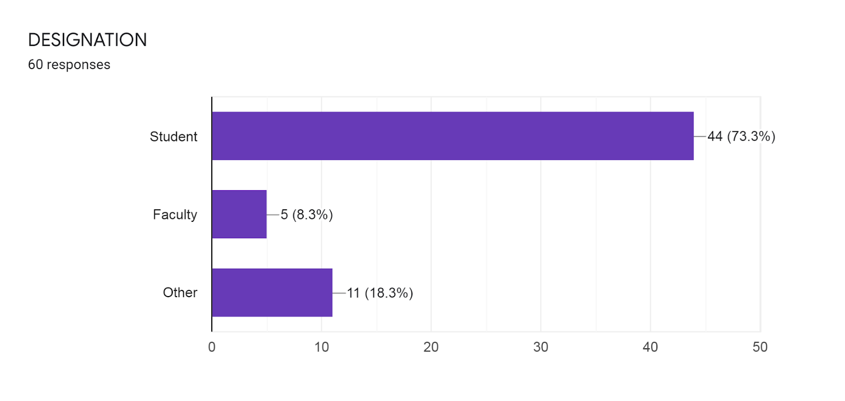

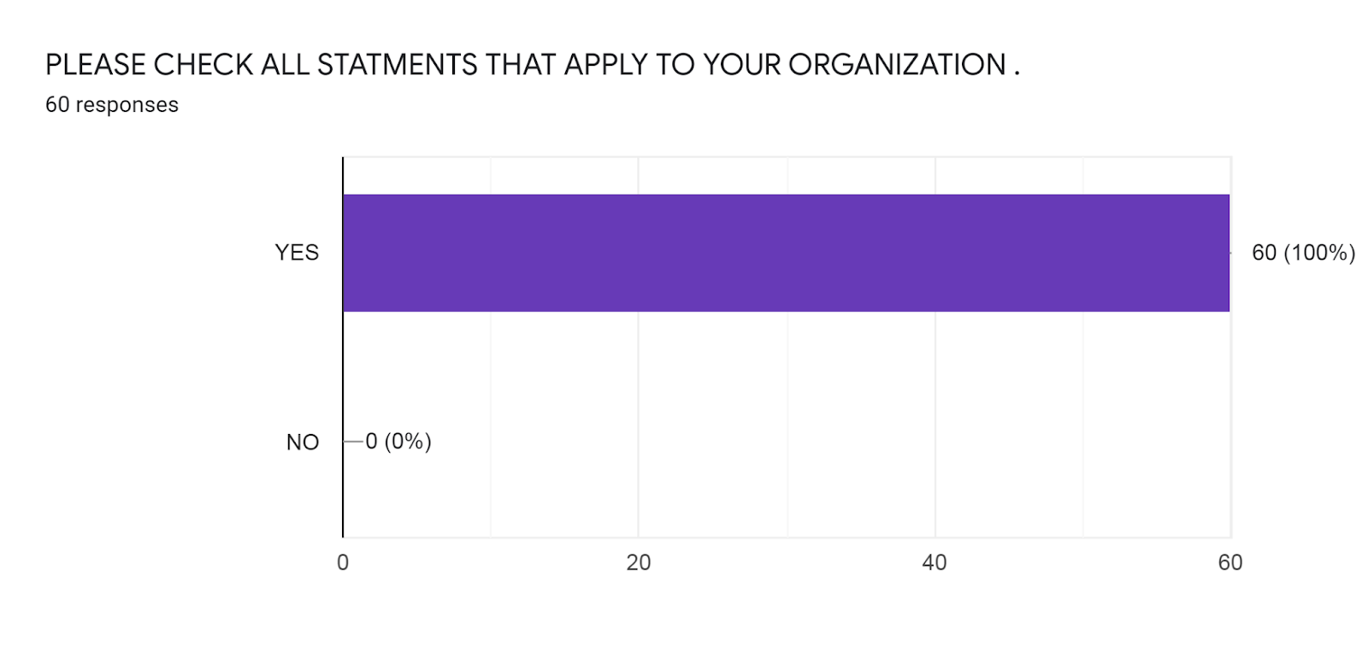
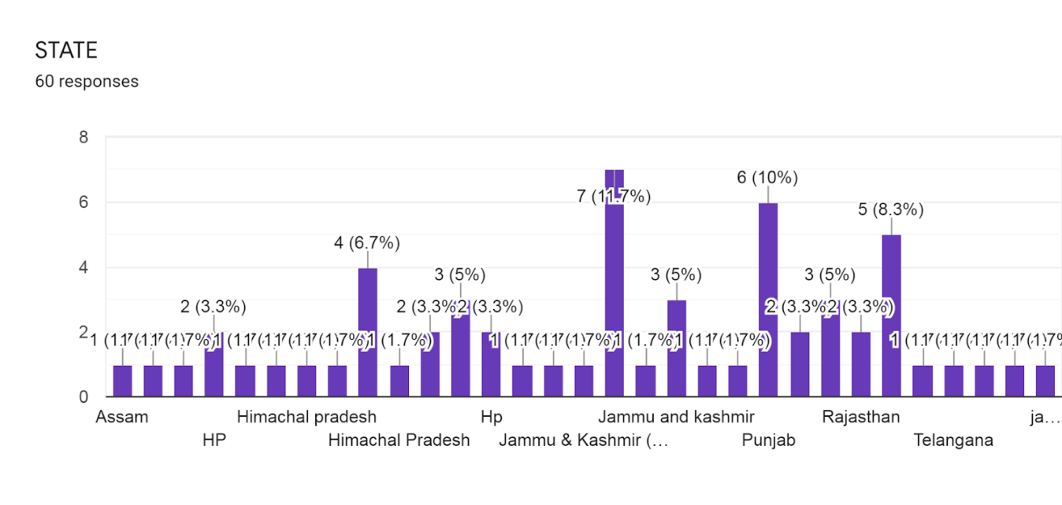
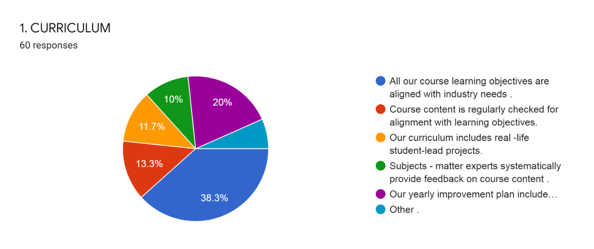

INTERPRETATION:
Out of 60 respondents 38.3% are goes with all our courses learning objectives that are aligned with industry needs:
- 20% are goes with our yearly improved plan include student success and satisfaction.
- 13.3% are goes with course content is regularly checked for alignment with learning objectives.
- 11.7% are goes with our curriculum includes real life student leads projects
- 10% are goes with subject – matter experts systematically provide feedback on course content.
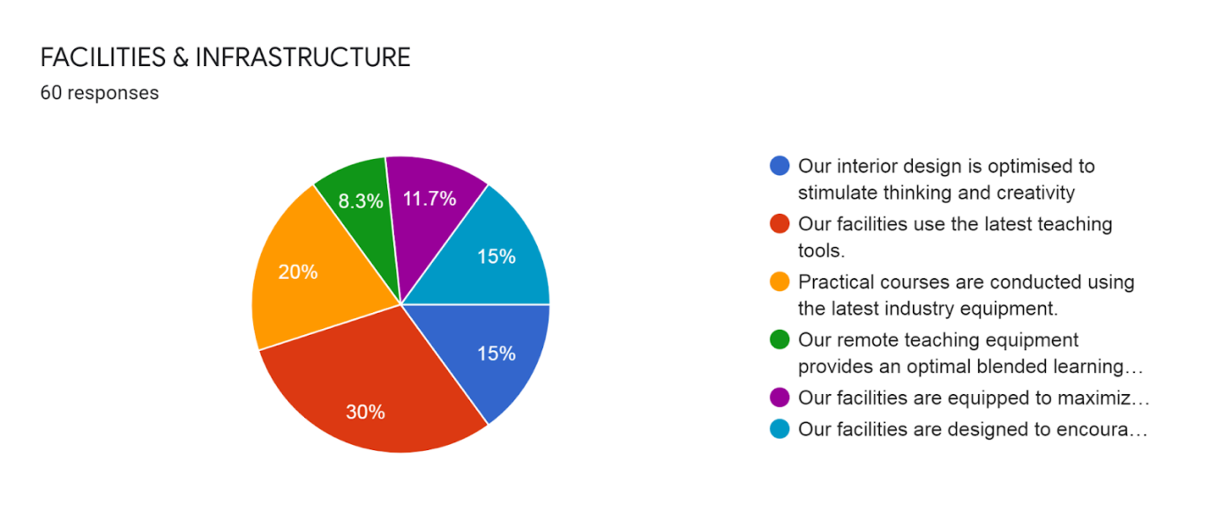
INTERPRETATION:
Out of 60 respondents 30% are goes with the facilities use the latest teaching tools.
- 20% are goes with Practical course are conducted using the latest industry equipment.
- 15% are goes with our facilities designed to encourage socialization.
- 15% are goes our interior design is optimized stimulate thinking and creativity.
- 11.7% are goes our facilities are equipped to maximize the learner’s comfort.
- 8.3% are goes with our remote teaching equipment an optimal blended learning experience.

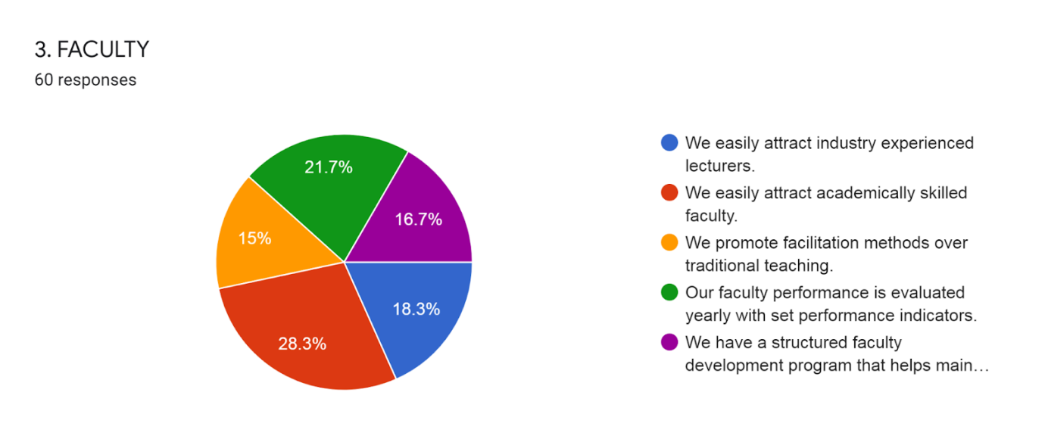
INTERPRETATION:
Out of 60 respondents 28.3% are goes with We easily attract academically skilled faculty.
- 21.7% are goes with our faculty performance evaluate yearly with set performance indicators. 18.3% are goes we easily attract industry experienced lectures.
- 16.7% are goes with We have a structured faculty development program that maintain industry relevancy.
- 15% are goes with We promote facilitation methods over traditional teaching.
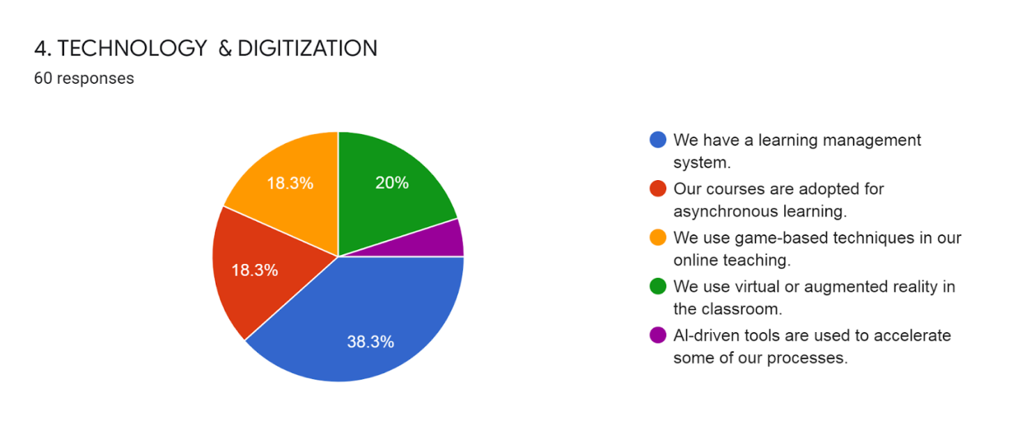

INTERPRETATION:
Out of 60 respondents 38.3% of the people are goes with the We have a learning management.
- 20% are goes with We use virtual or augmented reality in the classroom.
- 18.3% are goes with our courses are adopted for asynchronous learning.
- 18.3% are goes with We use game- based technique in online teaching.

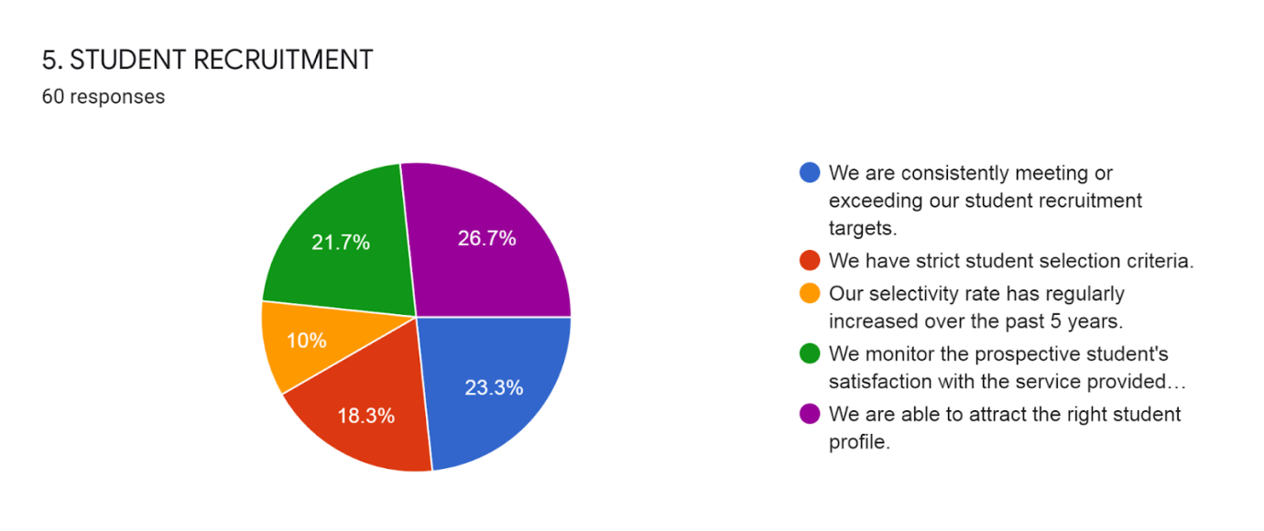

INTERPRETATION:
Out of 60 respondents 26.7% are goes with We are able to attract the right student profile.
- 23.3% are goes with We are consistently meeting or exceeding our student recruitment targets.
- 21.7% are goes with We monitor the prospective student satisfaction with the service provided by the recruitment team.
- 18.3% are goes with We have strict student selection criteria.
- 10% are goes with our selectivity rate has regularly increased over the past 5 years.

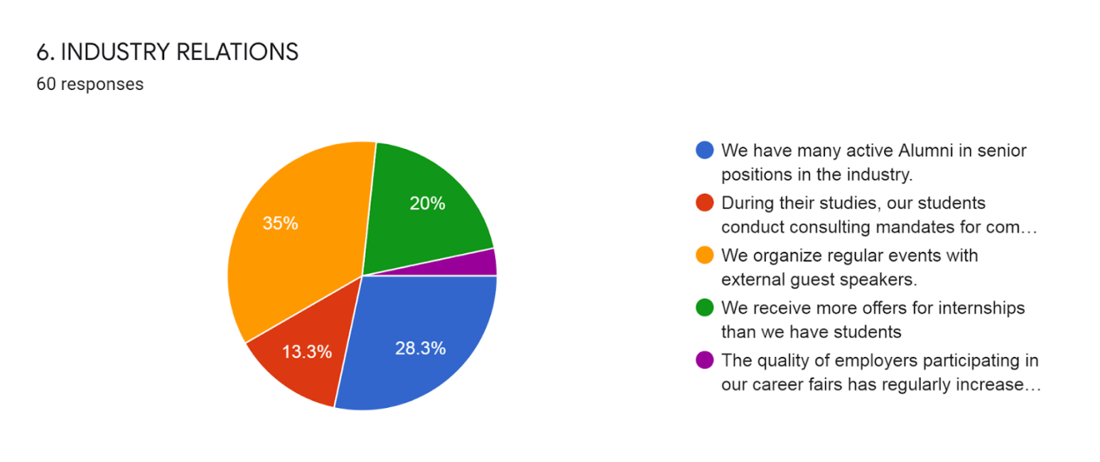
INTERPRETATION:
Out of 60 respondents 35% are goes with We organize regular events with external guest speakers,
- 28.3% are goes with We have many active alumni in senior positions in the industry.
- 20% are goes with We receive more offers for internships than we have students.
- 13.3% are goes with during their studies, our students conducting consulting mandates for companies.

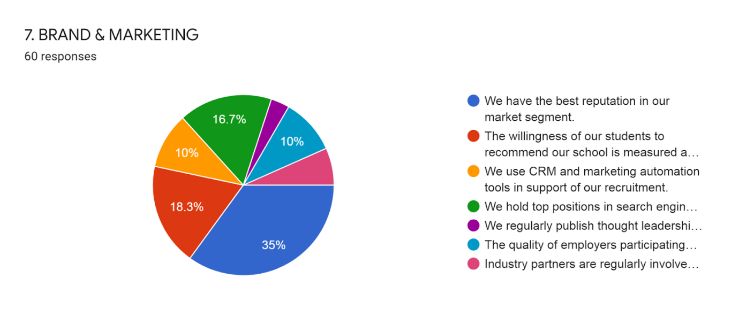

INTERPRETATION:
Out of 60 respondents 35% are goes with We have the best reputation in our market segment.
- 18.3% are goes with the willingness for our students to recommend our school is measured and exceeds 85%.
- 16.7% are goes with We hold top positions in search engine results on key topics.
- 10% are goes with We use CRM and marketing automation tools in support of our recruitment.
- 10% are goes with the quality of employees participating in our career fairs has regularly increased over the past 5 years.

FINDINGS
The findings of this research indicate that benchmarking can improve academic excellence by means of comparison and assessment. The study finds that process performance measurements can bring considerable outcomes of enhancement, improvement and transformation in higher education systems.
PRACTICAL IMPLICATIONS
This research on benchmarking in higher education institutions provides exemplar standpoints and practices for the pursuit of excellence in educational organizations, in order to gain additional knowledge and paradigm on quality improvement that can lead to excellence. Considering the population of rankings worldwide, the main idea is linked to benchmarking and the acceptance of being compared to others in the sector.
ORIGINALITY/VALUE
The value of this paper lies in the identification and presentation of several ideas and tools which can successfully be applied to higher education institutions in order to achieve excellence by using benchmarking practices.
SUGGESTIONS
- Competitive advantage, but seldom to reduced costs;
- Reorganization of the support of the organization and a reduction of the overhead of national universities considered of superiority;
- Improvement of quality in both research and education;
- High decrease on administrative costs;
- Reduction in total costs of student attendance;
- Grant application costing in the support for research and also to the sharing of certain costs with other local universities;
- Increased success in recruiting and improvement of enrolment management;
- Better service and consistency in getting a question answered or resolving a service issue;
- A much higher level of competence than the financial resources imply (retained equity, or endowment), much higher efficiencies than those of other local institutions;
- Increased improvement and more satisfying evaluations from departments taking part in benchmarking projects;
- Specific indicators in the field of research and use of these information during re-accreditation processes;
- Determination of position among peer institutions, as data is used to ensure that they stay competitive in attracting, retaining and graduating students;
- Staff reduction by about 30%, when redesigning the internal financial function by implementing external benchmarking, and reduction of space by using UK benchmarks on the amount of space used by university functions;
- Reduction in costs by benchmarking of Professional Services (project) and competitive advantage by benchmarking in terms of quality of research and education.
CONCLUSION
India is progressing in the field of higher education with many shortcomings. Demand for developing various types of skills including the digital skills, among the students is increasing. At this critical juncture, it is a crucial challenge to address the gaps between the skills that are imparted and the skills required at the workplace, so that the rate of employability can be increased. Similarly, higher education institutions should develop a good research ecosystem focusing on collaborative research projects to become more visible at the global level. But creating such an ecosystem is not easy, it requires intensive coordination among the government, universities and the regulatory bodies. It is high time that the Indian higher education system gears up with appropriate measures to put the system on right track. Implementation of valuable recommendations given by the education commissions and committees set up time to time in real sense of term would help in the process in a big way. The HEIs should be ready with positive mindset as well as readiness to implement the recommendations of the New Education Policy as soon as it is launched. Institutions like National Assessment and Accreditation Council (NAAC), National Board of Accreditation (NBA) which are responsible for quality assurance need to be strengthened.
Additionally, half of the respondents claimed to review their strategic plans annually and permanently to satisfy their constant need for improvement, by establishing diagnostic benchmarking in their strategic planning and control. Thus, there is an increased demand for higher education institutions all over the world to derive more information on the outcomes of their strategic plans by assessing them in this given period of time. The process of assessment is undoubtedly a hallmark on the effectiveness of quality planning that tertiary institutions establish to gain ground in the arena of continuous improvement. Considering students as customers in the higher education industry, with a more business-like approach, no university should pass over measuring their satisfaction with teaching and learning. Eliciting, documenting and validating customer satisfaction is one of the most essential quality processes that build up an educational organization identified with quality that leads to excellence, as enforced by the international standards and the growing demand for higher education. The qualitative analysis showed whether institutions can operate as businesses that pay the much of their attention to the satisfaction of their customers with the provided educational services. The feedback suggests that improvements in teaching and learning are achieved through a wide range of conducted surveys completed by students and graduates, as reported by the majority of the participants. A small number outlined outside evaluations and external assessment without stating the particular tools of evaluation. However, all participants indicated the development of metrics and communication strategies to report progress and results, as well as the selection of key performance indicators for enhancement, leaving space for implications of practicing benchmarking. Sticking to evaluation, the educational programmes cannot be excluded from this process. The discussion is upon what extent the practice of benchmarking is a basic tool for internal evaluation and continuous improvement. From the focus group study, 20 the findings granted evidence on the establishment of both internal and external evaluation of educational programmes through various surveys, evaluations and accreditations, rankings, focus groups, and educational outcomes. A statistical approach simplifies the results of research analysis by attributing a 62% to 38% ratio of internal to external evaluation of educational programmes. Consequently, self-evaluation is outlined for quality enhancement, which refers to making improvements within the organization, whereas external evaluation refers to external professionals determining whether aims have been accomplished. Thus, internal benchmarking is mostly outlined in this process of evaluation, probably due to the encumbrance of costly external evaluation, bureaucracy and the tendency of preserving university autonomy. It is common knowledge that institutional processes may be evaluated either continuously or periodically. In the area of process evaluation, the findings derived from research analysis were attributed in a statistical manner with permanent evaluation possessing a 25%, periodical evaluation holding a 65%, and evaluation that varies due to process content owning a 5%. The unfolding of this analysis regards the most critical challenge in the idea of benchmarking: continuous improvement through evaluation. Interestingly, the majority of the participants seem to be totally engaged with periodical evaluation, rather than permanent evaluation. This particular finding corresponds to the various literature regarding: (i) the product of higher education as invisible and intangible in relation to the manufactured product; and, (ii) the typical obstacles to a successful TQM implementation in higher education due to the non-standard human factor. This survey sought participant views on the issue of assessing the academic staff of educational institutions. Quality management in higher education involves the commitment of all institutional members that should give the best out of themselves. Given that ‘the best’ or ‘the exceptional’ can be totally subjective, the top management has to check and evaluate whether individual views and attitudes consort with the mission and vision of the university. According to the results derived from the survey, an aggregate of 85% of the respondents correspond to benchmarking requirements for excellence by evaluating their academic staff on an annual basis. Concluding the issue of evaluation, it was sound to ask the respondents if they actually apply the results of manifold evaluation. The analysis of submissions 21 indicates that the results of evaluation are taken into account for quality improvements by a 100% of the surveyed universities. Benchmarking can be viewed as a methodology of improvement and an opportunity to learn best practices, identify, establish and achieve exceptional standards. Although the classification of benchmarking types is characterized by wideness, the participants provided this survey with valuable data that led to the determination of the primary benchmarking type that is used by higher education institutions. The analysis of research ascribed a 36% to the use of internal benchmarking and a subsequent 32% to the use of competitive benchmarking, as indicative of examining their well-being and competing for national or international recognition. Though the findings yield a slight deviation (4%) between internal and competitive benchmarking, the selection of internal benchmarking can be explained in terms of measurable progress inside the institution which usually does not include the costly participation of external professionals. Moreover, the acquisition of information on competitors requires access to performance data that are made available by national or international comparator groups and associations, which may add unnecessary bureaucracy and extra costs to the institutions. Considering this survey as exemplary and paradigmatic, it is of high importance to understand how the theory of benchmarking is actually put into practice. Examining the co-occurrence between tools that are used by institutions in order to benchmark, a statistical analysis gave the lead to process performance measurements and questionnaire design, as the best practiced tools with a respective 18% quota. The next highly practiced tools are process mapping and project management with each of them possessing a 16% quota. Institutions need to be able to relate what they want to achieve with the benchmarking exercise. What they need to consider when selecting a benchmark are: (a) the level of their benchmark partners/competitors; (b) whether they choose their benchmark internally or externally, nationally or internationally; (c) the advantages or disadvantages of the group size; (d) the level of group homogeneity; and, (e) whether the benchmark is trustful and keen to benchmark with broadly similar goals. The findings generated from the analysis of research correspond to the search areas mentioned above, and also include the search of suitable competitors in top rankings. Qualitative analysis was made in order to realize whether this process is a standardized one, its level of difficulty, and to acquire paradigm. However, only a 22 limited number of respondents reported what this process entails: (a) discussion with faculties and participatory bodies; (b) top management meetings; and, (c) internally established criteria. However, prior to searching for the best and finally choosing a benchmark is to identify, analyze, and measure competitors with similar educational services, as underlined by the findings. An analysis of the external operating environment is an intricate process that entails covert difficulties due to the complexity of the higher education sector. Academic standards and culture of quality may differ beyond national boundaries and thus, international rankings allow for comparisons against competitors with required performance levels. A comparative analysis indicated that half of the research universities (regardless of the country that they operate) share valuable information with competitors of similar services and are given the opportunity to learn from each other by practicing benchmarking as a fundamental tool for improvement of their institutional and educational processes. Additionally, a small number reported the operation of particular associations that exchange data between higher education institutions. Universities are conscious of ranking and, thus, practice benchmarking in order to be able to collect data on their competitors from existing data sources. The qualitative analysis also included the competitive advantages that participants have perceived by the establishment of benchmarking in their institutions. The findings derived from this action research suggest that the most significant effects induced by benchmarking practices are: (i) reduction on administrative or total costs; (ii) level-up competitiveness; (iii) increased student and management enrolment; and, (iv) improvement of quality in both research and education. Thus, the majority of the surveyed universities reported satisfaction with practicing benchmarking in their institutions.
Annexure -1
REFERENCES
- Achtemeier, S.D., Simpson, R.D. (2005). Practical Considerations When Using Benchmarking for Accountability in Higher Education. Innovative Higher Education, Vol. 30, No. 2.
- Ali, M., & Shastri, R.K. (2010). Implementation of total quality management in higher education. Asian Journal of Business Management, 2(1), p. 9-16.
- Arthur, L., & Cox, E. (2014). From evaluation to research. International Journal of Research & Method in Education, 37(2), p. 137.
- Blackstock, D., Burquel, N., Comet, N., Kajaste, M., dos Santos, S. M., Marcos, S., ... & Sixto, L. C. V. (2012). Internal Quality Assurance Benchmarking. ENQA Workshop Report 20. ENQA (European Association for Quality Assurance in Higher Education). Avenue de Tervuren 36-38-boite 4, 1040 Brussels, Belgium. p. 8.
- Brusoni, M., Damian, R., Sauri, J.G., Jackson, S., Kömürcügil, H., Malmedy, M., ... & Rostlund, A. (2014). The concept of excellence in higher education. ENQA Occasional Paper, 20, p. 20.
- Consortium for Excellence in Higher Education. (2003). Benchmarking Methods and Experiences. Sheffield: Sheffield Hallam University.
- Gibbs, G. (2010). Dimensions of quality. York: Higher Education Academy. p. 11.
- Harman, G. (1998). The management of quality assurance: A Review of International Practice, Higher Education Quarterly, 52(4), 345-364.
- Henkel, M. (1999). The Modernizations of Research Evaluation: The Case of the UK. Higher Education 38(1), 105-122.
- Hogg, R. V., & Hogg, M. C. (1995). Continuous quality improvement in higher education. International Statistical Review/Revue Internationale de Statistique, 35-48.
- IAU. (2007) International Handbook of Universities – UNESCO. Palgrave-Macmillan. 19th Edition.
- Lund, H., & Jackson, N. (2000). Creating the Conditions for Benchmarking: A Brief History of Performance Assessment in UK HE. Benchmarking for Higher Education. The Society for Research into Higher Education (SRHE) and Open University Press, Buckingham.
- Joosten, H. (2015). Excellence for All: A Nietzschean-inspired approach in professional higher education. Educational Philosophy and Theory, 47(13-14), 1516- 1528.
- Kekäle, J. (2015). A human resources model supporting academic excellence. Tertiary Education and Management, 21(2), p. 1. 25
- Kettunen, J. (2012). External and internal quality audits in higher education. The TQM Journal. 24(6), 518-28.
- Lutfullayev, P. (2007). Research on Benchmarking in higher education: An overview. In Regional Conference on Quality in Higher Education. Research on Benchmarking in Higher Education: An Overview, p. 5.
- Mishra, S. (2007). Quality assurance in higher education: An introduction. National Assessment and Accreditation Council, India and commonwealth of Learning, Vancouver.
- Mueller, R.A. (2015). Do values drive the plan? Investigating the nature and role of organizational values in university strategic planning. Tertiary Education and Managemen, 21(1), 50-51.
- Newby, P. (1999). Culture and quality in higher education. Higher Education Policy. 12(3), 261-75.
- Ossiannilsson, E. (2012). Benchmarking e-learning in higher education: lessons learned from international projects. ACTA University Oulu, 436.
- Selesho, J. M. (2014). Enhancing the Culture of Quality Assurance in Higher Education: Perspectives of Managing Institutional Accountability. Mediterranean Journal of Social Sciences, 5(1), 405.
- Smith, H., Armstrong, M., & Brown, S. (1999). Benchmarking and threshold standards in higher education. Psychology Press.
- Unit, U., H., E. (2005). Guide to the Bologna Process. 1 Oliver's Yard, 55 City Road, London EC1Y 1SP United Kingdom: SAGE Publications Ltd.
- Venkatraman, S. (2007). A framework for implementing TQM in higher education programs. Quality Assurance in Education, 15(1), 92-112.
- Vlăsceanu, L., Grünberg, L., & Pârlea, D. (2004). Quality assurance and accreditation: A glossary of basic terms and definitions, Bucharest: Unesco-Cepes, p. 25, 46.
- Vukasovic, M. (2014). Institutionalisation of internal quality assurance: focusing on institutional work and the significance of disciplinary differences. Quality in Higher Education, 20(1), 44-63.
- Yarrow, D.J. & Prabhu, V.B. (1999), collaborating to compete: benchmarking through regional partnerships. Total Quality Management, Vol. 10 Nos 4/5 (Special Issues), p. S793-S802.
- Zairi, M. (1996). Effective benchmarking: learning from the best. London: Chapman & Hall.
Annexure -2
QUESTIONNAIRE
1. CURRICULUM
- All our course learning objectives are aligned with industry needs.
- Course content is regularly checked for alignment with learning objectives.
- Our curriculum includes real -life student-lead projects.
- Subjects - matter experts systematically provide feedback on course content.
- Our yearly improvement plans include student success and satisfaction.
- Other.
2. FACILITIES & INFRASTRUCTURE
- Our interior design is optimized to stimulate thinking and creativity
- Our facilities use the latest teaching tools.
- Practical courses are conducted using the latest industry equipment.
- Our remote teaching equipment provides an optimal blended learning experience.
- Our facilities are equipped to maximize the learner's comfort.
- Our facilities are designed to encourage socialization.
3. FACULTY
- We easily attract industry experienced lecturers.
- We easily attract academically skilled faculty.
- We promote facilitation methods over traditional teaching.
- Our faculty performance is evaluated yearly with set performance indicators.
- We have a structured faculty development program that helps maintain industry relevancy.
4. TECHNOLOGY & DIGITIZATION
- We have a learning management system.
- Our courses are adopted for asynchronous learning.
- We use game-based techniques in our online teaching.
- We use virtual or augmented reality in the classroom.
- Al-driven tools are used to accelerate some of our processes.
5. STUDENT RECRUITMENT
- We are consistently meeting or exceeding our student recruitment targets.
- We have strict student selection criteria.
- Our selectivity rate has regularly increased over the past 5 years.
- We monitor the prospective student's satisfaction with the service provided by our recruitment team.
- We are able to attract the right student profile.
6. INDUSTRY RELATIONS
- We have many active Alumni in senior positions in the industry.
- During their studies, our students conduct consulting mandates for companies.
- We organize regular events with external guest speakers.
- We receive more offers for internships than we have students
- The quality of employers participating in our career fairs has regularly increased over the past 5 years.
7. BRAND & MARKETING
- We have the best reputation in our market segment.
- The willingness of our students to recommend our school is measured and exceeds 85%.
- We use CRM and marketing automation tools in support of our recruitment.
- We hold top positions in search engine results on key topics.
- We regularly publish thought leadership content in support of the industry.
- The quality of employers participating in our career fairs has regularly increased over the past 5 years.
- Industry partners are regularly involved for feedback on industry needs and course design.

