Correlation between Rate of Tool Erosion and Black Layer formation during Electro Discharge Machining

Dr. Syed Asghar Husain Rizvi
Department of Mechanical Engineering
Khwaja Moinuddin Chishti Language University
Lucknow, India
sahr.me@gmail.com
Er. Mohd. Faizul Hasan
Department of Mechanical Engineering
RR Institute of Modern Technology
Lucknow, India
faizulhasan444@gmail.com

TOOL WEAR RATE AND BLACK LAYER

EDM is a manufacturing process in which the electrode cuts the desired shape on the workpiece by the spark erosion within a medium of dielectric fluid. The heat of the spark melts and vaporizes the work material and the dielectric flow flushes off the detritus from the spark gap. In this process of sparking, a black layer or carbon layer is stick to the surface of tool. This layer may impact the effectiveness of EDM process.
The black color on tool is developed because of the migration of carbon from dielectric [2,5,8]. It results due to interaction of EDM variables with performance measures and it modifies the thermal conductivity of tool [1]. The migration of material from workpiece and dielectric on tool take place at extremely high temperature and this black layer prevents the tool wear [3].
There is not only carbon in the black layer, but it also contains iron, chromium, vanadium and molybdenum [2,5]. The major component of black layer is carbon which releases through the dielectric [4]. The thickness of this layer is between 15 to 20 micro-meter that attaches quickly on tool surface [4]. Temperature distribution also has influence on formation of carbon layer over tool surface [4].
The black layer formed during machining is brittle and exerts influence over thermal conductivity of tool [5]. The thickness of black layer depends upon the discharge energy [6]. Considering pulse duty factor, higher value leads to black layer formation. No black layer was observed at a lower value of pulse duty factor [7]. This layer hinders the material removal from the workpiece [9]. The dielectric pyrolysis creates a fine black film of carbon over the tool surface [10].
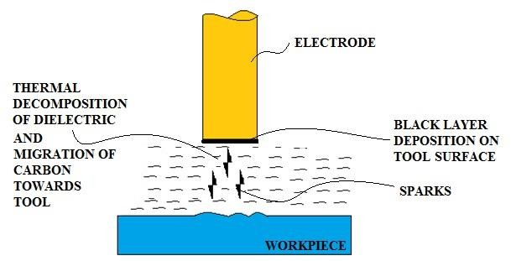

Figure 1 Development of Black Layer on Tool surface

Table 1 ANOVA analysis of 2FI model of Tool Wear Rate
Experiment Specifications
Work Material | AISI 4340
Tool Material | Copper-Tungsten
Dielectric | Kerosene
Selected Process Parameters | Peak Current (Ip), Pulse on Duration (Ton), Voltage (V), Pulse duty Factor (τ)

The above table 1 shows the experimental specifications considered for assessing the results.

    - Black Layer Formation

As the motion of electrons from tool start due to development of suitable voltage across the tool and workpiece, the process of de-ionization and ionization of dielectric prevail causing spark initiation. It generates very high temperature in the spark gap i.e., around 10000°C. Owing to thermal decay of dielectric medium at elevated temperature developed due to high discharge energy, a thin black film deposition is observed on the tool surface.
The black layer or carbon layer is the thin film of carbon and other constituents formed over the tool surface because of thermal decomposition of the dielectric medium caused by high temperature induced in the spark gap by the discharge energy. After the thermal decomposition of dielectric, the carbon moves towards the tool and forms a layer over it. This may create resistance towards the positive ions striking the tool surface and reduce the tool wear rate.
Pulse duty factor exert great influence over tool wear rate and has major dominance suggested by ANOVA in table 2. It can be observed from SEM images in figure 2, figure 3 and figure 4 that higher pulse duty factor more is the black layer visibility. The TWR of 0.05124 mm³/min at peak current 4A, pulse on time 25µsec, voltage 90V and pulse duty factor 0.8 is lowest among the samples. This shows that at higher pulse duty factor, the black film resists the momentum of positive ions striking the tool surface imparting lower TWR.

Table 2 ANOVA analysis of 2FI model of Tool Wear Rate
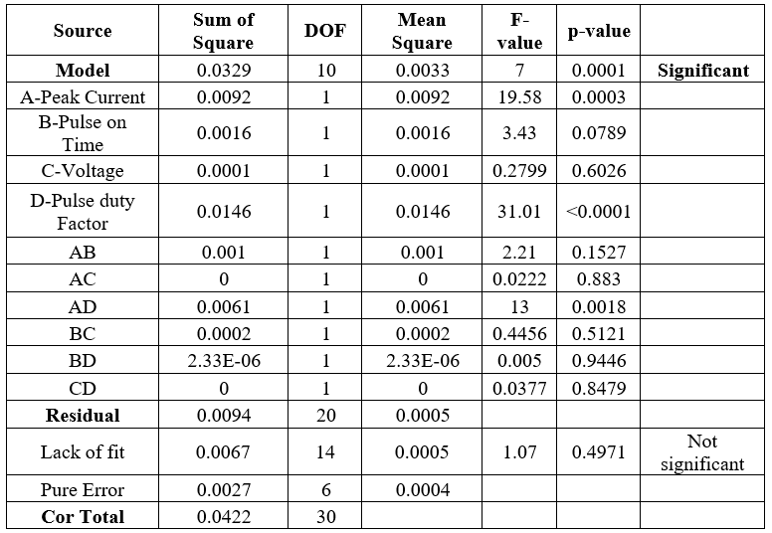
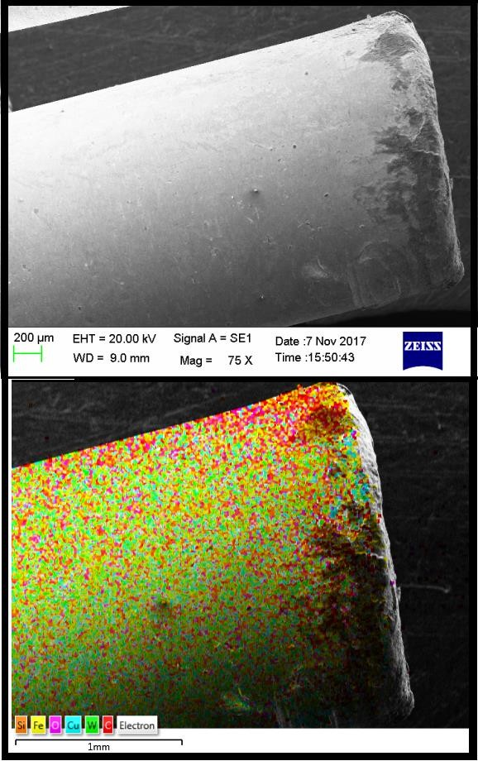

Figure 2 SEM and EDX of Sample 1(Ip-4A, Ton-15µsec, V-90V, τ-0.6)
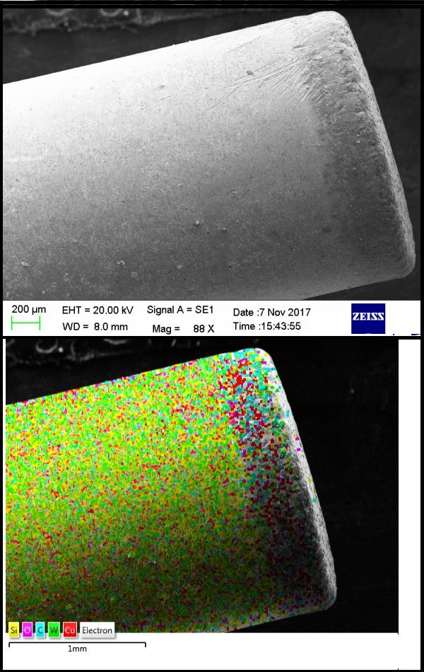
Figure 3 SEM and EDX of Sample 11(Ip-4A, Ton-25µsec, V-90V, τ-0.8)

From the EDX images on the previous page it is observed that the major constituents of black layer are carbon, silicon, oxygen and iron. The presence of carbon in the film is due to thermal decomposition of dielectric while the presence of silicon, iron is on account of the melting and evaporation from workpiece. The oxygen present in the layer is the result of oxidation during the machining.
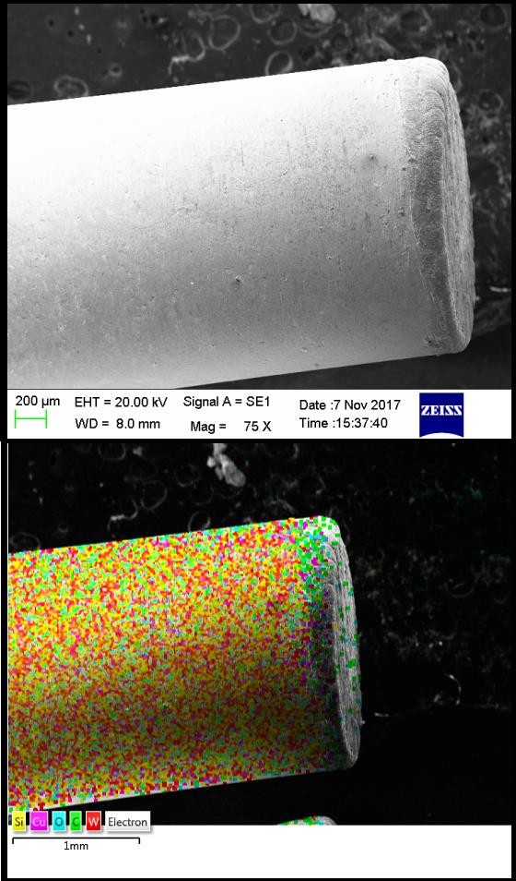

Figure 4 SEM and EDX of Sample 20 (Ip-7A, Ton-30µsec, V-105V, τ-0.7)

Effects of black layer over tool wear rate

From the previous section we could say that the composition found in black layer is not only carbon, but there are other elements too present in it. These elements are Silicon, Iron and Oxygen as identified by EDX analysis. The presence of iron (Fe) and silicon (Si) is due to their migration from the surface of workpiece during sparking.
The oxygen presence in the black layer is because of the oxidation that is caused during the machining. At higher levels of pulse duty factor, more visible black layer is observed. Pulse duty factor is crucial factor for tool wear suggested through ANOVA table 2. While keeping higher value of pulse duty factor, the black film formed will resist the momentum of positive ions striking the surface of tool and thus this will impart lower tool wear rate.
REFERENCES
- José Duarte Marafona, Black layer affects the thermal conductivity of the surface of copper–tungsten electrode, International Journal of Machine Tools and Manufacture, 2009, 482-488.
- José Duarte Marafona, Black layer characterisation and electrode wear ratio in electrical discharge machining (EDM), Journal of Materials Processing Technology, 2007, 184, 27-31.
- Pushpendra S. Bharti, S. Maheshwari, M.K. Satyarthi, Black Layer Characterization in Electric Discharge Machining of Inconel 718, Vth International Symposium on “Fusion of Science & Technology, 2016, 214-217.
- Lihua He, Jianwu Yu, Wen Duan, Zhikang Liu, Shaohui Yin, Hong Luo, Copper– tungsten electrode wear process and carbon layer characterization in electrical discharge machining, International Journal of Advanced Manufacturing Technology, 2016, 1759– 1768.
- Sanjeev Kumar, Rupinder Singh , Ajay Batish, T.P. Singh, Study the effect of black layer on electrode wear ratio in powder mixed electric discharge machining of titanium alloys, International Journal of Machining and Machinability of Materials, 2016, 18-25.
- Philipp Steuera, Andreas Rebschläger, Olivier Weber, Dirk Bähre, The heat-affected zone in EDM and its influence on a following PECM process, 2nd CIRP Conference on Surface Integrity, 2014, 276-28.
- F. L. Amorim, W. L. Weingaertner, Influence of duty factor on the die-sinking Electrical Discharge Machining of high-strength aluminum alloy under rough machining, Journal of the Brazilian Society of Mechanical Sciences, 2002, 194-199.
- NorlianaMohd Abbas, Darius G. Solomon, Pugh Method: Selection of Dielectric in Machining Tungsten Carbide with Electrical Discharge Machining (EDM), International Conference on Trends in Mechanical and Industrial Engineering, 2011, 204-207.
- S.SyathAbuthakeer, S.MohithKaameswaran, K.Venkatachalam, M.Vishhnuram, Influence of Process Parameters in EDM Machining of Aluminium Titanium Carbide Composite, International Journal of Recent Engineering Research and Development, 2017, 64-72.
- Amitabh Ghosh and Asok Kumar Mallik (2004), Manufacturing Science, New Delhi, East-West Press.

