PHARMACODYNAMICS

Annie Sherlyn R*, Dr.S.Muthukumar
Department of Pharmaceutics, KMCH College of Pharmacy
Affiliated to the Tamilnadu Dr.M.G.R Medical University, Coimbatore, India-641048
Contact: sherlynann02@gmail.com

ABSTRACT:
The field of pharmacodynamics studies how a ligand (Hormone or a Neurotransmitter), binds to its receptor to produce a pharmacological response. It's a term used to describe the effects of a drug on the body, including the biochemical and physiologic effects that influence the interaction of the drug with the receptor. The integration of the molecular actions into an effect on the organism as a whole is a subject addressed in this chapter. It is important to describe the effects of a drug quantitatively to determine appropriate dose ranges for patients, as well as to compare the potency, efficacy and safety of one drug to that of another.
KEYWORDS: Pharmacodynamics, ligand-receptor binding ,pharmacological response, interaction

INTRODUCTION:
Successful pharmacotherapy depends on the impact of these variables as well as how effectively the body responds to drugs at specific target locations. The process of drug delivery involves three phases, namely the drug administration phase, the pharmacokinetic phase and the pharmacodynamic phase. In this chapter, we will be discussing the third phase which deals with drugs producing a change or an effect on a specific target. This phase involves the interaction of a drug with its specific target, called a receptor.
DRUG ADMINISTRATION PHASE

PHARMACOKINETIC PHASE

PHARMACODYNAMIC PHASE

Pharmaco- is derived from the Greek word for "drug," pharmackon, and dynamics means "of or relating to variation of intensity." Pharmacodynamics (PD) is the study of the magnitude of drug response. In particular, it is the study of the onset, intensity, and duration of drug response and how these are related to the concentration of a drug to produce the desired effect in the site of action.

Pharmacokinetics and Pharmacodynamics:
There are two phases of drug action. (Fig.1) . The pharmacokinetic phase is concerned with the relationship between the value of the dose administered and the value of the drug concentrations achieved in the body; the pharmacodynamic phase is concerned with the relationship between drug concentrations at the site of action and the onset, intensity, and duration of drug response.

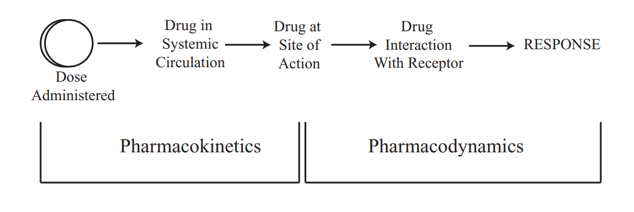
Fig.1

I.FUNDAMENTALS OF DRUG ACTION:
The alteration of the biochemical or physiological process of tissues of organisms by any chemical agent which is intended for diagnostic, preventive and therapeutic purposes is called a "drug". The term drug is derived from the French term "Drogue" which means a medicament. Sources of drugs can be plants, animals, synthetic sources, minerals and genetic means.

A drug molecule is expected to exhibit its mechanism of action on the target site. There are principles based on which the drug elicits an action that can be classified broadly into the following types,

(a)Activation: The drug molecule stimulates the process or selectively accelerates the process by binding to the target site. Example: Caffeine causes CNS stimulation and increased alertness.

(b)Inhibition: Drug molecule exhibiting its action by inhibiting the process or selectively deaccelerating the process by binding to the target site. Example: Aspirin inhibits cyclooxygenase, thereby inhibiting the formation of prostaglandins.

(c)Complexation: Drug molecule exhibiting its action by making a complex, thereby making it inactive by sequestration. Example: Deferoximine chelates ion.

(d) Neutralization: Drug molecule binding to the target site and neutralizing the action of the existing molecule directly through a chemical reaction. Example: Antacids

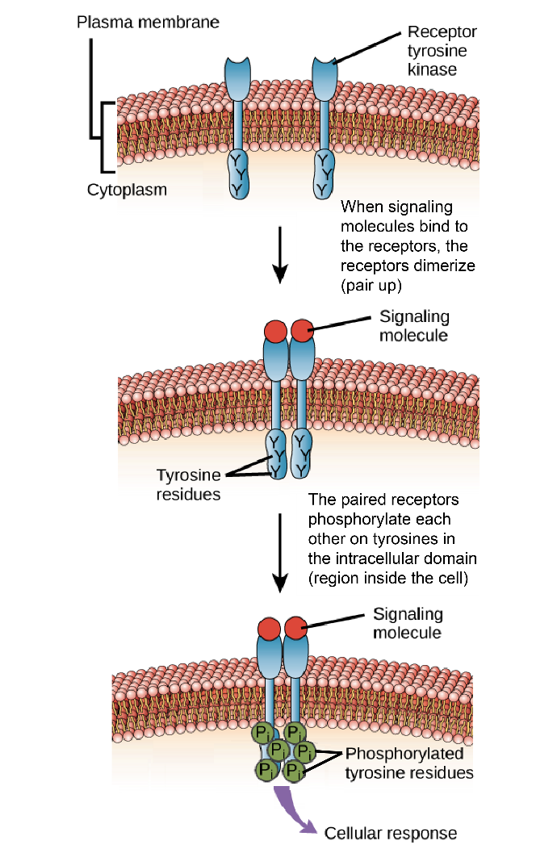
Fig 2. recognition of a drug by a receptor

II.FACTORS INFLUENCING THE EFFECTIVENESS OF DRUG THERAPY:

The concentration of administered drug
Metabolic rate
Frequency of doses administered
Genetics
Food-Drug interaction
Drug-Drug interaction
Excretion rate
Absorption rate
The half-life of an administered drug
Medical conditions

III.TARGETS OF DRUG ACTION:
In most instances, drugs act by associating with specific macromolecular elements in ways that alter their biochemical or biophysical activity. The principal targets for drug action on mammalian cells can be broadly divided into the following categories.

(a)Receptors are the most important targets of drug action. Ion channels, enzymes and carrier molecules can also be indirectly activated or inhibited by receptor-mediated actions. Receptors are the sensing elements chemical through chemical communication that coordinates the functions of the body, the chemical messenger can be a hormone or a transmitter substance. Some of the common receptors are biogenic amines, acetylcholine and opiates. The receptors determine the quantitative relation between drug dosage and pharmacological action and are responsible for the selectivity of drug action. Many drugs function by blocking receptors as antagonists although they do not alter receptor function as agonists do.

(b)Ion Channels can be modulated by drugs in different ways. Some are ligand-gated receptor-mediated ion channels, and others are modulated indirectly involving G-proteins or other intermediaries. But most of the ion channels are modulated by binding drugs directly to parts of the channel protein. Common ion channels are Na⁺, K⁺ , and Cl⁻.

( c)Enzymes are targets for many drugs. Most commonly the drug molecule acts as a substrate analogue which acts as a competitive inhibitor of the enzyme. In some cases, the inhibition can be irreversible, eg. organophosphorus compounds on AChE, and aspirin on platelet cyclooxygenase. Common target enzymes are cholinesterase, monoamine oxidase, cyclooxygenase and angiotensin-converting enzyme.

(d)Carrier molecules transport ions and small organic molecules across the cell membrane. These are carrier proteins with recognition sites which can be targeted for a drug. A few carrier proteins are Na⁺/K⁺ pump, proton pump and noradrenaline uptake. In addition to these some drugs act on structural proteins, eg. Colchicine on tubulin.

IV.SIGNAL-TRANSDUCTION:
Drugs are the signals, and receptors are the signal detectors. If a drug binds to a site on the receptor protein and initiates a function or reaction to produce the required response, it is called an "agonist".

A.drug-receptor complex:
There are different types of receptors present in a cell, each of which is specific. The magnitude of cellular response is proportional to the number of drug-receptor complexes. This concept is conceptually similar to the formation of complexes between an enzyme and substrate. It is also important to know that, not all drugs exert effects by interacting with a receptor. For example, antacids chemically neutralise excess gastric acid, thereby reducing stomach upset.

B.States of receptor:
Receptors can exist in at least two states, inactive (R) and active (R*), they are in reversible equilibrium with one another, usually favouring the inactive state. The magnitude of the biological effect is directly related to the fraction of R*. Agonists, antagonists and partial agonists are examples of ligands that bind to the activation site on the receptor and can affect the fraction of R*.

V.RECEPTORS AND RECEPTOR-BINDING:
Paul Ehrlich, who initiated the concept of 'receptor' at the beginning of this century, described the drug-receptor interaction as a 'lock and key system'. Most drug receptors are macromolecular proteins which provide both the necessary diversity and specificity of shape and electrical charge. Receptors present in different cellular constituents are specific in size, shape and structure, and allow interaction with specific ligands or substrates. Therefore, specific drugs bind with specific receptors. If the forces that bind the two are weak (hydrogen bonds, van der Waals bonds, electrostatic bonds), the binding will be reversible, but if the forces involved are strong, ie. In covalent bonds, the binding will be effectively irreversible. Drug-receptor binding is also known as receptor occupancy. Receptor occupancy of a drug is dependent on the affinity of the receptor for the drug which is a function of the structural relationship between the two-the drug and the receptor. The relationship between the ligand concentration and receptor occupancy law of mass action.

The law of mass action states the rate of a chemical reaction is directly proportional to the product of the reactant concentration values.

This means receptor occupancy (%) is directly related to log-concentration of ligand over a wide range. Drug-receptor interactions at different sites in the body are similar, but the transduction mechanisms or the signalling mechanisms by which the drug-receptor occupancy is translated into biological effects are different at different sites. Four such mechanisms have been distinguished, given below in the table.
(i)The first three types concern membrane-bound receptors
(ii)The fourth one concerns cytosolic or nuclear protein receptors.

From the table below it is evident that the time lag between ligand-receptor coupling and response is widely variable depending on the mechanism. The lag period may be in milliseconds, seconds, minutes or even hours or days.

 | Ligand-gated channel | G-protein coupled receptors | Tyrosine kinase-linked receptors | Intracellular receptors
RECEPTOR SITE | Membrane | Membrane | Membrane | Intracellular
RECEPTOR-EFFECTOR COUPLING | Direct | G-protein | Direct | via DNA
EFFECTOR | Channel | Enzyme/Channel | Tyrosine Kinase | Gene Transcription
COUPLING-RESPONSE TIME LAG | Milliseconds | Seconds | Minutes | Hours/days
CELLULAR EFFECTS | Hyperpolarization/  Depolarization | Second messenger/Channel modulation | Protein Phosphorylation | Protein synthesis
EXAMPLES | n-ACh receptor  GABA receptor  Glutamate receptor  Aspartate receptor | m-Ach receptor  Adrenergic receptor  5-HT receptor  Polypeptide Hormones | Insulin  Growth factors | Corticosteroids  Sex hormones  Vitamin D  Thyroid Hormones

Table.1. Receptor and receptor binding

VI.RECEPTOR GROUPS:
A receptor can be defined as any biological molecule to which a drug binds and produces a response. These receptors may be divided into four families (Fig.3)

- Ligand-gated ion channels
- G protein-coupled receptors
- Enzyme-linked receptors
- Intracellular receptors

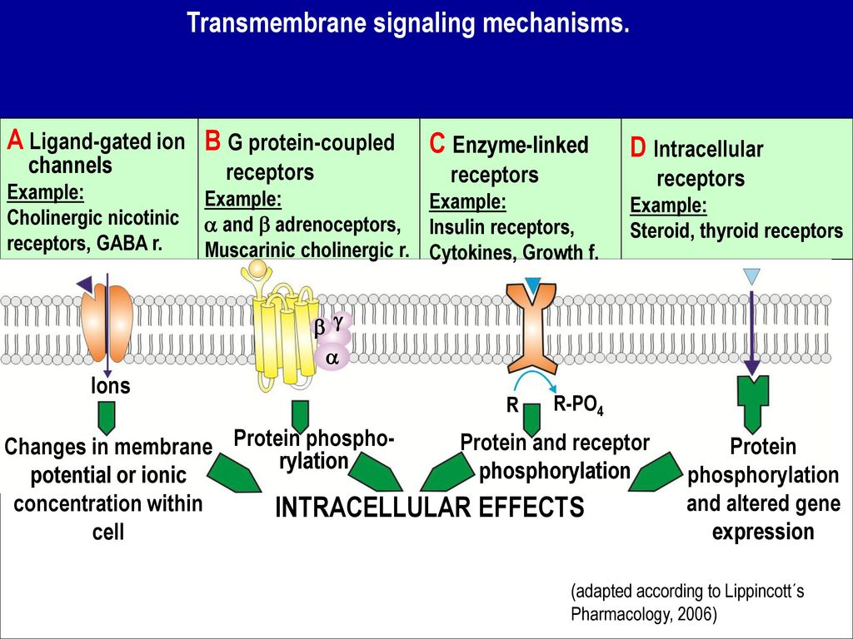
Fig.3.Transmembrane signalling mechanisms

- TRANSMEMBRANE LIGAND-GATED ION CHANNELS:
The drug binding site is located in the extracellular portion of ligand-gated ion channels. This regulates the opening and closing of the pore through which transport across cell membranes takes place. The channel will open only when the receptor is activated. The ions that are transported across this membrane have specific functions in different cells of the body.

- G PROTEIN COUPLED RECEPTORS:
The drug binding site is located in the extracellular portion of ligand-gated ion channels and the intracellular portion interacts with the G protein. There are different types of G proteins and they are all composed of 3 sub-units of protein. The α subunit, β ,γ subunits. The responses of these receptors last from several seconds to minutes. The activated effectors produce "second messengers", which further activate other effectors in the cell.

- ENZYME-LINKED RECEPTORS:
These receptors are a group of multi-subunit transmembrane proteins that contain either intrinsic enzyme activity on their intracellular domain or associate directly with the intracellular enzyme. When this family of receptors undergoes conformational changes it results in increased intracellular enzyme activity. Response lasts for minutes to hours. For example, growth factors and insulin possess tyrosine residues on themselves and other specific proteins. Phosphorylation acts as a molecular switch because they modify the structure of the target protein. Enzyme-linked receptors are similar to G protein-coupled receptors.

- INTRACELLULAR RECEPTORS:
Intracellular receptors are receptor proteins found on the inside of the cell. The ligands are small, hydrophobic molecules, to reach the receptors. The ligand must have lipid solubility to diffuse into the cell to interact with the receptor. This receptor takes hours to days to occur. Other targets of intracellular ligands are structural proteins, enzymes, RNA, and ribosomes.

VII. FEATURES OF SIGNAL TRANSDUCTION :
Signal transduction has two important features:
1)the ability to amplify small signals
2)mechanisms to protect the cell from excessive stimulation

1)Signal amplification: It is a feature of G protein and enzyme-linked receptors. They can amplify the intensity and duration of a signal through the cascade effect. The activated G-protein can prolong for a longer duration than does the original complex, this is mediated by the interaction of the G proteins and their intracellular target cells. This signal amplification makes the requirement of ligand less and a maximal response is also produced.

2)Desensitization and down-regulation of receptors: Continuous administration of a drug leads to changes in the responsiveness of the receptor. The response is diminished. This is called tachyphylaxis, This effect is common with drugs acting on the nervous system. The unresponsive receptors during the recovery phase are called "refractory".
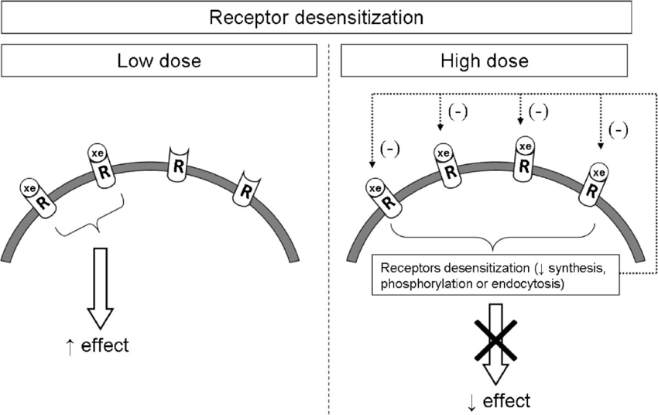
Fig.4.Desensitization of doses

VIII.RESPONSE OF DRUG-RECEPTOR INTERACTION:
If a drug has an affinity for the receptor, and if it is close to the receptor site, receptor-occupancy takes place. This drug-receptor coupling leads to a variety of responses depending upon the nature of the drug molecule.

- Agonists: Drugs resemble the natural transmitter or hormone, may activate the concerned receptor, and result in a response. The capacity of a drug to interact with a receptor is due to its 'affinity', and the capability to produce a response is called its "intrinsic efficacy" or "intrinsic activity". Thus an agonist has affinity as well as an intrinsic activity. Noradrenaline, acetylcholine, histamine, 5-HT and their chemical analogues are all examples of agonists.

- Antagonists: Some drugs because of their structural similarity with the natural ligand of a receptor have an affinity for the receptor and so bind with the receptor. They are however incapable of activating the receptor due to a lack of intrinsic activity (efficacy), and hence there is no response. These drugs compete with the endogenous ligand or exogenous agonists and prevent their receptor occupancy and response. Drugs with affinity without any intrinsic activity and which competitively antagonize the effects of agonists are called pure antagonists. A large number of antagonists are in clinical use, eg. Antiadrenergic, anticholinergics and antihistaminic.

Antagonists can be categorized based on whether they bind to a site on the receptor for agonist or interrupt agonist-receptor signalling by other means.

ANTAGONISTS

Receptor Nonreceptor
Antagonists antagonists

Active Allosteric Chemical Physiologic
Site binding binding Antagonist Antagonist

Reversible Irreversible Reversible Irreversible

Competitive Noncompetitive Noncompetitive
Antagonist active site allosteric
Antagonist antagonist

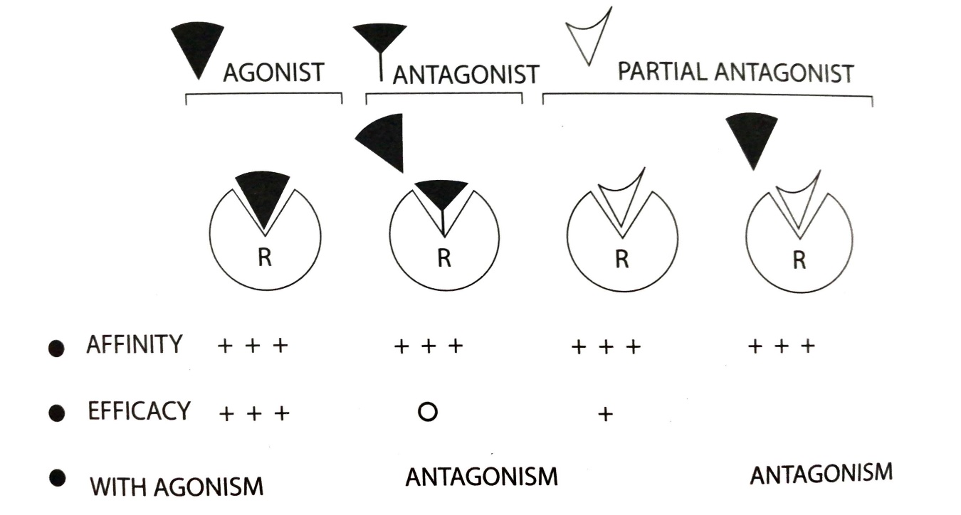
Fig.5.Drug receptor interaction

- Partial agonists: Some drugs have both agonist and antagonist actions. They have affinity but very low intrinsic efficacy. They competitively antagonize the effects of a full agonist, but by themselves produce a response much lower than that of a full agonist even at a full receptor occupancy. A classical example of a partial agonist is saralasin acting on angiotensin II receptors. It has an antihypertensive effect in patients with increased angiotensin II production but raises blood pressure in patients who produce low amounts of angiotensin.

- Inverse agonists: Some drugs produce paradoxical actions, and are specifically opposite to those of the agonists. These are called inverse agonists. β -Carbolines are examples of inverse agonists. These agents, by acting on benzodiazepine receptors produce anxiety, increased muscle tone and convulsions, while the agonist benzodiazepines by binding with the same receptors produce sedation, anxiolysis, muscle relaxation and control of convulsions. Both these types of drugs act by modulating the effects of the neurotransmitter GABA.

IX. RELATIONSHIP BETWEEN DOSE-RESPONSE:
Agonist drugs mimic the action of the endogenous ligand for the receptor. The magnitude of the drug effect depends on receptor sensitivity to the drug and the drug concentration at the receptor site, which, in turn, is determined by both the dose of drug administered and by the drug's pharmacokinetic profile, such as rate of absorption, distribution, metabolism, and elimination.

Graded dose-response relations: As the concentration of a drug increases, its pharmacologic effect also gradually increases until all the receptors are occupied. Plotting the magnitude of response against increasing doses of a drug produces a graded dose-response curve that has a general shape. Two important drug characteristics, potency and efficacy, can be determined by graded dose-response curves.

- Potency: It is the amount of drug necessary to produce an effect. The concentration of drugs producing 50% of the maximum effect (EC-50) is often used to determine potency. In the given graph, the EC-50 indicate the potency of the drug. (Fig.6) The therapeutic preparations of drugs reflect their potency. We can take, for example, candesartan and irbesartan are angiotensin receptor blockers used to treat hypertension. The therapeutic dose range for candesartan is 4 to 32 mg, as compared to 75 to 300 mg for irbesartan. Therefore, candesartan is more potent than irbesartan. Since the range of drug concentrations that cause from 1% to 99% of maximal response usually spans several orders of magnitude, semilogarithmic plots are used to graph the complete range of doses.

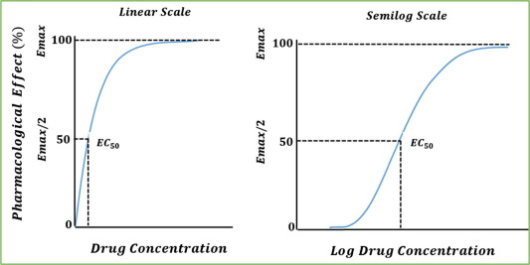
Fig.6.Potency-Drug concentration graph

- Efficacy: It is the magnitude of response a drug causes when it interacts with a receptor. Efficacy is dependent on the number of drug-receptor complexes formed and the intrinsic activity of the drug. Efficacy is a more clinically useful characteristic than potency since a drug with greater efficacy is more therapeutically beneficial than one that is more potent.

(b) Drug concentration on receptor binding: This applies the law of mass action to the kinetics of the binding of drug and receptor molecules.

DRUG + RECEPTOR DRUG-RECEPTOR COMPLEX BIOLOGICAL EFFECT

It is assumed that the binding of one drug molecule does not alter the binding of subsequent molecules and by applying the mass action, mathematically it is expressed as

[DR] = [D]
[Rt] Kd + [D]
Where,
[D]= the concentration of free drug
[DR]= the concentration of bound drug
[Rt]= the total number of receptors
Kd= the equilibrium dissociation constant for the drug from the receptor

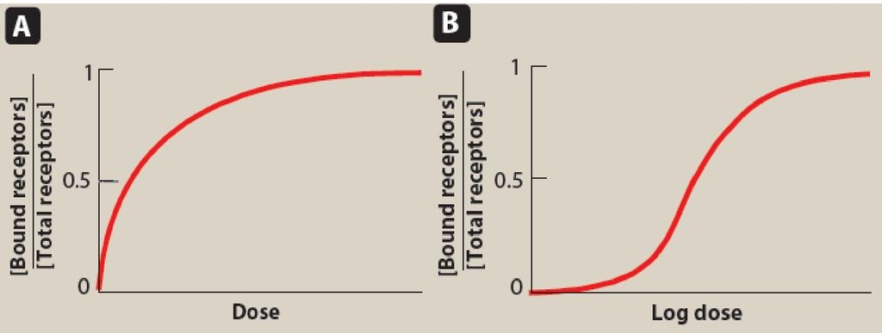

Fig.7.Drug concentration on binding receptor

- Drug binding to pharmacologic effect:

The law of mass action can be applied ,
[E] = [D]
[Emax] Kd + [D]

Where,
[E] = the effect of the drug concentration [D]
[Emax] = the maximal effect of the drug

Law of mass action can be applied to drug concentration-response when the following conditions are met,
- The magnitude of response is proportional to the number of receptors occupied by the drug
- Emax occurs when all receptors are bound
- One molecule of drug binds to only one molecule of receptor

X. THERAPEUTIC INDEX AND SAFETY TERM:

At the beginning of the last century, Ehrlich introduced the concept of the therapeutic index. Since the development of clinical pharmacology and scientific analysis of clinical data, the implications have undergone radical changes. Back then, the therapeutic index (TI) was derived from animal experiments and was defined as the ratio of TD₅ₒ to ED₅ₒ for some therapeutically relevant effect. Therefore, the therapeutic index of a drug is the ratio of the dose that produces toxicity in half the population to the dose that produces a clinically desired or effective response in half the population.
TI = TD₅ₒ
ED₅ₒ

The TI is a measure of a drug's safety because a larger value indicates a wide margin between doses that are effective and doses that are toxic.
From the above derivative, TI is a number and an indication of the 'margin of safety'. But in a clinical situation, TI has limitations

Limitations of therapeutic index:
- Clinical situations with Extrapolation of animal data.
- A toxic symptom is more relevant than lethality in humans.
- Drugs may have more than one ED₅ₒ which depends on the measure of effectiveness.
- Some significant toxic symptoms are seen in some individuals only.

Due to these limitations, the term safety margin is more in vogue. Based on this criterion, benzodiazepines, barbiturates and digoxin have a high, moderate and low therapeutic index. Two parameters are needed to calculate the safety margin in humans,
(i)Effective dose: To calculate the specific effect in most humans, viz. EDmax
(ii)Maximum tolerated dose, which does not produce any ADR, viz. TDₒ

TI = TDₒ
EDmax

Care is needed while using drugs with low margin of safety.

XI.DRUG-DRUG INTERACTIONS:

A drug interaction occurs when one drug is administered with or shortly after another drug and alters the effect of one drug or both drugs. This increases or decreases the effect of the drug or might cause unexpected effects. Consequences of drug-drug interactions are given below,

DRUG-DRUG INTERACTION | DEFINITION | EXAMPLE | REPRESENTATION
SYNERGISM | The interaction of two or more drugs when their combined effect is greater than the sum of the effects seen when each drug is given alone. | Barbiturate drugs when taken with general anaesthetics, alcohol and other sedative-hypnotic drugs can lead to greater adverse effects on the central nervous system | + =
ADDITIVE EFFECT | The combining effects of two drugs equal the sum of the effects of the two drugs acting independently. | Take aspirin and acetaminophen which is the active ingredient in drugs like Tylenol. | + =
THERAPEUTIC ANTAGONISM | One drug reduces or blocks the effect of another. This can happen in many ways, for example, drugs can interfere with each other in absorption or uptake by cells in the body | Verapamil is a blocker of L-type Ca channels, but blocks Na channels at high concentrations | - = 0
POTENTIATION | The effect of one drug is increased by the intake of another drug without causing a notable effect. Although, the toxicities of drug B can also be potentiated leading to increased adverse effects. | Diazepam may potentiate the effect of alcohol. | + =  0

Table.2.Drug-drug interaction

XII.FACTORS AFFECTING DRUG RESPONSE:
Drug responses can vary due to pharmacokinetic, pharmacodynamic variabilities and genetic differences. Pharmacodynamic variables can be because of genetic factors, tolerance, concurrent diseases affecting the patient, drug interactions and dependence.

- Sex:
  - Females have a smaller body size and require doses on the lower side range. They should not be given purgatives or uterine stimulants during menstruation, quinine during pregnancy and sedatives during lactation. Some drugs interfere with the sexual function of males exclusively and should be avoided, if possible, for example, antidepressants, statins and fibrates.

  - Body weight: The concept of varying the dose with the body weight of children is widely followed, adult doses have also been assumed to be the same irrespective of size and shape although adult weights may vary.

- Age:
  - Children: Children particularly neonates differ from adults in their response to drugs. Some drugs can cause problems in neonates but are tolerated by children. Examples of drugs associated with problems are chloramphenicol (grey baby syndrome).

  - Elderly: Drug use generally requires significant reductions in drug dose reflecting the decline in body function with age. More attention should be given to toxicity and failure of treatment. Patients react differently to medications than young adults, as they age. In the elderly, sometimes distinguishing subtle adverse drug effects from the effects of the disease is often difficult which may lead to prescribing cascade. Prescribing cascade occurs when the adverse effect of a drug is misinterpreted as a symptom. For example, antipsychotics can cause symptoms that are similar to Parkinson's disease and the patients may be put on antiparkinson drugs, which causes adverse drug reactions

- Food:
  - The presence of food, like fatty acids delays gastric emptying and also delays the absorption of certain drugs like rifampicin. Protein malnutrition causes many changes which may affect drug action. Alcohol induces drug-metabolizing enzymes. Calcium in milk interferes with the absorption of tetracyclines.

- Biorhythm:
  - It is the recurring cycle in the physiology or functioning of an organism, such as the daily cycle of sleep and waking. For example, Hypnotics taken at night produce sleep more easily at a lower dose than in the daytime.

- Psychological state:
  - In some patients, inert drugs (Placebo- refers to any therapeutic procedure without any specific activity, given deliberately to affect the patient that can be explained by drugs pharmacological and therapeutic properties) may introduce beneficial effects equivalent to the drug.

- Cumulation:
  - When a drug is excreted slowly from the body and too frequent doses are administered, there may be a build-up of a high concentration of the drug in the body which produces toxicity. For example, digitalis.

- Tolerance:
  - A higher dose of a drug is required to produce an effect, which can be ordinarily produced by the normal therapeutic dose of the drug. Natural tolerance may
  - also, be present in some cases.

REFERENCE:
[1] Introduction to Pharmacodynamics-Reza Karmini
[2] Basic Pharmacokinetics and Pharmacodynamics-Sara Rosenbaum
[3] Pharmacology Second edition-Salil K Bhattacharya, Paranrapa Sen, Arunabha Ray, Prasun K Das- editor
[4]Principles of Pharmacology, The Pathophysiologic Basis of Drug Therapy-David E.Golan, Armen H.Tashjian, Jr., Ehrin J.Armstrong, April W.Armstrong
[5]Applied Biopharmaceutics and Pharmacokinetics-Leon Shargel, Susanna Wu-Pong,Andrew B.C.Yu
[6]Core Concepts in Pharmacology- Norman Holland, Micheal Patrick Adams

