Operational Transconductance Amplifier (OTA)

- Introduction:
Generally, a simple operational amplifier ICs give an output voltage that is proportional to the difference between the voltages applied to its two input terminals known as voltage-differencing amplifier (VDA).
$$V_{o} ∝(V_{in+}- V_{in-})$$
There are two other types of op-amps that are common in use; one of these is the type that gives an output voltage that is proportional to the difference between the currents applied to its two input terminals known as a current-differencing amplifier (CDA).
$$V_{o} ∝(I_{in+}- I_{in-})$$
The third type of op-amp is known as an operational transconductance amplifier (OTA), and acts as a variable-gain and voltage controlled current source (VCCS) amplifier means that gives an output current that is proportional to the difference between the voltages applied to its two input terminals known as an operational transconductance amplifier (OTA).
$$I_{o} ∝(V_{in+}- V_{in-})$$
Where; $(V_{in+}- V_{in-})$ is a differential voltage at input terminal of OpAmp.

- Operational Transconductance Amplifier (OTA):
Operational transconductance amplifier (OTA) is to convert an input voltage to an output current that is why it is also called as voltage controlled current source (VCCS). The OTA can be configured to amplify either voltages or currents. The adaptability of an OTA permits its usage in many electronic systems such as audio signals, filters, analog to digital converters, oscillators etc.
OTAs can build by using bipolar or CMOS transistor technology. CMOS OTAs are commonly used in high-frequency applications but are less common use in audio circuits whereas bipolar OTAs are universal. The most commonly used OTA symbol is VCCS symbol improved with an additional bias current port as shown in Figure 2.1 (a). The OTA symbol usually found in circuit schematics is shown in Figure 2.1 (b).
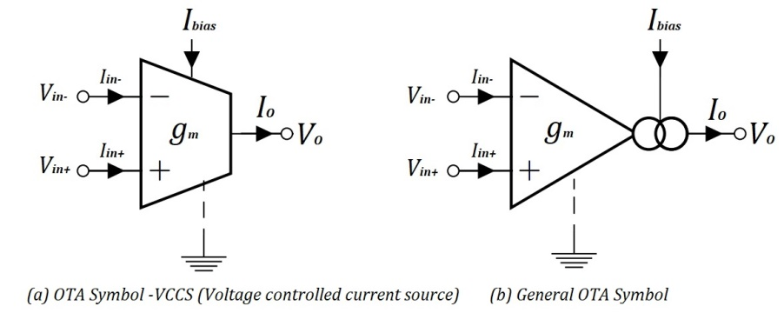
Fig 2.1: OTA Symbols

  - What is operational transconductance amplifier (OTA)?
The operational transconductance amplifier is a voltage to current amplifier in which output current is equal to the gain times of input voltage. Sometimes, OTA is also called as voltage controlled current source (VCCS). The double cycle in figure 2.1 (b) represents an output current source that is dependent on the bias current that is${ I}_{bias}$.
OTA has two differential input terminals, high input impedance, a high CMRR, bias current terminal, high output impedance and it has no fixed open loop voltage gain.
The transconductance is the gain of OTA. The transconductance of electronic devices is given by the ratio of output current to input voltage or differential voltage.
$g_{m}= \frac{I_{o}}{V_{in}}$ (2.1)
Where, $g_{m}$ is a transconductance, $V_{in}$ is the differential input voltage $(V_{in+}- V_{in-})$
In OTA, the transconductance is dependent on a constant K times the bias current ${ I}_{bias}$ and the value of K depend on the internal circuit of OTA and temperature.
$g_{m}= K* I_{bias}$ (2.2)
From equation 2.1, $I_{o}= g_{m}* V_{in}$
$I_{o}= K* I_{bias}* V_{in}$ (2.3)
So, we can see by this equation (2.3), $I_{o}$ equals to the K times $I_{bias}$ and ${ V}_{in}$, so the output current is dependent on the value of $I_{bias}$ and the value of input voltage. So we can say that the output current is controlled by the input voltage and the bias current.

- Symbol and operation of OTA:
The practical symbol of operational transconductance amplifier (OTA) shown in figure 3.1, here you can see an Op-Amp has input terminal and output terminal with biased terminal ($I_{bias}$).

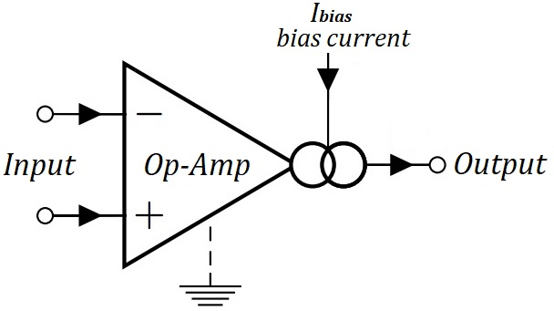
Fig 3.1: The basic Symbol of OTA

In general the symbolic representation of OTA is shown in fig. 3.2 (a).
The ideal small signal model of OTA is shown in fig. 3.2 (b), here the input impedance $(R_{i})$ and output impedances $(R_{o})$ are assumed as infinite because of ideal case.
Generally, we know that the transconductance $(g_{m})$ of OTA is directly proportional to the amplifier bias current $(I_{bias})$ from equation (2.2) that is;
$g_{m}= K* I_{bias}$ (3.1)
Where, K is the proportionality constant and it depends on the temperature.

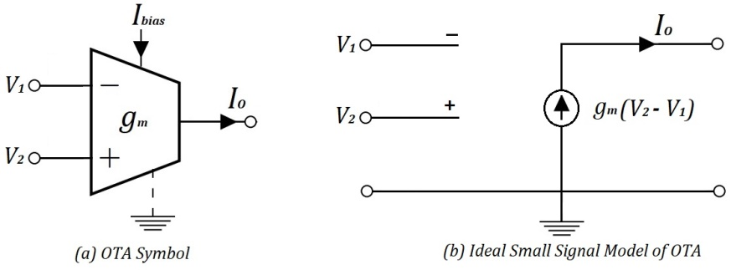
Fig 3.2: The basic OTA models

For Ideal small signal OTAs model of fig. 3.2 (b), the output current $(I_{o})$ is given by;
$I_{o}= g_{m}(V_{2}- V_{1})$ (3.2)
Where; $I_{o}$ = output current
$g_{m}$ = transconductance gain
$V_{2}$= non-inverting input voltage
$V_{1}$ = inverting input voltage

- Basic Circuit and Principle of OTA:
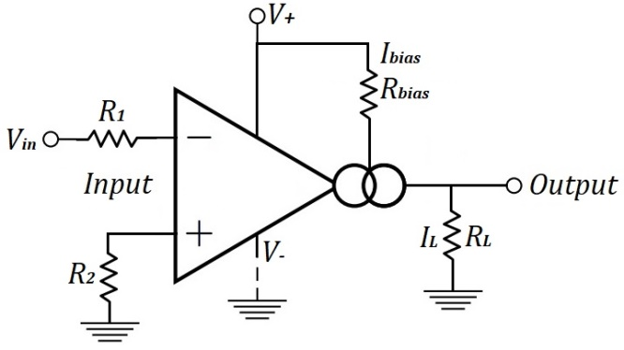
Fig 4.1: The basic circuit of operational transconductance amplifier (OTA)
In this basic circuit of OTA, the input voltage $(V_{in})$ is connected to the inverting terminal of Op-Amp with resistance $R_{1}$ and non-inverting terminal grounded with $R_{2}$. The double circles represent the bias current source $(I_{bias})$ with biasing resistance $(R_{bias})$ and this bias current flowing through the bias resistance. At output terminal the $I_{L}$ and $R_{L}$ are the load current and load resistance respectively.
The output current $(I_{o} or I_{L})$ is depends on the value of bias current and the value of input voltage $(V_{in})$.
From equation (2.3): $I_{o}= K* I_{bias}* V_{in}$ (4.1)

So, how do we fix the value of bias current? here we have two options:
- Variable Register: A variable Resistor can use to fix the value of $I_{bias}$.
- Reference Voltage: We can use a separate reference voltage to fix the value of $I_{bias}$.

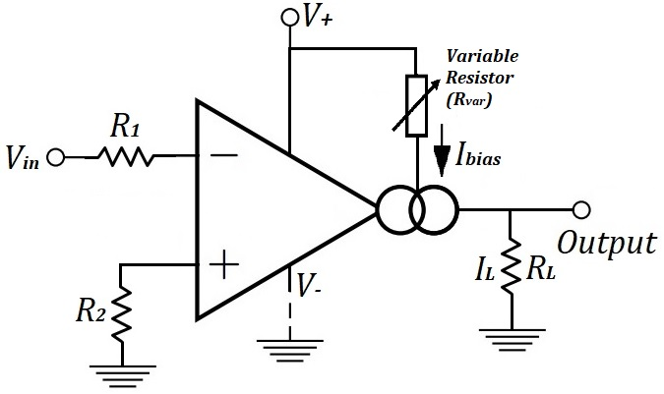
- By using variable resistor

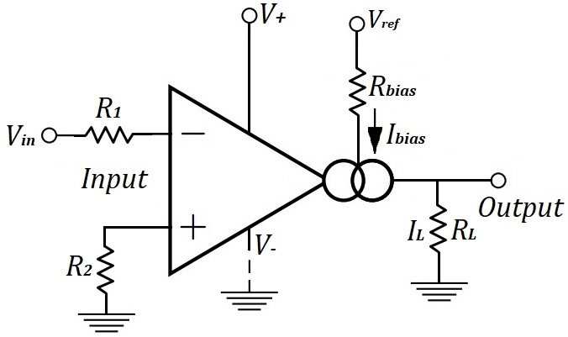
(b) By using reference voltage
Fig 4.2: To fix the bias Current

We can use a variable resistor in the place of $R_{bias}$ resister to fix the value of bias current by varying the value of variable resistor or we can use a separate reference voltage or voltage source to fix the value of bias current by changing the value of $V_{ref}$.

- Basic classification of OTA:
The characteristics of an ideal OTA and ideal operational amplifier (Op-Amp) are similar except output impedance; the OTA has very high output impedance. Due to this, the output signal is in terms of current, which is proportional to the differential input voltages $(V_{d}$).
$I_{o} ∝ V_{d}$
Where, $V_{d}=(V_{in+}- V_{in-})$ = differential voltage
The OTA is best defined in terms of its transconductance gain $(g_{m})$ rather than the voltage gain$(A_{V})$. The transconductance $(g_{m})$ of OTA can be linearly controlled through bias-control current $(I_{b})$ or voltage $\left(V_{b}\right).$
OTAs are also available in chip forms. So, the monolithic OTAs can be classified as follows:
  - Bipolar OTAs
  - MOS OTAs

  - Bipolar OTAs
The bipolar OTAs are usually available as typical chips from various IC manufacturing companies. They obtained as single device, as dual OTA on a chip and as triple OTA on a chip. Bipolar OTAs are also available in Enhanced performance OTAs, with on chip buffers and linearizing diodes.
A simple bipolar differential pair OTA as shown in figure which converts the difference of input voltage to the currents$(I_{B+}and I_{B-})$.

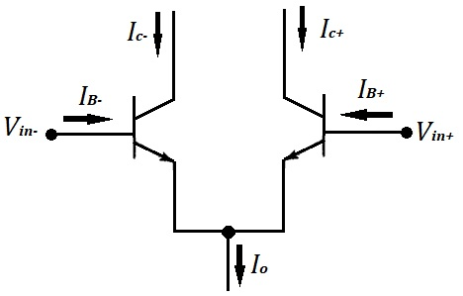
Fig. 5.1: Bipolar Differential pair OTA

For bipolar OTAs, the transconductance $(g_{m})$ is given by;
$g_{m}= \frac{I_{B}}{2V_{T}}$ (5.1)

Where, $I_{B}$ = base current and $V_{T}$ = thermal equivalent voltage of transistor in kelvin.

  - MOS or CMOS OTA:
Most commonly used amplifier is CMOS-OTA. The CMOS-OTA is a voltage-controlled device. The operational transconductance amplifier (OTA) has a huge numbers of applications in analog electronic circuits. It can be designed by using complementary metal-oxide-semiconductor (CMOS) technology. However, as CMOS technology scales down to the nanometer range.
One of the finest advantage of CMOS-OTA is the transconductance $(g_{m})$ of CMOS-OTA is adjustable by the control-voltage$(V_{C})$. The circuit of a CMOS-OTA is shown in fig. 5.2.

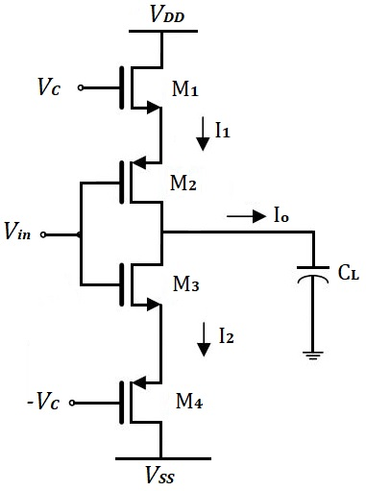
Fig. 5.2: Single input single output CMOS-OTA

Circuit diagram of single input single output CMOS-OTA is presented in figure 5.2. Single input $V_{in}$ is given and output current $I_{o}$ is obtained.

Output current: $I_{o}= g_{m} V_{in}$
Gain: $g_{m}= 2K (V_{C}- V_{th})$ (5.2)
Where, $V_{th}$ is threshold voltage of n-channel MOS.
One thing more we have to be noted that, from above equation 5.2, the $g_{m }$depends on$V_{C}$, so the $g_{m}$ is adjustable by the control voltage $V_{C}$, therefore, a MOS-OTA is ultimately a voltage-controlled device. Such type of OTA has wide ranging of electronic tunability with control voltage $(V_{C})$.

- Characteristics of OTA:
As we know that the characteristics of ideal Op-Amp similarly the important characteristics of an ideal OTA summarized as follows:

- Input resistance is infinite; $R_{i}= ∞$
- Output resistance is infinite; $R_{o}= ∞$
- Bandwidth is infinite; $ω= ∞$
- Perfect balance; $I_{o}= 0 ;$ when; $V_{1}= V_{2}$
- Transconductance $(g_{m})$ is finite and controllable with the amplifier bias current $I_{bias}$.

- Application of OTA:
The main applications of transconductance amplifier, it is used in amplitude modulation in the communication system. The OTA can easily be used as a voltage-controlled amplifier (VCA), oscillator (VCO), or filter (VCF), etc. The total current consumption of OTA is simply the twice of the $I_{bias}$current (which is less than 0.1µA), that’s why enabling the device to be used in micro-power applications.

