Amalgamation of Artificial Intelligence (AI) In Emergency Medicine; a Paradigm Approach

Dr. Shiv Shanker Tripathi, M.D.

shiv_shanker2@rediffmail.com; 8808073004

Professor, Department of Emergency Medicine Dr Ram Manohar Lohia Institute of Medical Sciences, Lucknow, India 226010

Dr. Pratika Mishra, Ph. D.
pratikamishra@presidencyuniversity.in: 9643103117
Professor -Marketing, School of Management, Presidency University, Bangalore 560064

Dr Swagat Mahapatra MS
Associate Professor ,Department of orthopaedics
Dr Ram Manohar Lohia Institute of Medical Sciences, Lucknow, India 226010

Dr. Avinav Bharati, PhD
Associate Professor ,Department of Radiation Oncology,
Dr Ram Manohar Lohia Institute of Medical Sciences, Lucknow, India 226010
avinavb4@gmail.com

Dr Anoop Kr Srivatava, Ph D

anoopsrivastava78@gmail.com; 8176007237

Professor, Department of Radiation Oncology, Dr Ram Manohar Lohia Institute of Medical Sciences, Lucknow, India 226010

General Discussion
The term ‘Artificial Intelligence’ (AI) was coined in 1956 and is defined as, “the science and engineering of making intelligent machines which is empowered to think and predict outcome of action as human being do”. It is also a promising tool for supporting the healthcare administration.Clinical Applications based on Artificial intelligence (AI) is the most important and innovative development in medical sciences which has enormous potential to positively influence the various aspect of diagnosis and treatment across all field of medical practices. AI-based tools have been used for predicting various factors in medicine including risk stratification, diagnosis and choice of treatment. The field of AI refers to a broad subset of computer science that simulates human intelligence, including speech recognition, predictive modeling, and problem solving as the human would attempt to attain. Machine learning (ML), a subset of AI, has recently gained popularity in medicine because of its ability to improve algorithms autonomously based on the clinical input from the medical practices. Rapid advances in computing power and processing techniques of large pool of stored clinical data, sophisticated ML subtypes have gained momentum such as deep learning and have shown potential to improve patient care. Artificial Intelligence has several applications in medicine including hospitals, emergency management, diagnostic radiology, clinical laboratories, and research facilities. Healthcare administration and operations, clinical decision support, predictions in healthcare, patient monitoring, and healthcare interventions are key domains where AI is applied. One of the most common AI predictive model is the patient streamlining the triage inflow into emergency department, management of disease. Predicting the outcomes, and in-patient mortality.
Emergency medicine is the emerging speciality which harnesses its strength by combining the knowledge of modern medical sciences and pooling the support of other related specialities for mitigating the serious patients reporting to emergency services and are suffering due to poising, burns, road accidents and other life threatening ailments and trauma. EM is inherently unpredictable and presents challenges that require creative solutions based on expert knowledge and clinical skills. Emergency Medicine is a medical speciality—a field of practice based on the knowledge and skills required to prevent, diagnose, and manage acute and urgent aspects of illness and injury affecting patients of all age groups with a full spectrum of undifferentiated physical and behavioural disorders. In this way Emergency medicine is concerned with the care of illnesses or injuries requiring immediate medical attention in coordination with Emergency Medical Services. EM is primarily responsible for initiating resuscitation and stabilization and performing the initial investigations and interventions. Sub-specializations of emergency medicine include; disaster medicine, medical toxicology, support of diagnostic radiology, point-of-care ultrasonography, critical care medicine, emergency medical services, hyperbaric medicine, sports medicine, palliative care, or aerospace medicine. It further encompasses an understanding of the development of pre-hospital and in-hospital emergency medical systems and the skills necessary for management. The difficulty faced by EM physician in variety of complex clinical situation to take precise and accurate judgment about diagnosis and treatment in split second poses challenge to0 human ability. The AI may assist in these complex situation by its interactive algorithms in ascertaining the the cource of treatment to be followed for care of the patients.

Challenges in emergency medicine
The challenges in emergency medicine are manifold and it encompasses to quick diagnosis, management of triage, attended the patient in golden hour, and arranging the expertise and specialist lifesaving services round the clock. The greatest challenge is and has always been emergency department capacity as the population has aged and increased , more people are suffering with chronic disease. Road traffic accidents, other traumas, and acute illnesses are continually on rising trends which have overburdened the ED. Emergency departments have to treat more complex illnesses within a stipulated time within golden hours, leads to suboptimal healthcare delivery to patients in need. Increased ED referrals from other hospitals due to various reasons have enhanced ED attendance. Emergency medicine physicians often don’t have all the information they need e.g. background, medical history and social factors. This causes more time consuming way of treatment. Moreover sometimes patients is alone or their attendant do not have enough medical information. So a proper and detailed electronic prior history is paramount and helpful for easy treatment plan. Ai can play vital role in quick assessment of such vast and complex clinical situations. Also better connectivity with AI with post discharge patients is necessary to navigate a patient to wellness. Crowding in the ED has become a widespread problem in hospitals across the country for two primary reasons: emergency medicine is the only specialty with a legal mandate to provide care to patients seeking treatment, and a shortage of primary care providers has forced more sick people to seek treatment in hospital emergency rooms. These include the following problems with emergency care:
- Patients walking out of the emergency department without being seen.
- Poor Patient or Attendant Satisfaction –.
- Poor Health care delivery – The patient did not see a provider to be evaluated for the health problem that brought him to the ED leading to potential negative healthcare outcomes down the line.
- Financial loss to hospital – Each patient that leaves without being seen represents a missed financial opportunity to provide a needed service.
- Excessive wait times. In May 2014, the Centers for Disease Control and Prevention (CDC) reported average emergency department wait times were roughly 30 minutes.
It may be possible to mitigate the problems faced by patients by calibrated induction and incorporation of AI in emergency medicine
AI in planning the Length of stay
Several studies have shown that AI algorithms are capable of managing patient flow and thus augmenting clinical care by reducing the administrative demands on clinicians. Automated diagnostic decision support applications can fast track diagnostic decisions in the emergency department as well as within the hospital departments and wards. AI algorithms are capable of predicting hospital readmissions within a specified duration of time and that indeed can reduce the cost in the healthcare system. Hospitals have consistently looked at ways to improve emergency department foot fall and traffic flow. EDs think in terms of minutes and hours, not hospital days. Shaving precious minutes off a patient encounter can vastly improve patient experiences .Regardless how rapid the response, though, if a hospital’s capacity is full, the admitted patient (about 25 percent of ED patients) has no choice but to remain in the emergency department (sometimes hours) until a bed opens. AI have shown promise in resolving many such problems by enhancing the decision making , interdepartmental referrals and clinical diagnosis capabilities.

AI in managing the Staffing in ED
Emergency departments are opened 365 days a year. Demanding schedules and a fast pace environment requires attention to the work-life balance of the staff to avoid burnout. This requires very sensitive management and allocation of duties. Numbers of staff are usually very less as compared to need of utmost care. The management of ED records and making the records available for further evaluation and research purposes become a challenge. Conventional Emergency medical records are still early in development and have not improved efficiency. Actually, it has added time to the patient-doctor encounter. The AI interphase by seamless transfer of patients clinical information in patients electronic data is most imperative input for systematic evaluation of the treatments and their outcomes. Thus, better communication between technology systems will streamline care and manage patient flow. The “high-risk” nature of emergency medicine is congruent with the nature of the work. EM physicians are forced to employ cognitive agility and make quick decisions based on limited information in order to do what is best for the patient in that immediate moment. Extensive diagnostic tests or procedures are performed to ensure that nothing is missed. It is imperative to add that an effort is made to mitigate liability be on the right side of the law. The bottlenecks faced are lack of proper infrastructure, unavailability of necessary equipment’s, diagnostic related manpower, lack of appropriate numbers of beds both in emergency as well as in main hospital to cater needy patients. The conventional method of staff allocation results in wasteful and unequal resource allocation which results in delays in delivery of the required health care.AI has evolved by its continued up gradation in its ability of pattern recognition and allocation of staff for their optimal use to maximise the patient care. There is a potential opportunity for ED flow metrics and resource allocation to be optimized through algorithm support and computerized decision making.
AI may be superior to humans in predictive modeling because of the ability to process multiple variables simultaneously across large data sets. So it is being used to calculate risk and predict mortality .
How AI changed the efficiency in Emergency
The emergency department may be uniquely situated to benefit from AI because of its potential value in prediction during triage, as well as its versatility in analyzing diverse patient factors. Patients are assessed in the ED with limited information, and physicians often find themselves balancing probabilities for risk stratification and decision making. Furthermore, there is a potential opportunity for ED flow metrics and resource allocation to be optimized through algorithm support and computerized decision making. This is otherwise difficult to perform with conventional computing because of the sheer number of variables involved and the constant flux of metrics. AI, has recently gained acceptance in medicine because of its ability to improve algorithms autonomously by recognising the pattern of clinical information. Rapid advances in computing power and processing techniques, “deep learning” have shown potential to improve patient care and overall management of patient in ED. To emphasize the assistive role of computers in healthcare the American Medical Association recommends use of the term ‘augmented intelligence’ rather than ‘artificial intelligence’ .
One of the prime example of inculcation of machine based interpretation and quick evaluation is ECG. The automatic measurements printed on electrocardiograms (ECGs) provide interpretation that would otherwise take precious time to calculate. This technology has been available for several decades. An ECG performed in triage that is automatically interpreted as “normal” may not need urgent interpretation by an EP, as findings on the ECG seldom change triage management . Implementation of a protocol using this information could reduce the number of distractions to which an EP is subjected and could improve flow within the ED. The use of AI in diagnosis and treatment is well proven and it is also being used in monitoring patients and even caregivers themselves. More recently AI enable tools have begun to use contactless sensors and machine learning, known as “ambient intelligence” techniques, to monitor patient care for harm reduction in practices such as hand washing and health care providers’ time spent with patients or in dictation to increase efficiency. Cognitive unburdening in one dimension of clinical care provides an opportunity to excel in others, including spending more time listening to and communicating with patients, promoting multidimensional advancements in patient care. “By next decades, majority of functions of doctors will be done much better and much more interactively by machines and machine
In view of continuously expanding Medical knowledge and that too far exceeds the capacity of individual human minds. AI has the ability to serve as the information repository to alleviate unrealistic information retention demands on students. New era would be towards a shift in focus from information acquisition to knowledge management and increased education on how to interpret and communicate to patients the diagnostic and therapeutic recommendations generated by AI. Fig-1 provide a blue print of the various process of AI in the medical practices.

A novel area of research is AI's potential to improve education with the use of virtual reality (VR). VR involves computer-generated simulation of real or imaginary settings. VR hardware, such as a headset and controller, allows for real-time interaction with the environment, providing an immersive experience.
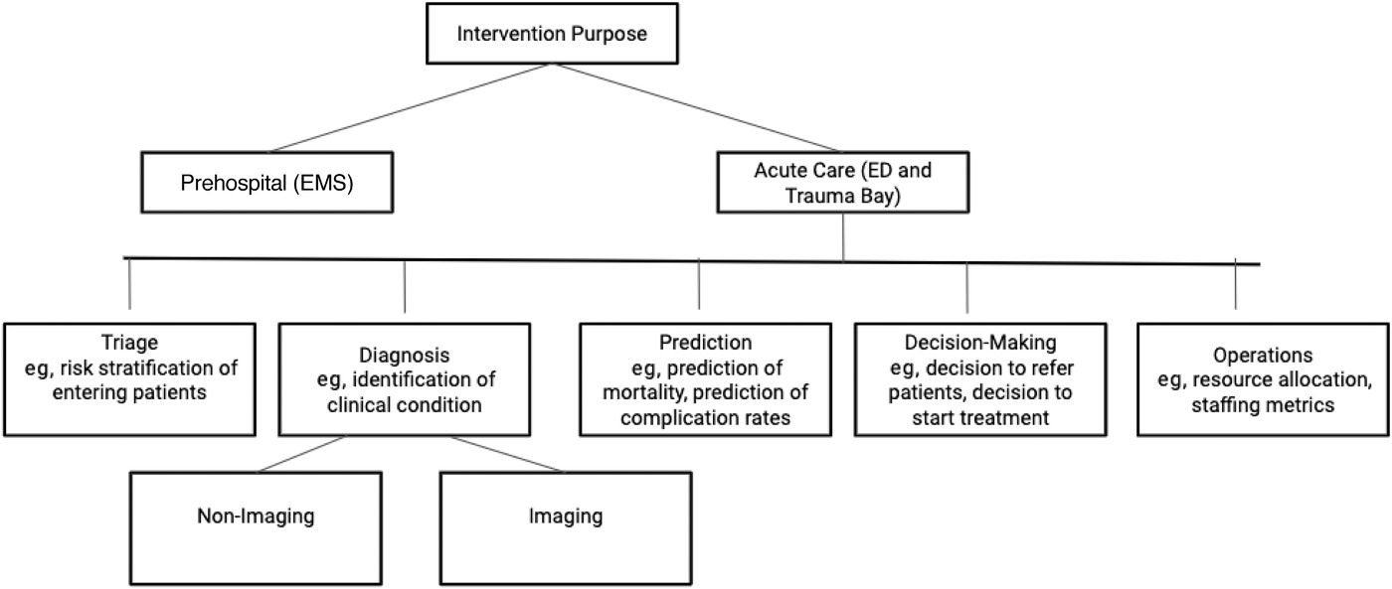
Fig: 1. Flow of information and AI
Future AI algorithms could be used to “data-mine” the electronic medical record to enable early diagnosis of complicated medical conditions, such as neutropenic fever, that require aggressive management and also help to choose appropriate antibiotic therapy. Other algorithms could be used to recognize early signs of shock requiring immediate stabilization .
The great advantage of machine learning systems is their ability to review medical record data from many thousands of patient encounters to identify significant associations and patterns that can guide diagnosis and treatment decisions. In recent years, EM practices have increasingly incorporated AI support systems, including some approved by the U.S. Food and Drug Administration. Examples include Critical Care Suite (GE Healthcare, Chicago, IL) and HealthPNX (Nanox, Neve Ilan, Israel), which assess chest radiographs for pneumothoraxes. Another example is BriefCase-ICH (Aidoc Medical, New York, NY) for analysis of noncontrast head computed tomography and notification of providers to assist with triage .
Considerations for implementing AI:
There are a few reasons why AI might be able to outperform human clinicians. For one, AI has the ability to process multiple variables simultaneously across large data sets. Humans often struggle when balancing numerous data points to predict outcomes, and our decision-making is often subject to biases and heuristics. In addition, AIs can take advantage of large data sets for stronger pattern recognition, which is particularly relevant in fields such as radiology. For example, an AI can process databases made of hundreds of thousands of radiographs and their reports, resulting in an algorithm that can accurately diagnose new radiographs based on pattern recognition. That’s one reason why there is a large focus on AI with radiology, such as the detection of fractures

How AI is Being Used for Triage
Triage is the ultimate in front line medical care, providing both the medical practitioner and patient with the coordinates they need to ensure that care is provided to the right person, on time. Against this backdrop artificial intelligence (AI) has become an increasingly powerful tool for emergency room triage. The algorithms and intelligence of AI have evolved significantly over the past few years to become more reliable and are designed to support physicians as they juggle increasingly challenging workloads. AI is using data sets and insights to create algorithms that are capable of identifying the different layers of patient triage so that physicians can ensure that patients are accurately categorized and cared for. This requires significant volumes of clean data that can be used to ensure that AI is not just capable, but also of value in an emergency room setting. This means that AI in triage has to follow rigorous process, testing and modeling to get the best results. AI entered into the daily clinical work of the radiology department to provide essential support for the practitioners managing extraordinary volumes of images. The solution is easy to use and fast, which is why it has been implemented on the emergency ward of the hospital. It has helped re-define department efficiency metrics and workload management. The implementation of AI in any medical situation has become highly specialized and certified. There are multiple applications of AI in triage in ED that range from apps designed for the patient to built-in AI algorithms that can be used to triage and manage patient care on the front line. Early identification of patients in the emergency department requiring admission may perhaps help in optimizing the hospital resources. In general, the prediction of patient admission to ward from the emergency department was based solely on the triage (demographics, vital signs, chief complaint, nursing notes, and early diagnostics). Triage-based prediction models include the Sydney Triage to Admission Risk Tool and the Glasgow Admission Prediction Score. The addition of historical information to triage information significantly improved predictive performance significantly vs. triage information alone.
Reducing the burden on ICU:
AI has immense potential in reducing the burden on the ED and the ICU. It can be used in telemedicine for proactive and predictive triage for remote patients or to keep patients remote until triage moves them to a different level of urgency, thereby limiting the spread of infection and ED influx. It can be used to manage patient fear as they are provided with high-level insight and support from remote locations without further risk to themselves or others.
This can also potentially ensure faster and more accurate triage, reducing pressure on the medical professional and allowing for patients in need of urgent care to receive it faster, thereby reducing the pressure on the ED. As it evolves it may become increasingly capable of providing a solid foundation for triage in ED, one that has the potential to minimize risk, improve accuracy, and reduce the burden on the ICU.

Legal Issues, Privacy, Confidentiality, and Big Data
Some of the points to ponder in application of AI are complex and have medico legal complexities. AI systems generate specific treatment recommendations and this need to be finally chosen by the emergency physician (EP) for implementation, however if EP lacks a clear understanding of the reasons for those recommendations or how to use the information in the ED context then that may delay, rather than expedite, patient care. A physician is liable for harm suffered by a patient only if the physician falls below the standard of care in treating the patient and breach of that standard is the proximate cause of the injury. Safest way to use medical AI under the current liability regimen is as a confirmatory tool to support existing decision-making processes rather than relying solely on AI to make treatment choices. If the use of AI is incorporated into the legal standard of care for a specific clinical situation, an injury caused by not following AI “recommendations” could result in compensable damages. One of the challenges of AI, however, is that it is dynamic and continually developing, often outpacing policies, protections, and legal guidance. However, there remain concerns regarding the use of AI and its implications for patient safety considering the limited body of evidence to support its implementation. Hence AI based on large pool of data will be universal and more clinically acceptable.
Any health care system have a fundamental professional duty to maintain patient confidentiality. With the advent of electronic data collection and transmission, there may be breach in the privacy of personal health care information .AI's reliance on large amounts of information, so-called “big data,” adds further complexity to the challenge of safeguarding patient confidentiality and privacy . Systems may use this information not only for patient benefit and quality improvement, but also for business and marketing purposes. The phenomenon of erroneous acceptance of an incorrect automatic interpretation is known as automation bias, which occurs when an overreliance on streamlined clinical processes leads to complacency and reduced vigilance in information seeking and processing. There extreme concerns and these groups have fear that machines will replace humans. A general acceptance is that AI is the integral part of the whole medical system and is here to stay.
.​​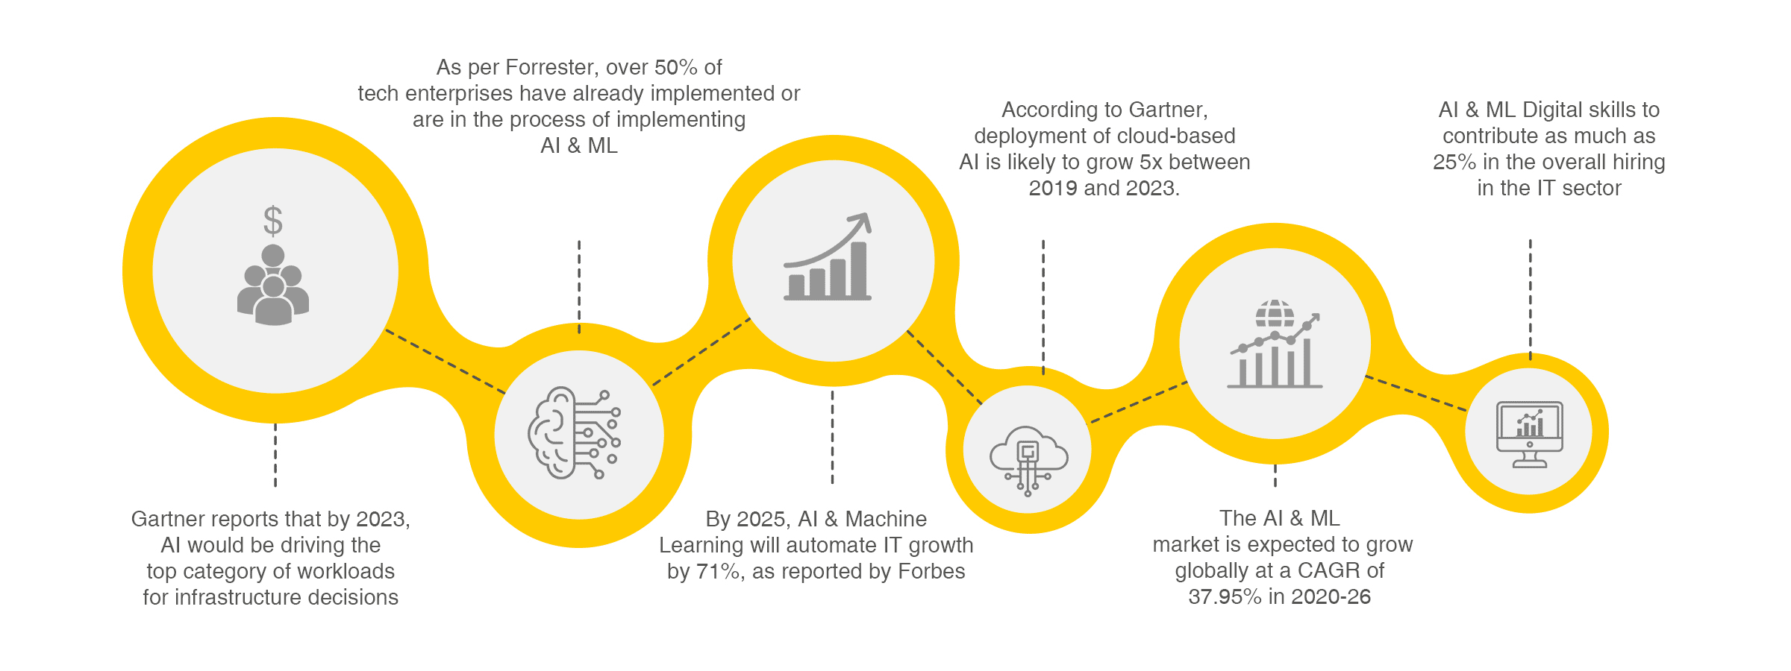
Fig:2, Projected progression in AI & ML in the years ahead.

DISCUSSION
Overall, it can be stated that AI interventions in the ED may help in optimize resource allocation in low-resource settings, classify computed tomography (CT) imaging, and predict hospital admission using electronic medical records (EMR). An emerging area of interest was radiology-focused AI interventions. Published literature has noted that radiology is particularly amenable to AI interventions because of its technology-driven interface, reliance on pattern recognition, and relative wealth of data sets available. As advances in automatic lesion detection and segmentation continue, it may help emergency medicine applications. Several studies showed AI outperformed existing decision tools and scoring systems that were originally derived using traditional statistical modeling. Examples include the superior ability of AI to predict mortality in pneumonia as well as calculate syncope risk based on clinical criteria. One explanation is that AI may be superior to humans in predictive modeling because of the ability to process multiple variables simultaneously across large data sets. AI given predictive power and ability to use various data points and predict outcomes. As such, we feel that AI will likely have a significant impact in the out-of-hospital setting as well.
Although AI appears superior to clinicians regarding predictive modeling, the current body of evidence still remains uncertain. Most studies identified did not involve a human comparator and lacked information on safety-oriented outcomes. By examining the breadth of the literature, it is clear that AI shows strong promise in improving outcome prediction in the ED. AI showed superiority over human comparators in several areas, particularly when analyzing large data sets and rapidly fluctuating variables. Further research should be conducted to determine further opportunities for predictive modeling within the ED, and particularly with comparisons to existing standards of care. Additional challenges surrounding AI include whether physicians and healthcare staff will have difficulty interfacing with AI-based tools, and whether errors will occur as a result of poor technological literacy. Future research must involve prospective controlled trials in order to determine true superiority, in addition to assessing costs, feasibility, and integration.

Recommendations
- AI is best understood as augmented intelligence that assists and enhances the skills and clinical judgement of specialty-trained EPs.
- EPs should exercise caution and use their own clinical skills to interpret the information and recommendations produced by AI systems.
- Professional societies and health care systems should develop policies to promote best practices in the use of AI in clinical care ,research and training.
- AI tools and applications should be evaluated with the same scientific rigor as other interventions prior to widespread implementation.
- Physicians should advocate for liability coverage that aligns with professional standards of care for the use of AI in EM.
- EPs should support regulations and legislation that protect patient confidentiality and privacy.
- EPs and their professional societies should continue to advocate for the central role of physicians in the provision of medical care. A nonphysician ED caregiver with an AI application may not provide care that is equivalent to—or as safe as—care provided by a specialty-trained, board-certified emergency physician.
- To lessen the potential for disastrous breaches of confidentiality and invasions of privacy, decoupling personal identifiers from the information subjected to AI analysis. Others methods to be adopted for de-identified information.
Concepts of machine learning should be incorporated into medical school curricula and that electives offer in-depth study of computer science. As AI technologies expand, the EM core curriculum will need to reflect the concepts that all trainees must master in this area. EM training programs and professional societies should encourage interested EPs to develop expertise in topics such as big data and machine learning. EPs with computer science expertise can provide guidance in the integration of AI into clinical practice and train others to have the appropriate literacy for this integration. EPs with interest and relevant skills should be involved in research and development of AI in EM for advancement of the field. Simulation education can help physicians integrate AI technology into clinical care and develop skills for its use . AI-related research is rapidly increasing in emergency medicine. Studies show promising opportunities for AI in diverse contexts, particularly regarding predictive modeling for patient outcomes. However, there remains uncertainty regarding their superiority over standard practice, and further research is needed before clinical implementation.
Summary :
The application of AI ranges from hospital administration to therapeutic decisions. It is changing the medical landscape. In AI, the algorithms are created in such a way that they can not only modify themselves in response to patterns in data set, they can also derive inferences when applied to new data. In lieu of availability of humongous data, several predictive models have been developed in the context of healthcare administration and operations; clinical decision support; predictions in healthcare; patient monitoring; and healthcare interventions. AI has been applied to predicting the flow of patients into the emergency department; streamlining patient flow to hospital; monitoring patients in ward and emergency department and predicting the availability of bed in in-patients. AI seems to be an ideal tool for optimizing patient management in hospitals. A wide range of AI algorithms are available for managing and predicting patient flow into the various departments of a hospital. Intelligence is defined by learning and reasoning. Learning is an essential element in AI and is realized through machine learning. Reasoning is another component of AI, which encompasses data manipulation to produce actions.

