Human Augmentation through IoT Smart Wearable Devices

Samuel Mores Geddam
Assistant Professor,
Presidency University,
Itgalpur, Bangalore 560 064,
Karnataka, India.
E-Mail: gsmorse1988@gmail.com
Phone: +91 7013397704

Dr. Anil B Gowda
Associate Professor,
Presidency University,
Itgalpur, Bangalore 560 064,
Karnataka, India.

Abstract:
Augmentation of Humans through digital technologies and wearable devices have opened a wide variety of opportunities to enhance the capabilities and performance of Humans. Assisted Wearable devices help to have enhanced understanding of the real world as they are supported with digital sensory stimulus, digital visual elements, which opens Augmented Reality (AR).

Keywords: Human Augmentation, IoT, Smart Devices, Wearable Devices

Introduction:
Humans are entwined with wearable augmented devices whether work or home. The concept of human augmentation as it shines could impact more productivity and well-being (Jarrahi, 2018). Human augmentation takes place with humans working in harmony with machine intelligence and technology to expand their capabilities to experience life more in more meaningful ways. The term ‘Augmented Humanity’ was first coined by the CEO of Google, Schmidt in 2010 and, called these converging phenomena as “the age of augmented humanity” (Gannes, Liz;, 2010). Augmentation happens through wearable smart devices which generate deep information cascades which are converted to meaningful data to augment humans to enhance their abilities (Stella, Cristoforetti, & Domenico, 2019). As AI technologies grow, there is more human-machine symbiosis which raised the division between humans and machines. This scenario has been shaping such that the mundane jobs shall be taken care of by machines and humans can focus on more creative jobs. Hence, AI is about to augment humans not replace them. This defines that AI is a tool for extending human capabilities (augmentation) rather not replacing them (automation) (Jarrahi, 2018). Wearable human augmented devices are no longer simply functional gadgets, but they are have become more or less like an extension to the human body (Nelson, Verhagen, & Vollenbroek-Hutten, 2019) and they offer direct interplay with the human mind (McCullagh, Lightbody, Zygierewicz, & Kernohan, 2014).
Types of Human Augmentation
Human Augmentation can be of three main categories based on its applications (Rangaiah, 2020)
- Replicating Human Ability – The human augmentation technology replicates natural and routine human abilities such as sensory abilities (Benssassi, Gomez, Boyd, Hayes, & Ye, 2018).
- Supplementing Human Ability – Human augmentation supplements human abilities such as sight, walking, etc. (Erat, Isop, Kalkofen, & Schmalstieg, 2018).
- Exceeding Human Ability – Human augmentation helps to carryout any phenomenon humans are physically limited naturally such as the ability to fly or breathe underwater, etc. such as (Gerez, Gao, Dwivedi, & Liarokapis, 2020)

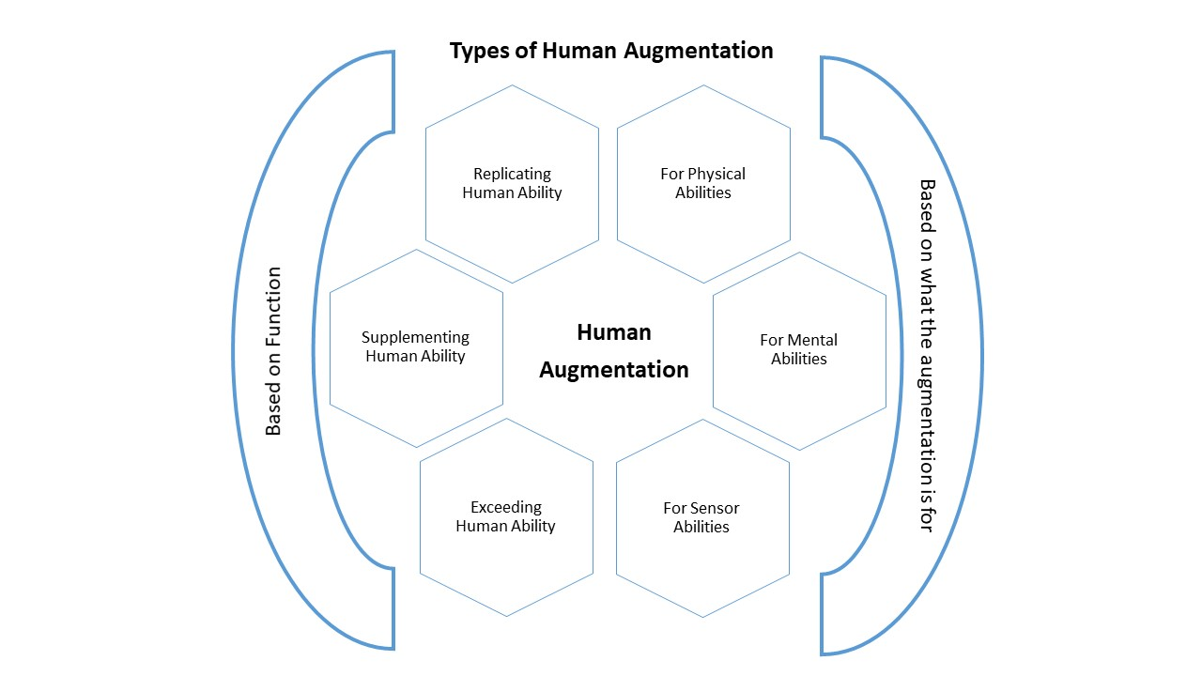
Picture: Types of Human Augmentation
Human Augmentation can be categorized based on what the augmentation is for
- Augmentation for Physical Abilities such as in (Stella, Cristoforetti, & Domenico, 2019) (Lee, Kwak, McLain, Kan, & Young, 2020) (O'Connell, et al., 2015)
- Augmentation for Mental Abilities such as in (Mohlman, et al., 2020)
- Augmentation for Sensor Abilities such as in (Gerez, Gao, Dwivedi, & Liarokapis, 2020)
The following table explains different categories of users and how the AH helps those users to get their work done.
User Type | Work done through Augmentation
Home User | - Surveillance  - Personal Accessories  - Interactive Gaming  - Outdoor navigation  - Virtual Coach  - Weight / Energy Check  - Chronic Disease Management  - Rescue Tracking  - Identity Recognition  - Emergency Services  - Emotional Response  - Self-Management  - Implants
Workers / Employee | - Working Support  - Posture Correction  - Shared Experience  - Identity recognition  - Meaningful insights derived from Analytics
Business Decision Makers / Managers | - Group Communication  - Data Analytics  - Decision Making Support  - Ubiquitous Media Access  - Data Processing  - Metaverse
Student / Youngsters | - Weight / Energy Check  - Sport Performance  - Interactive gaming  - Responsive Learning  - Personal Accessories  - Physical Expression  - Decorative Display / Fashion

The works mentioned for home users are also common for other users. For other users, the works that are specific for them are mentioned as they are a special category of users.
Applications of Human Augmentation in Business Setting:
It is very difficult to ascertain the possible applications of the Human Augmentation as there is no empirical data in this context. But certain assumptions can be made as to the managerial implications with respect to the human augmentations which has to be validated with a proper empirical study.
The augmented human with enhanced abilities shall have an advantage over those who are not augmented as the wearable augmented device give meaningful insights that are processed through Artificial Intelligence.
For an ordinary user, the advantages from the insights through the augmented devices shall be limited to personal management but when it comes to organization or human resources management, the insights are really helpful in better management. Human Augmentation shall contribute the management in the following areas as cited above
- Group Communication – Communication has a great impact at the work place with respect to work and efficiency. There shall be grey areas or blind spots which leads to misunderstandings and miscommunication. The communication shall be efficient when the workers at the are equipped with the augmented devices. Many scholars have emphasized the role of augmentation in communication. Some authors have coined the term ‘Augmentative Communication’ or ‘Alternative Communication’ for such communication (What is AAC? n.d.) (Light and McNaughton 2014). Augmentative communication is a great blessing for those who have speech defects or complex communication needs. Many potential candidates were not taken into jobs as they are not efficient communicators. In the era the people were screened based on the communication abilities, the human augmentation shall change the dynamics of recruitment and selection criteria in terms of communication abilities.
- Data Analytics – Collecting data is a very essential requirement for the data analytics. Data analytics plays an important role in execution of managerial functions. Data collection and readability of data through manual labels is very expensive and time consuming. Data collection through the augmented devices is very dynamic increases efficiency, accuracy, versatility and readability. It also helps in many other ways, for instance, data mining, data manipulation, slicing, etc. can be done with augmented data (Mi, et al. 2021).
- Decision Making Support - The real time data collected through augmented devices helps the business to be agile as the quick decision making is possible. Meaning decisions are possible as the augmented data can be tweaked and manipulated as per the requirements. This versatility shall not be there if the data is collected through the manual systems.
- Ubiquitous Media Access – Connecting the world with ubiquitous and access everywhere is the key for any business. It helps to develop solutions quick to the problems and take decisions quickly (Keengwe 2017).. The Ubiquitous Media access has provided the business to be more agile to grab the opportunities and resolve the problems quickly. The human augmentation provides the data quickly and the data access is possible anywhere at any time.
- Data Processing: The augmented devices with the support of AI provides data processing which saves a lot of time and money. It also provides for the data ready for execution of managerial functions. The AI and Machine Language technologies revolutionized the landscape and the Data analytics through them is providing competitive opportunities even for the small businesses by helping them to make smarter decisions (Myers 2019).
- Metaverse: This is an emerging technology which provides the participants a 3D world, allowing them creating virtual structures. This technology helps the business in many ways. It would help to have virtual business meets which saves lot of time and money over travel and other requirements for conducting business meets. It may provide virtual office space for organizing business activities. If the metaverse has to be implemented in the business setting, the augmented devices play a prominent role in the interactions among the business participants (Balis 2022).
Conclusion:
The human augmentation with the augmented devices is a very promising technology is in budding stage especially the business organizational are trying to figure out the applications that would help them to execute the business processes and application using the technology.
Many studies have proven that that some top companies started using the wearable devices to read the sensory information from the business participants especially employees to manage them. The new technologies such as Metaverse is very promising that it would change the landscape of business operations into the next level. Any digital technology without the digital augmented devices is no possible. The augmented devices are changing their shape and functionalities. Sky is the limit for the benefits that can be reaped with an appropriate use of the augmented wearable devices in the business setting.

References
Balis, J. (2022, January 03). How Brands Can Enter the Metaverse. Retrieved January 22, 2022, from hbr.org: https://hbr.org/2022/01/how-brands-can-enter-the-metaverse
Benssassi, E. M., Gomez, J.-C., Boyd, L. E., Hayes, G. R., & Ye, J. (2018). Wearable Assistive Technologies for Autism: Opportunities and Challenges. IEEE Pervasive Computing, 17(2), 11-21. doi:10.1109/MPRV.2018.022511239
Erat, O., Isop, W. A., Kalkofen, D., & Schmalstieg, D. (2018). Drone-Augmented human vision: Exocentric control for drones exploring hidden areas. IEEE Transactions on Visualization and Computer Graphics, 24(4), 1437-1446. doi:10.1109/TVCG.2018.2794058
Gannes, Liz;. (2010, September 7). Eric Schmidt: Welcome to “Age of Augmented Humanity”. Retrieved September 15, 2021, from gigaom.com: https://gigaom.com/2010/09/07/eric-schmidt-welcome-to-the-age-of-augmented-humanity/
Gerez, L., Gao, G., Dwivedi, A., & Liarokapis, M. (2020). A hybrid, wearable exoskeleton glove equipped with variable stiffness joints, abduction capabilities, and a telescopic thumb. IEEE Access, 8, 173345-173358. doi:10.1109/ACCESS.2020.3025273
Jarrahi, M. h. (2018). Artificial intelligence and the future of work: Human-AI symbiosis in organizational decision making. Business Horizons, 61(4), 577-586. doi:10.1016/j.bushor.2018.03.007
Keengwe, J. (2017). Handbook of Research on Mobile Technology, Constructivism, and Meaningful Learning. USA: University of North Dakota. Retrieved Jan 25, 2022, from https://www.igi-global.com/book/handbook-research-mobile-technology-constructivism/181918#table-of-contents
Lee, D., Kwak, E. C., McLain, B. J., Kan, I., & Young, A. J. (2020). Effects of Assistance during Early Stance Phase Using a Robotic Knee Orthosis on Energetics, Muscle Activity, and Joint Mechanics during Incline and Decline Walking. IEEE Transactions on Neural Systems and Rehabilitation Engineering, 28(4), 914-923. doi:10.1109/TNSRE.2020.2972323
Light, J., & McNaughton, D. (2014, Mar 10). Communicative Competence for Individuals who require Augmentative and Alternative Communication: A New Definition for a New Era of Communication? Augmentative and Alternative Communication, 30(1), 1-18. doi:10.3109/07434618.2014.885080
McCullagh, P., Lightbody, G., Zygierewicz, J., & Kernohan, W. G. (2014). Ethical challenges associated with the development and deployment of brain computer interface technology. Neuroethics, 7(2), 109-122. doi:10.1007/s12152-013-9188-6
Mi, Q., Xiao, Y., Cai, Z., & Jia, X. (2021, Jan). The effectiveness of data augmentation in code readability classification. Information and Software Technology, 129(106378). doi:10.1016/j.infsof.2020.106378
Mohlman, J. S., Leventhal, S. D., Hansen, T., Kohan, J., Pascucci, V., & Salama, M. E. (2020). Improving Augmented Human Intelligence to Distinguish Burkitt Lymphoma from Diffuse Large B-Cell Lymphoma Cases. American Journal of Clinical Pathology, 153(6), 743-759. doi:10.1093/AJCP/AQAA001
Myers, G. (2019, July 29). How Data Analysis Improve Decision Making. Retrieved January 25, 2022, from reflectivedata.com: https://reflectivedata.com/how-data-analysis-improve-decision-making/
Nelson, E. C., Verhagen, T., & Vollenbroek-Hutten, M. (2019). Is Wearable Technology Becoming Part of Us? Developing and Validating a Measurement Scale for Wearable Technology Embodiment. JMIR Mhealth Uhealth, 7(8). doi:10.2196/12771
O'Connell, S. G., Kerkvliet, N. I., Carozza, S., Rohlman, D., Pennington, J., & Anderson, K. A. (2015). In vivo contaminant partitioning to silicone implants: Implications for use in biomonitoring and body burden. Environment International, 85, 182-188. doi:10.1016/j.envint.2015.09.016
Rangaiah, M. (2020, May 09). An Introduction to Human Augmentation. Retrieved September 15, 2021, from analyticssteps.com: https://www.analyticssteps.com/blogs/introduction-human-augmentation
Stella, M., Cristoforetti, M., & Domenico, M. D. (2019). Influence of augmented humans in online interactions during voting events. PLoS ONE, 14(5). doi:10.1371/journal.pone.0214210
What is AAC? (n.d.). Retrieved Jan 22, 2022, from assistiveware.com: https://www.assistiveware.com/learn-aac/what-is-aac#:~:text=Communication%20devices%2C%20systems%2C%20strategies%20and,has%20difficulties%20communicating%20using%20speech.&text=Augmentative%20communication%20is%20when%20you%20add%20something%20to%20your%2

