**Fluorescent Carbon Quantum Dots for metal ion sensing**

Aayushi Kundu, Anushka Garg, Banibrata Maity*, Soumen Basu*

*School of Chemistry and Biochemistry, Affiliate Faculty—TIET-Virginia Tech Center of Excellence in Emerging Materials, Thapar Institute of Engineering and Technology, Patiala-147004, India*

*E-mail:* [*kunduaayushi@gmail.com*](mailto:kunduaayushi@gmail.com)*,* [*garg.anushka1996@gmail.com*](mailto:garg.anushka1996@gmail.com)

[*banibrata.maity@thapar.edu*](mailto:banibrata.maity@thapar.edu)*,* [*soumen.basu@thapar.edu*](mailto:soumen.basu@thapar.edu)

**ABSTRACT**

Fluorescent carbon quantum dots have gained much attention owing to their low-cost, biocompatibility, photostability, and low toxicity. The functionalization and surface passivation leads to the tuning of optical properties of carbon quantum dots (CQDs). Due to their desirable properties, they can be used in a plethora of applications. Top-down and Bottom-up are the two common broad approaches for the synthesis of CQDs. The synthesis method using green precursors can be attained using various methods like solvothermal/hydrothermal, microwave-assisted polymerization, and pyrolysis. The current chapter comprehensively discussed the applications of CQDs in the detection of metal ions.

**Keywords-** *carbon quantum dots*; *synthesis*; *metal ions*; *sensing*; *Cu2+*; *Fe3+*.

***Fluorescence*-**The emission of light by a substance that has absorbed light or other electromagnetic radiation. It occurs via emitting a longer wavelength than the absorbed wavelength.

***Photoluminescence-*** The process where a molecule absorbs a photon in the visible range, exciting one of its electrons ta o higher electronic state, then radiating a photon as the electron returns to a lower energy level.

1. **INTRODUCTION**

Concerns about global energy and the environment [1,2] have prompted the development of novel materials and techniques to reduce cost and environmental impacts [3]. To address the issue of sustainable nanomaterials production without the use of hazardous chemicals, it is vital to use environmentally benign and renewable raw materials. Luminescent carbon dots (graphene quantum dots and carbon quantum dots) have piqued the interest of researchers due to their potential uses in chemo- and biosensing [4], bio-labelling, cellular imaging, and nanomedical applications [5].

Carbon quantum dots (CQDs) are 0-dimensional carbon nanoparticles that are typically less than 10 nm in size. They are firstly discovered in the year 2004. The chemical composition of CQDs with numerous surface functionalization like oxygen and amino groups is strongly supported by their extraordinary properties. These functionalities have a considerable effect on photoluminescence activity and have increased the energy gap and surface energy level. They exhibit good photostability, highly tuneable photoluminescence, less toxicity, low cost, electrochemiluminescence, water solubility, and biocompatibility [6]. The suitability of light emission through carbon dots near the infrared range is particularly notable as light in this region has greater tissue penetration capability, and biological systems are transparent to these wavelengths. CQDs can be synthesized using two broad approaches: top-down and bottom-up [7] as shown in Figure 1. The “top-down” approach refers to the breakdown of large carbon macromolecules into smaller one with the help of hydrothermal treatment, microwave methods, electrochemical oxidation, solvothermal method, and ultrasonication. The “bottom-up” approach refers to carbonization or pyrolysis of small organic molecules [8]. The precursors utilized for CQDs synthesis such as carbon nanotubes, graphite, aromatic hydrocarbons are higher in cost and non-renewable. While the green synthesis using biomass materials is a cheaper, safer, and easier route. Utilizing waste and renewable material for the synthesis of CQDs is one step towards sustainable development [9]. The synthesis method using green precursors can be attained using various methods like solvothermal/hydrothermal, microwave-assisted polymerization, and pyrolysis. The Solvothermal method is a well-known process for fabricating CQDs followed by organic solvent extraction in which high carbon-yielding compounds are heated in high boiling point organic solvents before extraction and concentration. While, the hydrothermal carbonization is used for the preparation of self-passivated fluorescent CQDs in one-step. In this method organic precursor solution is sealed and reacted in the hydrothermal reactor at high temperature. Various green precursors including plants are used for the single step synthesis of CQDs. This method is non-toxic, cheap, and environment friendly method for the synthesis of CQDs. Microwave-assisted approach is a quick and economical way to synthesise CQDs as compared to other methods. In this method, carbon-based precursors can interact with microwave effectively because of effectual and localised heating. Pyrolysis or carbonization of carbon precursors comes under thermal decomposition method. This is more preferred approach for the fabrication as it includes simple operations, more precursor tolerance, less reaction time, solvent-free approach, inexpensive, and large-scale production. Also, optical properties can be altered using this method by changing reaction time, temperature, pH [10].



Figure 1: Schematic representation of the synthesis approach of CQDs.

1. **FLUORESCENCE PROPERTIES**

Significant optical absorption was observed in the ultraviolet range, which was then extended to the visible region. The region between 230-270 nm showed absorption due to p-p* transition of C=C bonds, whereas the peak shoulder in 300-390 nm range is due to the n-p* transition of C=O bonds [11]. The absorption peak variation can be modified between 270 nm to 390 nm based on the preparation methods of CQDs. Quantum-confinement effect [12] (QCE), surface-state emission [13], and molecular fluorescence are the different viewpoints for the origins of photoluminescence of CQDs.

Quantum-confinement effect is when the quantum dots are smaller than their exciton Bohr radius. It is a spatial confinement of electron-hole pairs also known as excitons in one or more dimension within a material. It contains discrete electronic energy levels. The optoelectronic features can be determined by shape and their size which can be altered. For instance, when CQDs were excited by photon of energy hn (n denotes the frequency of incident photon) which are comparatively larger in size, then they emit energy in wavelength of red or orange. While, the small size CQDs emits shorter wavelengths in green or blue range. Figure 2 depicts the variation in bandgap of CQDs as size changes. Surface state comprises the surface functional group and degree of surface oxidation. In the former one groups like C=O and C=N are associated with the fluorescence of CQDs. Sun and co-workers [14] inferred that the emission can be varied by varying the functional groups on the surface of CQDs. Degree of surface oxidation is also related to the CQDs fluorescence as the oxygen groups on the surface leads to red-shift of CQDs. More the degree of surface oxidation, more the number of surface defects which can trap excitons and ultimately their recombination causes red-shift [15]. Molecular fluorescence also contributes to the emission of CQDs. Baker’s et al. [16] demonstrated that the fluorescence impurities created as by-products of CQDs synthesis mostly responsible for PL emission by eliminating the molecular fluorophores. CQDs are photoluminescent irrespective of the synthesis method, but it depends on the different factors such as excitation, pH and solvent.

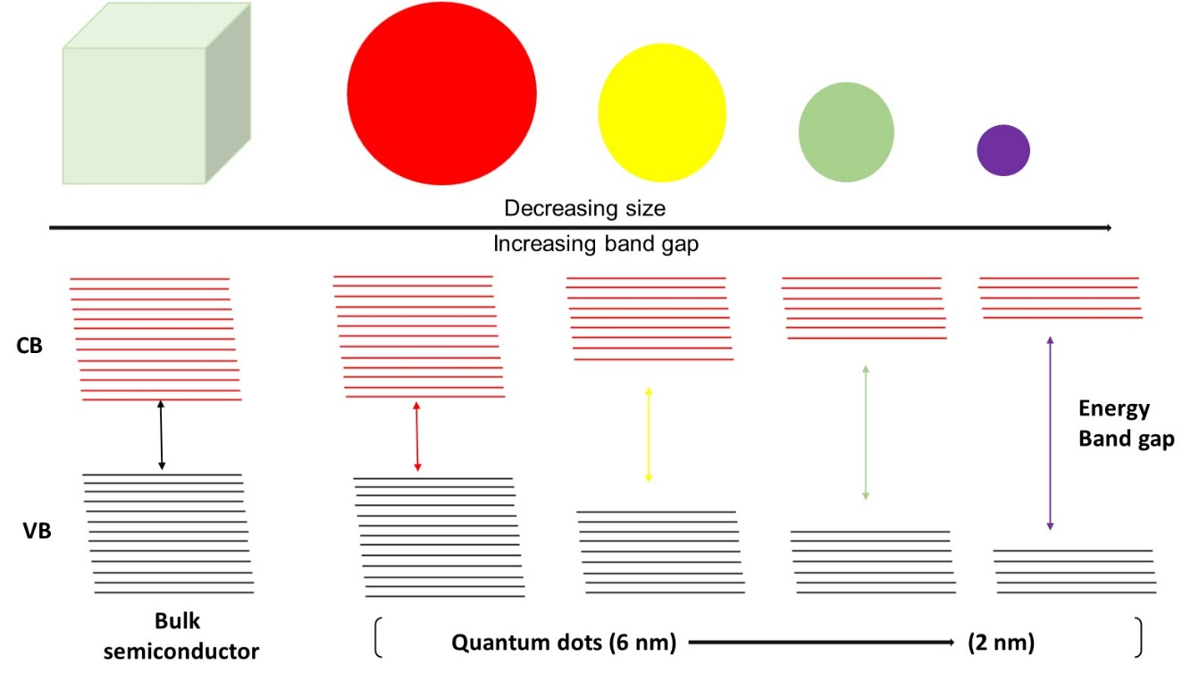

Figure 2: The energy band gap in quantum dots changes as size varied.

1. **SENSING APPLICATIONS**

CQDs are the promising candidates for the development of sensors with lot of merits. They have plethora of applications amid various fields as shown in Figure 3. In the upcoming section, the sensing of metal ions using CQDs are comprehensively discussed. As mentioned previously, CQDs showed the exceptional photoluminescence because of the specific functional groups, so that it shows the binding with the target analytes through the different interactions such as electrostatic, electron transfer, π-π conjugation. These ultimately leads to the PL quenching or restoration of CQDs. These fluorescence sensors also have a high selectivity, which means they can detect certain ions in a mixture of chemical species [17].

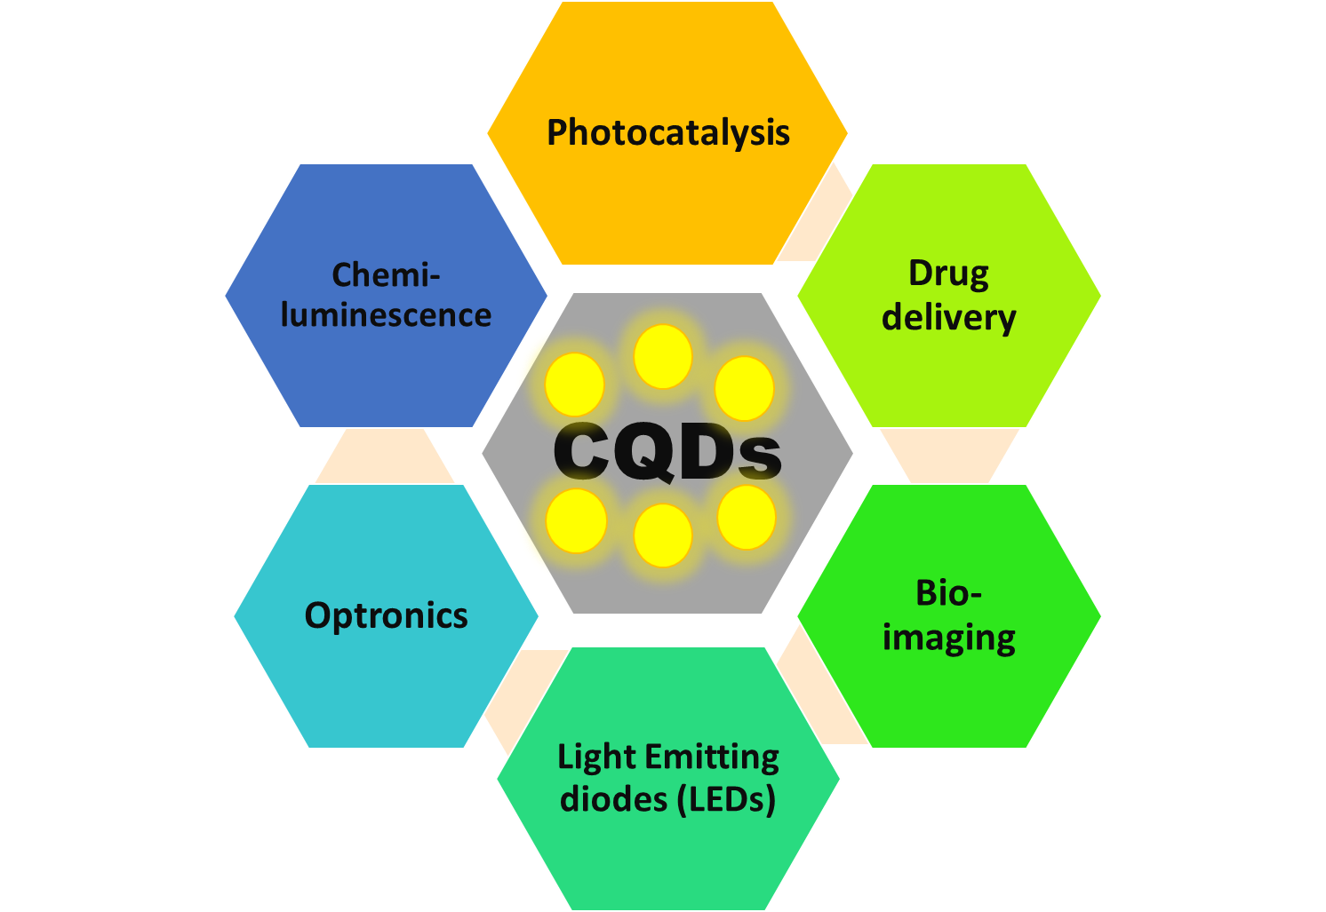

Figure 3: Various Sensing applications of CQDs.

**A. Metal ion sensing**

CQDs have been studied as fluorescent probes for the detection of metal ions. For the different metal ions like Cu2+, Fe3+, Ag+, Zn2+, Cd2+, and Co2+, sensors have been developed.

Xu et al. [18] prepared Carbon quantum dots with green luminescence by using bran and tartaric acid as a precursor. The synthesised CQDs were utilized as a fluorescent probe for Cu2+ detection with a detection limit of 0.0507 mM. Liu et al. [19] synthesized CQDs from hydrothermal method using bamboo leaves. The as-prepared CQDs exhibited high quantum yield (7.1%). The developed sensing system is a sensitive and reliable method for the detection of Cu2+ having detection limit of 115 nM within a range of 0.333-66.6 mM. Dong and co-workers [20] prepared polyamine-functionalized carbon quantum dots for the detection of Cu2+. They inferred that the strong quenching occurs because of the inner filter effect with a dynamic range of 10-1100 nM and a detection limit of 6 nM. They also tested it for a river water sample by the developed sensing system. Han et al. [21] fabricated carbon quantum dots using a hydrothermal method with o-phenlenediamine (OPD) and citric acid. The as-prepared CQDs acts a ratiometric fluorescent probe for the detection of Cu2+. The quenching of CQDs upon addition of Cu2+ is attributed to the Forster resonance energy transfer (FRET) which occurs between the CQDs and 2,3-diaminophenazine of OPD. The developed sensing system exhibited high sensitivity towards Cu2+ with a detection limit of 0.076 mmolL-1. They further used this system for the sensing of GSH having a detection limit of 0.30 mmolL-1.

Das et al. [22] prepared green emissive carbon quantum dots using a facile one-pot solvothermal method using pear juice. The as-prepared CQDs were used for the detection of Fe3+ and ascorbic acid using turn off-on strategy. The detection limit is 2.28 mM having a correlation coefficient of 0.989. Nan and co-workers [23] developed a fast spectrofluorimetric method for the detection of Fe (III) ions using carbon quantum dots modified with ZnO/CdS nanoparticles. The photoluminescence quenching with a detection limit of 1.72*10-7 M is attributed to strong interaction between the Fe (III) and CQDs/ZnO/CdS NPs. The quenching mechanism inferred was static quenching. They have also calculated different the value of entropy, enthalpy, and free energy from which they suggested that the quenching process was spontaneous and endothermic in nature. Wu and co-workers [24] fabricated nitrogen doped carbon quantum dots using microcrystalline cellulose as carbon source and ethylenediamine as nitrogen dopant via a hydrothermal method. The doping was confirmed using characterization techniques like FT-IR, XPS, TEM, and XRD. They were further used as a fluorescent probe for the detection of Fe3+. The CQDs exhibited higher quantum yield in acidic solution with a detection limit of 0.21 nM. The dynamic quenching mechanism was inferred using fluorescence decay time analysis.

Jiang et al. [25] synthesized N-doped hemi-cellulose-based carbon quantum dots (N-H-CQDs) using a green and straight forward solvothermal method. They have used it as off-on sensor for the ultrasensitive detection of Ag+ and L-Cysteine. The prepared sensor showed a high quantum yield of 23.45%. The detection of Ag+ is attributed to the complex formation between CQDs and Ag with a detection limit of 21 nM. The fluorescence restoration was achieved using cysteine with a LOD of 242 nM. The validation of the proposed method was done with real river water. Wang et al. [26] prepared a colorimetric nanosensor based on stable aggregation of gold nanoparticles with carbon quantum dots for the detection of Ag+ in glutathione presence. Their sensing strategy is based on the blue-red-blue or aggregation-dispersion-aggregation mode. The linear range for the detection is 100-4000 nM having a detection limit of 50 nM. The prepared sensor was also tested for the real sample detection in lake and tap water.

Dastidar et al. [27] synthesized carbon quantum dots using hydrothermal method from onion extracts. The prepared CQDs were used for the detection of Zn2+ in blood plasma. The fluorescence intensity was significantly increased in presence of Zn2+ in Tris buffer and blood plasma upon excitation at 325 nm. They exhibited quantum yield of 6.214% with a limit of quantification and detection limit of 21.3 mM and 6.4 mM, respectively. They have also calculated the affinity constant of CQDs and Zn2+ which was 600 M-1. Kaur et al. [28] prepared carbon quantum dots functionalized with Calix[4]arene using hydrothermal method for the detection of Zn2+ ions. The prepared carbon dots showed blue luminescence having quantum yield of 56%. The enhancement in the fluorescence intensity of carbon quantum dots were observed upon addition of Zn2+ ions which is due to the photo-induced electron transfer (PET). The detection limit was observed to be 7.34 nM. The real sample testing was also performed to validate the results.

Wang and co-workers [29] developed a fluorescent probe for the detection of Cd2+ using gold nanoclusters having red fluorescence as internal reference and with nitrogen and sulphur co-doped carbon quantum dots having blue fluorescence act as analysis signal molecule. Initially quenching was observed in between gold nanoclusters and quantum dots due to FRET effect. Then the Cd2+ interacts with gold nanoclusters and quantum dots forming stable complex and ultimately enhancement of fluorescence. They calculated the detection limit of Cd2+ in the linear range of 0-2.1 mM and a detection limit of 62 nM in tap water.

Various other researchers have also detected other metal ions like Hg2+[30], Cr6+[31], Co2+ [32]using fluorescent carbon quantum dots. Therefore, the carbon quantum dots are the promising candidate for the facile, low-cost, rapid, and efficient detection of metal ions.

**CONCLUSIONS**

CQDs, zero-dimension materials and presented a new outlook with numerous properties and applications in the various fields. CQDs displayed tuneable properties like size, heteroatom doping, chemical functionalization, edge states that resulted into the rise of exceptional applications. With the other nanomaterials, CQDs can also acquire composite nature due to the extensive and easy functionalization. It plays a significant role in designing of sensors and biosensor. The current chapter expansively discussed their applications for metal ions detection.

**ACKNOWLEDGEMENTS**

Aayushi Kundu and Anushka Garg are thankful to TIET-Virginia Tech Center of excellence in emerging materials for the fellowship.

**REFERENCES**

[1] A. Kundu, S. Basu, Microplastics and Nanoplastics in Aquatic Environment: Challenges and Threats to Aquatic Organisms, in: Assess. Eff. Emerg. Plast. Environ. Public Heal., IGI Global, 2022: pp. 71–89.

[2] A. Kundu, N.P. Shetti, S. Basu, K.R. Reddy, M.N. Nadagouda, T.M. Aminabhavi, Identification and removal of micro-and nano-plastics: Efficient and cost-effective methods, Chem. Eng. J. (2021) 129816.

[3] S. Sharma, A. Kundu, S. Basu, N.P. Shetti, T.M. Aminabhavi, Sustainable environmental management and related biofuel technologies, J. Environ. Manage. 273 (2020) 111096.

[4] A. Kundu, B. Maity, S. Basu, Coal-derived graphene quantum dots with a Mn2+/Mn7+ nanosensor for selective detection of glutathione by a fluorescence switch-off-on assay, New J. Chem. 46 (2022) 7545–7556. https://doi.org/10.1039/d2nj00220e.

[5] P. Devi, S. Saini, K.-H. Kim, The advanced role of carbon quantum dots in nanomedical applications, Biosens. Bioelectron. 141 (2019) 111158.

[6] N. Sohal, B. Maity, S. Basu, Carbon Dot-MnO2Nanosphere Composite Sensors for Selective Detection of Glutathione, ACS Appl. Nano Mater. 3 (2020) 5955–5964. https://doi.org/10.1021/acsanm.0c01088.

[7] D. Yoo, Y. Park, B. Cheon, M.-H. Park, Carbon dots as an effective fluorescent sensing platform for metal ion detection, Nanoscale Res. Lett. 14 (2019) 1–13.

[8] X.T. Zheng, A. Ananthanarayanan, K.Q. Luo, P. Chen, Glowing graphene quantum dots and carbon dots: properties, syntheses, and biological applications, Small. 11 (2015) 1620–1636.

[9] M.L. Liu, B. Bin Chen, C.M. Li, C.Z. Huang, Carbon dots: synthesis, formation mechanism, fluorescence origin and sensing applications, Green Chem. 21 (2019) 449–471.

[10] R.M. El-Shabasy, M. Farouk Elsadek, B. Mohamed Ahmed, M. Fawzy Farahat, K.N. Mosleh, M.M. Taher, Recent developments in carbon quantum dots: properties, fabrication techniques, and bio-applications, Processes. 9 (2021) 388.

[11] Y. Wang, S. Kalytchuk, Y. Zhang, H. Shi, S. V Kershaw, A.L. Rogach, Thickness-dependent full-color emission tunability in a flexible carbon dot ionogel, J. Phys. Chem. Lett. 5 (2014) 1412–1420.

[12] S. Kim, S.W. Hwang, M.-K. Kim, D.Y. Shin, D.H. Shin, C.O. Kim, S.B. Yang, J.H. Park, E. Hwang, S.-H. Choi, Anomalous behaviors of visible luminescence from graphene quantum dots: interplay between size and shape, ACS Nano. 6 (2012) 8203–8208.

[13] L. Bao, C. Liu, Z. Zhang, D. Pang, Photoluminescence‐tunable carbon nanodots: surface‐state energy‐gap tuning, Adv. Mater. 27 (2015) 1663–1667.

[14] L. Wang, S.-J. Zhu, H.-Y. Wang, S.-N. Qu, Y.-L. Zhang, J.-H. Zhang, Q.-D. Chen, H.-L. Xu, W. Han, B. Yang, Common origin of green luminescence in carbon nanodots and graphene quantum dots, ACS Nano. 8 (2014) 2541–2547.

[15] L. Bao, Z.L. Zhang, Z.Q. Tian, L. Zhang, C. Liu, Y. Lin, B. Qi, D.W. Pang, Electrochemical tuning of luminescent carbon nanodots: From preparation to luminescence mechanism, Adv. Mater. 23 (2011) 5801–5806. https://doi.org/10.1002/adma.201102866.

[16] J.B. Essner, J.A. Kist, L. Polo-Parada, G.A. Baker, Artifacts and errors associated with the ubiquitous presence of fluorescent impurities in carbon nanodots, Chem. Mater. 30 (2018) 1878–1887.

[17] M.J. Molaei, Principles, mechanisms, and application of carbon quantum dots in sensors: a review, Anal. Methods. 12 (2020) 1266–1287.

[18] J. Xu, C. Wang, H. Li, W. Zhao, Synthesis of green-emitting carbon quantum dots with double carbon sources and their application as a fluorescent probe for selective detection of Cu 2+ ions, RSC Adv. 10 (2020) 2536–2544.

[19] Y. Liu, Y. Zhao, Y. Zhang, One-step green synthesized fluorescent carbon nanodots from bamboo leaves for copper (II) ion detection, Sensors Actuators B Chem. 196 (2014) 647–652.

[20] Y. Dong, R. Wang, G. Li, C. Chen, Y. Chi, G. Chen, Polyamine-functionalized carbon quantum dots as fluorescent probes for selective and sensitive detection of copper ions, Anal. Chem. 84 (2012) 6220–6224.

[21] Z. Han, D. Nan, H. Yang, Q. Sun, S. Pan, H. Liu, X. Hu, Carbon quantum dots based ratiometric fluorescence probe for sensitive and selective detection of Cu2+ and glutathione, Sensors Actuators, B Chem. 298 (2019) 126842. https://doi.org/10.1016/j.snb.2019.126842.

[22] G.S. Das, J.P. Shim, A. Bhatnagar, K.M. Tripathi, T. Kim, Biomass-derived carbon quantum dots for visible-light-induced photocatalysis and label-free detection of Fe (III) and ascorbic acid, Sci. Rep. 9 (2019) 1–9.

[23] Z. Nan, C. Hao, X. Zhang, H. Liu, R. Sun, Carbon quantum dots (CQDs) modified ZnO/CdS nanoparticles based fluorescence sensor for highly selective and sensitive detection of Fe(III), Spectrochim. Acta - Part A Mol. Biomol. Spectrosc. 228 (2020) 117717. https://doi.org/10.1016/j.saa.2019.117717.

[24] P. Wu, W. Li, Q. Wu, Y. Liu, S. Liu, Hydrothermal synthesis of nitrogen-doped carbon quantum dots from microcrystalline cellulose for the detection of Fe 3+ ions in an acidic environment, RSC Adv. 7 (2017) 44144–44153.

[25] X. Jiang, J. Huang, T. Chen, Q. Zhao, F. Xu, X. Zhang, Synthesis of hemicellulose/deep eutectic solvent based carbon quantum dots for ultrasensitive detection of Ag+ and L-cysteine with “off-on” pattern, Int. J. Biol. Macromol. 153 (2020) 412–420.

[26] F. Wang, Y. Lu, Y. Chen, J. Sun, Y. Liu, Colorimetric nanosensor based on the aggregation of AuNP triggered by carbon quantum dots for detection of Ag+ ions, ACS Sustain. Chem. Eng. 6 (2018) 3706–3713.

[27] D.G. Dastidar, P. Mukherjee, D. Ghosh, D. Banerjee, Carbon quantum dots prepared from onion extract as fluorescence turn-on probes for selective estimation of Zn2+ in blood plasma, Colloids Surfaces A Physicochem. Eng. Asp. 611 (2021) 125781.

[28] H. Kaur, P. Raj, H. Sharma, M. Verma, N. Singh, N. Kaur, Highly selective and sensitive fluorescence sensing of nanomolar Zn2+ ions in aqueous medium using Calix [4] arene passivated Carbon Quantum Dots based on fluorescence enhancement: Real-time monitoring and intracellular investigation, Anal. Chim. Acta. 1009 (2018) 1–11.

[29] X. Wang, Q. Duan, B. Zhang, X. Cheng, S. Wang, S. Sang, Ratiometric fluorescence detection of Cd2+ based on N, S co-doped carbon quantum dots/Au nanoclusters, Microchem. J. 167 (2021) 106269.

[30] R. Zhang, W. Chen, Nitrogen-doped carbon quantum dots: Facile synthesis and application as a “turn-off” fluorescent probe for detection of Hg2+ ions, Biosens. Bioelectron. 55 (2014) 83–90.

[31] Y. Wang, X. Hu, W. Li, X. Huang, Z. Li, W. Zhang, X. Zhang, X. Zou, J. Shi, Preparation of boron nitrogen co-doped carbon quantum dots for rapid detection of Cr (VI), Spectrochim. Acta Part A Mol. Biomol. Spectrosc. 243 (2020) 118807.

[32] Y. Wu, Y. Liu, J. Yin, H. Li, J. Huang, Facile ultrasonic synthesized NH2-carbon quantum dots for ultrasensitive Co2+ ion detection and cell imaging, Talanta. 205 (2019) 120121.

[1] A. Kundu, S. Basu, Microplastics and Nanoplastics in Aquatic Environment: Challenges and Threats to Aquatic Organisms, in: Assess. Eff. Emerg. Plast. Environ. Public Heal., IGI Global, 2022: pp. 71–89.

[2] A. Kundu, N.P. Shetti, S. Basu, K.R. Reddy, M.N. Nadagouda, T.M. Aminabhavi, Identification and removal of micro-and nano-plastics: Efficient and cost-effective methods, Chem. Eng. J. (2021) 129816.

[3] S. Sharma, A. Kundu, S. Basu, N.P. Shetti, T.M. Aminabhavi, Sustainable environmental management and related biofuel technologies, J. Environ. Manage. 273 (2020) 111096.

[4] A. Kundu, B. Maity, S. Basu, Coal-derived graphene quantum dots with a Mn2+/Mn7+ nanosensor for selective detection of glutathione by a fluorescence switch-off-on assay, New J. Chem. 46 (2022) 7545–7556. https://doi.org/10.1039/d2nj00220e.

[5] P. Devi, S. Saini, K.-H. Kim, The advanced role of carbon quantum dots in nanomedical applications, Biosens. Bioelectron. 141 (2019) 111158.

[6] N. Sohal, B. Maity, S. Basu, Carbon Dot-MnO2Nanosphere Composite Sensors for Selective Detection of Glutathione, ACS Appl. Nano Mater. 3 (2020) 5955–5964. https://doi.org/10.1021/acsanm.0c01088.

[7] D. Yoo, Y. Park, B. Cheon, M.-H. Park, Carbon dots as an effective fluorescent sensing platform for metal ion detection, Nanoscale Res. Lett. 14 (2019) 1–13.

[8] X.T. Zheng, A. Ananthanarayanan, K.Q. Luo, P. Chen, Glowing graphene quantum dots and carbon dots: properties, syntheses, and biological applications, Small. 11 (2015) 1620–1636.

[9] M.L. Liu, B. Bin Chen, C.M. Li, C.Z. Huang, Carbon dots: synthesis, formation mechanism, fluorescence origin and sensing applications, Green Chem. 21 (2019) 449–471.

[10] R.M. El-Shabasy, M. Farouk Elsadek, B. Mohamed Ahmed, M. Fawzy Farahat, K.N. Mosleh, M.M. Taher, Recent developments in carbon quantum dots: properties, fabrication techniques, and bio-applications, Processes. 9 (2021) 388.

[11] Y. Wang, S. Kalytchuk, Y. Zhang, H. Shi, S. V Kershaw, A.L. Rogach, Thickness-dependent full-color emission tunability in a flexible carbon dot ionogel, J. Phys. Chem. Lett. 5 (2014) 1412–1420.

[12] S. Kim, S.W. Hwang, M.-K. Kim, D.Y. Shin, D.H. Shin, C.O. Kim, S.B. Yang, J.H. Park, E. Hwang, S.-H. Choi, Anomalous behaviors of visible luminescence from graphene quantum dots: interplay between size and shape, ACS Nano. 6 (2012) 8203–8208.

[13] L. Bao, C. Liu, Z. Zhang, D. Pang, Photoluminescence‐tunable carbon nanodots: surface‐state energy‐gap tuning, Adv. Mater. 27 (2015) 1663–1667.

[14] L. Wang, S.-J. Zhu, H.-Y. Wang, S.-N. Qu, Y.-L. Zhang, J.-H. Zhang, Q.-D. Chen, H.-L. Xu, W. Han, B. Yang, Common origin of green luminescence in carbon nanodots and graphene quantum dots, ACS Nano. 8 (2014) 2541–2547.

[15] L. Bao, Z.L. Zhang, Z.Q. Tian, L. Zhang, C. Liu, Y. Lin, B. Qi, D.W. Pang, Electrochemical tuning of luminescent carbon nanodots: From preparation to luminescence mechanism, Adv. Mater. 23 (2011) 5801–5806. https://doi.org/10.1002/adma.201102866.

[16] J.B. Essner, J.A. Kist, L. Polo-Parada, G.A. Baker, Artifacts and errors associated with the ubiquitous presence of fluorescent impurities in carbon nanodots, Chem. Mater. 30 (2018) 1878–1887.

[17] M.J. Molaei, Principles, mechanisms, and application of carbon quantum dots in sensors: a review, Anal. Methods. 12 (2020) 1266–1287.

[18] J. Xu, C. Wang, H. Li, W. Zhao, Synthesis of green-emitting carbon quantum dots with double carbon sources and their application as a fluorescent probe for selective detection of Cu 2+ ions, RSC Adv. 10 (2020) 2536–2544.

[19] Y. Liu, Y. Zhao, Y. Zhang, One-step green synthesized fluorescent carbon nanodots from bamboo leaves for copper (II) ion detection, Sensors Actuators B Chem. 196 (2014) 647–652.

[20] Y. Dong, R. Wang, G. Li, C. Chen, Y. Chi, G. Chen, Polyamine-functionalized carbon quantum dots as fluorescent probes for selective and sensitive detection of copper ions, Anal. Chem. 84 (2012) 6220–6224.

[21] Z. Han, D. Nan, H. Yang, Q. Sun, S. Pan, H. Liu, X. Hu, Carbon quantum dots based ratiometric fluorescence probe for sensitive and selective detection of Cu2+ and glutathione, Sensors Actuators, B Chem. 298 (2019) 126842. https://doi.org/10.1016/j.snb.2019.126842.

[22] G.S. Das, J.P. Shim, A. Bhatnagar, K.M. Tripathi, T. Kim, Biomass-derived carbon quantum dots for visible-light-induced photocatalysis and label-free detection of Fe (III) and ascorbic acid, Sci. Rep. 9 (2019) 1–9.

[23] Z. Nan, C. Hao, X. Zhang, H. Liu, R. Sun, Carbon quantum dots (CQDs) modified ZnO/CdS nanoparticles based fluorescence sensor for highly selective and sensitive detection of Fe(III), Spectrochim. Acta - Part A Mol. Biomol. Spectrosc. 228 (2020) 117717. https://doi.org/10.1016/j.saa.2019.117717.

[24] P. Wu, W. Li, Q. Wu, Y. Liu, S. Liu, Hydrothermal synthesis of nitrogen-doped carbon quantum dots from microcrystalline cellulose for the detection of Fe 3+ ions in an acidic environment, RSC Adv. 7 (2017) 44144–44153.

[25] X. Jiang, J. Huang, T. Chen, Q. Zhao, F. Xu, X. Zhang, Synthesis of hemicellulose/deep eutectic solvent based carbon quantum dots for ultrasensitive detection of Ag+ and L-cysteine with “off-on” pattern, Int. J. Biol. Macromol. 153 (2020) 412–420.

[26] F. Wang, Y. Lu, Y. Chen, J. Sun, Y. Liu, Colorimetric nanosensor based on the aggregation of AuNP triggered by carbon quantum dots for detection of Ag+ ions, ACS Sustain. Chem. Eng. 6 (2018) 3706–3713.

[27] D.G. Dastidar, P. Mukherjee, D. Ghosh, D. Banerjee, Carbon quantum dots prepared from onion extract as fluorescence turn-on probes for selective estimation of Zn2+ in blood plasma, Colloids Surfaces A Physicochem. Eng. Asp. 611 (2021) 125781.

[28] H. Kaur, P. Raj, H. Sharma, M. Verma, N. Singh, N. Kaur, Highly selective and sensitive fluorescence sensing of nanomolar Zn2+ ions in aqueous medium using Calix [4] arene passivated Carbon Quantum Dots based on fluorescence enhancement: Real-time monitoring and intracellular investigation, Anal. Chim. Acta. 1009 (2018) 1–11.

[29] X. Wang, Q. Duan, B. Zhang, X. Cheng, S. Wang, S. Sang, Ratiometric fluorescence detection of Cd2+ based on N, S co-doped carbon quantum dots/Au nanoclusters, Microchem. J. 167 (2021) 106269.

[30] R. Zhang, W. Chen, Nitrogen-doped carbon quantum dots: Facile synthesis and application as a “turn-off” fluorescent probe for detection of Hg2+ ions, Biosens. Bioelectron. 55 (2014) 83–90.

[31] Y. Wang, X. Hu, W. Li, X. Huang, Z. Li, W. Zhang, X. Zhang, X. Zou, J. Shi, Preparation of boron nitrogen co-doped carbon quantum dots for rapid detection of Cr (VI), Spectrochim. Acta Part A Mol. Biomol. Spectrosc. 243 (2020) 118807.

[32] Y. Wu, Y. Liu, J. Yin, H. Li, J. Huang, Facile ultrasonic synthesized NH2-carbon quantum dots for ultrasensitive Co2+ ion detection and cell imaging, Talanta. 205 (2019) 120121.