EVIDENCED BASED PRACTICE (EBP)
Author details
Meeksmita sahu. MSc. Tutor. SUM Nursing College. Siksha ‘O’ Anusandhan (Deemed to be University)
Email ID: meeksmita@gmail.com
Phone no. 9535937751
Editor Id: IIPER1655891646
Introduction
Evidenced based practice is merely a clinical practice of patient care which is based on scientific evidence. It requires a lots of research update and clinical expertise to develop a scientific rationale. Evidenced based practice helps the health care provider to render high quality care, which leads to higher patient satisfaction. EBP is a problem-solving approach. It requires in-depth knowledge about EBP and to implement this in to clinical practice. This is still a challenge for many health care providers as it requires computer and internet skills.
Definition
- EBP is a process used to review, analyse, and translate the latest scientific evidence. The goal is to quickly incorporate the best available research, along with clinical experience and patient preference, into clinical practice, so nurses can make informed patient-care decisions (Dang et al., 2022).
- Evidence-based practice attempts to bridge this gap by incorporating a review of the current published research, along with the practitioner's own expertise and the patient's preferences. The goal is to help practitioners make informed and personalized treatment-based decisions and deliver the highest quality health care to their patients. (John Hopkins University)
- EBP involves integrating the best available evidence with clinical knowledge and expertise, while considering patients’ unique needs and personal preferences. If used consistently, optimal patient outcomes are more likely to be achieved. (W. Barbar et al.)
- Evidence-based practice is defined as a problem-solving and decision-making approach in practice that involves the conscientious use of current best (research) evidence, clinical expertise, & patient preferences. Evidence-based practice involves critical appraisal of information used to answer a clinical question. (Waite R et.al.)
- Evidence based practice (EBP) is 'the integration of best research evidence with clinical expertise and patient values', which when applied by practitioners will ultimately lead to improved patient outcome. (Physiopedia)
Components of Evidenced Based Practice

Clinical Experience
Clinical experience in specific field is most necessary to build a scientific base for any intervention. Practice over years in specific department leads to expertise and in-depth knowledge about the intervention and clinical condition. Experience leads to perfection in patient care and which leads to better satisfaction.
Research Evidence
Research evidence work as specific guide for any intervention planned in clinical setup. A wide range of scientific literature helps to build better scientific evidence. Continuous research studies must be carried out to provide a better scientific body of knowledge to the existing literature.
Patient Preferences
It is utmost priority of all the health care workers to safe guard the patient’s right. Health care provider need to prioritize patient preference at the top while rendering any sort of care to the patients. The process of doing so in the clinical practice leads to better satisfaction and clinical outcome.
Models of Evidenced Based Practice
In terms of patient care John Hopkins and Iowa models are preferred for evidenced based practice.
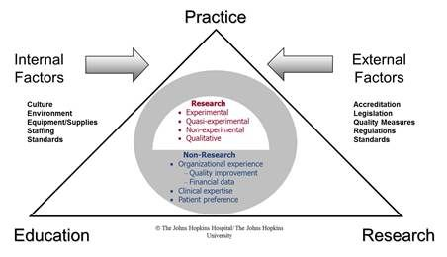
(John Hopkins EBP MODEL on Patient care)
- John Hopkins model for Evidenced based practice works as a tool for best clinical practice. Leadership skills, training and research also important part in that model. Health care providers like Nurses can use the model.
- This model is a problem-solving approach which is used in clinical decision making. This can be used by practicing nurse. For using this it can be done by three steps process called PET (Practice question, evidence and translation).
- Steps comprise of selecting a set of practice questions and to find out the possible evidence to answer the questions. Lastly translate the evidence to practice.
- The main goal of this model is to select the latest research findings and to incorporate this in to clinical practice.
Advantages of John Hopkins EBP model in clinical practice
- It helps the care givers in thorough assessment of the patients
- It helps the care givers to think critically and identify some sets of problems
- After setting a set of problems the care giver prepares some practice questions based on the problems existing problems in the patients.
- The care giver searches for scientific evidences to solve those problems.
- After solving those problems care giver explains and record those interventions.
- It helps to develop better rapport with the patients.
- It also helps in achieving patient satisfaction.
- Provides a better treatment outcome.

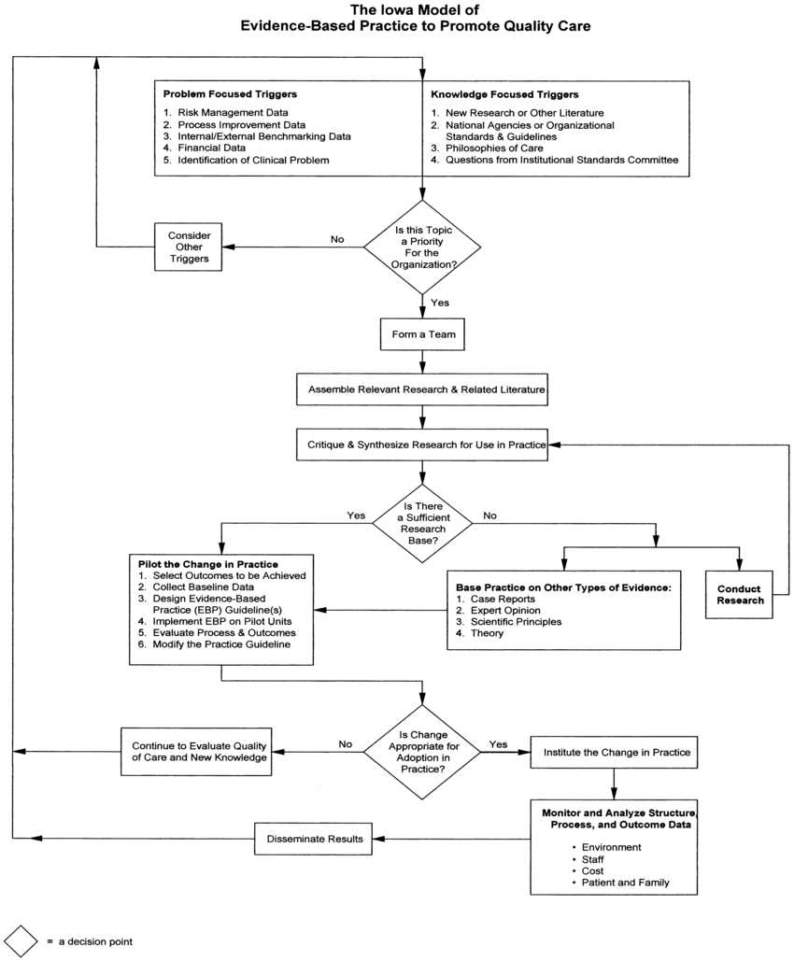

(The iowa model of evidenced based practice)
- The Iowa model of evidenced based practice is based on critical thinking aspect of health care provider.
- Critical thinking can be broadly divided in problem focused trigger and knowledge focused trigger.
- In problem focused trigger the physical problems seen in the patients are considered and the knowledge focused trigger the health care provider expected to search for the possible scientific research literature and to set few questions to solve through out the process of problem solving.
- After considering any other trigger in the process the care provider prioritizes the existing problems and form a team of experts having similar expertise.
- All the team members are expected to assemble related research literature. They set some specific problem for further research after considering the critics of all the team member.
- While conducting the research, team members look for various types of evidences and evaluate the research findings by comparing with the base line data.
- Still the result needs to be evaluated in terms of quality of care and new knowledge. And at last, after a thorough explanation about the need of the change to be made, the final result is disseminated for clinical practice.
- While incorporating the result in practice, a proper monitor needs to be done on the process and outcome data.
Advantages of iowa model of evidenced based practice
- Both subjective and objective data can be well assessed by using iowa model of EBP.
- The problem-solving process becomes more accurate as a team of experts works together.
- When the result is disseminated into practice further the result is evaluated for outcome.
Limitations
- It’s a time-consuming process.
- There is a need of manpower while building a team.

Process of Evidenced Based Practice
The process of Evidenced based practice can be best explained by the following 6 steps.

(Process of Evidenced based practice)
- Assess – This step starts with a thorough assessment of the patient condition to find out the clinical problem.
- Ask - After assessing the patient condition and clinical questions are formed.
- Acquire – Appropriate evidences are searched to answer the questions.
- Appraise – Best evidences are appraised for validation and applicability into clinical practice.
- Apply - The validated evidence is then incorporated into clinical practice based on the clinical expertise of the care giver and patient preference.
- Evaluate – In this stage patient outcome is evaluated in relation to the care giver’s performance.
Benefits of Evidenced Based Practice
- Different treatment options can be assessed at a time.
- Over all patient condition is assessed to gather all the information regarding the patient problem.
- Treatment outcome is good in comparison to the traditional method.
- Evidenced based practice plays a pivotal role in the use of health resources while considering relevant evidences.
- Thorough research helps in reformation of the clinical guidelines.
Myth related to Evidenced Based Practice
Many health care providers assume EBP is not convenient to incorporate into clinical practice, and the reason to this can be listed as a myth related to EBP.
- Always it requires a team to practice EBP in patient care.
- EBP always a time-consuming process.
- There is a need of autonomy for the care giver in practicing EBP.
- Health resources like funding is required to practice EBP.
- EBP cannot replace the traditional practice in terms of hands-on practice.
Conclusion
As Evidenced Based Practice is a problem-solving process, it requires a clinical expertise and personal interest to search for best evidences. Clinical decision-making in-patient care becomes easier and safer by the use of EBP. EBP is purely extensive research of some existing evidences. Practice of EBP also helps in synthesizing guidelines, standards, protocols and policies to direct the implementation of a variety of health practice and interventions, which ultimately helps in better treatment outcome.
References
- Sackett DL, Rosenberg WMC, Gray JAM, Haynes RB, Richardson WS: Evidence based medicine: what it is and what it isn’t. BMJ 1996;312:71-2
- EBP Process. Accessed at https://www.eboptometry.com/content/optometry/ebp-resource/practitioners-students-teachers/ebp-process-0 on 25 March 2015
- https://oxford-review.com/oxford-review-encyclopaedia-terms/evidence-based-practice/
- Dawes M, Summerskill W, Glasziou P et al 2005 Sicily statement on evidence-based practice BMC Medical Education 5(1) 1-7
- Jennings BM, Loan LA. Misconceptions among nurses about evidence-based practice. J Nurs Scholarsh. 2001;33(2):121–7. [PubMed]
- Goode CJ, Piedalue F. Evidence-based clinical practice. J Nurs Admin. 1999;29(6):15–21. [PubMed]
- Reynolds S. Evidence-based practice: A critical appraisal. John Wiley & Sons; 2008 Apr 30.
- Schaffer MA, Sandau KE, Diedrick L. Evidence‐based practice models for organizational change: overview and practical applications. Journal of advanced nursing. 2013 May;69(5):1197-209.
- Dollaghan C. Evidence-based practice: Myths and realities. The ASHA Leader. 2004 Apr;9(7):4-12.
- McKenna H. Evidence-based practice: demolishing some myths. Nursing Standard (through 2013). 2000 Jan 5;14(16):39.
- Lugtenberg M, Burgers JS, Westert GP. Effects of evidence-based clinical practice guidelines on quality of care: a systematic review. BMJ Quality & Safety. 2009 Oct 1;18(5):385-92.

