3D Printing of Drugs –A Boon or a Bane?
ALAGAMMAI. G, THIRUMALAI. A, ANURAGH SINGH*

*Correspondence-
Researcher, Dept. of Pharmacy, SRM Institute of Science and Technology, Chennai.
Email: anuragh199522@outlook.com

ABSTRACT:
The pharmaceutical sector is developing quickly and there is a growing demand in the heath sectors for the modernization of the pharmaceutical drugs and medical devices. The creation of innovative dose forms for targeted therapy is now possible due to modern technologies. 3D printing has evolved into one of the most ground-breaking and powerful instruments for precision fabrication of specifically designed dosage forms, tissue engineering, and disease modelling. However, the industry continues to rely on existing drug delivery methods, mainly modified tablets, and industrial-scale manufacture of novel dosage forms remains limited. The pharmaceutical industry's use of 3D printing technology has broadened the scope of study on printed materials and equipment. One of the primary benefits of 3D printing technology is the ability to produce customised drugs in small batches with individualised doses, forms, sizes, and release qualities. The manufacturing of medications in this manner may ultimately make the idea of personalized medicines a reality. This chapter provides an idea about 3D printing and about its technology, 3D printed dosage form and the materials used for the production and benefits and challenges of 3D printing of drugs and its application.
KEY WORDS: 3-Dimensional printing (3DP) of drugs, 3D manufacturing, 3D printers, personalized medicine, benefits and challenges, Applications.

I. INTRODUCTION
3-Dimensional (3D) printing (3DP) is the most advanced technique used in industries such as automobiles, aerospace, biomedical, tissue engineering, and even the pharmaceutical industry (initial phase) [1]. Unlike other production processes, 3DP provides a simple, low-cost manufacturing approach with final goods personalized precisely for patients [2]. The Food and Drug Administration (FDA) encourages the development of innovative manufacturing technologies like 3D printing using risk-based methods [3]. Additive manufacturing is another term for 3D printing. Engineer Charles Hull proposed it in the early 1980s. It is a manufacturing method that involves depositing components layer by layer to build an entity [4].
In the early 1980s, Ross Householder described a concept of sand binding by various materials in a patent titled "A moulding process for forming a three-dimensional article in layers," and Carl Deckard invented selective laser sintering (SLS), a method of solidification of powdery bed by laser beam [5]. In the process of designing a component, the SLS uses a laser beam as an energy source, which is then sliced on the horizontal plane using the necessary software. The powder is placed in a chamber during the manufacturing process. A laser is used to solidify the powder and build up a thin coating of material. Layer after layer is added from bottom to top until the component is complete. The excess powder may be reused, thus there is no waste [6]. 3DP is a tool for creating precise, low-cost, simple, structured, and customizable Drug Delivery Systems [DDS]. A 3DP process is a simple tool for producing tablets of various shapes (cube, cylinder, pyramid, sphere, and torus). Different types of 3D printers utilise different inks. Personalized medicine has the potential to revolutionise the healthcare business by personalising treatment to an individual's physiology, drug reactivity, and genetic profile. Many technologies, the most notable of which is three-dimensional (3D) printing, are on their way to usher in this paradigm shift from traditional "one size fits all" to personalised therapy [7]. More precise treatments are what personalized medicine promises. These are safer and more effective, enhance patient compliance, and are less expensive [8].
Binder jetting, direct energy deposition, material extrusion, material jetting, powder bed fusion, sheet lamination, and vat photopolymerization are the seven types of 3D printers recognised by the American Society for Testing and Materials (ASTM) International. Customized medication, as well as other sorts of customised tablets made by 3D printers, is a possible benefit of 3D printer-based production. A 3D printer's small size might be helpful for production in medical institutions such as hospitals and pharmacies. The structure in 3DP may be produced from a digital 3D file utilizing computer-aided design [CAD], Magnetic resonance imaging, for example, is a type of software. Imaging (MRI) or computer tomography (CT) scans are used to create things or drugs for individual patients [2]. The definition of 3D technology provided by the International Organization for Standardization (ISO) is the fabrication of objects by the deposition of a material using a print head, nozzle, or other printer technology [9].
It has many benefits over conventional pharmaceutical product manufacturing methods, such as high production rates due to its quick operating systems, the ability to achieve high drug loading with the desired precision and accuracy for only powerful drugs that are applied in small doses, a reduction in material waste that can lower production costs, and adaptability to more classes of pharmaceutical active ingredients with poor solubility [10].

FIRST 3D PRINTED DRUG - GUESS WHAT??
Spritam is the first 3D-printed drug authorised by the FDA in 2015; it was developed by Aperica Pharmaceuticals in New Jersey, USA, using powder bed ink jet printing and contains the epileptic treatment levetiracetam [11]. People with dysphagia can utilise Spritam more easily (a condition that makes it difficult to swallow pills common in patients who have epilepsy). It literally melts in your mouth, so you won't have to worry about choking on large, airway-restricting pills [12].

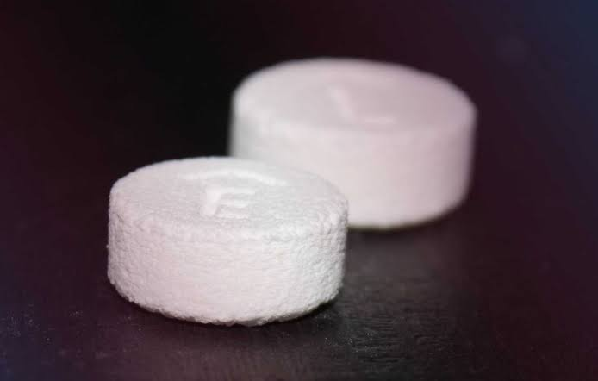
Fig 1: First 3D printed Drug

II. PERSONALIZED MEDICINE
The pharmaceutical sector had little interest in cutting-edge 3DP before the introduction of the first medicine that makes use of ZipDose technology, a form of 3DP Platform [13]. Zip Dose® Technology is a drug-formulation platform that enables the production of fast disintegrating variants of highly prescribed drugs. It is the first and only platform that makes drugs using 3D printing.While traditional techniques like direct compression of tablets, capsules, and film casting are economical for mass manufacturing; cutting-edge 3DP technology provides flexibility and the ability to produce free-form geometries. This contrasts with current technology, which is time-consuming, labour-intensive, and dosage-inflexible [14]. Personalized dosage medication forms with controlled release profiles may be created using the innovative method of fused filament 3DP. Personalized dosage medication forms with controlled release profiles may be created using the innovative method of fused filament 3D printing.
Personalized medicine combines patients' pharmacogenetic profiles and pharmacokinetic traits, either individually or in a subgroup, with clinical tools and treatments that account for genetic variation in order to develop therapies that are appropriate for their conditions while reducing adverse drug reactions and providing more effective treatments in Fig 2. The pharmaceutical industry was encouraged and subsequently shaped to customize medicines for individuals based on their genetic profiles [15]. For patients who are taking many drugs, 3DP offers this adaptability, which is very advantageous.
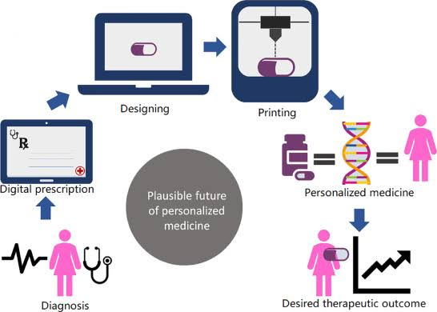
Fig 2: Personalized Medicine

3D printer materials
Polymers used in 3DP for medical purposes:
1. Acrylonitrile Butadiene Styrene:
One of the materials that have been utilized the most since 3DP first became popular. This material is ideal for 3DP since it is lightweight, moderately flexible, and extremely durable. Compared to another common 3D filament, Poly Lactic Acid, it extrudes with less force [9]. The fact that acrylonitrile butadiene styrene needs a higher temperature (250 °C) is a disadvantage.
2. Poly Lactic Acid:
Another common substance used in 3DP is biodegradable poly lactic acid, which is generated from corn [9] it is a thermoplastic that degrades naturally and is made from renewable materials. Therefore, compared to other plastic materials, poly lactic acid polymers are more environmentally friendly. The biocompatibility of poly lactic acid with the human body is another outstanding quality. Poly lactic acid has a tougher structural makeup than Acrylonitrile Butadiene Styrene Temperature is between 60 – 65 ° C [16].
3. Collagen:
Collagen, which is found in the extracellular matrix, is another natural polymer utilised to boost cell cultures (ECM). Collagen has lately been employed as a biomaterial in 3D bio printing and tissue engineering. When collagen is hydrolyzed, gelatin is produced, which when coupled with alginate generates a bio composite ink for 3D printing scaffolding material [17]. Where it was possible to 3D bio print cross-linked cell-laden constructions with 80% cell viability using a hydro gel made of alginate dialdehyde, gelatin, and platelet-rich plasma. Another linear polysaccharide that has been shown to produce very stiff structures is agarose. The agarose was changed (by TEMPO-mediated oxidation) and mixed with trace quantities of negative agarose to create a bio composite ink for 3D printing by micro-extrusion [18]. 3DP in suspension media provides a platform for patterning mechanically weak bio inks into complex, highly defined patterns. A cell-containing formulation called bio inks can be used in 3D bio printing.
Polylactic acid, polyvidone, hypromellose, 2-hydroxy propyl ether, and polycaprolactone are some of the other components utilised in medication 3DP. Enteric-based coating polymeric materials like as hypromellose acetate succinate, hypromellose 1-polyacrylic acid, and hypromellose 2-methyl propenoic acid have demonstrated their 3D printing capabilities for gastro applications [19].

III. 3D – PRINTED TECHNOLOGY
1. Fused deposition modeling (FDM):
The most common 3DP method is fused deposition modeling (FDM), often known as fused filament manufacturing following development, thermoplastic drug-loaded polymeric filaments which are fed into the printer where they are melted at a specified temperature and extruded via the nozzle [20]. The majority of the filaments used in FDM are made using the hot melt extrusion (HME) method, in which the medicine and other excipient are integrated into the polymer. This method employs a motor-driven screw-based extrusion mechanism in a barrel to melt the mixture under pressure and heat before allowing it to cool. The liquid is then allowed to solidify, producing the filament that will be utilized as the FDM feed [21] [22]. Due to its affordability, printing precision assured quality criteria, and inclusion of HME, FDM is widely used in the pharmaceutical industry [23].
A one-step FDM approach called direct powder 3D printing (DPP), which does not need HME, was studied. Here, the powder mixtures were loaded into an extrusion cartridge made of stainless steel, heated, and successfully printed to create tablets with a honeycomb pattern [24]. In order to create the new double-chamber dosage form known as the dual tablet using a dual-nozzle FDM printer, two filaments, each having a different drug concentration, had to be produced using HME (hot melt extrusion). The FDM approach made it possible to create tailored pills with reduced adverse effects from under- or overdose, increased ease of distribution, and enhanced patient adherence to medication [11].
2. Selective Laser Sintering (SLS):
In selective laser sintering, powder particles are heated and fused with laser radiation before being solidified to create 3D objects. The spreading platform, powder bed, and laser system make up the selective laser sintering (SLS) system's primary parts. [20]. It belongs to the class of 3DP developing technologies. To create the desired 3D structures just requires one step in which a laser selectively sinters particles into layers. This method involves creating accurate patterns on the surface of powders by stacking powder materials while employing focused lasers.[25]
3.STEREOLITHOGRAPHY TECHNIQUE (SLA):
A method of 3D printing is stereo lithography. Charles Hull discovered the SLA technique in 1988as a first technique of the 3D system. The product uses a laser beam to transform it from a liquid state into a solid state. Wang and colleagues created tablets of paracetamol (Acetaminophen) and 4-aminosalicylic acid (4ASA) via SLA 3D printing [26].It is completely based on the principle of photo polymerization [19].In SLA, UV light is permitted to travel perpendicular to the surface of the liquefied resin. Once a particular deposit is solidified upon exposure, another layer of liquid resin is placed. This procedure continues until a completed product is produced. A excess of resin is pumped off once a certain product is finished. To get rid of excess resins, the finished product is cleaned [27][28]
IV. STEPS INVOLVED IN A 3D PRINTED DOSAGE FORM
1. A pharmaceutical product uses computer-aided design to create a three-dimensional design.
2. The design is converted into a machine-readable format that specifies the exterior of the three-dimensional dosage form.
3. The computer program then splits this surface into a number of unique printable layers and sends each layer individually to the printer. [29]

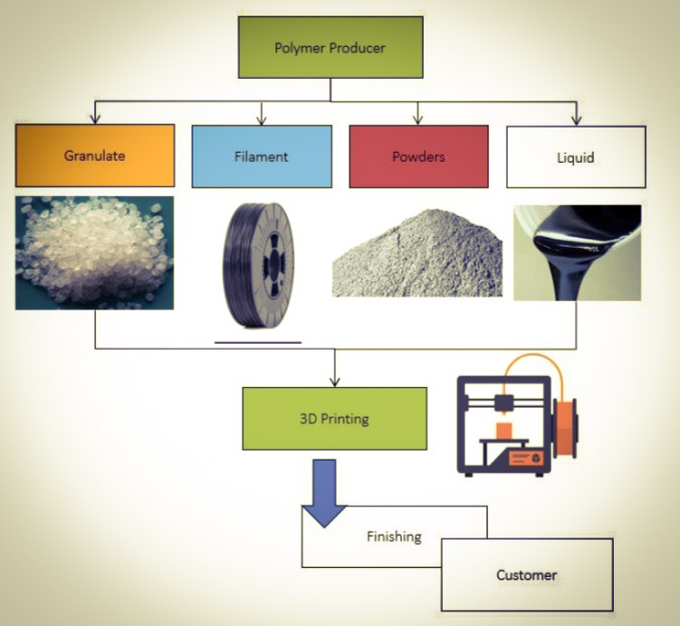
Fig 3: Manufacturing of Drug using 3D printing.

V.DOSAGE FORMS:
1. ORAL TABLETS:
Multidisciplinary techniques provide a wide range of dosage forms, each with its own set of consequences that are influenced by the tools and procedures used. To generate suitable dosage forms, active pharmaceutical ingredients (APIs) are mixed with materials such as polymer filament, hydro gels, or smart material polymers. In the pharmaceutical sector, these materials are used as drug carriers. They are sensitive to transforming to new shapes when exposed to specific environmental conditions such as temperature, light, or humidity [30].
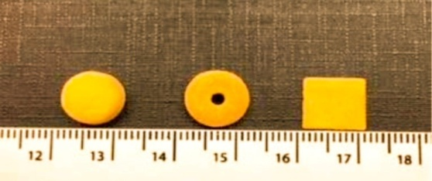
Fig 4: 3DP oral dosage form
Hot melt extrusion is used to produce two filaments with different medicine concentrations for oral dose forms. The breakthrough twin chamber dosage form known as the "Duo pill" was created using dual nozzle FDM printers. The use of computer-aided design in 3DP technology allows for the production of medicine formulations with the desired release rate and pattern. Regarding the patient's willingness or capacity to swallow the tablet, specific forms and sizes are preferable in 3DP. The adoption of conventional techniques might pave the way for the creation of tablets that are easier to use. The main benefits of 3D pharmaceuticals include their low cost, the absence of organic solvents, and the ability to combine the medications and polymer using hot melt extrusion, making multi-drug devices and being able to alter drug release profiles via changing shape and density.
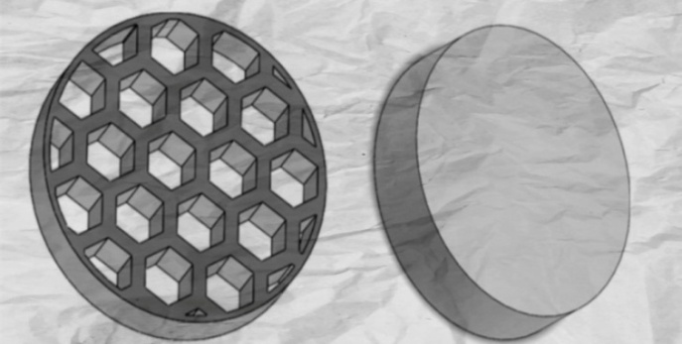
Fig 5: tablet shapes and textures used for 3DP
Lattice honey comb tablet (left) and cylindrical tablet on (right)
POLYPILL:
The World Health Organization (WHO) suggested combining many medications into a fixed-dose item, which is referred to as a polypill. It is possible to create an oral dose form with numerous layers using 3DP in Fig 6. These include TB, type 2 diabetes, hypertension or cardiovascular disease, and HIV-1 infection. PolycapTM, a type of multi-drug pill, is an illustration [31].

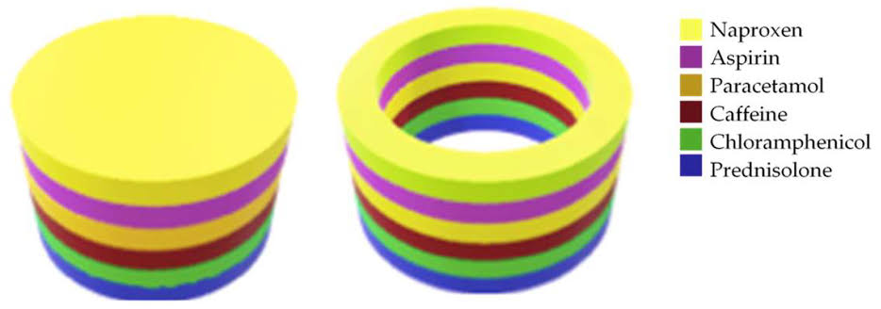

Fig 6: Polypill
2. BUCCAL WAFERS:
In particular, patients with challenges, such as small children or the elderly, as well as patients who are afraid of needles, benefit from buccal and orodispersible dose forms. It has been used to create polycaprolactone (PCL) and poly vinyl pyrrolidone-based antibiotic 3D film patches because of its high-resolution printing capabilities. The innovative dosage form is taken orally but it does not require water or swallowing. Tablets, wafers, and films are frequently used as buccal dosage forms; however wafers and films are favoured over tablets for prolonged transmucosal administration. FDM 3DP can speed up the production of buccal films, and the films have the property of unidirectional release. The FDA has approved a brand-new medication (libervant) for the treatment of cluster seizures that contains a diazepam buccal film [32].
3. TRANSDERMAL MICRO NEEDLES:
In contrast to syringes, biodegradable 3DP polymer micro needles have been created for transdermal medication administration that is painless and sanitary. These Micro needles were made using PLA. Different sizes, lengths, and densities might be produced using 3DP [33]. Using this method, medicine may be delivered via the skin without feeling any pain. Without activating the pain nerve, this permeates the skin and releases the medication in the dermis [31].

Table 1 - An Example of 3D printed dosage form developed by different technology
S.NO | DOSAGE FORM | DRUG | EXCIPIENTS | 3DP PRINTED TECHNOLOGY | REFERENCES
1. | Tablets | Paracetamol | Kollicoat IR or Eudragit L, candurin gold sheen | Selective Laser Sintering (SLS) | [34]
2. | Tablets | Captopril | Maltitol, maltodextrin, water, polyvinylpyrrolidone (PVP) | Drop on Solid (a type of Drop on Demand (DoD)) | [35]
3. | Tablets | Theophylline | Hydroxypropyl cellulose, triacetin, crospovidone, sodium starch | Extrusion-based Fused Deposition Modelling (FDM) | [36]
4. | Tablets | Paracetamol and 4- Aminosalicylic acid | Polyethylene glycol diacrylate (PEGDA), PEG 300 and diphenyl-(2,4,6- trimethyl benzoyl) phosphine oxide (DPPO) | Stereolithography (SLA) | [37]
5. | Multicompartment tablet (polypill) | Hydrochlorothiazide, Aspirin, Atenolol, Pravastatin and Ramipril | D mannitol, Polyethylene glycol (PEG) 600, cellulose acetate | Semi-solid Extrusion (SSE) or Pressure assisted micro syringe | [38]
6. | Micro needles | insulin | Dental SG resin Xylitol, Mannitol, Trehalose | Stereolithography (SLA) | [39]
7. | Soluble Micro needles | Human immunoglobulin (IgG) | Maltose and stainless steel | Inkjet printing | [39]
8. | Dissolving Micro needles | Bovine serum albumin and lysozyme | Carboxymethylcellulose | Stereolithography (SLA) | [39]
9. | Coated Micro needles | Desmopressin (synthetic peptide hormone) | Titanium screen microneedles + desmopressin coating | Stereolithography (SLA) | [39]
10. | Biodegradable microneedle | Cy3-labeled plasmid DNA encoding luciferase | PDMS, PLGA, poly (β-amino ester) (PBAE) | Stereolithography (SLA) | [39]
11. | Buccal wafers | Famotidine (20, 40 mg) | Mannitol, aspartame, mint flavor, gelatin, red ferric oxide and xanthan gum | Fused Deposition Modeling (FDM) | [40]
12. | Buccal wafers | Metopimazine (7.5 mg) | Aspartame, xantham gum, sodium docusate, dextran 70, mannitol | Fused Deposition Modeling (FDM) | [40]
13. | Buccal wafers | Paracetamol (500 mg) | Polysorbate 60, mono hydrous lactose Aspartame, xanthan gum, dextran 70, orange flavouring, | Fused Deposition Modeling (FDM) | [40]
14. | Buccal wafers | diazepam | Diazepam, Hydroxyl propyl β-cyclodextrin, Hydroxy propyl methyl cellulose E3, E5, E15 and Glycerin, PEG 400, Propylene glycols | Fused Deposition Modeling (FDM) | [41]
15. | Buccal wafers | Selegiline (1.25 mg) | Citric acid, gelatin, mannitol, grapefruit flavor glycine, aspartame, yellow iron oxide. | Fused Deposition Modeling (FDM) | [40]

VI.BENEFITS
1. Higher drug loading capacity compared to traditional dose forms.[42]
2. Precise and accurate dosage of powerful medications that are given in small doses.[42]
3. minimizes manufacturing costs because there is less material wastage.[42]
4. Based on genetic variances, ethnic differences, age, gender, and environment, medication can be specially formulated Or tailored for a patient in a certain situation. [42]
5. Due to the variable design and production of this dosage form, immediate and controlled release layers may be integrated, which helps in choosing the best treatment plan for an individual.[42]
6. Prevents batch-to-batch variations that occur when conventional dosage forms are manufactured in bulk [43].

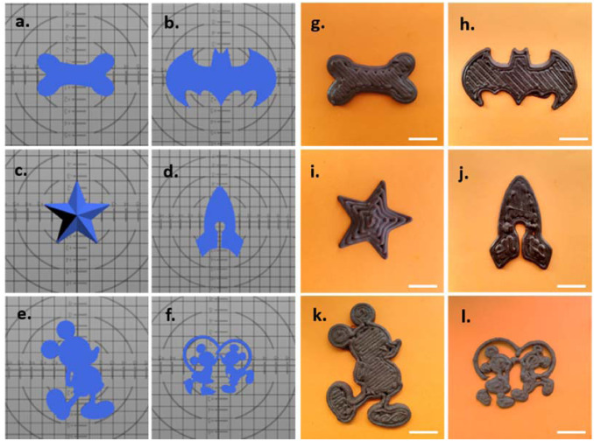
Fig 7: Different shapes of 3DP dosage form.
Computer aided design(left), final printed chocolate 3DP dosage form (right).

VII. CHALLENGES
It produces encouraging results in medication delivery applications. It confronts several problems, including the optimization process, enhancing device performance for varied usage, selecting appropriate excipients, post-treatment methods, and so on.
1. Problems with the nozzle provide a significant issue since they prevent the printer head, which affects the structure of the finished output.[44]
2. Another difficulty is clogging in powder printing.[44]
3. The potential to alter the final structure in response to mechanical stress, impacts of ink compositions and storage condition adaptations.[44]
4. The effects of various printer-related variables on printing quality, and printer cost. [44]

VIII. APPLICATIONS
Dental implants and custom prosthetics were the first items made using 3D printing in the field of medicine. The creation of tissues and organs, the development of prostheses, implants, and anatomical models, and pharmaceutical research into drug discovery, delivery, and dosage forms are some of the current medical uses of 3D printing.
1. These technologies enable the fabrication of almost infinite dosage forms, which is predicted to pose a challenge to traditional medication manufacturing. Previously, 3D printers were used to manufacture a variety of novel dosage forms, including microcapsules, hyaluronan-based synthetic extracellular matrices, antibiotic-printed micropatterns, mesoporous bioactive glass scaffolds, nano solution, and multilayered drug delivery devices.[45]
2. Potential use in industrial design, aerospace, medical engineering, tissue engineering, architecture, and pharmaceuticals for process improvement and performance improvement.
3. It primarily focuses on two possible places for expanding the scope of pharmaceutical product development by producing complex delivery systems and customized medication.
4. Helps with organ printing, biomaterials, and cell-laden materials. In the healthcare industry to create dental implants. On making an organized release multi-drug implant for bone TB treatment. [46]
5. Complex medication production procedures may also be standardised using 3D printing, making them easier and more practical.3D printing technology has the potential to be highly useful in the development of customised medicine.
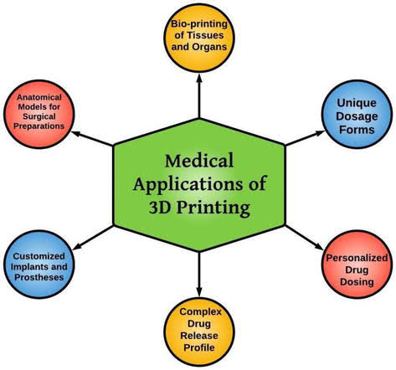
Fig 8: Application of 3D printing in medicine.

IX. DISCUSSION
This niche technology appears to be a breakthrough tool in pharmaceutical production, providing greater flexibility. 3D printing, a complicated layer-by-layer technology, can immediately build complex, customizable objects. The application of 3D printing in medication delivery systems is an intriguing technology for the manufacture of personalized items. Since a few years, the concept of 3D-printed drug formulation has fast grown under the supervision of patient-centric medicine in an attempt to enhance therapy. The FDA authorized the first pharmaceutical produced utilising 3D printing technology, resulting in an incredibly speedy development. The ability to construct multifunctional drug delivery systems, multidrug devices, and drug formulations with fast release qualities for personalised therapy is another advantage of 3D printing. To achieve the best therapeutic index, future research should focus on producing pediatric and geriatric dosage forms in individual dose and dimensional-specific medication formulations. A growing number of drug development studies have demonstrated the clear benefits of this approach, but leading complex innovative dosage forms on a large scale will yield the great outcome.

X.CONCLUSION
The application of 3D printing technology in the pharmaceutical business enables the production of individualised medication that is focused on the needs of the patient. It has many benefits, including improving production and cost-effectiveness. Speed of manufacturing has undergone a transformation because with 3D printing. It decreases lead time and tooling costs, enhances design manufacturing of products. This chapter summarized how the drugs are printed using 3D printing technology and its different dosage form, and its benefits and challenges and also about Application of 3DP in medical field. 3D printing of drugs has more benefits when compared to challenges hence, it is beneficial one. The pharmaceutical industry uses a wide range of technical aspects of 3D printing to create novel drug delivery systems, create new excipient, increase medication compatibility, and create personalized dosage forms. It is believed that 3D printers would eventually replace pharmaceutical shelves once the proper printing platform is built, launching a new era of digital health. As a result, it is expected that more 3D-printed pharmaceutical drugs and medical devices would be available in the market as sooner than expected.

REFERENCES
[1] Li Q, Guan X, Cui M, Zhu Z, Chen K, Wen H, Jia D, Hou J, Xu W, Yang X, Pan W. Preparation and investigation of novel gastro-floating tablets with 3D extrusion-based printing. International journal of pharmaceutics. 2018 Jan 15;535(1-2):325-32.
[2] Trenfield SJ, Awad A, Madla CM, Hatton GB, Firth J, Goyanes A, Gaisford S, Basit AW. Shaping the future: recent advances of 3D printing in drug delivery and healthcare. Expert opinion on drug delivery. 2019 Oct 3;16(10):1081-94.
[3] Ponni RT, Swamivelmanickam M, Sivakrishnan S. 3D printing in pharmaceutical technology–a review. International Journal of Pharmaceutical Investigation. 2020 Mar 12;10(1):8-12.
[4] Zhu X, Li H, Huang L, Zhang M, Fan W, Cui L. 3D printing promotes the development of drugs. Biomedicine & Pharmacotherapy. 2020 Nov 1;131:110644.
[5] Jamróz W, Szafraniec J, Kurek M, Jachowicz R. 3D printing in pharmaceutical and medical applications–recent achievements and challenges. Pharmaceutical research. 2018 Sep;35(9):1-22.
[6] ISSN (PRINT): 2393-8374, (ONLINE): 2394-0697, VOLUME-2, ISSUE-10, 201591SELECTIVE LASER SINTERING PROCESS –A REVIEWRajesh R1, Sudheer S2, Mithun V Kulkarni3
[7] Vaz VM, Kumar L. 3D printing as a promising tool in personalized medicine. Aaps Pharmscitech. 2021 Jan;22(1):1-20.
[8] Mathur S, Sutton J. Personalized medicine could transform healthcare. Biomedical reports. 2017 Jul 1;7(1):3-5.
[9] Gujrati A, Sharma A, Mahajan SC. Review on applications of 3D printing in pharmaceuticals. Int J Pharm Sci Rev Res [Internet]. 2019;59(1):148-54.
[10] Prasad LK, Smyth H. 3D Printing technologies for drug delivery: a review. Drug development and industrial pharmacy. 2016 Jul 2;42(7):1019-31.
[11] Wallis M, Al-Dulimi Z, Tan DK, Maniruzzaman M, Nokhodchi A. 3D printing for enhanced drug delivery: current state-of-the-art and challenges. Drug Development and Industrial Pharmacy. 2020 Sep 1;46(9):1385-401.
[12] Gilby S, Design L, Eaves Z. Overall supervision: Lewis Akenji.
[13] Khatri P, Shah MK, Vora N. Formulation strategies for solid oral dosage form using 3D printing technology: A mini.
[14] Trenfield SJ, Madla CM, Basit AW, Gaisford S. The shape of things to come: Emerging applications of 3D printing in healthcare. 3D Printing of Pharmaceuticals. 2018:1-9.
[15] Wallis M, Al-Dulimi Z, Tan DK, Maniruzzaman M, Nokhodchi A. 3D printing for enhanced drug delivery: current state-of-the-art and challenges. Drug Development and Industrial Pharmacy. 2020 Sep 1;46(9):1385-401.
[16] Gokhare VG, Raut DN, Shinde DK. A review paper on 3D-printing aspects and various processes used in the 3D-printing. Int. J. Eng. Res. Technol. 2017 Jun 6;6(06):953-8.
[17] Chinga-Carrasco G. Biocomposite Inks for 3D Printing. Bioengineering. 2021 Jul 22;8(8):102.
[18] Gu Y, Schwarz B, Forget A, Barbero A, Martin I, Shastri VP. Advanced bioink for 3D bioprinting of complex free-standing structures with high stiffness. Bioengineering. 2020 Nov 7;7(4):141.
[19] Mahmood MA. 3D printing in drug delivery and biomedical applications: A state-of-the-art review. Compounds. 2021 Sep 24;1(3):94-115.
[20] Vaz VM, Kumar L. 3D printing as a promising tool in personalized medicine. Aaps Pharmscitech. 2021 Jan;22(1):1-20.
[21] Shaqour B, Samaro A, Verleije B, Beyers K, Vervaet C, Cos P. Production of drug delivery systems using fused filament fabrication: a systematic review. Pharmaceutics. 2020 Jun 5;12(6):517.
[22] Awad A, Trenfield SJ, Gaisford S, Basit AW. 3D printed medicines: A new branch of digital healthcare. International journal of pharmaceutics. 2018 Sep 5;548(1):586-96.
[23] Araújo MR, Sa-Barreto LL, Gratieri T, Gelfuso GM, Cunha-Filho M. The digital pharmacies era: How 3D printing technology using fused deposition modeling can become a reality. Pharmaceutics. 2019 Mar 19;11(3):128.
[24] Fanous M, Gold S, Muller S, Hirsch S, Ogorka J, Imanidis G. Simplification of fused deposition modeling 3D-printing paradigm: Feasibility of 1-step direct powder printing for immediate release dosage form production. International journal of pharmaceutics. 2020 Mar 30;578:119124.
[25] Grix T, Ruppelt A, Thomas A, Amler AK, Noichl BP, Lauster R, Kloke L. Bioprinting perfusion-enabled liver equivalents for advanced organ-on-a-chip applications. Genes. 2018 Mar 22;9(4):176.
[26] Alruwaili NK, Rizwanullah M, Abbas Bukhari SN, Amir M, Ahmed MM, Fazil M. 3D printing technology in design of pharmaceutical products. Current pharmaceutical design. 2018 Nov 1;24(42):5009-18.
[27] Konda Gokuldoss P, Kolla S, Eckert J. Additive manufacturing processes: Selective laser melting, electron beam melting and binder jetting—Selection guidelines. materials. 2017 Jun 19;10(6):672.
[28] Zhang J, Hu Q, Wang S, Tao J, Gou M. Digital light processing based three-dimensional printing for medical applications. International Journal of Bioprinting. 2020;6(1).
[29] Norman J, Madurawe RD, Moore CM, Khan MA, Khairuzzaman A. A new chapter in pharmaceutical manufacturing: 3D-printed drug products. Advanced drug delivery reviews. 2017 Jan 1;108:39-50.
[30] Moulton SE, Wallace GG. 3-dimensional (3D) fabricated polymer based drug delivery systems. Journal of Controlled Release. 2014 Nov 10;193:27-34.
[31] Wallis M, Al-Dulimi Z, Tan DK, Maniruzzaman M, Nokhodchi A. 3D printing for enhanced drug delivery: current state-of-the-art and challenges. Drug Development and Industrial Pharmacy. 2020 Sep 1;46(9):1385-401.
[32] Cardoso MB, Ladio AH, Lozada M. Niche breadth and redundancy: Useful indices to analyse fuelwood use in rural communities. Journal of Arid Environments. 2017 Oct 1;145:52-9.
[33] Donnelly RF, Singh TR, Tunney MM, Morrow DI, McCarron PA, O’Mahony C, Woolfson AD. Microneedle arrays allow lower microbial penetration than hypodermic needles in vitro. Pharmaceutical research. 2009 Nov;26(11):2513-22.
[34] Fina F. Goyanes A. Gaisford S. Basit AW Int. J. Pharm. 2017; 529:285-93.
[35] Lee KJ, Kang A, Delfino JJ, West TG, Chetty D, Monkhouse DC, Yoo J. Evaluation of critical formulation factors in the development of a rapidly dispersing captopril oral dosage form. Drug development and industrial pharmacy. 2003 Jan 1;29(9):967-79.
[36] Huo X, Liu K. Renal organic anion transporters in drug–drug interactions and diseases. European Journal of Pharmaceutical Sciences. 2018 Jan 15; 112:8-19.
[37] Wang CC, Tejwani MR. WJ Roach, JL Kay, J. Yoo, HL Surprenant, DC Monkhouse, TJ Pryor, Development of Near Zero-Order Release Dosage Forms Using Three-Dimensional Printing (3-DPTM) Technology. Drug Dev. Ind. Pharm. 2006; 32:367-76.
[38] Khaled SA, Burley JC, Alexander MR, Yang J, Roberts CJ. 3D printing of five-in-one dose combination polypill with defined immediate and sustained release profiles. Journal of controlled release. 2015 Nov 10; 217:308-14.
[39] Wang CC, Tejwani MR. WJ Roach, JL Kay, J. Yoo, HL Surprenant, DC Monkhouse, TJ Pryor, Development of Near Zero-Order Release Dosage Forms Using Three-Dimensional Printing (3-DPTM) Technology. Drug Dev. Ind. Pharm. 2006;32:367-76.
[40] Costa JS, de Oliveira Cruvinel K, Oliveira-Nascimento L. A mini-review on drug delivery through wafer technology: Formulation and manufacturing of buccal and oral lyophilizates. Journal of Advanced Research. 2019 Nov 1;20:33-41.
[41] Ali MS, Vijendar C, Kumar SD, Krishnaveni J. Formulation and evaluation of fast dissolving oral films of diazepam. Journal of pharmacovigilance. 2016 May 28;4(3):1-5.
[42] Jose PA, GV PC. 3D printing of pharmaceuticals–a potential technology in developing personalized medicine. Asian journal of pharmaceutical research and development. 2018 Jul 10;6(3):46-54.
[43] Shaikh Siraj N, Jain Vrushabha G, GJ K. A review on 3d printing in pharmaceutical.
[44] Alhnan MA, Okwuosa TC, Sadia M, Wan KW, Ahmed W, Arafat B. Emergence of 3D printed dosage forms: opportunities and challenges. Pharmaceutical research. 2016 Aug;33(8):1817-32.
[45] Cui X, Boland T, DD'Lima D, K Lotz M. Thermal inkjet printing in tissue engineering and regenerative medicine. Recent patents on drug delivery & formulation. 2012 Aug 1;6(2):149-55.
[46] Katakam P, Dey B, Assaleh FH, Hwisa NT, Adiki SK, Chandu BR, Mitra A. Top-down and bottom-up approaches in 3D printing technologies for drug delivery challenges. Critical Reviews™ in Therapeutic Drug Carrier Systems. 2015;32(1).

