manual of housekeeping
This course is designed to introduce students to a career in the hospitality industry as a Hotel Housekeeper. It develops capabilities with regard to Guest Room cleaning, arrangement of public areas, handling & maintain linen and uniforms, maintain linen inventory and maintain Housekeeping stores, controlling and upgrading subordinates, handling guest requests / complaints etc. Training institutions may however combine the practical experience with centre learning, and the balance of training methods will be up to the institution to decide on, provided the competencies are developed | Training HANDOUT
BY: MRS.MOUSHUMI BANERJEE
ASSISTANT PROFESSOR,
BHMCT, SBM,
IFTM UNIVERSITY, MORADABAD

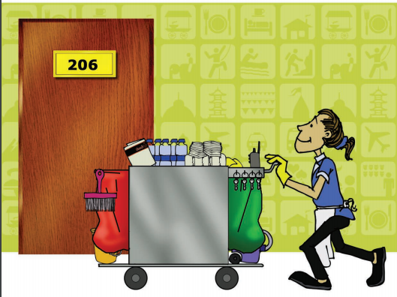
Job outlook, objectives of the course and career paths available following completion of the course:
High competition in the hotel industry demands more focus on housekeeping as it has been identified as the backbone of hotel operations. Housekeeping can be a way to set a hotel apart from its competitors, as it establishes a hotel’s reputation for cleanliness and quality. It is important to have a strong housekeeping department in the hotel industry for the guests’ health and safety. Students are required to engage in the below mentioned activities through practical sessions to deliver effective performance as per industry specified standards.

- Sweeping, Mopping, Suction Cleaning, Scrubbing, Polishing/Buffing, Shampooing of Carpets & Upholstery, Metal polishing of Brass, Silver & Chrome, Glass/Window Cleaning, Wall Cleaning, Elevator Cleaning, Stairway Cleaning, Office Cleaning and Cleaning Washrooms, Dusting, Glass Cleaning, Guest Room Cleaning and Bathroom Cleaning

TABLE OF CONTENTS
About Housekeeping Room Attendant curriculum
Objective of the housekeeping Learner manual
Learning outcome of the training
Career Path
MODULE 1: HOTEL AND HOUSEKEEPING
1 Introduction
1.1 Introduction of Hotel
1.1.1 The Organisation of Hotels
1.1.2 Staffing of the hotel
1.2 Classification of hotels
1.3 Different departments of the hotel
1.4 The Role of the Housekeeping department
1.4.1 Positions in the Housekeeping Department
1.5 Housekeeping personnel
1.5.1 Attributes and qualities of a house keeping personnel
1.6 Dress Codes and Uniforms of house keeping
1.7 Personal Hygiene
1.7.1 Characteristics of Housekeeping personnel
1.8 Communication
1.9 Guest complaints
1.10 Handling Guest Complaints

MODULE 2: PRINCIPLES AND PRACTICES OF CLEANING
2 Introductions
2.1 Definition of cleaning
2.2 Definition of Soiling
2.3 Equipment and Materials
2.4 Cleaning Agents
2.5 Principles of cleaning and cleaning procedures
2.5.1 Different cleaning techniques
MODULE 3: GUEST ROOMS, ROOM COMPONENTS AND KEY
3 Introductions
3.1 Types of Rooms
3.2 The components of the guest bed room
3.3 Bed types and Linen requirements standards
3.4 Key and Key Control
MODULE 4: HOUSEKEEPING TROLLEY (MAID CART) MANAGEMENT, GUEST ROOM CLEANING AND HANDOVER PROCEDURE
4 Introductions
4.1 Function of Housekeeping trolley (maid cart)
4.2 Efficient Room Cleaning
4.2.1 Sequence for Cleaning and Servicing a Guest Room
4.3 Cleaning of a Vacant Room
4.4 Closing down and preparing for the next shift
MODULE 5: PUBLIC AREA CLEANING
5 Introductions
5.1 Public Areas
5.1.1 Cleaning restaurant and bar areas
5.1.2 Public restrooms
5.1.3 Cleaning lifts
MODULE 6: LAUNDRY FUNCTIONS AND LINEN MANAGEMENT
6 Introductions
6.1 Laundry
6.1.1 Laundry Department
6.2 Laundry Equipment
6.2.1 Laundry process
6.3 Maintaining Linen Room & Linen
6.3.1 Activities of the Linen Room
6.3.2 Linen Items
MODULE 7: HOUSEKEEPING SERVICES AND OTHER DUTIES
7 Introductions
7.1 Other guest services
7.1.1 Room transfers
7.1.2 Guest Requests
7.1.3 Staff Requests
7.1.4 Service Housekeeping requests
7.1.5 Checking Room Allocations
7.1.6 Room status report
7.1.7 Guest Information Directory
7.1.8 Room Allocations
7.1.9 Assign rooms after they are cleaned
7.1.10 Turndown Service
7.1.11 Lost and found property
7.2 Responding to VIPs
7.3 Looking after Plants
7.4 Housekeeping supply management
MODULE 8: MAINTENANCE, UNDERSTANDING RISKS AND PREVENTIVE MEASURES
8 Introductions
8.1 Reporting Maintenance Problems
8.2 Safe Work Practices
8.3 Safety in room cleaning and servicing
8.4 Preventing Accidents
8.5 Safely handling cleaning agents, equipment and machinery
8.6 Hygiene and Safety Risks in Bathrooms
8.7 Precaution against infectious diseases like HIV/Aids
8.8 Personal Safety Issues
8.8.1 Procedure for Reporting Accidents
8.9 First Aid 104 8.9.1 Treating small common injuries
8.10 Proper use of the hazard signs
8.11 Safety Inspections
8.12 Security in Hotels
8.13 Pest control
8.14 Fire
8.14.1 Preventing fire accident in the hotel

ABOUT THE HOUSEKEEPING TRAINING MANUAL
The Housekeeping curriculum is developed to equip people working in the hotels, lodges and homes stays on technical and practical knowledge required in the profession. Especially for those who wish to start their career as a Housekeeper- Room Attendant in the hospitality sector. This curriculum gives all the necessary duties and areas of work that the housekeeper’s duties entail; personnel hygiene/attributes, cleaning methods, rooms, housekeeping services, laundry and many more relevant topics. Any hospitality establishment which caters to accommodation can use this manual, and modules can be individually selected as required. Throughout the development of the material, the competence of the present work force in the hospitality sector was considered through market needs analysis.
OBJECTIVE OF THE HOUSEKEEPING LEARNER MANUAL
By the end of the training course, you will have excellent knowledge of the duties, roles and responsibilities of a housekeeper/room attendant, reflecting high standards of work, customer service and best operational practices.
LEARNING OUTCOME OF THE TRAINING
Upon successful completion of this course, the beneficiaries should be able to demonstrate and practice:
• Understanding of the service sector, accommodation and tourism
• Explain the role, function and organisation of the housekeeping department of a hotel;
• Communicate professionally and effectively with guests.
• Demonstrate the principles and practices of cleaning as applied to the duties of a housekeeper/room attendant;
• Apply theoretical knowledge in the housekeeping operation in relation to guest room cleaning and public area cleaning;
• Proper use of housekeeping equipment, agents, chemicals and handling.
• Provide housekeeping services to guests;
• Conduct other housekeeping operations as necessary, and
• Maintain a safe and secure working environment;
TARGET BENEFICIARIES OF HOUSEKEEPING MANUAL
The target beneficiaries of this course are housekeeping staff who want to gain technical and practical skills to work in the housekeeping department.
Career Path After completing this course, a learner will be able to:
• join a hotel as a housekeeping intern / assistant
• Work as; Linen and uniform attendant
• Laundry
• As a houseman or a trainee in housekeeping department
ASSESSMENT
Formative Assessment
Learners may be formally assessed throughout the course. This will take place in the form of quizzes, practical exercises and/or applications.
SUMMATIVE ASSESSMENT
A final summative assessment may be given to learners at the end of the course and will be based on the learning outcomes for the course. This assessment is (indicate what format this assessment takes, for example, a paper-based assessment, practical, simulation) to be completed at the end of the course; for practical assessments, the practical components of the course must be combined into an integrated assessment to ensure that learners can demonstrate the entire process.
ICONS
The following icons are used in this learner guide:
Important to remember Did you know?
Definition 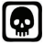 Danger / warning

MODULE 1

HOTEL AND HOUSEKEEPING

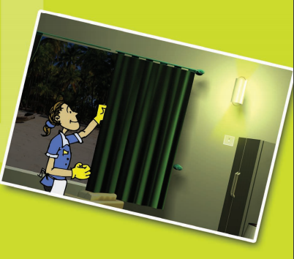

1 INTRODUCTION: HOTEL AND HOUSEKEEPING
This module will explain how a hotel operates, and the different departments in a hotel, including the housekeeping department. Your role as a Room Attendant will be discussed to ensure that you understand how to present and conduct yourself professionally in this occupation.
1.1 INTRODUCTION OF HOTEL
A hotel is an establishment that provides accommodation and also usually meals and other services for travellers and other paying guests. it provides paid lodging, usually on a short-term basis. Hotels often provide a number of additional guest services such as a restaurant, laundry, a swimming pool or childcare. Some hotels have conference services and meeting rooms and encourage groups to hold conventions, functions and meetings at their location. Hotels are found in almost all the cities of the world. Hotels operate twenty four hours a day, seven days a week. The principal factor that determines the guest’s attitude towards a hotel is the quality of service, although other amenities such as room, food and beverages are also of importance.
1.1.1 THE ORGANISATION OF HOTELS
Organisation means the arrangement of staff and assignment of their duties and responsibilities, so that the operation can function efficiently and as one unit. The organisation of the hotel will depend on its size and type. As the hotel varies in size, shape and age, so the exact role of the housekeeping department will differ from one hotel to another. However, whatever the type or size of hotel, regarding the work of housekeeping, the department has one basic function-to oversee the cleanliness and comfort of the hotel.
1.1.2 STAFFING OF THE HOTEL
An organisation chart is a drawing that shows the relationship between departments or divisions and specific positions within an organisation. There is no model or standard organisational chart that describes how all hotels should be organised. Each hotel has different charts according to their size. The plan for any particular hotel depends on a many things such as location, client base, and services to be offered, layout of the building, management structure, etc. However, despite such differences, there is a framework which many hotels use.

1.2 CLASSIFICATION OF HOTELS
Generally hotels are classified on the types of facilities, services, number of outlets, location, target market, affiliation and ownership. The classification
varies from place to place and from country to country and usually categorized as per following criteria’s.
Classification as per size
Small hotel: 1-25 rooms
Medium hotels: 25-100
Large hotel: 100 – above

Classification as per facilities and service:
- 2 star: minimum 1 food and beverage out let, service till 2200 hours, intercom and limited room services, etc.
- 3 star: minimum 2 food and beverage out lets, 1 bar, 24 hours room service, currency exchange, postal service and elevators etc.
- 4 star: conforming 3 star standards, more comfortable rooms, 3 restaurants including a coffee shop, mini bar, elevator, banquette, seminar, meeting facilities and parking lot, etc.
- 5 star: conforming 4 star standards plus health club, sauna, Jacuzzi, mini-bar etc.

The following is a sample organisation chart for a small hotel.
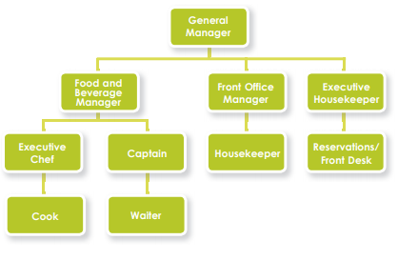

The following is a sample organisation chart for a relatively large hotel,
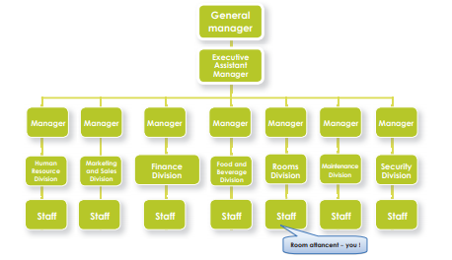
1.3 DIFFERENT DEPARTMENTS OF THE HOTEL
For a well run and smooth operation, the hotel work is divided into separate units which are responsible for specific duties and tasks. The following are separate departments you may find in the hotel. It is absolutely necessary to have a proper functional operation, so that all the departments work well together.
PERSONNEL (HUMAN RESOURCES) DIVISION
Helps other divisions with recruitment, selection and the training of staff. It also administers wages, medical and all personnel related matters. Links with Housekeeping: The personnel/HR division will be responsible for the coordination of in-service training and staff performance appraisals & hiring.
MARKETING AND SALES DIVISION
Sales and marketing staff help sell rooms, conference and food and beverage services. They are also involved in promotions, advertising and publicity activities.
• Association between Housekeeping and Marketing and Sales division: Housekeeping staff communicate guests’ feedback and complaints to this division in order for them to improve or use certain strong points in their marketing plan.
FINANCE DIVISION
This division, headed by a Chief Accountant or Finance Controller, is responsible for various accounting and record keeping functions, income collection and purchasing control.
•Association between Housekeeping and Finance division: Before the Executive Housekeeper can place any orders or buy new equipment or anything needed, he/she will have to get authorisation from the accounting department. This department will also inform the housekeeping department if they are using too much of a certain material e.g. toilet cleaner, which run up additional expenses.
FOOD AND BEVERAGE DIVISION
This division is responsible for all food and beverage products provided in the hotel.
• Association between Housekeeping and personnel marketing and sale division: Housekeeping will have to liaise effectively with this division with regards to room service, collecting dirty service trays, replenish guest supplies such as coffee in guest rooms, stocking of mini bars, updating room service menus, etc.
ROOMS DIVISION
This division is responsible for the front desk and all of its check-in and check-out activities. It is also responsible for reservations, telephone systems and porter/concierge duties. Housekeeping usually falls into this division. Housekeeping provides cleaning services for all public areas of the hotel, and some back of house areas.
Other key areas within Rooms Division include:
• Telephones/Switchboard/PBX
• Business Centre
• Reception
• Concierge/Porter/ Bell Desk All the above departments have a department head or supervisor who reports to the Rooms Division Manager.
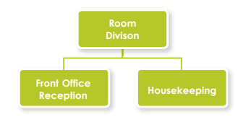
ENGINEERING DIVISION
The engineering division is responsible for repairs and maintenance of the hotel building and its contents, as well trying to anticipate problems which may occur with the facilities and equipment in the hotel; also to ensure that things do not break down, and maintain them in a constant state of good repair.
• Association between Housekeeping and Engineering Division: Close communication is needed between the maintenance and housekeeping division, as housekeepers are often the ones who check for faults or equipment/items that need repairs. A standard maintenance request form is available to request maintenance attention.
SECURITY DIVISION
This division helps protect guests, their property and the hotel's employees.
• Good communication between the Housekeeping and Security Division: Housekeeping Staff need to know how and where to find security personnel in the event of possible danger to themselves, other colleagues and guests. Housekeeping Staff should promptly call security when a threatening situation arises.
Tasks that are assigned to specialised positions in a large hotel are often combined into more generalised jobs in small hotels. For example, in a large hotel, different staff may be assigned to specialised positions, such as guest registration, reservation, and telephone switchboard duties etc. In a small hotel, one staff member i.e., the Front Office Clerk/ Receptionist may be responsible for all these duties.

Did you know?
The terms "front of house" and "back of house" are used to classify hotel departments and the personnel within them. Front of house departments are those in which employees have extensive guest contact – these are the public areas of a hotel. These include food and beverage, front office, the leisure department of resort hotels and reservations. Guest contact areas are critical in the role they play in ensuring customer satisfaction. Back of house departments are those in which personnel have less direct contact with guests and include housekeeping, engineering, personnel, accounting etc. These are the “Staff only” areas of a hotel

Front Office/Reception
Front Office is a key area within Rooms Division and, in many hotels, manages the interface between, on the one hand, guests and, on the other, the various areas which together go to make up the Rooms Division.
Good communication between the housekeeping and the front office is essential: the Housekeeping department’s primary communications are with the front office department, specifically the front desk area
HOUSEKEEPING
The main product of hotels is accommodation; therefore the Housekeeping Department has a very important role to play in any hotel operation. The housekeeper is responsible for preparing guestrooms for sale, guest laundry services and the cleanliness of all public areas in the hotel. Close liaison between housekeeping and reception is essential so that rooms are available to let as quickly as possible. Very often guests will request, for example, extra blankets, cots etc. These are passed to the housekeeping department from the reception. Therefore, good communication between these two important departments is essential. In terms of staffing, housekeeping is usually one of the largest departments in the hotel.
1.4 THE ROLE OF THE HOUSEKEEPING DEPARTMENT
The Housekeeping Department is responsible for the daily and periodic cleaning of guest's rooms; and in most cases, public areas. This department has in its care, linen and furnishings, carpets and furniture, beds and bedding, and sometimes laundry work for guests and the department. The housekeeping department must maintain high standards of housekeeping practice, or the guests will not be satisfied.
Working in Housekeeping is a very specialised and important job. You are not just a number among many individuals; you are part of an organisation. The efficiency of the Housekeeping staff contributes to the success of the whole hotel, equally with the staff of the Kitchen, Restaurant or Reception. The reputation and success of any hotel depends upon the efficiency and contribution of its entire staff, especially the people who deal with the guests.
1.4.1 POSITIONS IN THE HOUSEKEEPING DEPARTMENT
Some of the general positions in the department include:
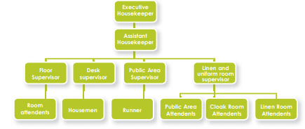
THE EXECUTIVE HOUSEKEEPER
This is the person overall in charge of the housekeeping department in a medium to large hotel, and will report directly to the general manager or to the Rooms Division manager.
Job Summary – Supervises all housekeeping employees, has the authority to hire or fire, plans and assigns work assignments, informs new employees of regulations, inspects housekeeping personnel work assignments and requisitions supplies.
ASSISTANT HOUSEKEEPER
Responsible for the overall housekeeping department and carries out work delegated by the executive housekeeper in his/her absence. The assistant housekeeper supervises all housekeeping employees, has the authority to hire or fire, plans and assigns work assignments, informs new employees of regulations, inspects housekeeping personnel work assignments and requisitions supplies.
All the duties and responsibilities of assistant housekeeper will be as same as that of executive housekeeper in his/her absence.
HOUSEKEEPING SUPERVISOR
Duties and responsibilities
• Supervise housekeeping staff when they are performing their duties
• Supervise laundry staff duties • Stock and maintain any housekeeping supply rooms
• Determine and process all guest complaints
• Check all guest rooms are ready for arrival
• Check that all common areas are hazard free and ready for guests
• Conduct daily morning meeting with housekeeping staff and organize all staff daily
• Ensure high level of customer service is maintained at all times
• Assist guests with all questions and reasonable requests
• Maintain clean and tidy work area
FLOOR SUPERVISOR
Duties and responsibilities:
• Assign duties to the floor housemen and housekeepers.
• Inspect each room completed by Housekeepers, according to specified room checklist and ensure that they meet the standards of the establishment in terms of cleaning, functional and aesthetic value.
• Check stocks of linen and guest supplies and cleaning supplies on floors and ensure timely delivery of soiled linen to laundry and requisition for fresh linen from linen room and guest supplies / cleaning supplies from the stores.
• Train Housekeepers and Housemen for maximum productivity and standards of efficiency.
• Submit performance appraisals periodically for each staff under his / her control.
• Check all safety systems on the allotted floors.
• Liaise with security on security aspects on guest floors.
• Account for movement of linen from his or her floors.
• Prepare housekeeping occupancy lists for front Office.
• Check all maids’ carts to ensure it is well stocked with linen and supplies and as per standards stipulated.
• Follow upon maintenance orders sent to Engineering.
PUBLIC AREA ATTENDANT
This person keeps all lobbies and public facilities (such as lobby restrooms, telephone areas, the front desk and offices) clean and tidy.
Duties and responsibilities:
• Cleans and maintains all lobbies and public restrooms
• Sweeps carpets
• Empties ashtrays and rubbish bins
• Polishes furniture and fixtures
• Vacuums and polishes elevators
• Keeps the front of the hotel free from trash
LINEN AND UNIFORM ATTENDANT
This person is responsible for storing and issuing uniforms, bed linen and table linen. He or she also takes stock and maintains linen room supplies.
Duties and responsibilities:
• Sorts items and counts and records number if items soiled
• Places linen and uniforms in containers for transport to laundry
• Examines laundered items to ensure cleanliness and serviceability
• Sends torn articles to the seamstress for repair
• Stores laundered linen and uniforms on shelves after verifying numbers and type of articles
• Issues linen and uniforms, which are both to be exchanged on a clean-for-soiled basis only
• Counts and records linen to fill requisitions
THE ROOM ATTENDANT
The Housekeeper/Room Attendant performs routine duties in cleaning and servicing guest rooms and bathrooms under the supervision of a housekeeping supervisor.
Duties and responsibilities:
• Enters and prepares the room for cleaning
• Makes the bed
• Dusts the room and furniture
• Replenishes guest room and bath supplies
• Cleans the bathroom
• Cleans the closet
• Vacuums the carpet
• Checks and secures the room
HOUSEMEN
This person performs any combination of the following tasks to maintain guest rooms, work areas and the hotel premises in general in a clean and orderly manner.
Duties and responsibilities:
• Cleans rugs, carpets and upholstered furniture using a vacuum cleaner, broom, and shampoo machine
Cleans rooms, hallways and restrooms
• Washes walls and ceilings, moves and arranges furniture and turns mattresses
• Sweeps, mops, scrubs, waxes and polishes floors
• Dusts and polishes metal work
• Collects soiled linen for laundry
• Receives linen supplies
• Stores linen supplies in floor linen closets
• Maintains housekeeping carts
• Removes trash collected by housekeepers
GARDENER
Duties and responsibilities
• Spring clean-up (raking, mulching, cutting back shrubs, grasses, and dead plants)
• Garden Prep (preparing flower and garden beds, adding compost, planting, mulching)
• Seeding/growing new plants, watering plants
• Managing flower beds around the property
1.5 HOUSEKEEPING PERSONNEL
The housekeeper’s major role is to ensure that the establishment is cleaned and serviced. The areas and departments involved may include guest rooms, bathrooms, public areas, linen department, laundry department etc.
1.5.1 ATTRIBUTES AND QUALITIES OF A HOUSE KEEPING PERSONNEL
Servicing guest bedrooms requires you to maintain a high standard of personal hygiene because housekeeping duties are physically demanding and it is likely that you will get hot and sweaty while working. Most establishments require housekeeping staff to wear a uniform. Shower facilities are often also provided for staff. Make sure that you shower or wash daily. Washing hair, brushing teeth and having a fresh clean body odour are very important if you are a housekeeper, and for anyone working in the hospitality industry, especially if you have guest contact.
Housekeepers need to adhere to certain grooming and personal presentation standards (official and/or unofficial).
This may include: Personal appearance Personal hygiene Personal characteristics
1.6 DRESS CODES AND UNIFORMS OF HOUSE KEEPING
Most establishments provide their staff with uniforms. You must always wear this uniform with pride. Your uniform serves
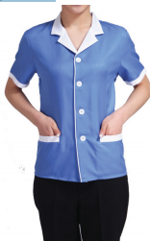
several purposes and benefits:
• It makes you easily-identifiable to guests
• It protects your own clothing from getting
dirty or damage
• It may protect you from chemicals and other related
materials you work with
• It ensures that you look smart and professional
– improving the image of the housekeeping department and the establishment it.
ALWAYS REMEMBER TO:
• Travel to work in your home clothes and change into your uniform at work. This makes sure your uniform does not get dirty on the way to work and that you do not carry in any bacteria from outside the establishment.
• Exchange your uniform for a clean one as often as is directed by the housekeeping department or as needed.
• Make sure that your uniform is clean and wrinkle free.
• Keep your uniform in good condition, reporting any repairs needed or taking care of them yourself – depending on your establishment’s policy.
• Ensure that your uniform has a full set of buttons at all times.
• Adhere to any code of conduct that your establishment may have about wearing your uniform, for example: you are not allowed to smoke in your uniform robe under the influence of alcohol while wearing it. You may also be prohibited to enter certain establishments in your uniform e.g. alcohol selling establishments like bars.
• Name Badges: Some establishments issue their employees with name badges to wear as part of their uniform. The badge may contain the name as well as department or position, for example: “Mona, Housekeeping”. Remember to wear your badge according to hotel policy.
HAIR AND NAILS
Your establishment will make mention of this in the personal appearance policy.
You must at all times:
• Have clean, well-kept hair
• Wear your hair in such a way that it does not interfere with doing your job properly, for example hang in your eyes and prevent full sight.
• Ensure, in the event that that you hair fall out a lot, that you wear something to prevent it being distributed all over a guest room, for example. Some establishments may require you to wear a head scarf or bandanna with your uniform.
• Make sure that your nails are tidy at all times. Your nails must not be long enough to damage items in the line of work e.g. catch on linen or scratch other items. Some establishments require short, unpolished nails. This will be indicated by the establishment’s policy.
• If your nails are long, it is difficult to clean them and you may collect and transfer dirt and bacteria, which may cause yourself, your colleagues and guests to become sick.
JEWELLERY AND COSMETICS
Once again the requirements will differ from one establishment to the next. Most establishments adhere to the following basic standards:
• No jewellery, except for a wedding band and possibly a watch is allowed
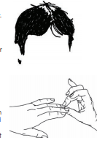
• A watch may be quite a handy tool for
a housekeeper to assist him/her with time keeping
• Chains around the neck, dangling earrings
and loose bracelets are usually not allowed, as they may pose a safety risk.
• Some establishments only allow basic day make-up to be worn by housekeepers – for the sole purpose of looking neat and tidy
• Be careful of very strong smelling perfume as the smell may hover in the guest room long after you have left and may not necessary be pleasant to the guest.
Use the following Personal Presentation Checklist to assess yourself:
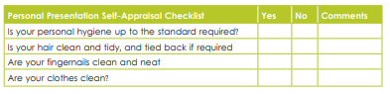
1.7 PERSONAL HYGIENE
Personal hygiene is important in all areas of the establishment, even in the housekeeping department. Your personal hygiene not only affects you, it affects others too!
Personal hygiene practices in the workplace
Good personal hygiene practices can be facilitated in the workplace by:
• Proper and sufficient changing rooms, basins with soap, hot and cold water, paper towels, hot air dryers etc • Clean laundered uniforms
• The use of disposable gloves where necessary
• Ensuring that you know what is expected of you interms of personal hygiene standards and practices
The key rules to good personal hygiene
There are five basic rules for personal hygiene:
1. Practice personal cleanliness If you carry dirt on your
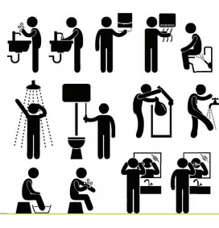
body or if you have not showered for some time,
bacteria will start growing on you in this dirt.
You could also smell stale and sweaty, which is
not pleasant for guests or your colleagues.
The following rules of personal cleanliness are important:
• Shower, bath or wash thoroughly every day
• Keep hair and nails clean and neat
• Brush teeth at least twice daily and use a breath refresher as needed throughout your shift (especially smokers)
• Always wear clean clothes
TRAVEL TO WORK IN HOME CLOTHES
• As previously mentioned, when you arrive at work, you are carrying a lot of bacteria and dirt with you on your clothes and possibly shoes. It is best to wear street clothes to work, wash if necessary and then put on a clean uniform before going on shift.
• Low-heeled closed shoes will protect you against potentially dangerous chemicals and machinery. They will also help you to move quickly and efficiently around your workplace.
• Most establishments require their housekeepers to wear clean socks, flesh-coloured stockings or tights to maintain a professional hygienic appearance.
WASH YOUR HANDS
It is important to wash your hands in order to prevent bacteria spreading from you to the guests, from one guest room to the next etc. Wash your hands every time you:
• Have used the toilet
• Blow your nose or use a tissue/handkerchief
• Cough or sneeze
• Have handled food
• Have handled rubbish
• Have smoked
• Take off gloves
• Have been in contact with any possibly contaminated items or areas e.g. condoms, toilets etc.
• Move from one room to the next
AVOID BAD HABITS
Bad habits like smoking, drinking and addiction to narcotic substances
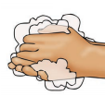
have a negative effect on your health and
appearance. Smoking causes bad odours,
smelly breath, stained teeth, chronic coughing,
yellow fingernails etc., all of which can be
detrimental to your work ability and
professional appearance. Other bad habits may
Include:
• Scratching your body – any areas
• Picking pimples or sores
• Wiping your hands on your clothes
• Continuously wiping your hands on your uniform/apron may
cause three things to happen:
- Your uniform/apron will get wet and be an ideal place for bacteria to grow
- You will deposit dirt and bacteria onto the uniform/apron
- You will transfer bacteria and dirt from your apron to the area you are working in and the items you handle.
These bad habits are not only detrimental to your own health and the satisfaction of your guests, but also cause unhygienic conditions, as bacteria spreads more readily.
General appearance and posture You need to be confident at work and looking and feeling good comes from taking pride in your appearance, and most importantly, your attitude to your appearance.
Remember:
A good appearance creates a good impression.

Maintain a good posture. When you are talking to a colleague or guest, remember to stand up straight, look professional and be positive. Do not slouch, lean against something or fidget with equipment or your hands.
ILLNESS AND INJURIES
You should be in good health from oral hygiene to general fitness. If you are physically sick or if you are injured in any way, it is important to check if you are fit for duty and whether there is a risk of your condition affecting your work as well as the safety and welfare of your colleagues and guests. Establishments also have policies in place with regards to coming to work if you can spread any infections to other staff or guests.
Injuries like cuts should be properly covered so as to prevent more bleeding and oozing of puss, as these body fluids may be contaminated with harmful bacteria. It is also true that a guest would not be very impressed to find a bloody fingerprint on his/ her pillow, for instance.
1.7.1 CHARACTERISTICS OF HOUSEKEEPING PERSONNEL
Housekeeping staff should have the following valuable characteristics: Tact, diplomacy and discretion
• Etiquette and good manners
• Politeness and civility
• Pleasing personality
• Honesty and dedication
• Willingness to be of genuine service
• Attention to detail
• Good Communication Skills
• Efficient
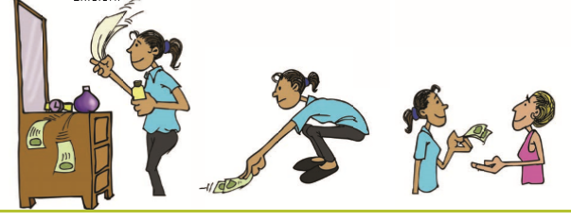
1.8 COMMUNICATION
Communication is the exchange of thoughts, messages or information. It is vital to the success of the restaurant or hotel business since it is only through effective communication that we can offer guests the services.
COURTESY AND COMMUNICATION SKILLS
The image that you present to the guests reflects on the hotel. You must always be polite and helpful towards guests in order to promote your hotel positively.
Your hotel will have guidelines about how you should approach guests. However, here are some general guidelines with regards to courtesy:
• Always greet guests politely. Smile at them and use their surname if you know what it is.
• Remember to be courteous – always say ‘thank you’ and ‘please’, and excuse yourself if you need to interrupt guests.
• Do not stare at guests or pass comments on their appearance, race, colour or religion.
• Be aware of guests’ body language. Don't stand too close to them if they appear to be uncomfortable. If they are in the room when you clean it, be aware of their personal space. Try to be as unobtrusive as possible.
Say “thank you”, “good morning” and “have a nice day” sincerely and in a friendly way.
If you are a cheerful, patient person with a good sense of humour, it is probably natural and easy to relate to people, no matter who they are. On the other hand, if you are shy it may be more difficult. Talkative people also have to be careful not to chat too much to guests.
As a housekeeper, you will be communicating with the following two groups:
1. Customers/guests – be polite, friendly and helpful
2. Colleagues – be polite, appropriate and efficient.
If you communicate well:
• Customers will experience a better quality of service
• Employers will have more business (through more guests using the establishment)
• All staff members benefit through teamwork
There are two main types of communication:
1. Verbal communication
2. Non-verbal communication
VERBAL COMMUNICATION
Verbal communication takes place when people speak to each other. Speech has certain characteristics which will affect the message that is being spoken:
Volume – loud speech may sound bossy, very quiet speech cannot be heard.
Tone – use warm tones without sounding over-friendly. Cool tones are very unwelcoming.
Pace – fast speech is not easy to follow, but very slow speech makes the speaker sound stupid, or gives the impression that he or she thinks the listener is stupid. Speak at a reasonable pace so that the other person has a chance to understand
The effect of speaking in any particular way will be modified or enhanced by the body language the person talking is using. A warm smile accompanying ‘Have a nice day’ will turn in a genuine greeting. Looking directly at the person who is being spoken will indicate a real interest in communicating the message (and make it easier to understand).
Communicating with guests who speak another language is difficult, so non-verbal communication is useful in these cases.
NON VERBAL COMMUNICATION
There are two kinds of non-verbal communication: Signs and symbols: for example pictures, or notices such as ‘no entry’
Gestures and expressions: hand signs, expressions or body language that can help to convey a message. You can learn to communicate better with your guests if you learn to recognise some of these.
• Facial expressions - a smile, a frown.
• Gestures - movements of hands and body to help explain or emphasise the verbal message.
• Body posture - how we stand or sit.
• Orientation - whether we face the other person or turn away.
• Eye contact - whether we look at the other person and for how long.
• Body contact - arm around the shoulder, a handshake.
• Proximity - the distance we are from a person.
• Non-verbal aspects of speech - tone and pitch of voice.
• Head nods - for encouragement, indication of agreement or disagreement.
• Appearance - dress and grooming.
These non-verbal clues are important as they can be used to improve the quality of communication.
They can be used to reinforce any verbal communication; for example, leaning forward and looking at the person you are speaking to and smiling naturally.
Your expressions, posture and appearance must be appropriate and should tell the guest that you are professional, competent and willing to help.
Communication takes place in mainly three different ways:
1. Talking and listening face-to-face and on the telephone
2. Writing and reading messages, forms etc.
3. Through body language including facial expression, gestures, eye contact or looking away/looking at the floor and how close you are to a person.
Definition: Body Language
The form of communication that takes place without words. Includes: facial expression, gestures, gaze (looking directly at the face of the person who is talking or listening) and space (keeping a certain physical distance from the other person, or using other barriers such as sunglasses, folded arms, a table Listening

People feel at ease and valued if they know they are being listened to. They will feel more confident and able to make their needs known. The listener gains too, learning more about the person talking –forming better relations with colleagues and providing better quality service to customers.
Listening involves more than just hearing what someone says. It is an active process:
• Full attention must be given to the speaker. It is no good letting the mind wander, or getting distracted by things going on around you
• Show interest in what the speaker is saying.
Avoid interruptions or attempts to disagree with the speaker.
• Identify the important things the speaker is saying but ignore interesting but irrelevant details.
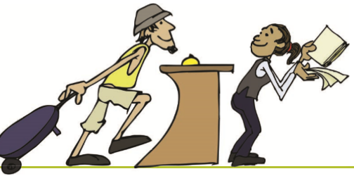
• Take action on what has been said.
If necessary make notes or fetch
other staff so they can take
actions. Listening also involves taking
notice of
the body language the person is using.
For examples:
• Yawning might that the person is
bored or tired
• Looking at the time might
suggest boredom,
or else that the person is in a hurry.How fast or slow, loud or soft, warm or
cold the person’svoice is and its pitch (high or low)will give further clues to what is being said.
For example: • Speaking softly
can suggest a desire for confidentiality or nervousness
• Speaking hesitantly can suggest unease or indecision.

PROVIDING INFORMATION TO GUESTS
Guests may ask you for hotel information and information about the area e.g. travel and tourism information. Housekeeping staff should be able to answer these where possible.
General guidelines and tips about communicating with guests and colleagues:
• Be brief and to the point. Colleagues and guests don’t want you to waste their time giving long-winded explanations
• Customers will expect you to be helpful and courteous, but not so chatty that they get bored or wonder why you aren’t getting on with your job
• Use commonly understood words
• Pick a time when the person can pay attention to what you are saying.
• Don’t talk at the same time as someone else, or try and deliver an important message when someone is using a noisy machine, or standing at the top of the ladder
• Pay attention to what is being said in reply. Look at the face of the person directly: it is far easier to understand words if you can see facial expressions.
• Ask for a message to be repeated if you think you have missed important information
• Read back important messages, for examples the numbers of the rooms you have been asked for service, quantity of cleaned linen to be collected, etc
. • Use controlled, carefully thought-out gestures where you think they will help to get the message across
Remember that it looks unprofessional to stand and gossip to other staff members.
RESPONDING TO SPECIAL NEEDS
You will at some time or another come across an unusual request or a guest with special needs. Here are some examples and guidelines on how to deal with these:
• Disabled or elderly guests may appreciate help – to hang up clothes, or to fill in their laundry form
- A guest in a hotel room who is obviously not well may appreciate being told where the nearest chemist is or the phone number of a local doctor
- Parents with restless children might be told about the leisure centre in the hotel/ town or the opening hours of the hotel pool
- Business travellers often need to press their clothes or to get skirts and blouses laundered very quickly, and might be pleased to borrow an iron and ironing board or know about the express laundry service
- Students in town for a student conference or exams may be studying late into the night and prefer their room to be cleaned later in the morning or on another day if the cleaning schedule can be re-organised.
1.9 GUEST COMPLAINTS
Complaints must be handled correctly as they can affect the business reputation and income. Guests whose complaints are not handled correctly usually do not return to the hotel.
Complaints will occur, but if handled correctly and efficiently, a scowl can be changed into a smile. Indeed, the guest may even apologise for bringing the complaint to someone's attention.
DEALING WITH COMPLAINTS
The term complaint means "to express resentment or displeasure" or "to make a formal protest".
A complaint may be totally unrelated to the member of staff personally, or to their job but the guest will still expect them to solve the problem brought to their attention. The challenge is to treat guests with complaints properly so that instead of being dissatisfied, they become loyal, satisfied guests.
In dealing with complaints, it helps to first, understand why guests complain.
WHY DO GUESTS COMPLAIN?
• The quality of the product or service was unacceptable, e.g. the room is not properly clean, they have no towels, etc.
• The guest feels that nobody cared about them - no greeting, long delays, no eye contact, etc.
• The guest got frustrated with the way they were treated - slow or poor service.
• They have some problem with the room, it is too noisy or some appliance is not working properly.
In some instances the complaint may quite extreme. In these situations you should call your supervisor to help.
WHAT DOES THE GUEST EXPECT?
When a guest complains they expect to be
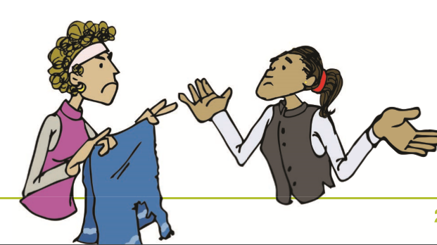
treated courteously, for example:
• They want a satisfactory outcome or
result.
• They want to be believed.
• They want someone to take personal
responsibility and make any necessary
decisions to rectify the situation.
• They do not want to be passed from
one person to another.
- They want to believe that the company or
establishment values them.
- They want to believe that the problem will not happen again.
- The last thing they want is an argument.
- Guest complaints represent a wonderful opportunity, rather than a threat. Handling complaints represents a great opportunity to retain and even improve guest goodwill. At the very least they represent opportunities to find out more about guests' needs and also to improve products/services for the future. Complaints are an opportunity to 'right a wrong'.
1.10 HANDLING GUEST COMPLAINTS
- It is important that hotels and you personally have a positive policy on complaints - make them work for, instead of against, the organisation. By using a structured approach it is more likely to achieve a result that is acceptable to both the guest and the company. Look for signs of discontent before they turn into complaints: a spare blanket on bed over the bedspread could infer that the guest is cold. If a guest is pacing up and down the corridor looking for someone, find out what is wrong and try to help.
- Proper handling of a complaint builds goodwill. When a staff member has succeeded in regaining the guest's confidence, he/she should tactfully try to turn the opportunity to promotional advantage, e.g. the staff member may say that he/she is looking forward to the guest's return visit.
When dealing with a complaint: learn to take the “HEAT” process
Use a 4-step process to handle guest complaints:
  - Hear them out: listen and do not interrupt. Do not say "That's not my job" or "You'll have to talk to the manager". Let the guest tell the whole story. Don’t interrupt; it is easy to jump to the wrong conclusion because you haven’t heard all the details.
  - Empathise: make them know that you understand their anger or frustration
  - Apologise without admitting liability. Do not make excuses. Do not blame another person or another department.
  - Take Action: rectify the problem. Handle the complaint personally if possible, but get help from your supervisor if the problem is outside your area of responsibility. Offer alternatives but know the hotel policies and do not offer something a staff member cannot deliver. Try to turn the dissatisfied guest back into a satisfied guest, i.e. turn a complaint into a compliment.
Then:
  - Thank the guest for bringing the matter to your attention. Record the complaint and pass on to supervisor or line manager.
Here are some more tips on how to deal with guest complaints:
  - If a problem arises that you cannot solve, don't waste the guest's time. Call the supervisor to help you
  - Never dismiss guests’ requests. Tell them if you are unable to help them and offer to find the information that they require
  - Be patient when dealing with a difficult guest or a guest complaint
- Keep calm. Your job is to put things right, not to wriggle out of an awkward situation
- Thank the guest for bringing the problem to your attention
- Remember customers who complain may well be angry. Don’t make the situation worse by getting angry or frustrated yourself. Speak calmly and clearly and try not to forget that it is the situation that I the problem – not you.
- Never use coarse language or slang when you speak to a guest or to someone else within hearing of a guest.
COMPLAINTS ARE SALES OPPORTUNITIES
- An important point to remember about complaints is that they represent an opportunity and not a threat.
- Complaints, if received with the right attitude and handled properly, can be a valuable source of information. There can be an opportunity to find out how the guest sees you, and what they think of the products. This information obtained free of charge by listening to your guests' complaints and can help you to provide a better service. Proper handling of a complaint, verbal or written, builds goodwill. When you have succeeded in regaining the guest's confidence, you can then tactfully turn the opportunity to your advantage.
Every complaint:
- Provides a chance to resolve the situation and regain the guest's goodwill.
- Can provide information/feedback on the operation, from which staff can benefit.

      - MODULE 2
    - PRINCIPLES AND PRACTICES OF CLEANING

- 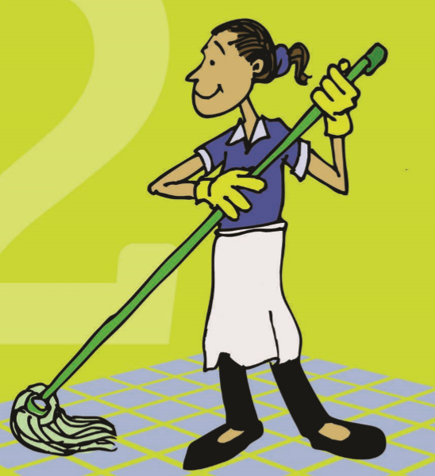

2 INTRODUCTION:
- Principles and Practices of Cleaning
- This module gives information about cleaning, cleaning processes, practices and equipment required for cleaning and how to use them in the daily work of a hotel according to the best practices applied in the industry.
2.1 DEFINITION OF CLEANING
- Cleaning means removing impurities, dirt and stains. In housekeeping, it relates to keeping and maintaining all areas, equipment, machinery, furniture, tools, and linen free from dust, impurities and unsoiled.
2.2 DEFINITION OF SOILING
Soiling can occur in many ways, but dirt usually comes into the building through windows, doors, on people's clothes, feet, baggage or dirty equipment. It can also be caused through using poor cleaning methods, stains, tarnish, fumes and smoke.
Even cleaning agents can cause soiling if they are spilled or splashed. In order to control soiling, you should always be aware of the cleaning utensils and liquids you are using and their uses and be careful never to spill them. If you do see spills or splashes then clean these up quickly.
Be aware of open windows and doors where, for example, rain could soil curtains or carpets.
2.3 EQUIPMENT AND MATERIALS
To keep the hotel clean and hygienic, various equipment and supplies are used. No work can be done without proper equipment. It is important that the housekeeper makes a careful selection of equipment based on necessity and suitability for use in a hotel industry.
Let’s take a closer look at the items you will be working with. The following section introduces the manual and mechanical equipment used in general cleaning.
MANUAL CLEANING EQUIPMENT
Brushes
The brushes are devices with bristles, wire or other filaments, used for cleaning. There are mainly three types of brushes:
1. Hard brush: have bristles that are stiff and
well spaced. These are most suitable
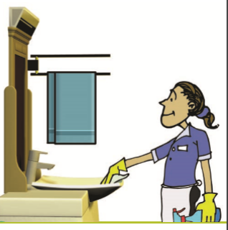
for removal of litter.
Example: upholstery brush, carpet brush etc.
2. Soft brush: have bristles that are flexible
and set close together. They can be used
to remove loose soil and litter.
Example: tooth brush, feather brush, shoe brush,
coat brush etc.
3. Scrubbing brush: can be used to remove
heavy soiling from small areas or by the use of mechanical scrubbing machines, if possible. Example: deck scrubber
- Mops
A mop is a tool generally used for cleaning floors, although when possible it is also used for cleaning other surfaces, for example tiled walls, to avoid unhygienic working conditions. The different types of mops are as following.
1. Dry mop or dust mop: A dry mop or dust mop is designed to pick up dry, loose contamination like dust, earth and sand from the floor surface.
2. Wet mop or moist mop: A wet mop or moist mop is, in professional cleaning, used as a second step in the cleaning of a surface. The wet mop is swept over the surface to dissolve and absorb fat, mud and dried-in liquid contaminations.
3. Hot mop: Wet mop is also called the hot mop, which works on a similar concept to a steam iron. After adding water, it is heated to make the water exude on top of a floor, which can then be cleaned without using a cleaning solvent. These can work best on surfaces where a regular mop would also be used, such as floors, hearths, and laminates.
- Broom
A broom is a cleaning tool consisting of stiff fibres attached to, and roughly parallel to, a cylindrical handle, the broomstick. A smaller whisk broom or brush is sometimes called a duster.

- Melamine Foam
Melamine foam is a foam-like material consisting of a formaldehyde-melaminesodium bisulphate copolymer. The foam, because of its micro porous properties, may remove otherwise "unclean able" external markings from relatively smooth surfaces. For example, it can remove crayon, magic marker, and grease from painted walls, wood finishing, and grime from hub caps.
- Squeegees
A squeegee is a cleaning tool with a flat, smooth and thick rubber blade, used to remove or control the flow of liquid on a flat surface. It is used for cleaning floors and small thin and flexible squeegee is used for cleaning windows.
- Carpet Sweeper
Carpet sweeper is a mechanical device for the cleaning of carpets in place. A carpet sweeper typically consists of a small box. The base of the box has rollers and brushes, connected by a belt or gears. There is also a container for dirt. The arrangement is such that when pushed along a floor the rollers turn and force the brushes to rotate. The brushes sweep dirt and dust from the floor and deposit the particles into the container.
MECHANICAL CLEANING EQUIPMENT
Vacuum Cleaners
A vacuum cleaner uses an air pump to create a partial vacuum to suck up dust and dirt, usually from floors. Most hotels with carpeted floors possess a vacuum cleaner for cleaning. The dirt is collected by a filtering system or a cyclone for later disposal. Vacuum cleaners come in variety of models owing to their usage.

VACUUM
CLEANER

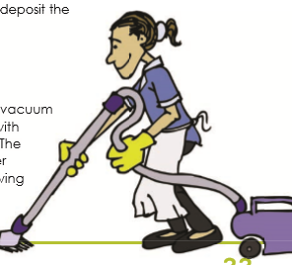
- Scrubbing / Polishing Machines
Scrubbing/ Polishing Machines consist of one large or several small brushes which revolve and scrub the floor while water and detergent are released from a tank attached to a machine. With suitable brushes this versatile machine can be used for shampooing carpets, polishing, spray buffing, spray cleaning or polishing floors
SELECTION OF EQUIPMENT
As equipment is expensive, their selection is of the utmost importance. The correct choice and quality of equipment could save costs due to break-downs, reduce fatigue and thereby demands on labour as also ensure efficiency in overall operations. In determining the purchase of equipment, the following needs to be kept in mind. Quality of equipment by usage history in other organizations. Reliability of supplier to meet time deadlines. Transportation on time to replenish stocks/replacements. Equipment should be light, well balanced and easy to manipulate. Availability of future stocks. Sturdiness in terms of usage. Cost factors.
2.4 CLEANING AGENTS
The purpose of any cleaning process is to remove dust and dirt. Some surfaces can be cleaned by dusting and vacuum cleaning when the dust and dirt form lose particles on the surfaces.
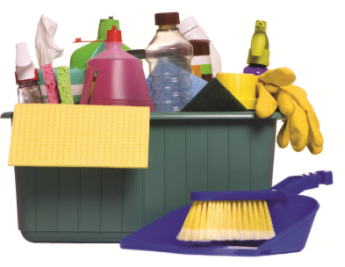
Cleaning Agents are substances, usually in liquid form, that are used to remove dirt, including dusts, stain, bad smell and clutter in solid surfaces. Purposes of using cleaning agents include health, beauty, elimination of offensive odour, and to avoid the spreading of dirt and contaminants to oneself and others. Some cleaning agents can kill bacteria & other microbes and clean at the same time. Cleanliness is a basic need that a hotel must full fill, and industrial cleaning agents are often the easiest, most efficient and economical options available.
Where dust sticks to a surface, cleaning agents must be used to loosen it. Water is the most common cleaning agent; but by itself water will not always loosen dirt. In order to be an effective cleaning agent, you will probably have to use a commercial cleaning agent.
Proper use of cleaning agents
Cleaning Agents | Uses | Brand
Water | • Use with some other agent, e.g. detergent for best results
Acids  • Lemon juice  • Vinegar  • Toilet cleanser | •Removes rust marks and tarnish from metal.  • Cleans toilet bowls
Alkaline cleaners  • Baking soda  • Ammonia  • Bleach | • Stain removal  • Cleaning enamel and porcelain  • Softens water. Cleans drains  • Removes heavy grease  • Removes grease stains  • Whitens and removes stains from fabrics and also in toilet bowls and sinks. Also a disinfectant. | Johnson Diversy  Piyus  Percloroeathling
Detergents  •Liquid  e.g.Washing-up liquid  • Powder  • Soap bars  • Synthetic detergents | Washing floors, walls and bathroom tiles. Cleans most hard surfaces. Washing crockery.  • Washing clothes.  • Washing hands  • Multi-purpose cleaner: contains both a sanitizer and detergent, and is diluted into a cleaning solution with water | Lysol, Vim bar, puja saboon
Abrasives  • Scouring powders  • Scouring paste  • Scouring liquid | Cleaning hard surfaces, especially baths, hand basins  • Same as above  • Same as above. | Johnson Diversy
Polishes  • Metal polish: Liquid • Furniture polish  • Paste  • Cream  • Liquid  • Spray | Removes tarnish and polishes metal  • Polishes wood surfaces  • Polishes wood surfaces  • Polishes wood surfaces  • Polishes wood, glass, chrome and bathroom tiles | Brasso
Window cleansers | Cleans windows | Collins
Solvents  • Methylated spirit  • White spirit  •Carbon tetrachloride (dry cleaning fluid) | Removes grease and wax  • Removes grease and wax  • Removes grease and wax | Percloroethylene
Disinfectants, Antiseptics | • Disinfectants kill bacteria. Antiseptics prevent bacterial growth. | • Detol
It is very important, when using cleaning agents, that you follow the manufacturer’s instructions to prevent accidents which occur because of incorrect dilution of chemical. If the solution is too strong, damage can occur to surfaces and to the person using the agent. On the other hand, if the agent is over-diluted then the solution is too weak to clean effectively and more agents will need which wastes money.
Remember the following points when using chemicals:
• Store chemicals away from guests, customers and especially children.
• Store chemicals in a locked, dark, cool storeroom away from heat and direct sunlight. Do not store chemicals near hot water heaters or operating machines.
• Read and follow the manufacturer’s instructions carefully before you use the chemical.
• Use chemicals only in well-ventilated spaces.
• Keep your face away from the chemical you are using — avoid breathing in fumes as some of these can burn you and make you feel sick, dizzy and even unconscious.
• Make sure that bottles of cleaning agents are clearly marked, and that chemical containers are not used for any other purpose, like storing food.
• Never use chemicals near an open flame or while you are smoking.
• Protect all parts of your body while you are using undiluted chemicals and even then, take care. • Wear protective clothing such as rubber gloves and safety footwear.
• Keep your mind on what you are doing — one mistake and the chemical could spill and injure you.
• Avoid splashing cleaning agents, as they can land on your skin and burn you.
• Wash your hands after using cleaning agents.
• Keep your hands away from your face — swallowing small parts of some cleaning agents can burn your mouth and throat.
• Replace caps tightly immediately after use
• Do not decant cleaning agents
• Do not incinerate (burn) any empty aerosol cans as they explode • Never mix chemicals, such as bleach with acid toilet cleaner
Remember: Chemicals are dangerous
If cleaning agents are misused they can cause serious personal harm in terms of damage to the skin, fumes which could cause breathing difficulties, or they may create a fire hazard, which may result in loss of life.

2.5 Principles of cleaning and cleaning procedures
Cleaning is an important part of all housekeeping work. Therefore, it must be understood what clean means and the functions involved in effective cleaning.

Did you know?
Clean means: "Free from dust, dirt, stains, marks, cobwebs, grease and other unwanted substance

REASONS FOR CLEANING
Cleaning is an essential function of the housekeeping department as it cleans the environment in which the guest stays for a period of time, i.e. the room. The cleanliness of the room will usually form the guest's perception of the hotel as a whole, so it is important to understand why cleaning is necessary. It helps:
• To improve the appearance and enhance the image of the hotel to guests.
• To preserve the condition of the fixtures, fittings and fabrics in guest rooms by removing stains and marks.
• To ensure and maintain a high level of hygiene which reduces the risk of disease and germs.
• To reduce safety and fire hazards such as open windows, burning cigarettes or electrical goods left switched on.
Cleaning Frequencies
Different types of cleaning should be carried out at differing frequencies which are dependent on:
• The type of soiling
• The amount of soiling
• How busy the area is
• How well an area was last cleaned?
• Special circumstances, e.g. VIP visits or the weather
• Equipment available
• Cleaning agents available
• Staff available
• Capabilities of staff
• Location to be cleaned
• Age of item to be cleaned
• Design of item to be cleaned
• Costs of cleaning, i.e. the budget
• Change of routine due to management policy decision.
The various cleaning frequencies are:
• Daily - toilets, floors, occupied rooms
• Weekly - door frames, skirting
• Periodic - carpet shampooing, floor polishing
• Check/clean (as many times as required) - ashtrays, table tops
The area which has to be cleaned will also dictate how often or what type of cleaning must be done. For example, public toilets may have to be checked many times but only actually cleaned if dirty.
2.5.1 DIFFERENT CLEANING TECHNIQUES
There are many different cleaning methods. Therefore, it is important for you to be able to choose the correct techniques and methods for specific tasks. The most commonly found dirt and dust are removed by:
Washing - water and a cleaning agent
Friction - using an abrasive
Suction - using a vacuum cleaner or wet pick up machine
Force - using pressurised water
Dusting - using duster to clean
The method chosen will depend on the type and amount of dirt and the surface to be cleaned, as it may be damaged. It is important to use the correct techniques, i.e. there is no point in dusting a deeply ingrained stain, or wiping a bath when friction would be a better method to remove the dirt.
Never use dirty water to clean. Dirty water is the source of many germs and can easily multiply germs and diseases throughout the hotel. Clean water is a cleaning agent but should be used with an additional cleaning agent because of "surface tension".
Did you know?
"Surface tension" describes water’s inability to wet a surface properly. Adding an additional cleaning agent allows the cleaner to get to the heart of the stain through reducing this tension. These are called ‘wetting agents”.

The most appropriate cleaning method should be chosen for the task to be carried out. The main methods are:
1. Damp dusting
This involves taking a clean cloth and dampening it with an all-purpose solution. Take care to wring the cloth in order to avoid drips and streaks, then go over the appropriate surfaces with the cloth. The dampness of the cloth prevents the dust from being scattered and is therefore more effective then dry dusting. Most surfaces can be cleaned in this way.
2. Polishing
Polish is primarily used to protect and nourish wood, especially for wood or antique furniture. You should always follow the manufacturer instructions. Bees wax is sometimes advised instead of spray. However, most surfaces are sealed and therefore polish is not effective or even required - damp dusting can be enough.
3. Dry dusting
This is not the most effective cleaning method. It only moves dust around, but does not fully clean surfaces. Only use this method where it is inappropriate to use damp dusting because of the surface.
4. Sweeping
Sweeping has the same effect as dry dusting and is therefore not an effective method of cleaning.
5. Disinfecting
This type of cleaning kills some types of bacteria, but is used mostly to reduce numbers of bacteria to a safe level. Disinfectants are NOT cleaning agents, but are used AFTER thorough cleaning of a surface.
6. Suctioning
This is the most effective type of cleaning, as dust is sucked into a bag and can be disposed of easily.
Floor cleaning methods Cleaning floors and floor coverings 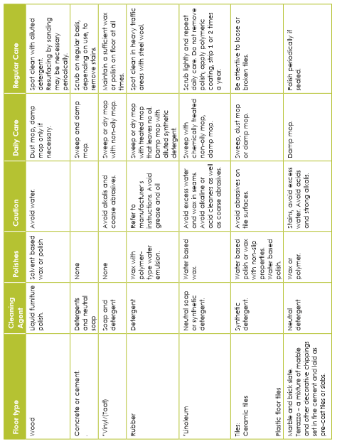Floor surfaces must be cleaned often but it is important to understand that there is a variety of floor surfaces found in a hotel and that each one has different cleaning implications.
HARD AND SEMI-HARD FLOOR COVERINGS
It is important when cleaning floors to remember to always use clean hot water as well as clean cloth and containers.
CARPETS
Different types of carpets to be added Correct care of carpeting is very important as carpets are expensive, and, unlike tiled floors or other hard floors, need to be replaced. The better they are cared for, the longer they will last, thereby saving replacement cost.
Maintaining carpets in top condition will require cleaning using water, foam or steam. It is vital that this type of cleaning is performed appropriately to prevent damage. Leaving excessive water on carpets after cleaning must be avoided because this could:
• Increase the re-soil rate
• Lead to shrinkage or seam splitting
• Formation of mildew and carpet rot
• Cause discoloration, i.e. browning.
DAILY CARE
Superficial dust and crumbs can be removed with a carpet sweeper or vacuum. Dirt and other soiling in the pile can be removed with a suction cleaner, i.e. vacuum cleaner.
• Blot up liquid spills with clean absorbent paper.
• Spot clean semi-soiled or greasy materials then wipe the affected area with a damp cloth. Remove any residual stain using solutions appropriate for the nature of the stain.
• Spring cleaning to be added in the relevant topic • Daily care and regular care to be merged
WEEKLY CARE
• Clean the carpet edges. Brush then vacuum with nozzle attachment. Thoroughly vacuum the whole carpet area, this will require furniture to be moved, e.g. under beds, couch etc.
Thoroughly vacuum long pile carpets, e.g. shag pile. Shag pile carpet must be vacuumed in 4 directions to ensure thorough cleaning. If the pile is very long it may need to be raked with a rake.
• Spot clean as required to remove marks and dirt before stains set. This will reduce the necessity to shampoo the carpet.
REGULAR CARE
Deep clean the carpet using a method appropriate for the carpet. The deep cleaning method used will depend upon the equipment available in your workplace and organizational requirements. Deep cleaning can be performed using of the following techniques:
• Foam
• Hot water extraction
• Dry particle extraction.
For each of these, follow the manufacturer’s instructions, or ensure that you have been trained to use the equipment and the cleaning agents that they may need.
Deep cleaning of carpets may be outsourced to professional carpet cleaners.

MODULE 3

GUEST ROOMS, ROOM COMPONENTS AND KEY

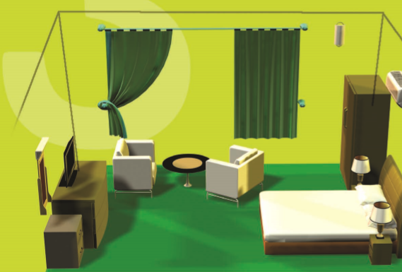

3 INTRODUCTION :
Guest rooms, room components and Key
This module introduces you to guest room and types, the components of the rooms and bed as wells as room keys and key management will be depicted in this module
3.1 TYPES OF ROOMS
Hotel bedrooms come in a variety of shapes and sizes. The types of bedrooms include:
Single Room
A single room has a single bed for single occupancy. It is a standard room having a dressing-cum-writing table.
Double Room
It is a room with one double bed meant for two people. It is a standard room having a dressing-cum-writing table.
Deluxe Room
This room is well furnished, carpeted and more suitable for single persons and small families. Deluxe Rooms are available with Single and Double beds.
Twin Room
A room with two single beds meant for two people having only one bedside table between the two beds.
Studio Room
The studio room is the room for the guest with option of self-catering. It has a queen size bed, air conditioning, fan and screens. There is also a dining area and a seating area.
Suite Room
A suite in a hotel mostly denotes a class of luxury rooms. Suites offer more space and furniture than a basic hotel room. In addition to the standard bed and bedroom fixtures, a suite will typically add a living room, usually with a couch that folds into a bed. Dining, office and kitchen facilities are also added in some suites.
Executive Room
It is larger bedroom with a sitting area provided with chairs and usually sofa. There is a dressing table as well as a writing table.
Duplex Room
A set of rooms not on the same level but it is connected by an internal staircase. Generally, the parlour is at the lower level and the bedrooms are at the upper level.
Interconnected Rooms
Two rooms adjacent to each other having an interconnecting door allowing entry from one room to another, without having to go through the corridor. The interconnecting doors can be opened or locked as per the guest’s choice.
Pent House Suite:
A set of room situated on terrace level, a part of which may be open to sky.
Hollywood Twin Bed Rooms:
A room that has two single beds with a single head board meant for two persons.
Cabana
A cabana room in a hotel is a separate small room that is independent of the hotel. Sort like a small beach cabin. Usually, these rooms are complete with small sitting room, bathroom and sometimes even a kitchenette.
3.2 THE COMPONENTS OF THE GUEST BED ROOM
A guest room consists of the bedroom and the bathroom. The components of the bedroom are floors, walls, windows, curtains, furniture, electrical equipment such as television, hairdryer, kettle etc. You will have to clean and check all these items when cleaning a guest room.
Beds: these will be different sizes: single, double, queen or king sized. They should be the best quality, made to withstand heavy use and must be comfortable. It must be possible to clean under the bed, and to move it for making the bed and for cleaning procedures. Headboards are usually attached to the wall above the bed to prevent greasy marks on the wall from guest leaning against the wall.
Bedside tables: these are on either side of the bed and usually house the telephone, ashtray (if it is a smoking room) message pad and pen, any remote controls for television
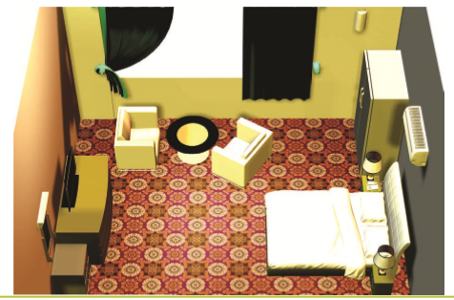
and other similar items. The bedside cabinet must be at the same level as the top of the bed so that guests can easily reach personal items such as books, glasses, and other items when they want to. If there is a door, this should open away from the bed.
Dressing table/desk and stool: these are provided for guests to keep cosmetics, hair brushes and other items. It may also contain drawers for storing clothes. A hair drier may be provided in one of the drawers. A mirror is usually mounted on the wall above the dressing table.
The desk is used for business or writing purposes, and should have access to electricity and to internet ports where these are provided in the hotel. There should be space for paper, documents and so on.
The desk/dressing table should be at the right height with enough clearance for knees when seated at the chair that is provided for it. If it is a desk as well, then the chair must have a backrest.
Luggage rack: these racks are provided so guests do not have to leave their luggage on the floor, and have to bend down to unpack or retrieve items. The rack may be fixed to the wall or may be a fold-up type. You should be able to clean underneath it, or store more luggage underneath it if required.
Storage space for clothes (replace with cupboard): a cupboard is usually provided for storage of the guest’s clothes. This should provide hanging space as well as shelves or drawers. The hanging space should have hangers for guest to hang their clothes – these are usually fixed to the rail so that guest cannot take them home with them.
There may also be a chest of drawers or other small cupboard for storage space for clothes.
Seating: comfortable chairs or a couch may be provided for the guest, depending on the room size and category of hotel. These may have wooden arms and upholstered sections, or may be totally upholstered.
Coffee table: this is often provided with the couch and easy chairs. Lamps: rooms are usually fitted with lamps – often a reading lamp at the desk, a corner lamp, and bedside lamps.
Long mirror: this is needed as many guests like to dress in front of a mirror or at least check their final appearance. The long mirror may be part of the room dcor or may be in the wardrobe door or attached to the back of the room door.
TV: Colour TV is usually provided in each bedroom. A remote control is also usually provided and may be placed on top of the TV, on the desk or next to the bed. The TV is often placed opposite the bed, on the counter that is part of the dressing table or desk.
Dust bins: Dust bins are provided so that guests have somewhere to throw their rubbish.
Mini-bar: Mini-bar comes in the form of a counter and small absorption refrigerator stocked with a precise inventory. The room's guests can take a beverage or snack at any time during their stay. The bar is commonly stocked with small bottles of alcoholic beverages, juice, and soft drinks.
Pictures, wall hangings and other ornaments: these are part of the room dcor, and are usually fixed to the wall so that they cannot be stolen. Deluxe hotels often decorate guest suites with ornaments such as baskets, vases, etc.
Telephone: each room is equipped with a telephone that can dial any of the extensions in the hotel, can dial other rooms and can dial outside the hotel. The telephone can also receive calls, and some can take and store messages that the guest can retrieve themselves.
Refreshment tray: many hotels provide their guests with their own tea and coffee making facilities. This usually consist of a tray with a small kettle, a basket or box of beverage items such as tea, coffee, creamer and sugar, and some cups, saucers and teaspoons. These items have to be cleaned if dirty, and checked and restocked whenever a room is cleaned. Water glasses, jugs, thermos here
Room safes: many rooms have safes for guests to store their valuables such as jewelry, passports or money. Make sure these re clean end checked that the guest has not left anything behind.
3.3 BED TYPES AND LINEN REQUIREMENTS STANDARDS
A variety of different beds are found in accommodation establishments. These include: Twin, King, Queen, Single, Double bed, Fold away bed, Roll away bed, and Hideaway bed
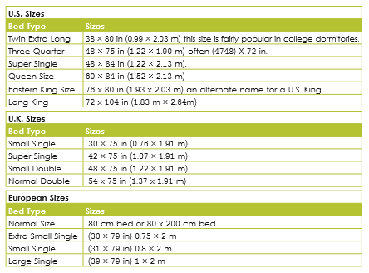

Following tables indicate common bed sizes in the industry
- Baby Cot: requested by guests who have small children
- Roll-away beds: These are used to put an extra bed into a room, often when a family with children is sharing a room. They are on wheels and usually fold up from the middle of the bed.
Beds consist of a base, mattress and headboard. In most hotels, the headboard is not part of the bed, but is mounted on the wall behind the bed, and is usually designed to match the other furniture in the room.
Bed coverings
These are the items that a bed is made up with. Traditionally beds are made up with sheets and blankets, however, duvets are being used in some hotels. Bed coverings, per double bed, include:
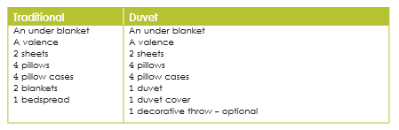
Linen descriptions: Bed Linen is a rectangular piece of cloth or linen cotton used to cover a mattress. It is this sheet that one typically lies on.
o Under blanket: this may also be a mattress protector, and goes under the bottom sheet. It protects the mattress against stains and moisture, adds as soft layer between sheet and mattress and provides extra warmth
o Sheets: the bottom sheet goes onto the mattress, and the top sheet goes on top of that and folds back on the blankets. The top sheet may be under a duvet instead of under the blankets.
o Duvet covers: duvets are put into the covers with minimum handling of the cover to hygiene reasons. The fastening may be at the top or the bottom of the duvet, depending on the pattern. Fastenings should ideally be at the bottom so that they are not uncomfortable for the guest.
o Pillow cases: these are placed on the pillows, the fold must be over the pillow, and placed on the bed with the open side facing the middle of the bed or away from the guest if possible.
o Bedspread: this is placed on top of the made bed, including over the pillows. Depending on the design and decorative effect of the duvet, a bedspread may or may not be put on top of a duvet.
o Valence: this covers the mattress base, and is sometimes called a base cover or night frill.
Bedding elements: Bedding elements include blankets, duvets and pillows set.
o Blankets: these may be made of wool or synthetic material. Wool is warm, but can be scratchy and is difficult to launder. Most establishments use acrylic blankets.
o Duvets: these may be made of synthetic filling (polyester) or natural materials such as down or silk. (Down is a luxury filling, however, it is not often used in the hospitality industry because it is very expensive and also guests may be allergic to it.)
o Pillows: these may be made of synthetic filling (polyester) or down
3.4 KEY AND KEY CONTROL
Safety and security of the guest are crucial elements in the hotel. It means that all the public and non-public areas are well secured with appropriate measures. Often this is assured with different types of key systems. In the hotels you often find keys that are allocated for the guest rooms, public areas and restricted areas and managed by respective department.
Key
A key is a device, which is used to open a lock. A typical key consist of two parts: the blade, which slides into the keyhole to unlock the door, and the bow, which is left protruding so that torque can be applied by the user to open the door. The blade is usually designed to open one specific lock, although master keys are designed to open sets of similar locks.
Types of Keys
Most lodging properties use at least three types of keys.
These types typically include emergency keys, master keys, and guestroom keys.
Emergency Key
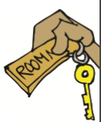
The emergency key opens all guestroom doors, even
when they are double locked. It can be used,
for example, if you enter a room when the guest needs help and is
unable to reach or open the door. The emergency key
should be highly protected and its use strictly
Controlled and recorded; it should never leave
the property. One procedure for emergency keys is to have them locked in a safe or safe deposit box and signed out by the individual needing one. The log should be dated and signed by the individual taking the key.
Master Key
A master key is designed to open a set of several locks. These locks also have keys which are specific to each one (the change key) and cannot open any of the others in the set. Locks which have master keys have a second set of the mechanism used to open them which is identical to all of the others in the set of locks. A master key opens all guestrooms that are not double locked. Depending upon the need, the master key may be further established as a housekeeping staff master key, a floor supervisor master key, and a grand master key for management purpose.
- Grand Master Key: Key operates all locks in the Hotel. Including laundry and linen rooms
- Floor Supervisors Master Key: Key operates all sections on the floor/ floors supervised by the particular supervisor.
- Housekeeping Staff Master Key: Key operates all rooms serviced by particular room maid or housekeeping staff.
The above keys will not open the lock when the Guest has Double Locked it from inside. From a security point of view, master keying is undesirable; but from a practical point of view, however it is necessary. A master key presents two security drawbacks:
• First is the danger that if a master key is lost or stolen, several locks in the system would be compromised, thus providing access to all those locks.
• Second is the loss of master key.
Guest Key
The hotel guest room key is normally issued to open only one room for which it was intended, viz. individualised key for each lock. If the guest room lock is in shut-out mode the guest room key can neither open it nor lock from outside of the room.
KEY CONTROL SYSTEM
• Security of keys is essential from the moment they arrive on site. Keys should be stored separately and securely.
• No unauthorised person should be allowed access to any key, either to examine or handle it, since a photograph or impression can be taken in few seconds and duplicate subsequently made. Keep a log book of all keys signed out.
• Establish protocol for distribution of keys.
• Use keys that do not identify the property’s name, address, logo or room number. Perform an annual key audit
• When keys are lost or stolen, the locks should be changed or rotated to another part of the property. Authorised employees should remind guests to return keys at check-out.
• The loss or suspected compromise of a key should be reported immediately and, after due investigation, a decision be made as to whether or not the lock should be changed. Place well-secured key return boxes in the lobby, at exit points of the property, and in courtesy vehicles.
LIMITATIONS OF METAL KEY
Metal keys require a hotel to maintain an elaborate key control system with daily inventories of master key and E-Key checkout logs for the staff. The guest has no way of knowing that an adequate key control system is in place. Metal keys can be easily duplicated. And if a master key is duplicated, the security of the rooms is seriously compromised. If a room key or master key turns up missing, the affected locks must be changed. This incident creates an on-going maintenance problem and expense for a hotel.
Key-Cards
Metal room keys are being replaced by electronically coded key-cards. A key card, while not actually considered a key, is a plastic card which stores a digital signature that is used with electronic access control locks. It is normally a flat, rectangular piece of plastic and may also serve as an ID card. There are several popular type of key cards in use and include the mechanical hole card, bar code card, magnetic stripe card, smart card (embedded with a read / write electronic microchip) and RFID proximity cards. Key-cards have the capability of being randomly coded at the point of registration, which re-emphasizes the guest perception of room security. Key-card control is computer-based and therefore creates the necessary audit trail automatically. Master keys can be changed in a matter of a few keystrokes and lost key-cards are easily removed from the system. One of the best security features is the ability of the computer to investigate each door lock and get a printout of everyone who accessed a particular room. This dramatically cuts down on theft from the rooms by hotel employees. The security advantage of the key-cards has made it popular and many medium and large sized hotels are adopting this key-card system.

MODULE 4

HOUSEKEEPING TROLLEY (MAID CART) MANAGEMENT, GUEST ROOM CLEANING AND HAND OVER PROCEDURE

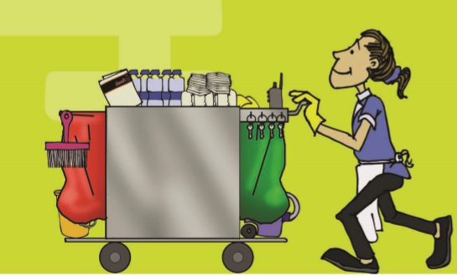

4 INTRODUCTIONS: HOUSEKEEPING TROLLEY (MAID CART) MANAGEMENT, GUEST ROOM CLEANING AND HANDOVER PROCEDURE
This module is for housekeeping trolley management and guest room cleaning procedure. It also talks about the room inspection and shift handover procedure.
4.1 FUNCTION OF HOUSEKEEPING TROLLEY (MAID CART)
It is important that you know the common features of the trolley. Trolleys are mobile metal carts with buffer wheels at the side which prevent damage to walls and wallpaper. They are designed to carry clean linen and fresh supplies to guest rooms. A "dirty linen" bag and a container for rubbish are also part of the trolley
. 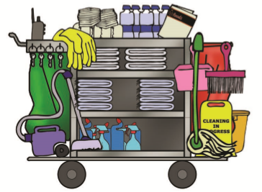
Before you begin to service the bedrooms in your section, collect all the linen, cleaning equipment and supplies you will need. The trolley usually contains items such as:
• Refuse bag (folded or attached to the trolley)
• Disposal bag
• Small plastic bag for used soap, attached to the side
• Cleaning agents (detergent, Dettol, harpic, polish, chemicals etc)
• Cleaning equipment (commode brush, carpet brush, shampooing machine, duster, etc.)
• Toilet brush
• Toilet cloth (for use on toilet bowl only)
• Glass cloth (for drying glasses)
• Floor cloth
Also, collect guest supplies and have them available on the trolley:
• Notepaper/envelopes
• Ballpoint pens
• In-house sales material
• Shower caps
• Toiletries, such as, shampoo, lotion etc.
• Sewing kits
• Water glasses
• Ashtrays
• Candle
• Matchbox
• Sanitary pad
• Bed cover
• Toilet rolls
• Laundry and dry cleaning list
• Shoes shine
You should also stock the trolley with linen according to the number of departures, plus one or two extras, to allow for changes or damaged linen. Linen includes:
• Single and double sheets
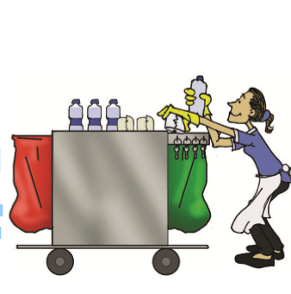
• Pillow slips
• Bath towels
• Hand towels
• Bath mats
• Wash cloths
(if provided)
• Spare under blanket
Setting up the trolley
It is important to have a neat and clean trolley which is easy for you to use and projects a professional appearance to guests. Stack the linen on the shelves of the trolley with folds facing outwards. This makes it easier to count and hygienically remove linen without handling it very much.You should also attach a bag; for soiled linen to one end of the trolley; and a refuse bag to the other. Set up all items on shelves of the trolley so that they will be convenient to reach and easy to use.
Using the Trolley
When in use, place the trolley outside the room where you are working in order to prevent unauthorised persons entering the room. Do not bump the trolley against walls or doors. Watch out for safety hazards resulting from untidy trolleys.
• Do not block fire doors or exits with the trolley.
• Empty linen bag and rubbish containers regularly.
• Do not overload trolley.
• Soak all cigarette ends in water before putting into rubbish container.
• Be careful not to collide with people or trays when moving trolley.
• When you have finished using the trolley, make sure that you empty it, dust the shelves, frame and handles and store correctly.
• Restock the trolley and store in a service area but not in a fire exit or doorway.
4.2 EFFICIENT ROOM CLEANING
The key principles to remember when cleaning rooms efficiently are:
• Work systematically: Save yourself as much time and energy as possible by organising your work routine.
• Work hygienically: Save yourself and others from infection.
• Be observant: Look at the room from the guest's perspective.
• Use a checklist: Make sure that you have remembered everything.

4.2.1 SEQUENCE FOR CLEANING AND SERVICING A GUEST ROOM
Cleaning and servicing are two different elements of making up a guest room.
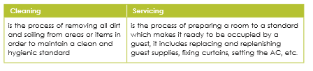
CLEANING SERVICING
is the process of removing all dirt and soiling from areas or items in order to maintain a clean and hygienic standard is the process of preparing a room to a standard which makes it ready to be occupied by a guest, it includes replacing and replenishing guest supplies, fixing curtains, setting the AC, etc.
The basis sequence for cleaning a guest room is explained below. While most of the elements will be the same in all hotels, some hotels may require that some things are done slightly differently. You will have to learn the specific procedures in every hotel.
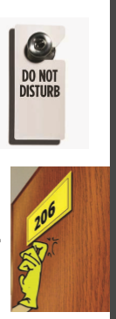
1. Collect materials and prepare for cleaning:
• Linen
• cleaning agents and materials
• Supplies
2. Enter the room appropriately
Observe if there is a Do Not Disturb sign on the door
and respect the guest’s wishes and return later to clean the
room.
You should never knock if there is a Do Not Disturb
sign on the door.
If the sign is still there towards the end of your shift,
report it to your supervisor, who will advise you about the
room.
Never disturb airline crews. Your supervisor will advise you which rooms numbers are occupied by airline crews and what to do about these rooms.
Knock on bedroom door before entering and announce your arrival, "Housekeeping service". Do not knock with the key, as it will mark the door and makes too much noise. Knock gently, but firmly with the knuckles of your hand. If the room is still occupied you should apologise to the guest and say that you will call back later, then proceed to the next room. Knock at least three times before assuming that the room is unoccupied – every time calling “Housekeeping service”. If after three knocks, there is still no answer, you may open the door, remembering to say “Housekeeping” again before you step inside.
It is important to follow these procedures to show respect for the guest’s privacy and to prevent an embarrassing situation.
3. Prepare the Room for cleaning and servicing
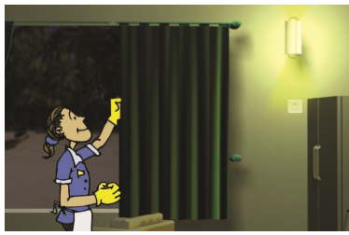
The room cannot be cleaned and serviced before a
few things have been put right. These things are:
Switch the lights on – This helps you to see what
you are doing and allows you to check for light
bulbs that need replacement. Draw back curtains
and open windows– if possible and weather
permitting to allow for ventilation and light into
the room.
Check the condition of the room – take a good look at the room and make a note of any damaged or missing items such as linen or wastebaskets. If anything is missing or needs repair/ replacement, notify your housekeeping
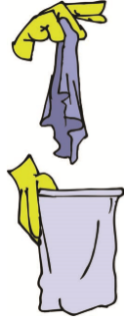
Clear rubbish– collect all rubbish from the room and bathroom.
Empty rubbish bins into the refuse bag on your service trolley.
Also empty ashtrays into this bag, however, take care to douse
any smouldering ashes in ashtrays with water before emptying
into refuse bag. Always be aware that you may come across
sharp objects or needles in the rubbish. Do not handle these
objects unless wearing gloves, but if you do get hurt, go straight to the designated first aid person and report where, how and when the accident happened.
Wash the rubbish bin and disinfect with disinfectant chemical agent. Replace the bin liner (if these are used). Never throw out any items in an occupied room unless it is placed in the waste basket/rubbish bin. Remove dirty room service trays and dirty room crockery and room service items – Follow your property’s procedure for taking care of these items properly. Sometimes the procedure is for these items to be placed outside in the hallway and for the housekeeper to call housekeeping to collect for cleaning. Alternatively, it may be expected of the housekeeper to wash these in the guest bathroom. When replacing ashtrays, remember to replenish the matches too
Linen – remove all soiled linen from guest room and bathroom (including bed linen, towels, etc.) and place these inside your dirty laundry bag on your trolley. Take care with contaminated linen.
Prepare your chemical bucket – add the chemicals and water you might need as well as your cloth, sponge etc. Place the bucket inside the room under the luggage rack to keep your supplies out of the way.
Prepare the bathroom for cleaning – the steps that may be followed when preparing a guest bathroom for cleaning are:
• Flush the toilet with the lid down to remove any residue
• Time, heat and energy (scrubbing) are the factors that help remove body oils and dirt from bathroom surfaces.
• Lift up the lid and seat and put toilet cleaner around the bowl and give it a quick scrub. • Follow this procedure to prepare for through cleaning.
• Leave the chemicals to work.
• Apply all-purpose cleaner on shower and bath areas including the tiles.
• Then use hot water to quickly wipe over the shower area.
Defrost fridge (if applicable) – This is done to stop excessive build-up of ice in the freezer. The steps that may be followed when defrosting a fridge/freezer are: • Turn the temperature control to “off” as soon as you enter the room, as it needs enough time to defrost completely. • Rinse out ice cube tray and refill with cold water. • Wipe out any excess water to prevent quick build-up of ice.
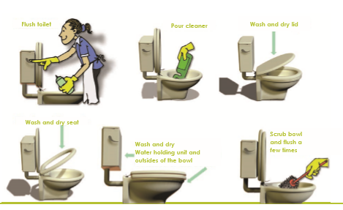

4. Making beds
Each departure room, where beds have been used, must be re-sheeted with fresh linen. In rooms where there is more than one bed, the beds must always be checked for cleanliness even if they appear unused.

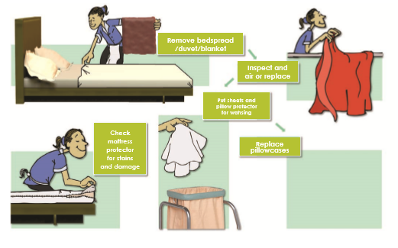

3 Steps to Good Customer Service
1. Greet the guest (Good morning)
2. Listen and understand the request (Two more towels for room 241?)
3. Respond (Here you are.)
CHANGING/MAKING A BED: 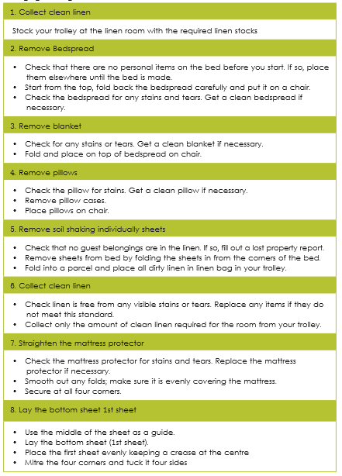

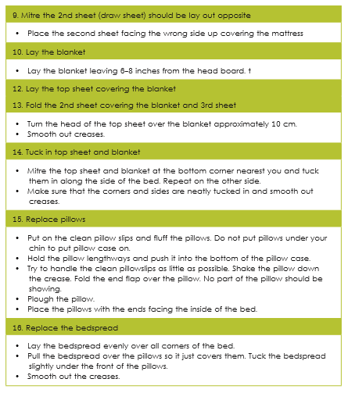

Steps for mitred corners Mitred corners make a bed look smart and neat.
See the illustrations and the description of the process below.
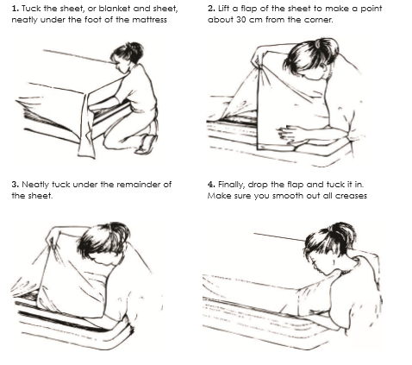
Preparing a VIP Room Rooms designated to VIPs will be listed on the arrival list and are often large executive or deluxe rooms/suites. Hotels will very often have a special policy and procedure for preparing a room for a VIP arrival. This usually entails the provision of extra guest amenities and other items indicating the very important status of the guest.
When setting up the trolley in preparation to clean a VIP room you should remember to include separate special supplies and linen. The additional supplies that may be required include chocolates and liqueurs, complimentary bathrobe and slippers or extra towels. You should also remember that the evening turndown service might be required, at which point, any additional cleaning required may be carried out.
In addition, some VIP rooms may be given a service two to three times a day depending on hotel policy.

Safety when making beds
• While you are performing bed making tasks it is important to work in a way that protects your health and safety.
Remember to:
• Pull the bed out from the wall to enable you to make it comfortably.
• Keep your back straight when pulling out or pushing in the bed.
• Work on your knees when tucking in blankets and mitre corners to avoid the strain of working with a bent back.
CAREFUL:
Mattresses and beds are heavy!

Turning the mattress
The mattress should be turned at least every couple of months or according to organisational requirements. This is an extra duty you will be required to perform from time to time. The mattress is turned to maximise the life of the mattress. This saves on establishment money because mattresses will need to be replaced less frequently. More importantly, customers value a comfortable bed and are more likely to complain or not return to the hotel if they have to sleep in a sagging bed.
5. Clean the bathroom
The reason for cleaning the bathroom before continuing with the bedroom is to allow ample time for dust to settle in the bedroom. Cleaning of the bathroom will be dealt with in the next section on cleaning and servicing a guest bathroom.
6. Cleaning the bedroom
• Dust and polish – This task requires a systematic and organised approach for efficiency and ease. Start from the entrance of the room and work around the room in one direction. This reduces the chance of overlooking a spot. Always begin with the highest spot so that dust doesn’t fall on items you have already dusted. If your establishment uses a dusting solution, spray the correct amount into your dusting cloth – never directly on to items or furniture as this may stain or cause stickiness.
Remember:
• Dust and polish all furniture and light fittings especially light bulbs
• Use appropriate cleaners to polish any surfaces when required.
• Clean and check inside drawers
• Use this time to check the condition of room fixtures and furniture. Fill out maintenance reports if required
Windows and mirrors – use window cleaner and a cloth to remove any dirt. Be careful not to leave streaks on glass surfaces.
• Cleaning floors- clean according to guidelines in
2.4.5. WHEN VACUUMING CARPETS, KEEP IN MIND THE FOLLOWING:
• Before vacuuming, loosen dirt with a broom or rag so it is easier for the vacuum cleaner to pick up.
• Run the vacuum cleaner over all exposed areas of the carpet that you can reach, including under tables and chairs etc. Inaccessible areas that require heavy lifting of furniture (e.g. under beds) are usually cleaned on a team basis. It is still your responsibility to check under the bed for guest belongings, room items etc.
• Start at one point and work through the room systematically.
• Be careful not to bump into any furniture.
Guest belongings – tidy up the guests’ belongings e.g. fold up clothes and place them neatly on the bed, tidy up books and papers, put shoes in luggage rack. Put all room items in their correct position e.g. bible, telephone directories, valet folder ashtrays. Use Extra Thoughtful Care (ETC) and place personal toiletries neatly on a clean face flannel. Put the toothbrush and toothpaste in a clean glass.
7. Replenish supplies and apply finishing touches
In most establishments, there are various items placed in bedrooms for the convenience and comfort of the guest. Some examples are:
• Coat hangers
• Dressing gown and slipper
• Ashtrays (in smoking rooms)
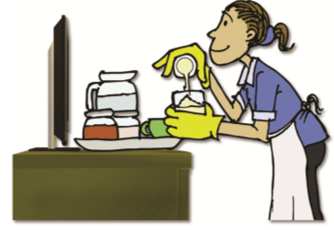
• Hairdryers
• Stationery, magazines etc
• A service tray with food and beverage items
including coffee, tea, cups, glasses etc.
• Some rooms are prepared with special items
like champagne and chocolates (honeymoon suite).
Your housekeeping supervisor will inform you of any
uch room.
• Mini bar – usually contains alcoholic drinks,
soft drinks, juice and sometimes even chocolates
and crisps. Some bar fridges automatically record what
has been taken and transmits the information to reception,
adding it to the guest’s account. This is not always the
case, and you may need to record what has been taken to inform reception as well as replenish supplies.
• Information on room charges, meal times, other guest services, telephone numbers for reception, bar restaurant etc.
• Door notices to indicate room ready for service/do not disturb and breakfast/early morning tea/coffee orders, newspaper requirements etc.
• Tourist information like brochures on attractions, a map of the area, a telephone directory etc • Replace supplies with the specified number of items. Present the room supplies according to the standards required in your hotel.
• Close windows and make sure that the air conditioner is set to the standard setting as required per hotel policy.

8. Final Inspection and checklist (including arrangement of furniture and deodorising the room)
The final check is a critical step in the process. Start at one point of the room and scan it in a circular fashion from one corner to next until you have visually inspected the whole room and each item. This way, you will see if there is anything you might have overlooked. Also check for any maintenance issues by checking all electric appliances like lamps, the air conditioner etc. If there is anything in need of repair, make a note immediately in order to remember to alert the maintenance department. Sometimes the appropriate procedure is to simply record it on your room record sheet for your housekeeping supervisor to alert the maintenance department.
Make sure that all furnishing are back in their proper places. Look for anything that is skew or crooked e.g. a painting hanging on the wall or a lampshade. Smell the air for any unpleasant odours and deodorise the room accordingly.
When you are satisfied that the room is neat and thoroughly cleaned, turn off the lights, close the door and check to see it is locked. Note the condition and status of the room on your assignment sheet and proceed to the next room on your schedule.
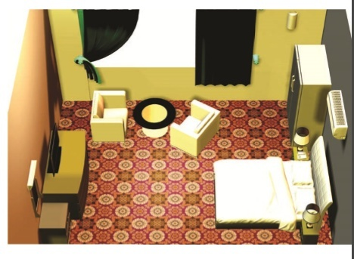
4.3 Cleaning of a Vacant Room
A vacant room is a room which has not been let to a guest and therefore there is no one sleeping in it or using the room. It is important, however, that although there is no one in the room that it is kept clean and tidy for when it will next be used by a new guest.
Daily Visual Check
Vacant rooms should be checked daily to make sure that they are clean and meet the hotel standards. The procedure for cleaning will depend on the length of time which the room has been vacant. If serviced on the previous day, it may only require a visual check to ensure that it is “vacant” and not a late check-out. This will mean checking the sheets and if turndown was completed, rearranging the bedclothes. As stagnant water stains, it is a good practice to flush the toilet daily.
REMEMBER:
Your last look is the guest’s first look!
1. Cleaning and Servicing a Guest Bathroom
Bathroom cleaning is normally completed after making the bed and before dusting and is carried out in accordance with the hotel’s policy and procedure. There are three main steps in the procedure that can be expanded on:
• clean all bathroom surfaces and toilet appliances.
• replace dirty bedroom linen, i.e. towels and bathmats, etc.
• clean the bathroom floor.
REMEMBER:
Make sure that you are wearing gloves at all times when cleaning bathroom areas. This is an important safety protection which should be adhered to for your own protection as well as that of your guests.

THE CLEANING SEQUENCE FOR A GUEST BATHROOM IS:
Cleaning the Bath and Shower
You should start by cleaning the bath or shower. Using a sponge or cloth, the correct cleaning agent and hand-hot water, systematically clean:
• Tiles - pay particular attention to the grouting between tiles.
• Showerhead - check that it is working and not blocked.
• Taps - polish all sides of the taps and chrome fittings to shiny finish using a dry cloth. The base of the taps must not have build-up of dirt or cleaning agent.
• Overflow – also check that overflows are not blocked.
• Top of the bath (special attention should be given to grouting, i.e. the filling between the tiles which can carry germs and dirt).
• Bath – on your knees
• Soap trays
• Bath handles (clean the inside, bottom and outside).
• Shower door or curtain (clean the inside and outside).
You should always rinse the bath with clean hand-hot water and dry it off using a dry clean cloth. There should be no water marks, hairs or cleaning agent residue on the bath. For hygiene reasons, soiled guest towels must not be used for wiping the bath.
Cleaning the toilet
The toilet must be cleaned using a toilet cloth, brush and correct cleaning agents as follows:
• Flush toilet.
• Sprinkle toilet cleaner and leave it to work for approximately one minute.
• Using hand-hot water and a toilet cloth systematically clean cistern, handle, cover, seat, and hinges, top of bowl, outside and behind bowl.
• Brush underneath rim, bowl and bend of toilet.
• Flush toilet.
• Check the overall cleanliness.
• Finally, clean the toilet roll holder and toilet brush holder.
Cleaning the hand basin and surroundings
Wash Hand basin
Clean inside and outside the hand basin. Remember to clean the pipes, taps, stopper and overflow - check for build-up of dirt and remove it.
Cabinet or vanity top
Clean the cabinet or vanity top thoroughly paying special attention to the mirror, glass shelves and inside the cabinet door.
Glasses
You must always wash the glasses and dry them with a glass cloth to stop the spread of germs - do not use the cloth for anything else. Check there are no watermarks by holding the glass up to the light by the base.
Other Items
Clean the inside of the bathroom door, skirting board and any other furnishings, e.g. towel rail/ rack, etc. using a damp duster. Wipe all light bulbs and light fittings with a dry cloth.
Floor Clean the floor according to its type using the correct equipment or cleaning agents. Refer to Module 2 for more info.
QUICK QUESTION
Why is it important to use a separate cloth for cleaning toilets, floors and glasses?
Replenish Guest Supplies/Amenities
Hospitality establishments generally provide amenities for the convenience and comfort of their guests. It is your responsibility to monitor the availability of these products when cleaning public toilet areas, and replace them as required. Guests expect complimentary supplies. If these are not supplied, it detracts from the level of service the establishment is offering the guests. Therefore, it is important to notify the appropriate staff member when stocks are low so a new order can be placed well before stocks run out.
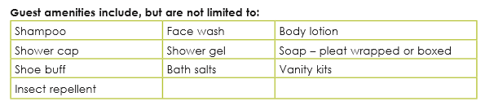
DEFINITION: AMENITIES
Amenities are: complimentary items for personal use of the guest.

The cost of wastage of these products will mean added costs for management. To minimise wastage:
• Collect the required quantities of your guest supplies and accessories from your trolley.
• Check that each of the items is clean and free from damage and stains.
• Supply only the specified quantity for each bathroom • Replenish supplies according to the establishment’s guidelines
• Handle and store the products carefully so you do not crush or damage the packaging. Never present damaged products as this appears unprofessional.
• Replace soap, toilet paper and other supplies and fold towels according to your training.
Always check the linen before folding and replacing in case of tears or soiling. You must replace the guest supplies properly in each room, as each room is standardised to a level of quality.

REMEMBER
• Check for lost property and follow the correct procedure.
• Check for faults and report them.
• Keep cleaning agents separate - do not mix in case of noxious gases.
• Clean hygienically at all times and be aware of the importance of sanitary conditions in all bathrooms

4.4 Closing down and preparing for the next shift
Some hotels may have a formal hand over, such as a brief staff meeting where staff from both shifts meet and pass on information, keys etc., thereby “handing over” responsibility to someone else.
Closing down Procedures
The procedures, which should be carried out at the end of each shift, are as follows:
• Empty trolley of stock.
• Clean and restock trolley.
• Remove dirty linen and rubbish from trolley and dispose of.
• Empty and clean the vacuum cleaner used during work.
• Clean and put away brushes, mops, buckets and wringers.
• Tidy the pantry and wash the floor.
• Lock up cupboards and pantry door.
Before going off duty certain information may have to be passed over to the supervisor in charge, such as:
1. Any incidents entered in the book.
2. Maintenance problems and completed maintenance forms
3. Any rooms which need to be cleaned due to late departure or if the guest is still in room and has requested a late service.
4. Any supplies or linen to be replenished, including cleaning agents.
5. Submission of the daily worksheet showing rooms cleaned and the room status list.
6. Any information recorded in the hand over book.
7. Return of any loan item such as an iron and board or adapters, which have been handed over by guests. 8. Submission of turndown report if it is a hand over to a late shift.
9. Any lost property not already handed in.
There will also be certain follow-up procedures, which should be made. These will include checking up on urgent maintenance already reported and informing the supervisor of any guest’s requests which have not yet been carried out, e.g. extra pillows, blankets, iron and ironing board or an extra bed.
All the information requires is to be reported on and followed up on, in order to ensure continuing service to guests and the smooth running of the department.
The critical points that need to be taken care of are:
KEY CONTROL SYSTEM:
All keys must be returned to the housekeeping office and are signed for in accordance with the hotel’s procedures. This is an important activity because of the security implications.
• Security of keys is essential from the moment guests arrive on site. Keys should be stored separately and securely
• No unauthorised person should be allowed access to any key, either to examine or handle it, since a photograph or impression can be taken in few seconds and duplicate subsequently made. Keep a log book of all keys signed out.
• Establish protocol for distribution of keys.
• Use keys that do not identify the property’s name, address, logo or room number. Perform an annual key audit
• When keys are lost or stolen, the locks should be changed or rotated to another part of the property. Authorised employees should remind guests to return keys at checkout.
• The loss or suspected compromise of a key should be reported immediately and, after due investigation, a decision be made as to whether or not the lock should be changed. Place well-secured key return boxes in the lobby, at exit points of the property, and in courtesy vehicles.
Logbook:
Very often the housekeeping department will maintain a log or “hand over” book, which must be completed at the end of each shift and read at the commencement of the next shift. This book will contain information relevant to the shift, for example, estimated time of arrival of a VIP guest; any uncompleted work e.g. request for cot in Room: 1007; and maintenance issues etc.
This is an important communication tool and it is the responsibility of all staff to familiarise themselves with it and to use it appropriately.
Guestroom inspection:
Each establishment will have a system for inspecting rooms that have been cleaned. They do this to ensure that standards are maintained and guests are not disappointed. If inspectors do not inspect the work, problems could arise that may make guests unhappy. Inspection programmes differ from one hotel to the next. In some hotels, rooms are spot-checked randomly; in others, each room is inspected daily. The person responsible for inspections is usually the shift or floor supervisor, but sometimes it could be the executive housekeeper or even a manager from outside the housekeeping department.
Each inspector is usually responsible for a certain number of rooms. She/he must know the status of each room that is inspected. As a general rule, he inspects checkout-rooms soon after the housekeeper has reported that it is clean. Rooms that are occupied or have refused service are inspected at different times. For these rooms the executive housekeeper will usually contact the guest and arrange for a convenient time for the room to be cleaned or inspected. Inspectors should also inspect empty rooms, depending on the number of days that the room is empty between sales. Room inspection helps to identify normal problems with cleaning and also helps to identify areas in the room that may need deep cleaning or maintenance – for example the carpets.
The inspector should submit a room inspection report that includes space where he can write notes on: • the condition of furniture, fixtures and equipment • the appearance of the ceiling and walls • the condition of the carpet and other floor coverings • the cleanliness of window interiors and exteriors.
During a room inspection, you enter the room and carefully inspect everything, moving in a clockwise direction so that nothing is missed. You will check that:
• All fixtures, fittings and furnishing are clean and in good working order
• All guest items have been replenished
• All surfaces are clean and free from marks
• Floors and floor coverings are clean and the appropriate finish has been achieved
• Beds have been made according to the establishment specifications
• Lighting, heating and cooling systems are in good working order
• Bathrooms have been thoroughly cleaned
• There are no signs of pests
• The finished room meets the standards set by the organisation.
Once the inspector has completed the inspection and has approved the room, the person responsible will notify the front office that the room is ready for use.

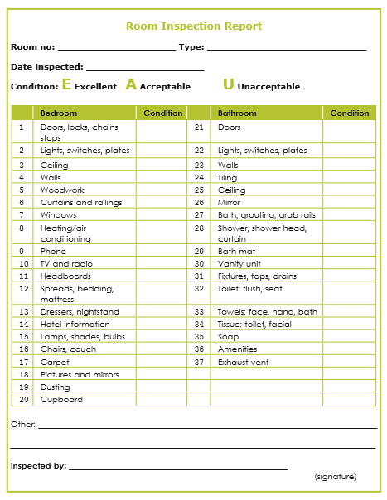

MODULE 5
HOUSEKEEPING TROLLEY (MAID CART) MANAGEMENT, GUEST ROOM CLEANING AND HAND OVER PROCEDURE

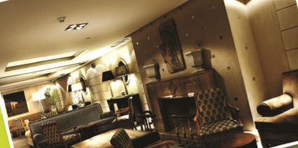

5 INTRODUCTION :
Public area cleaning Public areas, particularly entrance and reception areas, give a first impression to anyone coming into the establishment and visitors can form an opinion about the whole hotel based on that "first look". For this reason the overall appearance and cleanliness of public areas is very important. Housekeeping is usually responsible for this area.
5.1 PUBLIC AREAS
Public areas are the areas in which resident guests and other guests visiting the hotel may use during the course of the day. These are areas, such as:
• Lifts: these are often fitted with mirrors, carpets, brass or metal rails and other fixtures that must be kept clean.
• Circulation areas: corridors, stairs
• Lobbies or foyer: this is the entrance to an establishment, and is therefore a high traffic area that easily gets dirty and must be clean regularly to create a good first impression of the establishment.
• Public telephones: these are provided in some establishments for guest use. Not all establishments have them anymore because many people now have cell phones. However, the hygiene considerations of a public telephone are huge – people put the hand piece to their ears and speak into the mouth piece, thereby breathing germs onto the device. This must be cleaned regularly to ensure that public health is safeguarded.
• Reception: in a hotel, this is where the guests check in, and in a restaurant, this may house the desk where billing, queuing and other activities take place.
• Restaurant: the area where guest dine must be kept very clean and any food spills must be cleaned immediately so that they do not create any health risks. The area must also be well ventilated so that food and/or smoke odors do not linger and create a stale smell.
• Bar: bars are where guest enjoy drinks – often drinks are spilled so it is again important to keep it clean and smelling fresh so that stale beverage and smoke smells do not make the atmosphere unpleasant for guests. While carpets create a luxury feel in bars, they are difficult to keep clean and fresh, especially with drink spills, so often these areas have hard floors.
• Lounge areas: guests relax, socialize and meet in lounge areas, they must be kept clean and tidy and free from any rubbish or spills at all times.
• Public restrooms: ladies and gents restrooms must be serviced regularly to keep them clean, free flowing, and supplied with any amenities that guests may need such as soap, towels and toilet paper.
• Conference and meeting rooms: these are usually equipped with chairs and table for guests in a large room.
• Public phone areas, lounges, lobby and reception: These are usually cleaned daily and early in the morning before guests use them. These are important area in a hotel because it will create a bad and lasting impression if they are dirty.
Note the following procedure for cleaning pubic areas:
• Assemble the required cleaning equipment and cleaning materials.
• Remove all rubbish from the area and place it in the rubbish bag on your trolley.
• Empty and wash all used ashtrays making sure that all nicotine stains are removed. • Remove any dead flowers from flower arrangements.
• Dust and wipe all flat surfaces including shelves.
• Dust and polish all wooden surfaces with furniture polish including tables, chairs as well as the legs of the tables and chairs.
• Use a damp cloth on any surface where spillage may have occurred.
• Check the surfaces to ensure that they are free from dust, debris and removable marks. • Dust and wipe all fittings and picture frames.
• Dust or wipe all light fittings and shades ensuring that no marks remain.
• Check that all lights are working and that no light fittings are loose or broken. If a light is not working, this must reported to your supervisor and to maintenance.
• Vacuum all exposed areas of carpet and then move furniture out of the way so that you can remove dust that collects underneath furniture.
• Replace the furniture in its original position when you have finished.
• Clean tiled or hard floor surfaces such as front steps and lobby floor by:
• putting up the appropriate hazard sign • sweeping the areas to remove loose dirt
• washing the floor using the appropriate cleaning equipment and materials for the surface
• polish/buff the floor until the correct shine is achieved, using the appropriate polish and buffer for the surface
• move the furniture to sweep/wash/polish/buff the floor area underneath it.
• Make sure that the area is neat and tidy after you have completed this task.
• Check the arrangement of display items to ensure that they are in the correct place and have not run out.
• Clean armchairs and cushions by:
o Removing the seat cushions
o Wiping the grooves and the back of the chair with a dry cloth
o Vacuuming in the grooves to remove any remaining dirt
o Fluffing out the cushions and then replacing them.
5.1.1 Cleaning restaurant and bar areas
• Restaurants and bars should be cleaned at least once every day or more often if the area is used a lot.
• Clean glass surfaces (windows, mirrors) as well as brass or chrome surfaces using the appropriate polish or cleaning material.
• Check the surfaces to make sure that no removable marks remain and that no residue is left from the polish.
• Clean and polish the glass and frames of pictures.
• Dust and wipe all light fittings and shades. Make sure that all of the lights are in working condition.
• Pick up any rubbish lying around and place it in your rubbish bag.
Empty and wash all used ashtrays making sure that all nicotine stains are removed.
• Clean tiled or hard floor surfaces such as front steps and lobby floor by:
o Putting up the appropriate hazard sign
o Sweeping the areas to remove loose dirt
o Washing the floor using the appropriate cleaning equipment and materials for the surface
o Polish/buff the floor until the correct shine is achieved, using the appropriate polish and buffer for the surface
o Move the furniture to sweep/wash/polish/buff the floor area underneath it
5.1.2 PUBLIC RESTROOMS
• You have already learned how to clean bathrooms and toilets in Module 4. It is imperative that when a client or customer wishes to use the toilet facilities, that these facilities be in a clean, tidy and hygienic state.
• Areas to be cleaned include:
o Glass and mirrors and stainless steel using appropriate glass cleaning chemicals.
o Tops and hand basins using a hard surface cleaner and scourer type sponge to remove soap residue and dirt. Finish with drying sponge and polishing cloth.
o Soap dispensers should be free of any build-up of soap residue and have a sufficient level of soap present. Marks, fingerprints or water marks must be removed.
o Light fittings should be operating correctly, be free of dust and insects, and any marks or fingerprints present on fittings or switches removed.
o Extractor fans should be operating correctly and be free of any dust or lint, which can gather on the grill or cover of fan.
o Hand dryers should be in good working order and clean without marks or prints present.
o Bins should be emptied and a clean lining for bin refitted.
o Drainage from basins is free from debris and dirt.
o Tiled wall areas and floor are clean and free from dirt and grease, and any visible marks removed.
o Debris and other foreign matter must be removed from drainage points and overflows to prevent not only potentially embarrassing situations from occurring, i.e. overflowing toilet, but saving on costly repair and maintenance work taking place.
o This potential problem can be overcome by the regular/daily procedure of cleaning and clearing drainage points and overflows.
o If a blockage problem occurs, advise your manager/supervisor to take immediate action.
o Dangerous caustic chemicals can help with slow draining points.
o Protective clothing (gloves, goggles, work wear and breathing apparatus) will be required when using the above chemicals
o When servicing washrooms and toilet areas, it is necessary that the rubbish bins are emptied of their contents. Once emptied a new, clean bin liner must be fitted, and the rubbish bin replaced in designated or appropriate areas.
o Thoroughly wash hands after the above task is completed to provide a minimal risk of cross-infection to yourself and your clients or customers.
o Urinals are cleaned using the same procedure as that used for cleaning toilets.
Sanitary bins are usually serviced by an outsourced company; make sure that there are enough sanitary bags in each cubicle.
o Replace any gust items such as toilet seat wipes or liners.
o Check and replenish stocks of guest amenities such as soap (refill dispensers), towels, (paper towels, roller towels) tissues and other amenities.
5.1.3 Cleaning lifts
When cleaning the inside of the lift, make sure that the lift has been stopped and taken out of use, by changing the control from automatic to manual using a special key. Place an ‘out of action’ sign on each floor.
• Lifts should be cleaned first thing in the morning to avoid inconveniencing guests, and maintained throughout the day.
• Clean the button panel and the outside of the doors as part of the cleaning program
• Polish all glass, mirrors, brass, chrome or other metal fixtures using the appropriate polish or cleaning material.
• Check all surfaces to make sure that no marks remain and no residue is left from the polish.
• Clean and polish the glass and frames of pictures.
• Dust and wipe all light fittings and shades.
• Pick up any rubbish lying around and place it in your rubbish bag.
• Dust any other surfaces in the lift including the inside of the doors.
• Wipe any furniture with a dry cloth.
• Vacuum the carpets paying particular attention to the grooves at the front of the lift at the door where dirt tends to get caught and builds up.
• Clean a tiled or hard floor surface using the appropriate equipment and cleaning materials.
• Polish or buff the floor to required finish.
Cleaning frequency of the public areas
Like other areas, the work routine in public areas is divided into daily, weekly, monthly and periodic tasks.
• Daily tasks: It include dusting, emptying ashtrays and bins, arranging flowers, vacuuming carpets, mopping hard floors, removing marks from glass, and cleaning toilet areas – which should be checked regularly throughout the day.
• Weekly and monthly tasks: including scrubbing, or deep cleaning floors, cleaning walls, light fittings, washing and polishing woodwork, including wooden furniture. • Periodic tasks: It concentrates on items or areas that do not get cleaned on a regular basis. These are the heavier maintenance jobs such as wall washing, floor stripping, carpet shampooing, floor resealing or re-polishing and cleaning outside windows. Many of these jobs are done by maintenance staff or outside contractors.

MODULE 6
LAUNDRY FUNCTIONS AND LINEN MANAGEMENT.

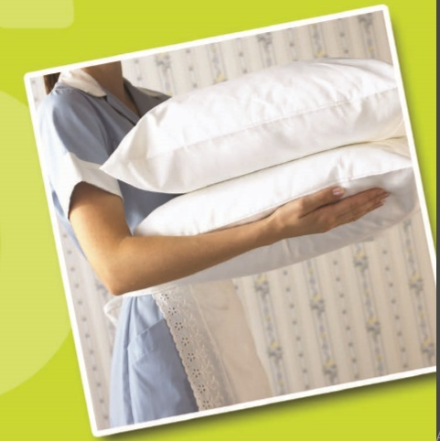

INTRODUCTIONS:
Laundry functions and linen management. This module is only for the laundry, layout and designing of laundry, machines, linen, and linen management 6.1 Laundry The word “laundry” means the removal of stains, washing and finishing (ironing and finishing) storage of all types of clothes and articles. The process of laundry ensures the care of clothes and other items made of textile fibres of different types.
6.1.1 LAUNDRY DEPARTMENT
Laundry Department is responsible for providing an efficient laundry service for our guests and crew. This 24-hour operation fulfils all on-board laundry needs including all bed linen, towels, guest clothes, and restaurant linen and staff uniforms. The laundry department includes Laundry Manager, Assistant Laundry Manager and Laundry Attendants.
Reasons for laundering clothes
• To remove perspiration which if not removed may damage the garment.
• To remove dirt and grease which may discolour the garment or cause them to smell • Launder clothes for hygienic purposes. Dirty clothes may carry germs which bring about diseases e.g. skin diseases.
• Well laundered clothes maintain their colour better
• Garment which are frequently and properly laundered last longer because perspiration is not given time to damage fibres.
• Laundered and well ironed clothes stay clean for a longer period as dust does not stick on the smooth surfaces.
• By ironing clothes, insects and germs which get on to the clothes as they dry are killed
• To give clothes good a shape and to make them look as new as possible.
6.2 LAUNDRY EQUIPMENT
Equipment and aids have continually been developed to make laundry work easier and more enjoyable. Despite the presence of this equipment, there is needed to understand the properties of the fabrics in common use to facilitate the choice of methods for the general care of clothes.
Equipping the on- premise laundry begins with the analysing how much must be done in the laundry. Factors to consider when selecting equipment are:
• Property size and category
• The space available for the laundry
• Budget
• Occupancy forecasts
• The profile of the business
• The forecast for function and business
Washers
Washers are the most basic items of the equipment. Most laundry requires washer/ extractors. The wash cycle launders the load. Then, during extraction, the items in the load are spun at very high speed to remove as much moisture as possible.
Dryers
Dryers finish the process of moisture removal. The general rule is that two dryers are required for every one washer.
Ironers, Rollers and Folders
Ironers or pressing machines remove wrinkles from clean laundry. Ironers roll over the item and presser flattens the item. Rollers /folders complete the drying process and iron the item during the rolling function, then fold the item and even stack it.
Other Basic Equipment
o Basins and Buckets
o Clothes Lines
o Clothes Pegs
o Clothes Rack or Hors
Irons and Ironing Surfaces
These are of different types and are basically used for finishing process in laundry work which may involve straight ironing or pressing.
6.2.1 LAUNDRY PROCESS
The laundry process includes the collection of soiled linen, sorting, mending, stain removal soaking, washing, and boiling, rinsing, blueing, starching, drying, damping, finishing and folding.
• Collection of soiled Linen
The housekeeper should separate bed from bathroom items, placing them in different containers. Heavily soiled items should be clearly set apart so laundry workers can initiate the necessary pre-treatment as soon as they arrive in the laundry room. The use of trolley to transport linen, rather than plastic bags, provide a better impression to guests.
- Sorting out
Before washing, linen are sorted out according to amount of dirt, Colour & type of fabric.
• Soaking (steeping)
This is usually practiced on linen that are made of strong materials and are very dirty .Soak for 24 hrs in cold water.
• Washing
Dirt is removed with the aid of water, soap and a certain amount of movement to free the dirt from the clothes. Grease or oil dissolves more readily in hot water than in cold water hence hot water is better for washing than cold water
• Boiling
Boil already washed white cotton and linen in soapy water for 10-20 minutes .Longer boiling has a tendency to yellow white fabrics .Avoid over packing the boiler with clothes so that the water can boil through the material.
• Rinsing
This is the process by which the dirty lather is washed off the clothes, thus leaving the clothes clean and soap less .The first rinse is best done in hot (warm) water.
• Blueing (white linen)
Blue may be bought in liquid form, powder or in cubes. Laundry blue has been found to possess a quality that helps to hide this unpleasant discoloration and makes the garment appear whiter than it really is.

• Folding
Clothes are folded so that they can be stored in little space and in such a way that the finish that has been given to them is not spoiled before they are required for use again rules.
• Pressing
When pressing the material is placed in position then the iron is pressed down where needed, lifted and replaced. Pressing is used to finish knitted fabrics, all thick fabrics, including lace, embroidery, woollens knitted fabrics.
• Storing
Once linens are folded, they should be handled as little as possible. Folded linen should be shelved in the linen room, placed on the mobile racks for transportation to the floor closets, place directly onto the section housekeeper carts
• Best results
The ultimate goal of a well-run laundry is to obtain optimum results in terms of appearance, odour and feel. Regarding appearance, the linen must be snow-white (white items) and free from wrinkles and spots caused by staining. The odour must be fresh and clean, not stale and musty. For the feel, the articles should be smooth and velvety, not coarse or rough.
• Valet service
Most first-class hotels offer laundry and cleaning services to their guests. However, it is common to contract these services with the outside commercial laundry because of the specialization and time consuming details that valet services entails. Properties that wash and dry-clean employee uniforms and draperies usually process valet service items in –house.
6.3 MAINTAINING LINEN ROOM & LINEN
The linen room is the centre stage for the supporting role that the housekeeping department plays in the hotel. Most linen rooms are centralized and act as a storage point and distribution centre for clean linen.

Following illustration shows general layout of a linen room
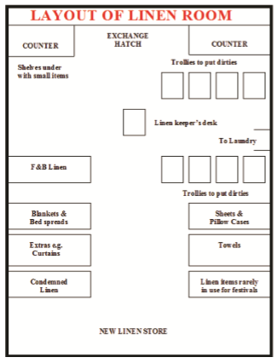
6.3.1 ACTIVITIES OF THE LINEN ROOM
The following are the activities of the linen room:
Collection and Transportation It is an essential activity when laundry services are on outside contract and is facilitated through chutes, canvas bags, trolleys, collapsible wire carts, skips etc. Guest laundry are also collected and appropriately marked for sending off- premises for cleaning.

• Sorting and Counting
Sorting is carried out primarily to make counting easy as well as for streamlining laundry procedures and to tally the exchange of linen between the linen room and the laundry.
• Packaging
Linen is packed in canvas bags to prevent damage on transit to the linen articles. Those articles that need mending and those, which are heavily stained, may be segregated and put into separate canvas bags.
• Dispatching
The time for off-premises laundry dispatch is usually anytime between 13:00 hours and 16:00 hours so that servicing of rooms is over by then and guest laundry will have been collected.
• Deliveries
Clean linen is delivered back in the morning hours and evening deliveries are usually for guest laundry.
• Checking and Inspection
Checking the quantity to ensure that the amount of laundered linen tallies with the amount of soiled linen articles sent and as well as inspection of the quality of wash.
• Storage
The amount of space to be allocated for storage depends on the size and type of operation and the quantum of linen supplies. When designing the storage space for linen it is necessary to consider the type of shelves required, the method of storage as well as hygiene and safety factors.
• Repairs and Alteration
Damaged items are mended by stitching or darning. Alteration of uniforms for correct fit is usual. Condemned linen is converted into useful items called cut-downs / makeovers.
• Distribution to Various Departments
This is generally done on a clean-for-dirty basis. Some hotels use other systems of
exchange such as topping up or a fixed issue based on expected occupancy. In some hotels specific timings are fixed for issue of linen.
• Linen Room Requirements
The following are the requirements of the linen room:
1. Storage shelves both open and closed
2. Hanging space
3. Reserve Stock storage
4. Drop counter for exchange of linen (stable-type door)
• Stock-taking and Records
Many records are entered on a day-to-day basis for the exchange of linen between the linen room, laundry and floors / departments. Purchase records are essential and records of condemned linen and makeovers are usually maintained. Periodical stocktaking is carried out and the annual stocktaking is recorded in the stock register, thereby providing the value of linen as an asset. Stock records also help generate purchase orders for replacement of lost or condemned articles.
It is important that the access to the linen room is restricted so as to prevent misuse and pilferage and to guard against fire breakouts. Linen room is strictly a non- smoking area.
6.3.2 LINEN ITEMS
Each individual piece of linen requires special consideration in terms of quality, type and size, besides cost.
• Room Linen
o Bed sheets
o Pillowcases
o Blankets
o Soft Furnishing
o Duvets
o Bedspread / Bedcover o Curtains / Draperies
o Cushion Covers and Upholstery
o Bath Linen
o Bath Towel
o Restaurant Linen
o Table Linen ( Table cloths)
o Multan
o Banquet Frills (Satins)
o Uniform
Uniforms play a very crucial role in establishing and reinforcing the image of a hotel or restaurant. Ill-conceived and poorly co- ordinate uniforms worn by hotel staff can create a jarring note in the entire image projected by the hotel. One of the many housekeeping operations also include maintaining and laundering different types of uniforms listed below.
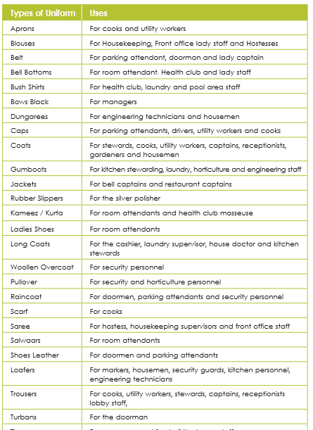

MODULE 7
HOUSEKEEPING SERVICES AND OTHER DUTIES

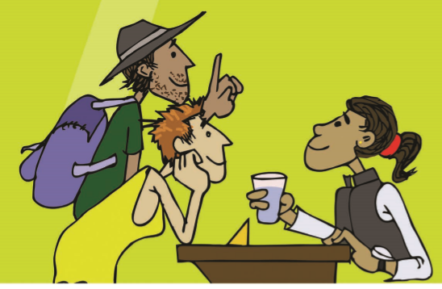
7 INTRODUCTION:
Housekeeping Services and other duties This module will introduce you to various different services that the housekeeping department provides to guests.
7.1 OTHER GUEST SERVICES
In addition to the provision of accommodation, food and beverage, hotels usually provide a range of ancillary services for guests. Some of these may be very simple, for example, complimentary shoes shine service or the availability of an iron for use by the guest in his room. Other services may be more business related, such as, the provision of a private secretarial/translation service.
There are many services available for guests to use in order to ensure that all their requirements for a comfortable stay in the hotel are catered for.
7.1.1 ROOM TRANSFERS
Guests may request a room transfer for a variety of reasons, including:
• The room has a bad view;
• The room is too noisy;
• The room is too near/far from a lift;
• The room is too expensive for the guest;
• The room is twin and the guest would prefer a double room;
• The guest requires a family room.
When a guest requests a room transfer, it must be completed in a safe and secure manner. Speed and efficiency, in effecting the room transfer, will also be important particularly if the guest is waiting to occupy the newly assigned room. Therefore good communication and co-operation between front office and housekeeping is essential to ensure that the room transfer is carried out properly.
The Room Transfer Procedure
Front Office will automatically send notification to housekeeping stating which room is being vacated, the room allocated for the guest(s) to move to and the number of guests. It is the responsibility of housekeeping to ensure that the newly assigned room is ready for the guest to occupy. This may involve checking and or cleaning the room, following the same procedure as for cleaning a departure/check-out room. Housekeeping will also be responsible for ensuring that the vacated room is serviced for occupation by a new guest.
Luggage Transfer
The porter/bell boy or a member of the housekeeping staff will usually complete the actual transfer of the guest's luggage and goods.
There should always be two members of staff present, for security purposes, when moving a guest's personal effects. Always check the room after a move to ensure no belongings are left behind in the room. You must record the move and inform the front office and the housekeeping supervisor as soon as the move has been carried out.
7.1.2 GUEST REQUESTS
From time to time, you will receive specific requests from guests. These requests may include:
• An instance where there has been a breakdown in normal room servicing and remedial service is required, such as rectification cleaning.
• Removing unwanted of defective items from rooms
• Cleaning up spills
• Extra equipment to cater for additional guests
• Replacement items to replace defective items
• Requests for information regarding in-house services and products
• Requests for information regarding local services, attractions, transport, shops, entertainment, etc
7.1.3 STAFF REQUESTS
Housekeeping requests from other staff in the hotel may be related to:
• Room service
• Valet
• Maintenance
All the above mentioned requests must be recorded according to the establishment’s requirements. Keep the following in mind:
• Use appropriate guest communication skills
• Record and confirm the name and room number
• Use the appropriate internal form
• Apologise appropriately, where necessary
• Confirm the details of the required service and/items
Services and items may include:
• Roll-away beds
• Additional pillows, blankets and bed linen
• Additional towels, bath mats and face cloths
• Ironing boards
• Supplementary give-aways and room supplies
• Facilitation of repairs and maintenance
• Replacement batteries for remote controls
• Response to lost and found situations
• Small electrical appliances including kettles, TV, hair dryers, irons, radios and alarm clocks
• Telephones
• In-room promotional materials
7.1.4 SERVICE HOUSEKEEPING REQUESTS
The steps to follow in order to ensure that the guest’s request is completed are:
1. Liaise with other staff to obtain and/or deliver the required service or item.
2. Locate and deliver the required items to the guest room
3. Set up the equipment in guest rooms – which may include:
o Delivery of the item to the guest room
o Entry to the guest room in accordance with protocols
o Removal of defective products and items
o Placement/replacement of item o Testing of item to confirm correct operation
4. Remove items from the guest room as required. This may relate to:
- Disconnection of unwanted/defective item
- Physical removal from the guest room
- Liaison with other departments to facilitate removal of the item, where necessary
- Tagging and logging of the defective items in accordance with internal and safety requirements
7.1.5 CHECKING ROOM ALLOCATIONS
After assembling supplies, you are ready to begin cleaning guest rooms. The order in which you will clean rooms will be determined by the room status report.
7.1.6 ROOM STATUS REPORT
The room status report, sometimes called the housekeeping report, provides information on the occupancy or condition of the property’s rooms on a daily basis. It is generated through two-way communication between the front office and the housekeeping department. For example, when a guest checks out, the front desk notifies housekeeping by phone or through the computer system. Housekeeping then knows that the room is vacant and ready for cleaning. Once this has been done and the room is clean, the housekeeping department then notifies the front desk, either by telephone or the computer system, to tell them the room is clean and ready for sale.
The room status report is generally easy to read and uses simple codes to indicate room status.
7.1.7 GUEST INFORMATION DIRECTORY
The services provided by the hotel are normally listed in the Guest Information Directory, which is located in each room. The information may be presented in a folder or book or very simply, may be listed on a sheet of paper. This information is usually displayed in alphabetical order with reference to the appropriate telephone numbers.
7.1.8 ROOM ALLOCATIONS
At the start of the day, the housekeeper will be given a list showing which rooms must be cleaned. This list will also detail any rooms that may be required in a hurry. Also on the list there will be a note of the current status of the room. The room may come under any of the following categories:

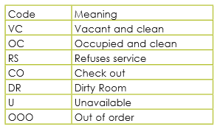
Note: different hotels may use different codes – you will have to get to know these in each hotel, but they always refer to similar room status even if the codes are slightly different.
A floor or shift supervisor uses information from the room status report to draw up room assignments for housekeepers. Room assignments usually list the room number and room status on a form. The number of rooms assigned to a housekeeper is based on the standard of work of the establishment for specific types of rooms and cleaning tasks. The housekeepers use the assignment sheet to prioritise the workday.
Once you have looked over your daily room allocations, you get a sense of where you should begin cleaning. It is important to clean each room as efficiently as possible and at the same time make sure that rooms are ready when needed.
It is important to remember that room allocation lists are printed early in the day and are subject to change at short notice. You must be flexible and be prepared to reprioritise your work if necessary.
It would make sense to start with room 1, then room 2 and so on, but in hotels, we cannot work in the easiest way, we must put guests’ needs first and then work accordingly. Generally, the order in which rooms are cleaned is the order that best serves the guests.

The following is a sample of a housekeeper assignment sheet from a four star hotel: Housekeeper Assignment Sheet:
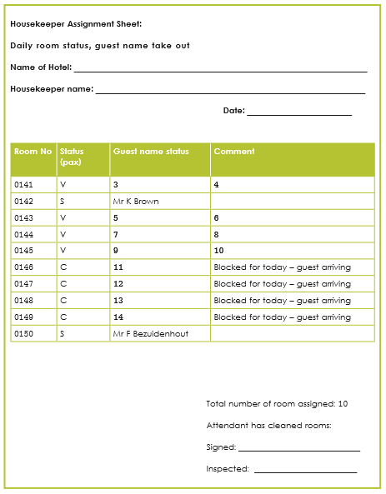

7.1.9 ASSIGN ROOMS AFTER THEY ARE CLEANED
The following process is followed to assign rooms after they are cleaned (recycling rooms for sale):
• Each night, the front desk agent produces an occupancy report. This report lists rooms occupied that night and indicates guests that are expected to check out the following morning.
• The executive housekeeper collects this list early in the morning and schedules the occupied rooms for cleaning.
• As guests check out of the hotel, the front desk notifies housekeeping. Housekeeping ensures that these rooms are prioritised so that clean rooms are available for arriving guests.
• At the end of each shift, the housekeeping department prepares a housekeeping status report based on a physical check (inspection) of each room in the establishment.
• This report indicates the housekeeping status of each room. It’s compared to the front desk occupancy report and any discrepancies are brought to the attention of the front office manager. A room status discrepancy is a situation in which the housekeeping department’s description of a room’s status differs from the room status information being used by the front desk to assign guest rooms.
• In order to ensure efficient room assignment, housekeeping and the front office must inform each other of changes in a room’s status. Promptly notifying the front desk of housekeeping status of rooms is a vitally important aspect in getting early arriving guests registered, especially during high occupancy seasons.
7.1.10 TURNDOWN SERVICE
Servicing guest bedrooms in the evening is normally carried out in luxury hotels (5star) or where a VIP turndown service is provided. This service intends to make sure that guests are as comfortable as possible before and during sleeping. Many hotels use this second daily visit by the housekeeper to distribute chocolates, "night caps" (e.g. liqueurs), etc., usually referred to as "give-aways". The evening housekeeping staffs should be well presented, efficient, observant and as quiet as possible to avoid inconvenience to guests.
Turn down service: it is a guest service, as it prepares the room for sleep, and it is form of control, as you can do a physical check of the room status.

PREPARATION AND PROCEDURE
• Collect list of rooms for evening service and "give-aways" from the housekeeping supervisor.
• Announce yourself at the door of guest's room. Make a note of any DND rooms and return to them before you go off duty. Report any refused service rooms to your supervisor.
• Turn on the bedside light, close drapes and blinds.
• Remove the bedspread, then fold and put it away.
• Begin "turndown". This means that you turn back the bedcovers on the side the guest is most likely to use. For single occupancy in a twin room, turn down one bed only.
• Unstuck one side of the top of linen and blankets and fold them back to form a right angle triangle
- Neaten edges and tuck in.
• Put a chocolate on the pillow or place guest's nightwear neatly on pillow (depends on the hotel’s policy).
• Place slippers at side of bed (if provided by the hotel or guests own).
• Place dressing gown on a chair.
• Empty and wash all used ashtrays. This avoids ash being spread around the room. • Empty bins
• Empty and wash all used glasses. Fill water jugs with water and ice.
• If bath/shower, basin or toilet has been used, wash and dry them to preserve hygiene.
• Replace any linen or towels if required.
• Replace guest supplies if required. Place "give-aways" on bedside table or where guest will see them.
• Observe and deal with any extra requirements the guest might need - flower vases, pillows, iron and ironing board.
• Leave bedside light on to welcome guest back into the room.

If required:
• Place breakfast card menu on bedside table or desk.
• Adjust air conditioning, close windows or doors.
7.1.11 LOST AND FOUND PROPERTY
It is important that a departure room is checked for property, which may have been left behind by the guest. You should check in the following areas:
• Drawers
• Behind and under bed
• Wardrobe, including shelves
• Behind curtains
• Down the side of the chairs
• Behind the bathroom door
It is important to follow the procedure of the hotel in which you are working. Lost property when found should be reported immediately. This is to prevent it from being misplaced or stolen if left lying around - never leave it lying on the trolley. You must hand in all property as guests may contact the hotel for return of their property. The exceptions would be: toothbrushes, toothpaste, used soap and other similar items.
Valuable Items
Something very valuable such as jewellery, a passport or credit cards should be handed in immediately in accordance with hotel procedures. This may involve notifying the supervisor and/or the security officer on duty. The lost item may also be returned to the guest before he/she has left the hotel.
In cases where valuable items are found (and the guest has already left) it is normally the priority of the hotel to contact the guest, through guest history records, to ensure the items are returned promptly and securely.
RECORDING AND STORAGE OF LOST PROPERTY
The following items are required for recording and storing lost property:
• Record book -It is usual practice to maintain a documented reference of all found Items. Information recorded includes, the date, where item was found, who found it, description of what was found, cross reference number for storage, date reclaimed or disposed of, and the date dispatched (if returned to the guest by post).
• Labels to attach to property
• Envelopes to put the item(s) in
• Wrapping paper if required to keep the property from becoming dusty/ damaged
• Cupboard and storage drawer to keep all property safe and secure
Unclaimed Items
Depending on the item involved, it will be kept for a certain period of time to allow for it to be claimed. The time an item may be kept is dependent on the legislation, hotels are required to keep lost property for six months. In other countries the time varies from three months to one year. It is, however, impossible to keep everything. The problem of what to do with unclaimed items can be solved in many ways, such as:
• Return the item to the finder or alternative staff member who may wish to have the item;
• Give item away to a hospital or a home;
• Hold a sale and the proceeds can go towards a staff event;
• Dispose of item in the rubbish.
A record of the disposal details of the item should also be maintained in the record book.

See a sample of lost and found ticket below
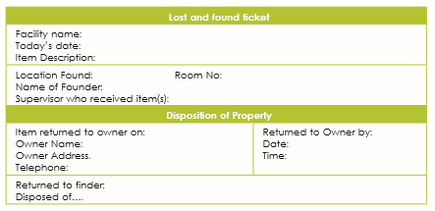
7.2 RESPONDING TO VIPS
VIP means: very important person
A guest may be classified as a VIP for many reasons. A VIP could be royalty, dignitaries, famous actors or singers, company directors, government officials or senior executive business people. Coordination on VIP arrivals, have a look, extra services included in the VIP rooms!
VIPs are very important to hotels as they bring much needed revenue to hotels through return visits and can be useful for promotional reasons also.
7.3 LOOKING AFTER PLANTS
It is important to look after indoor plants during your cleaning routine. Although the upkeep of plants may seem trivial, plants give a source of oxygen in public areas - they take away carbon dioxide and give out oxygen to purify the air. It is also important to use the display and fragrance of fresh plants to improve the comfort of guests and to make that all-important first impression, an attractive one. This can also extend to fresh flowers in the dining room, function suites and bedrooms. When tending flowers or plants, you should:
• Remove dead foliage.
• Remove any cigarette ends or rubbish from planters.
• Water flowers and plants.
• Damp dust plant holders/boxes when necessary to maintain the appearance of the display.
• Some plants may require you to dust their leaves with special plant wipes. This should be done according to manufacturer’s instructions.
Sometimes plan care is outsourced to special plant care service providers.
7.4 HOUSEKEEPING SUPPLY MANAGEMENT
Almost of all the hotels have its own housekeeping supply management system and inventory. The scale of the operation may differ from place to place depending on the scale operation. Large hotels usually outsource to second party for supplying while small hotels procure themselves. The purpose of the housekeeping supply management is to have proper system of inventory, record keeping so that housekeeping can fulfil all the requirements effective and efficiently. Housekeeping supplies that may be used in a large establishment could include:
• Guest toiletries such as soap, shampoo and shower caps • Guest amenities such as coffee, tea and biscuits
• Complimentary items such as fruit, chocolate and cereals • Stationery items such as pens and paper
• Crockery, cutlery and glassware for rooms
• Toilet rolls and bin liners
• Cleaning agents such as detergents
• Cleaning equipment such as mops, brooms and dusters
• Linen for guest rooms such as towels, sheets and pillowcases
• Shoe polishing kits
• Irons and ironing boards
• Machinery such as vacuum cleaners and polishing machines
• Furnishings such as beds, chairs, tables and cabinets
• Fixtures and fittings such as lamps, pictures, ornaments and hairdryers.

DID YOU KNOW?
Some establishments will provide supplies that are specific to the place where they are located. For example, if in tropical or wet areas, they may provide mosquito repellent for guests. If at a beach or holiday resort, the guest amenities may include sun block or beach hats and towels.
MODULE 8
MAINTENANCE, UNDERSTANDING RISKS, PREVENTIVE MEASURES

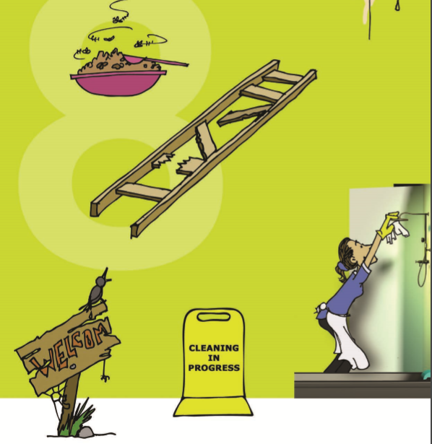
8 INTRODUCTION : MAINTENANCE, UNDERSTANDING RISKS AND PREVENTIVE MEASURES
This module will help you understand the risks at work place and preventive measures that you should be aware of while at work.
8.1 REPORTING MAINTENANCE PROBLEMS
Maintenance problems should always be reported as customers expect that everything in the hotel will be in good working order. Reported faults will be needed to be dealt with quickly and efficiently to prevent accidents and to prevent loss of revenue due to rooms being put out of commission.
Examples of items, which may require repair in the guest room:
• Broken chair
• Broken tables
• Light bulbs
• Dripping taps
• Blocked toilets
• Air conditioning
When a maintenance problem is discovered, the housekeeper must complete a maintenance request form in writing and follow the policy and procedure of the hotel. It is important to fill the form in correctly, to ensure the relevant information is communicated to the maintenance department, in order to avoid misunderstandings.
This maintenance request form is usually prepared in triplicate, one each for:
1. Tradesman (i.e. plumber/electrician)
2. Chief maintenance engineer 3. Housekeeping, as a record and follow up
The standard procedure may be for these forms, to be given to the supervisor, for submission to the appropriate department, at the end of a shift or earlier.

An example of a maintenance request/report:
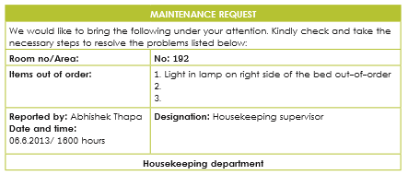
These forms would be on the trolley along with the guest supplies and can be placed in the information folder.
8.2 SAFE WORK PRACTICES
Unless precautions are taken accidents may easily happen, so the Housekeeper should take responsibility to avoid accidents in the work place. The Housekeeper, in addition to training the staff to be aware of the causes of fire and personal industry, should make the necessary safety inspections, reports to maintenance and follow up these reports. We all have a role to play to ensure we work and stay (the guests) in a safe and secure environment.
The main parties responsible for safety in the workplace are:
• You: the employee - you should work in a safe manner at all times considering your personal safety and other workers/guests safety.
• Your employer: is responsible for providing a safe working environment for you.
• Manufacturers: to provide the hotel with equipment and cleaning agents, which are produced to high safety standards.
• Contractors: to complete work within the hotel in a safe manner; which does not endanger staff or guests.
• Guests: guests also have a responsibility - they should not to abuse the property of the establishment, which may result in an accident.
• Everybody: is responsible to be safety conscious, to report any potential safety hazards and to make the environment in which we work and visit, safer for all of us.
SAFETY MEASURES AT WORK
Following are necessary measure that you should always observe at work
• Remember to always protect yourself properly!
• Never run at while at work.
• Wear safe shoes with non-slip soles. You could trip on sandals or high heels.
• Wear protective clothing/gloves when using chemicals.
• Display warning signs for wet floors or work taking place.
• Cordon off the area/section being cleaned.
• Use ladders properly erected when cleaning high areas. Do not stretch in case you lose your balance and fall.
• Avoid stretching cables across doorways, someone may trip.
• Report damaged handrails or fittings.
• Never have wet hands near electrical sockets as you could be electrocuted.
• Lift all items, whether vacuum cleaners or boxes, carefully - bend your knees and keep your back straight. Do not lift too much at the same time as it could obstruct your vision.
• Do not leave equipment and rubbish in corridors, stairways or blocking fire exits where an accident could happen due to a blockage or a trip hazard.
• Wear safety equipment such as gloves, ear muffs, glasses and face masks to protect you from potential hazards.
• Use trolleys for moving chemical containers and heavy cleaning equipment so as to prevent back injuries.
• Never mix chemicals together as some mixes can become volatile.
• Use signs when cleaning to indicate slippery areas.
• Know when to replace products, e.g. mop heads, cloths.
• Use the right dilutions of products; this will help to ensure cost efficiency, minimal build-up on surfaces and less fumes or vapours.

8.3 SAFETY IN ROOM CLEANING AND SERVICING
Keep in mind the following safety precautions when cleaning guest rooms:
- Do not leave cleaning liquids or equipment unattended - especially if there are any children around.
- Load trolleys carefully so that items will not fall off, and so that you can see where you are going. Do not overload trolleys.
- Do not empty broken glass or crockery into the plastic waste bag; wrap them before throwing them away, or throw them away separately.
- Do not empty ashtrays into plastic bags or cardboard boxes.
- Do not leave linen lying in piles in the corridors or in fire escape routes, where they may cause a fall, or prevent evacuation in an emergency situation.
- Do not run your hands along surfaces you cannot see without checking first that there are no sharp edges.
- Take care when running hot water from taps in bathrooms - it might be hot enough to burn or scald you.
- Let light bulbs cool down before touching them to clean or replace them.
- Report any loose light fittings to your supervisor, or to the maintenance department.
- Clean the other side of the bath first, so that you do not have to lean over a slippery, wet surface.
- Wet bathroom floors can also be very slippery; leave them as dry as possible.
- Wash your hands after cleaning the toilet, or wear protective rubber gloves.
- Don’t reach into waste paper baskets without looking, as they might have broken glass or razor blades in them.
- Check that there are enough ashtrays available for guest use so that they do not use waste paper baskets that could cause fires.
- When changing beds, check the bed for any sharp objects. Get help when turning the mattress.
- Furniture must not block the passages or fire exits, not even for a short time.
- Do not stack armchairs or small tables on top of chairs when cleaning rooms, they might topple over and hurt you.
8.4 PREVENTING ACCIDENTS
It is important to try and avoid accidents from occurring. In case an accident does occur, you should know the location of the First Aid Box and be able to use it.
• PREVENT FALL
o Pick up anything that falls on the floor immediately.
o Avoid over-wetting floors when washing, as they could be slippery.
o Never run.
o Wear suitable shoes with a non-slip sole. You could trip in high heels or sandals.
o When using a step ladder only use the area within your reach. Make sure your ladder or working platform is safe to stand on.
o securely fasten all windows before attempting to clean them. Never lean against a window when cleaning it. You could over balance and fall out.
o Report minor maintenance faults that could be safety hazards (e.g. torn carpets, damaged flooring, worn stair heads).
o Bad lighting can be dangerous, especially in stairwells. Replace burnt out bulbs immediately.
o Never leave objects on the stairs.
- PREVENT CUTS
o Clean up any broken glass immediately before it cuts you or a guest. Wrap in paper before disposal.
• PREVENT ELECTRICAL SHOCK
o Protect electrical sockets and plugs from water.
o Do not use vacuum cleaners with frayed flexes.
• Prevent Chemical Burns
o Replace lids tightly on all cleaning materials after use.
o Use cleaning agents according to the directions. Do not mix them. Follow instructions about ventilation.
o Do not pour cleaning materials into unlabelled containers, glasses or coffee cups.
• PREVENT PERSONAL INJURY
o Use "in and out" doors correctly.
o Never run.
o Do not leave obstacles in corridors, on stairways or blocking fire exits (e.g. trolleys, equipment, linen bags, refuse bags).
o Do not obstruct your vision with bundles. Do not walk where you cannot see. o Use long handled equipment carefully to avoid breaking a window or hitting somebody.
o Do not leave cupboard doors open.
o Do not lift heavy objects without assistance.
o Do not run your hands along surfaces that you cannot see, without checking first for protruding nails, broken glass, etc.
o If you have an incident, report immediately to your accommodation supervisor.
Remember, accidents can result in injury or pain, medical expenses and loss of earnings.
8.5 SAFELY HANDLING CLEANING AGENTS, EQUIPMENT AND MACHINERY
All housekeeping staff must be fully trained to ensure that they are familiar with the correct use of cleaning agents and equipment. You should only operate machinery after you have studied the manufacturer's instructions and know exactly what to do. Following table indicates good working practices and handling procedures.
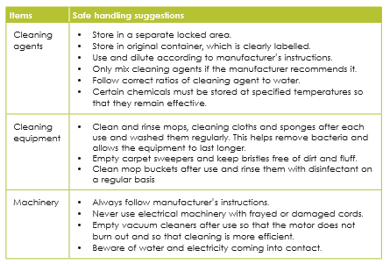
• VACUUM CLEANER HANDLING
Many accidents are caused by careless use of electrical equipment, such as vacuum cleaners. When working with electrical equipment, the following safety procedures should be followed:
o Work backward with vacuums towards the socket. This keeps the flex in a safe place.
o Place cable down one side of the corridor, avoiding doorways
o Never use a vacuum, which has a frayed cable.
o Do not stretch the cable from the socket; simply move to another nearer socket.
o Make sure the socket is in an OFF position before plugging anything into it. o Make sure that the machine is in an OFF position when plugging it into the socket.
o Keep plugs and connections away from water.
o Always report faults or unusual noises o Keep dust-bags and filters clean.
o Rewind the cable carefully.
Handling of Manual Equipment
It is also essential that you work safely with the manual and mechanical equipment in your department.
o When preparing to mop a surface you should not overfill the bucket to avoid spillage. o You should also wash and change mop heads and the brushes from carpet sweepers frequently.
o When pushing and pulling a mop/carpet sweeper, keep you back straight and tuck in your chin - if it is necessary to lean forward then keep your whole body at the same angle: rear of legs, back and back of head.
8.6 HYGIENE AND SAFETY RISKS IN BATHROOMS
A clean bathroom is important for maintaining the standards of presentation of the hotel, and also for maintaining hygiene standards. The bathroom is a potential source of infection and disease because it is the area used for personal bathing. It must be cleaned to a standard where it smells fresh and is free from all bacteria and germs.
There are a number of hygiene risks that you may be exposed to when cleaning bathrooms. Various body fluids may be found in guest bathrooms, including blood, vomit and semen. These may carry contagious illnesses, and must therefore be handled and treated very carefully.
8.7 PRECAUTION AGAINST INFECTIOUS DISEASES LIKE HIV/AIDS
HIV/Aids is transmitted from one person to another by the exchange of body fluids, because the virus is carried in the body fluids, particularly semen and blood. Staff need to take special care when handling or cleaning anything that may have had contact with any other person’s blood or semen, such as razors, used razor blades, hypodermic needles, used condoms, sanitary towels, soiled sheets or towels, vomit or excreta.
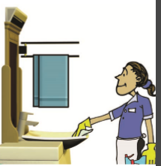
Disinfection Procedure: Follow these
procedures when wiping up spills of blood,
semen, mucus, vomit and other body fluids:
1. Make sure that any cuts or grazes you
might have are covered with waterproof
dressings.
2. Make up your disinfectant according to
manufacturer’s instructions.
3. Put on rubber gloves, and wear a plastic apron if you need to.
4. Disinfect the contaminated area;use a cloth or mop, but not a scrubbing brush, as this can cause splashes.
5. If soft furnishings such as upholstered chairs are affected,
soak the contaminated area with a disinfectant, and then allow it to air dry.
6. Leave the disinfectant to work - the length of time will depend on the instructions, then mop up the disinfectant, and wash the surrounding areas.
7. Without taking them off, rinse the gloves in the disinfectant; rinse and wipe the apron.
8. Throw the disinfectant down a toilet; place the cloth in a plastic bag and put it with the rubbish.
9. Wash out the mop head in disinfectant.
10. Leave gloves, apron and mop, if used, to dry before putting away.
11. Wash hands thoroughly.
There are also other risks and safety issues to take into consideration e.g. hazardous waste, personal safety and the use of chemicals: (Follow as with steps 6 to 10 of the disinfection procedure.)
Removing Needles and Syringes:
- Put on rubber gloves and a plastic apron.
- Pour disinfectant over the syringe and needle; and leave it for 20 minutes. This applies to needles on floors or in toilets.
- Make sure no one touches them.
- Pick up the syringe carefully with tweezers or pliers, and put it into a container.
- Mop up the disinfectant or flush the toilet. Wash the surrounding areas with disinfectant.
8.8 PERSONAL SAFETY ISSUES
When you are cleaning a bathroom you should be careful not to injure your back. Many of the cleaning tasks require vigorous effort and you may have to reach across baths to clean tiles and clean areas high above your head.
• To protect your back from unnecessary strain, clean the bath on your knees to avoid working with your back bent.
• Stand in the bath if you have to clean tiles rather to avoid working while reaching out because you could strain your muscles. Rather than reaching across and straining your back, place a cloth bath mat in the tub and stand on it while you clean the tiles and shower.
• Never stand on the edge of the tub when cleaning the shower or tiles.
8.8.1 PROCEDURE FOR REPORTING ACCIDENTS
All accidents should be reported to your supervisor. It should also be recorded in the accident book. The information required will be date and time, description of the accident, the staff and guests (s) involved and the supervisor in attendance.
8.9 FIRST AID
In the case of an accident where someone required first aid you should contact the designated “first aid person”, i.e. the person who is trained to give first aid treatment. However, you should know the basic treatments for minor injuries in case you have to treat someone.
8.9.1 TREATING SMALL COMMON INJURIES
• Minor Burns
o Place injured part under slow running cold water
or soak in cold water for 10 minutes or as long as
the pain persists.
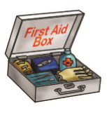
o Gently remove any rings, watches, belts, shoes
from the injured area before it starts to swell.
o Dress with clean, sterile, non-fluffy material.
o Do not use adhesive dressings.
o Do not apply lotions, ointments or fat to
burns or scalds.
o Do not break blisters or otherwise interfere with the injured area. o If in doubt, seek medical aid.
• Minor Cuts
o Wash the cut or scrape and dress it with a clean bandage.
o If the bleeding persists, apply a clean dressing to the wound with firm, constant pressure, for up to twenty minutes.
o If in any doubt about the injury, seek medical aid.
• Difficulty in Breathing
o Loosen the clothing around the neck (unbutton shirt/blouse and any scarf/tie).
o Give the person a paper bag do breathe into and out of to steady their breathing. o If in doubt, seek medical aid.
8.10 PROPER USE OF THE HAZARD SIGNS
Hazard warning signs are used to warn staff and customers to a potential danger. They are very important and the guidelines for their use must be strictly adhered to. Hazard warning signs are most commonly used during cleaning operations or when spillages occur and can be placed directly at the problem area.
Before cleaning commences, hazard warning signs must be in place. Cleaning can cause floors to become slippery and cleaning machines with electrical cords can be dangerous to people in the immediate area. However, a hazard warning sign can easily tell people to stay away and therefore avoid injury.
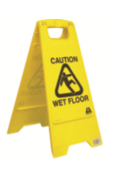
It is important that hazard warning signs:
• are placed where the hazard is
• are sufficient in number to indicate where the
hazard starts and finishes
• be placed in a position that they are not a hazard
• be the correct types of hazard sign to warn
Staff and customers what the hazard is.
8.11 SAFETY INSPECTIONS
It is very important to carry out regular safety inspections, to identify any potential safety hazards. For example,
• Worn or threadbare floor coverings may cause pedestrians to trip and fall; • Lights not working, particularly in areas where natural light may be at a minimum and therefore visibility,
• Poor; inadequate or inappropriate storage facilities for cleaning agents and equipment.
The list is endless and the potential safety hazards too numerous to list here. This makes the need for regular safety inspections even more important in the operation of any establishment. If potential safety hazards are detected, these must be reported and corrected as soon as possible.
8.12 SECURITY IN HOTELS
Security refers to both the security of the guests and their belongings, and also the security of the building. Poor maintenance and dishonesty can jeopardise security, and once again, both management and staff have a shared responsibility to control both of these threats.
Many establishments have one or more security officers on their staff to prevent crime and to protect guests and their staff from such dangers as theft, fire or assault. However, all employees of the hotel have the responsibility to safeguard the property of the guest and company. The Housekeeper and her staff are about the building perhaps more than many other staff and must be aware of the ways in which they can be security minded.
Outside of work: refrain from discussing guests outside of the workplace.
Suspicious items, persons and situations Suspicious items need to be reported to the applicable responsible person according to your hotel’s policy and safety and security procedure. This could be your housekeeping supervisor, security officer etc.
The nature and urgency of the situation will influence the procedure followed and the person/department to be notified e.g. a stranger with a weapon will not be reported to housekeeping via a written report, the security department will be notified immediately via the internal telephone system.
Suspicious items or situations may include:
- Blood-stained items
- Unattended packages in public areas/corridors and even rooms
- Drugs and equipment used to take drugs e.g. syringes, pipes, etc.
- Weapons
- A person(s) in a restricted area
- A person who tries several doors, with or without a key
- A person seen using the service stairs
- A person in the hotel uniform who does not look familiar
- Use of excessive force against another person
- Strange (out of place) smells e.g. unusual chemical smells, smoke other than the norm, rotting smells etc.
8.13 PEST CONTROL
A pest is any organism unwanted creatures in the hotel that spreads disease, causes destruction. They are often responsible for spreading disease and bacteria. Therefore you should take every precaution to have pest free environment to avoid guests falling ill. Good pest control needs good mechanism and systemic control. If you do follow proper cleaning and monitoring, it is absolutely possible to have 100 pest free working place. Following table indicates common pests and necessary measure to prevent.
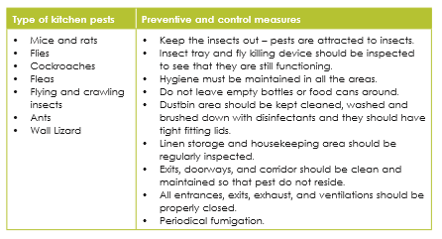

8.14 FIRE
Fire is most threatening and most common hazard in the hotels. It does not discriminate people and property. You have to take every possible precaution to reduce the risk of fire in the working environment. Always observe tools, equipment and machinery connected to electricity and ensure they work properly. It is absolutely essential that you are aware of hotel fire evacuation plans and procedure as well as follow the guideline in dealing with fire incidents.
Types of fire
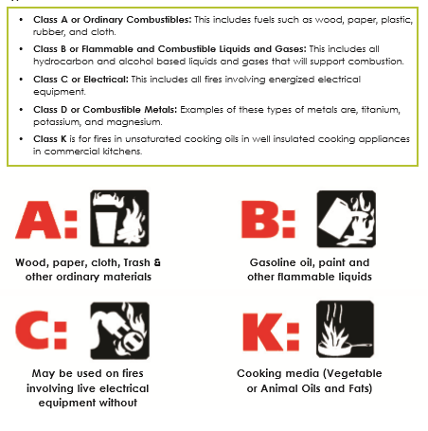
Causes of fire Following are the major sources that can cause fire incidents in the hotel.
- Electricity.
- Cleaning supplies (liquid substances).
- Flammable liquids.
- Combustible liquids.
- Careless smoking.
- Improper storage.
- Unattended cooking.
8.14.1 PREVENTING FIRE ACCIDENT IN THE HOTEL
- Keep electrical appliance away from water to avoid electrical shock and fire.
- Store linen, liquids and chemicals only in designated areas, otherwise that may increase the risk of fire.
- Take special care when dealing with flammable chemicals.
- Make sure paper towels, linen and equipment are kept away from hot surfaces, so they do not catch fire.
- Dress properly, don’t wear loose fitting.
- Never leave tools, equipment unattended if you connected to the electricity.
- Do not smoke within the working environment.
- Know the use of fire extinguisher and their location.
- Keep combustibles like cloth, paper, chemicals and etc free from the hot surface.
TYPE OF FIRE EXTINGUISHER
Commonly used fire extinguishers for civilian purpose are:
- Water based extinguisher.
- Dry chemical based extinguisher.
- CO2 based extinguisher.
- Foam based extinguisher.

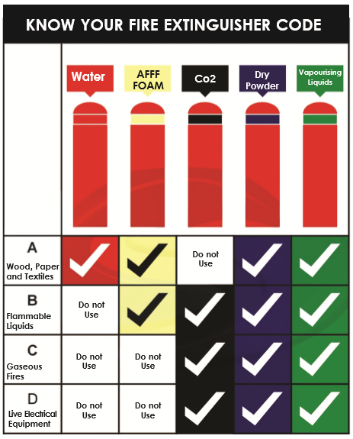

When using a fire extinguisher, always remember the PASS
• P - Pull (pull the pin that locks the handle)
• A - Aim (aim the nozzle at the base of the fire)
• S - Squeeze (Squeeze the handle to discharge the extinguishing agent)
• S - Sweep (Sweep the nozzle from side to side, to cover the fire)

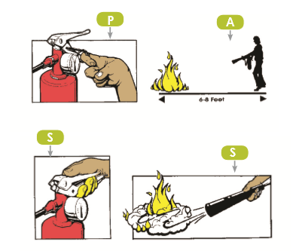

THE FUTURE
Congratulations, for successfully completing the Housekeeping. Now you are fully equipped to start your career with complete understanding of the industry demands. It is one of the most rewarding professions in the hospitality sector.

