Future Trends in Additive Manufacturing

Dr. Sridhar Sathyanarayana,
(former)Professor, Mechanical Engineering Department,
Channabasaveshwara Institute of Technology,
Gubbi, Tumkur, India
Email:s.sridhar957@gmail.com

Shilpa Sridhar,
Software Engineer, RSA,
Bengalure, India,
Email:shilpa.sridhar18@gmail.com
Sanjan S Aathray,
Student, Mechanical Engineering Department,
New Horizon College of Engineering,
Bengaluru, India,
Email:sanjansaathray18@gmail.com

Phaniraj Karanth K C,,
Software Engineer, Minko,
Bengaluru, India,
Email:phanirajkaranth@gmail.com

ABSTRACT

Manufacturers are working to reduce the manual or labour costs of Additive Manufacturing work flows to bring 3D printing from batch or small scale production to medium or mass production. Automation and software development with process improvements can bring down the costs of production. Over the years, the computing system has changed and evolved from mainframes to desktop PC’s, 3D printing systems are also evolving and shifting from single system to multiple systems for performing tasks. Robotic arms and other extended systems carry out part removal to reduce operator’s task. To handle irregularly shaped work pieces, the systems should be automated. To improve further and automate other aspects of 3D printing, like supports removal, cleaning the build, performing finishing jobs like heat treatment and apply coatings, etc, automation needs to be applied at all stages of fabrication, thus progressing towards digital fabrication and digital assembly.

Keywords—3D printing, automation, multiple system, digital fabrication, digital assembly.

INTRODUCTION

Additive manufacturing (AM) is a method that describes the technique and use of 3D printing to make functional parts and components, including tools and production parts. Additive manufacturing parts are built by adding suitable materials in the form of filament, wire or powder, by adding material layer-upon-layer using a heat source. 3D printing describes an entire operation of part making processes that generally build components layer by layer. There are seven distinct types of AM technology [1].

- Vat photopolymerization: A vat photopolymer resin is selectively cured through point-by-point or layer-by-layer exposure to light.
- Powder bed fusion: Powdered metal or polymer is fused together using an energy source, typically laser or electron beam.
- Binder jetting: A binding agent deposited onto powdered metal or sand creates the geometry; in the case of metal, binding is typically followed by sintering to fuse the powder.
- Material jetting: Droplets of material are precisely deposited to build the geometry.
- Sheet lamination: Sheets of material are arranged in a stack and laminated by bonding layers of material together through different joining means like ultrasonic welding, brazing, adhesives or by chemical means.
- Material extrusion: A material such as polymer filament or pellets is heated and extruded through a nozzle.
- Directed energy deposition (DED): Metal powder or wire is fed into a meltpool created by a laser or electron beam in a process similar to welding.
Hybrid manufacturing describes a process that combines AM with conventional subtractive technologies. A CNC machine tool could be equipped with a wire-fed DED head, e.g., allowing the same machine to both, to add material and machine it away. The different categories of materials used in 3D printing today are:

- Polymers: Stereolithography was the first 3D printing process to be developed. Polymer parts are built by curing the polymer resin by a method called vat polymerization. Polymers are one of the largely used category of 3D printed materials today. Thermoplastics like Polyesters and ABS are also largely used as materials in AM systems and filament-driven systems. Nylons and polyurethane are used in powder bed fusion process systems. Thermoset materials are used commonly in vat polymerization and also used for extrusion and selective laser sintering applications. Polymer materials are usually provided in the form as solid filament, pellets, liquid resin or powders [1].
- Metals: Metals like aluminium, stainless steel, titanium, cobalt chrome and inconel, are the most common 3D printed materials. Copper can also be used by employing blue-light lasers. Metals for 3D printing are generally used and provided in wire or powder forms. They can also be mixed with other materials, and also be suspended in resin or supplied as paste [1].
- Composites: Polymer composites, polymers reinforced with chopped or continuous carbon fibers and glass fibers can be made strong and can act as an alternative to metal. Metal matrix composites, ceramic matrix composites which blend metal alloy with another material forms another type of material [1].
- Ceramics: Ceramics exhibit low absorption properties and are difficult to print with laser-based systems. But ceramic solutions or ceramic slurry or blend of material can be utilized on extrusion, metal jetting and photopolymerization systems [1].
- Sand: Binder jetting is a 3D printing process which uses sand and to selectively glue the grains together for both prototype and production foundry moulds and other types of tooling [1].
A. AM workflow
For most AM production applications the general workflow will be as follows. 3D printing is only a part of the AM process flow.

- Design the part: Design may mean modifying an existing design for 3D printing or starting a new design for AM. Computer simulation, generative design and topology optimization can all be applied to optimize the function of the part. Printing process and material selection usually occurs in the initial design step.
- Plan to build: This step includes selecting part orientation, adding support structures, packing multiple parts together, setting printing parameters such as layer height, laserspot size, feed rate, etc.
- 3D print the part: A 3D printing build might take from minutes to days.
- Post process the part: Depending on the process, post processing include unpacking powder, cutting parts from a build platform, cleaning, curing, heat treating, hot isostatic pressing, etc.
- Finish the part: Finishing steps might include machining surfaces, drilling or tapping holes, dyeing, coating or painting, welding or assembly with other parts.
- Inspect the part: Some parts can be evaluated with CMM measurement or 3D scanning; those with complex features may require X-ray or CT scanning.
B. Additive Manufacturing system equipment and safety
3D printer equipment is only one part of the complete AM process equipment. Each and every AM process and application will require other support equipments other than the printer and material. New software products such as slicing programs, generative design or topology optimization and build simulation are important. Some simplified equipment lists depending on specific 3D printing process and system used for common AM methods are given in the table 1:

Table 1. Equipment lists for common AM methods

Sl.No | Metal powder bed fusion | Metal binder jetting | Polymer powder bed fusion | Photopolymerization
1 | Shielding gas such as argon | Sieving and powder handling equipment | Sieving and powder handling equipment | Resin handling and mixing equipment
2 | Sieving and powder handling equipment | 3D printer | 3D printer | 3D printer
3 | 3D printer | Debinding station | Vacuum down-draft table for unpacking parts | Parts washing equipment
4 | Band saw or wire EDM for part cut-off | Machining capacity for finishing | Dyeing equipment
5 | Oven for heat treatment | Sintering furnace | Mass finishing equipment such as sand blasters and tumblers | Curing oven
6 | Machining capacity for finishing

Appropriate safety measures and equipment such as electrostatic dissipative flooring, fire suppression systems and air quality monitoring equipment, personal protective equipment (PPE) for operators such as respirators and flame resistant clothing should be provided.
Additive Manufacturing is soon gaining importance as an alternative production method and enabling engineers to design and consolidate parts and produce components of complex shapes and dimensions quickly. The AM technology should move fast from low-volume prototype production to high volume mass production-ready parts. Recent AM applications involving Automated Guided Vehicles (AGV), robots, high speed printers has shown automation is the key to development of AM. As manual costs are increasing, hidden cost such as operator time for scheduling print jobs, uploading CAD files and loading machines, lack of availability of operators to remove parts, cost of print bed removal from parts in post production stage, software development and automation can help reduce cost and improve production rate and material handling and improve quality. Automation will be critical to AM in high volume applications. Automation can bring in stability and improve accuracy and can enable to transform 3D printing from a batch production to a continuous production. Manual processes like removing a build box from a printer; lifts the build box and transfers to the next stage of production, can be automated by using an AGV, conveyor or robots in the future.

TRENDS IN ADDITIVE MANUFACTURING

The progress of AM in the recent times has continued, with the software companies by and large, big or small focusing on software development solutions to meet the requirements and expectations of additive manufacturing technologies. This evolution will fuel the next generation of software tools which will drive AM forward towards industrialization. Three new advancements in metal 3D printing like Metal Fused deposition modeling (FDM) 3D printing, HP’s Binder jetting system, Intelligent layering for economical metal 3D printing are gaining importance. The advantage of using 3D printing systems, can produce parts and components by allowing for small changes without requiring extra tools or equipment in comparison with other methods. This future possibilities are exponential, and it has the potential in mass production of goods from food to medical supplies. 3D printing machines could make applications that may be used at places in homes, businesses, disaster sites and even outer space. Software development can save engineering time with an automated workflow and CAD integration, build plate leveling, and other manual jobs.

The trends that will define the future of AM [2]
The five trends that will define the future advancements of AM:

- Additive manufacturing process software innovation and integration: Software integration forms a critical step with workflow integration from ordering, part design, build preparation, production planning and monitoring, post production processing, cleaning, inspection and logistics of delivery. Till recently, software solutions are not been optimized for better results of some 3D printing. Many processes are manual and are inefficient because companies are using poor technologies for AM. Software is a crucial part in the evolution of 3D printing. There is a gap between hardware development and software enablement as 3D printing becomes a mass production method. The industry has been working for reducing and closing the existing gap, but still there is room for development. This will push the generation of software tools which will drive AM forward towards industrialization.
- Increased focus on Machine connectivity and integration: The biggest trends is making AM solutions- both hardware and software, should be made easier to integrate and connect with the production floor. Hardware manufacturers should shift their focus to systems, which are open to integration with factory floor. Closed systems which cannot be easily integrated to third-party solutions are viewed as limiting the collaboration and connectivity. System integration and connectivity is the need of the day and need no longer to be viewed as an option, but a necessity for AM work flow.
- To continue integration of AM and AI: AI and ML are becoming integral parts of AM growth. AI may be integrated with AM systems to enable greater process control and repeatability. This can reduce defects and improve accuracy and use less material. e.g., Inkbit is developing an AI based vision system integrated to AM polymer system. This has the ability to analyze the print process. This system will be able to scan each of the 3D printing layers and predict the material behavior during the print process. Our dream to develop a fully automated process design may be achieved with the advancement taking place in the generative design. This can be mostly used to optimize loading directions where strength and stiffness are considered, and which can also be used for thermal and vibration optimization. AI can be integrated with manufacturing executive systems within AM industry. In future, the machine analytics and capabilities can be developed and can be applied to analyze collected data and suggest where improvement to the production operations can be done.
- AM will drive multiple or distributed manufacturing: Nowadays many organizations are moving to new logistic and supply chain models and technologies to reduce costs and also switching over to new products or product mix bringing more flexibility among the products they manufacture. This may facilitate multiple manufacturing and promote a distributed localized manufacturing system, which is driven by AM. Automation in AM can sufficiently reduce the number of process steps that is required to make complex part or component shapes. This may bring down or cut-down lead times and also facilitate the shift towards digital inventories and digital manufacturing.
- The next area of growth in AM is Manufacturing Execution Systems (MES): Digital manufacturing technologies require a good software foundation and automation. Design and development of MES softwares, can make the AM work flow to run smoother and cheaper and facilitate mass production. This promotes automation of key processes like order management, build setup, production scheduling and monitoring, post production processing, etc.
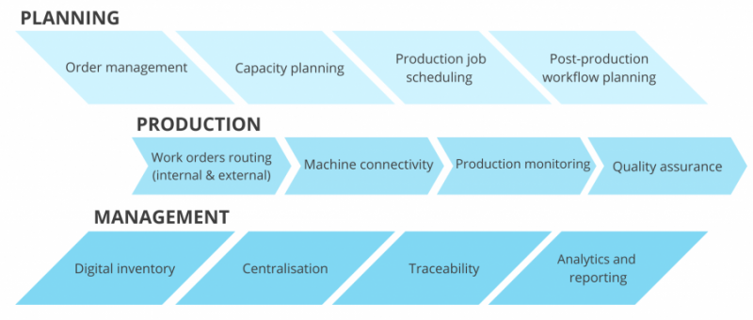
Fig.1. MES workflow management[2]

MES integration with AI and machine learning, advanced connectivity with hardware, greater inter-operability may facilitate the future growth and sustainability in AM and beyond.

Automation of post-production management planning for AM:
For AM post-production management refers to the process of planning and coordinating all the required activities once a print run has been completed. This includes and not limited to:
- Planning and managing post-processing tasks
- Conducting Quality Assurance (QA) inspection
- Planning and managing logistics and delivery
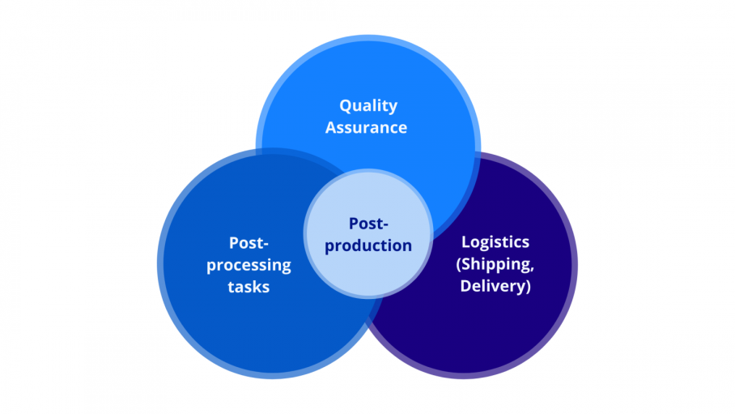
Fig.2. Post-production management planning[2]

Post-production stage comprises of [2]:
- Post-processing planning: The overall process of managing how resources are acquired, stored and transported to their destination which refers to Post-processing planning can become very difficult if not properly planned and executed. When dealing with hundreds of projects and several different machines, the resources have to be assigned and allocated to different projects and different machines. Each project has to be assigned resources and task managers can do the allocation for each project. Using manual processes, to manage and coordinate, may be difficult and will only prolong the process. To obtain optimum and maximum efficiency, automating the task of planning post-processing activities is inevitable. Workflow management software can be used to automate this process and post-processing schedule system. This may reduce manual errors and can allocate the correct post-processing tasks and the right sequence of actions to be undertaken..
- Faster part identification: After completing the build process, parts are need to be identified and assigned. This stage of identification in most companies and for vast majority of AM departments, identifying and tracking parts is a completely manual process. Using workflow management software this can be automated and simplifying the part identification stage
- Enhanced quality assurance: Quality assurance (QA) inspection and control is a crucial and an ongoing step at each point of post-production stage. Manual QA inspection and checking involve fixed set of inspection check elements, and workflow management software will facilitate to digitize this process.
- Robust data management: A single build process may consist of huge amount of data usually tens or thousands of terabytes. Hence, QA inspection for AM is an area that requires robust data management process. Data of key parts information has to be stored, maintained and updated. This is impossible to do manually, the digital approach using data analytics may optimize and enables to store data for each individual part and larger production process work flows..
- Integration of communication tools: In traditional processes, the rapid prototyping setup facility, needs to check data available with a spread sheet system and email a response, and when encountered with multiple parts and sending email responses, a lot of effort and time is spent, pertaining to the status of the project. Integrated with a workflow management software, the status of the project with all required information can be ascertained within seconds.

FUTURE OF ADDITIVE MANUFACTURING

New materials and system automation will drive the future of AM in engineering
Many materials for use in AM systems are commercially available, but each material type has different properties and is specific for particular applications, particular deposition processes such as inkjet printing, fused deposition mould, aerosol deposition, etc. Many AM manufacturing systems are not flexible enough to use different materials and build processes, creating an obstacle to computing. Each, specialized application decides its own set of materials and a specialized process system. Researchers in academia and industry are developing a set of adaptable materials to be used in standard AM techniques and AM systems. These new systems has broader adaptability of materials and systems, increasing flexibility and improving productivity, printing resolution, flexible in build parts, loading/unloading procedures. This may decrease the costs of AM production systems compared to traditional manufacturing methods.

AM aids Research & development
AM systems allow researchers to expedite research in variety of areas, including and not limited to electronics, medicine, computer science, material science, biotechnology, mechanical, instrumentation and much more. AM of some unique electronic units or devices having non-planar or unequal shapes allows researchers to explore and develop new electronic adaptable materials for AM processes and systems with unique device architectures in areas like sensor and drone networks. Also, some Embedded wireless devices having unique printed antenna architectures allow researchers to experiment and develop new network arrangements, shapes and sizes of communication protocols between these electronic devices for these systems. On the industry side, new electronic parts or units, and RF devices for aerospace applications are being experimented and developed.

REFERENCES

[1] AMFG-Autonomous Manufacturing, Feb 2021
[2] AMFG-Autonomous Manufacturing, Sep 2021
[3] The future of Additive manufacturing in Engineering, Nano Dimension, May 2019

