ISOLATION, PRODUCTION AND CHARACTERIZATION OF PHOSPHATASE ENZYME PRODUCED BY FUNGI AND BACTERIA FROM GARDEN SOIL.
Eugin Amala.V*, .Krishnaveni.R, N.Hira ¹ ., S.Afrin Sahanaz ¹ ., V.Nithya Sri ¹
1.Assistant professor and Head,PG & Research Department of Microbiology, Idhaya College for Women, Kumbakonam
*Corresponding author: amalaeugin@gmail.com
- ABSTRACT
Phosphatase enzyme which is produced from bacteria and Fungi from garden soil. The garden sample was collected and inoculated in the pikovskaya's agar culture medium. As a result the activity of Aspergillus niger the highest solubilizing capacity than the other organisms. Then the phosphatase enzyme is extracted, purified and the activity of enzyme is determined. Then the molecular weight of enzyme is identified using SDS PHAGE. The farmers were instructed to use phosphate solubilizing organisms instead the usage of chemical fertilizer.
(Key words: pikovskaya’s media, activity, SDS PHAGE, chemical fertilizer)

- INTRODUCTION
Phosphorus is a chemical element with an atomic number of 15 which includes 15 protons and 15 electrons. It occurs in two forms (i.e) white and red phosphorus. White phosphorus emits faint glow when exposed to oxygen. The phosphorescence, is the property of phosphorus though it produces a glow after illumination.
Phosphorus is an essential element for plant nutrition. It is found in soil organic and inorganic forms. Phosphorus is one of the component for crop production on many tropical and sub- tropical soils as a result of high phosphorus fixation. The soluble inorganic phosphate is applied to soil as chemical fertilizer and is renderly inactive state and becomes unavailable to plants (Dey, 1988). In tropical soil the concentration of soluble phosphorus (P) is very low. The minerals and nutrients in soil are present in millimolar while, the phosphorus is only available in micromolar quantity (Goldstein, 1994). The majority of phosphorus is fixed in soil that the plants are poorly available to plant roots. In soil the most predominant form of inorganic phosphate is calcium phosphate. Where, Iron (Fe) and Aluminium (A₁) are also associated (Gyaneshwar et al., 2002).
Chemical fertilizer play an important role in green revolution, but the unequal usage of them, it had lead to the reduction of soil fertility and environmental degradation. Unfavorable PH, and high reactivity of aluminium and iron in soil decrease the phosphorus availability to plants. And also decrease the phosphorus fertilizer efficiency in the soil (Hao et al., 2002). The utilization of available phosphate to plants is done by phosphate – mobilizing microorganisms. Most of the soil fungi, bacteria, and Actinomycetes are involved in solubilizing inorganic phosphates. Phosphate solubilization is based on the production of organic acids and acid phosphates play major role in the mineralization of organic phosphorus in the soil. Production of organic acids results in acidification of the microbial cells and its surroundings.
Phosphorus is an essential component that promotes the growth of photosynthetic algae and cyanobacteria, leading to eutrophication of lakes. Phosphorus is divided in three categories: absorbed phosphate (soluble), organic phosphate and mineral phosphate.
The absorbed form of phosphate is the anionic orthophosphate (PO₄³⁻). Orthophosphate precipitates with Ca²⁺, Mg²⁺ and Fe²⁺ at neutral, and alkaline PH. But at high PH, it is associated with Na²⁺. This activity does not do any good to plants, because the alkalinity inhibits the growth. The most common identified form is inositol phosphate. One of the most common plant produced organic phosphate is phytin. Inositol phosphate may be 15- 30% of the organic phosphate present in the soil. There are over 200 mineral forms of phosphate in the soil. Some of the most common forms are the apatite which have general formula:
M₁₀ (PO₄)₆ × 2
Where, M=Ca, Mg
X= F, Cl, OH
Phosphorus is obtained by mycorrhizal fungi and phosphate solubilizing microorganisms. Though solubilization, these microorganisms are effective in releasing the phosphorus (Narula et al., 2000). Pikovaskaya’s medium is integrates with tribalism phosphate which is used for the enrichment of phosphate solubilizing bacteria. The samples were serially diluted and plated on the medium and incubated for 4 days. The colonies showing solubilization were picked up and purified by streaking on the surface of the agar medium. The purified colonies were preserved on pikovaskaya’s agar slants.
PHOSPHATE SOLUBILIZING MICROORGANISM (PSMs):
Species of Aspergillus and Penicillium are among fungal isolates identified to have phosphate solubilizing ability. Among the bacterial genera: Pseudomonas, Azospirillum, Bacillus, Alcaligenes, Serratia, Enterobacter, Acinetobacter, Flavobacteria, Erwinia (Rodiriguez etal., 1996)
Among the algal genera, cyanobacterium, pythium and phoma which are able to solubilize phosphate. Seed or soil inoculation with PSMs is used to improve the solubilization of soil phosphorus and applied phosphorus which proceed in higher crop yield (Jones et al., 1994)
In a mixed population of microbes they are essential to promote enzymatic degradation of naturally occurring organic compounds. The enzymatic degradation results in the formation of orthophosphate,which can be readily utilized by the primary producers and even the smallest concentration of phosphate in water enhance the production process of aquatic ecosystem.
- METHOD
The sample was collected and the pikovskaya’s agar medium, and were transferred to petri plates after sterilization.
- MICROBIAL COUNT:
1g of soil was weighed and dissolved in 10 ml of distilled water. This was consider 10⁻¹ dilution. Then 1ml an aliquots is transferred with sterile pipette to 9ml sterile distilled water in test tube, this was 10⁻² dilution continuous serial dilution were done until 10⁻⁸ dilution. Transfer 0.1ml aliquots suspension from each dilution into pikovskaya’s agar plates which is supplemented with phosphate. Then the plates were incubated at 25º C for 4 -5 days. Transparent zones of clearing around the colonies of microorganisms indicate that the phosphate present in the medium has been solubilized in clearing zones. Isolate the culture and purify it.
- THE EFFECT OF PH ON PHOSPHATE ENZYME:
Analyzing acid phosphatase assay:
Acid phosphatase assay was used to count various adherent and non- adherent cells. The acid phosphatase assay has similar sensitivity but a wider lineal response range. To estimate the acid phosphatase assay – take 1ml of citrate buffer of pH 3, 4, 5, and 6 in separate test tubes. Mix the 1ml of culture filtrate and the buffer for 5 minutes. Then in each test tubes 1ml of p-nitro phenol phosphate is added. Then the tubes were incubated at room temperature for 30 minutes. Then 4ml of 0.1 N of sodium hydroxide was added and the OD value was noted at 405nm.
Analyzing alkaline phosphatase assay:
To estimate alkaline phosphatase assay, take 1 ml of sodium carbonate and bicarbonate buffer of pH 8, 8.5, 9 and 10 in separate test tubes. Then mix the 1ml of culture filtrate and the buffer for 5 minutes. Add 1ml of p-nitro phenol phosphate in each test tubes. Then the tube were incubated at room temperature for 30 minutes, Then add 4ml of 0.1 N of sodium hydroxide and the OD value was noted at 405nm.
- THE EFFECT OF TEMPERATURE ON PHOSPHATASE ENZYME:
Analyzing acid phosphatase assay:
To estimate acid phosphatase assay 1ml of citrate buffer of pH 4 for Bacillus polymerase and pH 5 for Aspergillus niger, Penicillium chrysogenum, and aerobic spore former were taken in separate test tubes. Then 1ml of culture filtrate was added to this buffer and mixed for 5 minutes. Then 1ml of p-nitro phenol phosphate was added to each test tube. Then the tubes were incubated at different temperature i.e. 10°C, 30°C, 40°C and 60°C for 30 minutes. To this add 4ml of 0.1N sodium hydroxide was added and the OD value was noted at 405nm.
Analyzing alkaline phosphatase assay:
1ml of sodium carbonate and bicarbonate buffer of pH 8.5 for Penicillium chrysogenum and aerobic spore former, and pH 9 for Aspergillus niger and Bacillus polymyxa were taken in separate test tubes. Then 1ml of culture filtrate obtained, was added to this buffer and mixed for 5 minutes. Then 1ml of p-nitro phenol phosphate was added to each test tubes. Then the tubes were incubated at different temperature i.e. 10°C, 30°C, 40°C, and 60°C for 30 minutes. To this add 4ml of 0.1N sodium hydroxide was added and the OD value was noted at 405nm.
- THE EFFECT OF VARIOUS SUBSTRATES ON PHOSPHATASE ENZYME:
Tricalcium phosphate, mono potassium phosphate, p-nitro phenol phosphate were used as substrates. Inoculate the broth with selected microbial culture (Bacterium and Fungus) and incubated for 48 hours for bacteria and 1 week for fungi. Based on the growth of the organism in minimal medium, the substrate used by the organism for its growth is identified. Then the pikovskaya’s liquid medium with tricalcium phosphate and mono potassium phosphate were prepared as substrates and used for the estimation of phosphates solubilized by the microorganisms. Inoculate the broth with saluted microbial cultures (Bacterium and Fungus) and incubate for 1 week for fungi and 48 hours for bacteria.
- QUALITATIVE AND QUANTITATIVE MEASUREMENT OF PHOSPHATE SOLUBILIZATION IN CULTURE MEDIUM:
Quantitative measurement by Vanadium molybdate method:
The pikovskaya’s liquid medium with tricalcium phosphate as substrates were prepared with specific pH and temperature for acid and alkaline phosphatase of Aspergillus niger, Penicillium chrysogenum, Bacillus polymyxa and aerobic spore former. Inoculate the broth with selected microbial cultures and incubate for 48 hrs for Bacteria and 1 week for fungi. Filter the microbial culture through No.1 whatman filter paper to remove insoluble phosphate (in case for fungi filter with No. 42 whatman filter paper). The culture filtrate may be colored due to fungal pigments; then add 1-2 g of activated carbon. Centrifuge the filtrate at 10,000 rpm for 10 – 15 minutes. Repeat filtration and centrifugation until clear solution is obtained. Add distilled water to solution to make a known volume (50-100ml). Take 10ml aliquots of the clear filtrate and add 2.5ml of Barton’s reagent and make the volume up to 50ml. After 10 minutes, measure the OD value of the resultant color in calorimeter at 430nm. Calculate the amount of phosphate solubilized in culture medium by comparing with standard curve.
Qualitative measurement:
The pikovskaya’s agar plate was prepared and well was made on the agar plate using gel puncher. Then the enzyme extracted was added onto the well at various concentration like 1µl, 3µl, 5µl, 7µl and 9µl and observed for the zone around the well.
- EXTRACTION OF PHOSPHATASE ENZYME:
The fungi isolates like Aspergillus niger and Penicillium chrysogenum were grown in pikovskaya’s broth for 2 weeks. The fungal filtrate was filtered through whatman No. 42 filter paper, the fungal mat was then homogenized in a mortar and pestle using 0.02M tris buffer (pH 7.5), the macerate was centrifuged at 16,000 rpm for 20 minutes and the supernatant was collected. The bacterial culture (Bacillus Polymyxa, and aerobic spore former) were grown in pikovskaya’s broth for 48 hrs. Then the broth is centrifuges at 6,000 rpm for 10 minutes. Then the pellet is treated with 0.02M tris buffer (pH 7.5) and homogenized using magnetic stirrer for 20 minutes. Then the macerate was centrifuged at 16,000 rpm for 20 minutes and the supernatant was collected.
- PURIFICATION OF ENZYMES:
The enzyme extracted obtained was measured and taken in a conical flask. To that 20% of ammonium sulphate salt is added and macerated using magnetic stirrer for 30 minutes. Then centrifuge at 4,000 rpm for 10 minutes. To that add 40° of ammonium sulphate salt and macerate it using magnetic stirrer for 30 minutes. Again centrifuge at 4,000 rpm for 10 minutes. To the supernatant add 60% of ammonium sulphate salt and macerate it using magnetic stirrer for 30 minutes. Then again centrifuge at 4,000 rpm for 10 minutes and the pellet was collected and dissolved in tris buffer and stored at 4°C and then the dialysis process was carried out.
- DIALYSIS:
Enzyme precipitate obtained in previous step is dissolved in small quantity of buffer solution in which the enzyme was originally extracted. The solution is taken in a dialysis bag after sealing securely. The magnetic Bea is dropped inside the beaker where the bag is suspended. The magnetic stirrer is switched on, and the process is carried out overnight.
- ESTIMATION OF PHOSPHATASE ENZYME ACTIVITY:
Acid phosphatase assay:
1ml of citrate buffer of pH 4 for Bacillus polymyxa, and pH 5 for Aspergillus niger, Penicillium chrysogenum and aerobic spore former were taken in separate test tubes. Then 1ml of enzyme extract was added to the buffer, 1ml of p-nitro phenol phosphate was added to each test tube. Then the tubes were incubated at 30°C for Aspergillus niger, and Penicillium chrysogenum and 40°C for Bacillus polymyxa and aerobic spore former for 30 minutes. To this add 4ml of 0.1N of sodium hydroxide was added and the OD value was noted at 405nm.
Alkaline phosphatase assay:
1ml of Sodium carbonate and bicarbonate buffer of pH 8.5 for Penicillium chrysogenum and aerobic spore former, and pH 9 for Aspergillus niger and Bacillus polymyxa were taken in separate test tubes. 1m of culture filtrate obtained was added to this buffer and mixed for 5 minutes. 1ml of p-nitro phenol phosphate was added to each tube. Then the tubes were incubated at 30°C for Penicillium chrysogenum, Aspergillus niger, and Bacillus polymyxa and at 40°C for aerobic spore former for 30 minutes. To this add 4ml of 0.1N sodium hydroxide was added and then the OD value is noted at 405nm.
- RESULT
Phosphate solubilizing microbes include different groups of microorganisms. It contains insoluble and soluble form of phosphate. These insoluble phosphate not only assimilate phosphorous, but they also cause a large portion of soluble phosphates to be released in excess quantity for their requirements.
- Characterization of phosphate solubilizing microorganisms:
In pikovskaya’s agar plate the transparent zones of clearing around the colonies were appeared. Among many organisms isolated, two fungal and two bacterial species were formed, that shows transparent zones of clearance around them. That indicates them as a phosphate solubilizing organisms. Based in the morphology, the fungal and bacterial culture were obtained. They were identified as Aspergillus niger, Penicillium chrysogenum, Bacillus polymyxa, and aerobic spore former.
- Characterization of Aspergillus niger and Penicillium chrysogenum:
The Aspergilli are widespread in soil. Identification of Aspergillus niger is easy based on growth characteristics and morphology. When grown on pikovskaya’s agar medium, it shows transparent zones of clearing around the colonies. In sabouraud dextrose agar, black colonies were developed. When observed on light microscopy, it had septate hyphae, sterigmata and conidophores. Penicillium chrysogenum were producing white colonies on Matt agar (Fig 1 A). When observed under light microscopy, it had been identified by morphological character by which the brush like arrangement of conidia were seen.
- Characterization of Bacillus polymyxa and aerobic spore former:
The Bacillus polymyxa found in soil. They were gram positive, rod shaped, spore- forming bacteria when observed on light microscopy (fig 1 B). Aerobic spore former were gram negative, rod shaped, spore forming, motile bacteria when observed under light microscopy (Fig 1 B).
- The effect of pH on phosphate enzyme:
In our present investigation, Table 1 shows the acid phosphatase of Aspergillus niger, Penicillium chrysogenum, and aerobic spore former shows the maximum activity at pH 5. But acid phosphatase of Bacillus polymyxa shows the maximum activity of pH 4. Graph (1) alkaline phosphatase of Penicillium chrysogenum and aerobic spore former shows the maximum activity of pH 8.5. But alkaline phosphatase of Aspergillus niger and Bacillus polymyxa shows the maximum activity at pH (Fig2).
- The effect of temperature on phosphatase enzyme:
In our study, Table 2 shows the acid phosphatase of Aspergillus niger and Penicillium chrysogenum shows the maximum activity of temperature 30°C. But acid phosphatase of aerobic spore former and Bacillus polymyxa shows the maximum activity at temperature 40°C. Graph (2) alkaline phosphatase of Penicillium chrysogenum, Aspergillus niger and Bacillus polymyxa shows the maximum activity at temperature at 30°C. But alkaline phosphatase of aerobic spore former shows the maximum activity at temperature 40°C (Fig 2).
- The effect of various substrates on phosphatase enzyme:
In our present study table 3A, 3B, in minimal medium it contains P-nitro phenol phosphate which act as a substrate, there was no growth observed in it. The minimal medium which contains tricalcium phosphate and monopotassium phosphate, which act as a substrate there was growth is observed (Graph 3). The pikovskaya’s liquid medium with calcium phosphate act as a substrate. It is used for the estimation of phosphate solubilization which showed a greater value when compared to pikovskaya’s liquid medium with mono potassium phosphate as substrates (Fig 2).
- Quantitative measurement of phosphate solubilization in culture medium:
In the study, Table 4 the Aspergillus niger which shows the acid phosphatase. It contains a highest solubilization when compared to Penicillium chrysogenum, aerobic spore former and Bacillus polymyxa. The Penicillium chrysogenum which shows the alkaline phosphatase. It contains a highest solubilization when compared to Aspergillus niger, Aerobic spore former and Bacillus polymyxa (Graph 4).
- Qualitative measurement on phosphate solubilization in culture medium:
The enzymes extracted from the Aspergillus niger, Penicillium chrysogenum, Bacillus polymyxa and aerobic spore former are seen. In that it shows a very good zone of clearance. Even the 1µ of enzyme extracted showed the zone of clearance (Fig 2A).
- Extraction of phosphatase enzyme activity:
In our study (Fig 3 & 4), the enzymes extracted successfully from phosphatase enzyme by Aspergillus niger, Penicillium chrysogenum, aerobic spore former and Bacillus polymyxa. The enzyme was purified by dialysis method which contains 60% of Ammonium sulphate salt.
- Determination of molecular weight by SDS PAGE:
The bands were observed and the molecular weight was found to be 60 kilo Daltons.
- DISCUSSION
Phosphorous and Nitrogen potassium is an major important plant nutrient. Microorganisms are involved in a range of processes that affect the transformation of soli phosphorus (P) and are thus an integral component of soil P cycle. However, a large proportion of soluble in organic phosphate added to the soil is rapidly fixed as insoluble forms soon after the application, and become unavailable to the plants (Rodriguez and Fraga, 1999). The phenomenon of fixation and precipitation of P in soil is pH dependent; Al and Fe phosphate are formed in acidic soil while in calcareous soils high concentration of Ca results in pH precipitation. Microorganisms are critical for the transfer of P from the poorly available soil pools.
Plants utilize only inorganic P, organic P compounds must first be hydrolyzed by the phosphatase enzyme, which mostly originates from plant roots, through the action of bacteria. Since then it has been established that there are specific groups of soil microbes which increase the availability of phosphates to the plants, not only be mineralizing organic phosphorus compounds but also rendering inorganic phosphorus compounds more available to them (Jackson et al., 1972, Peix et al., 2001).
Phosphate solubilization microbes includes bacteria and Fungi. Amongst Bacteria most efficient phosphate solubilizers belongs to genera Bacillus and Pseudomonas. Microbes directly affect the ability of the plants to acquire Phosphorus from soil through a number of structural or process mediated mechanisms (Richardson., 2001).
In our present study, the phosphate solubilizing microbes are isolated from the garden soil. From the isolated cultures, two bacterial strains like Bacillus polymyxa, aerobic spore former and two Fungal strains like Penicillium chrysogenum, Aspergillus niger are selected for the enzyme extraction. The maximum activity of phosphatase enzyme at a particular pH, temperature and substrate is identified. On the parameter study, the activity of acid phosphatase enzyme is maximum at pH 5 for Aspergillus niger, Penicillium chrysogenum and aerobic spore former and pH 4 for Bacillus polymyxa and for alkaline phosphates, pH 8.5 for Aspergillus niger, Bacillus polymyxa and pH 9 for Penicillium chrysogenum and aerobic spore former. Acid phosphatase of Aspergillus niger and Penicillium chrysogenum shows the maximum activity at temperature 30°C. But acid phosphatase of aerobic spore former and Bacillus polymyxa shows the maximum activity at temperature 40°C. Alkaline phosphatase of Aspergillus niger, Bacillus polymyxa and Penicillium chrysogenum shows the maximum activity at temperature 30°C. But alkaline phosphatase of aerobic spore former shows the maximum activity at temperature 40°C.
The tricalcium phosphate substrate showed the better activity for the growth of organism when compared with p-nitro phenol phosphate and mono potassium phosphate.
In our present investigation shows, on qualitative and Quantitative measurement of Fungal cultures showed better activity than bacterial culture. On estimating phosphatase enzyme activity, the alkaline phosphatase enzyme showed the highest activity when compared to acid phosphatase enzyme. Phosphatase enzyme extracted and purified by Ammonium sulphate precipitation method and dialysis is carried out overnight. The molecular weight of the enzyme is identified using SDS PHAGE.
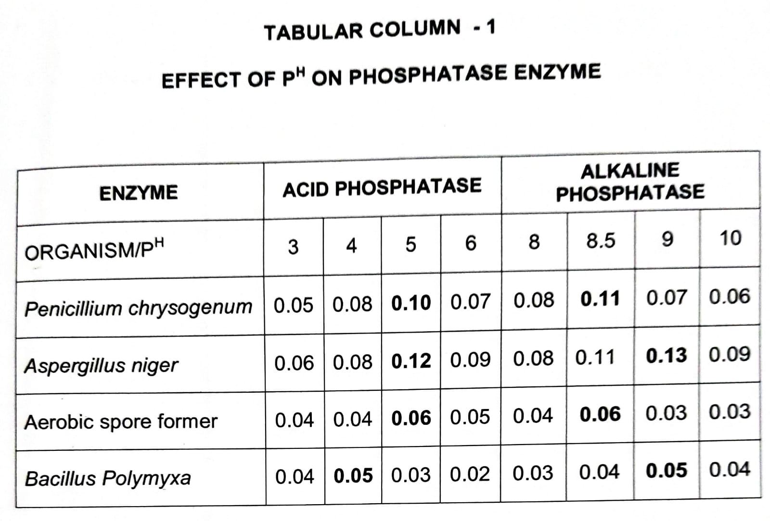

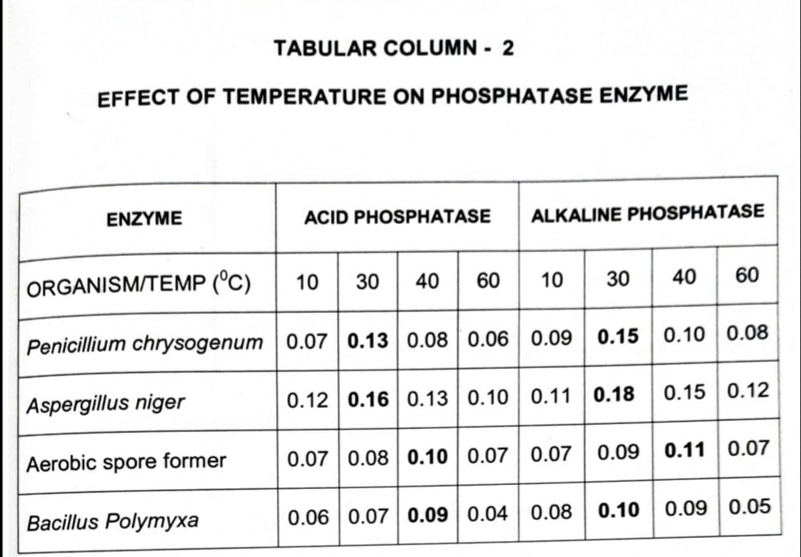

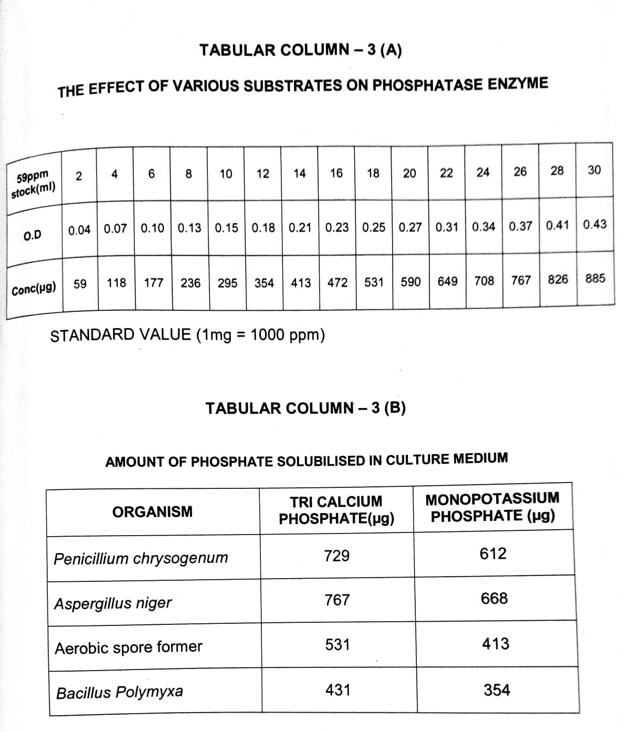

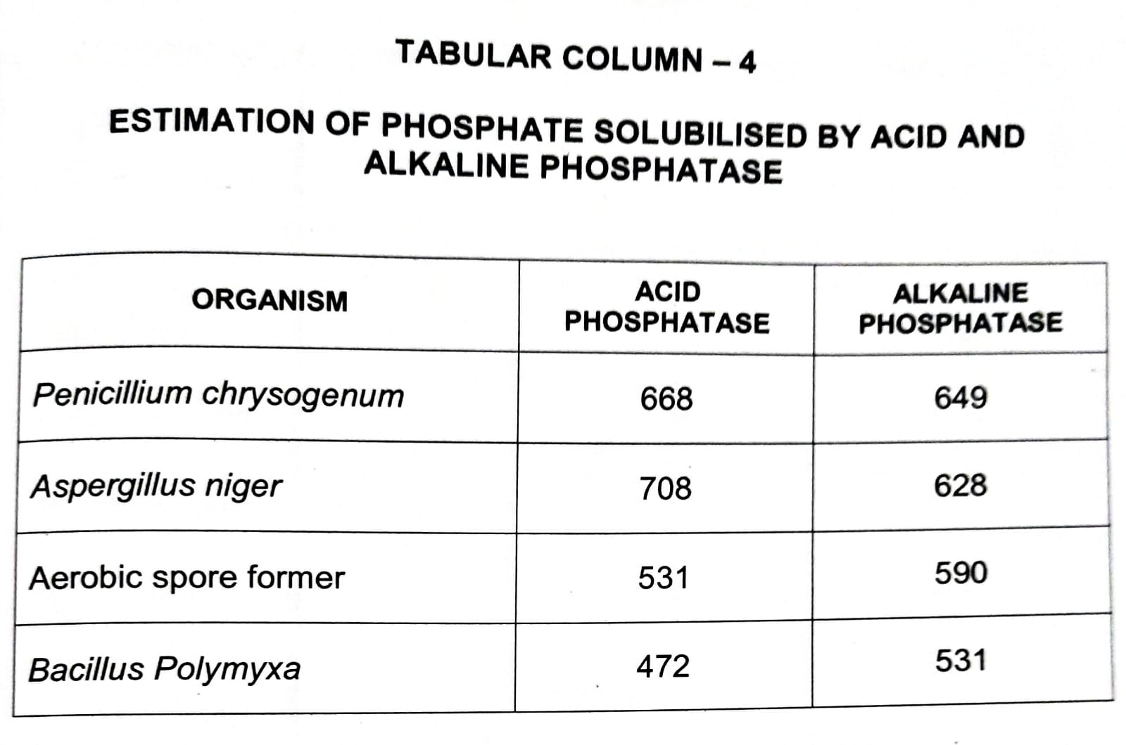

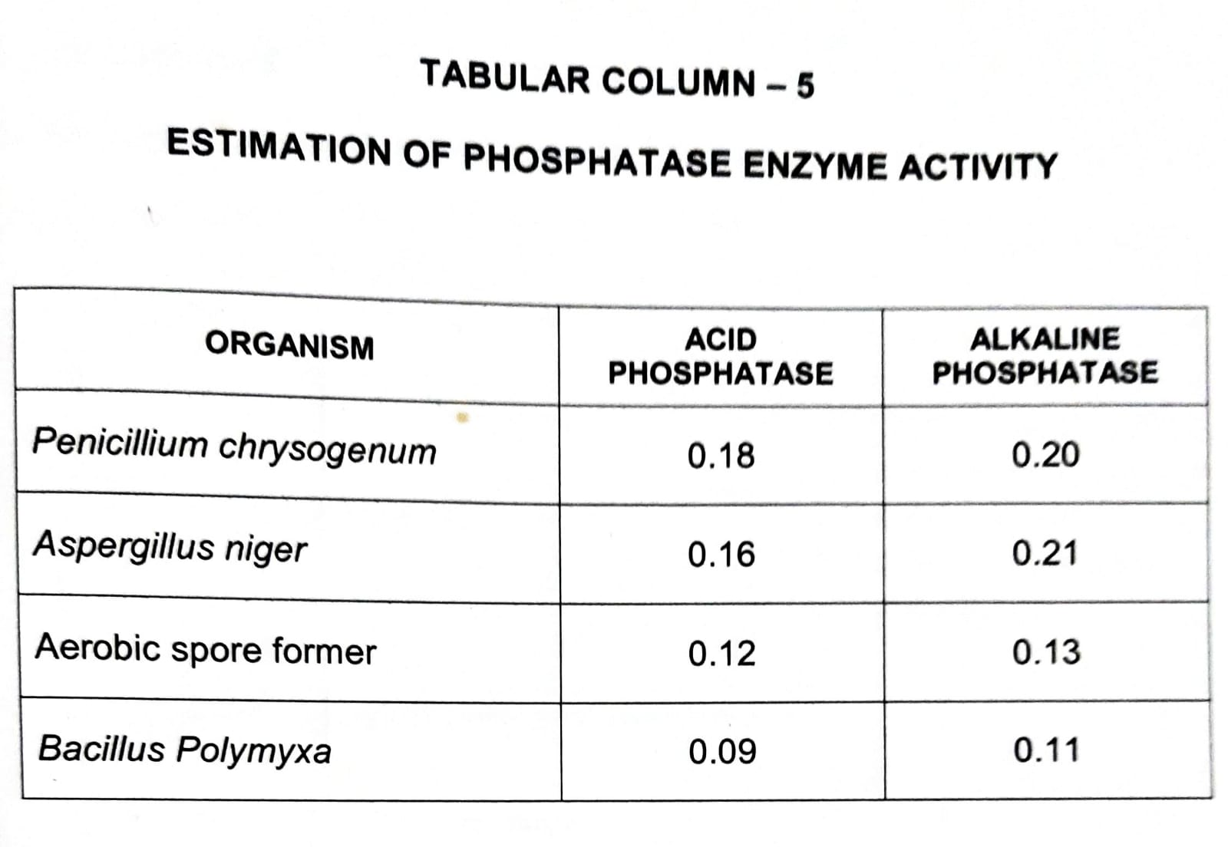
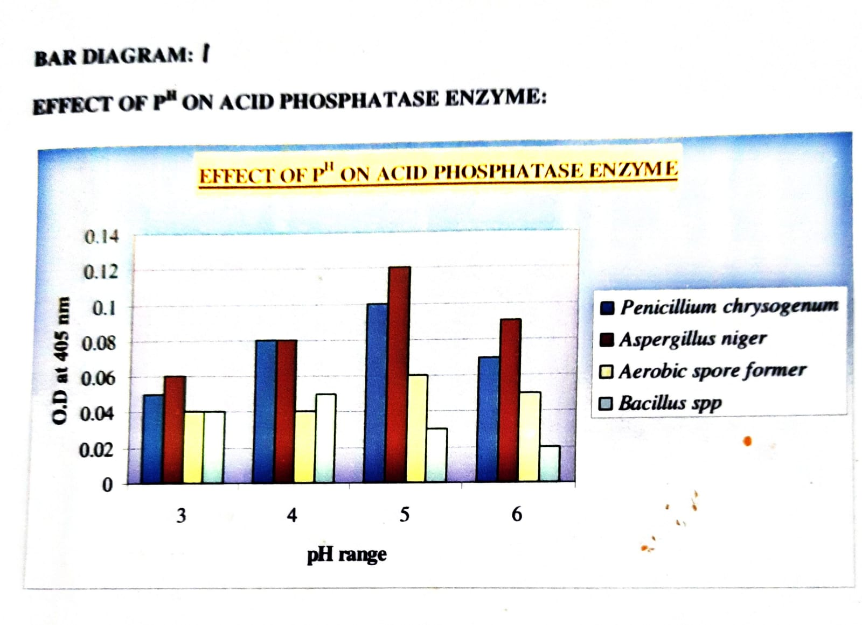
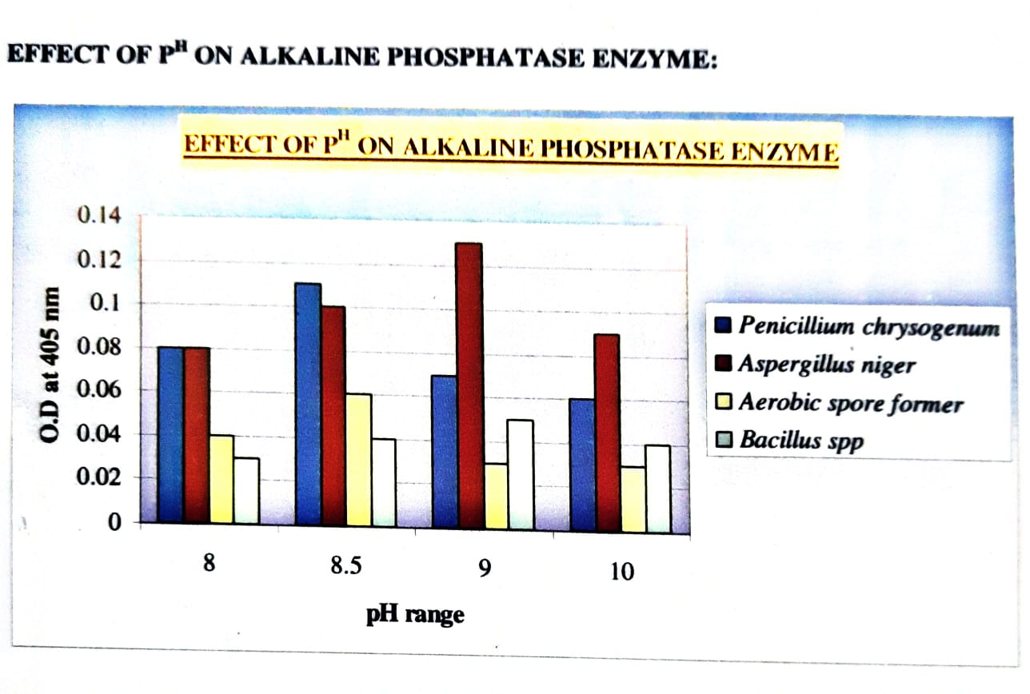
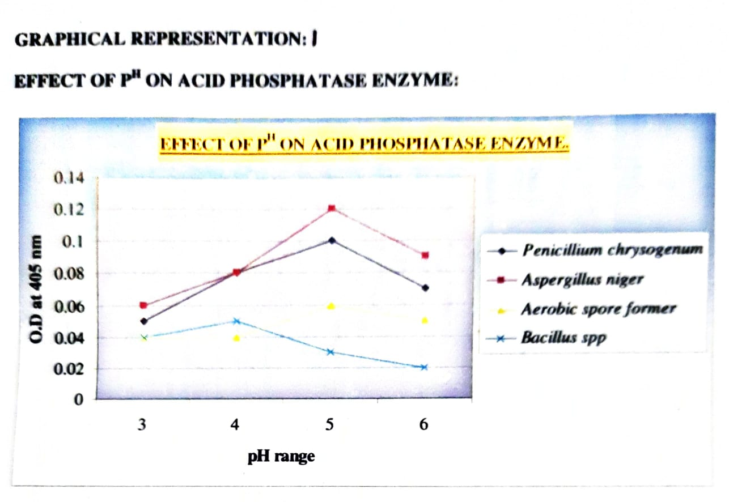

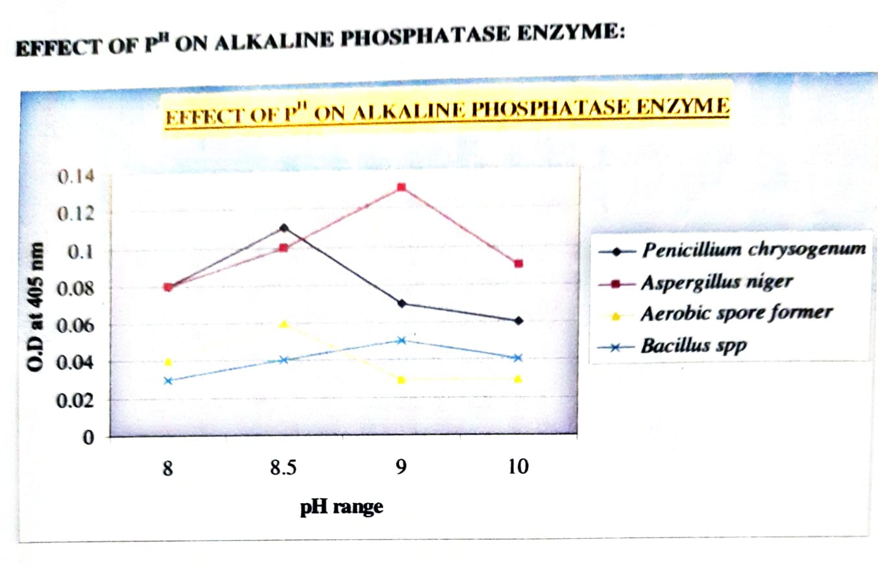

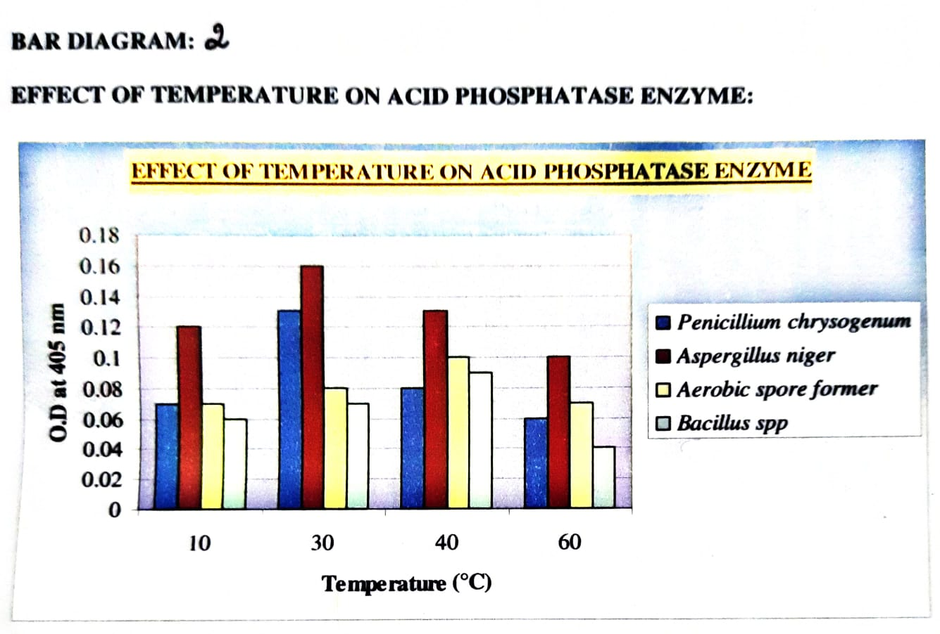
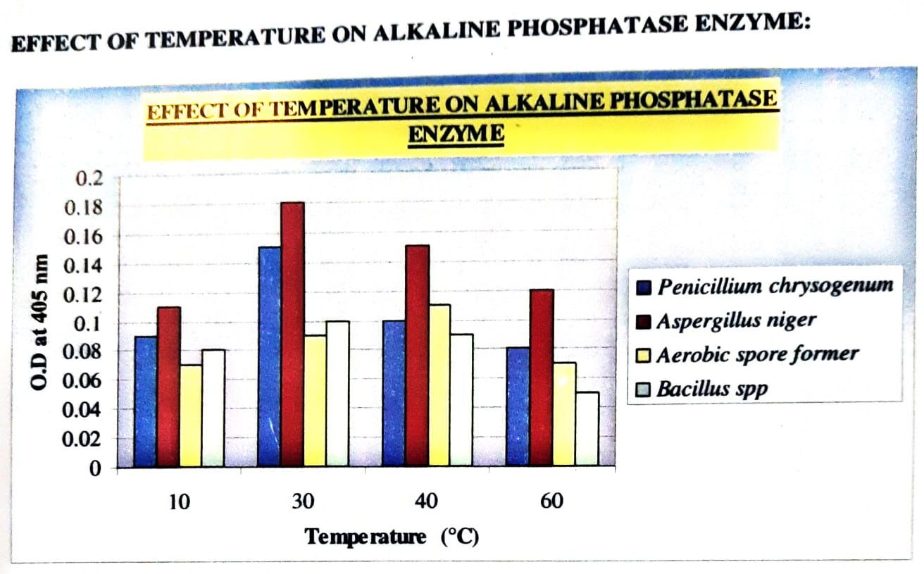

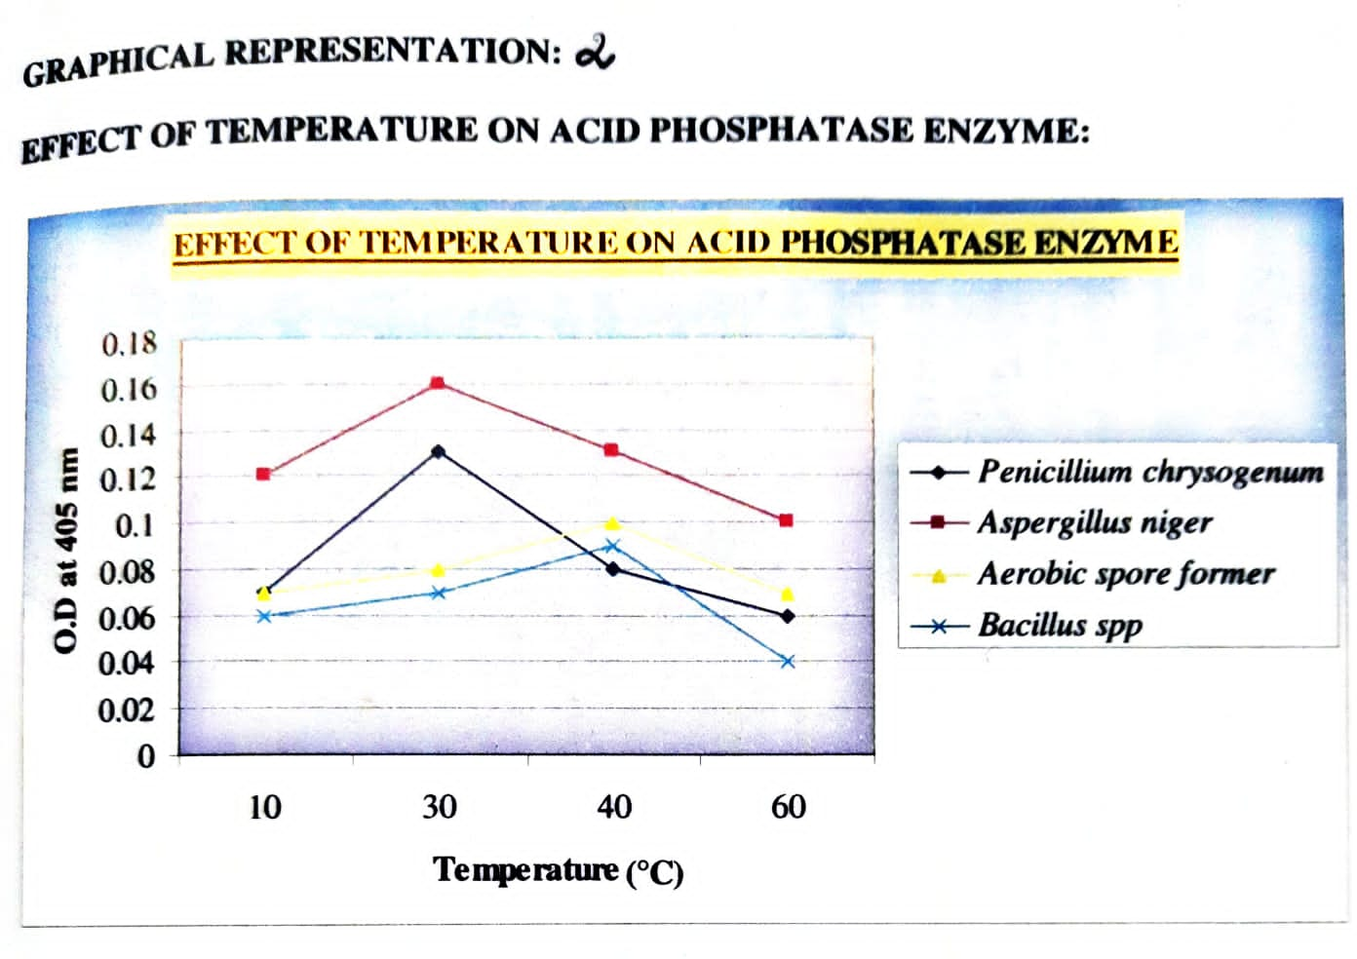
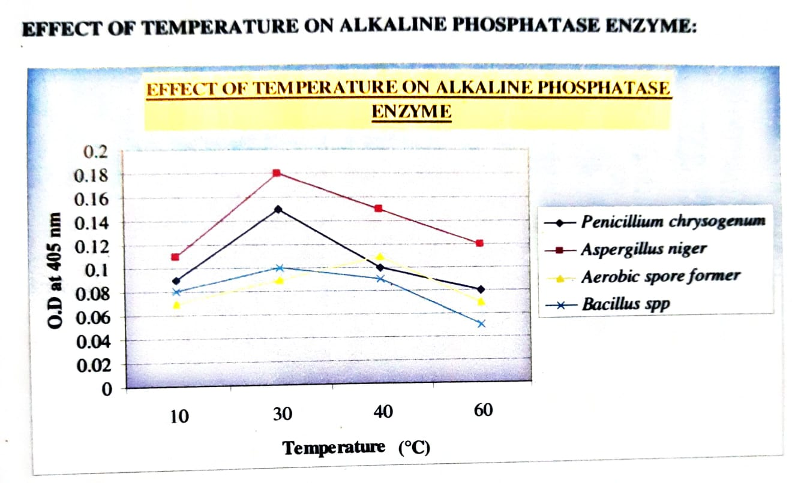

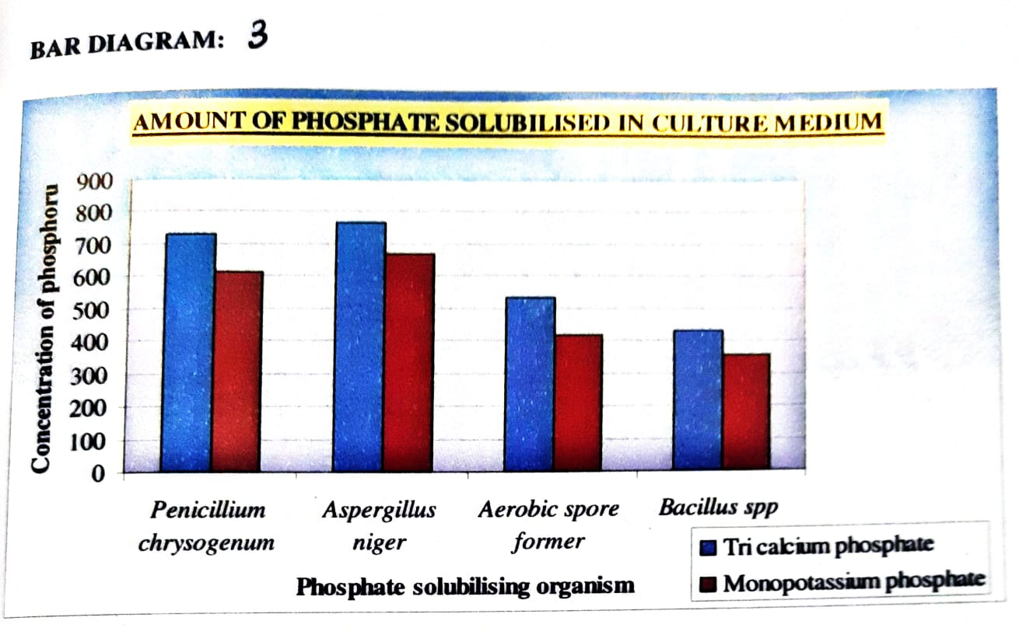

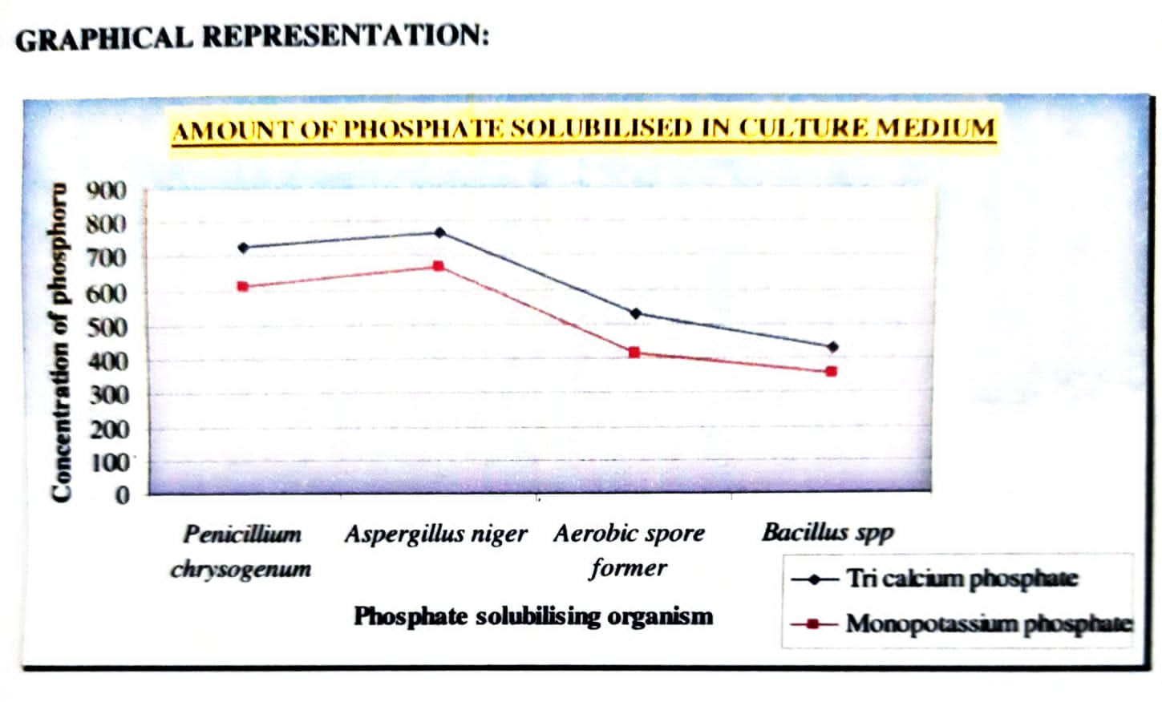

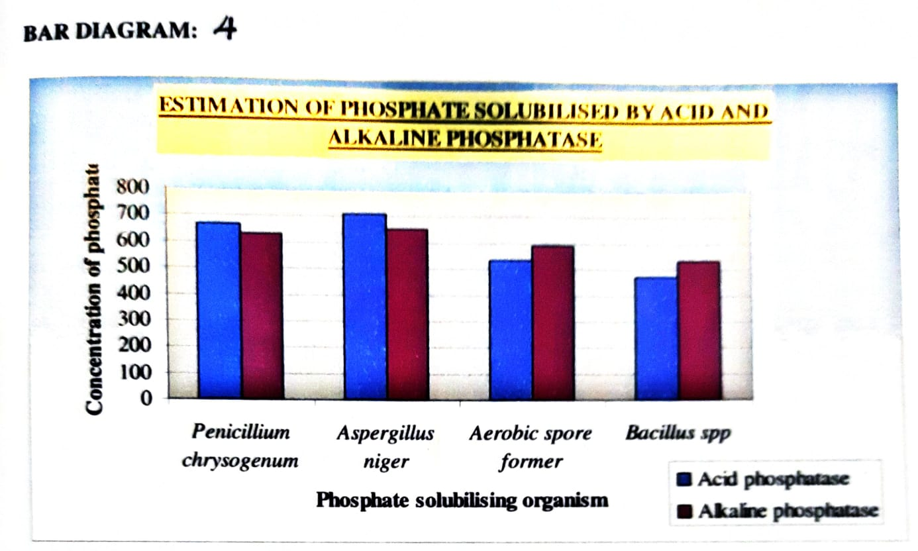

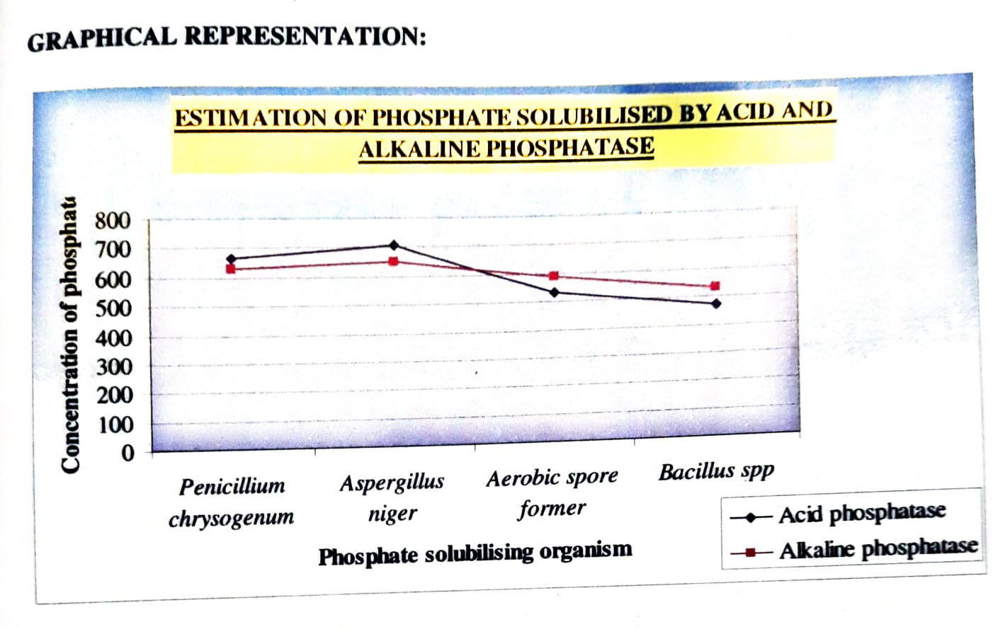

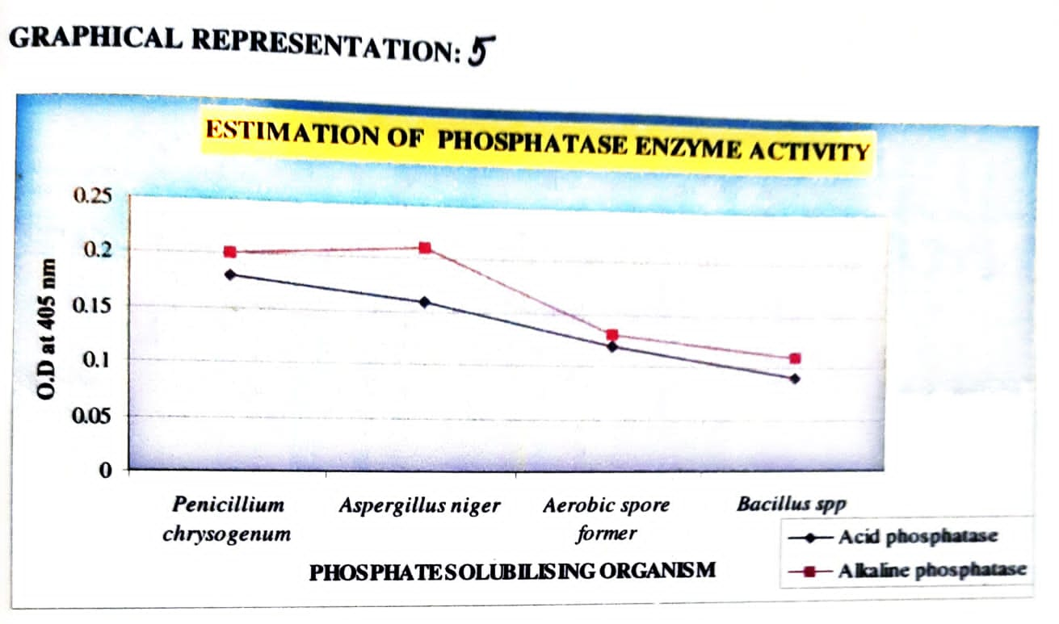

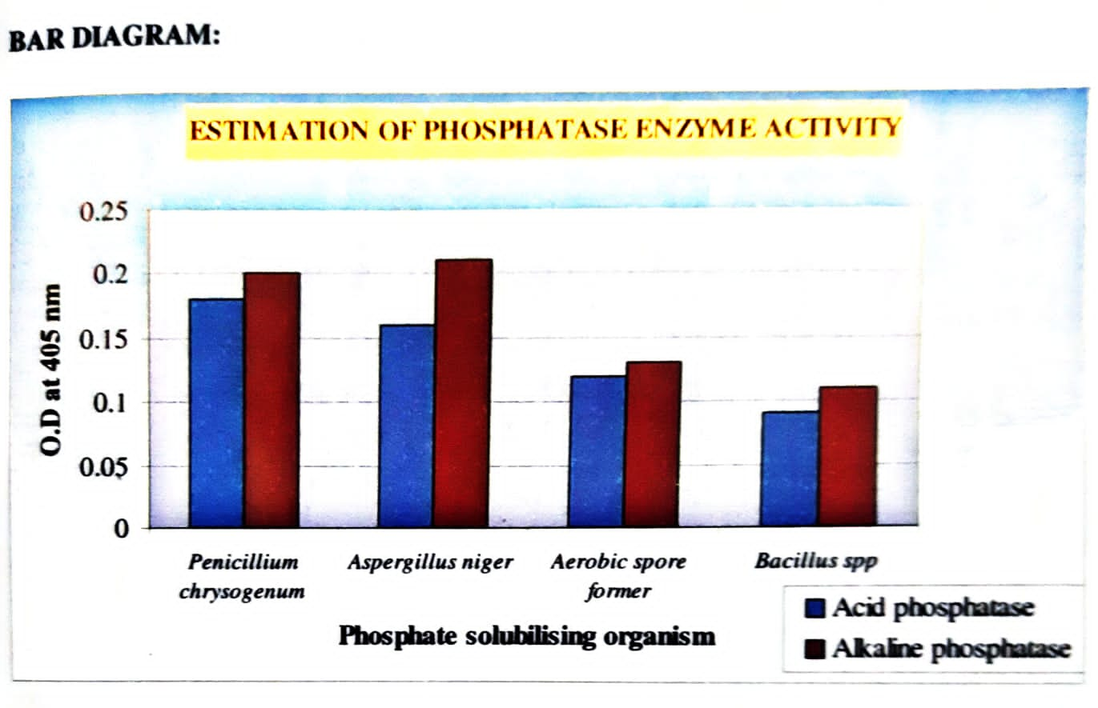

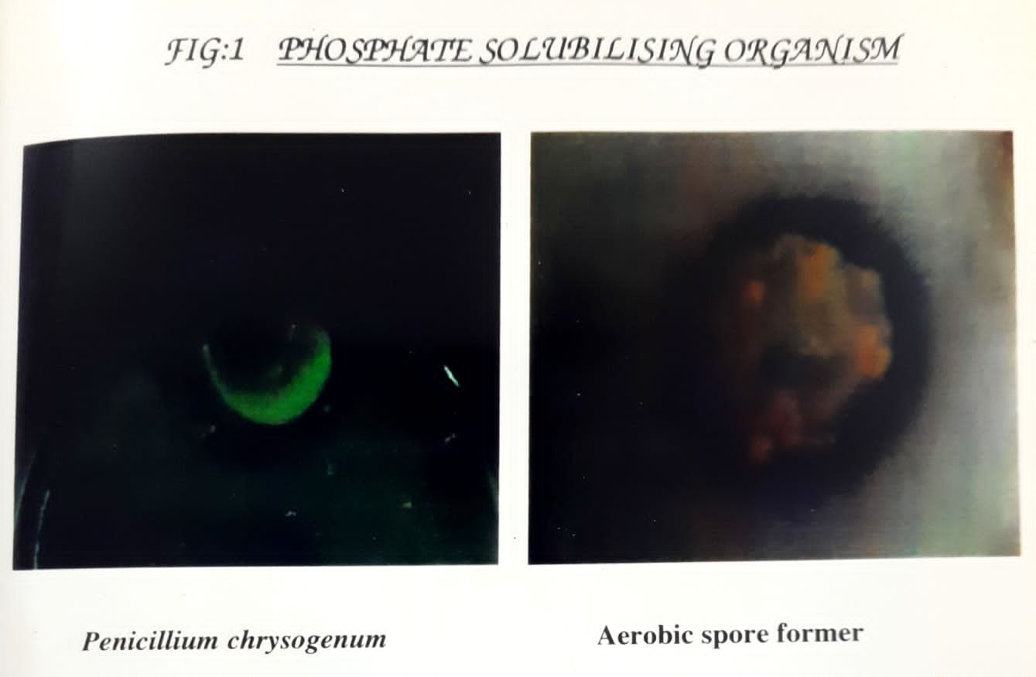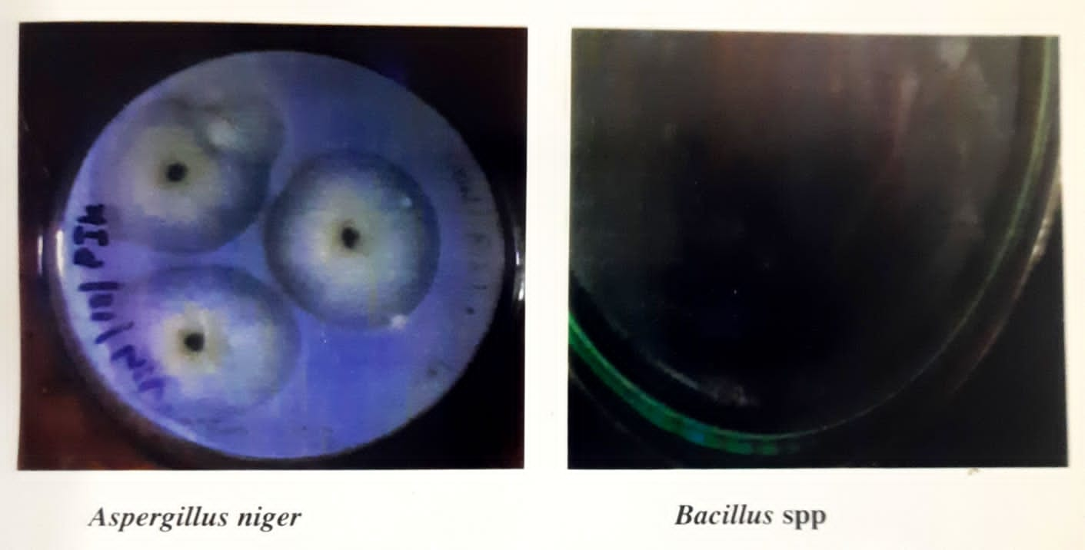

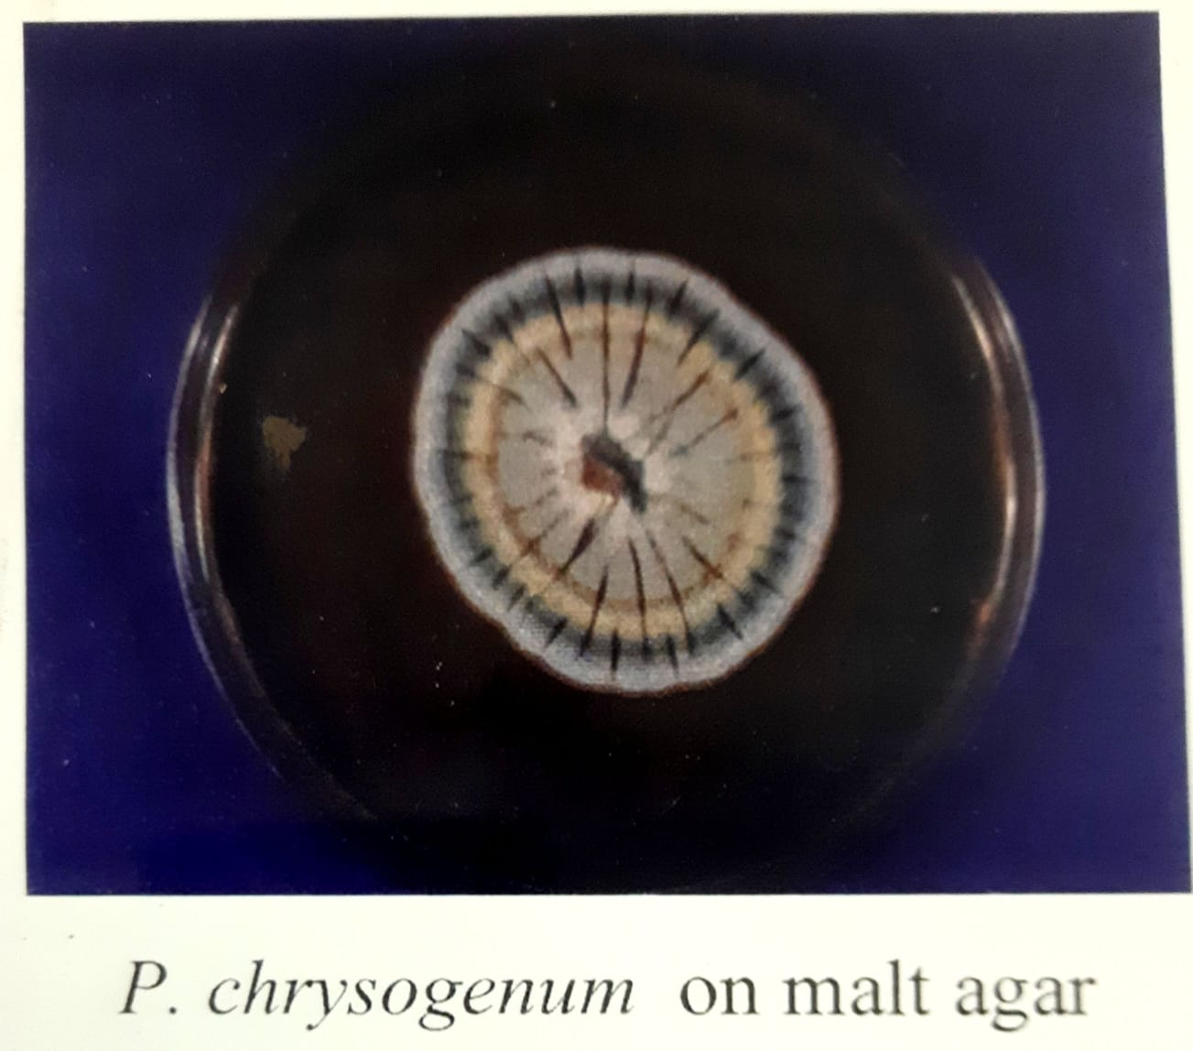
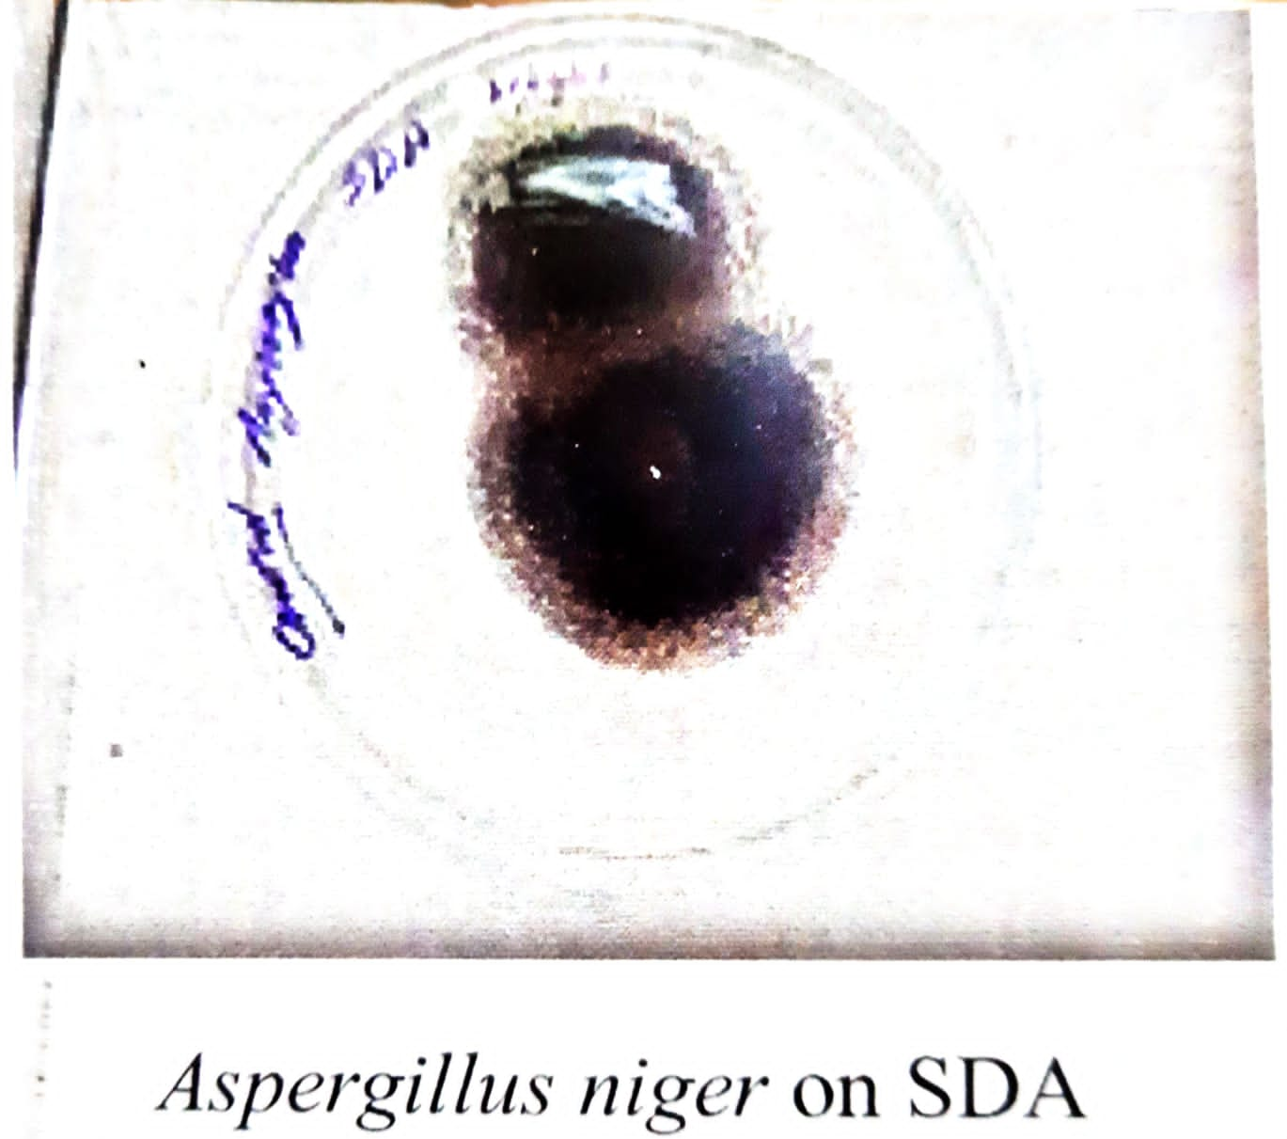
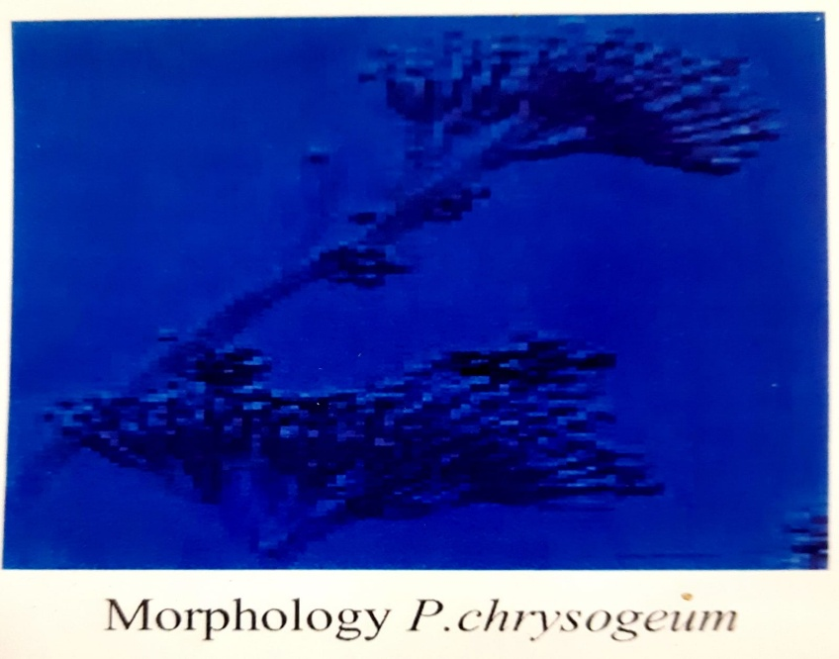

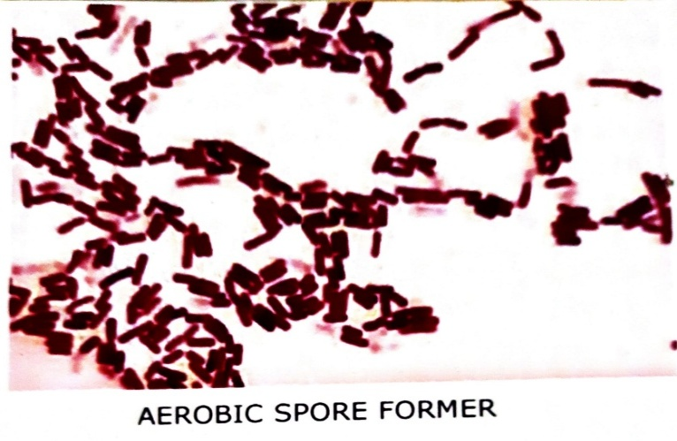
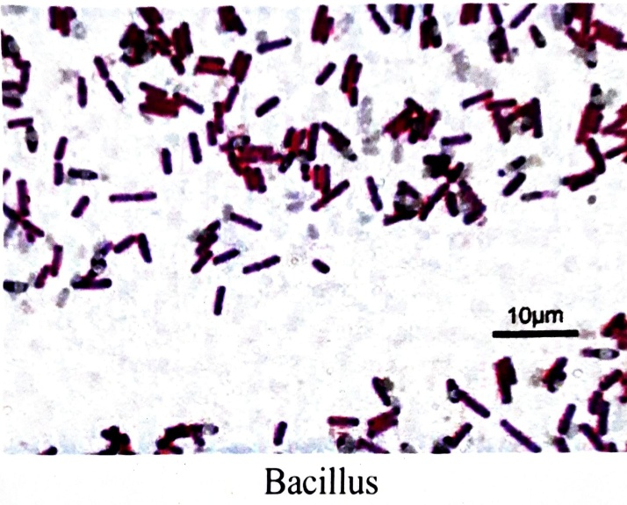
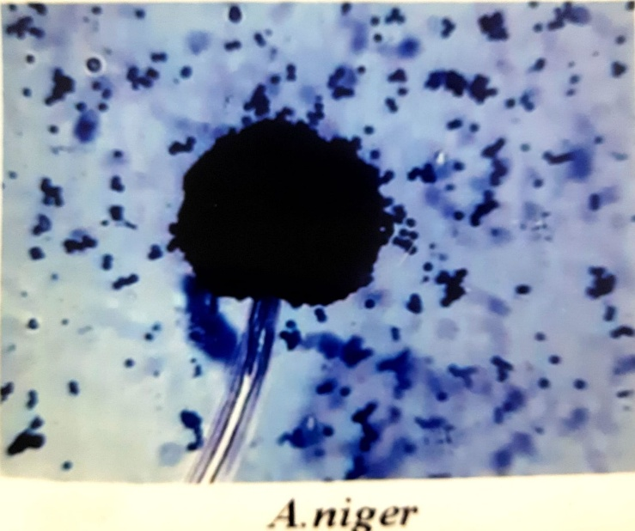

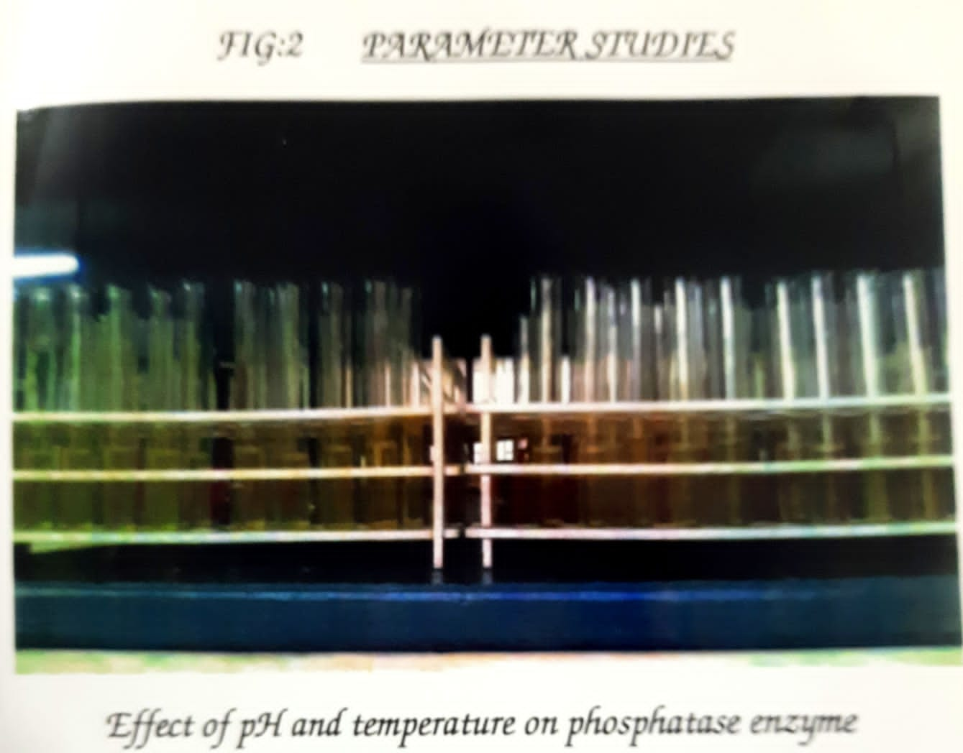
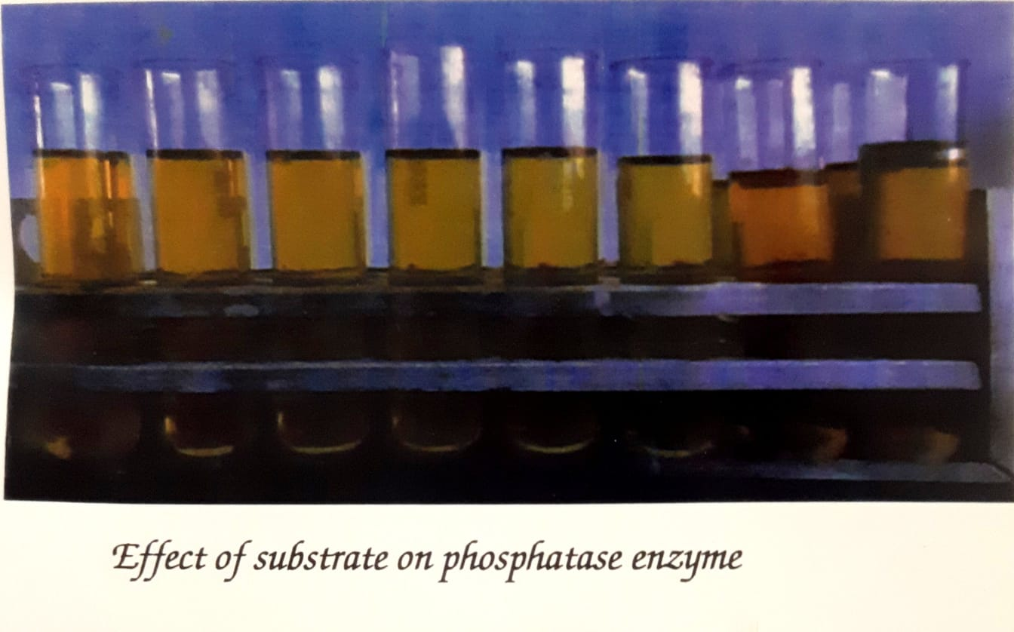

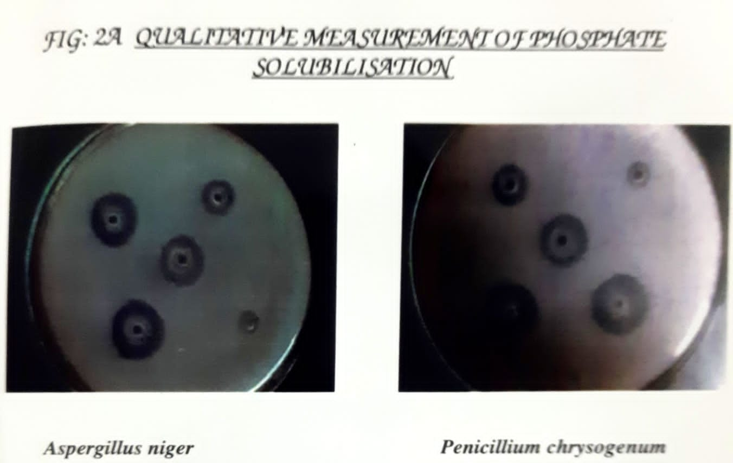
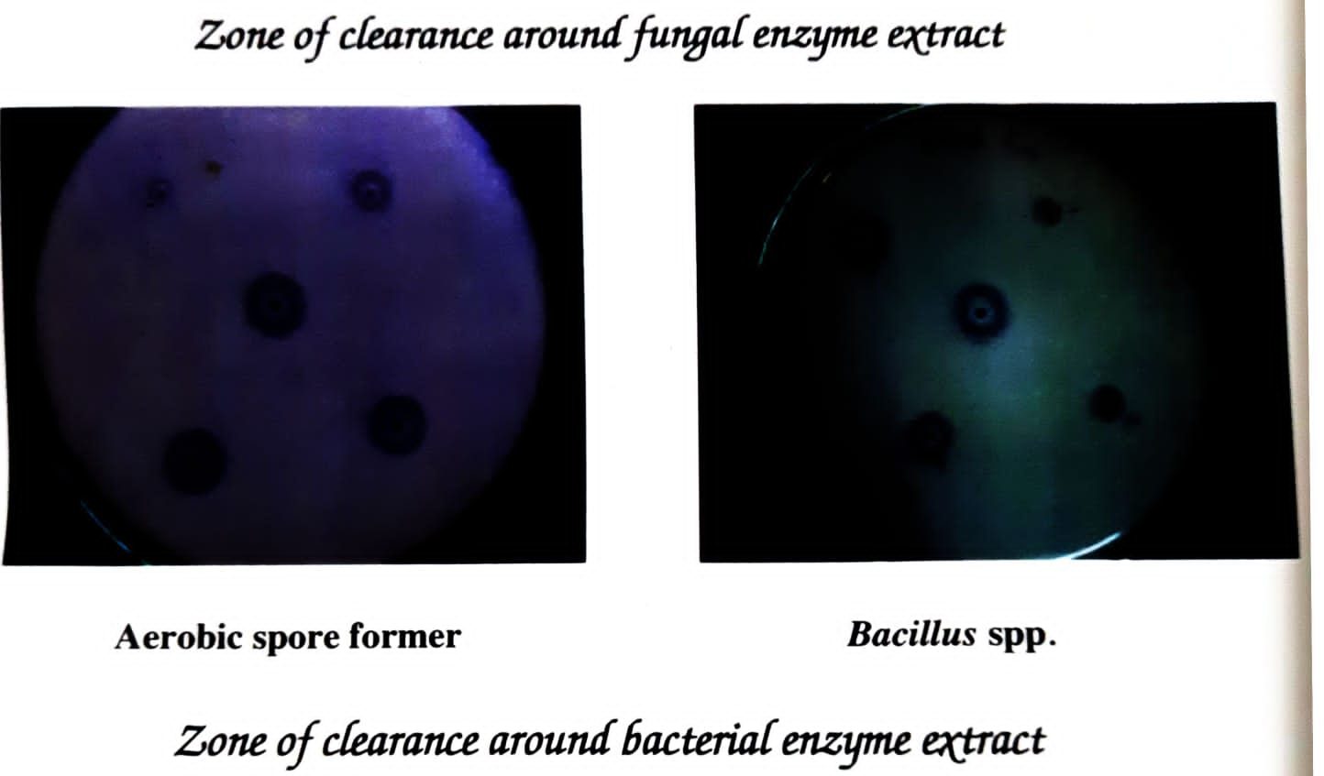

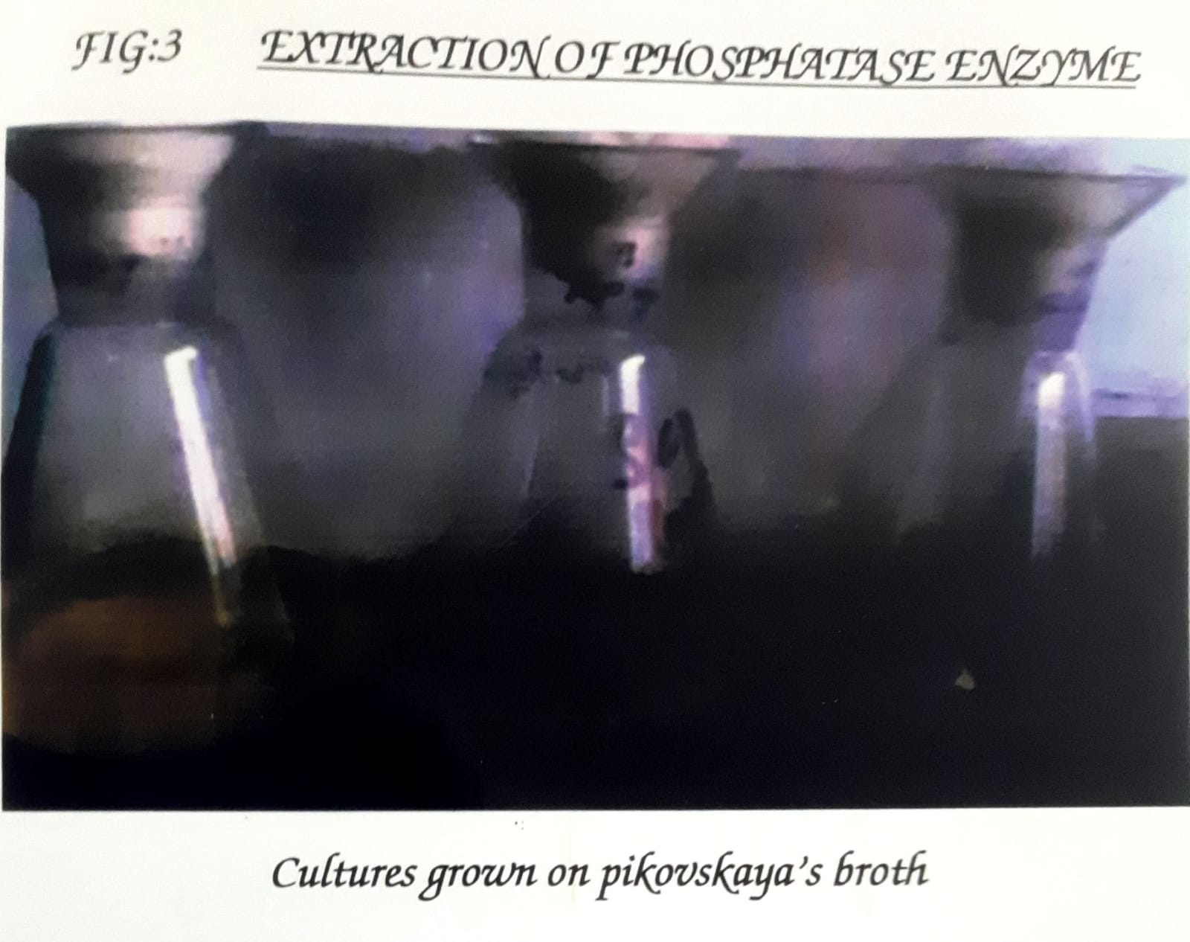
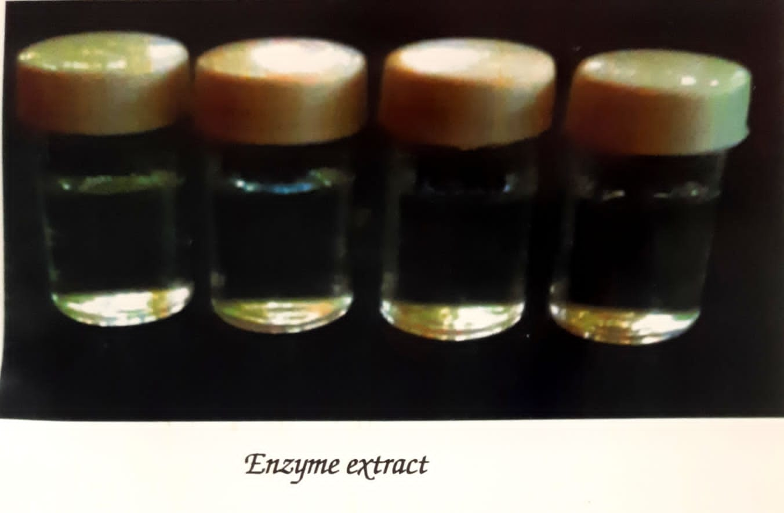

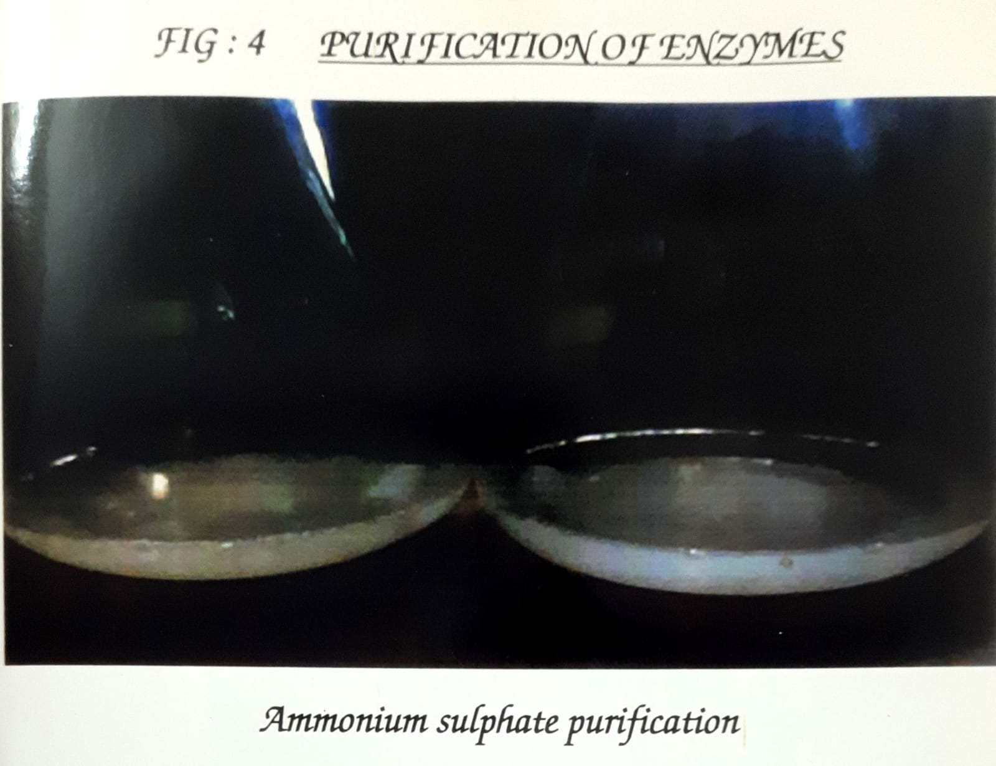
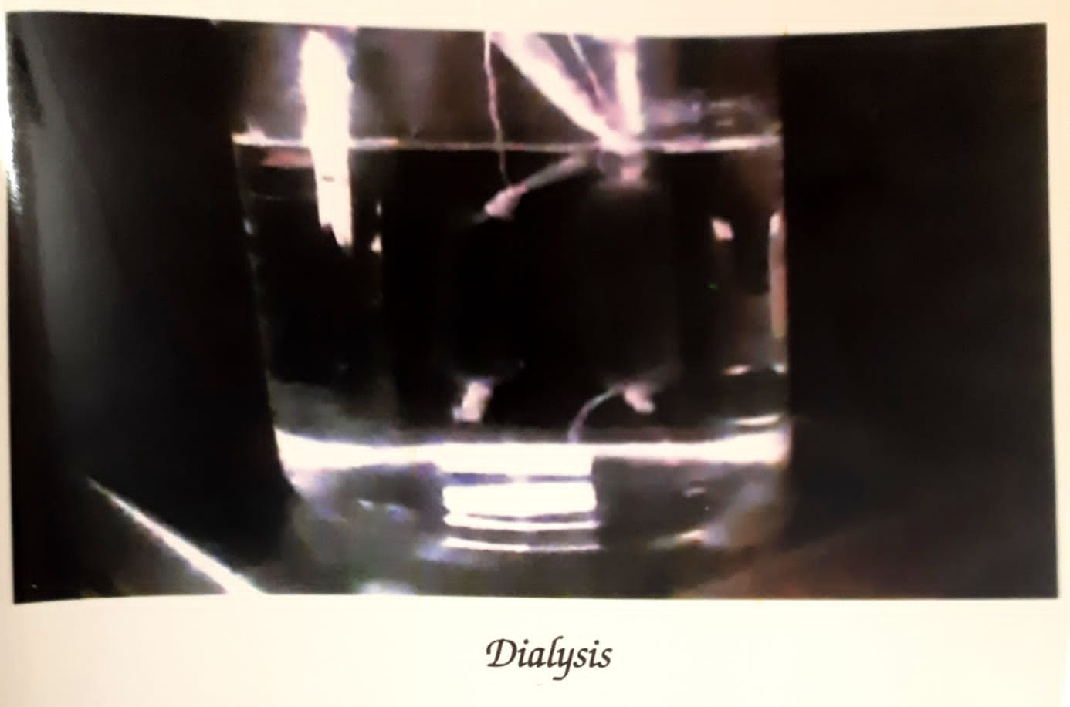

DETERMINATION OF MOLECJLAR WEIGHT BY SDS PHAGE
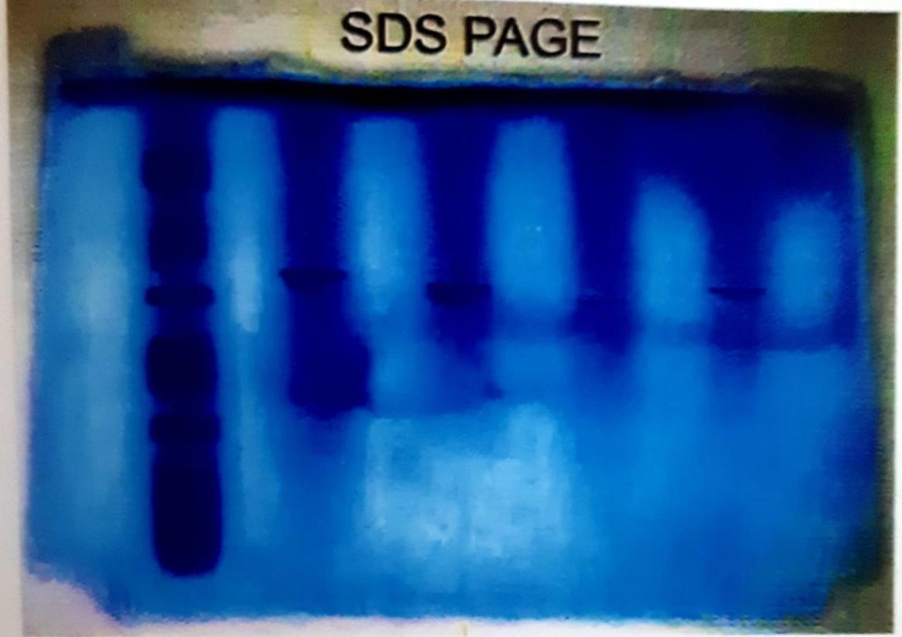

- SUMMARY
- In this present work the soil was collected from garden. The organisms like Aspergillus niger, Penicillium chrysogenum and Bacillus polymyxa.
- For testing the pH by adding the acid buffer to Aspergillus niger, Penicillium chrysogenum, and aerobic spore former shows the maximum activity at the pH 5, while Bacillus polymyxa shows the pH at 4. By adding alkaline buffer to Penicillium chrysogenum, and aerobic spore former at pH 8 8.5 while, Aspergillus niger and Bacillus polymyxa at pH 9.
- The temperature shows maximum activity at 30°C for acid phosphate of Aspergillus niger and Penicillium chrysogenum. But for aerobic spore former and Bacillus polymyxa shows activity at the temperature of 40°C. The temperature in alkaline phosphate of Penicillium chrysogenum, Aspergillus niger, and Bacillus polymyxa shows highest activity at 30°C while, the aerobic spore former at 40°C.
- In our present work the pikovskaya’s liquid medium with tricalcium phosphate, highly solubilize phosphate compared with monopotassium phosphate.
- In this present investigation activity of Aspergillus niger, shows the highest solubilizing capacity than the others. The activity of alkaline phosphate of Penicillium chrysogenum shows the highest solubilizing capacity than the others.
- Then the phosphate enzyme is extracted, purified and the activity of enzyme is estimated. Then the molecular weight of enzyme is identified using SDS PAGE.
- The farmers are instructed to use phosphate solubilizing organisms instead the usage of chemical fertilizer. The greater part of the soil phosphate is in the form of insoluble phosphate which can’t able to utilize by plants, while by using phosphate solubilizing microbes, phosphorus is easily soluble.
- The commercial production of more phosphate solubilizing microbes is done by using pikovaskaya’s agar medium.

- REVIEW OF THE LITERATURE
[1] Sundara Rao and Sinha, (1963) found that the phosphate containing solid media that the microorganisms are capable of dissolving phosphates. Transparent zones of clearance, the microbial colonies indicate the extent of phosphate solubilization.
[2] Francisco congregado et al., (1979) added dimethoate and marathon to the soil at 10 and 100ųg/g. This caused the initial stimulation of CO₂ production. Total counts of bacterial propagates were increased.
[3] Mukherjee and Subba Rao (1982) proposed that the roots of higher plants provide an ecological niche to the soil microbes within the soil. This was done by genus of Pseudomonas and Bacillus. Those bacteria are able to solubilize available forms of Fe, Ca, Mg, Al, and P. The solubilization effect is generally due to the production of organic acids. (Kucey, 1983)
[4] The plant growth promoting rhizobacteria (PGRR) from rhizosphere enhance the growth of plants and reduce the damage from soil bone plant pathogens (Kloepper et al,).
[5] The most important role of soil organism in ecosystem is decomposing of organic matters, synthesize and release them as inorganic forms that plant can use (Setiadi et al., 1989).
[6] Nautical et al., (2000) observed that PGRR are able to exert a beneficial effect upon plant growth. N₂ fixing and P- solubilizing bacteria may be important for plant nutrition by increasing N and P uptake by the plant playing a significant role as PGRR in the bio fertilization of crop.
[7] Antananarivo Sharma et al., (2002) done invitro studies on phosphate removal by Citrobacter koseri and Micro coclus variants revealed that they could remove phosphate upto 84 and 88% respectively from the gelatin and soap industry effluents.
[8] Luis Henrique et al., (2006) isolated many enzymes produced by fungi. Isolation of filamentous fungi from the soil and humus, plant and sugarcane forty were isolated and examined for their ability to produce Xylanase, glucose- oxidase, alkaline phosphatase, acid phosphatase, phytase, pectinase, and amylase.
[9] Stephen Joseph et al., (2008) isolated phosphate solubilizing bacteria (PSB) possessing the ability to solubilize insoluble in organic phosphates from rhizosphere soil. The efficiency of phosphate solubilization was decreased in buffered media compared to non- buffered media.

