BIO-MARKERS

Naga Jogayya Kothakota1 Suryakanta Swain2

1School of Forensic Sciences 2School of Pharmacy & Paramedical Sciences

Centurion University of Technology and Management K.K University, Berauti, Bihar Sharif

Bhubaneswar, Odisha Nalanda- 803115

India Bihar, India, Email: swain_suryakant@yahoo.co.in

Email: [knjbiotech@gmail.com](mailto:knjbiotech@gmail.com)

Bikash Ranjan Jena3

3School of Pharmacy & Life Sciences,

Centurion University of Technology and Management,

Bhubaneswar, Odisha, India

Email: bikashranjan.jena97@gmail.com

**ABSTRACT**

Biomarkers offer an innovative and effective method to explore the scope of different applications, such as sickness diagnosis. and various research studies requests in experimental and investigative epidemiology, rigorous medical studies, monitoring, assessment, and prediction. These markers, defined as changes in the constituents of tissues or bodily liquids, allow for homogeneous arrangement of a sickness and risk aspects. They can help us understand disease pathogenicity. Biomarkers are also representing the whole disease spectrum, from early to late stages. The primary applications of biomarkers in clinical research are described in this concise overview. The validity of biomarkers must be carefully assessed concerning the disease stage. Variability in biomarker measurements varies due to factors ranging from the individual to the laboratory. In this review, Biomarker analysis issues are critically discussed, as these are systematic recommendations for dealing with bias and confounding.

Keywords— Biomarkers, Clinical studies, Species Identification, Pathogen identification, Pharmacodynamics.

**INTRODUCTION**

Biomarkers generally characterized "physiological, biotechnological, or biochemical variations that are identifiable in various entities, including body cells, tissues, or secretions."[1]. Subsequently, the term was enlarged to incorporate features that could be reliably measured and assessed as indicator of natural systems, pathogenic processes and pharmaceutical reactions to a therapeutic suppository. Biomarkers are methods and tools that can assist in sickness prognosis, causation, diagnosis, advancement, retraction, or treatment result in the application [2]. Many different biomarkers are accessible for acquiring information on the living systems of diverse animals, both healthy and ill. Measures done straight on natural fluids e.g., blood or cerebrospinal fluid or measurements like brain tomography and genetic disease identification that accept direct samples of biological fluid but monitor changes in the configuration or purpose of the living systems are examples of these. A biomarker (standing for potential biomarker) seems to be an objective measure of whatever is occurring in an organism or a cell at whichever specific moment; biomarkers may function as wellness systems of early warning, i.e., Tomography biomarkers (positron emission tomography, computed tomography, and electromagnetic resonance imaging) and biomarkers can be classified based on numerous constraints, particular features. Non-Imaging biomarkers with physicochemical traits that enable these to be assessed in biological specimens are known as molecular biomarkers. It includes nucleic acid-based biomarkers such as gene alterations or genetic variants and quantification transcriptomics, proteins, peptides, fatty acid metabolic products, and other organic compounds.

Diagnostic biomarkers, disease stage biomarkers, illness prognosis biomarkers (cancer biomarkers), and biomarkers for assessing treatment diagnosis to intervention are indeed instances of biomarkers. [**Figure 1**]. Some other kind of biomarker is the one that is utilized in selection throughout the beginning phases of pharmaceutical discovery. Potential therapeutic biomarkers, for instance, are markers of different pharmacological responses and have fundamental significance in treatment modification research [3].

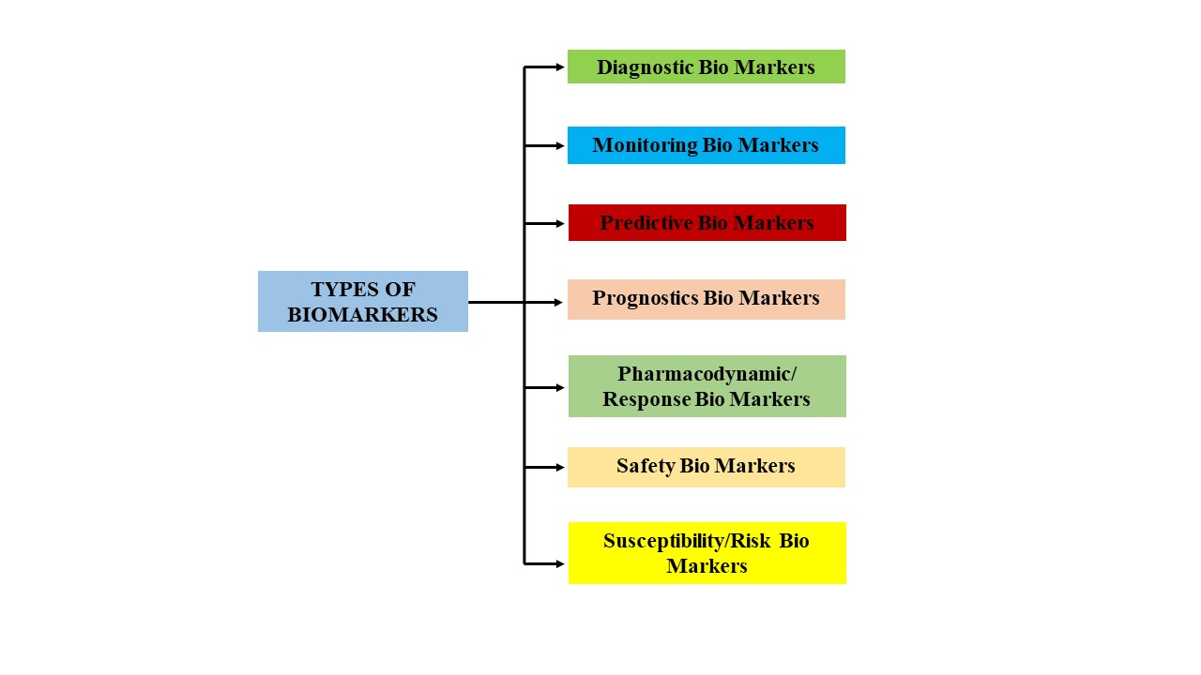

**Figure-1:** Classification of Biomarkers

1. **Diagnostic Biomarkers:**

A class of biomarkers is used to diagnose or authorize the existence of an illness or disease. This kind of biomarker can be employed to differentiate among disease subgroups. The development of personalized medicine emphasizes the notion that diagnostic biomarkers are helpful for identifying patients with diseases and reclassifying them. This is critical since many illnesses have subcategories having variable prognostications or therapeutic outcomes. Therefore, diagnostics biomarkers might assist in the progression of precision medicine by improving the effectiveness of therapy reactions. These biomarkers may be helpful to as prognostic biomarkers or predictors of treatment outcome biomarkers [4]. This clinical relevance of biological technologies for biomolecules research to clarify, detect, and monitor humanoid sicknesses is called a molecular diagnosis. It's a broad term encompassing methods employing DNA, RNA, genes, or proteins as diagnostic test bases. Utilization of monoclonal antibodies (MAbs) and enzyme-linked immunosorbent assays (ELISA) falls under the umbrella term "in vitro diagnostics (IVD)," which encompasses a wide range of applications not always connected to healthcare. This application of molecular diagnostics in a living organism, either human or animal, is known as "in vivo diagnostics." It involves molecular imaging, the use of particular molecules to create picture contrast, and in vivo assessment and description of molecular and cellular level developments in human or animal patients [5].

1. **Monitoring Biomarkers:**

A monitoring biomarker is continuously monitored over time. It can be used to identify illness advancements, such as the emergence of a new epidemic, exacerbation of already existent anomalies, or changes in symptom severity or specific malformations. Response of a disease or condition to treatment, either favorable or unfavorable. These can also be used in creating healthcare equipment, such as in treatment or prevention trials of new medications, biosimilars, or tools [6]. Modifications in biomarker measurements observed during or after medication might indicate a pharmacological effect or an anticipatory response to therapy. Another safe biomarker that's also measured frequently in initial development clinical studies could be a variety of organ toxic effects surveillance biomarkers [7]. Monitoring biomarkers are applied in medicinal or prevention studies to assess respondent commitment to an allocated treatment. For illustrate, as part of an interventional trial to discourage cigarette consumption, the biomarker may be a bloodstream level of a delivered medication or a serum quantity of cotinine (an indication of tobacco product usage). Measuring biomarkers, as well as influencing clinical care, may help enhance the comprehensibility and credibility of intervention investigations. Screening biomarkers can be performed at the individual or population level to identify the prevalence of infections or medical complications and the likelihood of developing them. Individuals observed might not have any medically apparent disorders or diseases, or they could have such a medical problem or prior exposures predisposing an individual to acquire a new ailment or illness. Healthy young adults having undergone annual check-up investigations are monitored continuously for metabolomic levels, including blood cholesterol, glucose levels, and urine creatinine, to manage risk for and detect the emergence of medical conditions such as hypercholesterolemia, and metabolic syndrome, and diminished kidney function, including both [8].

1. **Predictive Biomarker:**

This group involves biomarkers examined at diverse times to monitor towards development of sickness or disorder, as well as an indicator of responsiveness to treatment, such as the administration of a medicinal product or even an ecological pollutant. Biomarker reading modifications are recognized as indications of therapeutic situation progression, in addition to evaluations of pharmaceutical response and other treatment modalities [9]. A sample of predictive surveillance biomarkers’ potentiality towards response to various biological treatments is depicted examples of Juvenile Idiopathic Arthritis [**Figure 2**]: CHAQ: childhood health assessment questionnaire, HLA-B27: Human Leukocyte Antigen B27, JIA: Juvenile Idiopathic Arthritis, ADC: Apparent Diffusion Coefficient, MRP8/14: Myeloid Related Protein 8/14, ADA: Anti-drug Antibodies.

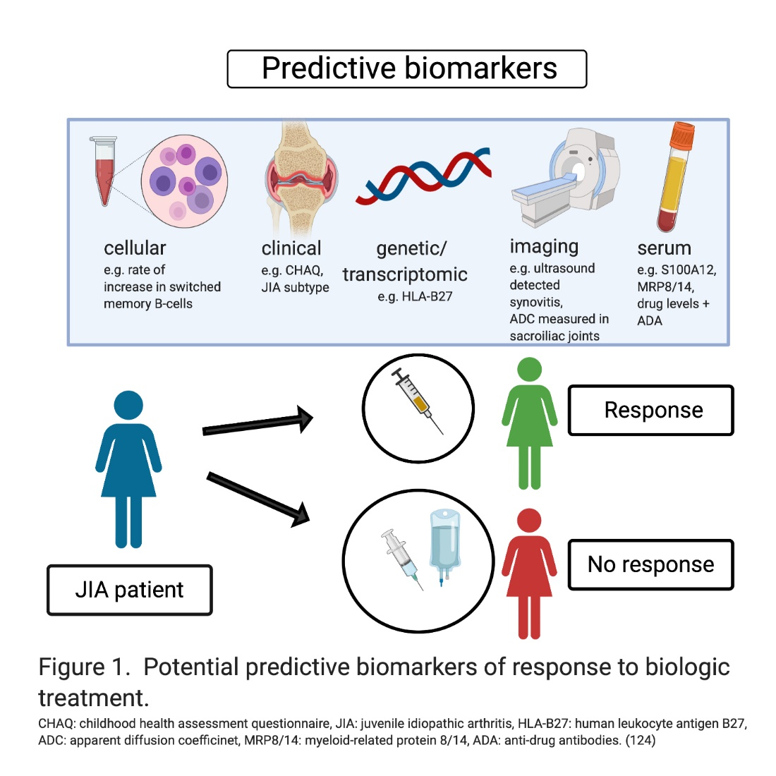

**Figure 2:** Predictive biomarker’s potentiality towards response to selected biological treatment

1. **Prognostics Biomarkers:**

A prognostic biomarker is a measure that indicates the probability of future research and evaluation, disease repetition, or development in a specific subgroup. Predictive biomarkers are evaluated at the specified benchmark, it’s included which may be a pre-existing action. Several good examples of biomarkers prognostic exist within healthcare situations where an individual has also been identified with a disease or disorder, and it is necessary to anticipate the probability of a future medical outcome [Figure 3]. Mortality, illness evolution, disease recurrence, or the expansion of a new health issue were examples of future instances.

Investigation of predictor and predictive biomarkers is essential for patient assessment and when scheduling follow-up or deciding on medication in a period of specialized medicines. This difference between predictive and prognostic biomarkers has been discussed in detail [10]. In conclusion, prognosis biomarkers differentiate among groups of people who've already different results autonomously of treatment. In contrast, a prognostic biomarker provides data on the potential advantage of detailed treatment and might exploit in diagnostic executive procedure. Most effective predictive and prognostic biomarkers were discovered during the CIT era. However, conventional approaches have already validated their authenticity [11]. Whereas individual factors can serve as a robust predictive tool, the authenticity is more challenging because each disease may have several biomarkers having variable prognostic factors. Prognosis ratings integrating biomarkers within algorithms have been developed to 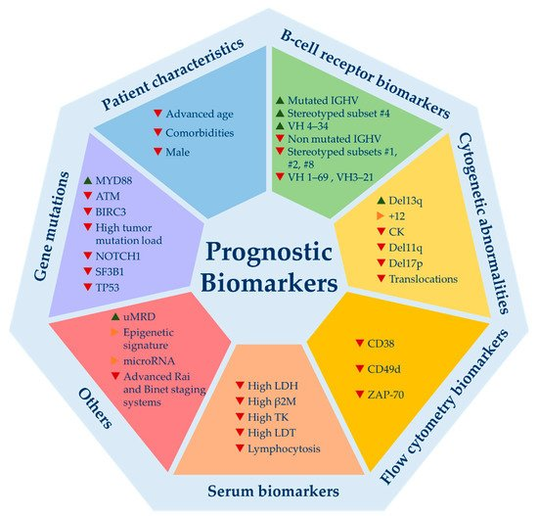tackle this issue.

`

# Figure 3: Various types of prognostic Biomarkers in selected disease (Source: [Isabel Gonzalez-Gascon-y-Marín](https://sciprofiles.com/profile/1428821) et al.: From Biomarkers to Models in the Changing Landscape of Chronic Lymphocytic Leukemia: Evolve or Become Extinct; Cancers2021*,*13(8), 1782) [12].

1. **Pharmacodynamic Biomarkers:**

Biomarker classification based on primary clinical relevance. Characteristics were routinely used to predict the likelihood of developing adverse impacts [13]. Screening biomarkers can be employed in various contexts, involving clinical practice or preclinical studies, there at the beginning of therapy, for medicinal product design, like a measurement of disease severity, or even to assess the pharmacodynamics of therapeutic involvement. Response or Pharmacodynamic biomarker is a potentially valuable technique in medical care which generates vital information for a treatment plan.

A pharmacodynamic biomarker changes according to either a health condition or psychosocial approaches, including pharmacological treatment. Due to the complementary flow of their evaluation, this kind of biomarker is commonly considered a surveillance biomarker. The above biomarker's primary value is to assist clinical care, giving critical data for selecting whether or not to continue medication. Consequently, pharmacodynamic biomarkers dictate therapy progression [14]. Additional potential for all these biomarkers is already in new therapeutic developing drugs, where they can assist generate a confirmation that a medication causes pharmacodynamic alterations in individuals that are associated with its therapeutic value and direct potency investigations [15].

1. **Safety Biomarkers:**

Healthcare procedures and natural factors can also have unintentional, extremely harmful, or outright hazardous implications. The capacity to identify or anticipate these adverse medication or exposure impacts are shared by all safety biomarkers. In certain circumstances, the discovery or change in a biomarker signals toxicity, allowing dosage reduction or therapy termination before the toxicity becomes severe [16]. A safety biomarker would ideally detect emerging toxicity, such as induced drug organ destruction, preceding medical symptoms before permanent impairment occurs. Nursing creatinine phosphokinase aimed at medications that might cause muscle damage, serum creatinine for possibly nephrotoxic pharmaceuticals, and transaminases for potentially hepatotoxic drugs is just a few examples. Frequently biomarker symptoms indicate the potential of significant (although uncommon) disaster. Even a few people with a high plasma level and bilirubin predict the probability of significantly contributing to a decrease (i.e., "Hy's Law"), which is an unnecessary risk as with most treatments [17].

Additionally, safety biomarkers can indeed be used to determine sick people among whom certain treatments cannot be commenced because of high workplace accidents. Imbalances in metabolizing enzymes for example can recognize vulnerable individuals of intoxication except if the drug dose is whittled down or service users who are unlikely to interact to either a vital rehabilitation because they cannot produce the effective chemical compound (e.g., azathioprine or thiopurine methyltransferase (TPMT) nucleotide sequence employed to classify individuals who are unlikely to offered 6-mercaptopurine since unembellished harmfulness due to high drug absorptions may occur; affected role with H Biomarker assessments there at populations can identify individuals who have recently been susceptible to various environmental pollutants, necessitating public health programs or actions to restrict or minimize risks[18]. For instance, plasma, lead quantities can be analyzed to determine lead levels, whereas urine cotinine levels can indeed be measured to diagnose nicotine vulnerability (i.e., cigarette smoke). The outcomes of environmental protection biomarkers assessments can trigger an examination into the origin of something like the contamination, followed by a public health measure.

1. **Susceptibility/Risk Bio Markers**

The highly susceptible biomarker is a biomarker correlated with either an enhanced and in some circumstances, diminished risk of catching medical or disease problem on individuals who doesn't really necessarily possess ailment or medical problem medically. A susceptibility biomarker that tells whether an individual is more likely to acquire a disease later in life. It differentiates from the analysis can be described, that reflects an increased probability of a explicit clinical condition in an distinct that has previously been treated with a diagnosis or health problem, and diagnostic inflammatory markers, which could also identify the presence of a disorder. Highly susceptible biomarkers can be discovered multiple generations, if not decades, before symptoms and clinical signs occur. Highly susceptible biomarkers are really not associated with any certain therapeutic interventions. Excessive low-density lipoprotein (LDL) triglyceride values, especially signify an increase in the risk of cardiovascular disease, have become an indication of a biological predisposition biomarker [19]. LDL cholesterol should be included in almost every cardiac risk scenario to assess the possibility of experiencing a cardiovascular incident at approximately imminent period opinion. Other qualities increased lipoprotein cholesterol stages, hypertension, age, gender, health status, & personal history are frequently applied in risk models to increase prediction performance. Susceptibility/risk biomarkers, like prognostic biomarkers may be valuable for clinical experimental enhancement in a medical product development environment. It is frequently difficult to accumulate enough clinical events in a basic preventative measures context to make clinical trials viable [20]. Enriching preventative clinical trials for participants who are especially vulnerable to acquiring a certain illness may thus be required, notably for the evaluation of chemoprevention treatments or the focused use of vaccinations. The above helps 1) the study to be done realistically by enrolling people who are more likely to acquire the illness or medical condition 2) preventative therapies with possible side effects are effectively targeted strike to the optimal combination of risks and benefits are similar to prognostic biomarkers in that they predict the likelihood of a disease-related event occurring in the future. The primary difference is that these biomarkers utilized in people who have already been analyzed with a disease, whereas susceptibility biomarkers might be employed in people who else look healthy. In certain cases, the distinction between these sorts biomarkers may blurred [21].

1. **Other Biomarkers (Genomic Biomarkers)**

Functional genomic biomarkers aim to broaden our considerate of sickness pathogenesis and progression by providing new goals for disease recognition, early detection, and effective therapeutic approaches (drug expansion, drug design, and serious complications) to recommend treatment methods to sick people based on different characteristics [22]. A chromosomal biomarker is defined by the European Medicines Agency (EMEA) as "a detectable DNA/RNA distinguishing that is a signal of regular biological functioning, pathogenic progressions, and/or reaction to therapeutic or other interventions"[23]. Measurable qualities encompass genetically distinct expression, development, and management. Genetic variations (Single Nucleotide Polymorphisms), natural variation toward short palindromic repeats, linkage disequilibrium, deletions or insertions of a copy number variations, single nucleotide (s), and cytogenetic reinterpretations (translocations, replication, inversions or deletions) can all be found in DNA [24]. Recent advances in genetic technology enable the exploration of genome-wide studies, candidate genes and risk score pattern analysis are better understand diverse mental illnesses [Figure 4]. CGH (Comparative Genomic Hybridization), microarray, transcriptome, and whole genome sequencing were among the techniques used. Pharmacogenomics, in especially, is useful in understanding genetic mutations in drug-metabolizing enzymes, exchangers, receptors, and other chemotherapeutic drugs, which together appear to be significant for both pharmacology research and drug therapeutic applications [25].

**Figure 4:** Discovery and validation of biomarkers to probe multidimensional phases of the disease. CGH, comparative genomic hybridization; Seq, sequencing; qRT-PCR, quantitative real-time PCR; qPCR, semiquantitative real-time PCR; HPLC, high-performance liquid chromatography; NMR, nuclear magnetic resonance spectroscopy. (**Source**: Garcıa-Gutie rrez MS, Navarrete F, Sala F, Gasparyan A, Austrich-Olivares A and Manzanares J (2020) Biomarkers in Psychiatry: Concept, Definition, Types and Relevance to the Clinical Reality. Front. Psychiatry 11:432.[12])

**CONCLUSION**

Both the process of developing new drugs and the larger field of biomedical research place a significant emphasis on the use of biomarkers. It is essential to do research into the connections that may be made between quantifiable biological systems and clinical outcomes in order to broaden our toolbox of treatments for a variety of conditions and improve our knowledge of the physiological processes that underlie a state of health. At the very least since the 1980s, there has been a lively discussion going on over whether or not large-scale clinical trials of major illnesses, such as cancer and heart disease, should employ biomarkers as surrogate outcomes. As a result, the FDA maintains its support for the utilization of biomarkers in both fundamental and clinical research, in addition to research on possible novel biomarkers that could be used as surrogates in subsequent studies [Figure 5]. However, despite the potential benefits of biomarkers in clinical trials, such as minimizing exposure to ineffective investigational therapies and so on, biomarkers can present considerable risks if the designers of the studies mistake them for clinical criteria. If we fully understood the metabolic homeostasis of a natural system, the pathophysiological of that process when disease is present, and the consequences of a pharmacologic, device, or other manipulation on these mechanisms, biomarkers might be able to serve as effective equivalents to important clinical endpoints. Because we rarely, if ever, have a complete picture of these processes, and because there are always more aspects that we do not know or comprehend, biomarkers as surrogate endpoints need to be regularly assessed. At the very least for the purpose of doing a retrospective analysis of the success of biomarker linkage, clinical outcomes should always be the end measure in biomarker research. If the connection between surrogate endpoints and actual clinical endpoints is not continually reevaluated, we run the risk of approving entire classes of drugs that offer patients either no significant gain or, even worse, cause patients harm.

**REFERENCES**

[1] Hulka BS. Overview of biological markers. In: Biological markers in epidemiology (Hulka BS, Griffith JD, Wilcosky TC, eds), pp 3–15. New York: Oxford University Press, 1990.

[2] Naylor S. Biomarkers: current perspectives and future prospects. Expert Rev Mol Diagn 3: 525–529, 2003.

[3] Rossi, D.; Gerber, B.; Stassi, G. Predictive and prognostic biomarkers in the era of new targeted therapies for chronic lymphocytic leukemia. Leuk. Lymphoma 2017, 58, 1548–1560.

[4] Biomarker Working Group F-N. BEST (Biomarkers, Endpoints, and other Tools) Resource. In: Spring S, editor. BEST (Biomarkers, Endpoints, and other Tools) Resource. Silver Spring (MD): FDA-NIH (2016).

[5] Aronson JK, Ferner RE. Biomarkers-A General Review. Curr Protoc Pharmacol (2017) 76:9 23:1–9 17. DOI: 10.1002/cpph.19

[6] Novelli G, Ciccacci C, Borgiani P, Papaluca Amati M, Abadie E. Genetic tests and genomic biomarkers: regulation, qualification and validation. Clin cases Miner Bone Metab (2008) 5(2):149–54.

[7] European Medicines Agency (EMA) ICH Topic E15 Definitions for genomic biomarkers, pharmacogenomics, pharmacogenetics, genomic data and sample coding categories. (2007).

[8] European Medicines Agency (EMA) Definitions for genomic biomarkers, pharmacogenomics, pharmacogenetics, genomic data and sample coding categories. (2007).

[9] Jiang W, King TZ, Turner JA. Imaging Genetics Towards a Refined Diagnosis of Schizophrenia. Front Psychiatry (2019) 10:494.   10.3389/fpsyt.2019.00494.

[10] Montserrat, E.; Gale, R.P. Predicting the outcome of patients with chronic lymphocytic leukemia: Progress and uncertainty. Cancer 2019, 125, 3699–3705.

[11] Tausch, E.; Schneider, C.; Robrecht, S.; Zhang, C.; Dolnik, A.; Bloehdorn, J.; Bahlo, J.; Al-Sawaf, O.; Ritgen, M.; Fink, A.-M.; et al. Prognostic and predictive impact of genetic markers in patients with CLL treated with obinutuzumab and venetoclax. Blood 2020.

[12] [Isabel González-Gascón-y-Marín](https://sciprofiles.com/profile/1428821) et.al: From Biomarkers to Models in the Changing Landscape of Chronic Lymphocytic Leukemia: Evolve or Become Extinct; Cancers 2021, 13(8), 1782.

[13] Califf RM. Biomarker definitions and their applications. Exp Biol Med (Maywood) (2018) 243(3):213–21. DOI: 10.1177/1535370217750088

[14] Kraus VB. Biomarkers as drug development tools: discovery, validation, qualification and use. Nat Rev Rheumatol (2018) 14(6):354–362. DOI: 10.1038/s41584-018-0005-9

[15] Prata J, Santos SG, Almeida MI, Coelho R, Barbosa MA. Bridging Autism Spectrum Disorders and Schizophrenia through inflammation and biomarkers - pre-clinical and clinical investigations. J Neuroinflammation (2017) 14(1):179. DOI: 10.1186/s12974-017-0938-y

[16] Olsson B, Lautner R, Andreasson U, Ohrfelt A, Portelius E, Bjerke M, et al. CSF and blood biomarkers for the diagnosis of Alzheimer's disease: a systematic review and meta-analysis. Lancet Neurol (2016) 15(7):673–84. DOI: 10.1016/S1474-4422(16)00070-3.

[17] Kraus VB. Biomarkers as drug development tools: discovery, validation, qualification and use. Nat Rev Rheumatol (2018) 14(6):354–362. DOI: 10.1038/s41584-018-0005-9.

[18] Wu TN, Lee CS, Wu BJ, Sun HJ, Chang CH, Chen CY, et al. Immunophenotypes associated with bipolar disorder and lithium treatment. Sci Rep (2019) 9(1):17453. DOI: 10.1038/s41598-019-53745-7.

[19]Schizophrenia Working Group of the Psychiatric Genomics Consortium. Biological insights from 108 schizophrenia-associated genetic loci. Nature (2014) 511(7510):421–7. DOI: 10.1038/nature13595.

[20] Ripke S, O'Dushlaine C, Chambert K, Moran JL, Kahler AK, Akterin S, et al. Genome-wide association analysis identifies 13 new risk loci for schizophrenia. Nat Genet (2013) 45(10):1150–9. doi: 10.1038/ng.2742.

[21] Pu S, Setoyama S, Noda T. Association between cognitive deficits and suicidal ideation in patients with major depressive disorder. Sci Rep 2017 7(1):11637. doi: 10.1038/s41598-017-12142-8. PMID: 28912439.

[22] Rosen C, Zetterberg H. Cerebrospinal fluid biomarkers for pathological processes in Alzheimer's disease. Curr Opin Psychiatry 2013 26(3):276–282. doi: 10.1097/YCO.0b013e32835f6747.

[23] Wiecki TV, Antoniades CA, Stevenson A, Kennard C, Borowsky B, Owen G, et al. A Computational Cognitive Biomarker for Early-Stage Huntington's Disease. PLoS One 2016 11(2):e0148409. doi: 10.1371/ journal.pone.0148409.

[24] Rosen C, Zetterberg H. Cerebrospinal fluid biomarkers for pathological processes in Alzheimer's disease. Curr Opin Psychiatry 2013 26(3):276–282. doi: 10.1097/YCO.0b013e32835f6747

[25] Wiecki TV, Antoniades CA, Stevenson A, Kennard C, Borowsky B, Owen G, et al. A Computational Cognitive Biomarker for Early-Stage Huntington's Disease. PLoS One 2016 11(2):e0148409. doi: 10.1371/ journal.pone.0148409