Phage Therapy – A New Approach in Science

Subhajit Nath, Sancharee Sensarma, Sahana Ghosh*

Department of Microbiology, Vijaygarh Jyotish Ray College, Kolkata, West Bengal, India,
*Faculty, Department of Microbiology, Vijaygarh Jyotish Ray College, Kolkata, West Bengal, India.
Mail ID - sahanaghosh2102@gmail.com

ABSTRACT

Bacteriophages have been at the peak of interest to scientists, not only as tools to understand fundamental molecular biology but also as vectors of horizontal gene transfer and novel therapeutic agents. Unraveling the mystery of phages and their biology and relationship with their hosts, is the key to understand microbial systems and their exploitation in it. In this review, we describe the different types of phages, how their modification is done, their application in clinical and research field is done. This review also shows how modeling of phages is done and how they have been administered via different routes. All the data have been merged together to provide unparalleled insights into these tiny but vital constituents of the microbial world. This narrative review highlights the current understanding of phages and strategies for a phage revolution.

Keywords – Antimicrobial resistance; Bacteriophages; cocktails; Antibiotics

I. INTRODUCTION

Although the role of “good” viruses in human health is still relatively mysterious, we are slowly discovering the importance of our viral visitor friends. Here, we introduce a neglected section of the microbiome - the virome (World of viruses). The role of bacteria and our microbiome in health and disease is somewhat well known in the field of medical research, but we are a long way from answering the many questions posed by latest findings in terms of viruses. Although it is now firmly established that without our ally known as “friendly” microorganisms we would not thrive. Medical science, however, does not sit idly and its eyes are always fixed on the horizon, straining to shape the unexpected, hidden in the far distance. As we struggle to unlock the complex interactions between bacteria and health, the next challenge is already waiting at the door: the role of the virome in our lives.
In present day, scientists consider the virome to be most diverse, dynamic and probably the largest part of the microbiome, The majority of the viruses in our guts are bacteriophages. Where there are bacteria, the bacteriophages are found in abundance. As some researchers explain ‘Phages are the most abundant life forms on Earth, being virtually omnipresent’ Some freshwater sources may contain up to 10 billion per [milliliter]. [1]
Bacteriophages first infect bacteria, then commandeer their cell machinery and finally use it to replicate their genetic material. It is now abundantly clear that gut bacteria influence health and disease so it is no surprise that viruses that infect gut bacteria may have a significant influence in our lives too.

II. BACTERIOPHAGES IN LEGENDS AND MYTHS

Sometimes, often a question rises, why does the river water doesn’t get extensively polluted, despite of so many pollutions done by man? Or, as a matter of fact why isn’t out own Ganga river, is said to purify even the impurities? What’s the real concept among the stories and what’s the real science behind it?
The Ganges water never gets spoiled, also there is no insect remains in this river. People have done many atrocities on the Ganges time and time again. Drains were thrown in it, dead bodies and garbage was thrown, but nothing happened in the Ganges water. [2]
Actually the real secret is the virus (bacteriophage). It is the reason why Ganga water never gets spoiled. Such viruses are found in this river, which prevents from causing rot. This news is almost about 125 years old. The famous British scientist Ernest Hankin researched the Ganges water in the 1890s because cholera was spreading at that time. People used to throw the bodies of those who died, in the River Ganges so Hankin feared that the other people who bathed in the Ganges might also get cholera. But it did not happen. Hankin was surprised about this and started doing research on it. In 1896, one of the first published works on Ganges water by Ernst Hankin, demonstrated antibacterial property of Ganges water against Vibrio cholera.
After 20 years, a French scientist took the research of Hankin forward. Then it was found that the viruses that were mixed in the Ganges water were penetrating into the bacteria (which spread cholera) and eliminating them. Due to this virus, the Ganges water remained pure.
For centuries, Ganges, has been revered for its special healing and self-cleansing properties. More than 450 million people depend on the waters of Ganges for various aspects. [3]
The presence and abundance of lytic bacteriophages against seven most commonly found bacteria were studied during Kumbh. The host-specific bacteriophages against Escherichia coli (E. coli B and E. coli K12), Vibrio cholerae, Enterococcus faecalis, Staphylococcus aureus, Salmonella typhimurium and Pseudomonas aeruginosa were analysed at all the selected bathing sites during each event. [4]

III. STRUCTURE OF BACTERIOPHAGES

Bacteriophages are viruses which are generally natural predators of bacteria. They are self-replicating, obligatory intracellular parasites, which are biochemically inert in extracellular environment. They control the biosynthetic machinery of host bacterium and behest them to produce different viral proteins. They are ubiquitous organisms, found in diverse environment such as soil, water etc. Typically, bacteriophage morphology exhibits a three dimensional structure. The genetic material is enclosed in a protein capsid icosahedral head, a tail and surface receptor proteins.

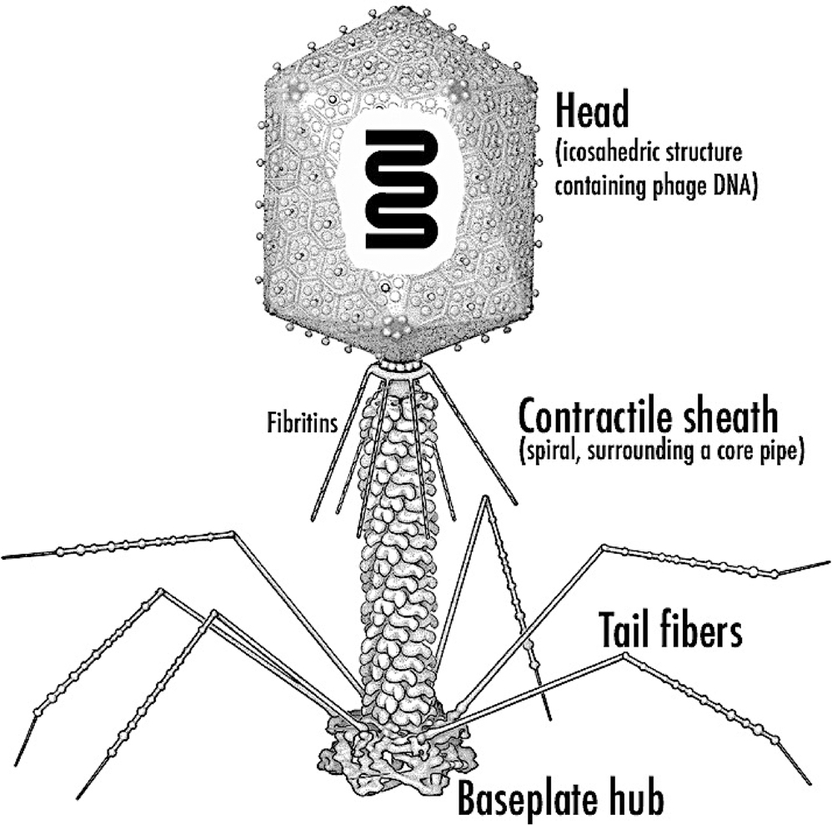

Figure 1. Schematic representation of a prototypical bacteriophage particle. Rossmann et al. (2005)

IV. WHAT IS PHAGE THERAPY AND WHY THE TIME FOR USING PHAGES HAS COME?

A phage is a virus, not quite alive not quite dead. Also they look as if someone made them up. Their head is like an icosahedron – a dice, with 20 faces and 30 edges. It contains the genetic material of the virus and often sits on a long tail that has leg like fibres. There are more phages on earth than every other organisms combined, including bacteria, and probably they are everywhere where living things exists. Although, they do commit genocide for breakfast, they only kill bacteria. Upto 40% of all bacteria in the oceans are killed by them every single day.[6]
But phages also have major flaws, like any other virus, phages need a host to survive and reproduce. They are not much more than genetic material in a hull and they usually chose a specific bacteria or maybe some of its close relatives to prey on.

Like a cruise missile, phage only hunts and kills members of very specific unlucky family of bacteria. After the virus particles are assembled, in the final step they produce endolysin – a powerful enzyme that punches a hole the bacterial membrane. The lysine goes through the membrane and cleaves the bonds in the peptidoglycan. Then after the genetic material is inserted, new phages are created inside the bacterium. The pressure becomes so high, that the pressure in the bacterium is greater than the external environment. As a result the organism explodes, releasing the phage progenies, in the environment to start a new cycle. This whole process is phage therapy – using a phage and its cycle to kill a bacteria.
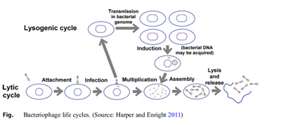

Figure 2: Bacteriophage life cycles. [6]

Also in another process, using a technique called 5 phase lysine where using only Lysine itself as a standalone molecule, that can be used from the outside to punch a hole in the bacteria, causing the explosion process to kill the bacteria. Phage combinations are able to treat dysentery, pneumonia, rhinosinusitis and UTI before antibiotics were discovered.
But there are some issues regarding this therapy. First is the cultural barrier. It’s very difficult to culture a virus. They are biological entities , not small molecules like antibiotics , that means scalability is potentially an issue because every one of them is unique in its own right and may have specific ways in which it has to be made .The second barrier is , the regulatory approval . Like, whether or not it is fit to deal with a biologic like this, as a medicine.
Recently in many experimental studies we started looking into them by injecting millions of them into our bodies, because we are sort of getting desperate, when MDR showed in certain bacterial strains.
In the past, a single cut from the wrong puddle could kill us. Bacteria were our phages. Tiny monsters that hunted us mercilessly. But then, about 100 years ago, we found a solution in nature .By accident we found fungi that produced compounds that killed bacteria – the Antibiotics.

Suddenly, we had a powerful super weapon. Antibiotics were so effective that stopped thinking of bacteria as monsters. Only the old and weakest among us were killed by them. So, we used antibiotics more and more for less and less serious causes. We lost respect for the weapon. But bacteria are living things that evolve, and one by one they started to become immune against our weapons .This continued, until we had created what are called superbugs – mutant bacterial species immune to almost every antibiotics we have. This immunity of bacteria is spreading across the world as we speak. By 2050, superbugs could kill more humans than the cancer. The days, when a cut or a bladder infection, or a cough could kill you, are coming back. In US alone, more than 23000 die alone from resistant bacteria each year. But it turns out, phages, our tiny killer virus robots, could save us .We could inject them into our bodies to help cure infections.[7]
But how? Actually phages are specialized killers of bacteria. They are so specialized that humans are completely immune to them. We are too different. We encounter billions of phages every day and we just politely ignore each other.

Antibiotics are like carpet bombing, killing everything, even the good bacteria in our gut and intestines that we don’t want to harm. Phages are like guided missiles that only target what they are supposed to. But the question arises, if we use phages to kill bacteria, wont bacteria develop ways of defending themselves? Well, it’s more complex than that. Phages evolve too. For billions of years there has been an arms race between the phages and the bacteria and till now they are doing great. This makes phages smart weapons that are getting constantly getting better at killing. But even if bacteria were to become immune against our phages, we still might be able to win. It turns out, in order to become resistant to even just a few species of phages, bacteria have to give up their resistance to antibiotics. We should be able to trap them in a play of catch 22.This therapy has already has already been successfully tested with patients who had no hope left. The bacteria Pseudomonas Aeruginosa, one of the most feared bacteria, infected a man’s chest cavity. This specific strain of bacteria is mostly resistant to most antibiotic and can even survive an alcoholic hand gel.
After years of suffering, a few thousand phages were directly inserted into his chest cavity, together with antibiotics that bacteria were immune to. In 48 hours the patient woke up from his coma. After a few weeks the infection had completely disappeared. In another case study, a man was diagnosed with pancreatic pseudo cyst, filled with Acinetobacter baumannii, which was treated with a phage cocktail.
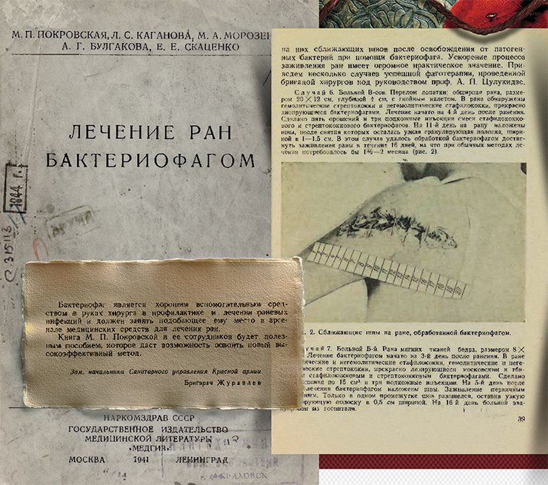
Phages are ubiquitous .In earlier days, France and former Soviet union had various experiments regarding this therapeutic agents. Bacteriophage had been kind of brought back from the shelf as a potential new approach to therapy.[7]

But they are not simple to use and we have to develop a cocktail for each patient’s own isolate as they seem to be relatively safe together. But the problem is they are difficult to develop from both the research and regulatory perspective.

However , the good news is that we have awfully , good tools now – robotics , and much more sophisticated molecular tools that enable this to be done , which 10 – 15 years ago would have been impossible to contemplate .
This publication summarizes the experience in the use of bacteriophages to treat wounds and purulent infections in the military field conditions during the Russian–Finnish war of 1939–1940.
Unfortunately, this treatment is experimental and pharmaceutical companies are still reluctant to invest the necessary billions in a treatment that has no official approval yet.

But things are finally changing , In 2016 the largest phage clinical trial to date began , which showed that phages are getting more and more attention , and we better get used to it because the era in which antibiotics have been our super weapon is about to meet an end . It might be a weird concept, but injecting the deadliest being directly in our bodies could save millions of lives.

V. BRIEF ON PHAGE THERAPY – HISTORY OVERVIEW
In 1896 Ernest Hanbury Hankin discovered bacteriophages showing antibacterial properties against Vibrio cholerae from the water of Indian river [4]. Phages were discovered first in 1915 and in 1917 by Fredrick William Twort and Felix d’Herelle respectively. It was Felix d’Herelle, a French Canadian microbiologist, who first coined the name “Bacteriophage” (viruses that kill bacteria) for the first time. After his discovery, he suggested that phages could serve as a therapeutic tool against bacterial infections. He used phage preparations to successfully treat Cholera outbreak in India and Shigella dysentery patients in France. Since then phage therapy was considered as an eminent therapeutic tool and the exquisite treatment for bacterial infections [5].
Phage therapy use viruses to attack a specific gram-positive and gram-negative bacterial pathogen to treat specific bacterial infections. These viruses are called phages or bacteriophages, their target is selective and destroys the target either by lysis or lysogeny or pseudolysogeny, without harming the host beneficial microflora of the gut, hence minimizing the complication of phage therapy.
Phages, natural parasites of bacteria have a capsid that encloses their genetic material, in some cases, they have a proteinaceous tail. Tailed phages of the class Caudoviricetes include myovirus, podovirus, and siphovirus [8], and the polyhedral Microviridae family are usually associated with the applications of phage therapy [9,10]. Phages are ubiquitous and can be found in feces, seawater, sewage, soil, sludges, and anywhere and everywhere bacteria grow [11,12].

Table 1: Shows the discovered phages, having potent biomedical applications from the year 2011 to 2021 [37].
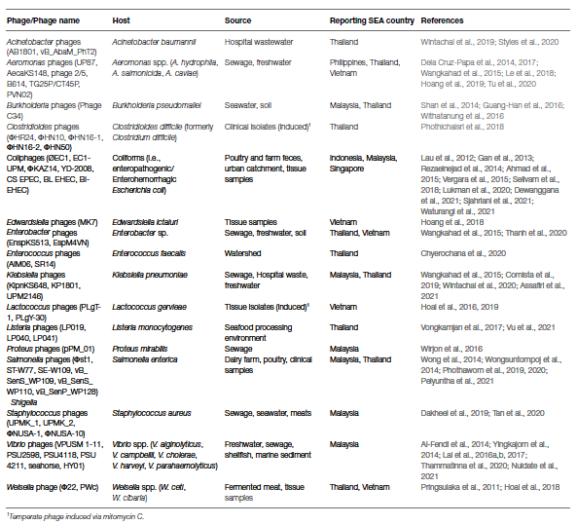

VI. EVOLUTION OF PHAGE THERAPY
The 20th century marked the implementation of phage therapy to decrease the incidence of several disease-causing bacterial pathogens. In 1919, D’Herelle administered an oral dosage of anti-shigella phages to four patients who were suffering from dysentery, caused by Shigella bacteria, and they showed recovery within a day [13]. A new era began on 1945 called the golden age of antibiotics, which lead to the taking off of phage products from the market. Shortly after, penicillin resistance became a clinical problem, and in response to that new classes of antibiotics and modifications of older ones were being developed [14]. Today, multiple drug resistance (MDR) bacteria are making the available antibiotics harder to survive in the market [15]. Phage therapy is back again being considered an important means to treat bacterial infections not amenable to antibiotics. In March 2016, a 30 years old woman severely injured her leg in a suicide bombing at Brussels airport. Even after the administration of antibiotics, her wounds did not heal due to the presence of a resistant Klebsiella pneumoniae strain. Antibiotic treatment in turn caused several side effects but failed to clear the infection. It was in the year 2018, she was finally treated with the phage in combination with antibiotics. Within weeks, her condition improved and the badly damaged femur started to heal (Nature Communications, doi.org/hdbt). In 2019, the third leading cause of death globally was AMR behind ischaemic heart attacks and strokes. The more conservative estimate means that AMR killed more people that year than AIDS. By 2050, deaths due to AMR are predicted to rise to 10 million.

Bill Bryson’s book The Body: A Guide for Occupants (2019) says: “At the current rate of spread, antimicrobial resistance is forecasted to lead to ten million preventable deaths a year”. Then, an article from Chemistry World, reports: “Already, drug-resistant bacterial infections kill 700,000 people every year and this figure may rise to 10 million by 2050.” An April 2019 report by an UN interagency group stated: “Drug-resistant diseases already cause at least 700,000 deaths globally a year, including 230,000 deaths from multidrug-resistant tuberculosis, a figure that could increase to 10 million deaths globally per year by 2050 under the most alarming scenario if no action is taken” . Again, in an analysis done in PLoS Medicine, referring to the 10 million figure, observes: “The scenario that seems to be underlying the most often quoted line entails a sharp initial rise of current resistance rates by 40 percentage points, after which rates remain stable until 2050, and doubled infection rates.” [16]

When we hear that there could be 10 million deaths in 2050 from antimicrobial resistance, we should take the warning of the threat very seriously. When scientists tell us that we must take far-reaching and unprecedented changes in society to avoid particularly disastrous levels of climate change, we must achieve at least to a minimum level of reduction in that timeframe. This is even as 2030 is more of a critical benchmark in the timeline of humanity. Journalists should provide the full context expected possibilities of future events so that their audience can understand just what the claim is. In this case, the AMR Review highlights – there will be 10 million deaths annually by 2050.[17]

Based on various criteria such as mortality, the prevalence of resistance, and treatability. The situation is critical for most difficult-to-treat, community-acquired, healthcare-associated, and nosocomial infections caused by ESKAPEE which stands for Enterococcus faecium, Staphylococcus aureus, Klebsiella pneumoniae, Acinetobacter baumannii, Pseudomonas aeruginosa, Enterobacter species, and Escherichia coli pathogens and Mycobacterium tuberculosis, is an additional eye on the global health threat [40].

Table 2: The global priority pathogens list of antibiotic-resistant bacteria released by the World Health Organization in the year 2017 [4]

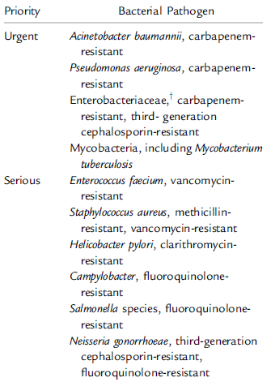

VII. PHAGE SELECTION
Phages ideal for therapy should be obligately lytic to ensure the killing of the target pathogen [9,18,19]. The phage should have a high rate of adsorption to the target pathogen, a short generation time [20], and species-specific activity [11]. As in the case with typical antimicrobial agents, scientists also recommend profiling the phages in a phagogram [21]. Phagogram continuously tests the efficacy of the phage particle against a defined collection of pathogens called a pathogen library [22,23] and hence will ensure that the therapeutic phages are specific to their target pathogen.

VIII. PHAGE FORMULA
Clinically phages are typically administered as a cocktail of viral strains [24,25, 26,27.] A single phage strain will precisely target a specific bacterial strain [28,29.] The drawback of the approach is it requires a very careful definition of the etiologic bacterium before therapy. It is only applicable for proof of the concept, checking of efficacy and tolerability in vitro. However, the benefits linked with the cocktail approach are increasing the target bacterial strain spectrums, targeting multiple species in one go, increasing the dose potency by multiple phage strains attacking the same bacterial cell, and limiting resistance by forcing the target bacterium to evolve resistance to multiple phages simultaneously to survive [30-34.] The only drawback individual phages generally require a reduction in concentration when mixed into a single dose and the phages need to compete with one another for the same bacterial cell surface receptor and drive cross-resistance [35].

IX. PHAGE RESISTANCE
Bacteria can thwart phage attacks through various antiviral mechanisms, which are spontaneous chromosomal mutations (major problem), the ability to block the entry of genetic material of the phage particle, DNA restriction-modification enzymes present, abortive infection, and lastly CRISPR-Cas adaptive immunity of the bacteria. Switching to new phages with different binding sites or orders of exposure can be used to improve the efficacy of phage therapy [36] Maintenance of bacterial antiviral defense mechanisms comes with a cost [37,38]. However, phages also have a defense system to counteract bacterial immunity [39,40] and counter-adapt to reinfect resistant bacteria [41,42] which are among the sweet benefits.

X. PHAGE ADJUVANT
Phage adjuvants are active compounds not affect bacterial growth in isolation and help to block phage resistance or enhance phage activity when administered in combination with the phages. The combination of synergistic antimicrobials is an adjuvant as they boost phage production. For example, phage-infected Burkholderia cenocepacia cells produce higher phage particles in the presence of sub inhibitory concentrations of ciprofloxacin, tetracycline, and meropenem [43]. Tetracycline causes cell clustering, which may promote an increase in phage infections by minimizing lateral travel between the two adjoining cells, hence increasing contact with phage receptors on the cell surface of uninfected cells. The increase of phage production is unaltered when bacteria are antibiotic resistant. Combining phages with sub inhibitory concentrations of ciprofloxacin or meropenem may inhibit the regrowth of the resistant phage mutants in a murine endocarditis model and hence improve phage therapy outcomes. Phages in combination with antibiotics may provide a chance for the discovery of newer antibiotics and increase the pressure on the development of phage therapy. The major drawbacks are in most cases phage antibiotic interactions are unknown and even though in vitro studies of synergy justify the combination of phage antibiotic therapy, they are further not pursued within animal models [44].Apart from this, bacterial biofilms act as a major hindrance in the fight against bacterial infections because they are inherently refractory to various antibiotics. DNAs are a potent adjuvant that will degrade extracellular DNA, which plays various roles in both aggregations of bacteria and interaction of the resulting biofilm with polymorphonuclear leukocytes during the inflammatory response [45]. Other phage adjuvants can be sugar alcohols such as xylitol, sorbitol which inhibits bacterial growth by diffusing through the biofilm and accumulating as a toxic substance, nonmetabolizable sugar alcohol phosphate. These findings suggest that phage adjuvants may help to improve the efficacy of bacterial killing during the treatment.

XI. THREE-PHASE PHAGE STRATEGY
A structured research and implementation approach are necessary for the use of phage therapy against multidrug-resistant infections, which is divided into three phases, which are as follows:[49]
Phase One: includes extensive isolation, characterization, and matching of phages to their target pathogen, which will be guided by the existing knowledge of phage biology and the mechanisms of phage infection.
Phase Two: includes designing appropriate models, both laboratory-based and clinical-based, to implement phage therapy protocols.
Phase Three: requires establishing regulatory guidelines and standards for phage therapy.

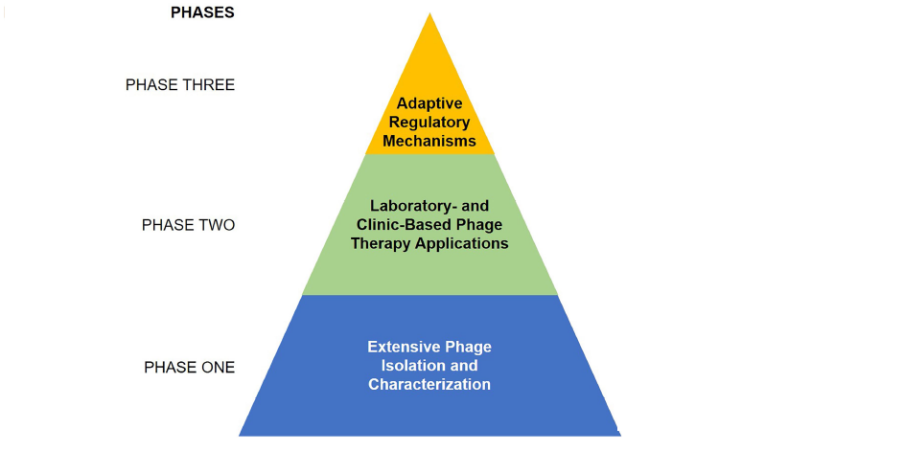

Figure 3: Three-phase phage strategy to combat multiple drug resistance (adopted from Carascal, B., M., et al., 2022.)

XII. TYPES OF PHAGES GENERALLY FOUND
Over the last ﬁfty years, more than 5100 bacteriophages have been identiﬁed and studied, with more than 90% of them belonging to the Siphoviridae , Myoviridae and Podoviridae families . In relation to the type of genetic material they have within the capsid's core, bacteriophages can be divided into four major groups (see): single stranded DNA phages (ssDNA), single stranded RNA phages (ssRNA), double stranded DNA phages (dsDNA), and double stranded RNA phages (dsRNA). [50]

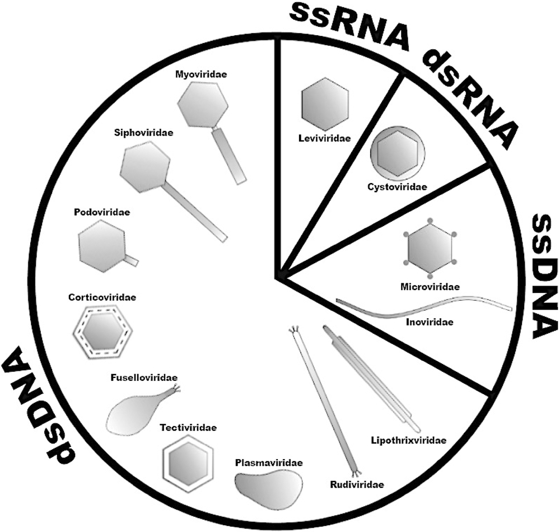
Figure 4: Classiﬁcation of bacteriophages according to their morphology, genetic material and major characteristics.

XIII. STRATEGIES OF REPLICATION AND POSSIBLE FUTURE COMMERCIALIZATION
In general terms, Bacteriophages or phage cultures require host cells in which they multiply. Cultures are grown by infecting bacterial cells with bacteriophages. The phages can be isolated then from the resulting plaques in a lawn of bacteria on a microbial plate.[48]

XIV. THEORETICAL MODELS FOR BACTERIOPHAGE PRODUCTION
The three basic parameters for phage production are - the populations of phage-infected bacteria, susceptible uninfected bacteria and free phages. Starting from this, different models have included additional variables such as resistant uninfected bacteria or multiple bacterial species. All these populations interact controlled by kinetic parameters associated with bacterial growth and phage infection. Based on the nomenclature used by other authors we use the Greek characters to name the different kinetic parameters in phage reproduction. Burst size can be symbolized by β, eclipse time by ε, phage decay rate by λ and adsorption rate by δ. The only exceptions is phage concentration, which is commonly indicated as “P,” and latency time, as “L.” Uniformity in this mathematical language facilitates the understanding and data mining for future academic reviewers.
Many efforts were made to describe models of phage production, describing its population behavior under several conditions and methods. Table 1. summarizes different phage production models, given as differential and integral equations .
Phage production models generally describe phage population change over time. This may be represented as a kinetic change in plaque forming units (PFU) per unit of time, final concentrations obtained after a batch process, or a continuous process. Models proposed by Campbell (1961) and Beretta and Kuang (1998) are consistent in balancing phage particles with generation terms and loss of free bacteriophage .These models are useful due to their simplicity and also tend to underestimate the influence of parameters such as burst size and latent period .
One interesting model proposed by Santos et al. (2014) considers the influence of bacterial growth rate on the phage adsorption constant .Other models have explored the influence of multiple bacterial species, and the occurrence of bacterial resistance
Another interesting analytical study is of Krysiak-Baltyn et al. (2018), which also describes variable infection parameters as a function of bacterial growth rate and it also estimates operational cost and productivity in a two-stage process system.
Bacteriophage evolution must be considered in a production process, since the phages might increase their efficiency to infect bacteria over time. This idea could be represented as infection rates in host-range experiments, where even methods for host-range expansion can be achieved for phage therapy applications and a better way to solve the MDR problems. [47]

Table 3. Models of bacteriophage production
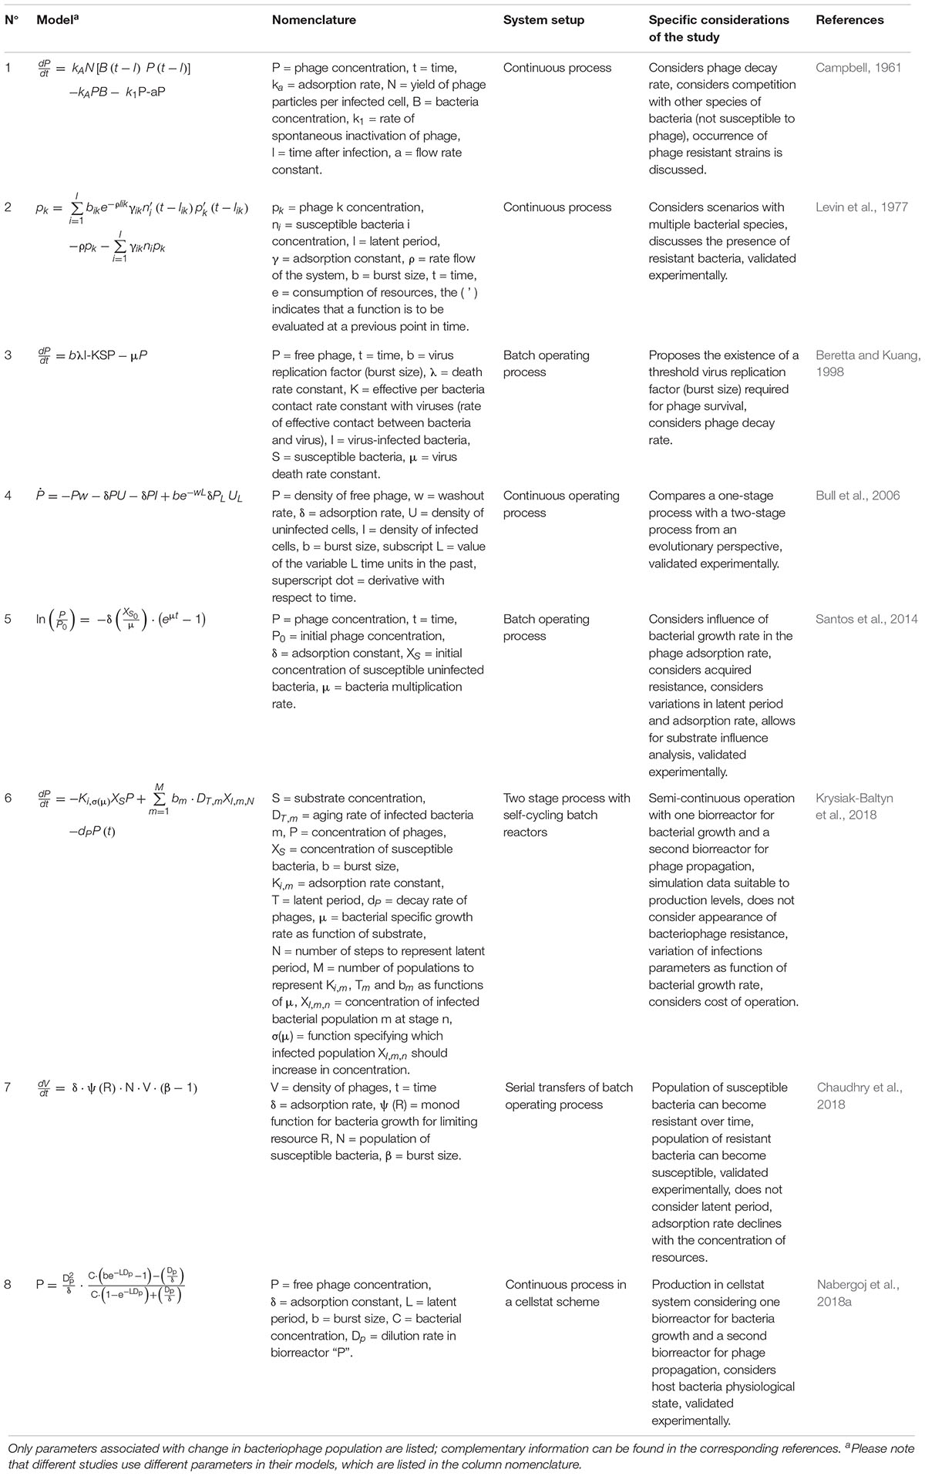

Table 4. Production data available on bacteriophage production cases evaluated experimentally
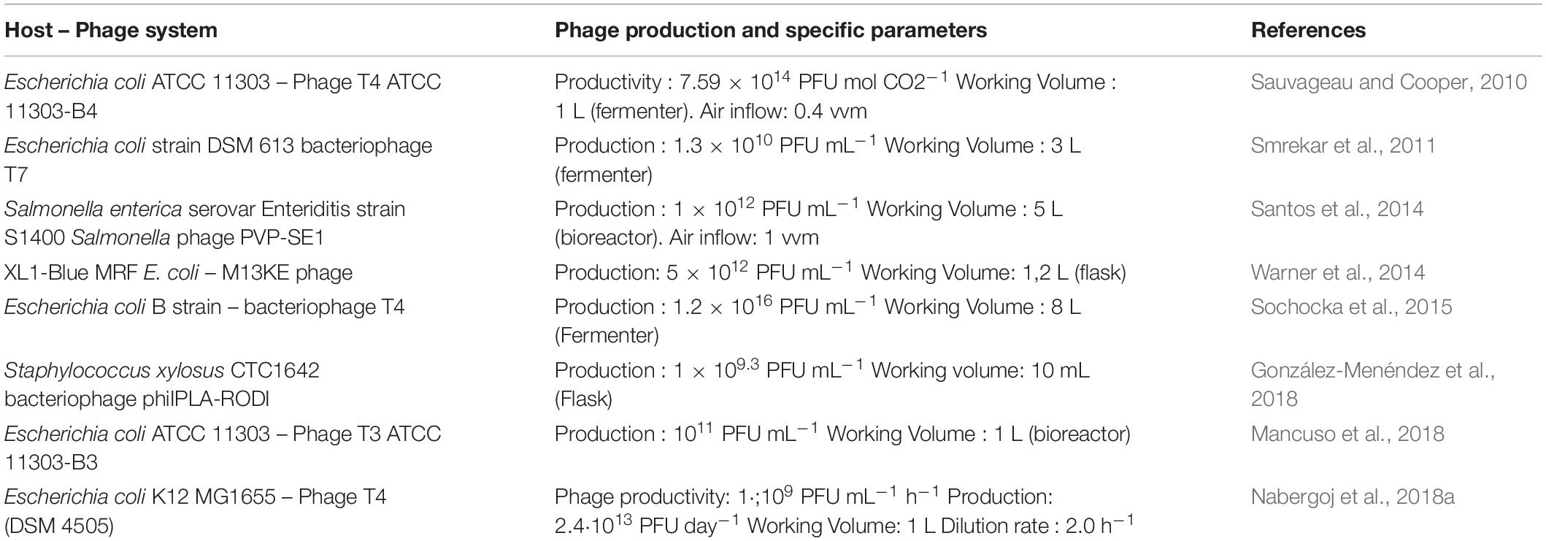

XV. PHAGE ABUNDANCE AND DIVERSITY
Considering the possible phage life cycles, it is quite logical to review where phages are found, and how they are characterized. Specific phages and their characterization are being in the case studies. The first approaches which led to the realization of phage abundance were based on epifluorescent microscopy followed by DNA staining which suggested that, in sea water there are approximately around 10 phages in existence for each bacterial or archaeal cell. Hence, to make sense of phage abundance, one must establish where the majority of their hosts exist. Most of the Earth’s Bacteria and Archaea are found in the open ocean, in ocean sediments and in terrestrial sub-surfaces, where, an estimation of 1.2 x 10²⁹, cells can be found respectively. Bacteria and Archaea are often associated with humans and animals, who provide many niche environments within them, where these micro-organisms become an essential symbiont. Although not significant, bacteria are of essential importance when associated with humans, particularly either in a disease, or as a food producing context, which can fall prey to the bacteriophage attack. Therefore, in terms of human impact, a study of the roles of bacteriophages which infect these bacteria is of immense importance. [46,47]

XVI. METHODS TO GENETICALLY ENGINEER PHAGES
Although, there is abundance of naturally occurring phags in the environment, phages can be enhanced using genetic engineering approaches. These are the techniques which allow researchers to increase phage killing efficacy and to introduce other desirable properties in them. Like, expanded host range, elimination of lysogeny, increased biofilm degradation, and the addition of secondary antimicrobial payloads. One of the most widely used approaches for phage engineering is homologous recombination, where a heterologous segment of DNA, within a bacterial host, is recombined with the phage genome at sites of homology. The efficiency of recombination is very low, therefore an efficient screening method is necessary to identify recombinant bacteriophages. Yeast-based and in vitro phage genome assembly methods have been developed to avoid the possible toxic effect of the phage replication. Alternatively, phage genomes can be assembled from synthesized DNA fragments that have been assembled by methods such as Gibson assembly. Lastly, cell-free transcription-translation systems can create the phage or virus-like particles from DNA. The Noireaux laboratory has developed cell-free systems to successfully synthesize, replicate and assemble infectious MS2, T7, phiX174 and even T4 phage.[48,49]

XVII. ADMINISTRATIVE ROUTES AND REAL LIFE EXAMPLES OF PHAGE COCKTAILS IN PATIENTS
It is well known, that every recipients of phage therapy have been treated empirically so far, with the incomplete information, like, the phages, their adequate routes of administration, duration, dosing, and compatibility of antibiotics. Fig. 5, briefly summarize the selected phage therapy clinical trials and the single-patient reports in between 2005 and 2020 in terms of routes of administration. [49,50,51] With limited clinical trial data available , the experience , gathered from personalized case studies , that (under eIND) has top notch medicinal phage technologies and potential risks and challenges, which we have showed in the following figure .

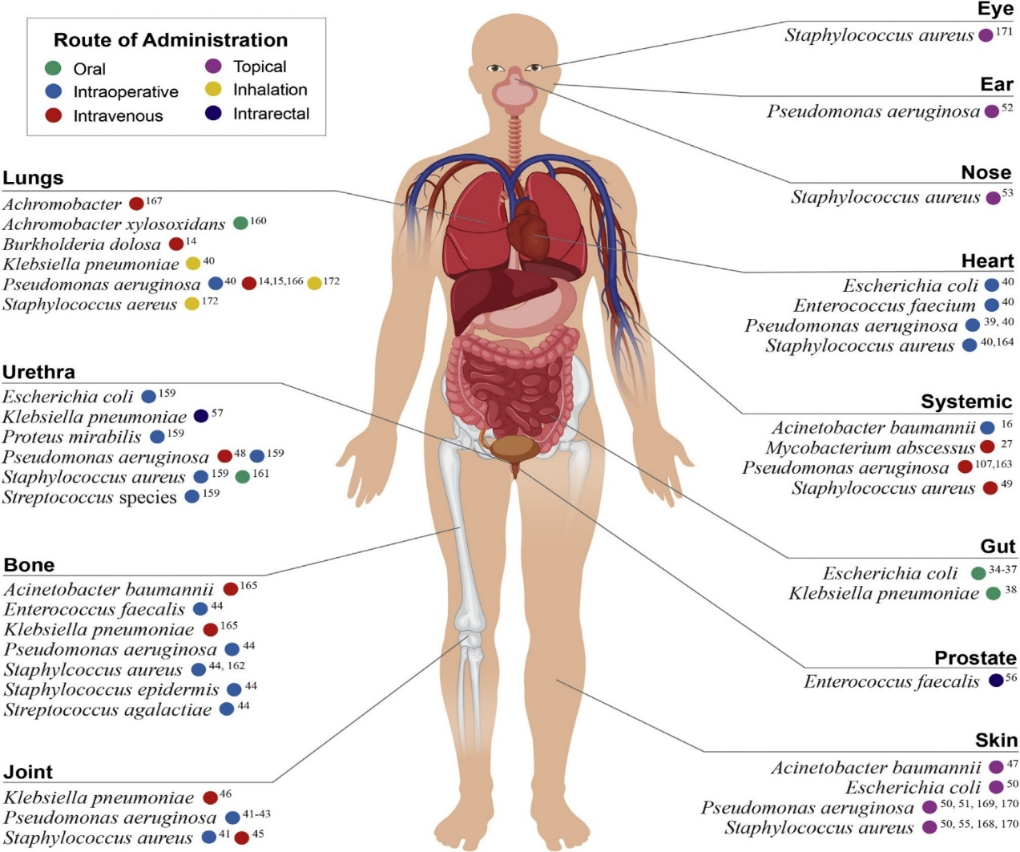

Figure 5. Summary of the phage therapy clinical trials (case reports between 2005 to 2020). Case reports are grouped by the site of infection and target pathogen. The color coding, however, represents the primary route of phage administration.

XVIII. APPLICATIONS OF BACTERIOPHAGES IN REAL LIFE:

A. Phage Therapy Enhancement
The use of genetically modified (synthetic) phages can extend the therapeutic potential of phage therapy. By prophage induction, phage ϕEf11 was first isolated from a clinical isolate of Enterococcus faecalis in an oral biofilm [52]. Zhang and colleagues removed genes associated with lysogeny to make the phage insensitive to repression and fully lytic, transferred genes associated with DNA replication and packaging from another related phage to extend the host range and enhance lytic growth. [53] They demonstrated its efficacy in killing vancomycin-resistant E. faecalis within a biofilm [54]. More recently, the first clinical application of engineered bacteriophages was used to treat a patient with cystic fibrosis with a Mycobacterium abscessus infection. Despite having a bank of over 1800 mycobacterial phages, only one killed the clinical isolate of M. abscessus (GD01). 9 days after the implementation of phage therapy, the patient was able to leave the hospital, and after 7 months of treatment (topical phage therapy and antibiotics), there was significant improvement in the lungs, liver, and skin. [55].

B. Phage Host Range alteration
Phages typically infect a limited range of bacterial species [56]. This narrow specificity is an advantage in a way, that , phages will not be able to disrupt commensal bacteria of the host. To circumvent this limitation, multiple phage populations can be mixed into a cocktail that will have a broader range of activity. Also, phages can be genetically altered to expand their host range [57,58,59]. Yehl and colleagues developed a high-throughput method to broaden host-range using targeted mutagenesis of well-defined regions of the tail fiber that mediates host recognition. This approach generated a vast amount of diversity. The mutant phage library with expanded host range reduced the emergence of phage- resistant bacterial mutants [60].

C. Antibiotic Sensitivity alteration
Various phage components can also be modified to carry payloads to enhance the bactericidal activity of antibiotics. One such example, Lu and Collins modified a lysogenic phage M13mp18 to over- express lexA3, which represses the SOS DNA repair system [61]. They further demonstrated, that the effectiveness of this method in an in vivo mouse model where mice treated with the antibiotic and modified phage had an 80% chance of survival [62]. In another example, Edgar and colleague engineered, the phage λ to carry wild-type versions of the rpsL and gyrA genes [63].
Several groups have also engineered phages to carry CRISPR-Cas systems to disrupt antibiotic resistance [64]. Citorik and colleagues [65] designed filamentous phage-based constructs, targeting β-lactamase genes, which gives resistance to β-lactam antibiotics.

D. Gut Microbiome Modification
The use of bacteriophages to alter the gut microbial community has been attempted in animal models. Hsu and colleagues tested the effect of phages on germ-free mice, comprised of bacterial species known to colonize the human gut. They targeted each member individually with phages, which though reduced but did not fully eliminate the target bacteria. Within two days, 28% of the E. faecalis population were phage resistant [66]. This work demonstrates the importance of bacteriophages in modulating the gut microbiome, but the development of resistance is a impactful concern for the potential use of virulent phages to therapeutically alter the microbiome.

E. Delivering of Antimicrobials
The remarkable ability of phages to target specific bacteria opens the door for more targeted delivery of antimicrobials. Yacoby and colleagues used filamentous phages as targeted drug carriers to elliminate pathogenic bacteria [67,68]. They targeted phage to specific bacteria by genetically modifying the p8 coat protein of the phage to display a bacterial-specific peptide. An inactive form of chloramphenicol, was chemically conjugated to the phage. The modified phage carrying chloramphenicol were successful to bind the target bacteria as esterases in serum cleaved the linker releasing an active form of chloramphenicol near the target bacteria. This approach increases the local concentration of the drug at the target site, hence increasing the potency and decreasing the general toxicity [69,70].

F. Deploying the Targeted CRISPR Editing
CRISPR editing gives the potential to inactivate any gene in a bacterial population. Selle and colleagues used genetically modified phage ΦCD24-2 encoding a self-targeting CRISPR to redirect the type I-B CRISPR-Cas3 system in C. difficile towards the bacterial chromosome [71]. Upon infection, the phage-delivered CRISPR activated the endogenous Cas3 protein to digest the chromosomal DNA of the bacterial host. It was found that the modified phage, carrying the self-targeting crRNA was significantly more effective at killing C. difficile than the wild-type bacteriophage [72].
G. Disrupting of Biofilms
Biofilms typically provides tolerance to antimicrobial agents by providing a physical barrier [73]. Phages which infect bacterial strains (containing a capsule made up of these same extracellular matrix components) produce depolymerases, enzymes that degrade polysaccharides. Lu and Collins developed a T7 phage which expresses the biofilm-degrading enzyme dispersin B (DspB) during phage infection. The modified phage reduced the bacterial biofilm cell counts by 99% and was two orders of magnitude more effective at biofilm breakdown than the wild-type phage lacking dispersin B [74]. Phages can also be engineered to inactivate the quorum-sensing molecule. T7aiiA reduced the quorum sensing of Pseudomonas aeruginosa in a mixed biofilm resulting in a reduction in biomass by 75% at 4hrs [75].

H. Killing specific bacteria with Endolysins
Rather than using virulent phages to kill bacteria, several group of scientists have focused on the cell wall degrading endolysins encoded by phages. Near the end of the replication cycle, phage endolysins degrade the host peptidoglycan, which causes cell lysis, releasing the phage particles [76].The most active endolysin was able to kill Gardnerella bacteria without disrupting the remaining vaginal microbiome in thirteen out of fifteen patient samples [77].
The lysocin PyS2-GN4 is bactericidal above 0.1 µg/mL and capable of sterilizing high concentrations of Pseudomonas.

I. Delivering Drugs to Eukaryotic Cells (In terms of Eukaryotic Applications)
The ability of engineered phages to deliver drugs to specific cancer cells has the potential to minimize the off target toxicity and side effects of more traditional cancer therapies [77,78,79]. Phages can be linked to drugs that have low water solubility which allows for a lower dose and enhanced delivery to be administered. Bar and colleagues reported a 1000-fold improved potency of hygromycin (carried on phages) compared to free drug treatment of the human breast adeno-carcinoma [80].Also , Du and colleagues coupled phages , which were targeting the human hepato-carcinoma cell line BEL- 7402 with doxorubicin and observed a reduction in tumor growth [81]. Modified phages have also been designed to deliver photosensitizers to cancer cells, inducing targeted killing of cancer cells following light activation [82]. Also diagnosis and treatment of intractable brain disorders like tinnitus, Parkinson’s, and Alzheimer’s disorders are being carried out with phages.

J. Phages as Sensors
Sensors generally have minimum of two functional components. First is recognition element for a target and the Second is transducing for reporting when the recognition element detects that target. The receptor binding proteins detects the target, a bacterium. The genome of the phage is the reporter, creating more phages after it enters the target cell, as a plaque. Therefore, this way, bacteriophages have extraordinary specificity in recognizing their target like a biosensor. [82,83,84].Another lucrative method for detecting bacteria relies on phage proteins that have specificity for binding to bacteria. These proteins include the receptor binding proteins and the cell binding domains of the phage endolysins [84,85]. Each of them binds to specific molecules on the surface of a bacterium.[86,87]. The reporter molecule is then able to specifically bind to a bacterial surface. Poshtiban and colleagues [88] used the putative RBP of a Campylobacter jejuni phage to functionalize paramagnetic beads which were used to concentrate C. jejuni from food samples in terms of detection.

K. Genetically Engineered Phages in Tissue Construction
Phage display can also be used to create phages containing cell binding peptides that can facilitate tissue construction. Phages can self-assemble into 2- and 3-D structures [89,90] and can be used in 3-D printing to create scaffolds for cells to grow on [91,92]. The most commonly used phages for this are the filamentous phages that have multiple proteins which can be used for display [93]. Finally, phages are modified both chemically and genetically [89] and can be cultured at various scales if needed [94].

L. Delivering of genes to eukaryotic cells and treatment in fighting Cancer cells
Conventional gene therapy approaches have mostly relied on eukaryotic viral vectors, but interest in using phage vectors is increasing due to key benefits they offer regarding targeting, safety and cargo capacity [95,97]. Bacteriophages have a large cargo capacity and many can be easily engineered to express eukaryotic cell targeting motifs. Bacteriophages might also be safer than mammalian viral vectors due to their lack of natural tropism for eukaryotic cells .Additionally, instead of DNA, siRNA can also be delivered using phage virus-like particles (VLPs) [96-98]. Hajitou and colleagues developed a viral vector (chimeric) - AAVP, in which, into the phage genome, a chimeric genome containing an adeno-associated virus (AAV) cassette is inserted and packaged in a M13 phage particle that also displayed a eukaryotic cancer cell targeting motif. Also, the international team at Imperial College London had promising results while using bacteriophages to target cancer cells in the brains of mice. Using the approach, they were able to deliver targeted therapy directly to cancer and with TMZ, amplify the effect. Also, Antitumor activity of bacteriophage T4 in a mouse B16 (melanoma model) was seen in a study.
Finally, as CRISPR Cas systems are emerging and enhancing our ability to edit the genetic information, Qazi and colleagues used P22 VLPs to create a programmable delivery vehicle for Cas9.[99]

M. Vaccines
The innate immunogenicity of some phages makes them useful in terms of vaccine delivery machines [99,100]. The methods for gene therapy of phages can readily be applied to DNA based vaccines [101,102] with the added benefit of the nucleic acid cargo deliverer. Moreover, the ability of some phage capsid proteins to activate the innate immune system obsoletes the need of an additional adjuvant [99,103,104]. T4 bacteriophages have been used to display multiple antigens for HIV, foot-and mouth disease virus (FMDV) and anthrax toxin. The results of these preliminary studies demonstrate the ability of phage-based vaccines to elicit both cell mediated (HIV) and antibody mediated responses [105]

XIX. CHALLENGES AND LIMITATIONS OF PHAGE THERAPY

Phage therapy can also show some cons.

1. Over millions of years, since the bacteria have coevolved with viruses (Bacteriophages), they also have adapted numerous resistance mechanisms.

2. Phage adsorption blocking is one of the major resistance mechanisms.

3. Extracellular matrix production as a barrier between bacterial receptor is done by bacteria to avoid bacteria from phage infection.

4. By the super injection exclusion (Sie) system Bacteria can inhibit phage genome injection

5. Mechanisms developed by host bacteria to digest extrinsic (Phage) DNA (restriction modification) is also one headache in this terms.

6. Replication of phage genome can be hindered by bacteriophage exclusion (BREX) system

7. Phage therapy can elicit adaptive immune system to produce phage neutralizing antibodies that clear the phages from the body. Also, some phages are antigenic and known to elicit anti-phage antibodies

8. Pharmacokinetics of bacteriophage therapy is much more complex than other methods.

9. Lastly, all bacteriophages are not good therapeutic bioagents. The challenge for phage application is their stability and their competency to reach and lyse the bacterial host.

XX. CONCLUSION – AN END AND A BEGINNING
For combating bacterial infections the available literature on the use of phages and phage derived proteins, especially those of multidrug-resistant bacteria, increasingly shows promise for the prospect of phage therapy as either a supplement to antibiotics or as an alternative. However, discrepancies in recent findings on the potential for horizontal gene transfer and the host range, the immunomodulatory effects , makes it clear that we need a better understanding of the interaction between phage, the human host and the microbiome, before doing a large scale implementation on phage therapy . Phage endolysins may thus be a much more practical therapeutic tool for their immunological potential, besides their ease of production, purification, and storage. Despite the promising preliminary leads on phage and phage-derived lytic proteins, it is more than likely that no panacea for antibiotic-resistant infections should arise. The enhanced efficacy of antibacterial agents when used in conjunction, states that, therapy, when using some combination of phage, phage-derived lytic proteins, bioengineered phage, and/or antibiotics will be necessary for addressing the rising problem of antibiotic-resistant infections.

XXI. FINAL THOUGHTS
If there is a disease, the nature will always create a therapy for it. We just need to find it, like we did with the bacteriophages. In the biome it’s always a inter – relationships between a prey and a predator. So, what seems like a predator must be a prey to some other organism or microorganism.
Finally, if the findings of ours, in this review, can help even 1% of the population we would think this work of ours has reached its zenith of success.

REFERENCES

1. How 'good' viruses may influence health. https://www.medicalnewstoday.com/articles/327167#What-is-the-virome?

2. News Track .Know the deep secret about Ganga water, Scientists proved. Jul 13 2020
https://english.newstracklive.com/news/why-ganga-water-is-so-pure-scientifically-secret-is-so-deep-sc108-nu910-ta294-1106121-1.html

3. Hankin EH. L’action bactéricide des eaux de la Jumna et du Gange sur le vibrion du choléra. Ann Inst Pasteur. 1896;10:511–23.

4. Dwivedi, S., Chauhan, P.S., Mishra, S. et al. Self-cleansing properties of Ganga during mass ritualistic bathing on Maha-Kumbh. Environ Monit Assess 192, 221 (2020). https://doi.org/10.1007/s10661-020-8152-2

5. Phage therapy .https://www.whatisbiotechnology.org/ index.php/science/ summary/phage-therapy/#:~: text=Definition, to%20treat% 20 pathogenic%20bacterial%20infections.

6. Harper, D.R. (2020). Introduction to Bacteriophages. In: Harper, D.R., Abedon, S.T., Burrowes, B.H., McConville, M.L. (eds) Bacteriophages. Springer, Cham. https://doi.org/10.1007/978-3-319-40598-8_48-2

7. Science First Hand , 15 Mar 2017 , Bacteriophages the enemies of our enemies , volume 46, N1

6-8. Liu, Y., Demina, T. A., Roux, S., Aiewsakun, P., Kazlauskas, D., Simmonds, P., et al. (2021). Diversity, taxonomy, and evolution of archaeal viruses of the class Caudoviricetes. PLoS Biol. 19:e3001442. doi: 10.1371/journal. pbio.3001442

9. Harper, D. R., and Enright, M. C. (2011). Bacteriophages for the treatment of Pseudomonas aeruginosa infections. J. Appl. Microbiol. 111, 1–7. doi: 10.1111/j.1365-2672.2011.05003.x

10. Lin, D. M., Koskella, B., and Lin, H. C. (2017). Phage therapy: an alternative to antibiotics in the age of multi-drug resistance. World J. Gastrointest. Pharmacol. Ther. 8:162. doi: 10.4292/wjgpt.v8.i3.162

11. Khawaja, K. A., Rauf, M., Abbas, Z., and Rehman, S. U. (2016). A virulent phage JHP against Pseudomonas aeruginosa showed infectivity against multiple genera. J. Basic Microbiol. 56, 1090–1097. doi: 10.1002/ jobm.201500764

12. Bhetwal, A., Maharjan, A., Shakya, S., Satyal, D., Ghimire, S., Khanal, P. R., et al. (2017). Isolation of potential phages against multidrug-resistant bacterial isolates: promising agents in the rivers of Kathmandu, Nepal. Biomed. Res. Int. 2017:3723254. doi: 10.1155/2017/3723254

13. Summers WC. The strange history of phage therapy. Bacteriophage. 2012;2:130e133.

14. Aminov RI. A brief history of the antibiotic era: lessons learned and challenges for the future. Front Microbiol. 2010;1:134.

15. CDC. Antibiotic resistance threats in the United States. http://www.cdc.gov/drugresistance/threat-report- 20132013.

16. New report calls for urgent action to avert antimicrobial resistance crisis . 29 April 2019 https://www.who.int/news/item/29-04-2019-new-report-calls-for-urgent-action-to-avert-antimicrobial-resistance-crisis

17. Eric A. Friedman . Behind the Headlines: 10 Million Deaths From Antimicrobial Resistance by 2050 (or Not?) .February 12, 2020
https://oneill.law.georgetown.edu/behind-the-headlines-10-million-antimicrobial-deaths-by-2050-or-not/

18. Wirjon, I. A., Lau, N. S., and Arip, Y. M. (2016). Complete genome sequence of Proteus mirabilis phage pPM_01 isolated from raw sewage. Intervirology 59, 243–253. doi: 10.1159/000468987

19. Lehman, S. M., Mearns, G., Rankin, D., Cole, R. A., Smrekar, F., Branston, S. D., et al. (2019). Design and preclinical development of a phage product for the treatment of antibiotic-resistant Staphylococcus aureus infections. Viruses 11:88. doi: 10.3390/v11010088

20. Drulis-Kawa, Z., Majkowska-Skrobek, G., and Maciejewska, B. (2015). Bacteriophages and phage-derived proteins–application approaches. Curr. Med. Chem. 22, 1757–1773. doi:10.2174/0929867322666150209152851

21. Barbu, E. M., Cady, K. C., and Hubby, B. (2016). Phage therapy in the era of synthetic biology. Cold Spring Harb. Perspect. Biol. 8:a023879. doi: 10.1101/ cshperspect.a023879

22. Deresinski, S. (2009). Bacteriophage therapy: exploiting smaller fleas. Clin. Infect. Dis. 48, 1096–1101. doi: 10.1086/597405

23. Casey, E., Van Sinderen, D., and Mahony, J. (2018). In vitro characteristics of phages to guide ‘real life’ phage therapy suitability. Viruses 10:163. doi: 10.3390/v10040163

24. Law N, Logan C, Yung G, et al. Successful adjunctive use of bacteriophage therapy for treatment of multidrug-resistant Pseudomonas aeruginosa infection in a cystic fibrosis patient. Infection. 2019;47:665e668.

25.Schooley RT, Biswas B, Gill JJ, et al. Development and use of personalized bacteriophage-based therapeutic cocktails to treat a patient with a disseminated resistant Acinetobacter baumannii infection. Antimicrob Agent Chemother. 2017;61. e00954-17.

26.Dedrick RM, Guerrero-Bustamante CA, Garlena RA, et al. Engineered bacteriophages for treatment of a patient with a disseminated drug-resistant Mycobacterium abscessus. Nat Med. 2019;25:730e733.

27. Jault P, Leclerc T, Jennes S, et al. Efficacy and tolerability of a cocktail of bacteriophages to treat burn wounds infected by Pseudomonas aeruginosa (PhagoBurn): a randomised, controlled, doubleblind phase 1/2 trial. Lancet Infect Dis. 2019;19:35e45.

28. Chan BK, Turner PE, Kim S, Mojibian HR, Elefteriades JA, Narayan D. Phage treatment of an aortic graft infected with Pseudomonas aeruginosa. Evol Med Public Health. 2018;2018:60e66.

29.Doub JB, Ng VY, Johnson AJ, et al. Salvage bacteriophage therapy for a chronic MRSA prosthetic joint infection. Antibiotics. 2020;9:241.

30.Ross A, Ward S, Hyman P. More is better: selecting for broad host range bacteriophages. Front Microbiol. 2016;7:1352.

31.Schmerer M, Molineux IJ, Bull JJ. Synergy as a rationale for phage therapy using phage cocktails. PeerJ. 2014;2, e590.

32.Levin BR, Bull JJ. Population and evolutionary dynamics of phage therapy. Nat Rev Microbiol. 2004;2:166e173.

33.Oechslin F. Resistance development to bacteriophages occurring during bacteriophage therapy. Viruses. 2018;10:351.

34.Costa P, Pereira C, Gomes A, Almeida A. Efficiency of single phage suspensions and phage cocktail in the inactivation of Escherichia coli and Salmonella typhimurium: an in vitro preliminary study. Microorganisms. 2019;7:94.

35. Abedon ST, Thomas-Abedon C. Phage therapy pharmacology. Curr Pharm Biotechnol. 2010;11:28e47.

36. Wright RCT, Friman VP, Smith MCM, Brockhurst MA. Resistance evolution against phage combinations depends on the timing and order of exposure. mBio. 2019;10. e01652-01619
37. Vasu K, Nagaraja V. Diverse functions of restriction modification systems in addition to cellular defense. Microbiol Mol Biol Rev. 2013;77:53e72.

38.Vale PF, Lafforgue G, Gatchitch F, Gardan R, Moineau S, Gandon S. Costs of CRISPR-cas-mediated resistance in Streptococcus thermophilus. Proc Biol Sci. 2015;282:20151270.

39.Piya D, Vara L, Russell WK, Young R, Gill JJ. The multicomponent antirestriction system of phage P1 is linked to capsid morphogenesis. Mol Microbiol. 2017;105:399e412.

40.Pawluk A, Davidson AR, Maxwell KL. Anti-CRISPR: discovery, mechanism and function. Nat Rev Microbiol. 2018;16:12e17.

41. Cortez MH, Weitz JS. Coevolution can reverse predator-prey cycles. Proc Natl Acad Sci U S A. 2014;111:7486e7491.

42. Hampton HG, Watson BNJ, Fineran PC. The arms race between bacteria and their phage foes.Nature. 2020;577:327e336.

43. Kamal F, Dennis JJ. Burkholderia cepacia complex phage-antibiotic synergy (PAS): antibiotics stimulate lytic phage activity. Appl Environ Microbiol. 2015;81:1132e1138.

44. Luong, T., Salabarria, C., A., Roach, R., D., 2020. Phage Therapy in the Resistance Era: Where Do We Stand and Where Are We Going? https://doi.org/10.1016/j.clinthera.2020.07.014

45. Harper D, Parracho H, Walker J, et al. Bacteriophages and biofilms. Antibiotics. 2014;3:270e284.

46. 9.4A: Batch Culture of Bacteriophages https://bio.libretexts.org/Bookshelves/Microbiology/Book%3A_Microbiology_ (Boundless)/9%3A_Viruses/9.4%3A_Culturing_Viruses/9.4A%3A_Batch_Culture_of_Bacteriophages#:~:text=which%20to%20multiply.-,For%20bacteriophages%2C%20cultures%20are%20grown%20by%20infecting%20bacterial%20cells.,of%20viruses%20that%20 infect %20bacteria

47. García, R., Latz, S., Romero, J., Higuera, G., García, K., & Bastías, R. (2019). Bacteriophage Production Models: An Overview. Frontiers in microbiology, 10, 1187. https://doi.org/10.3389/fmicb.2019.01187

48. Clokie, M. R., Millard, A. D., Letarov, A. V., & Heaphy, S. (2011). Phages in nature. Bacteriophage, 1(1), 31–45. https://doi.org/10.4161/bact.1.1.14942

49. Hyman, P. (2019). Phages for phage therapy: isolation, characterization, and host range breadth. Pharmaceuticals (Basel) 12:35. doi: 10.3390/ph12010035

50. Harada, L.K., Silva, E.C., Campos, W.F., Del Fiol, F.S., Vila, M., Dąbrowska, K., Krylov, V.N., & Balcão, V.M. (2018). Biotechnological applications of bacteriophages: State of the art. Microbiological research, 212-213, 38-58 .

51. Qadir, M. I., Mobeen, T., & Masood, A. (2018). Phage therapy: progress in pharmacokinetics. Brazilian Journal of Pharmaceutical Sciences, 54(1). doi:10.1590/s2175-97902018000117093

52. Stevens, R.H.; Porras, O.D.; Delisle, A.L. Bacteriophages induced from lysogenic root canal isolates ofEnterococcus faecalis. Oral Microbiol. Immunol. 2009, 24, 278–284. [CrossRef]

53. .Zhang, H.; Fouts, D.E.; DePew, J.; Stevens, R.H. Genetic modifications to temperate Enterococcus faecalis phage Ef11 that abolish the establishment of lysogeny and sensitivity to repressor, and increase host range and productivity of lytic infection. Microbiology 2013, 159, 1023–1035. [CrossRef]

54.Tinoco, J.M.; Buttaro, B.; Zhang, H.; Liss, N.; Sassone, L.M.; Stevens, R. Effect of a genetically engineered bacteriophage on Enterococcus faecalis biofilms. Arch. Oral Biol. 2016, 71, 80–86. [CrossRef] [PubMed]

55. Bioscience,E.Eligobiotics®(Re)Programmingthe Microbiome. Available online: https://eligo.bio/technology/ (accessed on 1 April 2021).

56. Yehl, K.; Lemire, S.; Yang, A.C.; Ando, H.; Mimee, M.; Torres, M.D.T.; de la Fuente-Nunez, C.; Lu, T.K. Engineering Phage Host-Range and Suppressing Bacterial Resistance through Phage Tail Fiber Mutagenesis. Cell 2019, 179, 459–469.e9. [CrossRef] [PubMed]

57.Mahichi, F.; Synnott, A.J.; Yamamichi, K.; Osada, T.; Tanji, Y. Site-specific recombination of T2 phage using IP008 long tail fiber genes provides a targeted method for expanding host range while retaining lytic activity. FEMS Microbiol. Lett. 2009, 295, 211–217. [CrossRef]

58.Sarkis, G.J.; Jacobs, W.R., Jr.; Hatfulll, G.F. L5 luciferase reporter mycobacteriophages: A sensitive tool for the detection and assay of live mycobacteria. Mol. Microbiol. 1995, 15, 1055–1067. [CrossRef] [PubMed]

59.Edgar, R.; Friedman, N.; Molshanski-Mor, S.; Qimron, U. Reversing Bacterial Resistance to Antibiotics by Phage-Mediated Delivery of Dominant Sensitive Genes. Appl. Environ. Microbiol. 2012, 78, 744–751. [CrossRef] [PubMed]

60.Vaks, L.; Benhar, I. In vivo characteristics of targeted drug-carrying filamentous bacteriophage nanomedicines. J. Nanobiotechnol. 2011, 9, 58. [CrossRef] [PubMed]

61. Sarker SA, Sultana S, Reuteler G, et al. Oral phage therapy of acute bacterial diarrhea with two coliphage preparations: a randomized trial in children from Bangladesh. EBioMedicine. 2016;4: 124e137.

62. Gibb B, Hyman P, Schneider CL. The Many Applications of Engineered Bacteriophages-An Overview. Pharmaceuticals (Basel). 2021 Jun 30;14(7):634. doi: 10.3390/ph14070634. PMID: 34208847; PMCID: PMC8308837.

63. Selle, K.; Fletcher, J.R.; Tuson, H.; Schmitt, D.S.; McMillan, L.; Vridhambal, G.S.; Rivera, A.J.; Montgomery, S.A.; Fortier, L.-C.; Barrangou, R.; et al. In Vivo Targeting of Clostridioides difficile Using Phage-Delivered CRISPR-Cas3 Antimicrobials. mBio 2020,11. [CrossRef]

64. Lu, T.K.; Collins, J.J. Dispersing biofilms with engineered enzymatic bacteriophage. Proc. Natl. Acad. Sci. USA 2007,104, 11197–11202. [CrossRef] [PubMed]

65.Pei, R.; Lamas-Samanamud, G.R. Inhibition of biofilm formation by t7 bacteriophages producing quorum-quenching enzymes. Appl. Environ. Microbiol. 2014, 80, 5340–5348. [CrossRef]

66. Ross, A.; Ward, S.; Hyman, P. More Is Better: Selecting for Broad Host Range Bacteriophages. Front. Microbiol. 2016, 7, 1352. [CrossRef] [PubMed]

67. .Díez-Martínez, R.; De Paz, H.D.; Garcia-Fernandez, E.; Bustamante, N.; Euler, C.W.; Fischetti, V.A.; Menéndez, M.; García, P. A novel chimeric phage lysin with high in vitro and in vivo bactericidal activity against Streptococcus pneumoniae. J. Antimicrob. Chemother. 2015, 70, 1763–1773. [CrossRef]

68.Landlinger, C.; Tisakova, L.; Oberbauer, V.; Schwebs, T.; Muhammad, A.; Latka, A.; Van Simaey, L.; Vaneechoutte, M.; Guschin, A.; Resch, G.; et al. Engineered Phage Endolysin Eliminates Gardnerella Biofilm without Damaging Beneficial Bacteria in Bacterial Vaginosis Ex Vivo. Pathogens 2021, 10, 54. [CrossRef]

69.Briers, Y.; Walmagh, M.; Van Puyenbroeck, V.; Cornelissen, A.; Cenens, W.; Aertsen, A.; Oliveira, H.; Azeredo, J.; Verween, G.; Pirnay, J.-P.; et al. Engineered endolysin-based “artilysins” to combat multidrug-resistant gram-negative pathogens. mBio 2014, 5, e01379-14. [CrossRef]

70. Heselpoth, R.D.; Euler, C.W.; Schuch, R.; Fischetti, V.A. Lysocins: Bioengineered Antimicrobials That Deliver Lysins across the Outer Membrane of Gram-Negative Bacteria. Antimicrob. Agents Chemother. 2019, 63. [CrossRef]

71. Kim, D.; Kwon, S.-J.; Wu, X.; Sauve, J.; Lee, I.; Nam, J.; Kim, J.; Dordick, J.S. Selective Killing of Pathogenic Bacteria by Antimicrobial Silver Nanoparticle—Cell Wall Binding Domain Conjugates. ACS Appl. Mater. Interfaces 2018, 10, 13317–13324. [CrossRef]
72. Grigonyte, A.M.; Hapeshi, A.; Constantinidou, C.; Millard, A. Modification of Bacteriophages to Increase Their Association with Lung Epithelium Cells In Vitro. Pharmaceuticals 2021, 14, 308. [CrossRef] [PubMed]

73.Karimi, M.; Mirshekari, H.; Basri, S.M.M.; Bahrami, S.; Moghoofei, M.; Hamblin, M.R. Bacteriophages and phage-inspired nanocarriers for targeted delivery of therapeutic cargos. Adv. Drug Deliv. Rev. 2016, 106, 45–62. [CrossRef] [PubMed]

74.Hyman, P.; Denyes, J. Bacteriophages in Nanotechnology: History and Future; Springer International Publishing: Cham, Switzerland, 2021.

75. Schmelcher, M.; Tchang, V.S.; Loessner, M.J. Domain shuffling and module engineering of Listeria phage endolysins for enhanced lytic activity and binding affinity. Microb. Biotechnol. 2011, 4, 651–662. [CrossRef] [PubMed]

76. Yayon, A.; Aviezer, D.; Safran, M.; Gross, J.L.; Heldman, Y.; Cabilly, S.; Givol, D.; Katchalski-Katzir, E. Isolation of peptides that inhibit binding of basic fibroblast growth factor to its receptor from a random phage-epitope library. Proc. Natl. Acad. Sci. USA 1993, 90, 10643–10647. [CrossRef]

77. Hosseinidoust, Z. Phage-Mediated Gene Therapy. Curr. Gene Ther. 2017, 17, 120–126. [CrossRef]

78.Bedi, D.; Musacchio, T.; Fagbohun, O.A.; Gillespie, J.W.; Deinnocentes, P.; Bird, R.C.; Bookbinder, L.; Torchilin, V.P.; Petrenko, V.A. Delivery of siRNA into breast cancer cells via phage fusion protein-targeted liposomes. Nanomed. Nanotechnol. Biol. Med. 2011, 7, 315–323. [CrossRef] [PubMed]

79. Bedi, D.; Gillespie, J.W.; Petrenko, V.A., Jr.; Ebner, A.; Leitner, M.; Hinterdorfer, P.; Petrenko, V.A. Targeted Delivery of siRNA into Breast Cancer Cells via Phage Fusion Proteins. Mol. Pharm. 2013, 10, 551–559. [CrossRef]

80. Ashley, C.E.; Carnes, E.C.; Phillips, G.K.; Durfee, P.N.; Buley, M.D.; Lino, C.A.; Padilla, D.P.; Phillips, B.; Carter, M.B.; Willman, C.L.; et al. Cell-Specific Delivery of Diverse Cargos by Bacteriophage MS2 Virus-like Particles. ACS Nano 2011, 5, 5729–5745. [CrossRef] [PubMed]

81.Hajitou, A.; Trepel, M.; Lilley, C.E.; Soghomonyan, S.; Alauddin, M.M.; Marini, F.C., 3rd; Restel, B.H.; Ozawa, M.G.; Moya, C.A.; Rangel, R.; et al. A hybrid vector for ligand-directed tumor targeting and molecular imaging. Cell 2006, 125, 385–398. [CrossRef]

82. Staquicini, F.I.; Sidman, R.L.; Arap, W.; Pasqualini, R. Phage display technology for stem cell delivery and systemic therapy. Adv. Drug Deliv. Rev. 2010, 62, 1213–1216. [CrossRef]

83.Hyman, P. Bacteriophages and Nanostructured Materials. Adv. Appl. Microbiol. 2012, 78, 55–73. [CrossRef] [PubMed]

84. Wang, J.; Yang, M.; Zhu, Y.; Wang, L.; Tomsia, A.P.; Mao, C. Phage nanofibers induce vascularized osteogenesis in 3d printed bone scaffolds. Adv. Mater. 2014, 26, 4961–4966. [CrossRef] [PubMed]

85. Cao, B.; Yang, M.; Mao, C. Phage as a Genetically Modifiable Supramacromolecule in Chemistry, Materials and Medicine. Acc. Chem. Res. 2016, 49, 1111–1120. [CrossRef] [PubMed]

86.Lee, D.-Y.; Lee, H.; Kim, Y.; Yoo, S.Y.; Chung, W.-J.; Kim, G. Phage as versatile nanoink for printing 3-D cell-laden scaffolds. Acta Biomater. 2016, 29, 112–124. [CrossRef] [PubMed]

87.Yoo, S.Y.; Merzlyak, A.; Lee, S.-W. Facile growth factor immobilization platform based on engineered phage matrices. Soft Matter 2011, 7, 1660–1666. [CrossRef]
88.Chung, W.-J.; Merzlyak, A.; Lee, S.-W. Fabrication of engineered M13 bacteriophages into liquid crystalline films and fibers for directional growth and encapsulation of fibroblasts. Soft Matter 2010, 6, 4454–4459. [CrossRef]

89.Shao, Z.; Zhang, X.; Pi, Y.; Wang, X.; Jia, Z.; Zhu, J.; Dai, L.; Chen, W.; Yin, L.; Chen, H.; et al. Polycaprolactone electrospun mesh conjugated with an MSC affinity peptide for MSC homing in vivo. Biomaterials 2012, 33, 3375–3387. [CrossRef] [PubMed]

90.Yoo, S.Y.; Kobayashi, M.; Lee, P.P.; Lee, S.-W. Early osteogenic differentiation of mouse preosteoblasts induced by collagen-derived dgea-peptide on nanofibrous phage tissue matrices. Biomacromolecules 2011, 12, 987–996. [CrossRef] [PubMed]

91.Raja, I.S.; Kim, C.; Song, S.-J.; Shin, Y.C.; Kang, M.S.; Hyon, S.-H.; Oh, J.-W.; Han, D.-W. Virus-Incorporated Biomimetic Nanocomposites for Tissue Regeneration. Nanomaterials 2019, 9, 1014. [CrossRef] [PubMed]

92.Paczesny, J.; Bielec, K. Application of Bacteriophages in Nanotechnology. Nanomaterials 2020, 10, 1944. [CrossRef]
93.García, R.; Latz, S.; Romero, J.; Higuera, G.; García, K.; Bastías, R. Bacteriophage Production Models: An Overview. Front.Microbiol. 2019, 10, 1187. [CrossRef]

94. Ryan O'Hare. Tumour-targeting viruses hold hope for incurable brain cancers. 01 April 2019 https://www.imperial.ac.uk/news/190727/tumour-targeting-viruses-hold-hope-incurable-brain/#:~:text=Now%2C%20an% 20international%20team%20led,in%20the%20brains%20of%20mice.&text=Using%20the%20approach%2C%20they%20were,amplify%20the%20effect%20with%20TMZ.

95.Abbaszadeh, F., Leylabadlo, H.E., Alinezhad, F. et al. Bacteriophages: cancer diagnosis, treatment, and future prospects. J. Pharm. Investig. 51, 23–34 (2021). https://doi.org/10.1007/s40005-020-00503-x

96.Gibb B, Hyman P, Schneider CL. The Many Applications of Engineered Bacteriophages-An Overview. Pharmaceuticals (Basel). 2021 Jun 30;14(7):634. doi: 10.3390/ph14070634. PMID: 34208847; PMCID: PMC8308837.

97. Bahadir, A.O.; Balcioglu, B.K.; Uzyol, K.S.; Hatipoglu, I.; Sogut, I.; Bas¸alp, A.; Erdag, B. Phage displayed hbv core antigen with immunogenic activity. Appl. Biochem. Biotechnol. 2011, 165, 1437–1447. [CrossRef]

98. Caldeira, J.; Bustos, J.; Peabody, J.; Chackerian, B.; Peabody, D.S. Epitope-Specific Anti-hCG Vaccines on a Virus Like Particle Platform. PLoS ONE 2015, 10, e0141407. [CrossRef] [PubMed]

99.Mogus, A.T.; Liu, L.; Jia, M.; Ajayi, D.T.; Xu, K.; Kong, R.; Huang, J.; Yu, J.; Kwong, P.D.; Mascola, J.R.; et al. Virus-Like Particle Based Vaccines Elicit Neutralizing Antibodies against the HIV-1 Fusion Peptide. Vaccines 2020, 8, 765. [CrossRef]

100.Sartorius, R.; D’Apice, L.; Trovato, M.; Cuccaro, F.; Costa, V.; De Leo, M.G.; Marzullo, V.M.; Biondo, C.; D’Auria, S.; De Matteis, M.A.; et al. Antigen delivery by filamentous bacteriophage fd displaying an anti- DEC -205 single-chain variable fragment confers adjuvanticity by triggering a TLR 9-mediated immune response. EMBO Mol. Med. 2015, 7, 973–988. [CrossRef]

101. Thrane, S.; Janitzek, C.M.; Matondo, S.; Resende, M.; Gustavsson, T.; de Jongh, W.A.; Clemmensen, S.; Roeffen, W.; van de Vegte-Bolmer, M.; van Gemert, G.J.; et al. Bacterial superglue enables easy development of efficient virus-like particle based vaccines. J. Nanobiotechnol. 2016, 14, 30. [CrossRef]

102. Whaley, S.R.; English, D.S.; Hu, E.L.; Barbara, P.F.; Belcher, A.M. Selection of peptides with semiconductor binding specificity for directed nanocrystal assembly. Nature 2000, 405, 665–668. [CrossRef]

103. Tkhilaishvili, T., Winkler, T., Müller, M., Perka, C., & Trampuz, A. (2019). Bacteriophages as adjuvant to antibiotics for the treatment of periprosthetic joint infection caused by multidrug-resistant Pseudomonas aeruginosa. Antimicrobial Agents and Chemotherapy. doi:10.1128/aac.00924-19

104. Ferry, T., Kolenda, C., Batailler, C., Gustave, C.-A., Lustig, S., Malatray, M., … Laurent, F. (2020). Phage Therapy as Adjuvant to Conservative Surgery and Antibiotics to Salvage Patients With Relapsing S. aureus Prosthetic Knee Infection. Frontiers in Medicine, 7. doi:10.3389/fmed.2020.570572

105. Van Belleghem, J., Dąbrowska, K., Vaneechoutte, M., Barr, J., & Bollyky, P. (2018). Interactions between Bacteriophage, Bacteria, and the Mammalian Immune System. Viruses, 11(1), 10. doi:10.3390/v11010010

