NJCA_35_20
Article type - ORIGINAL ARTICLE
TITLE – Lateralization of Broca’s speech area and its relation to Sylvian fissure morphometric asymmetry and sexual dimorphism. – A cadaveric study.
ABSTRACT : Background – Laterality is a feature of human cerebral hemisphere. The left hemisphere is usually the dominant hemisphere for a right handed person. The Sylvian fissure or lateral sulcus is divided at the Sylvian point into posterior, anterior and ascending limbs. Broca’s motor speech area is found at this point of bifurcation. Various studies have documented asymmetry and sexual dimorphism in the Sylvian fissure. Aim – To study sexual dimorphism and asymmetry of Sylvian fissure in Maharashtrian population. Material and methods – 50 formalin embalmed cerebral hemispheres of known sex were used. Sylvian fissure was studied for length, shape of bifurcation and angles. Result – Angle between anterior and ascending limbs was larger in females. The most common shape of bifurcation found was U shaped. U shaped bifurcation is seen in more on left side. Y shaped bifurcation seen only in male hemispheres and prominently on right side. The posterior, and anterior and ascending limbs were longer on left side. Angle between anterior and ascending limbs was more in females and on left side. Conclusion – Sylvian fissure shows morphometric asymmetry and sexual dimorphism. This morphometric asymmetry points to lateralization of Broca’s speech area. Knowledge of such asymmetry and sexual dimorphism is very important for neurosurgeons.
KEY WORDS – Lateral sulcus, Sylvian Fissure, Broca’s speech area, Lateralisation, Brodmann’s area 44 and 45, Sexual dimorphism.
BACKGROUND
The cerebral hemispheres show the tendency for some neuronal functions to be specific for one hemisphere, this is called brain lateralization.¹ Sylvian fissure also called lateral sulcus of cerebrum is one of the first sulcui to form on the cerebrum.² The Broca’s speech area and Wernicke’s speech association area are located around the Sylvian fissure in the dominant hemisphere. This area is also called Perisylvian area and perisylvian language area.³ In a right handed person the left hemisphere is mostly the dominant hemisphere.⁴
The Sylvian fissure is located on the lateral surface of cerebral hemisphere, separating the frontal and parietal lobes from the temporal lobe inferiorly. Deep to the fissure we get insular cortex. The Sylvian fissure divides ventrally at the Sylvian point. It divides into an anterior/anterior inferior limb or ramus and ascending ramus or limb. This division is seen as V shaped, U shaped and Y shaped. ( An ascending stem which bifurcates to form a Y shape) Posterior limb limb continues dorsally from the sylvian point.(Fig1) The anterior limb separates pars orbitalis below from pars triangularis above, while the ascending ramus separates the pars triangularis anteriorly from pars opercularis posteriorly.^{5,6} As per Brodmann’s classification, functional area number 45 and 44 are the primary motor speech areas. Area 44 and 45 are located in the pars triangularis and opercularis respectively.⁷
Operative approach through Sylvian fissure is used in neurosurgical treatment of Temporal lobe epilepsy⁸ and lesions in insular cortex and basal ganglia.⁹
For embolic occlusion of branches of Middle cerebral arteries in the Sylvian fissure, the clinical term MCA “dot” sign is used. An early warning sign for brain edema and cerebral infarction is hyperdense appearance of main middle cerebral artery (HMCA). A positive MCA dot sign is associated with better patient outcome¹⁰. Mohammad and Niemela¹¹ state that supersellar pathologies, middle cerebral artery and distal basilar artery aneurysms require operation through the Sylvian fissure corridor.
Inter hemispherical asymmetry in anterior part of Sylvian fissure reflect to lateralization of Broca’s speech area while the posterior part reflect to lateralization of Wernecke’s association area.¹² Loss of asymmetry has been considered as a test of laterality in schizophrenia as per a study done by Bartley et al¹³ in Washington DC. Rani A¹⁴ and Boni R.C¹⁵. did a study on asymmetry of Sylvian fissure in Lucknow and Brasil respectively. Sexual dimorphism has been seen documented for morphometry of Sylvian fissure by Ide Andres et al¹⁶ and Liu and Philips¹²
So this study is undertaken with Maharashtrian population to study the asymmetry of Sylvian fissure for sexual dimorphism and interhemispherical variations.
MATERIAL AND METHODS
This study was done in department of Anatomy of Dr.D.Y.Patil Medical College, Pimpri, Pune, Maharashtra, India.
Study type - A morphometric comparative cadaveric study and study design – A Cadaveric morphometric study of 50 cerebral hemispheres,25 right and 25 left sided from 25 formalin embalmed cadavers of known sex used for routine 1st MBBS teaching for 2018-19 batch was done to analyse for asymmetry and sexual dimorphism of Sylvian fissure and compare with earlier studies. 19 [76%] male and 6 [24%] female cadavers were used.
Inclusion criteria – Adult cerebral hemispheres with no gross damage .
Exclusion criteria – Infant or adolescent cerebral hemispheres and hemispheres with damage or any gross morphological variation in the hemisphere.⁶
Following measurements were taken –
- Length of posterior limb of Sylvian fissure [P]
- Length of anterior limb of Sylvian fissure [ANT]
- Length of ascending limb of Sylvian fissure [ASC]
- Angle between anterior limb and ascending limb [< ANT-ASC]
- Angle between posterior limb and ascending limb [ < P-ASC],
- Incidence of bifurcation into anterior and ascending limbs as V (Fig 1) or U (Fig 2) shape at anterior Sylvian point
- Incidence of Formation of a common stem which bifurcates at the Sylvian point to form Y shape [Y] (Fig 3)
All measurements were taken by placing a thread on the surface of the hemisphere and both ends held by forceps.⁶ Gender was noted for each hemisphere. The measurements of the thread length were done by digital vernier caliper (Fig 4) and angles were measured by protractor.

RESULTS
Sylvian fissure and branching of anterior and ascending limb was seen in all 50 hemispheres used for the study. Branching of anterior and ascending limb in a U shape was seen in 54% hemispheres. 58% on right side and 50% on the left side. V shaped branching was seen in 40% hemispheres.34 % on right side and 46 % on left side. Y shaped branching was noted in 6 % hemispheres.8% on right side and 4% on left side.(Table 1)
Maximum length of posterior limb is 5.47 cm on right side and 5.49 cm on left side. Maximum length of anterior limb is 2.1 cm on right side and 2.23 cm on left side. Ascending limb showed maximum length of 2.47 cm on right side and 2.90 cm on left side. The average length of posterior, ascending and anterior limb was 4.14, 1.46 and 1.92 cm respectively on right side and 4.61, 1.51 and 2.18cm respectively on the left side.
The average angle between posterior and ascending limb is 98 degrees on right and 104 degrees in left side.(Table 3) Also this angle was seen 92 degrees on right and 108 degrees on left side in males and 98 degrees on right and left side in females.(Table 4) The average angle between ascending and anterior ramus is 66 degrees on right side and 72 degrees on left side. Also this angle was seen as 54 degrees on right side and 56 degrees on left side in males. In females this angle was seen as 58 degrees on right side and 68 degrees on left side. Sexual dimorphism was seen in percentages (%) of U, V and Y shape as 63.16, 26.32 and 10.52% respectively in males and 66.67,33.33 and 0% respectively in females.(Table 2)
Also considering sexual dimorphism we found the ascending ramus to be larger than anterior ramus in 78.9% (30 out of 38) male hemispheres and 75% (9 out of 12) female hemispheres. Ascending ramus was larger on right side in 70% of the male hemispheres and in 60% of female hemispheres.

DISCUSSION
In this morphometric study of Sylvian fissure, we found morphometric asymmetry and sexual dimorphism in length various limbs and the angles between them. To discuss for regional variations we compared our findings of current study with various other studies in table number 5.Knowledge of morphomertric variations of Sylvian fissure are helpful for neurosurgeons and radiologists during operative^{8.9} and investigating procedures^{10,11}
S Chakrabarti and Vijayalakshmi ⁶ in a cadaveric study of Sylvian fissure found inter-hemispheric variations. They noted the total length of Sylvian fissure to be more on left (8.48 cm) than the right side (8.39cm). The posterior ramus length was also more on the left (6.43cm) than the right side (6.23cm). But the Anterior ramus was longer on the right (1.97cm) than the left side (1,96cm) while the length of ascending ramus was longer on the left (2.41cm) than the right side (2.37cm).This contradicts our finding of length of posterior, ascending and anterior ramus being more on the left side. The branching at the anterior Sylvian point showed U, V and branching from a common stem in 43.4 %,35% and 21.6% on the right and 33.3%,33.6% and 30% on the left side respectively. We found less incidence of Y shaped bifurcation as 8% on right and 4% on left side respectively. The incidence of higher V shape on the left side is contraindicating to our findings of U shape being the most common shape bilaterally.
In an analysis of language lateralisation and cortical symmetry, Greve et al¹⁷ did an MRI based study. They mention that among brain functions language is the most lateralised and the cortical language areas are the most asymmetrical. In conclusion they state that gross cerebral morphometric asymmetry is related to laterality of language function.
In a morphological study Sandra and Debra¹⁸found the vertical ramus to be twice as larger on right side, while the horizontal ramus was twice as larger on left side. The anterior ramus did not show any variation in length on both sides. While we found the posterior ramus to be larger by 10.3% on the left side. We also found the left anterior ramus to be larger than right side.
Ide A et al¹⁶ conducted a morphometric study of Sylvian fissure in Santiago Chile to determine sexual dimorphism and inter hemispheric differences. They found the superior ascending ramus larger in males and on the right side. Both ascending and anterior ramus were of approximately equal size in females and on the left side. But in contradiction to this study we found ascending ramus to be larger than anterior ramus and on left side both in males and females.
We found the angle between ascending and anterior ramus to be more in Females and on left side. This angle lodges the Broca’s speech area in the dominant hemisphere. So we can say that most women are right handed with left hemisphere as their dominant hemisphere.
Liu and Philips¹² did a comparative study of Sylvian fissure in Capuchin monkeys. These monkeys with large size of brain, socially complex and rich vocal repertoire showed sex differences in Sylvian fissure lateralization. Females showed significant leftward lateralization of Sylvian fissure.
In a cadaveric study done in Brazil, Boni et al ⁽¹⁵⁾ mention that the length of Lateral sulcus in left hemisphere to be more than right hemisphere .This is similar to our finding. Eberstaller (1890) and Cunningham (1892) also confirm our findings with similar findings of left lateral sulcus length being more than left side.⁽¹³⁾
Rani A et al¹⁴ state that inter hemispheric asymmetries are associated with hemispheric specialization of speech areas. Embryological lateralization starts in 29th to 30th week of gestation. They give observations of U,V and Y shaped branching of Sylvian fissure in 40% ,52% and 8% on the right side and 28%,48% and 24% on the left side. Their finding of maximum number of V shape on right and left side contradicts our findings of maximum number of U shape on both sides.
Idowu et al¹⁹ did a post autopsy brain study to find asymmetry and morphometric variations of Sylvian fissure and state that speech and language function is one of the most lateralized cerebral function. They quote in consideration to the clinical and functional asymmetry of language expression, the leftward asymmetry of pars triangularis and pars opercularis can exist. During intra-operative dissection, sound knowledge of the gross structure and variations will be of vital importance for the neurosurgeons.
Ngando et al²⁰ state that knowledge of variations in anatomy of Sylvian fissure will help neurovascular surgeons in training. They show that various postoperative complications like formation of ischemic lesions or brain edema are related to anatomical variations of Sylvian fissure. Procedure related morbidity will decrease significantly with preoperative knowledge of Sylvian fissure variations and adapted surgical approach.

CONCLUSION
Morphometric asymmetry was found in the study of Sylvian fissure. Posterior, anterior and ascending limb of Sylvian fissure were larger on the left side. U shaped branching was the most common shape bilaterally and in both sexes. The angle between ascending and anterior limb was found more in females and on the left side, thus reflecting laterality and sexual dimorphism. So we can conclude that females have more area for Broca’s speech area on left side. Considering the Broca’s speech area is prominently in dominant hemisphere, we can say more number of female cadavers in our study have left hemisphere as dominant. This may reflect them being right handed. A larger sample size and regional studies are required to confirm this hypothesis globally. Morphometric asymmetry points towards laterality of the Broca’s speech area to the left side. Knowledge about sexual dimorphism and morphometric asymmetry in Sylvian fissure is of prime importance for neurosurgeons during operative procedures.
REFERENCES
1] Groen MA, Whitehouse AJ, Badcock NA, Bishop DV. Does cerebral lateralization develop? A study using functional transcranial Doppler ultrasound assessing lateralization for language production and visuospatial memory. Brain Behav. 2012;2(3):256-269. doi:10.1002/brb3.56
2] Jee G. Chi; Elizabeth C. Dooling; Floyd H. Gilles. "Gyral development of the human brain". Annals of Neurology.1997 1 (1): 86–93. doi:10.1002/ana.410010109. PMID 560818.
3] Xiang H , Fonteijn H M, Norris D G, Hagoort P, Topographical Functional Connectivity Pattern in the Perisylvian Language Networks, Cerebral Cortex, Volume 20, Issue 3, March 2010, Pages 549–560, https://doi.org/10.1093/cercor/bhp119
4] Knecht S, Dräger B, Deppe M, Bobe L, Lohmann H, Flöel A, Ringelstein E B, Henningsen H. Handedness and hemispheric language dominance in healthy humans. Brain, Volume 123, Issue 12, December 2000, Pages 2512–2518
5] https://radiopaedia.org/articles/sylvian-fissure
6] Chakrabarti S, S. Vijayalakshmi. Interhemispheric variation of Sylvian fissure : A cadaveric study. Int J Anat Res 2015;3(2):1143-1148.
7] Dutta A K, The forebrain(prosencephalon), Essentials of neuroanatomy. 3rd edition. Kolkata: Current books international; 2007. 42-61.
8] Al-Otaibi F, Baeesa SS, Parrent AG, Girvin JP, Steven D. Surgical techniques for the treatment of temporal lobe epilepsy. Epilepsy Research and Treatment. 2012 ;2012:374848.
9] Potts MB, Chang EF, Young WL, Lawton MT; UCSF Brain AVM Study Project. Transsylvian-transinsular approaches to the insula and basal ganglia: operative techniques and results with vascular lesions. Neurosurgery. 2012;70(4):824-834.

10] Barber PA, Demchuk AM, Hundon ME, Pexman JH, Hill MD, Buchan AM. Hyperdense Sylvian fissure MCA “dot” sign. A CT marker of acute ischemia. Stroke. 2001;32(1) :84-88.
11] Muhammad S and Niemela M. Technical aspects of microsurgical dissection of Sylvian fissure. Ann Clin Case Rep. 2019;4:1583

12] Liu S T and Phillips K A. Sylvian fissure asymmetry in capuchin monkeys (Cebus apella) Laterality: Asymmetries of Body, Brain and Cognition , 2009,14, 3;217-227.

13] Bartley AJ, Jones DW, Torrey EF, Zigun JR, Weinberger DR. Sylvian fissure asymmetries in monozygotic twins: a test of laterality in schizophrenia.Biol Psychiatry. 1993 Dec 15;34(12):853-63.
14] Rani A, Verma RK, Pankaj AK, Diwan RK, Rani A, Kori D. Cerebral asymmetry: a cadaveric study , IJCRR December 2016;23(08) : 21-25
15] Boni RC, Prodoscimi FC, Bonsi AB, Almeida TM, Ribeiro LAM. Asymmetries of the left and right temporal lobes. Int. J. Morphol. 2007; 25(1):117-20.
16] Ide A, Rodriguez E, Zaidel E, Aboitiz F. Bifurcation patterns in the human Sylvian fissure : Hemispheric and sex differences. Cerebral Cortex Sep/oct1996 6(5) : 717-725
17] Greve D N, Van der Haegen L, Cai Q, Stufflebeam S, Sabuncu M R, Fischl B, Brysbaert M. A surface-based analysis of language lateralization and cortical asymmetry. J Cogn Neurosci 2013 Sep;25(9):1477-92.

18] Sandra F. Witelson and Debra L. Kigar. Sylvian fissure morphology and asymmetry in men and women: Bilateral differences in relation to handedness in men. Journal of comparative neurology.1992; 323( 3) : 326-340

19] Idowu OE, Soyemi S, Atobatele K. Morphometry, asymmetry and variations of the Sylvian fissure and sulci bordering and within the pars triangularis and pars opercularis: An autopsy study. J Clin Diagn Res 2014;8(11): AC11-AC14.
20] Ngando H M, Maslehaty H, Schreiber L, Blaeser K, Scholz M, Petridis A K. Anatomical configuration of the Sylvian fissure and its influence on outcome after pterional approach for microsurgical aneurysm clipping. Surg Neurol Int. 2013; 4: 129.
FIG 1
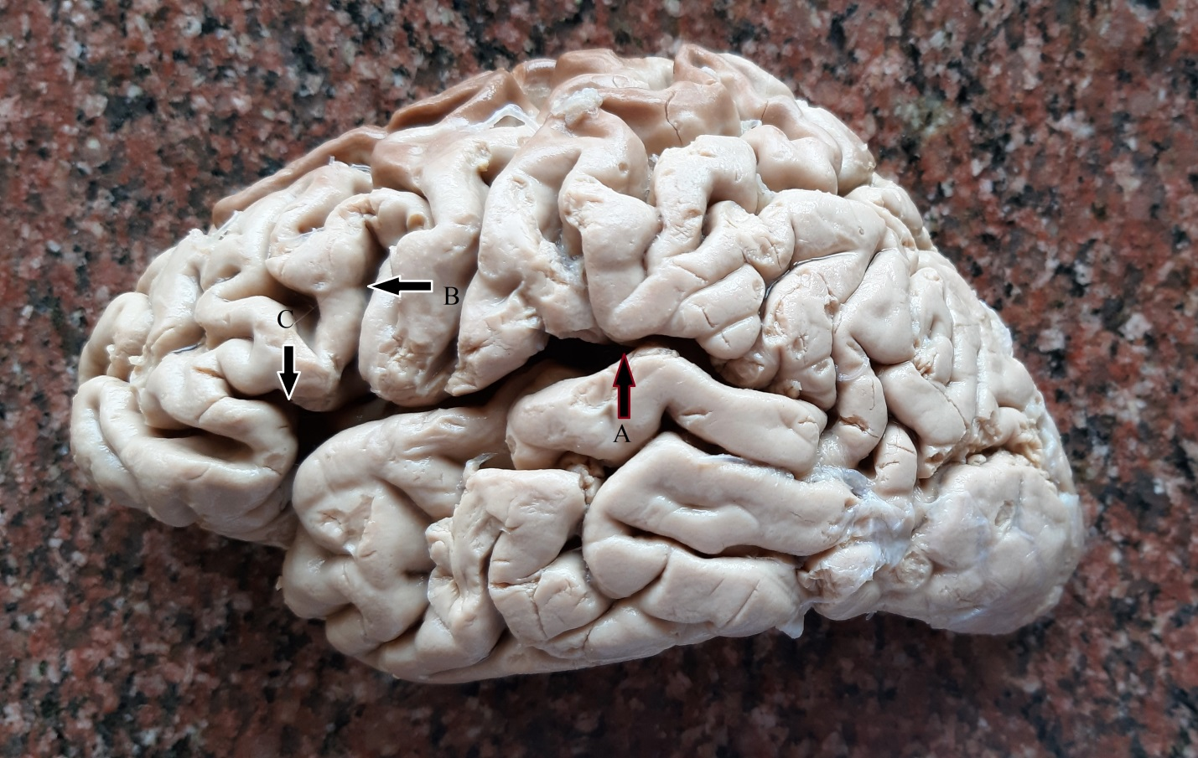
FIG 2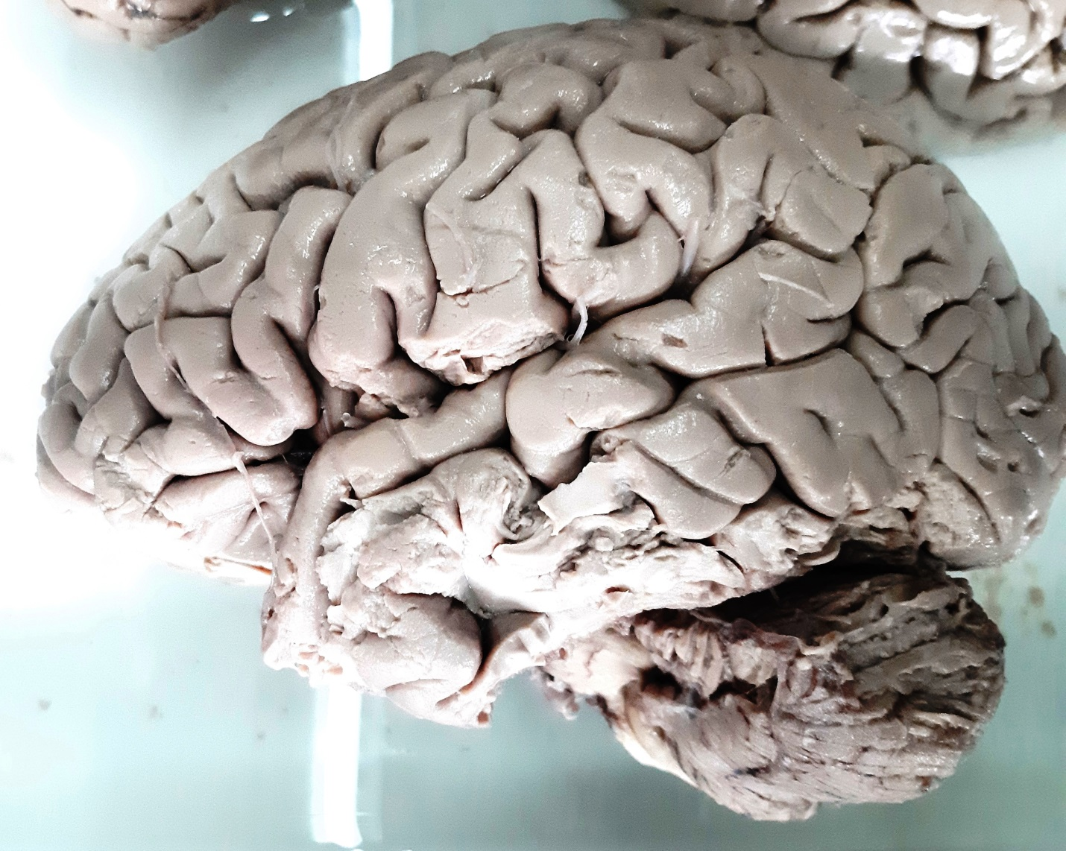
FIG 3
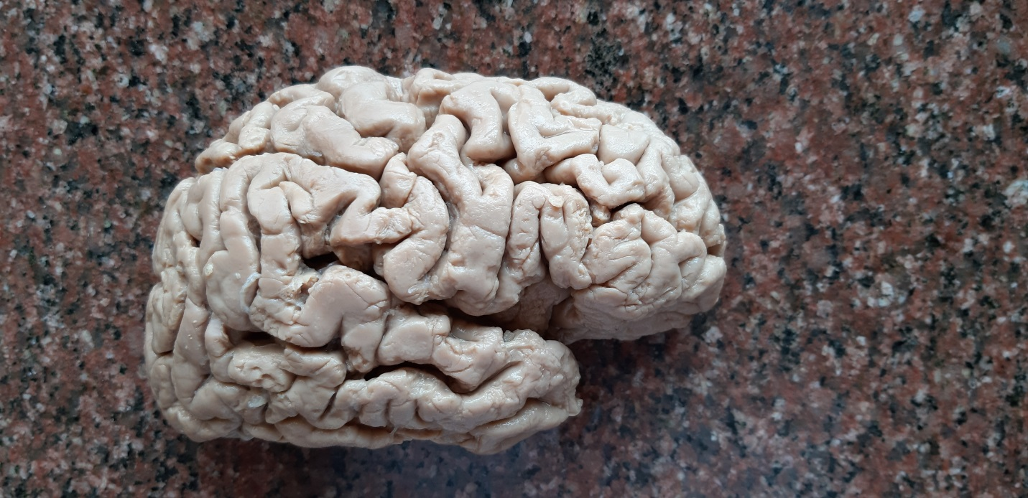
FIG 4
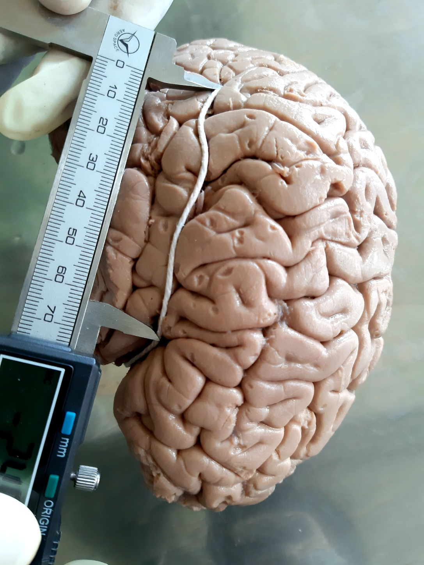

FIGURE CAPTIONS
Figure 1. Cerebral hemisphere showing Sylvian fissure.
- A – Posterior limb of Sylvian fissure
- B – Ascending limb of Sylvian fissure
- C – Anterior limb of Sylvian fissure
B and C form a V shaped bifucation
Figure 2. Ascending and Anterior limbs bifurcating to form U shape
Figure 3. Ascending and Anterior limbs joining to form a common stem which bifurcates to form Y shape
Figure 4. Measurements of limbs of Sylvian fissure taken by digital verniar caliper.

TABLES
Table 1. Observations of Current study.
 | Current Study
Length of Posterior limb[P] - RT | 4.14 cm
- LT | 4.62 cm
Length of Anterior limb [ANT] - RT | 1.46 cm
- LT | 1,51 cm
Length of Ascending limb [ASC] – RT | 1.92 cm
- LT | 2.18 cm
U shaped bifurcation - RT | 58%
- LT | 50%
V shaped bifurcation - RT | 34%
- LT | 46%
Y shaped bifurcation - RT | 8%
- LT | 4%

Table 2. Percentage of shape of branching found in Males and Females
Shape of branching | Male | Female
U | 63.16% | 66.67%
V | 26.32% | 33.33%
Y | 10.52% | 0 %

Table 3. Angle between limbs of Sylvian fissure (in degrees)
Angle | Right | Left
< P-ASC | 98 | 104
<ASC-ANT | 66 | 72

Table 4. Angle between limbs of Sylvian fissure in Males and Females( in degrees)
Angle | Male [Rt] | Male [Lt] | Female [Rt] | Female[Lt]
< P-ASC | 92 | 108 | 98 | 98
< ASC-ANT | 54 | 56 | 58 | 68

Table 5. – Comparison of current study with earlier studies
 | Odowu OE et al [2014] | Chakrabarti S and Vijayalakshmi[2015] | Rani A et al [2016] | Current study [2020]
Length [P][ posterior limb]  –RT |  | 6.23 | 5.64 cm | 4.14cm
-LT |  | 6.47 | 6.43 cm | 4.62 cm
Length[ANT][anterior limb]-RT |  | 1.97 |  | 1.46cm
-LT |  | 1.96 |  | 1.51cm
Length[ascending limb] [ASC]-RT |  | 2.37 |  | 1.92cm
-LT |  | 2.41 |  | 2.18cm
U shape –RT | 38.7% |  | 40% | 58%
-LT | 35.48% |  | 28% | 50%
V shape –RT | 35.48% |  | 52% | 34%
-LT | 29.03% |  | 44% | 46%
Y shape-RT | 25.8% |  | 8% | 8%
-LT | 35.49% |  | 24% | 4%

