The Correlations between Rate of Tool Erosion and Black Layer formation during Electro-Discharge Machining

Dr. Syed Asghar Husain Rizvi
Department of Mechanical Engineering
Khwaja Moinuddin Chishti Language University
Lucknow, India
sahr.me@gmail.com
Er. Mohd. Faizul Hasan
Department of Mechanical Engineering
RR Institute of Modern Technology
Lucknow, India
faizulhasan444@gmail.com

TOOL WEAR RATE AND BLACK LAYER

Electro-Discharge Machining is a technique where the electrode machines the required contour over the work by the spark erosion facilitated by dielectric medium. The spark heat removes the material while the dielectric flushes off the detritus from the spark gap. During sparking, a black layer sticks to the tool surface that may impact the efficacy of machining.
The blackness on the tool is due to the relocation of carbon through the dielectric [2,5,8]. It results due to correspondence of machine variables with its outcome and it modifies the tool’s thermal conduction [1]. This phenomenon occurs at high temperature and it resists tool wear [3].
Other than carbon, the black layer also contains Fe, Cr, V and Mo [2,5]. Its major component is carbon which releases through the dielectric [4]. The thickness of this layer is between 15 to 20 micro-meter that attaches quickly on the tool surface [4]. Temperature distribution also has influence on the formation of carbon layer over tool surface [4].
The black layer formed during machining is a brittle and exerts influence over tool’s thermal conduction [5]. The discharge energy dominates the thickness of black layer [6]. Higher duty factor also leads to formation of black layer while it disappears at a lower level of duty factor [7]. This hinders the machining of work material [9]. The dielectric pyrolysis lays a fine black carbon skin over the tool’s surface [10].
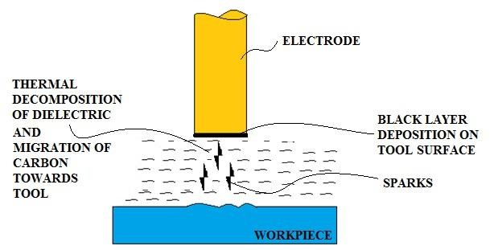

Figure 1 Black Layer over the Tool’s surface

Table 1 ANOVA analysis of 2FI model of Tool Wear Rate
Experiment Specifications
Work Material | AISI 4340
Tool Material | Copper-Tungsten
Dielectric | Kerosene
Selected Process Parameters | Current, On Duration, Voltage, Duty Factor

The above table 1 shows the experimental specifications considered for assessing the results.

    - Black Layer Formation

When the electrons travel from tool because of developed suitable voltage between the tool and work, the spark initiates due to ionization and de-ionization of dielectric medium. A temperature of about 10000°C is generated. Owing to the thermal decay of dielectric medium at elevated temperature developed due to high discharge energy, a thin black film deposition is observed on the tool surface.
Subsequently due to the thermal decomposition, the carbon progresses in the direction of the tool and cover its surface in form of a layer. This layer resists the positive ions that strikes the surface of the tool resulting in lower rate of tool erosion.

Table 2 ANOVA analysis of the 2FI model of Tool Wear Rate
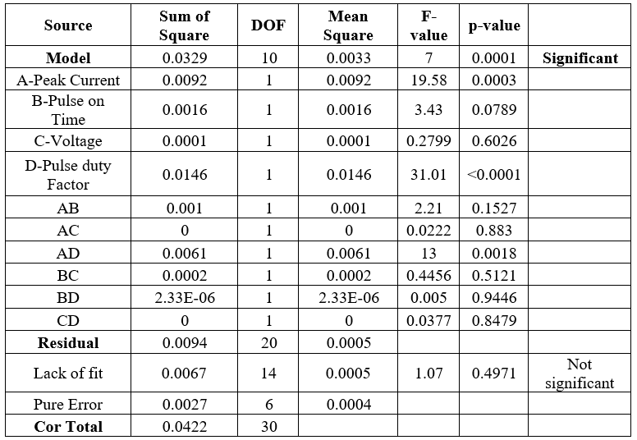
The duty factor exerts much influence on tool erosion. It is also detected as crucial factor as per ANOVA in table 2. It can be observed from scanning electron microscopy images in figure 2 (a), 2 (b) and 3 that the elevated duty factor results in higher occurrence of the black layer. The TWR of 0.05124 mm³/min at Ip = 4A, Ton = 25µsec, V = 90V and τ = 0.8 is minimum. It depicts that the higher value of τ will lead to more resistance to the positive ions impinging the tool surface thus contributing minimum TWR.

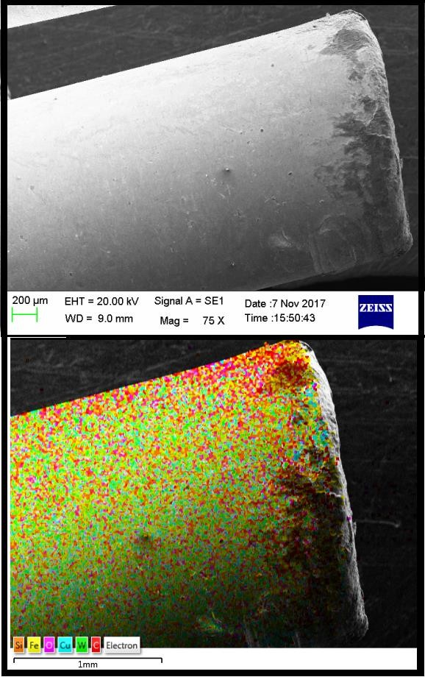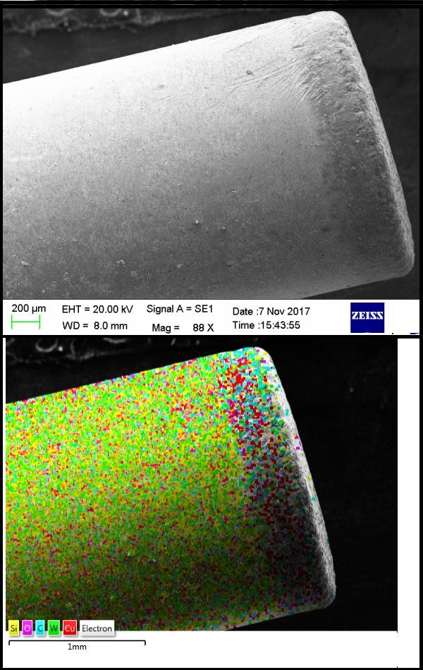
- (b)

Figure 2 Electron Microscopic and Spectroscopic images

(a) Sample 1 (Ip-4A, Ton-15µsec, V-90V, τ-0.6)

(b) Sample 11(Ip-4A, Ton-25µsec, V-90V, τ-0.8)

From the EDX images, black layer majorly constitutes carbon, silicon, oxygen and iron. The thermal decomposition of dielectric results in carbon deposition while the other elements account their deposition through the workpiece. The oxygen present results due to the oxidation.
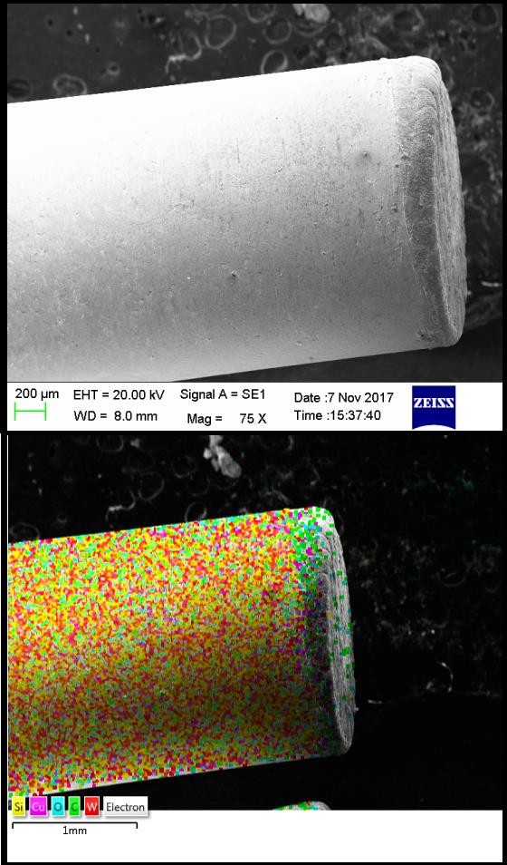

Figure 3 Electron Microscopic and Spectroscopic image of Sample 20 (Ip-7A, Ton-30µsec, V-105V, τ-0.7)

1.2 Effects of black layer over tool erosion

From the previous section we could say that the composition detected in the black layer constitutes other elements along with carbon. These elements are Silicon (Si), Iron (Fe) and Oxygen as identified by EDX analysis. The presence of iron (Fe) and silicon (Si) is due to their migration from the work surface.
The presence of oxygen indicates the oxidation that is caused while machining the work. The elevated duty factor results in higher occurrence of the black layer. The duty factor was most dominating parameter for the development of black layer. It depicts that the higher value of τ will lead to more resistance to the positive ions impinging the tool surface thus contributing minimum TWR.
REFERENCES
- José Duarte Marafona, Black layer affects the thermal conductivity of the surface of copper–tungsten electrode, International Journal of Machine Tools and Manufacture, 2009, 482-488.
- José Duarte Marafona, Black layer characterisation and electrode wear ratio in electrical discharge machining (EDM), Journal of Materials Processing Technology, 2007, 184, 27-31.
- Pushpendra S. Bharti, S. Maheshwari, M.K. Satyarthi, Black Layer Characterization in Electric Discharge Machining of Inconel 718, Vth International Symposium on “Fusion of Science & Technology, 2016, 214-217.
- Lihua He, Jianwu Yu, Wen Duan, Zhikang Liu, Shaohui Yin, Hong Luo, Copper– tungsten electrode wear process and carbon layer characterization in electrical discharge machining, International Journal of Advanced Manufacturing Technology, 2016, 1759– 1768.
- Sanjeev Kumar, Rupinder Singh , Ajay Batish, T.P. Singh, Study the effect of black layer on electrode wear ratio in powder mixed electric discharge machining of titanium alloys, International Journal of Machining and Machinability of Materials, 2016, 18-25.
- Philipp Steuera, Andreas Rebschläger, Olivier Weber, Dirk Bähre, The heat-affected zone in EDM and its influence on a following PECM process, 2nd CIRP Conference on Surface Integrity, 2014, 276-28.
- F. L. Amorim, W. L. Weingaertner, Influence of duty factor on the die-sinking Electrical Discharge Machining of high-strength aluminum alloy under rough machining, Journal of the Brazilian Society of Mechanical Sciences, 2002, 194-199.
- NorlianaMohd Abbas, Darius G. Solomon, Pugh Method: Selection of Dielectric in Machining Tungsten Carbide with Electrical Discharge Machining (EDM), International Conference on Trends in Mechanical and Industrial Engineering, 2011, 204-207.
- S.SyathAbuthakeer, S.MohithKaameswaran, K.Venkatachalam, M.Vishhnuram, Influence of Process Parameters in EDM Machining of Aluminium Titanium Carbide Composite, International Journal of Recent Engineering Research and Development, 2017, 64-72.
- Amitabh Ghosh and Asok Kumar Mallik (2004), Manufacturing Science, New Delhi, East-West Press.

