**Effect of Ionic Liquids in Nanoparticle synthesis: Interaction and Organization**

Durga Gupta, Madhulata Shukla*

Department of Chemistry, G.B. College, Ramgarh, Kaimur,

Veer Kunwar Singh University, 821110, India

E-mail: [madhu1.shukla@gmail.com](mailto:madhu1.shukla@gmail.com)

**Abstract:** Ionic liquids (ILs) are becoming an innovatory synthesis medium for nanomaterials, permitting more efficient, safer, and environmentally friendly preparation of high-quality nanoparticles. Usually, the stabilities of nanoparticles in ionic liquids are highlighted as one of their outstanding advantages. Ionic liquids are utilized as synthesis and dispersion media for nanoparticles as well as for surface functionalization. This chapter aims to cover in explaining the stabilities of nanoparticles in imidazolium ionic liquids using experimental and theoretical evidence. The morphological and structural characteristics of these NPs were studied using scanning electron microscopy (SEM), high-resolution transmission electron microscopy (HR-TEM), and UV-visible spectroscopic studies. A better understanding of interactions presents in imidazolium ILs using Density Functional Theory (DFT) and other theoretical calculations has been carried out. Interaction in various imidazolium ILs with nanoparticles as well as their strength has been deliberated using IR spectroscopic techniques with strapping support from DFT calculation.

**Keywords*:*** *Ionic Liquids, Green reduction, Nanoparticle, DFT calculation.*

**Introduction:** Ionic liquids (ILs) are defined as compounds mainly composed of ions with a melting point below 100°C. The first IL (ethyl ammonium nitrate) was reported by Paul Walden [1] in 1914, who never realized at that time that ILs would become a major scientific area after almost one century. Research activity on ionic liquids (ILs) has been witnessing a steady growth in the past 30 years. [2-13]. More than thousands of SCI papers are being published every year on ionic liquids. Room-temperature ILs have received extensive attention as substitutes for volatile organic solvents. Since they are non-flammable, non-volatile, and recyclable, they are classified as green solvents. It appears from the recent development that the novel properties of various ILs are of more interest than just application as ‘green solvent’ [4] in organic chemistry. [5-6, 10-11] ILs now appear to be whole new materials with many wonderful properties, much of it are yet to be discovered. [12] The defining characteristic of ILs is their constitution - molecular ions as their building blocks as opposed to molecules in the normal solvents. ILs have also been termed designer solvents because of the flexibility of choosing different functional groups (shown in **Figure 1**) to synthesize many novel ILs for different purposes. Popular imidazolium-based ILs are among the most studied ILs. The selection of the imidazolium ring as a cation (Figure 1) is often due to its stability within oxidative and reductive conditions [14], the low viscosity of imidazolium ILs, and their ease of synthesis [15]. There are also several reports regarding the application of imidazolium-based ILs as catalysts for the improvement of reaction time, yield, and chemoselectivity of many organic reactions [16-19] Imidazolium ILs are the most studied ILs in the last three decades, hence seems to be much interesting.



**Figure 1.** Different combinations of ILs can be synthesized by varying cations and anions.

ILs are rather unique in the sense that in addition to ionic and covalent interactions, there are relatively weaker interactions such as H-bonds, π-stacking, [20-22] which are not commonly found in conventional solvents. The challenging ideas were that interionic interactions in these ionic liquids were either via hydrogen bonding [23] or they had a stacked structure with anions positioned above and below the plane of the imidazolium ring [24-25]. This debate was resolved by recognizing that the imidazolium ring protons can indeed act as hydrogen bond donors, but only in the presence of sufficiently strong hydrogen bond acceptors [26-27], and that stacked structures were also present [28-29], particularly for ionic liquids with large anions that are poor hydrogen bond acceptors. The nature of the forces in different ILs may however differ from one - another and mainly control their physical properties. As the properties of any material depending on the structure of molecules in different phases, it is very important to understand the structural features of ILs in depth. In this chapter, we can see that Imidazolium ILs had attracted ongoing interest, with most work focusing on structures, interactions present in them, and thermodynamic properties.

Nanoparticles (NPs) have a wide variety of potential applications as a result of their unique electronic, optical, magnetic, mechanical, physical, chemical, and catalytic properties. The properties of many bulk materials change when they are considered in nanoparticle form. Properties of NPs are determined by their size, shape, composition, stability, crystallinity, structure, etc. Bottoms up NPs synthesis can proceed by chemical reduction, thermolysis, photochemical decomposition, electroreduction, microwave, and sonochemical irradiation. In recent literature, there are a large number of reports on the synthesis, properties, and applications of noble metals Au, Ag, and Cu NPs. [30-31] This is mainly because all three elements show well-localized surface plasmon resonance (LSPR) absorbance in the visible range and also have a large number of catalytic applications. However, the high cost of Au and to a lesser extent Ag restrict their applications in many cases. As an alternative to Au and Ag NPs, researchers have investigated Cu nanoparticles. CuNPs are less expensive and exhibit comparably higher electrical conductivity and catalytic activity. [32-33] The LSPR absorbance of CuNPs in the visible range is comparatively less intense. Another issue is that Cu nanoparticles are easily oxidized [34], yet nanoparticles of copper oxides also have wide applicability as catalysts. Bimetallic nanoparticles (i.e., Ag-Cu nanoparticles) may be a technologically and economically promising solution [35] Novel properties such as electronic and optical emanate from the nanoparticle’s large surface-area-to-volume ratio and the quantum confinement effect, which are both consequences of their nano-scale size dimensions. [36-38]

Ionic liquids and nanoparticles can form together various hybrid structures, depending on the intra- and intermolecular interactions among them. For example, ionic liquids serve as solvent media for colloidal dispersions, [39]facilitating the dispersion of metal nanoparticles [40], nanostructured inorganic particles [41], graphene [42], and carbon nanotubes [43-44], Some colloidal particles can be stably suspended in ionic liquids without any added stabilizers such as surfactants or polymers.[45] Ionic liquids, contributing electrostatic forces on the surface of nanoparticles, can also be utilized as colloidal stabilizers for nanoparticles synthesized in an aqueous solution.Being new materials, the catalytic properties of such nanocomposites are being extensively studied currently. Nevertheless, only a few research papers have investigated the effect of such stabilization of nanoparticle surfaces on the electronic properties of such nanocomposites. Moreover, limited studies have taken up the issue of the effect of IL stabilization on the catalytic properties of these particles. This becomes topical because a few recent experimental, as well as theoretical investigations, have shown that many macromolecules (other than ILs) stabilizing nanoparticles also affect their electronic structures and their catalytic activity.[46] Imidazolium-based ionic liquids with stable anions e.g., tetrafluoroborate are the best materials for the synthesis of NPs because of their stability and basic properties of the bmimBF4. [47] DFT calculations can be employed to understand such mechanistic issues and to analyze the effect of ILs on the NPs.

Few reports are available for the synthesis of Ag and Cu2O nanoparticles in 1-butyl-3-methyl imidazolium-based ILs.[48-50] The present chapter reports the synthesis of Ag and Cu2O NPs stabilized by 1-butyl-3-methylimidazolium tetrafluoroborate (bmimBF4) IL with glucose as the reducing agent. We then investigate the orientation and interaction of cation and anion parts of IL around both the nanocluster, experimentally as well as theoretically. DFT calculations are performed to analyze whether IL just acts as a stabilizer to prevent the aggregation of NPs clusters or also acts as an electron donor to activate the nanoclusters for further reaction. Very recently we have shown in our previous research that B3LYP functional calculations give the stable cluster and also reproduce well with the experimental results obtained for UV visible and IR spectra. [51-52]

**2. Methodology**

Materials used for the synthesis of silver nanoparticles were AgNO3 (Merck), Cu(NO3)2.3H2O (Merck) bmimBF4 (IoliTech), and glucose (Merck). All reagents were used as received without further purification

**2.1 Synthesis and characterization of Ag NP in bmimBF4 IL (Sample1):**

A schematic diagram for the synthesis of Ag NP in bmimBF4 IL is shown in **Scheme 1.1**. 2 mL of 0.05 M AgNO3 solution (in water) was taken in a round bottom flask and heated with continuous stirring at 80°C. To this flask, 2 mL of 0.1 M, aqueous glucose solution was added in a dropwise manner. After 15 minutes of continuous stirring at 80°C, 2 mL bmimBF4 IL was added dropwise to the above reaction mixture, and stirring continued for further 30 minutes at 105-110°C in an oil bath. Stirring of the reaction mixture at 105°C was continued and both the peaks observed in the initial UV-vis spectrum remain as such till 150 minutes. After completion of 3 hours, UV-visible spectrum was recorded which shows a peak shift from 430 nm (broad) to 423 nm (quite sharp), which suggests the formation of silver NP (AgNPs). AgNPs solution was light yellow in color in which silver nanoparticles of grey color are suspended in bmimBF4 IL. The resulting solution was kept under a vacuum to remove all the water molecules present in it. FTIR, NMR, and TEM used for further sample characterization.



**Scheme 1.1.** Synthesis of silver nanoparticle in 1-butyl-3-methylimidazolium tetrafluoroborate IL

**2.2 Synthesis of cuprous oxide nanoparticles using bmimBF4 ionic liquid (Sample2):** Schematic diagram for the synthesis of Cu2O NP in bmimBF4 IL is shown in **Scheme 1.2**. 25mL of 0.1M Cu(NO3)2.3H2O solution was taken in a round bottom flask. The reaction mixture was kept in a water bath whose temperature was maintained at 80°C. Dropwise 1mL (0.2 Mol/L) BMIMBF4 IL was added with continuous stirring. Stirring was continued for 20 minutes. 15mL of 0.5M Glucose was added with stirring at the same temperature. Stirring was done for 20 min at this temperature. The color of the solution changes from blue to greenish-blue. After that 7mL 1M NaOH was added to gain the PH approx. 11.5 stirring was done at the same constant temperature of 80°C for one and half hours. Color of the solution changes to brown-yellow. The solution was centrifuged and the sample was washed well with ethanol. Dried in a vacuum oven for 2 days. UV visible spectra were recorded and a sharp peak was observed at max 435nm and along with that, a broad spectrum was observed in the 494-541nm range wavelength. A sharp peak at 329nm corresponds to bmimBF4 IL.



**Scheme 1.2.** Synthesis of cuprous oxide nanoparticle in 1-butyl-3-methylimidazolium tetrafluoroborate IL

**2.2 Characterization**

X-ray diffraction measurements were carried out by Rigaku Mini-X 600, Japan. Transmission electron microscopy imaging and electron diffraction of as-prepared IL-Ag and Cu2O NPs were carried out with a TECNAI 20 G2-electron microscope operating at a voltage of 200 kV. The EVO-MA15/18 instrument was used to take the scanning electron microscope (SEM) images of the S1 and S2 samples. Agilent Cary 60 spectrophotometer was used to record the UV-Visible absorption spectra of both the samples dispersed in the aqueous medium.

**2.3 Computational Details:** MAPS software (Scienomics) was used to carve out the FCC Ag lattice and Cu2O nanocluster. DFT calculations at Becke’s three functional parameters and Lee–Yang–Parr hybrid functional (B3LYP) level [53-54] of calculation were carried out using Gaussian 16 program [55]. LANL2DZ basis set was used for silver and copper atoms [56] and 6-31G++(d,p) basis set for C, H, N, O, B, and F atoms. The literature survey illustrates that the B3LYP level of calculations gives the stable cluster and also reproduces the experimental UV visible and IR data very well [51-52] Calculations were carried out for ground state geometry optimization in the gaseous phase.

**3. Results and discussion**

**3.1. TEM measurements:**

TEM micrograph of AgNPs sample and its corresponding electron diffraction pattern shown in Figure **2**. Figure 2 shows bright-field TEM image of bmimBF4 IL stabilized AgNPs. Particles with sizes ranging from 55 - 135 nm are observed. Due to the presence of Ag NPs in IL itself, all particles are not separated from each other, as ILs are associated with the NPs. Anisotropic shapes such as triangular, pentagonal, and hexagonal nanoparticles can be seen (shown in Figure 2). NP shape and size vary extremely with the type and amount of IL used, as well as a trace amount of impurities or water present in ILs affecting its shape and size. [57-58]

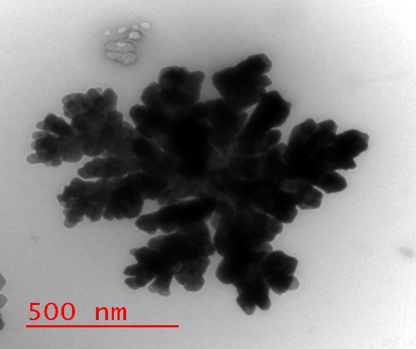

Figure 2) TEM image of bmimBF4 IL stabilized AgNPs .

TEM micrograph of Cu2O NPs sample and its corresponding electron diffraction pattern shown in Figure **3**. Figures 3a and 3b show bright-field TEM and HRTEM images of bmimBF4 IL stabilized Cu2O NPs. Particles with sizes ranging from 11 - 15nm are observed.

|  |  |  |
| --- | --- | --- |
| E:\UGC Project work\21.12.2019\s2\14.jpg  **(a)** | E:\UGC Project work\21.12.2019\s2\10.jpg  **(b)** | F:\MADHU-NEW\UGC Project work\21.12.2019\s2\6.jpg  **(c)** |

Figure 3a) TEM image of bmimBF4 IL stabilized Cu2O NPs, b) HRTEM image of bmimBF4 IL stabilized Cu2O NPs c) Selected area electron diffraction pattern .

**3.2 Spectroscopic investigations**

The UV-visible spectrum of the Ag NPs in IL prepared by the protocol given in scheme 1.1 shows a maximum absorbance peak in the spectrum located at about 423 nm, similar as reported by us earlier. [45] This is characteristic of the localized surface plasmon resonance (LSPR) absorption due to AgNPs. UV-visible spectrum of the Cu2O NPs in bmimBF4 IL prepared by the protocol given in the scheme 1.2. It is clear from Figure 4 that a sharp peak in the 300-350 nm range corresponds to the bmimBF4 IL absorption while a broad peak in the 425-550nm region confirms Cu2O NP.

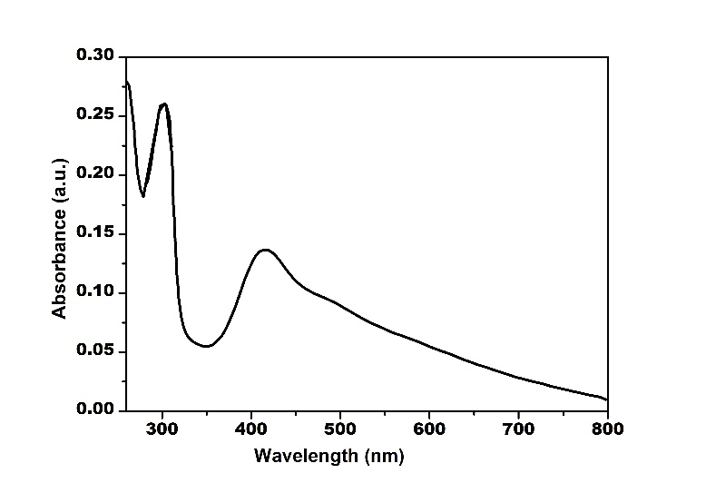

Figure 4 UV visible spectrum of Cu2O nanoparticle in bmimBF4 IL

Experimental IR spectra of pure bmimBF4 IL (solid blue line) and IL containing silver NPs (solid black line) are shown in Figure 5. To better understand the mechanism of stabilization of AgNPs by bmimBF4 IL, comparisons were made between the experimental FTIR of the pure IL (blue line) and that of IL containing AgNPs (black line). FTIRs of these two have been compared and are shown in Figure 5. The 850 cm-1 peaks in pure IL shift to 833 cm-1 (redshift) for AgNPs synthesized in IL. Other peaks at 1062 cm-1 in pure IL get red-shifted to1028 cm-1 in Ag-bmimBF4. The obtained product was further characterized by 1H and 13C NMR spectra. It has been reported by us previously that no NMR peaks shift was observed when a comparison was made between the spectrums of pure IL and AgNPs prepared in the same IL. [45] This confirms that the Ag cluster is surrounded mostly by anions and not by cations, as reported earlier also [59].

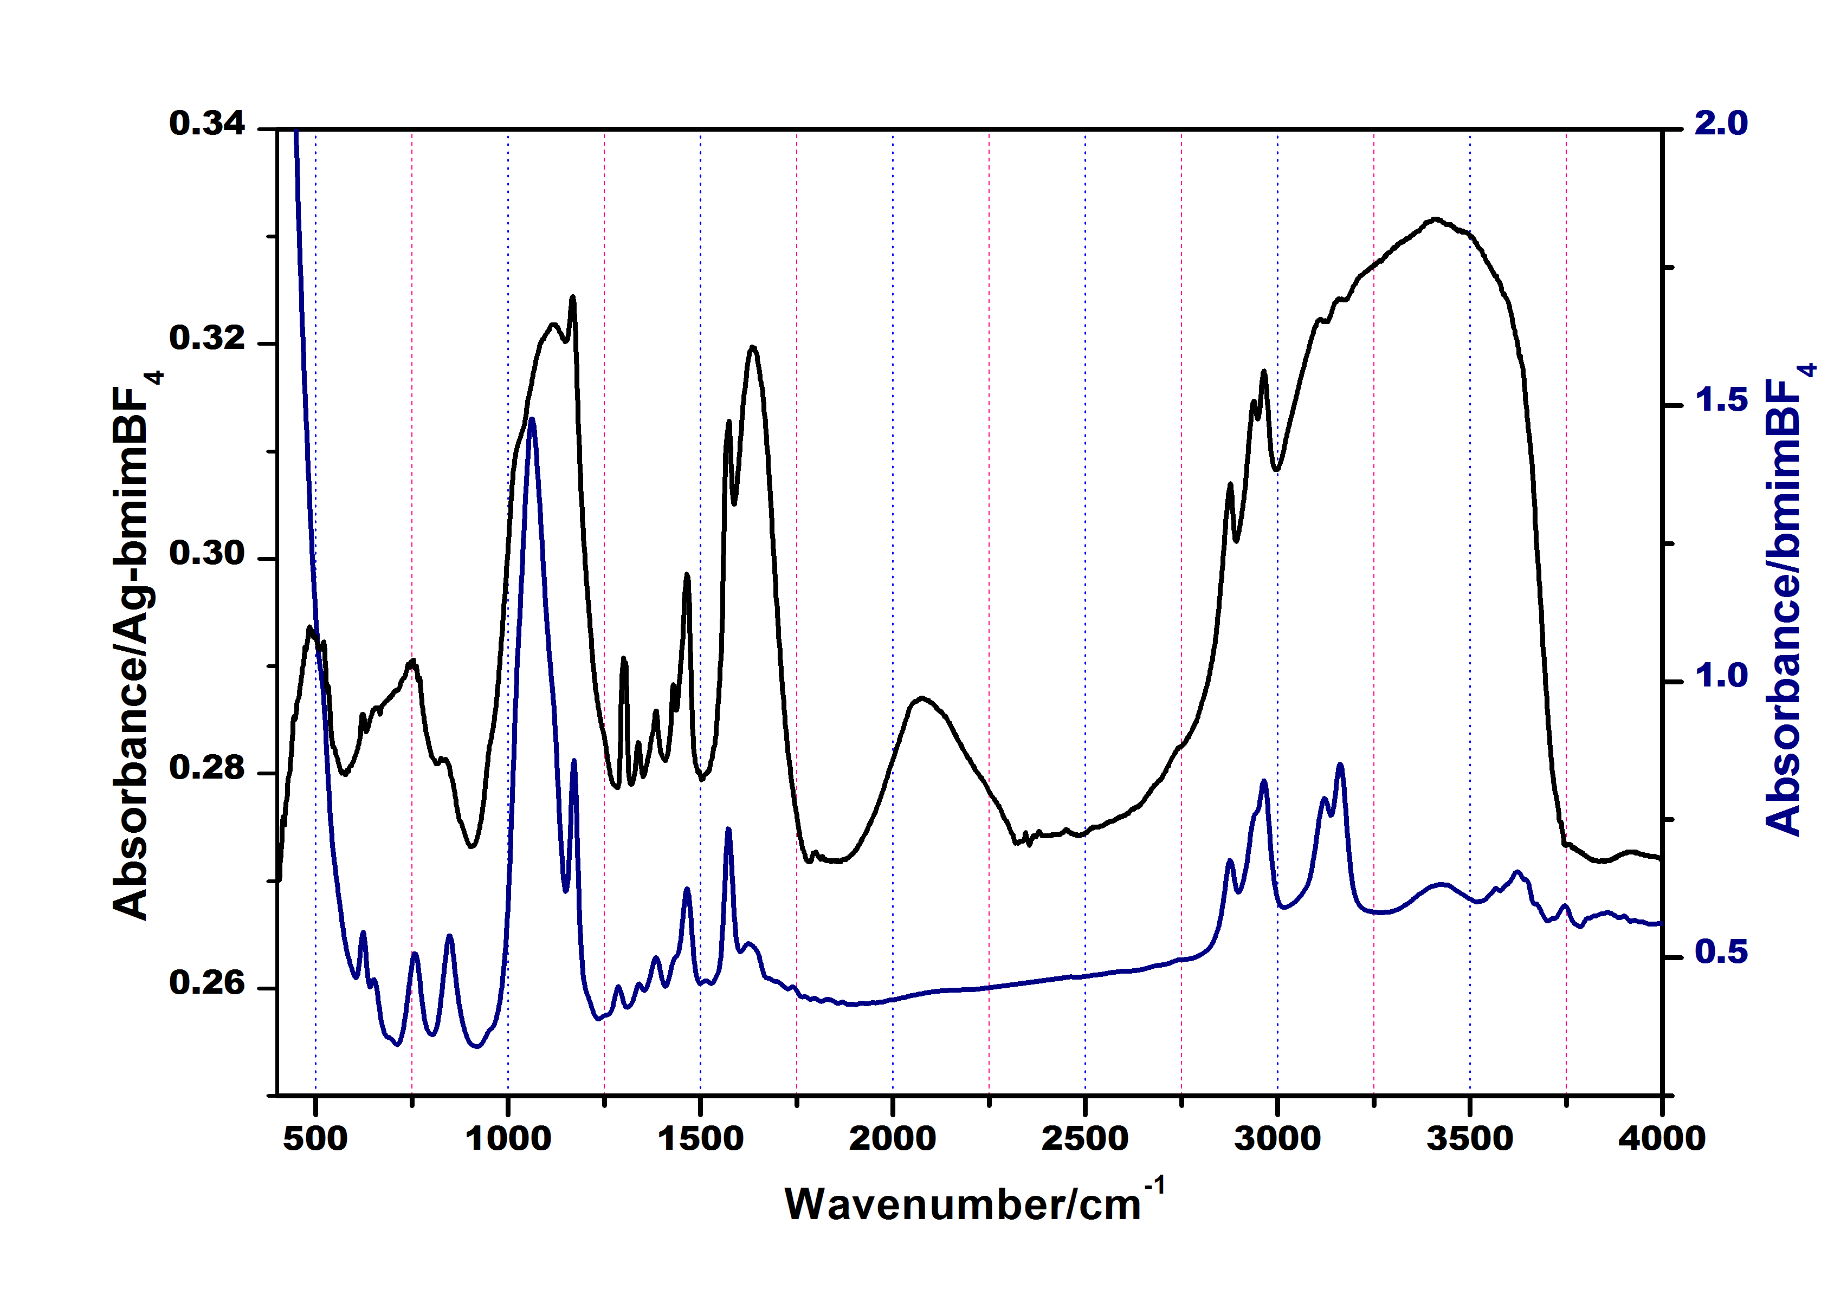

Figure 5: Experimental IR spectra of pure bmimBF4 IL (solid blue line) and IL containing silver NPs (solid black line)

**3.3 Geometry Optimization:** Ag13-2bmimBF4 and Cu2O-2bmimBF4 moieties were optimized in the gas phase at the B3LYP level of calculation and using the Gaussian 16 program. Figures 6(a) and 6(b) represent the optimized structure of Ag13-2bmimBF4 and Cu2O-2bmimBF4 respectively in which several interactions are shown by the dotted line. Ag-Ag distance was found to be nearly between 2.80-3.0The distanceance between Fluorine (BF4- anion of IL) and silver nanocluster is between 2.53-2.70 Å, which implies anions are much closer to nanocluster rather than cationic part. H----B-F hydrogen bonding distance found to be 2.28- 2.52 Å. BF4- anion interacts with different hydrogens of a methyl group, butyl group as well as hydrogens of imidazole ring, as reported by us in our previous research. [25] In the optimized structure of Cu2O-2bmimBF4, the distance between Fluorine (BF4- anion) and Cu2O nanocluster is between 2.92-3.12Å. Cu-O distance found to be 1.84-1.86Å, H----B-F hydrogen bonding distance found to be 2.04- 2.62 Å. It is clear from Figure 6 that BF4 is oriented more towards the silver and Cu2O cluster instead of the imidazolium cation. This statement proposed earlier in the literature [45] gets verified for the first time from our calculation. This indicates that nanoparticles are surrounded by more anions rather than cations. Also, this statement has been supported by the NMR data reported previously where it was found that no NMR shift was observed for IL before the synthesis and after the synthesis. [45]

|  |  |
| --- | --- |
| E:\Manus\Book chapter2022\Book chapter-1-IL\Ag-bmimBF4 opt fig.png  **(a)** | E:\Manus\Book chapter2022\Book chapter-1-IL\Cu2O-opt fig.png  **(b)** |

Figure 6: Optimized structure of (a) Ag13-2bmimBF4 and (b) Cu2O-2bmimBF4 moiety

**3.4 Mechanism for the stabilization of metal NPs**

Stabilizing agents predominantly provide a repulsive force which is necessary to provide stable metal NPs in the solution phase [60]. It states that stabilizing agents stabilize the metal NPs by passively synchronizing with them thereby preventing the agglomeration of NPs. Moreover, strong reducing agents such as sodium borohydride rarely control the shape and size of metal NPs and the usage of mild reducing agents such as sodium citrate and ascorbic acid control the size and shape of metal NPs.[61] The size of metal NPs could be controlled by varying the concentration of metal salt precursors, reducing agents, pH, and temperature. The stabilization of metal NPs by these capping agents is mainly of three types: (a) electrostatic, (b) steric stabilization, and (c) a combination of both electrostatic and steric stabilization [62]. Imidazolium-based ILs exhibit a high degree of 3D network organization due to the presence of the virtual rigid and planar ring. The three acidic hydrogen sites in the imidazolium cation enhance the directionality of hydrogen bonding and van der Waals interactions. [63] Several reviews provide a brief discussion about the applications of imidazolium-based ILs (specifically) as stabilizing agents for metal NPs concerning their counteranions and substitution on their heteroatom.[64] ILs such as 1-butyl-3-methyl imidazolium hexafluorophosphate bmimPF6 and 1-butyl-3-methyl imidazolium tetrafluoroborate bmimBF4 are the most widely used as a solvent for the synthesis of NPs and also used as stabilizing agents for the in situ synthesis of NPs [65].

It is expected from the previous research outcomes that the NPs were stabilized by the electrostatic interactions between the charged anionic and cationic moieties of ILs and metal atoms and also by the interaction between functionalized IL side chains (if present) and metal atoms. Therefore, the stabilization of metal NPs by ILs may not be only due to an electrostatic double-layer alone but may also be governed by weak attractive forces. [66] Just by a change in the counter anions only and cation remaining same or incorporation of different functional groups or substitutions at the cationic position of ILs when used as stabilizers results in varied applications of metal NPs. From the geometry optimization and Mulliken charge distribution (shown in Figure 7a and 7b for (a) Ag13-2bmimBF4 and (b) Cu2O-2bmimBF4 respectively) calculation, it is very clear that anions are mainly localized around the nanoclusters and charges are present on the outermost surface of the nanoclusters, which is easily available for the catalytic activity.

|  |  |
| --- | --- |
| **E:\Manus\Book chapter2022\Ag-IL-mulliken.jpg**  **(a)** | F:\MADHU-NEW\Manus\Manus\Book chapter2022\Book chapter-1-IL\Cu2O-Mulliken.jpg  **(b)** |

Figure 7: Mulliken charge distribution on (a) Ag13-2bmimBF4and (b) Cu2O-2bmimBF4 cluster showing the inner silver and copper atoms are highly electropositive (Light green color) as compared to outer copper atoms which are in contact with ionic liquid ion pairs.

Hence we can say that ILs not only effects the size and morphology of the NPs but it also activates the NPs by decreasing the band gap, as reported by us in our earlier research[45] Contour plot of HOMO and LUMO of Cu2O-2bmimBF4 nanocluster shown in Figure 8(a) and 8(b) respectively shows electron density is localized on Cu2O cluster. It is seen that it is localized on the Cu2O cluster only and not on the IL ion pairs. ILs just activate the Cu2O for further photocatalytic reactions. Also, ILs act as a stabilizer and solvent for the synthesis of nanoparticles. Many reports are available for the recyclability of the ILs and they can be reused for the other synthesis after further purification, as the catalyst could be easily separated from the reaction mixture without any significant loss in the catalytic activity.

|  |  |
| --- | --- |
| **E:\Manus\Book chapter2022\Cu2O-Alpha-HOMO surace countour.jpg**  **(a)** | **E:\Manus\Book chapter2022\Cu2O-Alpha-LUMO surace countour.jpg**  **(b)** |

**Figure 8:** HOMO - LUMO contour plot for Cu2O-2bmimBF4 IL nanocluster

**3.5 Calculated IR spectra analysis**

To better understand the strength and nature of the interaction between the nanoclusters and the IL molecules IR frequency calculations were carried out. IR frequency calculations were performed on the optimized structure of Ag13-2bmimBF4 and Cu2O-2bmimBF4 moiety at the same B3LYP level of calculation and using the same basis functions. The calculated frequency data for Ag13-2bmimBF4 is presented in **Table 1**. Calculated frequencies at 842 and 1075 cm-1, which is due to symmetric and asymmetric stretching of B-F bond in bmimBF4 ion pair shown in Figures 9(a) and 9(b), gets red-shifted to 818 and 1060 cm-1 (shown in Figure 9(c) and 9(d)) respectively for Ag13-2bmimBF4. As mentioned earlier in section 3.2, the experimental FTIR spectrum shows that two peaks (at 850 and 1062 cm-1) in pure IL get red-shifted in AgNPs-IL. Therefore, the DFT calculated results are in agreement with experimental observations. C-H frequencies other than the C2-H frequency, do not show any shift. The calculated C2-H stretching frequency present at 3273 cm-1 in bmimBF4 (Figure **9(e)**) ion pair gets blue-shifted to 3322 cm-1 in Ag13-2bmimBF4 cluster (Figure **9(f)**). This indicates that the C2-H bond in IL is being affected by the Ag cluster-IL interaction. Similarly, with Cu2O nanoclusters also, we can see from the optimized structure (Figure 6b) that Cu2O nanoclusters are surrounded mostly by BF4- anions rather than imidazolium cations. The interaction between imidazolium cation and BF4 anion is quite strong in isolated form. However, this interaction weakens when BF4 gets attached to the Ag cluster. To conclude, BF4 is more closely attached to the Ag cluster. This decreases the interaction between the cation and anion part of the IL. The lack of shift in other C-H stretching frequencies indicates that the imidazolium ring remains unaffected. Moreover, the imidazolium ring part is located away from the Ag cluster whereas the anionic part interacts strongly with the Ag cluster.

|  |  |
| --- | --- |
| **E:\Manus\Book chapter2022\BF str sym-IL.jpg**   1. **842 cm-1** | **E:\Manus\Book chapter2022\BF4 str asym.jpg**   1. **1075 cm-1** |
| **E:\Manus\Book chapter2022\BF str sym.jpg**  **(c) 818 cm-1** | **E:\Manus\Book chapter2022\BF str asym-NP.jpg**  **(d) 1060 cm-1** |
| E:\Manus\Book chapter2022\c2-h-il.jpg  **(e)** 3273 cm-1 | E:\Manus\Book chapter2022\c2-h.jpg  **(f)** 3322 cm-1 |

Figure 9: Different stretching frequencies of bmimBF4 ion pair and Ag13-2bmimBF4 cluster. Displacement is shown by calculated eigenvectors (the blue arrow represents the direction of atomic displacement).

**Table 1: Calculated IR frequency of bmimBF4 and Ag13-2-bmimBF4**

|  |  |  |
| --- | --- | --- |
| Wavenumber/cm-1/ bmimBF4 | Wavenumber/cm-1 /Ag13-2-bmimBF4 | Assignment |
| 3273 | 3322 | C2-H stretching in imizadole ring |
| 3112 | 3115 | Asymmetric C-H str in terminal CH3 gr |
| 3084 | 3099 | Asymmetric C-H str in CH2 gr |
| 3069 | 3059 | Symmetric C-H str in terminal CH3 gr |
| 3034 | 3038 | Symmetric C-H str in CH3 |
| 1604 | 1596 | C=N str coupled with C=C sr |
| 1523 | 1523 | H-C-H scissoring in CH3 gr |
| 1469 | 1467 | Umbrella bending in CH3 gr |
| 1075 | 1060 | Asymmetric B-F stretching coupled with C-N stretching |
| 1016 | 1058 | Scissoring of C-N-C in imidazole ring coupled with B-F asymmetric stretching |
| 967 | 1012 | Op bending of C2-H in imidazole ring coupled with B-F asymmetric stretching |
| 932 | 953 | Op bending of C2-H in the imidazole ring |
| 842 | 7818 | Symmetric stretching of B-F |
| 699 | 698 | Op bending of C-H in the imidazole ring |

**Conclusions**

Green synthesis of silver and copper (I) oxide nanoparticles stabilized by 1-butyl-3-methylimidazolium tetrafluoroborate (bmimBF4) IL has been carried out using glucose as the reducing agent. Unlike other slower green synthesis protocols, the synthesis is completed in only three hours. Anisotropic AgNPs with different shapes such as triangular, pentagonal, and hexagonal have been reported under these conditions. Cu2O NPs are in the 11 - 15nm range with hollow spherical shapes. The insignificant shift in 1H NMR for Ag NPs indicates that the IL molecules stabilize and bind to nanoclusters through their anionic part. Stretching frequencies associated with the anion of the pure IL undergo red-shift when the IL stabilizes AgNPs. The effect of IL on Ag and Cu2O nanoparticles has been better explained using DFT calculations. Geometry optimization through DFT calculations has been undertaken to understand the stabilization mechanism better. The optimized geometry of both the nanoclusters attained through these calculations also shows that the model nanoclusters interact with IL molecules through their anionic portions. The calculated IR spectrum supports this conclusion. Mulliken charge distribution calculation shows that anions are mainly localized around the nanoclusters and charges are present on the outermost surface of the nanoclusters, which is easily available for the catalytic activity. Research outcomes show that NPs were stabilized by the electrostatic interactions between the charged anionic and cationic moieties of ILs and metal atoms.

**Acknowledgments:** Financial assistance from UGC, India (F.30-446/2018 (BSR)) is gratefully acknowledged. MLS also acknowledges IIT-BHU for providing computational facilities. The author also thanks CIF IIT(BHU) for TEM and XRD characterization facilities.

**Declaration of conflict of interests**

The authors declare no conflict of interest.

**Declaration of interests**

The authors declare that they have no known competing financial interests or personal relationships that could have appeared to influence the work reported in this chapter.

**References:**

1. P. Walden, *Bull. Acad. Imp. Sci. St. Petersburg*, Ser. **8** (1914) 405.
2. K. R. Seddon, *Nature Mater.* **2** (2003) 363.
3. P. Wasserscheid and W.Keim, *Angew. Chem. Int. Ed.* **39** (2000) 3772.
4. R. D. Rogers and K. R. Seddon, *Science* **302** (2003) 792.
5. H. Ohno, *in* "Ionic liquids: The Front and Future of Material Developments", CMC press, Tokyo, 2003.
6. M. Shukla, S. Saha, *Comput. Theor. Chem.***1015** (2013) 27.
7. A. Paul and A. Samanta, *J. Phys. Chem. B* **111** (2007) 4724.
8. H. C. Chang, J. C. Jiang, C. Y. Chang, J. C. Su, C. H. Hung, Y. C. Liou, and S. H. Lin, *J. Phys. Chem. B* **112** (2008) 4351.
9. S. Patra and A. Samanta, *J. Phys. Chem. B* **116** (2012) 12275.
10. K. Santhosh, and A. Samanta, *J. Phys. Chem. C* **116**(2012)20643.
11. K. Iwata, H. Okajima, S. Saha and H. Hamaguchi, *Acc. Chem. Res.* **40** (2007) 1174.
12. J. N. A. C. Lopes and A. A. H. Pádua, *J. Phys. Chem. B.* **110** (2006) 3330.
13. M. Shukla, S. Saha, in *Ionic Liquids - New Aspects for the Future*" InTech Publication (2013**)** *pp* 61-84
14. *D. Weingarth, I. Czekaj, Z. Fei, A. Foelske-Schmitz, P. J. Dyson, A. Wokaun and R. Kötz, J. Electrochem. Soc*., **159** (2012) 611-615*.*
15. C. Wang, H. Luo, X. Luo, H. Li and S. Dai*, Green Chem.,* ***12*** *(2010) 2019.*
16. J. S. Ghomi, A. R. Hajpour, M. Emaeili, *Digest J. Nanomaterials and Biostruct.* **5** (2010) 865.
17. J. I. Yu, H. Y. Ju, K. H. Kim and D. W. Park, *Korean J. Chem. Engineer.*, **27** (2010) 446.
18. A. Sarkar, S. R. Roy, N. Parikh and A. K. Chakraborti, *J. Org. Chem.*, **76** (2011) 7132.
19. D. Sarkar, R. Bhattarai, D. A. Headley and B. Ni, *Synthesis*, **12** (2011) 1993.
20. J. Dupont, *J. Braz. Chem. Soc.* **15** (2004) 341.
21. S. Saha and H. Hamaguchi, *J. Phys. Chem. B.* **110** (2006) 2777.
22. S. Saha, S. Hayashi, A. Kobayashi, and H. Hamaguchi, *Chem. Lett.* **32** (2003) 740
23. M. Shukla *J. Mol. Struc.* **1131** (2017) 275.
24. M. Shukla, N. Srivastava and S. Saha *J. Mol. Struc.* **975** (2010) 349.
25. M. Shukla, N. Srivastava, S. Saha, *in Ionic Liquids-Classes and Properties* InTech Publication, (2011**)** *pp* 153.
26. R, Lungwitz, S. Spange *Chem. Phys. Chem.* **13** (2012)1910.
27. P. A. Hunt *Top Curr. Chem.* **375** (2017) 59.
28. A. Elaiwi, P. B. Hitchcock, K.R Seddon, N. Srinivasan, Y. M. Tan, T. Welton, J. A. Zora *J Chem Soc Dalton Trans* (1995) 3467.
29. M. Shukla, H. Noothalpati, S. Shigeto, S. Saha, *Vib. Spect.***75** (2014) 107.
30. K.G. Stamplecoskie, J. Scaiano, *J. Phys. Chem. C* **115** (2011) 1403.
31. X. C. Duan, J. M. Ma, J. B. Lian, W. J. Zheng, *Cryst Eng. Comm* **16**, (2014) 2550.
32. C. S. Choi, Y. H. Jo, M. G. Kim, H. M. Lee, *Nanotechnology* **23** (2012) 065601.
33. T. Wu, Q. Huang, W. Li, G. Chen, X. Ma, G. Zeng, *Journal of Nanomaterials* 2014, Article ID 751424, 6 pages.
34. A. Muzikansky, P. Nanikashvili, J. Grinblat, D. Zitoun, *J. Phys. Chem. C* **117** (2013) 3093.
35. K. Shin, D. H. Kim, S. C. Yeo, H. M. Lee, *Catal. Today* **185 (**2012) 94.
36. A. N. Shipway, E. Katz, I. Willner, *Chem. Phys. Chem.* 1 (2000) 18.
37. P. K. Jain, X. H. Huang, I. H. El-Sayed, M. A. El-Sayed, *Acc. Chem. Res.* **41** (2008) 1578.
38. H. Wender, P. Migowski, A. F. Feil, S. R. Teixeira, J. Dupont, *Coord. Chem. Rev.* **257**, (2013) 2468-2483.
39. K. Ueno, M. Watanabe Langmuir 27 (2011), 9105.
40. G. S. Fonseca, G. Machado, S. R. Teixeira, G. H. Fecher, J.Morais, M. C. M. Alves, J. Dupont, *J. Colloid Interface Sci.* **301** (2006), 193.
41. Y. Zhou, M. Antonietti, *J. Am. Chem. Soc.* **125 (**2003) 14960.
42. S. Ravula, S. N. Baker, G. Kamath, G. A. Baker, Nanoscale **7** (2015) 4338.
43. Y. Shim, H. J. Kim, *ACS Nano* **3** (2009) 1693.
44. T. Fukushima, A. Kosaka, Y. Ishimura, T. Yamamoto, T. Takigawa, N. Ishii, T. Aida, *Science* **300** (2003) 2072.
45. M. Shukla, A. Verma, S. Kumar, S. Pal, I. Sinha Heliyon 7, **2021**, e6065.
46. M. Shukla, I. Sinha *Int. J. Quantum Chem.***2018**; e25490 doi.org/10.1002/qua.25490.

1. [T. A. Kareem](https://www.sciencedirect.com/science/article/pii/S1878535215001793" \l "!)[,](https://www.sciencedirect.com/science/article/pii/S1878535215001793" \l "!) [A. A. Kaliani](https://www.sciencedirect.com/science/article/pii/S1878535215001793#!), *Arabian j. Chem.* **12** (2019) 2810.
2. W. Wang, X. Peng, H. Xiong, W. Wen, T. Bao, X. Zhang and S. Wang *New J. Chem.*, 2017, 41, 3766.
3. K. W. Araneda, C. Valdebenito, M. B. Camarada, G. Abarca, D. C. Arriagada *J. of Mol. Liquids* **310** (2020) 113089.
4. C. M. Correa. M. A. Bizeto, F. F. Camilo *J Nanopart Res* **18** (2016) 132.
5. A. Verma, R. K. Gupta, M. Shukla, M. Malviya, I. Sinha *J. Nanosci. Nanotechnol.* **20** (2020).
6. A. Verma, M. Shukla, S. Kumar, S. Pal, I. Sinha *Spectrochemica Acta-A Molecular and Biomolecular Spectroscopy*  [doi.org/10.1016/j.saa.2020.118534](https://doi.org/10.1016/j.saa.2020.118534).
7. C. Lee, W. Yang, R. G. Parr *Phys. Rev. B***,** *37* (1988) 785.
8. A. D. Becke *J. Chem. Phys.* **98** (1993) 5648.
9. M. J. Frisch, G. W. Trucks, H. B. Schlegel, G. E. Scuseria, M. A. Robb, J. R. Cheeseman, G. Scalmani, V. Barone, G. A. Petersson, H. Nakatsuji, X. Li, M. Caricato, A. V. Marenich, J. Bloino, B. G. Janesko, R. Gomperts, B. Mennucci, H. P. Hratchian, J. V. Ortiz, A. F. Izmaylov, J. L. Sonnenberg, D. Williams-Young, F. Ding, F. Lipparini, F. Egidi, J. Goings, B. Peng, A. Petrone, T. Henderson, D. Ranasinghe, V. G. Zakrzewski, J. Gao, N. Rega, G. Zheng, W. Liang, M. Hada, M. Ehara, K. Toyota, R. Fukuda, J. Hasegawa, M. Ishida, T. Nakajima, Y. Honda, O. Kitao, H. Nakai, T. Vreven, K. Throssell, J. A. Montgomery, Jr., J. E. Peralta, F. Ogliaro, M. J. Bearpark, J. J. Heyd, E. N. Brothers, K. N. Kudin, V. N. Staroverov, T. A. Keith, R. Kobayashi, J. Normand, K. Raghavachari, A. P. Rendell, J. C. Burant, S. S. Iyengar, J. Tomasi, M. Cossi, J. M. Millam, M. Klene, C. Adamo, R. Cammi, J. W. Ochterski, R. L. Martin, K. Morokuma, O. Farkas, J. B. Foresman, and D. J. Fox, Gaussian, Inc., Wallingford CT, 2016.
10. P. J. Hay, W. R. Wadt *J. Chem. Phys.* **82** (1985)270.
11. F. Samari, S. Dorostkar *J. Iran Chem* *Soc.***13** (2016)689.
12. J. B. Chang, C. H. Liu, J. Liu, Y.Y. Zhou, X. Gao, S. Dong W. *Nano. Micro Lett.* **7** **(2015)** 307.
13. C. Janiak *Review Ionic Liquids for the Synthesis and Stabilization of Metal Nanoparticles Z. Naturforsch*. **68b** (2013) 1059.
14. D Astruc Nanoparticles and catalysis. *Wiley Online Library, Weinheim* (2008).
15. Y Qin, X Ji, J Jing, H Liu, H Wu, W Yang *Colloids Surf A* **372** (2010) 172.
16. D P Stankus, S E Lohse, J E Hutchison, J A Nason *Environ Sci Technol* **45** (2010) 3238.
17. M Antonietti, D Kuang, B Smarsly, Zhou *Angew Chem Int Ed* **43** (2004) 4988.
18. K. Manojkumar, A. Sivaramakrishna, K. Vijayakrishna *J Nanopart Res***18**(2016) 103.
19. B Mohan, H Woo, Jang S, Lee S, Park S, Park KH *Solid State Sci* **22** (2013)16.
20. H Zhang, H Cui *Langmuir* **25** (2009) 2604.