The Need To Consume Ten Leafy Vegetables During Monsoon - A review
Maneesha C R¹, Sona A² and Jyothilekshmi.S¹
¹Department of Bio sciences, Union Christian College, Aluva
²Department of Biotechnology, SAS SNDP College, Konni.
Email: jyothilekshmis@uccollege.edu.in

Abstract

Swasthavritta in ayurveda mainly focuses on following a proper daily regime as well as seasonal regime. Leaves can reduce the acidity in the body and make it alkaline, which prevents several diseases. The consumption of a combination of leaves of ten medicinal plants (pathila)which are available from our surroundings has immense health benefits during the month of Karkidaka , June- July in south India.
Keywords

Ayurveda, swasthavritta, ten leaves, medicinal properties

I. Introduction

The earliest texts of ayurveda like Charaka Samhita is its specific emphasis of the relationship between health and seasons. Swasthavritta in Ayurveda means maintenance of the health of an individual. Ayurveda propounds daily routine -Dinacharya and Ratricharya, seasonal activities -Ritucharya , Dietary guidelines etc. for maintenance, promotion of health, prevention of diseases and to enhance quality of life. Though the seasonal changes and climatic changes have a particularly important effect on the health, ayurveda has recommended a seasonal specific conduct to cope up with the changes in the environment.
. Green leaves are rich in minerals and iron and extremely good for detoxing and cleansing the body. Wrong diets can cause many illnesses during this season. Our ancestors made it a practice to consume a wide range of leaves during this month, usually set apart for reawakening the body. one of which was following a diet rich in greens such as “ Karkiddkakka kanji and PathilaThoran” ( a stir fry of then leaves). These leaves can be used to make different types of vegetable dishes and available from fields and homesteads. These include Colocasia esculenta, Benincasa hispida, Vigna unguiculata, Amorphophallus paeoniifolius, Amaranthus spinosus, Cucurbita maxima, Senna tora, Diplocyclos palmatus, Boerhaavia diffusa , Solanum nigrum .
Consumption of these ten leaves (Pathila) has immense health benefits during the month of June-July in South India (Karkidaka). These leafy vegetables are easily available from our surroundings and are rich in antioxidants, vitamins, minerals, and proteins that help to improve our immune system.This chapter summarises the bioactivities of these ten leaves reported.

II. Traditional uses, phytochemistry amd biological properties

- Colocasia esculenta (kaatu thal)

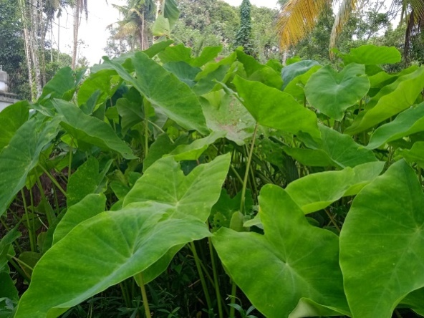
Figure 1 colocasia esculenta
Colocasia esculenta is a herbaceous erect perennial tuberous plant belonging to the family Araceae. It is a fast growing plant seen along streams canals and other aquatic locations with large edible corms. The large leaves are arrowheaded in shape and are peltate grows up to 2 feet long. The taro leaves are well known for their hydrophobicity[1]
Pytochemicals from the plant leaves were extracted and characterized using FTIR to find the functional groups. leaf was studied using three solvents (methanol, chloroform, and ethanol). Powder of the leaves of Colocasia esculenta (L.) was employed to obtain the extracts, which was qualitatively and quantitatively analyzed for phytochemical content using standard methods. Phytochemical constituents were abundant in the leaf extract and was found to have various phytochemicals such as alkaloids, glycosides, flavonoids, terpenoids, saponins, oxalates and phenols etc., which could have lot of medicinal benefits such as reducing headache, treatment of congestive heart failure, prevent oxidative cell damage etc. These phytochemicals were identified using UV spectrophotometer and results were presented. In order to find the antioxidant activity of the extract, DPPH (2,2-diphenyl-1- picrylhydrazyl) method was employed using ascorbic acid as standard. DPPH scavenging activity of ascorbic acid was found to be 84%, whereas for ethanol it was observed to be 78.92%, for methanol: 76.46% and for chloroform: 72.46%. Looking at the high antioxidant activity, Colocasia esculenta may be recommended for medicinal applications. The characterizations of functional groups were analyzed using FTIR spectroscopy and the results showed that the wavenumbers at 3347, 3350 & 3395 cm-1 were identified as phenolic compound; 2969, 2916, 2847, 1378, 2921, 2850 & 1377 cm-1. as alkyl methyl and alkyl methylene groups; 1734, 1645, 1451, 1736, 1657, 839 & 878 cm-1 as aromatic groups in ethanol and chloroform extracts; 1271 & 1551 cm-1 as carboxylic acids in ethanol and chloroform extracts respectively; 1462 cm-1 and 1216 cm-1 as organophosphorus aromatic and aliphatic amine groups respectively[2].
Phytochemical screening of Colocasia esculenta leaves reveals the presence of phenols, tannin, saponins, steroids, quinine, trepenoids, glycosides, alkaloids except flavonoids and the antibacterial property of leaves in ethyl acetate extract for 100 ppm concentration showed more effective against Pseudomonas aeruginosa[3].
In a pharmacognostic and pharmacological review of Colocasia esculenta (L.) Schott (Family: Araceae) reported that several countries uses the plant in traditional medicine, mainly in tropical and subtropical regions. South Asians are the major cultivars of colocasia, which is an annual herbaceous plant and the plant is commonly called as Arbi, Arvi, and Eddoe. The roots and young leaves contain calcium, phosphorus, thiamine, riboflavin, niacin, oxalic acid, calcium oxalate, sapotoxin and flavones, apigenin, and luteolin and also rich in vitamin C and starch. Alkaloids, glycosides, flavonoids, terpenoids, saponins, oxalates, phenols are the phytochemicals screened in the plant. The plant is used in the treatments like asthma, arthritis, diarrhea, internal hemorrhage, neurological disorders, and skin disorders traditionally. The phytopharmacological properties like antimicrobial, antihepatotoxic, anti-cancer, antioxidant, antibacterial, antifungal, anthelmintic activity, antidiabetic, hypolipidemic, anti-melanogenic, estrogenic and neuropharmacological effects are explained in this review [4].
The colocasia leaf yield in northern New Zealand was studied. They used the young leaves for preparation of traditional dishes like palusami. The plants are grown in tunnel houses, and he observed a linear relationship between rising degree-days above 10°C in a month and monthly leaf production. He recommended the usage of raised beds in green houses from mid winter to early spring for higher leaf yield and also utilising cool-tolerant Japanese cultivars [5]
An overview regarding the taxonomy and morphology, photochemistry, nutritional value reported that Colocasia esculenta commonly called taro is a tropical plant is grown in the high rainfall areas under flooded condition. Due to this nutritional importance both the tuber and young leaves are consumed in many developing countries. The tubers are rich in carbohydrates, proteins, minerals, and vitamins, 70 to 80 percentage of starch and highly digestible small granules. Therefore taro is used as ornamental plant and are utilised for medicines, root crop and leafy vegetable [6]
A review on nutritional and phytochemical properties of colocasia leaves as a potentionalin human nutrition was done and the report showed that iron (3.4–11.7 mg 100 g–1), copper (0.29–0.8 mg 100 g–1), magnesium (170–752 mg 100 g–1), potassium (0.4–2.4 g 100 g–1), and zinc (0.6–4.2 mg 100 g–1) are the micronutrients present in high amounts in colocasia leaves. The concentration of the nutritional components depends on agronomical factors of the location, climatic conditions etc. 1:40 ratio of sodium to potassium in leaves seems to be effective as antihypertensive. Antidiabetic, antihemorrhagic, neuropharmacological properties are supported by preclinical and clinical studies and also used for stomach and liver ailments. Chlorogenic acid, anthraquinones, cinnamic acid derivatives, and other phenolics are the metabolites which supports these properties. Oxalate, the major limiting factor in the leaves can be suppressed through food processing strategies[7].
In another study the oxalate content of taro leaves upon the effect of soaking and cooking was focused and reported that this is used as staple food in New Zealand and Pacific Island. The oxalate content leached in to tap water when the raw leaves soaked for 30 minutes, the soluble oxalate content reduces from 236.10 mg oxalate/100 g wet matter. 18 hours soaking reduces 26 percentage soluble oxalate. The insoluble oxalate (calcium oxalate) remained constant upon soaking treatments. Soluble oxalate content remained approximately same while baking but a 36 percentage reduction was observed in boiled taro leaves. 226.28mg oxalate /100g wet matter was the mean insoluble oxalate content of the raw, boiled and baked tissue[8].

- Benincasa hispida (kumbalam)

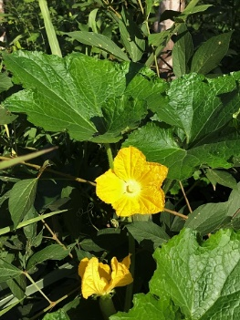
Figure 2 Benincasa hispida
Benincasa hispida is an annual climbing plant cultivated for its edible fruits belonging to the family Cucurbitaceae. It is also known as wax gourd, winter melon, white gourd etc. the 5 lobed leaf is simple and coarsely textured that reach 10 to 15cm in width[9].
The hypogylcemic and protective effect of Benincasa hispida (BH) fruit was studied. Experiment was conducted in Streptozotocin-Induced diabetes mellitus rats with aqueous extract. 250 mg/kg of extract was seen to be most effective for decreasing blood glucose level in rats. The blood glucose level of diabetes mellitus rats (21.4±1.0 mmol/l) is seen to be lower than control diabetic rats (30.1±3.8 mmol/l) after eight weeks of treatment aqueous extract of Benincasa hispida (BH) fruit. The treated rat shows weight gain, improvement in lipid profile, liver function test, kidney function test and HbA1c. They also compared rats which are treated with metformin and the results indicated that impaired organ (liver and kidney) structures of diabetic rats treated with Benincasa hispida aqueous extract are rectified [10]
A review on pharmacological importance of Benincasa hispida was done and the results showed that volatile oils , flavonoids, glycosides, saccharides, proteins, carotenes, vitamins, minerals, beta-sitosterin and uronic acid are the major phytochemicals analysed. The pharmacological properties include effect on central nervous system (anxiolytic , muscle relaxant , antidepressant , in the treatment of Alzheimer's disease and to minimize opiates withdrawal signs), antioxidant, anti-inflammatory, analgesic, antiasthmatic, diuretic , nephroprotective , antidiabetic , hypolipidemic and antimicrobial effects. The review focused on pharmacological properties and chemical constituents of Benincasa hispida.[11]
Another review of Benincasa hispida on botanical features, traditional uses, ethnopharmacological, phytochemical, pharmacological properties, molecular mechanisms including anticancer mechanism and toxicology shows that the Chinese people is cultivating ash gourd since 2000 years ago, and they uses as medicine it to treat epilepsy, lung diseases, asthma, antipyretic, antitussive, antiobesity(fruit) and urinary retention (peel). In ayurveda it is used as antiepileptic, antiasthmatic, bronchodilator, antibacterial and diuretic. In India the fruit is used to make Petha cubes (sugar compote) for vegetarian diet. It act as anti-inflammatory by lowering histamine release, anti-bacterial by decreasing bacterial growth, anti-cancer by increasing cancer cell death, antiobesity by decreasing adipocyte differentiation, PPARγ: peroxisome proliferator activated receptor gamma and C/EBPα: CCAAT enhancer-binding protein alpha, and also act as neuroprotective by increasing cognition, memory, catalase, superoxidase dismutase, reduced glutathione and by increasing lipid peroxidations[12].
The application of ash gourd in food, pharmacological and biomedical industries were studied. Rich energy, high dietary fiber, vitamin C, mineral content, and low levels of anti-nutrients are the health benefits of ash gourd fruit. Not only the fruit but the leaves, flower, fruit peel seeds are also rich in these nutrients. Antioxidative, anti-inflammatory, anti-angiogenic, detoxificant, and curvative effects made the fruit more effective for various ailments. Ca, Mg, Fe, Cu, Zn and Se are the minerals present [13]
The effect on hyperplasia of the prostate by Benincasa fruit extracts were studied. In rats the hyperplasia is induced by subcutaneous administration of testosterone and the study was conducted with petroleum ether extract, ethanolicextract , and B hispida seed oil. In vitro studies were conducted to determine the 5α- reductase inhibitory potential of the extracts. The extracts were administered simultaneously and a standard 5alpha reductase is used as positive control. The results of in vitro studies shows that petroleum ether extract and Benincasa hispida seed oil exhibited inhibition of 5 alpha-reductase. A negative result was exhibited by ethanol extracts [14]
The anatomical and phytochemical studies of Benincasa hispida were conducted . The plant from Nigeria was used to carry out the studies. Anti-compulsive effect, angiotensin-converting enzyme (ACE) inhibitor activity in vitro, Alzheimer disease treatment, anti-ulcer, anti-inflammatory, anti-obesity and anti-diarrheal properties are exhibited by the phytochemical constituents [15]. A comparative review regarding the effect of antioxidants in Benincasa hispida on physiological parameters was done. It is reported that the plant exhibit antioxidant, anti-inflammatory, analgesic, diuretic, nephroprotective, antidiabetic, hypolipidemic and antimicrobial effects and also the effect on central nervous system include anxiolytic, muscle relaxant, antidepressant, in Alzheimer's disease treatment to minimize opiates resignation signs. Triterpenes, phenolics, sterols, and glycosides gives the plant these pharmacological properties [16].Pharmacognostic property of roots of Benincasa hispida belonging to Cucurbitaceae family was studied.The powdered roots are used to study the macroscopy, microscopy, physiochemical, phytochemical and fluorescence studies. The brownish yellow roots have longitudinal striations. Starch grains, fragments of cork, prismatic crystals of calcium oxalate, a few xylem vessels with reticulate thickening and phloem fibres are observed in microscopy. 7.5% w/w of total ash and 1% of moisture were found. Alkaloids, flavonoids, steroids, triterpenoids and glycosides are the phytochemicals analysed[17]
The percentage of lupeol (a constituent of high pharmacological potential) in seed extract was evaluated using chromatographic techniques. The shade-dried seeds are extracted using soxhlet apparatus followed by phytochemical screening and thereby evaluating the lupeol concentration using HPLC and HPTLC. 1.2% (w/w) of extract was obtained and carbohydrates, glycosides, alkaloids, fixed oils and fats, tannins phenolic compounds, steroids and flavonoids are the phytochemicals screened. The HPTLC results showed the presence of 0.47% w/w of lupeol and 6.85% w/v from HPLC analysis [18].

- Vigna unguiculata (Cowpea)

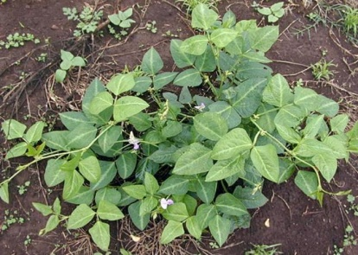
Figure 3 vigna unguiculata
Vigna unguiculata is a leguminous plant which have medicinal properties belongs to the family Papilionaceae. Review regarding medicinal, phychemical and pharmacological properties are studied. Alkaloids, phenols, flavonoids and phytic acid are the major phytochemicals and the plant exhibits antioxidant, antidiabetic and hypocholesterolemic activities[19]
Fresh and shade dried Vigna unguiculata leaves are subjected to nutrient analysis. 8 week matured plant is selected to take tender leaves for nutrient analysis. HPLC and standard spectrophotometric method is used for analysis. 80.08% and 3.18% moisture, 5.35% and 12.470% ash, 2.45% and 24.68% fibre, 6.34% and 39.70% carbohydrate, 0.92% and 3.69% fat, 4.85% and 16.290% crude protein are present in fresh and dried leaves respectively. Ca, Na, K, Fe, Mg, Zn, Mn are the minerals present in reasonable amounts. Vitamin A, D, E, K, C and B complex are observed in high levels in both fresh and dried leaves, and higher values of vitamin B 1, 5, 6, 9 and vitamin C in fresh leaves [20]
In a study the anti-diabetic, anti-cancer, anti-hyperlipidemic, anti-inflammatory and anti-hypertensive properties were evaluated and the results shows that it is effective on diabetes, hyperlipidemia and hypertension [21]. Protein was isolated from the defatted whole bean by its alkaline solubilisation and isoelectric precipitation. Amino acid composition of the protein isolate was determined by ion-exchange chromatography. Protein digestibility was assessed by the nitrogen balance method. Methionine was the limiting amino acid in both the whole bean and the isolate. The true digestibility of the protein corrected by the amino acid score is an estimate of its nutritional value. The amino acid score for the whole bean was 0.44, and protein digestibility was 86.7%. For the isolate, these values were 0.60 and 96.7%, respectively. Correcting each score by the digestibility resulted in an estimated nutritive value of 38% and 58% for the whole bean and the isolate, respectively. Therefore, by having higher digestibility and increasing the bioavailability of essential amino acids, cowpea protein isolate is of interest for inclusion in food products,especially cereal-based products, which contain lysine as a limiting amino acid and are rich in methionine [22].

- Amorphophallus paeoniifolius (Elephant yam)

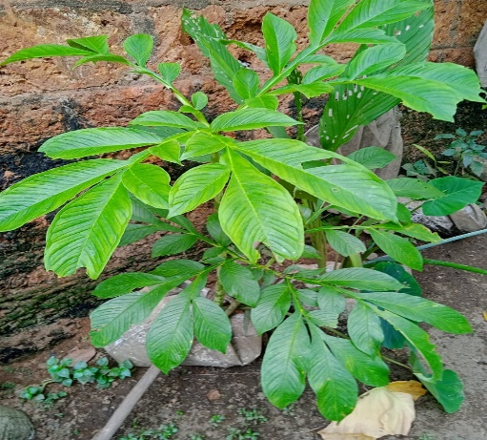
Figure 4 Amorphophallus paeoniifolius
Elephant yam is a perennial herbaceous plant belonging to the family Araceae grows up to 2 meters tall and is utilised for underground tuber that grows up to 25 kilos[23].
The in vitro anti oxidant activity and phytochemical analysis of Amorphophallus paeoniifolius was done. Methanolic extract of tuber is used for evaluation, the extraction is carried out using soxhlet apparatus. The results showed the presence of Carbohydrates, Alkaloids, Flavonoids, Steroids and Terpenoidsupon phytochemical analysis. Antioxidant activity was screened by DPPH method, and the results showed that the tuber possess anti-oxidant properties which is compared with standard Ascorbic acid[24]. In vivo anti-diarrhoeal activity of the leaves are studied.Castor oil-induced Diarrhoea model of Swiss Albino rats of either sex weighing 150-180 g were used for the study. 100, 200 and 400 mg/kg doses showed prominent anti-diarrhoeal activity [25].
Anti-oxidant property with respect to phenolic content was studied .Ethanolic extract of the tuber was used for the study. Lipid peroxidation inhibition in terms of formation of thiobarbituric acid reactive substances (TBARS) were studied and the result showed that 4.3% to 67.2% reduction in a dose-dependent manner. The extract showed 68.6% of DPPH scavenging activity, 74% and 67.2% of ABTS scavenging activity and H2O2 scavenging activity respectively. The anti-oxide efficiency and oxidative inhibition varied in accordance with dose-dependent manner (1-50 µg/mL concentrations). gallic acid, resveratrol, quercetin are the polyphenols identified in HPTLC profiling[26].
A review on medicinal importance of the plant with respect to phytopharmacological properties was don and says that the plant is used for long period in various chronic diseases therapeutically. Particulars of pharmacological activities, phytochemical isolation, toxicity studies etc. were extracted from the published reports focussing on the safety profile of the plant. Safety of the whole plant was concluded in the review[27].
Amorphophallus tubers are useful in impaired condition of Vata and Kapha, arthralgia, elephantiasis, tumors, inflammations, haemorrhoids, haemorrhages, vomiting, cough, bronchitis, asthma, anorexia, dyspepsia, flatulence, colic, constipation, helminthiasis hepatopathy, splenopathy, amenorrhoea, dysmenorrhoea, seminal weakness, fatigue, anaemia and general debility. And also the tuber exhibit properties like astringent, thermogenic, irritant, anodyne, anti-inflammatory, anti-haemorrhoidal, haemostatic, expectorant, carminative, digestive, appetizer, stomachic, anthelmintic, liver tonic, aphrodisiac, emmenagogue, rejuvenating and tonic [28]. It is reported that Amorphophallus paeoniifolius used as neutraceuticals for food disorders, anti-microbial resistance, novel bacterial & viral diseases like MDR-TB and COVID-19. [29].Alkaloids, steroids, fats & fixed oil, flavonoids, tannins, proteins and carbohydrates are the phytoconstituents in the tuber of Amorphophalluspaeoniifolius [30]

- Amaranthus spinosus (Mullancheera)

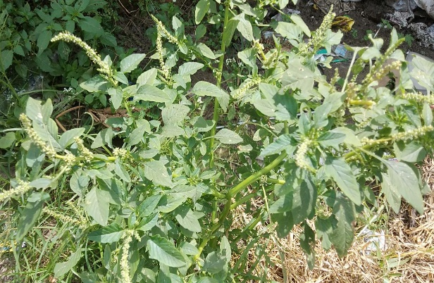
Figure 5 Amaranthus spinosus
Amaranthus spinosus is an annual or perennial herb with erect branched spinosus belonging to the family Amaranthaceae, which is common and abundant in cultivated land and waste land as weed. It is commonly known as prickly amaranthus in English and as Kate matha, Tandullajaa in India[31].
The increased levels prolactin and breast milk production in postpartum mothers were analysed after giving spinach leaf (AmaranthusSpinosus L) extract, this is because of the effect of non-synthesis lactagogues to increase milk production [32]. Anti-stress and nootropic activity in dose dependent manner is exhibited by hydro alcoholic extract of Amaranthusspinosus stem & root (200, 400 mg/kg), Swimming endurance test, Anoxia stress tolerance test and Immobilization stress test are carried out to determine anti-stress activity and Elevated plus maze and the Morris water maze for nootropic activity (Raj Kumar Singh Bharti et al., 2022)[33]. In vivo studies were conducted on growing pigs so as to determine effect of Amaranthusspinosus leaf extracts on the haematological characteristics .The ethanol extract is orally administered and packed cell volume (PCV) red blood cell (RBC) and white blood cell (WBC) counts, and haemoglobin (HB) concentration analysed. PCV, RBC and Hb of the pigs reduced with seven days posttreatment and the weight is improved[34].
Antidiabetic effects of Amaranthus spinosus leaf extract was studied in albino rats of streptozotocin-nicotinamide induced diabetes & oxidative stress. Single dose streptozotocin (60 mg/kg) administered intraperitoneally followed by nicotinamide (120mg/kg). Reduced glutathione (GSH) content and enzymatic activities of superoxide dismutase (SOD), catalase (CAT), and glutathione peroxidase (GPx) in liver and kidney were analysed to measure the oxidative stress along with histology of liver, kidney and pancreas. The diabetic rats showed increased blood glucose, and decreased GSH content and enzymatic activities..Administration of ASEt (250 & 500 mg/kg bw/day, i.p) for 21 days caused a significant reduction in blood glucose in STZnicotinamide treated rats when compared with diabetic rats. Also, rats treated with ASEt leaf extract showed a significant increase in the activities of both enzymatic and non-enzymatic antioxidants when compared to those of diabetic rats. Degenerative changes of pancreatic cells in STZ treated rats were minimized to near normal morphology by administration of ASEt leaf extract as evidenced by histopathological examination.[35]. It is reported that Amaranthus spinosus leaves are rich in carbohydrate, phenolic compounds, phytosterols, alkaloids, flavonoids [36].
In vivo anti-inflammatory property of leaves of Amaranthus spinosus was studied . Methanol extract was used for the study on rats with castor oil-induced diarrhea and gastric mucosal integrity. The methanol extract of Amaranthus spinosus L. leaves was evaluated for anti-inflammatory activities in different animal models. The effect of the plant extract was also studied on castor oil–induced diarrhea and gastric mucosal integrity. The extract (25–100 mg=kg) inhibited the carrageenan-induced rat paw edema and produced significant ( p< 0.05) inhibition of acetic acid–induced increased vascular permeability. Inhibition of the cotton pellet granuloma was also inhibited by 100 mg=kg of the plant extract. Analgesic activity was exhibited with the significant and dose-related reduction in the number of writhings induced with acetic acid, as well reduction in paw licking induced by injection of formalin in mice. The extract (50 and 100 mg=kg) produced gastric erosion in rats, following repeated administration for 4 days, and with 25–100 mg=kg of the extract, there was a statistically significant (p < 0.05) reduction in castor oil–induced diarrhea in rats. These results demonstrate the antiinflammatory properties of the leaf extract of A. spinosus. It is also suggested that the plant extract probably acts by the inhibition of prostaglandin biosynthesis[37].
Antiulcer property of ethanolic extracts of Amaranthusspinosus were studied in comparison with famotidine in shay rats. The results showed that 400mg/kg oral dose reduced ulceration and 800mg/kg ailed in complete absence, which is equal to effect of 2mg/kg famotidine. Reduced acidity and peptic activity would might be the reason for inhibition of ulceration. 4000mg/kg dose of all extracts are safe [38].In another study it is reported that saponins, alkaloids, flavonoids, terpenoids and glycosides are the phytochemicals present in methanolic extracts of Amaranthus spinosus leaves. 17.40 g was the extract yield and the results of antimicrobial assay showed that the extract is active against Staphylococcus aureus (15mm), Aspergillus flavus (15mm), E. coli. (13mm) and Mucorspp (10mm)[39].

- Cucurbita maxima (Pumkin)

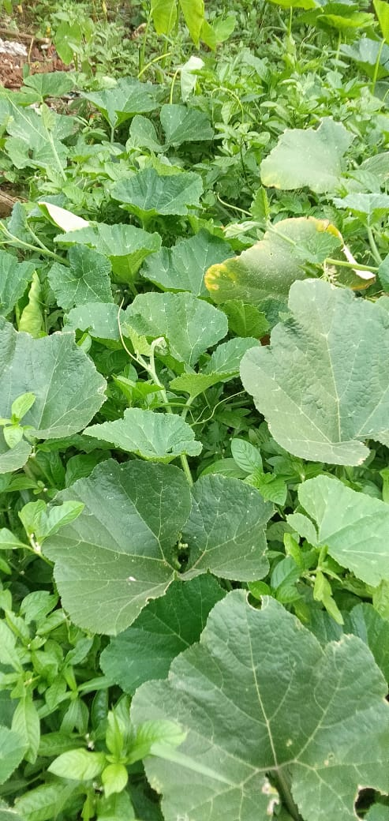
Figure 6 Cucurbita maxima

Cucurbita maxima is a creeper belonging to the family Cucurbitaceae. Saponins, resin, protein, sugar, starch along with glutamic acid and calcium are present. The seeds had antihelminitic properties, fruit and leaves are largely used by Indian cuisine[40].
Anti-diabetic property of methanolic extract of aerial parts of Cucurbita maxima was evaluated .Streptozotocin induced Wistar albino rats at the doses of 200 and 400 mg/kg for 14 days are taken for the study. Lipid peroxide, catalase and glutathione (reduced) levels of liver, kidney and pancreas along with biochemical parameters like SGPT, SGOT and ALP were estimated. The results showed reduction in fasting blood glucose, reversed antioxidant and biochemical parameters towards normal levels.[41].
The hepatoprotective activity of aerial parts of Cucurbita maxima in wistar rats was evaluated in which the hepatotoxicity is induced with carbon-tetrachloride. Liver function parameters (SGPT, SGOT, ALP, total protein and total bilirubin) along with antioxidant assays of liver homogenate (lipid peroxidation, reduced glutathione content, superoxide dismutase and catalase activity) and histology of liver tissue were evaluated. The results showed that the abnormal parameters that changed after carbon-tetrachloride administration is rectified upon treatment with leaf extract, and also the liver section histology showed the presence of normal hepatic cords, absence of necrosis and fatty infiltration [42].

- Senna tora (Thakara)

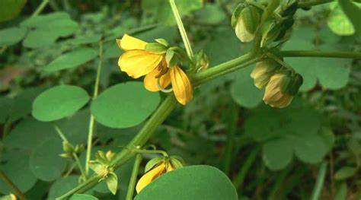
Figure 7 Senna tora
Senna tora is an annual herbaceous foetid herb that grow12–35 inches tall and consists of alternative pinnate leaves belonging to the family Fabaceae[43].
Quantitative estimation of phenol, tannin and ascorbic acid in leaves, stem, root and seeds of Senna tora were evaluated. The results showed that the leaves contained higher level of phenol, tannin and ascorbic acid than stem, root and seed. The seasonal variation of phenol, tannin and ascorbic acid content were studied. Phenol contents of Senna tora showed higher level in leaves (range 5.740 to 6.408 mg/g dry wt.) than stem (range 3.768 to 4.419 mg/g dry wt.), root (range 1.284 to 1.828 mg/g dry wt.) and seeds (3.873 mg/g dry wt). Comparative account of tannin contents of the plant showed higher level in leaves (range 0.356 to 0.410 mg/g dry wt.) than stem (range 0.300 to 0.356 mg/g dry wt.), root (range 0.112 to 0.156 mg/g dry wt.) and seeds (2.940 mg/g dry wt.). Comparative account of ascorbic acid contents showed higher level in leaves (range 3.011 to 3.620 mg/g dry wt.) than stem (range 1.988 to 2.612 mg/g dry wt.), root (range 0.970 to 1.109 mg/g dry wt.) and seeds (2.067 mg/g dry wt.)[44].
The in vitro antidermatophytic activity of methanolic extract of leaf of Senna tora was evaluated. Low polar petroleum ether and interpolarmethanolic extracts were used for study. The results of phytochemical analysis showed that the presence of alkaloids, flavonoids, phenols, triterpenoids and saponins. Antidermatophytic property of five dermatophytic fungi and five bacteria are studied and the results showed that interpolarmethanolic extract at a concentration of 40 mg/ml was more effective when compared to petroleum ether is observed against M. gypseum (11.66±1.15 mm) followed by T. rubrum extract. The maximum antifungal activity (09.33±0.57 mm), C. albicans (08.00±0.00 mm), T. tonsurans (08.66±1.52 mm) and T. mentagrophytes (07.33±0.57 mm); and 14.66±1.15 mm inhibition in E. coli followed by P. aeruginosa (11.33±1.15 mm), S. aureus (10.66±1.15 mm) and B. subtilis (08.00±0.00 mm) was observed in the antibacterial study [45].
The concentration of protein, amino acid, alkaloid and lipid in Senna toraleaves, stem, root and seeds with respect to different seasons were studied. The results showed that protein content was higher in seeds (26.648 mg/g dry wt.) than leaves (range 5.763 to 6.544 mg/g dry wt.), stem (range 3.785 to 4.341 mg/g dry wt.) and root (range 1.871 to 2.349 mg/g dry wt.). Amino acid content was higher in seeds (10.436 mg/g dry wt.) than leaves (range 0.085 to 1.143 mg/g dry wt.), stem (range 0.872 to 0.943 mg/g dry wt.) and root (range 0.287 to 0.324 mg/g dry wt.). Alkaloid content was higher in seeds (5.938 mg/g dry wt.) than leaves (range 3.109 to 3.749 mg/g dry wt.), stem (range 2.083 to 2.378 mg/g dry wt.) and root (range 0.854 to 1.015 mg/g dry wt.). And the lipid contents was higher level in seeds (14.730 mg/g dry wt.) than leaves (range 8.638 to 9.630 mg/g dry wt.), stem (range 3.682 to 4.319 mg/g dry wt.) and root (range 1.232 to 1.914 mg/g dry wt.)[46].
Chemical constituents and antimicrobial activity against Gram positive (Staphylococcus aureus and Enterococcus faecalis) and Gram negative bacteria (Klebsiella pneumoniae, Salmonella typhi, Escherichia coli and Pseudomonas aeruginosa) of Senna tora leaves and seeds were evaluated. The results showed that the presence of cisoleic acid (29.4%), 1, E-11, Z-13-octadecatriene (13.4%), palmitic acid (13.3%), 1,E-8,Z-10-pentadecatriene (11.4%) and stearic acid (11.0%) in leaf extract and methyl-1-allyl-2-hydroxycyclopentanecarboxylate (20.0%), 6,9- pentadecadien-1-ol (20.0%), cis-oleic acid (16.2%), methyl-7-hexadecenoate (7.5%) and palmitic acid (6.5%) in seed extract. And the antimicrobial activity is higher in leaves than seeds, in which Klebsiella pneumoniae exhibited highest zone of inhibition (18.5 mm) and Salmonella typhi showed the lowest (10 mm)[47].

- Diplocyclos palmatus (Neyyunni)

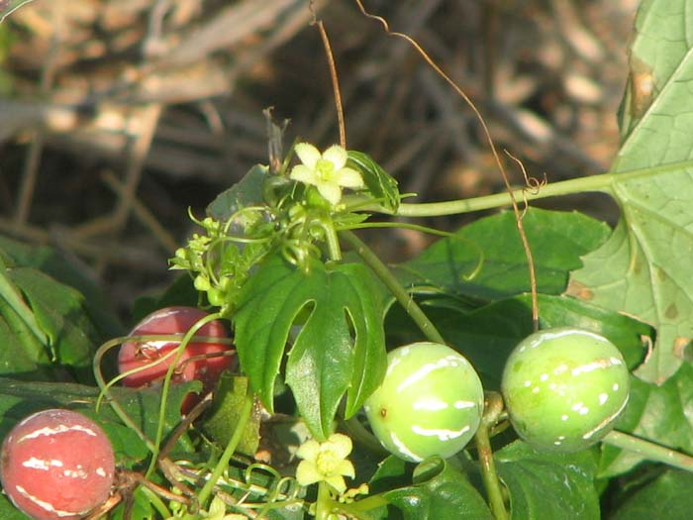
Figure 8 Diplocyclos palmatus
Morphological variations and medicinal uses of Diplocyclos palmatus (L.) was studied. It is potentially applied for Anti inflammation (Leaf) Antiasthmatic (Root), Analgesic (Stem and Leaf), Antimicrobial (Stem and Leaf), Antidotes (Root, Leaf) etc. The fruits and leaves are used to cure stomachache, stems are used as an expectorant, fruits are used as a laxative and seeds are febrifuge. The aerial plant parts are potentially utilized for several purposes such as for Aphrodisiac and tonic, Constipation, Stomach problem, Diarrhoea and Malaria [48].
In vivo study on analgesic property of Diplocyclos palmatus (L.) in albino rats along with antimicrobial activity was conducted . Ethanolic extract of the fruits were used for study and the results showed that the maximum zone of inhibition in Escherichia coli while comparing to extracts of other plant parts. Also the plant exhibited analgesic activity when compared to standard Aspirin and control [49].
The anti-diabetic property of Diplocyclos palmatus Linn. In Streptozotocin-Induced Diabetic Mice using methanolic extract of seed was studied. Oral glucose tolerance, fasting blood glucose, urine glucose, liver glycogen content, serum lipid profile, change in body weight and histopathology are determined to assess the anti-diabetic potential. A maximum of 53.87% reduction in fasting blood glucose was observed in 15 days treated with 150 mg/kg methanolic extract. The serum lipid profile get reversed, loss of body weight become controlled, liver glycogen content increased, urine sugar level decreased and the histological results showed normal pancreas [50].
Phytochemical analysis, antioxidant potential and phenolic profiling of the leaf and fruit extracts were carried out. Hexane, chloroform, methanol and aqueous extracts are used for the study. The results showed that the higher phenolics, flavonoids and terpenoids contents are observed in methanol fruit extract and higher amount of tannins in chloroform extract of leaf and fruit. Highest DPPH radical scavenging activity, metal chelating activity and phospho- molybdenum activity are showed by methanol fruit extract. RP-HPLC analysis showed the presence of bioactive phenolic compounds such as catechin (CA) and hydroxybenzoic acid (HBA) in leaves than fruit and chlorogenic acid (CLA) is present in fruit [51]. Physicochemical and preliminary phytochemical analysis of fruit was studied.The results showed that the presence of alkaloids, triterpinoids, flavonoids, saponins, steroids and proteins in the dried fruit extract[52].

- Boerhaavia diffusa (Thazhuthama)

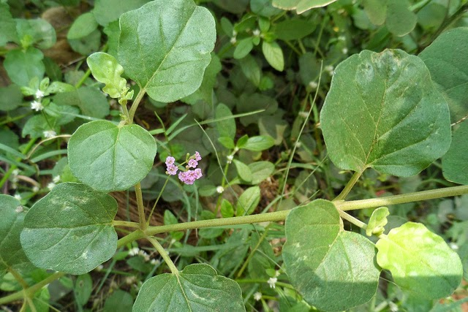
Figure 9 Boerhaavia diffusa
Boerhaavia diffusa Linn.Is a diffusely branched, glabrous prostrate herb belonging to the family Nyctanginaceae.Boerhaaviarepens Linn. andBoerhaaviaprocumbensRoxb. are its two synonym varieties, which is called as Shweta punarenava used for Punarnava drugs and Raktapunarnava for Varhabhu drugs in ayurveda respectively. The plant is commonly known as Hogweed, Patagon in English and Punarnawaa, Raktavasu, Biskhafra are Indian names[53]. Boerhaavia diffusa is a creeping herbaceous plant, with cylindrical, creeping stem sometimes purplish or greenish in colour, swollen at the nodes 54].
The antibacterial activity of Boerhaavia diffusa Linn.. Six bacteria were screened with Benzene-ethyl acetate (4:1) eluate of chloroform extract and n-butanol extract of alcohol extract. The results showed that chloroform extract exhibited activity against Escherichia Coli, Salmonella typhimurium and Pseudomonas aeruginosa and alcohol extract against Proteus mirablis and Salmonella typhimurium[55]. A review on medicinal importance of Boerhaavia diffusa is studied. Aerial parts and root of the plant were prominent in disease ailment which include treatment of stress, dyspepsia, abdominal pain, inflammation, jaundice and the plant also exhibit Anti-bacterial, Anti-nociceptive, hepato-protective, hypo-glycemic, anti-proliferative, anti-estrogenic, anti-inflammatory, anti-convulsant, anti-stress and anti-metastatic activities [56].
Another review on Boerhaavia diffusa its medicinal importance and pharmacological activities were studied . The phytochemical constituents are responsible against cancer, inflammation, diabetes, harmful radiations induced damage, gastrointestinal problems, microbial infections, liver disorders, prostatic hyperplasia, cardiac problems, anxiety problem etc. [57].

- Solanum nigrum (Manithakkali)

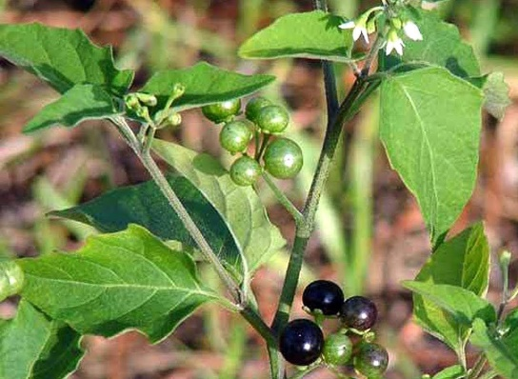
Figure 10 Solanum nigrum

Solanum nigrum Linn. is a herbaceous weed commonly seen in waste places and roadsides throughout India. Kaangannee, Kaamonnee, Makoi are the common Indian names and Black night side in English. Solanum subrum Mill ex Wight and Solanum incertum Dunal ex Graham are two synonym varieties of the plant [58].
The cardioprotective and anti-oxidant activity of methanolic extract of dried fruit of Solanum nigrum. Global in-vitro ischemia-reperfusion injury and tissue biochemical anti-oxidant profile were conducted to determine the cardioprotective activity doses of 2.5 and 5.0 mg/kg for 6 days per week for 30 days and positive results were obtained [59]. The phytochemical analysis and amtimicrobial activity against respiratory tract pathogens was studied. Aqueous, ethanol and diethyl ether extracts were used for the study and the results showed that the maximum antibacterial activity by ethanolic extract. And the phytochemical analysis showed the presence of alkaloids, terpenoids, flavonoids,saponins, steroids and phenols [60].
Anti-convulsant property of the leaves were studied in experimental animals. The anti-seizure property was potentiated by amphetamine and the results showed that the extract exhibited anti-convulsant property in the animals [61]. The antiulcerogenic activity of methanolic extract of Solanum nigrum fruit was evaluated.The ulceration in rats were induced with aspirin and the antioxidant status in gastric mucosa also have been studied. Acute gastric mucosal injury along with high lipid peroxide was taken as oxidative stress index. The results showed that the extract exhibited gastro protective activity by free radical scavenging action [62].
Phytochemical properties, acute oral toxicity and anticonvulsant activity of Solanum nigrum berries were studied. Ethanol extract were used in the study in pentylenetetrazole (PTZ)- induced seizure in mice. 3129 mg/kg body weight was the oral median lethal dose and at a dose of 300mg/kg delayed the latency. And the result of phytochemical analysis showed the presence of carbohydrates, flavonoids, saponins, tannins, alkaloids, phenols and steroids [63].

III. Conclusion

Ayurvedic herbs have been an integral part of traditional medicine for centuries. Scientific evidence supports their health benefits. The ayurvedic lifestyle followed by our ancestors and their vitality is a proof in itself on how beneficial following a healthy regime is. Health and Longevity are certain to follow, if the rules of maintaining health, as given in Ayurveda, are strictly followed.

IV. Reference

1. Kapoor, L. D. "CRC handbollk of ayurvedic medicinal plants." CRC, Boca Raton 53 (2000)
2. A Keshav, A Sharma, B Mazumdar . Phytochemical Analysis and Antioxidant Activity of Colocasiaesculenta (L.) Leaves. World Academy of Science, Engineering and Technology International Journal of Chemical and Molecular Engineering Vol:13, No:1, page 20- 23. 2019.
3. Nakade, D., S. Mahesh, N. Kiran, and S. Vinayak. "Phytochemical screening and antibacterial activity of western region wild leaf Colocasia esculenta." Int Res J Biol Sci 2, no. 10 (2013): 18-21.
4. Sudhakar, P., V. Thenmozhi, S. Srivignesh, and M. Dhanalakshmi. "Colocasia esculenta (L.) Schott: Pharmacognostic and pharmacological review." J Pharmacogn Phytochem 9, no. 4 (2020): 1382-6.
5. Bussell, W. T. "Taro leaf production in northern New Zealand." In Proceedings of the Agronomy Society of New Zealand, vol. 36, pp. 1-3. 2006.
6. Rashmi, D. R., N. Raghu, T. S. Gopenath, P. Palanisamy, P. Bakthavatchalam, M. Karthikeyan, A. Gnanasekaran, M. S. Ranjith, G. K. Chandrashekrappa, and K. M. Basalingappa. "Taro (Colocasia esculenta): an overview." Journal of Medicinal Plants Studies 6, no. 4 (2018): 156-161.
7. Gupta, Kritika, Ashwani Kumar, Vidisha Tomer, Vikas Kumar, and Mona Saini. "Potential of Colocasia leaves in human nutrition: Review on nutritional and phytochemical properties." Journal of food biochemistry 43, no. 7 (2019): e12878.
8. Savage, G. P., and M. Dubois. "The effect of soaking and cooking on the oxalate content of taro leaves." International journal of food sciences and nutrition 57, no. 5-6 (2006): 376-381.
9. Yaniv, Zohara, and Uriel Bachrach, eds. Handbook of medicinal plants. CRC Press, 2005.
10. Zakaria, Fatariah, Wan Rosli Wan Ishak, Wan Amir Nizam Wan Ahmad, Sabreena Safuan, and Tengku Alina Tengku Ismail. "Hypoglycaemic and Protective Effects of Benincasa hispida Aqueous Extract in Streptozotocin-Induced Diabetic Rats br." SAINS MALAYSIANA 51, no. 3 (2022): 783-793.
11. Al-Snafi, Ali Esmail. "The Pharmacological importance of Benincasa hispida. A review." Int Journal of Pharma Sciences and Research 4, no. 12 (2013): 165-170.
12. Islam, Muhammad Torequl, Cristina Quispe, Dina M. El-Kersh, Manik Chandra Shill, Kanchan Bhardwaj, Prerna Bhardwaj, Javad Sharifi-Rad et al. "A literature-based update on Benincasa hispida (Thunb.) Cogn.: traditional uses, nutraceutical, and phytopharmacological profiles." Oxidative Medicine and Cellular Longevity 2021 (2021)
13. Gupta, Prerna, Sivanand Chikkala, and Priyanka Kundu. "Ash gourd and its applications in the food, pharmacological and biomedical industries." International Journal of Vegetable Science 27, no. 1 (2021): 44-53.
14. Nandecha, Chetan, Alok Nahata, and Vinod Kumar Dixit. "Effect of Benincasa hispida fruits on testosterone-induced prostatic hypertrophy in albino rats." Current therapeutic research 71, no. 5 (2010): 331-343.
15. Ekeke, Chimezie, Chinedum A. Ogazie, and Ikechukwu O. Agbagwa. "Anatomical and phytochemical studies on Benincasa hispida (Thunb.) Cogn.(Cucurbitaceae)." Notulae Scientia Biologicae 11, no. 1 (2019): 102-111.
16. Alsaadi, Sarmad Abdul Razak Abood, and Kasim Sakran Abass. "Benincasa Hispida Is An Antioxidant Of Possible Physiological Importance: A Comparative Review." Plant Archives 20, no. 2 (2020): 2833-2838.
17. Pal, Rashmi Saxena, Yogendra Pal, Pranay Wal, and Ankita Wal. "Pharmacognostic evaluation of roots of Benincasa hispida (Thunb.) Cogn.(Cucurbitaceae)." The Open Plant Science Journal 11, no. 1 (2018).
18. Une, Hemant D., and Gaurav M. Doshi. "Chromatographic studies on Benincasa hispida (thunb.) Cogn. seed extract scrutinized by HPLC and HPTLC." Pharmacogn J 6 (2014): 42.
19. Zaheer, Mehreen, Salman Ahmed, and Muhammad Mohtasheemul Hassan. "Vigna unguiculata (L.) Walp.(Papilionaceae): A review of medicinal uses, Phytochemistry and pharmacology." Journal of Pharmacognosy and Phytochemistry 9, no. 1 (2020): 1349-1352.
20. Achimugu E O, Emmanuel T F. Evaluation of nutrients composition of fresh and shade dried black-eyed bean (Vignaunguiculata) leaves for food. International Journal of Food Science and Nutrition ISSN: 2455-4898 ,Volume 6, Issue 6, 2021, Page No. 10-15. 2021
21. Jayathilake, Chathuni, Rizliya Visvanathan, Afka Deen, Ruksheela Bangamuwage, Barana C. Jayawardana, Srinivas Nammi, and Ruvini Liyanage. "Cowpea: an overview on its nutritional facts and health benefits." Journal of the Science of Food and Agriculture 98, no. 13 (2018): 4793-4806.
22. Frota, Karoline de Macêdo Gonçalves, Lays Arnaud Rosal Lopes, Izabel Cristina Veras Silva, and José Alfredo Gomes Arêas. "Nutritional quality of the protein of Vigna unguiculata L. Walp and its protein isolate." Revista Ciência Agronômica 48 (2017): 792-798.
23 Rai, M. K., Geoffrey A. Cordell, Jose L. Martinez, Mariela Marinoff, and Luca Rastrelli, eds. Medicinal plants: biodiversity and drugs. CRC Press, 2012.
24 Korem Raju, G.Shylaja, M.Manoj, K.Neeraj Kumar, J.Tejashwini, M.Manasa.. Phytochemical Screening and In Vitro Antioxidant Activity of Amorphophalluspaeoniifolius. Korem Raju et al. Ijppr.Human; Vol. 20 (4): 299-318. 2021
25. Li, T.S.C. Medicinal Plants: Culture, Utilization and Phytopharmacology (1st ed.). CRC Press. (2000).
26. Angayarkanni, Jayaraman, Kunga Mohan Ramkumar, Ulaganathan Priyadharshini, and Poornima Ravendran. "Antioxidant potential of Amorphophallus paeoniifolius in relation to their phenolic content." Pharmaceutical biology 48, no. 6 (2010): 659-665.
27. Dey, Yadu Nandan, Sarada Ota, N. Srikanth, Mahvish Jamal, and Manish Wanjari. "A phytopharmacological review on an important medicinal plant-Amorphophallus paeoniifolius." Ayu 33, no. 1 (2012): 27.
28. Jaykaran, Preeti Yadav, Nilesh Chavda, and N. D. Kantharia. "Factors associated with performance of second year student in pharmacology examinations." Journal of pharmacology and pharmacotherapeutics 2, no. 2 (2011): 123-125.
29. Biswal, Susanta Kumar, Padan Kumar, Sanjeet Kumar, and Lorena Antunes. "AMORPHOPHALLUS PAEONIIFOLIUS (ARACEAE): A NUTRACEUTICAL FOR FOOD DISORDERS, NOVEL BACTERIAL & VIRAL INFECTIONS." Education 2016 (2011).
30. De, S., Y. N. Dey, and A. K. Ghosh. "Phytochemical investigation and chromatographic evaluation of the different extracts of tuber of Amorphaphallus paeoniifolius (Araceae)." Int J Pharm Biol Res 1, no. 5 (2010): 150-7.
31. Che, Chun-Tao. "Review of Duke’s Handbook of Medicinal Plants of the Bible." (2018): 1128-1129.
32. Kuswaningrum, Okta, Agus Suwandono, Ida Ariyanti, Soeharyo Hadisaputro, and Suhartono Suhartono. "The impact of consuming amaranthus spinosus l extract on prolactin level and breast milk production in postpartum mothers." Belitung Nursing Journal 3, no. 5 (2017): 541-547.
33. Kumar, Raj & Bharti, Singh & Kumar, Amit & Singh, Munna & Tripathi, Ankita. (2022). BEHAVIORAL AND BIOCHEMICAL INVESTIGATION OF AMARANTHUS SPINOSUS FOR ANTISTRESS AND NOOTROPIC ACTIVITY ON RATS. Journal of Biological & Scientific Opinion. 10. 2022. 10.7897/2321-6328.103156.
34. Olufemi, B. E., I. E. Assiak, G. O. Ayoadi, and M. A. Onigemo. "Studies on effects of Amaranthus spinosus leaf extract on the haematology of growing pigs." African Journal of Biomedical Research 6, no. 3 (2003).
35. Saravanan, R. "Evaluation of In-Vitro and In-Vivo Anticancer Activity of Leaf Extracts of Amaranthus Spinosus Linn." PhD diss., College of Pharmacy Madras Medical College, Chennai, 2016.
36 Mishra, Shanti Bhushan, Amita Verma, Alok Mukerjee, and M. Vijayakumar. "Pharmacognostic Standardization and Phytochemical screening of Leaves of Amaranthus spinosus L." Pharmacognosy Journal 3, no. 26 (2011): 34-38.
37. Olajide, Olumayokun A., Babatunde R. Ogunleye, and Temitope O. Erinle. "Anti-inflammatory properties of Amaranthus spinosus leaf extract." Pharmaceutical biology 42, no. 7 (2004): 521-525.
38. Panda, Santosh Kumar, Gourab Sarkar, Manini Acharjya, and P. K. Panda. "Antiulcer activity of Amaranthus spinosus leaf extract and its comparision with famotidine in shay rats." Journal of Drug Delivery and Therapeutics 7, no. 2 (2017): 96-98.
39. Nasir, Rabiu, Haruna Saeed Alhassan, Ahmed Abubakar, and Yusuf Ibrahim. "Phytochemical analysis and antimicrobial activity of leave extract of Amaranthus spinosus." (2020).
40. Dubey, Sarvesh. (2012). Overview on Cucurbita maxima. International Journal of Phytopharmacy. 2. 10.7439/ijpp.v2i3.492.
41. Saha, P., A. Bala, B. Kar, S. Naskar, U. K. Mazumder, P. K. Haldar, and M. Gupta. "Antidiabetic activity of Cucurbita maxima aerial parts." Research Journal of Medicinal Plant 5, no. 5 (2011): 577-586.
42. Saha, Prerona, U. K. Mazumder, P. K. Haldar, Asis Bala, Biswakanth Kar, and Sagar Naskar. "Evaluation of hepatoprotective activity of Cucurbita maxima aerial parts." Journal of Herbal Medicine and Toxicology 5, no. 1 (2011): 17-22.
43. Austin, Daniel F. Florida ethnobotany. CRC Press, 2004.
44. Gaykhe, R., S. Khan, and V. Kadam. "Biochemical Profile of Senna tora Linn." Int J Biomed Investig 2018; 1: 116. doi 10 (2018): 2581-4745.
45. Shivakumar Singh, P., and G. M. Vidyasagar. "IN-VITRO ANTIDERMATOPHYTIC ACTIVITY OF LOW POLAR PETROLEUM ETHER AND INTER POLAR METHANOLIC LEAF EXTRACT OF SENNA TORA L." (2014).
46. Gaykhe, R. C., and V. B. Kadam. "Phytochemical Evaluation of Senna tora Linn." Int J Biomed Investig 2018; 1: 105. doi: 10.31531/2581 4745.
47. Alao, F. O., Z. S. Ololade, and C. V. Nkeonye. "Phytochemical and antibacterial potentials of Senna tora leaf and seed extracts against some clinically isolated bacteria." Journal of Bacteriol Parasitol 9, no. 3 (2018): 14.
48. Patel, D. "Diplocyclos palmatus (L.) Jeffry: Morphological variations and medicinal values." J. Med. Plants 6 (2018): 3-5.
49. Kishan, Ram & Zeeyauddin, Khaja & Vemula, Sateesh & Jatoth, Ramkishan. (2019). EVALUATION OF ANTIMICROBIAL AND ANALGESIC ACTIVITY OF DIPLOCYCLOS PALMATUS FRUITS ON ALBINO MICE. Asian Journal of Pharmaceutical and Clinical Research. 12. 81-85. 10.22159/ajpcr.2019.v12i2.28346.
50. Tripathi, Jaynarayan, Reena Kumari, Vrish Dhwaj Ashwlayan, Parveen Bansal, and Ranjit Singh. "Anti-diabetic activity of Diplocyclos palmatus Linn. In streptozotocin-induced diabetic mice." Indian Journal of Pharmaceutical Education and Research 46, no. 4 (2012): 352-359.
51. Attar, USMANGANI A., and SAVALIRAM G. Ghane. "Phytochemicals, antioxidant activity and phenolic profiling of Diplocyclos palmatus (L.) C. Jeffery." Int J Pharm Pharm Sci 9, no. 4 (2017): 101-6.
52. G, Venkateshwarlu, Shanta T R, Shiddamallayya N, Ramarao V, Kishore K R, Giri S K, Sridhar B N, and Pavan Kumar S. 2011. “Physicochemical and Preliminary Phytochemical Studies on the Fruits of â€œShivalingiâ€ [Diplocyclos Palmatus (Linn.) Jeffrey]”. International Journal of Ayurvedic Medicine 2 (1).
53. Duke, James A. CRC handbook of medicinal spices. CRC press, 2002.
54. Gulshan, Chaudhary, and Kumar Dantu Prem. "Morphological, phytochemical and pharmacological, studies on Boerhaavia diffusa L." Journal of Medicinal Plants Research 5, no. 11 (2011): 2125-2130.
55. Gopal, Hamsaveni, Saradha Vasanth, and J. Herbat Mebel. "Anti bacterials from Boerhaavia diffusa." Ancient Science of Life 18, no. 3-4 (1999): 254.
56. Mahesh, A. R., Harish Kumar, M. K. Ranganath, and Raviraj Anand Devkar. "Detail study on Boerhaavia diffusa plant for its medicinal importance-A Review." Res J Pharm Sci 1, no. 1 (2012): 28-36.
57 Ashwani Kumar and Nisha Gadhwal. TRADITIONAL MEDICINAL PLANT BOERHAAVIA DIFFUSA‘PUNARVA’ AND ITS PHARMACOLOGICAL VALUE: A REVIEW. Volume 9, Issue 12, 1367-1373. 2020.
58 Warrier, P.K., Nambiar, V.P.K., Ramankutty, C. (1995). Indian Medicinal Plants—A Compendium of 500 Species, vol. 3. Orient Longman Ltd., Chennai, India. pp. 120–123.
59. PRATIM, MAITI PARTHA, KUMAR ABHINIT, TULI ATUL, ARA TASNEEM, and KHAN MASIH UZZAMAN. "Evaluation of cardio protective Activity of Methanolic Extract Of Solanum Nigrum Linn. in Rats." International Journal of Drug Development and Research 3, no. 3 (2011): 0-0.
60. Modilal, M. Rajathi D., R. Anandan, R. Sindhu, and M. N. Logeshwari. "Screening of Solanum nigrum for its phytochemical and antimicrobial activity against respiratory tract pathogens." International Journal of Pure and Applied Zoology 1, no. 3 (2015): 210-215.
61. Wannang, Noel N., Joseph A. Anuka, Helen O. Kwanashie, S. Gyang, and Asa Auta. "Anti-seizure activity of the aqueous leaf extract of Solanum nigrum linn (solanaceae) in experimental animals." African Health Sciences 8, no. 2 (2008).
62. Jainu, Mallika, and C. S. Devi. "Antioxidant effect of methanolic extract ofSolanum nigrum berries on aspirin induced gastric mucosal injury." Indian journal of clinical biochemistry 19, no. 1 (2004): 57-61.
63. Son, H. L., and Phan Thi Hai Yen. "Preliminary phytochemical screening, acute oral toxicity and anticonvulsant activity of the berries of Solanum nigrum Linn." Tropical Journal of Pharmaceutical Research 13, no. 6 (2014): 907-912.

