Design of Protected Water Supply Scheme of  
Amrutha Nagar habitation of Kottapalli

[1]Dr.T. Kiran Kumar, [2] P. Jason Karunakar,

[1]Professor, Department of Civil Engineering, K.S.R.M. College of Engineering (Autonomous),

Kadapa, Andhra Pradesh, E-mail: [kiranced@ksrmce.ac.in](mailto:kiranced@ksrmce.ac.in)

[2] Deputy Executive Engineer, Rural Water supply, Kadapa, Andhra Pradesh,

E-mail: [jasankarunakar777@gmail.com](mailto:jasankarunakar777@gmail.com)

***Abstract -*** Amrutha nagar has total population of 4964 according to 2011 census. This habitation has total 1296 households. This habitation is located near Nagayapalli habitation of proddatur Mandal. Amrutha nagar habitation of three phases i.e., phase 1, 2 and 3. At present Amrutha nagar phase 1 is provided with drinking water facilities of to bore well source {at Nagayapalli kunta}, one over head tank of capacity 60000 lit and distribution pipe line network. Amrutha nagar phase 2 & 3 is provided with drinking water facilities of three bore well sources and direct pumping scheme. As per the design to estimate the 2011 census which is set for 10 years has been completed lot of problems occur due to damage of pipe friction loss, corrosion and undesirable design of pipes and other many losses. This paper present work conducts a detailed analysis and design for providing protected water supply scheme with sustainable sources for Amrutha nagar habitation phase 1, 2 & 3. This project details the required capacities of bore wells, over head tank, pump sets and pipe line diameter which are required for providing drinking water supply with required pressure.

**Keywords –**

**I. INTRODUCTION**

Amrutha nagar is located 14.76N and 78.82E about 50km from Kadapa and about 5 km from Proddutur mandal Kadapa district in the Rayalaseema region of Andhra Pradesh. The area situated in the Proddutur or kundu river east Nagayappali pond North, Jammalamadugu - Ananthapuram highway on west side, and south side Duvvur road. it has average elevation of 149M(448feets).

Proddutur municipal corporation is the district head quarters of the Y.S.R district. In 2005, it is upgraded from the selection grade of municipality to municipal corporation. It is spread over the area of the 164.08 sq.kms. It is constituted of the 40 election wards. The annual average rainfall in the Proddutur Town is about 121mm. The average elevation level of the ground in Kadapa town is +158.000.And in the Amrutha nagar town 40,462 individual water supply house service connections are present. The water consumption 250 LPCD during normal season and 150 LPCD during summer season.

Kundu river is the main source of water supply to Amrutha nagar . Water flows in the river from July/August to February. The above first two sources are situated on the bank of kundu river are at a distance of 6 KM and 10 KM respectively from the town. Besides the above there are tube wells and open wells fitted with pump sets and connected to the existing distribution system to supplement water. The pro rata supply is 105.00 LPCD for the present population of 8926 which is inadequate as per CPEHO guidelines.

Still there are about 1762 nos of households are not having house service connections. Those households are getting the potable water through Public taps, neighbor houses and water tankers. It is proposed to give House Service Connections in a phased manner & presently about 9,000 number of HSCs are proposed by increasing the population day by day the existing water supply (105.0 LPCD) to Amrutha nagar is not sufficient. So we planned to supply the sufficient water to amrutha Nagar from the another location of kundu river tributary.

The Andhra Pradesh, along with its member countries, regularly monitors access of water and sanitation of the world people. The World Health Organization (WHO) reported that, 1.1 billion people around the world lacked access to improved water supply and more than 2.4 billion, or roughly 40 percent of the world’s population lacked access to improved sanitation in 2000. In response to this, an increasing number of nations, international water conferences, and aid organizations have announced series of efforts to improve global access to fresh water and water-related services (WHO, 2000).

Thirty percent of urban and 90 per cent of rural households still depend completely on untreated surface or groundwater (Singh and Sharma, 2005). The access to drinking water in India has increased over the past decade, the tremendous adverse impact of unsafe water on health continues (WHO, 2004). It is estimated that about 21 per cent of communicable diseases in India is water-related.

**Need of the Project**

Amrurha nagar day by day is growing in the industrial and the technological way. So from the different areas people are coming to here for employment and living. So the population is going increases and there is no sufficient water availability for all such people.

Kadapa is also an agricultural district here different types of crops are growing in all seasons. In Amrutha nagar there is only one river that which provides the water for lively hood. By the unavailability of sufficient of water all will depend upon the ground water. In summer seasons the ground water also decreases in the ground level. So it is not sufficient for all people. So we have construct the extra structures for storing the water.

So government providing the kundu river tributary of the penna river in the Rayalaseema region of Andhra Pradesh.

It is very big and huge project. For the drought prone areas these project is very useful. By these project so many farmers and industries are economically beneficiary.

In the year 2000, the Andhra Pradesh announced Millennium Development Goals (MDGs) for human development in next several decades. It aims at reducing in half the proportion of people, who are unable to reach or afford safe drinking water by 2015. World countries are moving impressively with this objective. But, even if they move in right direction, hundreds of millions of people will still be running short of basic water services, after two decades from now.

**Statement of the Problem**

Socio-economic and location factors greatly influence supply and access of water. Developing countries may lack the capital and technology to tap potential water resources. Within a country, powerful industrial, agricultural, and economic interests may claim a disproportionate share of water resources. People with the least status and wealth often suffer disproportionately when supplies are limited.

It is generally observed that the Indian cities experience limited, intermittent, unreliable water supply; poor water quality; an irresponsive administration, a grossly inequitable distribution of the available water over different areas and among different groups; an implicit subsidization of the rich through low water rates; an Inadequate coverage of the poor by the public system forcing them to buy water at much higher rates from private sources; and lack of confidence over quality of the public water supply system. At the same time, the rural water supply despite six decades of planning and implementation of series of programmers, targets of covering uncovered villages under water supply grows faster.

When we look at the particular geographical area, the level of uneven distribution may be high. This is common in developing countries like India. Many villagers in the country are living without adequate and protected water supply. In 1993, only 78 per cent of rural and 85 per cent of urban inhabitants had access to drinking water. About 1,43,000 villages faced acute water problems, and many more had unreliable water supply. The government provided drinking water to these villages and urban centers in the Ninth Five Year plan at the cost of Rs.40,000 crores. Total allocation for drinking water sector in the Eleventh Plan was Rs.39,490 crores (GOI, Dept. of Drinking Water Supply, 2007).

**Objectives of The Project**

Following are the specific objectives of the study:

1. To understand the differences in status of municipal water supply and ground water supply.
2. To increase the patterns and quantum of water collected by the households from different sources;
3. We have examine the increasing population form the 20 above years from that year in the design period of water supply.
4. We put additional investment and cost incurred to make the municipal water quality better at household level.

**II. STUDY AREA**

Amrutha nagar is a small town in the neighborhood of Proddatur city in Andhra Pradesh. It is the district headquarters of [Kadapa district](https://en.wikipedia.org/wiki/Kadapa_district). As of 2011 [Census of India,](https://en.wikipedia.org/wiki/Census_of_India) the city had a population of 4964. It is located 3miles west from the city center.it has a planned residential area, with many of recently constructed streets and residential blocks. The community is very rapidly expanding since more and more of new houses are appearing in the town. The area situated in the Proddutur or kundu river east Nagayappali pond north, Jammalamadugu- Ananthapuram highway on west side, and south side duvvur road.

Amrutha nagar is located at [14.45°N 78.35°E](https://tools.wmflabs.org/geohack/geohack.php?pagename=Kadapa&params=14.47_N_78.82_E_) about 378 km from [Hyderabad](https://en.wikipedia.org/wiki/Hyderabad) and about 288 km from [Bangalore,](https://en.wikipedia.org/wiki/Bangalore) in the [Rayalaseema](https://en.wikipedia.org/wiki/Rayalaseema) region of [Andhra Pradesh.](https://en.wikipedia.org/wiki/Andhra_Pradesh)it has average elevation149 (448) feet. Amrutha nagar has a [tropical wet and dry climate](https://en.wikipedia.org/wiki/Tropical_climate) characterised by year round high temperatures. It has a record of reaching more than 50 degree Celsius Summers are especially uncomfortable with hot and humid climate. During this time temperatures range from a minimum of 34 °C and can rise up to a maximum of 45 °C. Temperatures are range in the mid thirties during the day. Humidity is around 75% during the summer months. [Monsoon season](https://en.wikipedia.org/wiki/Monsoon_season) brings substantial rain to the area. Amrutha nagar gets rainfall from both the [South west monsoon](https://en.wikipedia.org/wiki/South_west_monsoon) as well as the [North East Monsoon](https://en.wikipedia.org/wiki/Northeast_monsoon). June to October is usually the monsoon. [Winters](https://en.wikipedia.org/wiki/Winter) are comparatively milder and the temperatures are lower after the onset of the monsoons. During this time the temperatures range from a maximum of 25 °C and can rise up to a maximum of 35 °C. Humidity is much lower during the winter season. Winter season is the best time to visit the place.

Amrutha nagar total population is 4964 according to 2011. It is having three phases, such as phase-1, phase-2, phase-3. Phase -1 is having a over head tank the water is supplied over the area. Phase -2 and Phase -3 are not having over head tank. The water is supplied to entire area is only bore wells at near the kundu river, the gate wall at the starting point of phase-2 and phase-3.

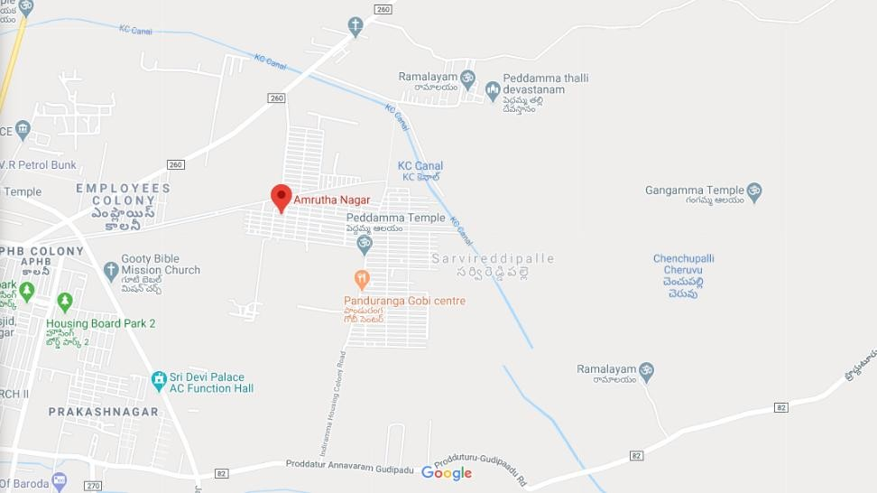

## Figure 1 Amrutha nagar base map

Amrutha nagar is a part of Proddutur town. Proddutur is a municipal corporation is the district head quarter is 53 km of the Y.S.R district. In 2005, it is upgraded from the selection grade of municipality to municipal corporation. It is spread over the area of the 164.08 sq.kms. It is constituted of the 40 election wards. The annual average rainfall in the Amrutha nagar is about 130mm. The average elevation level of the ground in Amrutha nagar town is +149.000. And in the Amrutha nagar 1782 individual water supply house service connections are present. The water consumption 105 LPCD during normal season and 75 LPCD during summer season. In Amrutha nagar 280 kms of pucca and katcha storm water drains are constructed.

**III. METHODOLOGY**

**Intake Structure:**

Intake structures are used for collecting water from the surface sources such as river, lake, and reservoir and conveying it further to the water treatment plant. These structures are masonry or concrete structures and provides relatively clean water, free from pollution, sand and objectionable floating material.

**Water distribution Pumps:**

Different types of applications require different types of pumps. Pumps are selected based on system requirements, discharge pressure required, flow capacity required, and availability of space. The types of pumps most often found in water distribution systems are: centrifugal pumps, vertical turbine pumps and submersible pumps. Centrifugal pumps are the most common type used in water distribution. Centrifugal pumps have a circular “fan/turbine shaped” structure called an impeller that is mounted on a centrally supported structure call the shaft. The motor rotates the shaft and can be powered by electricity or diesel fuel. Water enters at an opening in the center called the suction. The rotating impeller imparts a high velocity to the water, and it is circulated and thrown outward. Vertical turbine pumps are most often used at raw water intakes and at booster stations in the distribution system. In vertical turbine pumps, the water flows vertically through a channel or uniform cross- sectional area. The impeller is positioned in the center along the axis and the blades of the impeller are shaped so that the water flows in a radial direction. Submersible pumps are placed below the water level and are used mostly for pumping groundwater from wells. The pump is basically a multi-stage centrifugal pump and the impellers of the pump are mounted on a vertical shaft. The pump is driven by an electric motor placed adjacent to the pump and is constructed for submerged operation.

## Water Distribution System :

## The purpose of distribution system is to deliver water to consumer with appropriate quality, quantity and pressure. Distribution system is used to describe collectively the facilities used to supply water from its source to the point of usage.

## Distribution Reservoirs:

Distribution reservoirs, also called service reservoirs, are the storage reservoirs, which store the treated water for supplying water during emergencies (such as during fires, repairs, etc.) and also to help in absorbing the hourly fluctuations in the normal water demand.

## Storage capacity of Distribution Reservoirs :

The total storage capacity of a distribution reservoir is the summation of:

1. **Balancing Storage:** The quantity of water required to be stored in the reservoir for equalising or balancing fluctuating demand against constant supply is known as the balancing storage (or equalising or operating storage). The balance storage can be worked out by mass curved method.
2. **Breakdown Storage:** The breakdown storage or often called emergency storage is the storage preserved in order to tide over the emergencies posed by the failure of pumps, electricity, or any othe mechanism driving the pumps. A value of about 25% of the total storage capacity of reservoirs, or 1.5 to 2 times of the average hourly supply, may be considered as enough provision for accounting this storage.
3. **Fire Storage:** The third component of the total reservoir storage is the fire storage. This provision takes care of the requirements of water for extinguishing fires. A provision of 1 to 4 per person per day is sufficient to meet the requirement.

The total reservoir storage can finally be worked out by adding all the three storages.

## Layouts of Distribution Network :

The distribution pipes are generally laid below the road pavements, and as such their layouts generally follow the layouts of roads. There are, in general, four different types of pipe networks; any one of which either singly or in combinations, can be used for a particular place. They are:

1. [Dead End System](http://nptel.ac.in/courses/105104102/Dead%20end%20layout.htm)
2. [Grid Iron System](http://nptel.ac.in/courses/105104102/Grid%20iron.htm)
3. [Ring System](http://nptel.ac.in/courses/105104102/Ring.htm)
4. [Radial System](http://nptel.ac.in/courses/105104102/Radial.htm)

**IV. RESULTS & DISCUSSION**

## Population forecasting in geometrical increase method:

Now days we are using geometric increase method because they can shows accurate population. This method is also prefer to the state government of Andhra Pradesh.

In the year of 2011 the Amrutha nagar population has 4964 We can calculate the population for the year of 2020.

To calculate the population by using the geometrical increase method.

According to 2011 census Amrutha nagar population has 4964

Pn=Po[1+1/100]n

By using the 2011 population we can calculate the 2021 population by using geometric method

P2020=4964[1+1/100]10 = 5429

By using the 2021 population we can calculate the 2031population by using geometric method

Pn=Po[1+1/100]n P2030=5429[1+1/100]10

=5996

By using the 2031 population we can calculate the 2041 population by using geometric method

Pn=Po[1+1/100]n P2040=5996[1+1/100]10

=6623

**Population forecasting for 20 years:**

|  |  |
| --- | --- |
| **Year** | **Population** |
| 2011 | 4964 |
| 2021 | 5429 |
| 2031 | 5996 |
| 2041 | 6623 |
| TOTAL | 23,012 |

Population forecasting graph for 20 years

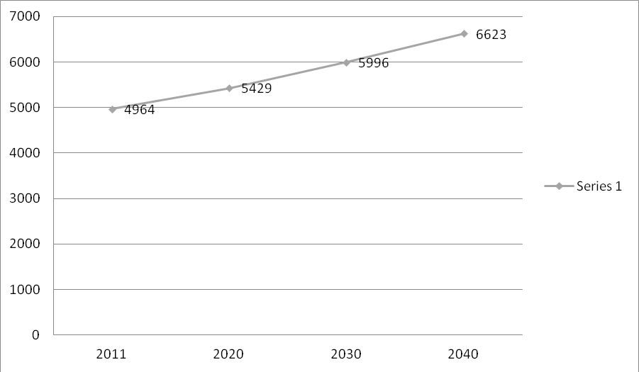

## Water Assessment to the Amrutha Nagar People :

Present Amrutha nagar population is 5429

Minimum water domestic consumption =105 l/d

380.80l/h/d

**38.8MLD**

Assuming maximum daily demand at 1.8 times the average

The maximum quantity of water required

For Kadapa town = 38.8 X1.8

= 69.84 MLD

 = 0.808 cumecs

**Design of Circular Water Tank :**

Design of circular Tank :-

Capacity of circular tank = 6,00,000 lit

Height of a tank = 8 mts

Free board = 200 mm

Characteristic strength of concrete (*fck*) = 20N/mm2

Yield strength of steel (*fy*) = 415N/mm2

**Step 1:-Dimension of tank :-**

Depth of water in the circular tank (H) = (height of tank – free Board)

(H) = 8-0.2 = 7.8 mts

Volume of circular tank 

Area of circular tank (A) 

Diameter of circular tank (D) 

D =

D = 10 mts

Thick is assumed as (t) = (30 H+50)

(t) = (30×3.3+50)

( t) =160 mm

**Step 2: Design of vertical wall:**

γ = unit of weight of water = 10kN/m3

σst = allowable stress in steel = 150N/mm2

Area of steel 

*Ast min* = 0.24% of area of concrete

 (d=t)

 = 384mm2

The steel required (1430mm2) is more than the minimum steel (384mm2)

Let the diameter of the bar used = 16mm

Area of each bar 

Spacing of 16mm dia bar = 



= 140.59 ≅ 140.6mm

Hence provided 16mm dia bars of 140mm c/c hoop tensile steel.

**Step 3: Check for Tensile stress:**

Actual area of steel provided = 



= 1436mm2

Modular ratio (m) = 

Stress in concrete 

(σc) = 1.207 ≅ 1.2N/mm2

Permissible stress  = 1.2N/mm2

Actual stress is equal to permissible stress

(Hence OK)

**Step 4: Cartulment of hoop steel:**

Quantity of steel required at 1mts, 2mts and top are tabulated.

**at 2.3H:** 



Spacing of 16mm φ bars = 

 = 201.8 ≅ 200 mm c/c

**at 1.3H:** 



Spacing of 16mm φ bars = 

 = 356.81 ≅ 350 mm c/c

**At top** : minimum steel = 384mm2

Spacing of 16mm φ bar at 400 mm c/c

**Step 5: Vertical reinforcement**

For temperature and shrinkage distribution steel in the form of vertical reinforcement is provided 0.24%

*Ast* = 384mm2 (previous)

Spacing of 10mm φ bars

Area of one bar 

Spacing (S) = 

 = 204 ≅ 200 mm c/c

**Step 6:-Tank floor :-**

As to slab rest on the ground ,minimum steel @0.3% is provided. The thickness of slab is assumed as 150mm. 8mm dia meter bars@200mm c/c is provided in both at top and slab.

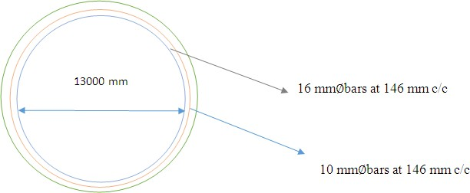

Plan at base of the tank

**Design of Intake Structure :**

Velocity of water in reservoir (v) = 1.3 m/s

Discharge required (or)tube received by Intake structure (Q) = 1.19 cusecs

(Q) = 1.19  0.02831

(Q) = 0.034 cusecs

Area of opening required to take water from river by Intake structure



Minimum flow depth of water = 0.6 mts

Proposed opening is rectangular

Hence breadth 

Hence opening proposed to draw water 1.0 × 0.05 mts from overcoming adverse condition.

LWL of river = +158.75

Bed level of river = +150.3

Assuming diameter of line as per design standard = 1.2 mts

Assuming the diameter of Intake structure as per design = 1.20×2 = 2.40 mts

However adopt 2 mts as diameter of Intake structure.

**Design of Intake Pipe Line :**

Design discharge = 1.19 cumecs =0.034 cusecs

Bed fall adopted = 1 in 500

Assuming two numbers of 1000mm φ RCC pipes is provided for most economical section

Area of pipe  = 0.78 Sq.mts

Wetled perimeter  = 1.57mts

Hydraulic mean path = 0.49mts

Using manning’s formula 

 = 1.11 m/sec

Discharge through pipes = 0.78 × 1.11 = 0.865 cusecs

Hence the section assumed is safe and can discharge 0.85 cusecs than 0.045 cusecs.

**Design of Roof Slab for Pump House :**

**Dimensions of Slab :-**

Clear span =20.7 mts

Effective diameter = 20.7+0.3 =21 mts

Effective radius =21/2 = 10.5 mts

RCC circular floor slab is proposed for installing the pump sets and control panels etc, at height of 20.175 mts. The slab is retrained partially at the edges

**Design loads on slab :-**

Clear span of slab =20.7 mts

Let the total depth of slab assumed =160 mm

Self weight of slab =0.16×1×1×2500 = 4000 N/mm2

Live load = 1500 N/m2

Dead load = 560 N/m2

Total load = 6060 N/m2 = 6.06 kg/m2

Maximum bending moment per width = 3/16wR2

= 3/16 × 6.06 × 10.5 = 125.9 kN-m

Check for depth for B.M. consideration  = 213.57mm

Hence effective depth (d) = 210mm

Overall depth (D) = 210 + 20 = 230mm

Area of steel required at centre of slab

 

= 2010 mm2 ≅ 2000 mm2

Min (Ast) = 0.12% of BD



= 192mm2 < 2010 mm2

(Hence OK)

Provided 16mm φ bar

Spacing (S) 

(S) = 100 mm/c

Total circumferential reinforcement at edges = 2/3 × 2000 = 1300 mm2

Using 12mm φ bar in form of rings @ 80mm c/c



S = 80mm c/c

Development length of 12mm φ bars = 56φ

= 56 × 12 = 67.2 mm

Since moment at edges is 2/3 of that mid span beyond 2/3 of total development length the mesh provided by 12mm bars will effective, 12mm rings are required only

2/3 × 675 = 448 mm distance

Use 4 rings @ 80mm c/c

Area of provided by 4 rings =  = 452.38m2

**Check for shear:**

Maximum shear force @ the edges is given by







T4 = 0.15N/m2

Which is less than allowable stress

(Hence safe)

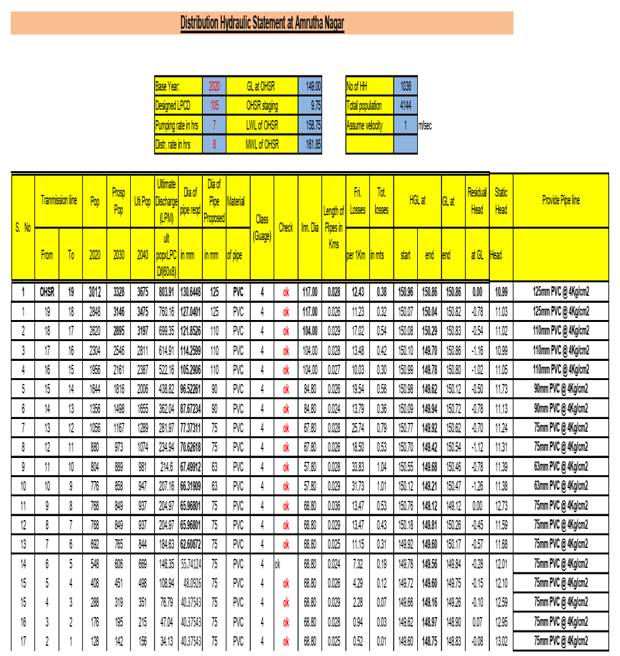

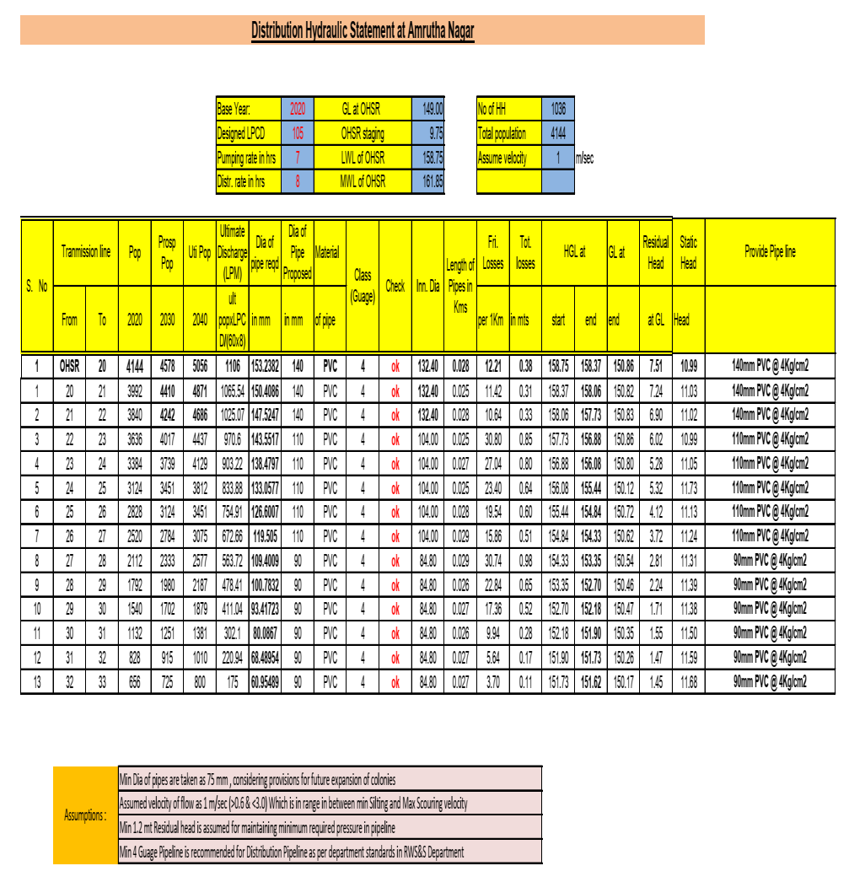

**CONCLUSIONS**

* There are different methods for calculating the population but we used the geometric increase method for calculating the future 20 years population for the design period of the forecasting.
* We had collected the two water samples at the kundu river and does the water quality test on the sample. The organic solids in the water are permissible limit. So it is very useful for drinking purpose. Then it can used in the Municipal Water Supplying process.
* In Amrutha nagar phase 2 and phase 3 there are 2446 nos of total no of house holds in that existing house service connections are 872 nos. so the required House Service Connections are 1574 nos. so we are requested to provide the House Service Connections of all households.
* By increasing the population day by day the existing water supply (105.0LPCD) to Amrutha nagar is not sufficient. So we planned to supply the sufficient water to Amrutha nagar from the another location kundu river.
* We have design the intake structure and the pump house to supply the water from the kundu river location to the Amrutha nagar town.
* Due to sufficient water supply people are depending upon the ground water. They were using the ground water to domestic and sanitation purpose.
* We had design the circular tank and pipelines that which required to supply from river to Amrutha nagar.
* Our proposal to Proddutur Municipal Corporation is to Laying of new pipe lines and resizing the pipes and replacement of distribution network.

**REFERENCES**

* Irrigation and water resources engineering by Dr.B.C.PUNMIA, Dr.PANDE BRIJI LAL, Dr. ASHOK KUMAR JAIN and Dr. ARUN KUMAR JAIN (SIXTEENTH EDITION) Lakshmi publications Pvt.Ltd.
* Kadapa district water wealth at a glance and study area of kadapa district from NEERU-PRAGATHI BOOK
* Environmental Engineering Laboratory Manual by N.KUMAR SWAMI and Dr.B. kotaiah first edition by charotor publisher house., Gujarat.
* Reinforced Concrete (Limit State Design) by ASHOK.K.JAIN – Sixth edition by NemChand and bros, Roorkee.
* WATER and WASTE WATER ENGINEERING by G.M.FAIR and J.C. GEYER published by khanna publishers.
* Hydraulics and Fluid Mechanics by the MODI and SETHI standard book house. New Delhi.
* Engineering hydrology by the K.SUBRAMANYA Tata M.C. GrawHill publishing co.Ltd., New Delhi.
* Indian Standard Code Books
* IS 8329 (2000) – For different types of pipes in water supply.
* IS 1172: 1993 – for explaining the water demands to the people