DR. APARAJITA MUKHERJEE
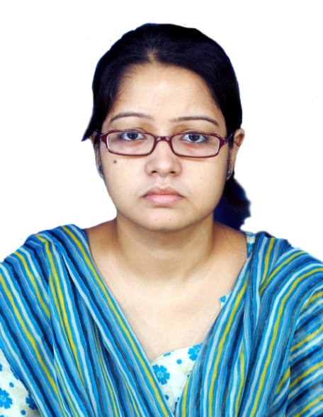
Assistant Professor
Department of Electrical Engineering
Meghnad Saha Institute of Technology
Nazirabad, Utchepota, Kolkata-700150

Mailing Address: C/O RAMKUMAR MUKHERJEE
72/B/16, May Fair Shivam,
Flat No-303, Lawrence Street,
Uttarpara, Dist. Hooghly,
PIN: 712258, West Bengal
Mobile No : 6289434152/ 8900061365
e-mail id : mukherjeeaparajita29@gmail.com/aparajita.mukherjee@msit.edu.in
Google Scholar id : https://scholar.google.com/citations?user=yh7_VQYAAAAJ&hl=en&oi=ao
linkedin : www.linkedin.com/in/dr-aparajita-mukherjee-8b17a850

Education
Ph.D., EE (Power System Engineering), Indian Institute of Technology (Indian School of Mines), Dhanbad, 2018
Concentrations: Optimal power flow, Soft computing techniques.
Dissertation: Optimal Power Flow using Evolutionary Optimization Techniques.
Dissertation Supervisor: Dr. Vivekananda Mukherjee, Department of Electrical Engineering, Indian Institute of Technology (Indian School of Mines), Dhanbad.

M. Tech, EE (Power System Engineering), West Bengal University of Technology (Dr. B.C. Roy Engineering College, Durgapur), 2014, 9.09
Concentrations: Transient stability, Optimal power flow.
Dissertation: Transient Stability Constrained Optimal Power Flow using Evolutionary Algorithms.
Dissertation Supervisor: Dr. Provas Roy, Department of Electrical Engineering, Kalyani Government Engineering College, West Bengal.
B. Tech, Electrical Engineering, West Bengal University of Technology (Asansol Engineering College), 2011, 8.56

Higher Secondary Examination, West Bengal Council of Higher Secondary Education, 2007, 82.4%
Secondary Examination, West Bengal Board of Secondary Education, 2005, 82.62%

TEACHING EXPERIENCE

Assistant Professor, Meghnad Saha Institute of Technology, Kolkata, 2018 - Present
Meghnad Saha Institute of Technology (Affiliated to MAKAUT).
Courses: Power System-I, II & III, Electrical & Electronics Measurements, Power Generation and Economics, Basic Electrical Engineering.

Lecturer, Bengal College of Engineering and Technology for Women, 2011 - 2012
Courses: Basic Electrical Engineering, Power system-I.

PUBLICATIONS

Status | In Journal | In Conference | In Book Chapter | Total
Published¹ | 10 | 2 | 2 | 14
Communicated | 4 | - | - | 4
¹Details are shown on Pages 4-5

GRANTS AND FELLOWSHIPS

Ph.D. Scholarship in AICTE and Centrally Funded Technical Institutions under the M/o HRD (2014-2018).

AWARDS AND HONORS

- Student Scholar Award from WBSEDCL, 2007.
- Best Paper Presentation Award on ICONCE-2014.
- Selected as Potential Reviewer for Applied Soft Computing, Swarm and Evolutionary Computation and Annals of Nuclear Energy (Elsevier).

PROFESSIONAL MEMBERSHIPS

International Association of Engineers (IAENG) (membership number is: 259156).

RELEVANT SKILLS
- IOT proficiency.
- Software known:
MATLAB, PSPICE, MIPOWER, ETAP, Typesetting using LATEX.
- Skilled in MS Office.
- Time management skills.
- Knowledge of research methodologies.
- Writing and presenting reports.

CONDUCTION OF TRAINING/WORKSHOP

Name | Duration
Two-week workshop, named “Familiarization and Fabrication of Electrical and Electronics Components” | 8th April, 2019 to 19th April, 2019
30-hour domain knowledge training program on “Application of MATLAB in Electrical Engineering” | 12th August to 29th August, 2020
Two-week training program on “How to Write a Research Article” | 7th Sept., 2020 to 18th Sept., 2020
30-hour Training program on “Familiarization of Different Electrical and Electronic Components” | 1st Sept. to 10th Sept., 2021
Training program on “Internet of Things” | 15th Feb. to 27th Sept., 2022

COURSES ATTENDED
- Specialization on Energy Production, Distribution and Safety – certification done from Coursera.
- Electrical Distribution System Analysis - certification done from NPTEL.
- SCILAB – An Open-Source Substitute for MATLAB – certification done from Spoken Tutorial Project, IIT Bombay.
- One day workshop on Arduino- certification done from Teaching Learning Centre, ICT at IIT Bombay, funded by the Pandit Madan Mohan Malaviya National Mission on Teachers and Teaching (PMMMNMTT), MHRD, Govt. of India.
- One-week National Faculty Development Program and Online Training on LaTeX- certified from Spoken Tutorial Project, IIT Bombay.
- The Bodhi Tree and SAFE Tools for Effective Online Teaching: A Hands-On Workshop”- certification done from Teaching Learning Centre (ICT) of IIT Bombay, funded by the Pandit Madan Mohan Malaviya National Mission on Teachers and Teaching (PMMMNMTT), MHRD, Govt. of India.

Details of Paper Publication :

In Journals:
- Prasad, D., Mukherjee, A. and Mukherjee V. (2021) Temperature dependent optimal power flow using chaotic whale optimization algorithm. Expert Syst., DOI: https://doi.org/10.1111/exsy.12685.
- Prasad, D., Mukherjee, A. and Mukherjee V. (2017) Application of chaotic krill herd algorithm for optimal power flow with direct current link placement problem. Chaos, Soliton. Fractal., 103, pp. 90-100.
- Prasad, D., Mukherjee, A., Shankar, G. and Mukherjee V. (2017) Application of chaotic whale optimisation algorithm for transient stability constrained optimal power flow. IET Sci. Measurem. Tech., 11 (8), pp. 1002-1013.
- Mukherjee, A. and Mukherjee, V. (2016) Chaos embedded krill herd algorithm for optimal VAR dispatch problem of power system. Int. J. Electr. Power Energy Syst., 82, pp. 37-48.
- Mukherjee, A. and Mukherjee, V. (2016) Solution of optimal power flow with FACTS devices using a novel oppositional krill herd algorithm. Int. J. Electr. Power Energy Syst., 78, pp. 700-714.
- Mukherjee, A. and Mukherjee, V. (2016) Chaotic krill herd algorithm for optimal reactive power dispatch considering FACTS devices. Appl. Soft Comput., 44, pp. 163-190.
- Mukherjee, A., Roy, P.K. and Mukherjee, V. (2016) Transient stability constrained optimal power flow using oppositional krill herd algorithm. Int. J. Electr. Power Energy Syst., 83, pp. 283-297.
- Mukherjee, A. and Mukherjee, V. (2015) Solution of optimal power flow using chaotic krill herd algorithm. Chaos, Soliton. Fractal., 78, pp. 10-21.
- Mukherjee, A. and Mukherjee, V. (2015) Solution of optimal reactive power dispatch by chaotic krill herd algorithm. IET Gener. Transm. Distrib., 9 (15), pp. 2351-2362.
- Mukherjee, A., Paul, S. and Roy, P.K. (2015) Transient stability constrained optimal power flow using teaching learning based optimization. Int. J. Energy Optimization Engin. (IJEOE), 4 (1), pp. 18-35.

Published Book Chapter:
- Mukherjee V., Mukherjee, A. and Prasad, D. (2018) Whale optimization algorithm with wavelet mutation for the solution of optimal power flow problem: WOA with wavelet mutation for the solution of OPF problem. Chapter 23, Handbook of Research on Predictive Modeling and Optimization Methods in Science and Engineering, DOI: 10.4018/978-1-5225-4766-2.ch023.
- Prasad, D., Mukherjee, A. and Mukherjee V. (2017) Transient stability constrained optimal power flow using chaotic whale optimization algorithm. Chapter 17, Handbook of Neural Computation, Elsevier, edited by Pijush Samui, Sanjiban Sekhar Roy, Valentina E. Balas, DOI: 10.1016/b978-0-12-811318-9.00017-x.

In Proceedings of Conferences:
- Mukherjee, A. and Mukherjee, V. A solution to optimal power flow with DC link placement problem using chaotic krill herd algorithm. Paper presented at the International Conference Emerging Technological Trends (ICETT), October 21-22, 2016, Kollam, India.
- Mukherjee, A. and Roy, P.K. Chemical Reaction Optimization for Transient Stability Constrained Optimal Power Flow. Paper presented at the International Conference on Non-Conventional Energy (ICONCE-2014), January 16-17, 2014, Kalyani, India.

PERSONAL DETAILS

Date of Birth | : 29.06.1989
Marital Status | : Married
Sex: | : Female
Nationality: | : Indian

ACADEMIC REFEREE

1. | Dr. Vivekananda Mukherjee
 | Associate Professor,
 | Department of Electrical Engineering, IIT (ISM), Dhanbad
 | E-mail: vivek_agamani@yahoo.com
2. | Prof. Dr. S. K. Bhattacharya
 | Director,
 | Academic Quality Assurance
 | Techno India Group
 | E-mail: skbhatta1957@gmail.com

DECLARATION

I do hereby declare that the information furnished above is true to the best of my knowledge and belief.
Place: Kolkata 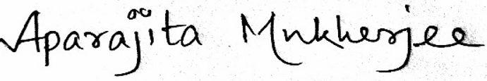
Date: 13.9.2022 (Aparajita Mukherjee)

