A REVOLUTIONARY TECHNOLOGY IN PHARMA PROFESSION: 3D PRINTING

R. PRABHU*, A. ABDUL HASSAN SATHALI, P. ELAKKIYA,
S. GOWSIKKUMAR, S. KARTHIKEYAN

Department Of Pharmaceutics,
College Of Pharmacy,
Madurai Medical College,
Madurai-625020 (TN), India

CORRESPONDING AUTHOR*
R. Prabhu, M.Pharm.,
Assistant Professor,
Department Of Pharmaceutics,
College of Pharmacy, Madurai Medical College,
Madurai-625020 (TN)
Mobile No: 09443314062
Email: prabhurajaram2005@gmail.com

A REVOLUTIONARY TECHNOLOGY IN PHARMA PROFESSION: 3D PRINTING
R. PRABHU*, A. ABDUL HASSAN SATHALI, P. ELAKKIYA, S. GOWSIKKUMAR, S. KARTHIKEYAN
DEPARTMENT OF PHARMACEUTICS, COLLEGE OF PHARMACY, MADURAI MEDICAL COLLEGE, MADURAI-625020 (TN), INDIA
CORRESPONDING AUTHOR* R. Prabhu, M.Pharm., Assistant Professor, Department of Pharmaceutics, College of Pharmacy, Madurai Medical College, Madurai-625020 (TN)

1. INTRODUCTION
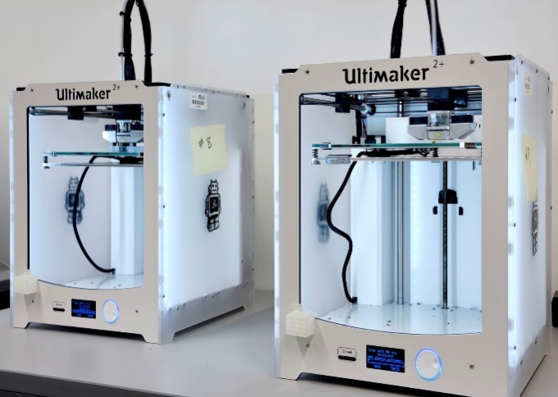
3D printing (3DP) is a versatile process used to fabricate three-dimensional items by depositing materials consecutively as layers which is effective in forming different shapes with varied sizes. 3D printing is also known as additive manufacturing (AM) and solid freeform technology. AM was discovered by Charles Hull in 1984. It can be done efficiently by a computer simulation using computer-aided design (CAD) [1]. The CAD software is used to feed the data and the instructions required for printing to commence. These instructions direct the printer nozzle to stack the ink with the intended materials layer by layer. At present, there are certain technologies used for 3D printing of drugs that include binder jetting, vat polymerization, powder bed fusion, material jetting, and material extrusion. 3DP advances the production of drugs with certain release characteristics and geometrics. 3D printing has been depicted as a game-changing technology, and it is being used in various fields, including the military, aviation, and medicine. In medicine, it is primarily used for the production of the moulds that can produce pills, and with great precision, 3DP is being used to print the actual drugs. 3DP has certain advantages like formulation optimization and production of personalized drugs (chewable tablets with required flavours have been printed for age groups of paediatrics and geriatrics). In the year 2015, the Food and Drug Administration (FDA) approved a drug named Spritam® (levetiracetam), which is widely considered the world’s first 3D printed drug commercially available on the market. It is a prescription medicine taken by mouth that is used to treat partial-onset seizures in people 4 years of age and older [2]. Filament Deposition Modeling (FDM), 3DP technology has been utilized for the fabrication of 10 different printlets (the names for novel 3D printed formulations), stating the fact that researchers can print chewable isoleucine printlets for the treatment of patients with maple syrup urine disease and has been met with competent ability [3]. Considerable progress has been made in the last decade with translating the theoretical knowledge to actual working applications and aiming to advance 3DP as an authentic pharmaceutical production process. Compared to conventional methods of drug manufacturing, 3D printing has various advantages in the production of accurate micro-controlling of drug doses, fast forming, and also a stable operation with precision. Customary pharmaceutical manufacturing processes are confined to the case of drugs, which encapsulates the size, release type, and other specifications. It is advantageous to the combination of multiple drugs into a single drug (Polypill). With new developments in fields like cell biology, regenerative medicine, and bionic medicine, the 3DP technology will be efficient in these biomedical fields for regenerative therapy [4], this method is described as 3D Bio-Printing. Bionic bones and cochlear implants have already been printed and are in the market for a while. With more knowledge and technical developments organs can also be printed using the 3DP techniques.

Fig.1: 3D Printer

Timeline of 3d printing
Fig. 8: Material Jetting Apparatus
BIOPRINTING
PHARMACEUTICAL TECHNOLOGY
YEAR 1984
CHARLES HULL CREDITED FOR THE FIRST 3D PRINTER. CHARLES PIONEERED IN SOLID IMAGE PROCESSING KNOWN AS STEREOLITHOGRAPHY (STL)

YEAR 1990
APPLICATION IN CLINICAL LEVEL TISSUE REGENERATION
- SELECTIVE LASER
SINTERING PATENT
- FUSED DEPOSITION MODEL (FDM)

THREE-DIMENSIONAL PRINTING
YEAR 2000
- PERSONALIZED MEDICINE
- LARGE-SCALE MANUFACTURING
- AVAILABILITY OF PRINTABLE APIs AND EXCIPIENTS
- FULLY FUNCTIONING 3D PRINTED ORGANS

YEAR 2012 - 2015
YEAR 2020
- FDM PRINTED TABLETS
- BILAYER TABLETS AND MULTI-DRUG DELIVERY

FUTURE ASPECTS
ExVIVE LIVER COMMERCIALLY AVAILABLE 3D HUMAN LIVER TISSUE
FABRx LAUNCHED M3DIMAKER 3D PRINTER FOR PERSONALISED MEDICINE
IN-SITU BIOPRINTING REALISED ON ANIMALS
FIRST 3D PRINTED BLADDER
ANNOUNCEMENT OF WORK ON A FULLY BIOPRINTED KIDNEY
IMPLANTATION OF 3D-PRINTED JAW
BIOPRINTING ARTIFICIAL LIVER BY EXTRUSION BASED METHOD
SPRITAM® BECOMES THE FIRST FDA-APPROVED 3D PRINTED DRUG TO BE SOLD IN THE MARKET. IT WAS MANUFACTURED BY APRECIA PHARMACEUTICALS

FIRST 3D PRINTED MINIATURE FUNCTIONAL KIDNEY
FDA THEN PUBLISHED, “TECHNICAL CONSIDERATIONS FOR ADDITIVE MANUFACTURED MEDICAL DEVICES” WHICH ACTS AS A GUIDANCE FOR INDUSTRY AND FOOD AND DRUG ADMINISTRATION STAFF
YEAR 2016
ALLEVI LAUNCHES THE ALLEVI 2, THE FIRST DESKTOP BIOPRINTER
YEAR 2010

Applications Of 3D Printing in The Pharmaceutical Industry
The major limitation in the conventional methods of drug manufacturing is that the drug product cannot always be dosed, but with the accuracy and flexibility of 3D printing technologies, that limitation is no longer a hindrance. Once there is overall control over the area of accurate dosing and dose flexibility, then it paves the way for the implementation of personalised medicine or personalised therapy. This can also mean that the drug product can be fabricated for a certain age group of patients. Drugs with varied release rates and release mechanisms can also be manufactured through 3DP. Dosage forms such as transdermal patches and microneedle patches have also been developed and are constantly being improved with advancements.

Fig. 2: Representation of the applications of 3D Printing in Medical and Pharmaceutical Fields
Apart from dosage forms, the 3DP technology has also been used in the manufacturing of medical devices such as leg, arm casts, stents, and models of organs and diseases for academic purposes [5]. The advantageous ability to fabricate a customised implant and a prostheses on demand has solved most persistent problems in many fields, the reason of modifications by the surgeons during the grafting process can be highly reduced when customised models are available. As mentioned previously the 3D printing technology is already a widely used technique in the manufacturing of 3D printed hearing aids, other models like the Invisalign are also efficiently manufactured using the 3D printing methods. Currently the Oxford Performance Medicals have received the approval from the FDA for a 3D printed Polyetherketoneketone (PEKK) skull implant. A supplementary method of 3D printing, when living cells and tissues are utilised instead of the drug materials is known as 3D Bioprinting. The bioprinted invitro models are made to use in the processes of drug testing and toxicity studies of drugs, irrespective of the above-mentioned applications, the major application of the process of bioprinting is the development of the fully functioning organs. The current treatment for an organ failure is the organ transplant, however the necessary organs are not always readily available, this causes the patients to wait for their turn to receive the organ until a matching donor is assigned, the follow up transplant surgery is also expensive. Considering these limitations, the 3D bioprinting is in development stages. The research and the organs printed so far are the miniature versions have a comparatively simpler working and those working can vary from the actual organ. Various medical devices and materials are built using 3D printing techniques with required porosity and physical characteristics.

2. DIFFERENT 3D-PRINTING TECHNOLOGIES USED IN THE PHARMACEUTICAL INDUSTRY:
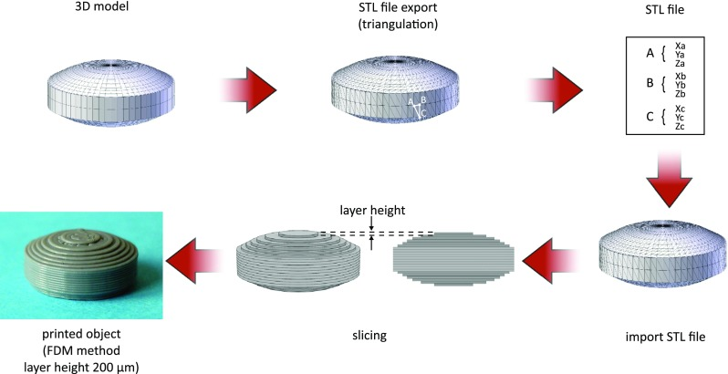
Ever since the beginning of the late 1980s, numerous 3D printing technologies have emerged, and highly capable printers also had been invented and incorporated into the development of theoretical knowledge. The American society of testing materials (ASTM) assorted the seven major additive manufacturing technologies as binder jetting, directed energy deposition, VAT polymerization, powder bed fusion, material extrusion, directed energy deposition, and sheet lamination [6], among which only a handful can be utilised in the field of pharmaceutics for the manufacturing of drugs, which includes Vat Polymerization, Binder Jetting, Material Extrusion, Powder Bed Fusion, and Material Jetting. All the technologies follow the basic principles of modelling, printing, and finishing. Before printing a 3DP model, an STL (Standard Tessellation Language or Standard Triangle Language) file is created for the required product. The file must be processed by software known as a "slicer." The Slicer (or) the slicing software, which is used to translate the 3D -object model to a set of specific commands for the 3D Printer, interprets the 3D model into a file known as the G-Code file format. The G-Code is an extensively used computer numerical control (CNC). It is a computer-programming language used in the operations following computer-aided manufacturing. The G-Code instructs the printer on how to layer the material according to the original 3DP object model.

Fig.3: Steps followed by a slicer software

ADDITIVE MANUFACTURING TECHNOLOGIES:
- Vat Polymerization
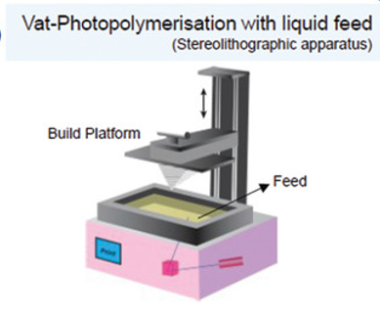
The above-mentioned types of AM technologies vary from each other in the application process or the principles involved in printing. The oldest of them all is the method of VAT polymerization. The curing method is used as a benchmark for the classification of photopolymerization which encloses, digital projection (digital light processing (DLP), light-emitting diodes (LEDs), and continuous liquid interface production (CLIP). The photopolymerization process involves a photopolymer that with the use of UV (or) visible illumination can excite a photo-initiator and that indeed can kick start polymerization. VAT polymerization is currently being incorporated into the production of multidrug-containing polypills [7]. VAT polymerization uses a laser for solidification where the light causes chains of the present molecule to link to each other, which indeed solidifies the drug material. This solidification is followed layer by layer until the intended solid structure is formed⁸. The major challenge for VAT polymerization is the selection of resins and the possible toxicity that may increase due to the reactions.

Fig. 4: Vat-Polymerization with liquid feed

B) Binder Jetting
Spritam® is the world’s first FDA-approved 3D printed drug, which was shaped and crafted using the method of binder jetting. The method includes a binding solution that is electively deposited using the printer nozzle on a powder bed. This binder solution further solidifies the powder bed layer. In other words, the solution is deposited to join the particles in the powder bed. The Binder jetting process is designed to produce pharmaceuticals with a high degree of porosity. The drugs produced can have quick dissolving properties [8]. For instance, Spritam has a dissolving time of 11 seconds in saliva.
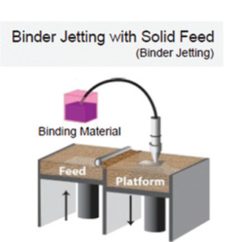

Fig. 5: Binder Jetting

- Material Extrusion
Fused Deposition Modeling (FDM)
FDM is a vivid example of material extrusion. This is an AM process including the deposition of successive layers of soft molten materials in a predetermined pattern to obtain an intended shape. Drugs with geometric specifications that are not possible with conventional powder compaction., FDM can be used to modify the drug release design and can allow one to obtain a controlled release in a drug product. The biggest limitation of FDM is that the method requires high printing temperatures, and those temperatures can include a change for possible drug degradation.

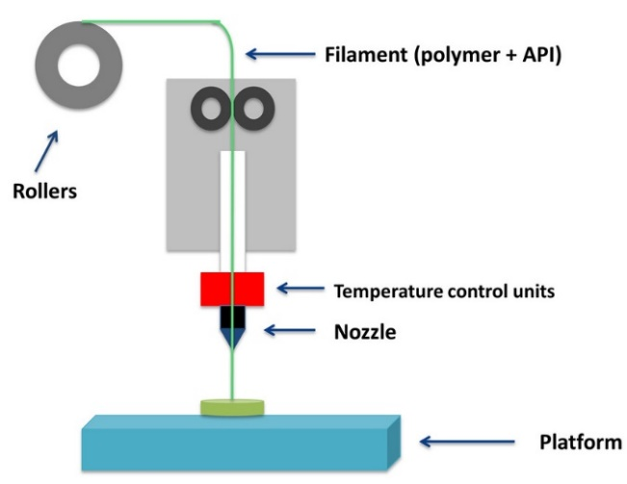

Fig.6: Fused Deposition Modelling

Direct Powder Extrusion (DPE)
This is a varied type of extrusion method that directly prints using the hot melt extruder inside the nozzle of the printhead. A very crucial advantage of DPE is that the requirement for the excipients and the printing materials is fairly lower than the other methods.

- Power bed fusion
This method utilizes a laser to obtain the required patterns on the powder bed surface. Selective laser sintering (SLS), multi-jet fusion, direct metal laser sintering or selective laser melting, and electron beam melting are all incorporated into the technologies in the powder bed fusion method. SLS is the primary technique engaged in the fabrication of medicines and medical devices8. In former times, high localized temperatures were mandatory to sinter the powder materials which in need can cause drug deterioration, hence this method is only instituted for the construction of medical devices. In 2010, it has been reported that the manufacturing of tablets, incorporating SLS, excluded and overcame the degradation by the use of an alternative diode laser [9].
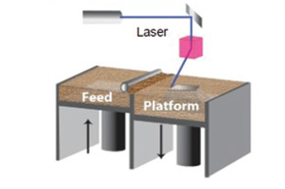

Fig.7: Powder Bed Fusion

- Material Jetting
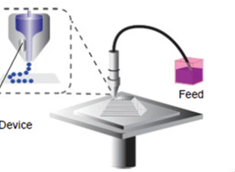
On a whole, this technique includes the process of depositing the materials as liquid droplets, onto the powder surface. often under UV [10], this technique includes drop-on-demand and nanoparticle jetting, this technology is heavily employed in the production of oral films.

Fig.8: Material jetting

3. MANAGEMENT OF DISEASES USING 3D PRINTED DRUGS:
The treatment of chronic diseases is considered a significant burden since long-term treatment and therapy are required. The treatment regimen can be influenced by both patient and medication acceptance. For efficacious remedial effect, variation for the above-mentioned factors should be effectively changed, which includes a change in dose or change in a drug used. The 3D printed approach for chronic disease treatment has effective advantages, including a reduction in dosing errors and regular treatment monitoring [11]. The 3D printed approaches include drugs fabricated by additive manufacturing and polypills.
 |  |  | STATISTICS
DISEASE |  | DIAGRAM | PREVALENCE OF THE DISEASE IN THE UNITED STATES OF AMERICA | PREVALENCE PERCENTAGE IN THE UNITED STATES OF AMERICA | ASSOCIATED COST OF TREATMENT IN THE UNITED STATES
OSTEOARTHRITIS | 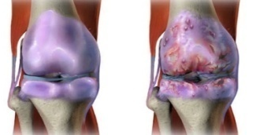 |  | 54.4 MILLION | 16% | 185.5 BILLION USD
DIABETES MELLITUS | 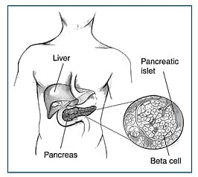 |  | 34.2 MILLION | 10.5% | 49.4 BILLION USD
CHRONIC OBSTRUCTIVE PULMONARY DISEASES (COPD) | 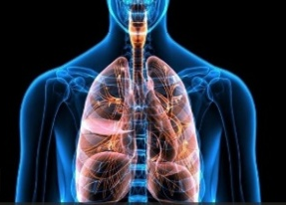 |  | 24 MILLION | 9% | 49 BILLION USD
CARDIO VASCULAR DISEASE (CVD) | 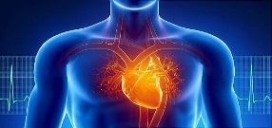 |  | 18.2 MILLION | 9.3% | 219 BILLION USD
CANCER |  |  | 16.9 MILLION | 5.5 % | 208.9 BILLION USD
EPILEPSY |  |  | 3.4 MILLION | 1.2% | 28 BILLION USD

Table 1: Statistics of Chronic Diseases Prevalent in the USA
3.1 EPILEPSY:
An abnormality in brain activity that influences the central nervous system (neurological) and results in seizures or periods of strange behaviour, feelings, and occasionally loss of consciousness.
A chronic brain condition known as epileptic seizures is characterized by a recurrent propensity to produce unprovoked seizures. Around the world, there are about 50 million impacted people. Epilepsy may affect anyone, regardless of sexuality, wherever in the world. But around 80% of those impacted reside in LMICs (low- and middle-income countries) [11]. It is discovered to be somewhat more common in men than in women, with a greater occurrence in men than in women, particularly in the elderly.
The pathophysiology of epilepsy:
- Stroke, brain malignancies, severe head trauma, alcoholic or drug addiction, neurological complications, or inadequate oxygen levels during birth.
Epilepsy can be divided into the following categories:
Generalised, focal, generalised and focal, and unknown whether it is generalised or focal.
The first tablet made with 3D printing was:
SPRITAM:
The world's first and only 3D-printed medication is Spritam (levetiracetam) [12], an anti-epileptic treatment from Aprecia Pharmaceuticals. It is produced via Zip-Dose technology [13], which belongs to Aprecia, and was given FDA approval in 2015.

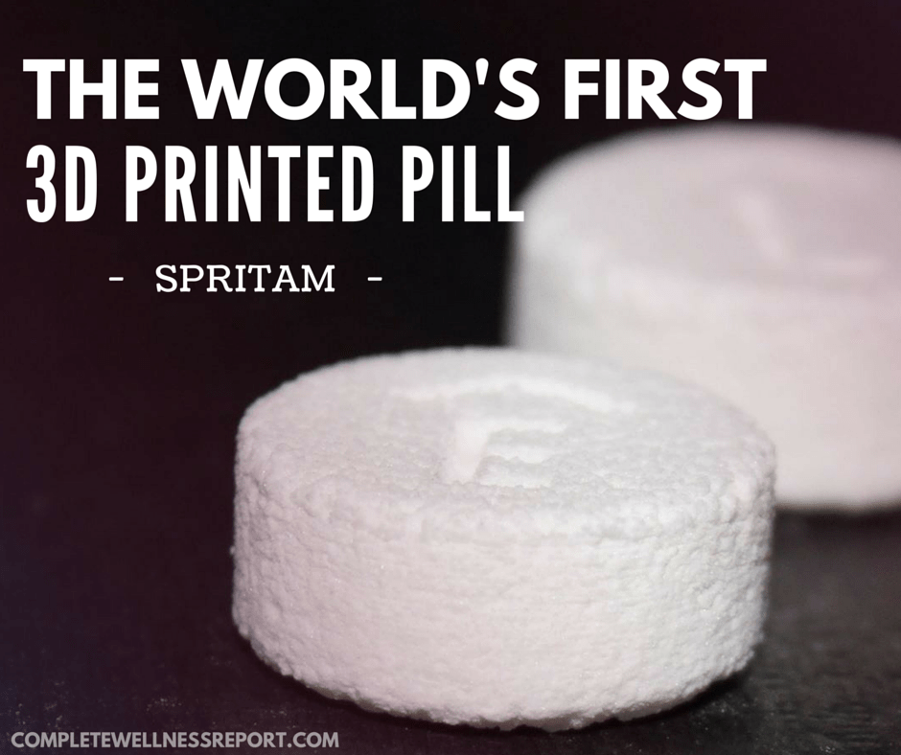
Fig 9: Schematic representation of the first 3D printed pill – SPRITAM

New Colour Jet 3D Printing of Paediatric Levetiracetam Preparations for Epilepsy Treatment:
Pharmaceutical companies are using the potential 3D printing technology to create advanced oral dose administration products. To create colourful, cartoon-like levetiracetam paediatric formulations with incredible precision and reproducibility and to establish the possibility of individualised dosing, this study first describes a new colour jet 3D printing (CJ-3DP) technology.
The CJ-3DP tablets were noticeably better than the previous 3D printed medication listed (Spritam®) [14], as seen by the uneven surface.
The development of personalised products using 3D printing technology is a promising strategy. Rapid prototyping, solid free form fabrication, and additive manufacturing are some alternative terms for 3D printing.
The following 3D printing methods are used in the pharmaceutical industry:
- Binder Jet 3D printing (BJ-3DP): Also called as Drop-on-Powder (DoP), this technology was used to create this formulation.
- Stereolithography (SLA) is the method of creating layered three-dimensional structures by using a moving platform to solidify a thin layer of liquid resin and sealing the material with an ultraviolet laser beam that passes throughout the fluid at a predetermined depth.
- Fused Deposition Modelling (FDM): FDM is the 3D printing method that has been the most thoroughly studied in the pharmaceutical industry.

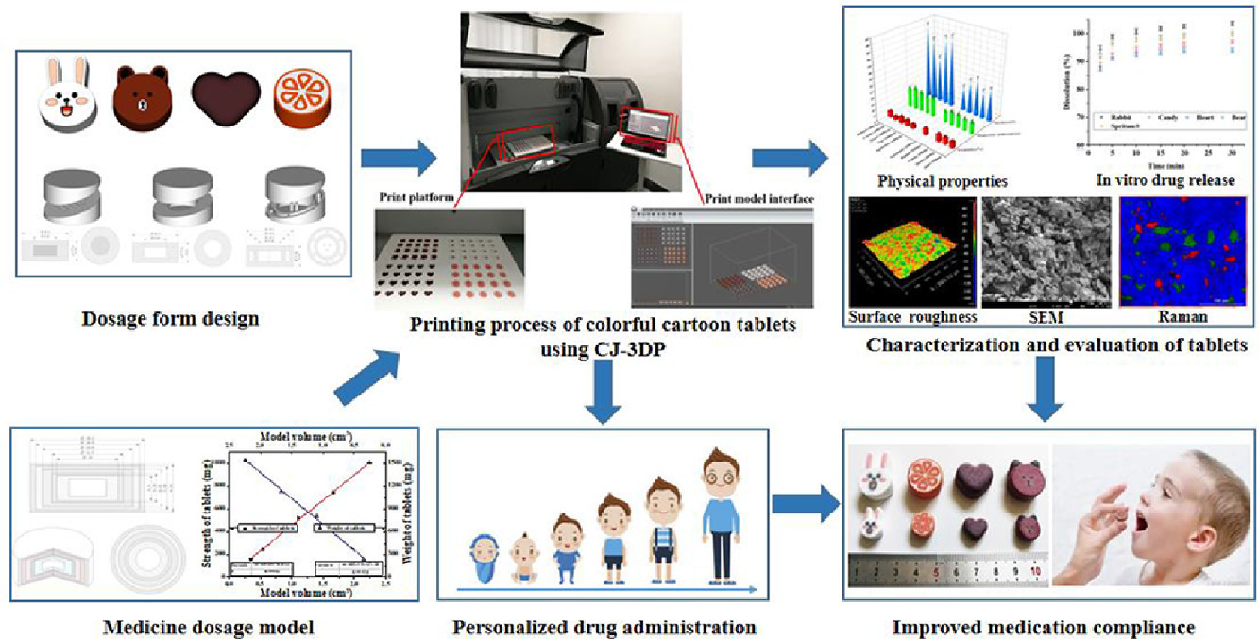

Fig 10: Schematic representation Process of 3D printed tablet
Utilizing CJ-3DP allows for the creation of vibrant cartoon levetiracetam paediatric pills. The 3D printed tablets used to have an ideal design and a lesser surface roughness thanks to the composition and tablet structure, each of which was noticeably enhanced over Spritam's features.
3.2 CARDIOVASCULAR DISEASE:
A hypothetical polypill was created in 2003 by Wald and Law to lower the risk of coronary heart disease (CVD) and haemorrhage by at least 80% while retaining a generally safe profile [15]. Patients, more than 55 years would receive any multi-component combination tablet irrespective of the existence of factors associated with cardiovascular illnesses.
Adverse effects:
- Gastric, Cough, Dizziness, Hypotension, Myopathy.
Cardiovascular disorders come in a variety of forms, including:
- Cardiomyopathy,
- Heart attacks,
- Cardiogenic shock,
- Tachycardia,
- Peripheral arterial disease
- Hemorrhage, and
- Congenital heart defects.
Polypills for Cardiovascular diseases:
Recent Clinical Studies:
The initial double-blind, randomized Phase 2 experiment employing a polypill formulation was released in 2009. TIPS aims to assess the efficacy, usability, and toxicity of once-daily Polycap (simvastatin 20 mg, aspirin 100 mg, hydrochlorothiazide 12.5 mg, atenolol 50 mg, ramipril 5 mg). 2053 patients from various centres in India were allotted at random to 1 of 9 therapy groups, which contained the Polycap and the personalized components in varied combinations15. Reduced levels of urinary 11-dehydrothromboxane B2, hypertension, heartbeat, LDL-C, and dropout rates were the main outcomes of this non-inferiority research. Patients between the ages of 45 and 80 who had just one coronary heart disease risk factor were included. The 12-week experiment was planned.

Effect on Clinical Research:
While research in increased-risk patients had shown a greater advantage in lowering blood pressure and Low-density lipoprotein -C [15], danger factors that are associated with Coronary and brain haemorrhage, studies in minimal individuals haven't demonstrated the same benefit as initially anticipated by Wald and Law. The polypills for coronary heart disease conceptual image [16].
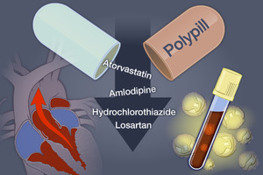

Fig 11: Schematic representation of Polypill
3.3. DIABETES MELLITUS:
As one of the most prevalent chronic glycaemic illnesses, diabetes mellitus is characterized by low levels of glucose in the body.
- In Type 1 Diabetes Mellitus (T1DM), the endocrine pancreas' beta cells are destroyed by the immune response.
- Hyperinsulinemia tolerance, poor control of gluconeogenesis, and deteriorating beta-cell activity, which ultimately results in beta-cell failure, are all characteristics of Type 2 Diabetes Mellitus (T2DM).
Causes of Diabetes Mellitus:
- Obese and excess weight,
- Tobacco,
- Increased alcohol consumption,
- Illnesses of the neurological and hormone secretion,
- A rise in cortisone,
- Inactivity, and
- Biological factors like ageing can all contribute to diabetes mellitus.
Types of Diabetes Mellitus:
- Type 1 Diabetes
- Type 2 Diabetes
- Gestational Diabetes
- Maturity onset Diabetes of the young (MODY)
- Neonatal Diabetes
- Wolfram Syndrome
- Alstrom Syndrome
- Latent Autoimmune Diabetes in Adults (LADA)
In the latest years, 3D printing technology has been created to combine two or three pharmacological ingredients into a single pill, lowering HBA1c results with a less frequent dosage. According to the tested trial, tri-oral therapy is a medication plan that enlists a medicine that is mixed with a mixture of two ineffective medicines in a polypill and starts a decline in the sugar content and HbA1c%. To easily lower HBA1c levels in type 2 diabetes patients, a combination pill comprising glimepiride, metformin, and pioglitazone (GMP) was given along with a combo of slow-release metformin and 70/30 human glucagon twice daily (BD).

Additionally, 3D printed controlled-release tablets including glipizide were created using hot-melt extrusion (HME) technology and polyvinyl alcohol (PVA) as an additive.
Interestingly, the polyvinylidene (PVA) loaded with glipizide had peaked in the Fourier-transform infrared spectroscopy (FTIR) suggesting the glipizide chemical structure was maintained altogether. Similarly, FDM was used to create a bilayer dosage form with metformin and glimepiride encapsulated in the layers of polyvinyl alcohol (PVA) and the Eudragit RL sustained-release layer.
Furthermore, 3D extrusion-based printing techniques were utilized to create multi-active tablets that included 3 distinct medications with distinct and also well-controlled release regimes. The tablet contained captopril, nifedipine, and glipizide in addition to HPMC, which served as a supplement. This dual-purpose pill reduced blood pressure and treated diabetes.
Polypill for Diabetes mellitus:
The bilayer oral solid dosage form combines metformin for prolonged and glimepiride for immediate drug delivery:
Personalized medications with distinct characteristics and release behaviours have already been developed using fused deposition modelling (FDM; 3D printing). In the current study, a bilayer dosage form holding the diabetes medications metformin and glimepiride were created using FDM 3D printing, investigated using several methods, and categorized in vitro. Both metformin and glimepiride were inserted in the polyvinyl alcohol (PVA) layer and the Eudragit® RL sustained release layer, respectively. Over than one active substance should be used in the formulation as it improves patient adherence and lowers medical costs, especially when 3D printing allows for personalized adjustment of API dosages to fit the unique demands of each patient. To create Eudragit® RL [17] drug-loaded filaments for printing the sustained release layer, various preparation techniques using various plasticizers and extruders were tested. Conventional and physiological testing methods were utilized to evaluate the created strands' attributes, and the strands with the best qualities were then used for printing.
Immediate release layer containing glimepiride (upper)
According to earlier studies, 3D printing frequently creates things that are not entirely rigid but do have tiny internal gaps and holes. By printing and weighing dose forms with various heights, a linear equation between these two variables was created. Mass (m) was stated as a function of only one dimension (height-h) of the 3D printed formulation.
Five alternative single-layer dosage forms with varying heights were printed and weighted as the basis for the calculation. In light of the filament's 2% weight-to-weight glimepiride content [17], the intended strand mass should be changed to milligrams = 100 mg. The amount of glimepiride that was absorbed into glimepiride-loaded PVA filament17 was determined to be 89.49%. Therefore, an upper PVA layer weighing 111.74 mg might accomplish the theoretical calculation of 2 mg of glimepiride. Finally, hg = 0.552 mm is the appropriate height for the overlying glimepiride-loaded PVA layer.
Based on their qualities, MowiolR 4-88 (PVA) and mannitol were selected as the filaments for the manufacture of glimepiride-loaded PVA filament.
Metformin-loaded sustained release layer (Lower):
In this instance, two distinct strands were used, one from a mono extruder and another from a dual extruder. Given that the filament includes 50% weight-weight metformin, the target strand mass should be changed to mm = 1000 mg. Metformin-loaded filament [17] was discovered to have 99.53% of Glucophage that was hypothetically integrated or an upper PVA layer of 1004.72 mg. The ideal heights for the lowest metformin-loaded Eudragit® layer are hmT = 5.54 mm and HMS = 5.18 mm.
Metformin, Eudragit ^{R} RL PO, PLA (Resomer), PLA filament (granulated), TEC, CA monohydrate, and PEG 400 make up the filament needed to make metformin-loaded EudragitR filament.

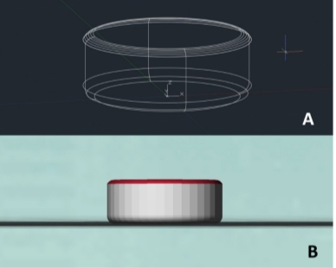
- A 3D printed medication form is drawn in AutoCAD, and
- A stereolithography model of the same

Fig 12: Schematic representation of 3D printed dosage form – Diabetes Mellitus
3.4 TUBERCULOSIS (TB):
Tuberculosis is a bacterial infection which targets and infects the lungs. The pathophysiology of Mycobacterium tuberculosis infections is known as tuberculosis.
The Causes of Tuberculosis:
Poverty, HIV infections, homelessness, substance abuse, and taking medications that weaken the immune system. Diabetes and kidney disease, as well as organ transplants.
Types of Tuberculosis:
Tuberculosis is classified into two types [18].
- Latent Tuberculosis: In this situation, you have a TB infection, but the germs in your body are dormant and don't produce any symptoms. It is often referred to as Tb disease or inactive TB.
- Active TB: This illness makes you sick and, in most situations, can transmit to other people. It also goes by the name TB illness.
The design and manufacture of an oral dual-compartmental dose unit (dcDU) were studied in vitro and in vivo in order to physically isolate and modulate the controlled release of an anti-tuberculosis medication combo. Rifampicin (RIF) and isoniazid (ISO) are first-line combination medicines for mycobacterium (TB) medication that poorly combine each other when released concurrently in an acidic environment. The dcDUs were created in two processes using hot-melt extrusion (HME) after the drug-containing filaments had been created using computer-aided design (CAD) in silico. First, the exterior structure was printed in three dimensions (3D). SEM was used to visualize the manufactured dcDUs' structural details (SEM). The 3D-printed fragmented capsules were loaded with filaments containing the active pharmaceutical ingredients (API) and individually encapsulated to control medication solubility. Pharmacokinetics tests in rats and pH-transfer dissolution in vitro were used to characterize the profile of drug release of the dcDUs, and the results indicated that the APIs released differently from the dcDUs than they did from free filaments. Furthermore, selective physical compartment closing resulted in an effective delay of in vitro API release. These results encourage the creation of dcDU systems that are controlled by design for use in combination therapies order to facilitate effective clinical translation of oral dose forms. The process for producing 3D-printedprintedprin isoniazid caplets and bi-layer caplets [19].

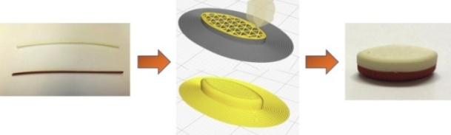
Fig 13: Procedure for fabrication of bi-layer tablet
- Isoniazid filament extruded from hot melt (top) and rifampicin filament extruded from hot melt (bottom)
- Bi-layer tablets are designed and then cut into thin slices before
- Being 3D printed using fused deposition modelling.

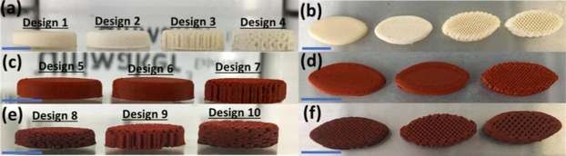
- A side view and
- A top view of a 3D-printed, 25%-rifampicin-loaded caplet.
- A side view
- 3D-printed, 35%-rifampicin-loaded caplet, top view
- Top view
- Side view
Fig 14: 3D printed Isoniazid caplet

Polypill for Tuberculosis diseases:
1. Hot-melt extrusion
The API (ISO or RIF) was physically mixed with PEO in a 70%:30% (w/w) ratio with a batch size of 4 g. The mixtures were extruded in a lab-scale twin screw compounder (DSM, ®XPLORE, The Netherlands) equipped with two co-rotating screws, moving components, and a warmed chamber with a 5 mL volume. All three of the warmed barrel's temperature-adjustable zones were extruded [20] at 80℃ while the API-PEO combinations were fed continuously to the extrusion and executed at 30 rpm with a 1 mm spherical die. The extrudates were gathered and extruded once more using the same extrusion parameters, except the exception of ISO-PEO extrudates20, in which the extrusion rate was set to 10 rpm. This second extrusion was required to create long, homogenous high-dose filaments that had been between 0.7 and 0.9 mm in diameter and could fit inside the perforations of the intended dosage forms. The batches at the ends of the die packed with the drug filament but without a cap were manually pulled to the desired diameter of the filaments.

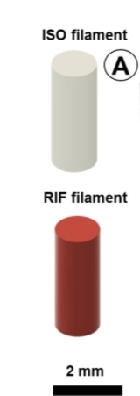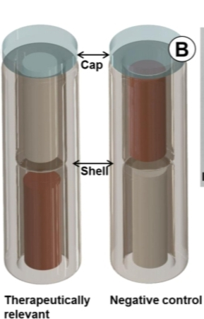
B. The photograph of the final dcDUs
- Final dual compartmental dosage units (dcDUs)
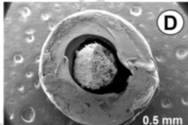
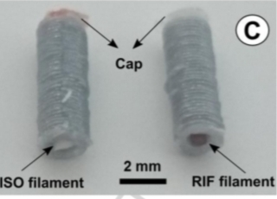
C. The scanning electron micrograph of the compartment D.ISO – Isoniazid, RIF – Rifampicin.

Fig 15: Schematic representation of the Hot-melt extruded drug filaments
2. Dual-compartmental dosage unit (dcDU) design and 3D printing:
In COMSOL Multiphysics, two water-insoluble compartments (made of PLA) were created to be loaded either with ISO or RIF extruded products during 3D printing. The water-soluble cap (made of PVA) was placed over the 3D-printed API-loaded dcDU to seal the top compartment.
A dual-nozzle Containing 3 Extended printer that employs the fused deposition modelling (FDM) process was used for the 3D printing. Printing temperatures of 210 °C (for PLA) and 225 °C (PVA) were used; layer height of 0.2 mm; constructed plate temp of 60 °C; filling parameters of 100%; printing rate of 35 mm/s; and top as a build plate adhesive type were used. Each geometry took 4 minutes to print in total
Using PLA filament, the dcDU's shell was 3D printed in a vertical orientation from the bottom up in a spherical, layer-by-layer method (35 layers). Before producing the PVA cap, the 3D printer was stopped. A known weight of either ISO or RIF extrudate was manually added into the top container during this pause. The printing process was then resumed, and the final two layers of PLA were created before the closing lid was printed twice in PVA [20]. The two-compartment systems were then separated from the construction layer afterwards when. A weighed amount of ISO or RIF extrudate was manually placed in the bottom container. There was no lid on the bottom storage area.
Evaluation Of Morphological Texture and Structure by Using Scanning Electron Microscopy (SEM):
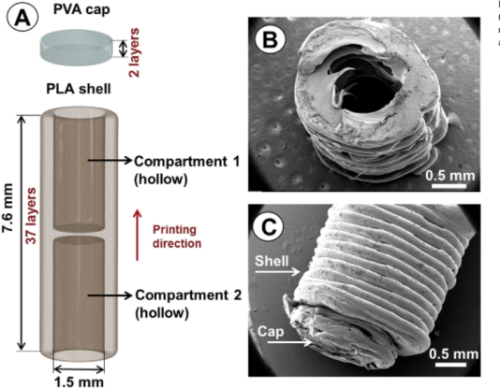
Before scanning, the samples were mounted on a double-sided carbon-coated copper grid, fastened to stainless-steel tubes, and sputtered encased with a layer of gold (5 nm) using a Leica EM ACE200 (Wetzlar, Germany) coater. The photos were taken using a secondary electron detector using an FEI/Philips XL30 FEG scanning electron microscope (SEM) in Hillsboro, Oregon, in the United States.

Fig 16: Schematic representation of the dual – compartmental unit
- SEM images of the unfilled chamber were taken in the top and
- side views, respectively.
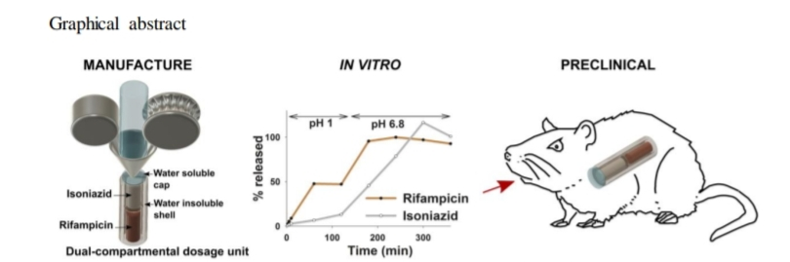
- Polyvinyl alcohol is also known as PVA or Polylactic acid.

Fig17: Graphical abstract of the dual – compartmental dosage unit

REPORT:
The only 3D-printed medication currently sold in the US is called Spritam. 3D printing in clinical trials and the development of treatments for conditions like cardiovascular disease, type 2 diabetes, and tuberculosis are currently in preliminary stages.

4. BIOPRINTING IN 3D VIEWS
The development of 3D bioprinting technology is based on stereolithography (SLA). The process of printing biomedical structures using living cells, biomaterials, polymers, and biological molecules—collectively referred to as "bioink"—is known as "bioprinting." To put it another way, 3D bioprinting is the layer-by-layer deposition of biological material to produce 3D structures like tissues and organs [21],[22],[23]. The ultimate goal of 3D bioprinting is to offer a practical replacement for tissue implants and animal testing practices during research on illnesses like cancer and the production of medication in the pharma industry [24]
Cyclic representation of Bio-printing:
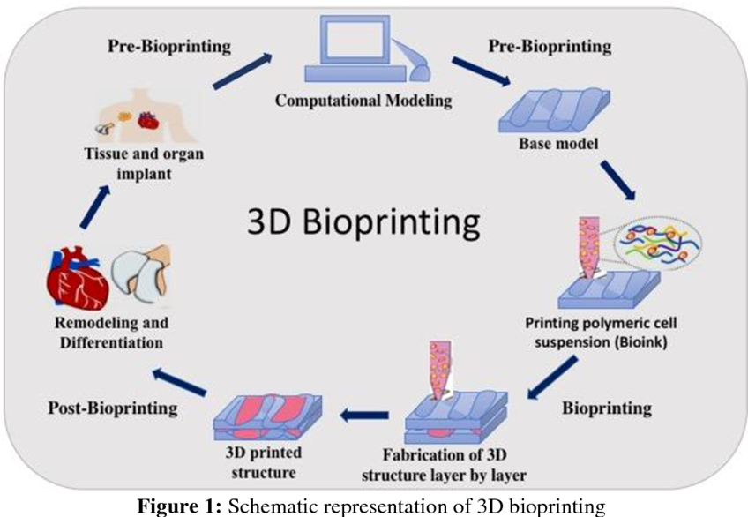

Fig.20: Schematic representation of 3D bioprinting

Data for pre-bioprinting is gathered using computational modelling techniques like computed tomography (CT) or magnetic resonance imaging (MRI). CAD (computer-aided design) software is one of the tools used to create the basic model for the intended organ. The choice of biomaterials and cells is then made in accordance with the structure of the tissues or organs. Bioink is the term for the substance formed when live cells are combined with biomaterial. After that, the bioink is put into the bioprinter, which is similar to the inkjet bioprinter, which was the first bioprinter in 2003. The required organ is then created by the bioprinter.
4.1. BIOINK

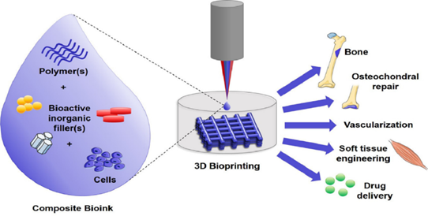
With the use of 3D bioprinting, biological materials (polymers, bioactive inorganic filters, and living cells) are referred to as "bioink" and are utilised to replicate the architecture of live tissue. The word "bioink" refers to both carrier molecules that sustain the developing cells as well as the cells employed in the production of tissues. The biopolymers employed in bioink are crucial for retaining water, which gives the designed tissues mechanical stability. The polymer gels serve as 3D molecular scaffolding that allow cells to adhere to one another and develop. To get the appropriate physicochemical features, including mechanical, chemical, biological, and rheological characteristics, the choice of bioink is a crucial step[25].

Fig.19: composition of bioink-like polymers, bioactive compounds and viable or living cells.
Fig.20: Components in Bioink

4.2. PROPERTIES OF BIOINK
To encourage suitable mechanical strength and robustness, bioink is employed. For fidelity during bio-printing, the bioink molecules should have adaptive gelation and stabilisation. Both biocompatibility and biodegradability are required for the bioink. The bioink need to be capable of chemical alterations to create certain tissues [25].

4.3. Principle of 3D Bioprinting
The foundation of 3D printing relies on the precise layer-by-layer placement of biochemicals, biological elements, polymers, and live cells to reproduce the manufactured 3D structure. Three main applications—autonomous self-assembly, biomimetics or biomimicry, and small-scale tissue building blocks—are necessary for the 3D bioprinting process [26].

4.4 Steps involved in 3D Bioprinting
Fig.21: Diagrammatic representation of 3D Bioprinting
The process of 3D bioprinting can be accomplished by three different steps; those are pre-bioprinting, bioprinting, and post-bioprinting
PROCESS/ STEP | PROCEDURE | REPRESENTATION
PRE-BIOPRINTING | The initial stage is to create a pre-bioprinting model, which the printer uses to choose the materials. The process begins with the removal of a tissue sample, which provides a biological model for the 3D bioprinting technique to replicate. scans using magnetic resonance imaging (MRI) or computed tomography (CT) [26]. This stage also makes use of these technologies. These techniques produce 2D images by topographically reconstructing the images captured. The cell is then multiplied after being chosen, which is important for the process. To maintain their viability, the cell mass is combined with oxygen and other nutrients. | 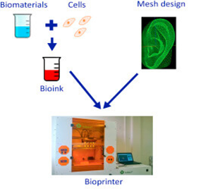
BIOPRINTING | The actual printing process begins at this stage when the bioink is inserted into the printer to produce a 3D structure. Bioink is created by combining cells, nutrients, polymers, and a matrix to make the substance. This bioink is then put into a printer cartridge to deposit the substance on the created digital model. This procedure requires the development of different cell types based on the type of tissues and organs to be generated after the layer-by-layer deposition of bioink on the scaffold to create a 3D tissue structure. Because of this, the bioprinting process is complicated [27]. | 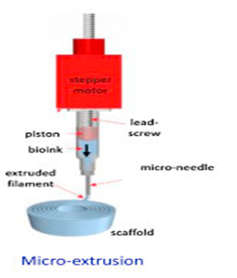
POST-BIOPRINTING | The final phase in the bioprinting process, known as post-bioprinting, is crucial for ensuring the integrity of the printed structure. The structure and operation of living matter must be maintained by physical and chemical stimulation. These stimuli provide messages to the cells instructing them to reorganise in order to support tissue growth [28]. Absent this process, the material's mechanical structure might be compromised, which would impair the material's functionality. | 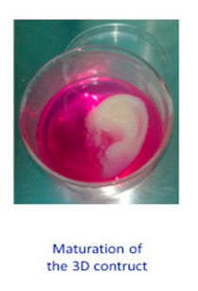
Table :2 Steps involved in 3D Bioprinting

Advantages and disadvantages of bioprinting:
Technique | Advantages | Disadvantages
Stereolithography-Based | High resolution  Easy to remove trapped materials | Expensive equipment  Only photopolymer materials
Extrusion-Based | Wide range of material choices  Low cost  Good mechanical properties | Limited materials to thermoplastics  Filament required  Viscosity and temperature of materials
Laser-Based | Wide range of material choices  High resolution | Expensive equipment  Heat effects
inkjet-Based | Low heat effect  High resolution | Limited choice of materials  Limited height  Difficulties in complex 3D geometries  Poor Mechanical properties
Table: 3 Advantage and Disadvantage of 3D Bioprinting

Organ on chip
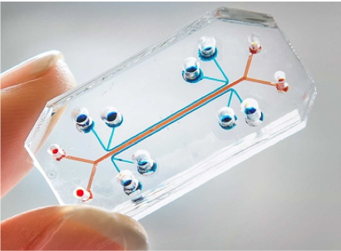
Organs-on-chips (OOC) are systems with artificial or real tiny tissues grown inside microfluidic chips, allowing the culture of cells in a microenvironment that is similar to that seen in vivo and that promotes the high expression of organotypic features. OOCs can replace or lessen the need for animal or pre-clinical testing. Additionally, OOCs contain biosensors that enable online assessments of cell viability and functioning in real time. Microfluidic methods might be used to link numerous OOCs made of tissues from various sources. The chip's tissues are exposed to the drug, and the tissue's reaction is determined based on how well the organ functions. This response includes the tissue's toxicity, drug metabolism, pharmacological effects, drug absorption and transport systems, and cell viability [29]. The terms "Chip" and "Organ" relate to designs that are based on microchip technology and the creation of microenvironments that are motivated by organ-level function, respectively. Animal sacrifice for pre-clinical research or experimental objectives will no longer be practised in the future. It is also used to predict how drugs would affect an organ's reaction to the environment.
.

Fig.23: Organ on chip

Single-Organ Chips
To eventually connect the single-organ chips with the full body system on a chip, scientists began to build the single-organ chips. These single-organism chips were created with the aid of the microchip and semiconductor industries. The first chip-based lungs were announced in a scientific publication, garnering worldwide attention [29]. Following the development of more biomimetic organ systems on chips, examples of chip-based organs include a liver on chip, kidney on chip, lung on a chip, gut on a chip, heart on chip, muscle on chip, blood brain barrier on chip, and a person on chip. Only intriguing subjects will be covered in further detail. That is a chipped lung and a chipped heart.
Multi Organ Chip
The body-on-chip (BOC) is another name for the multi-organ chip [30]. This device, which consists of many chambers connected by microfluidic flow channels that accurately mimic blood circulation, is nothing more than a mix of microscale technology and mathematical PK-PD (pharmacokinetic and pharmacodynamic) modeling [31]. The use of numerous micro-wells and a bioreactor allows for the connection of multiple micro-organs on the same plate. Each chamber is made up of several cellular kinds that correspond to various organs. For instance, the liver, skin, bone marrow, and tumour are linked chambers [32].
Timeline of organ on chip
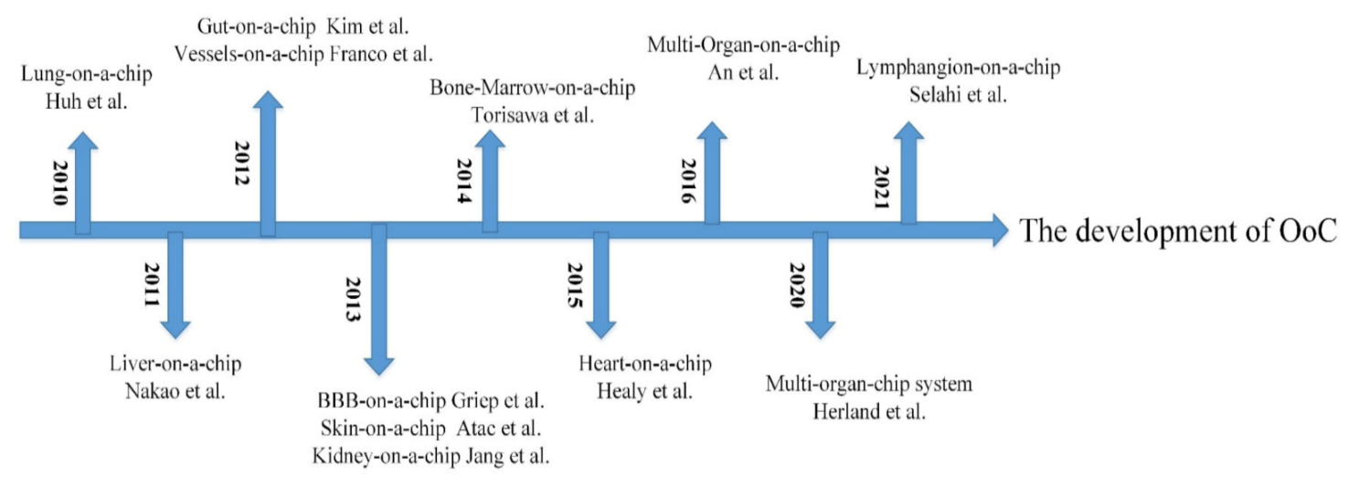
Fig.24: The development of Organ on chips
Lung on chip
The lung was described as the first organ system on a chip in a science publication, garnering widespread media attention.
The two lung lobes in each lung are further split from the trachea to the tiniest portion of the alveoli. On the broad surface of the alveoli, the gas exchange between the blood and the air takes place. The alveolar-capillary unit exists in the lungs. It has pulmonary microvascular endothelial cells and alveolar epithelial cells that are separated by a thin interstitial. In order to investigate lung toxicity or the use of pulmonary drugs, the alveolar membrane is crucial. Because of this, the alveolar membrane is a crucial functional component of the lung-on-chip model created by Huh. using PDMS (polydimethylsiloxane), which has a multi-layer microfluidic structure.
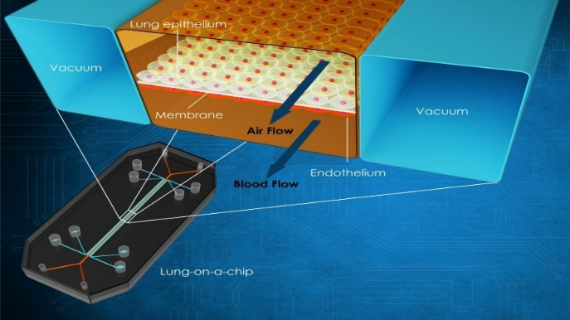
A thin (10 m) porous flexible PDMS membrane that was coated with ECM was used to isolate the instrument (fibronectin or collagen). Alveolar epithelial cells and pulmonary microvascular endothelial cells were grown on each side of the membrane. Vacuuming and restoring the gap on both sides should be done to activate the breathing-induced cyclic mechanical [33]. They discovered that silica nanoparticles considerably boosted the pro-inflammatory activity of respiratory exercise, which significantly contributed to the development of acute lung inflammation, in trials that give good knowledge about the hazardous effects of silica nanoparticles[34]. The experiment's findings demonstrate that the multi-layer OOC can more accurately replicate the mobility condition of minute particles in the human body as compared to the typical static culture system. This finding offers a study premise for a number of illnesses and medication toxicity.

Fig.25 Diagrammatic representation of lung on chip

:

Heart on chip
The heart is the most important organ in the human body, yet it is also one of the least regenerable [35]. In the past year, cardiovascular issues have gotten more attention [36]. In order to avoid heart disease, it is crucial to understand its pathophysiology. The advantage of microfluidic chips has been applied to in vitro research on cardiac tissues. By using muscle membrane MTF technology, the beat of cardiomyocytes is frequently utilised to determine a drug's impact and the heart's pumping action [37]. In 2011, scientists created a heart-chip construction. In order to obtain the muscular membrane, neonatal rat cardiomyocytes were transplanted on the elastic membrane. Based on this, Agarwal was able to assess the contractility that aids the heart test by utilising an engraving laser machine to produce sub-millimetre MTF. The design was made with the physiological environment in mind by Marso, Zhang . created endothelium myocardial tissue utilising the most recent 3D Bioprinting technique (direct laser writing photo lithography) [38],[39]. Human umbilical vein endothelial cells are moved around the microfiber scaffold after it has been produced to create a vascular bed. In order to create an endothelialized myocardium, cardiomyocytes were finally anchored onto the scaffold created by 3D bioprinting technology. This may then be utilised for drug screening after being cultivated in a microfluid perfusion bioreactor [40].
Applications Of Heart on Chip
Various applications of heart on chip, including disease modeling, drug screening, and physiological study
Physiological study
To better understand the physiological behaviour of the heart using organ-on-chip technology. Using the agarose material, Yasuda et al. created a heart-on-chip with a microchamber array [41]. A heart-on-a-chip was created by Wu to boost the circulatory system [42]. The four-chamber chip is referred to as having four pump units. In the heart-on-chip prototype, Varghese et al. looked at the impact of electrical stimulation on cardiomyocyte contraction [43].
Drug screening
Drug testing is one of the heart-on-most chip's crucial uses. Some medications' side effects might harm the heart or possibly lead to heart failure. Therefore, it is crucial to research the drug's induction of cardiotoxicity. Heart-on-chip is a reliable in vitro model that has a great potential for testing cardiotoxicity. Parker et al. discovered that isopropyl noradrenaline affects the contraction force of CMs utilising heart-on-a-chip [44].
Disease modelling
Another crucial stage in the research and development of medications for patient treatment is the understanding of illness processes with the use of disease modelling [45]. The pathophysiology of cardiac fibrosis may be studied using the heart-on-a-chip, and the patient can receive a successful therapy. Healy et al. created a 3D in vitro arrhythmia model with the aid of heart-on-a-chip, using ipsc-CMs and filamentous matrix to create the 3D microtissues [46].

CONCLUSION
3D printing is a revolutionary technology which advances the production of drugs with preplanned release characters and geometries. This technology utilizes CAD software (Computer-aided design) to feed data for printing to commence. 3D printing was found to be efficient and accurate technology in bionic and regenerative medicine various methods of capturing prints in this technology includes Vat polymerization Binder jetting, fused deposition modelling Power bed fusion and material jetting. Spritam “levetiracetam” was the first launch of 3Dprint, used for epilepsy. Current and future prospects focus on the coordination of 3D printing for the treatment of various diseases and for placing biochips, and prospective transformation of Organ transplants like kidneys, lungs, heart etc.…
REFERENCES:

- Vinod G Gokhare, Dr.D.N Raut, Dr.D.K Shinde. A review paper on 3D Printing aspects and various processes used in the 3D printing. International Journal of Engineering Research and Technology. Vol-6 Issue 06, June (2017)
- (https://spritam.com/what-is-zipdose-technology/ )
- Xiao Zhu, Hongjian Li, Lianfang Huang, Ming Zhang, Wenguo Fan, Liao Cui. 3D Printing promotes the development of drugs. Biomedicine &Pharmacotheraphy.131(2020) 110644
- Gu Qi,Hao Jie, Lu Yangjie, Wang Liu, Wallace gordon G, Zhou Qi. Three Dimensional bioprinting. Science China, vol-58 (2015) 411-419
- Jamróz W, Szafraniec J, Kurek M, Jachowicz R. 3D Printing in Pharmaceutical and Medical Applications - Recent Achievements and Challenges. Pharm Res. 2018 Jul 11;35(9):176. doi: 10.1007/s11095-018-2454-x. PMID: 29998405; PMCID: PMC6061505
- N.Shahrubdin,T.C.Lee, R.Ramlan. An Overview on 3D Printing technology: Technological materials and applications. Procedia Manufacturing (2019) 35 (1286-1296)
- Pamela Robles-Martinez, Xiaoyan Xu, Sarah J.Trenfield, Atheer Awad, Alvaro Goyanes. 3D Printing of a multi-layer polypill containing six drugs using a novel Stereolithography method. Pharmaceutics (2019),11 (274)
- Iria Seoane Viano, Sarah J. Trenfield, Abdul W. Basit, Alvaro Goyanes. Translating 3D Printing Pharmaceuticals; From Hype to real – world clinical application. Advanced drug delivery and reviews. 174.553-575(2020)
- F.Fina, A.Goyanes, C.M.Madla, A.Awad, S.J.Trenfield, J.M.Kuek,er.al. 3D Printing of drug loaded gyroid-lattices using selective laser sintering. International Journal of Pharmaceutics. 547 (1-2) (2018) 44-52
- C.Silbernagel, “Additive Manufacture: What is Material jetting? Canada Makers, (2018) (online) https://canadamakes.ca/what-is-material-jetting
- Ryan Varghese, Sahil Salvi, Purab Sood, Jainam Karsiya, Dileep Kumar. “3D Printed medicine for the management of chronic disease : The road less travelled”. Annals of 3D printed medicine 5 (2022) 100043.
- https://3dprintingindustry.com/news/triastek-receives-fda-ind-clearance-for-3d-printed-drug-to-treat-rheumatoid-arthritis-184159/.
- https://images.app.goo.gl/zTbA6vpyvJkMiULR7.
- Zengming Wang, Xiaolu Han, Ruxin Chen, Jingru Li, et.al, “Innovative color jet 3D printing of Levetiracetam personalized paediatric preparation”. Asian Journal of Pharmaceutical Sciences (2021).
- Katherina M Carey, Morgan R Comee, Jennifer L Donovan, and Abir O kanaan. “A Pollypill for all? Critical review of the polypill Literature for primary prevention of cardiovascular disease and stroke”. Annals of pharmacotherapy 2021 May, volume 46.
- https://images.app.goo.gl/dVWoyYqVGsRxHosCA.
- Christos I. Gioamouxouzi, Apostolos Baklavaridis,Orastis L,et.al,.“A 3D printed bilayer oral solid dosage form combining Metformin for prolonged and Glimepride for immediate drug delivery”. European Journal of Pharmaceutical sciences 120 (2018) 40- 52.
- https://www.mayoclinic.org/diseases-conditions/tuberculosis/symptoms-causes/syc-20351250.
- Atabak Ghanizadeh Tabirz,, Uttom Nandi, Andrew P.Hurt, Ho-Wah Hui,et.al, “3D Printed bilayer tablet with dual controlled drug release for Tuberculosis treatment”. International Journal of Pharmaceutics volume 593, 25 January 2021, 120147.
- N.Genina, J.P.Boetker, S.Colombo, N.Harmankaya,et.al,. “Anti-tuberculosis drug combination for controlled oral delivery using 3D printed compartmental dosage forms: From drug product design to in- vivo testing”. Journal of controlled release 268 (2017) 40 – 48.
- https://thebiologynotes.com/3d-bioprinting/
- Murphy, S., Atala, A. 3D bioprinting of tissues and organs. Nat Biotechnol 32, 773–785 (2014). https://doi.org/10.1038/nbt.2958
- Dey, Madhuri, and Ibrahim T Ozbolat. “3D bioprinting of cells, tissues and organs.” Scientific reports vol. 10,1 14023. 18 Aug. 2020, doi:10.1038/s41598-020-70086-y
- Peng, Weijie & Datta, Pallab & Ayan, Bugra & Ozbolat, Veli & Sosnoski, Donna & Ozbolat, Ibrahim.3D Bioprinting for Drug Discovery and Development in Pharmaceutics. Acta Biomaterialia.. (2017). 57. 10.1016.
- Susan Heid, Aldo R.Boccaccini. Advancing bioinks for 3D bioprinting using reactive fillers. Acto biomaterials 113(2020) 1-22
- Zhengjie Wu, Xin su, Yuanyuan Xu, Bin kong, Wei’s son & Shenglime. Bioprinting Three-dimensional cell-laden tissue constructs with controllable degradation. Scientific Reports Published;19 April (2016)
- Ecem Saygili, Asli Aybike Dogan-Gurbuz, Ozlem Yesil-Celiktas, Mohamed S. Draz. 3D Bioprinting: A powerful tool to leverage tissue engineering and microbial systems. Bioprinting. Volume 18. (2020).
- Pereira F.D.A.S., Parfenov V., Khesuani Y.D., Ovsianikov A., Mironov V. (2018) Commercial 3D Bioprinters. In: Ovsianikov A., Yoo J., Mironov V. (eds) 3D Printing and Biofabrication. Reference Series in Biomedical Engineering. Springer, Cham.
- N.Beibner, T.Lorenz and S.Reichl. Organ on chip. Springer International Publishing Switzerland (2016).
- Wang Y.I., Oleaga C., Long C.J. Self-contained, low-cost Body-on-a-Chip systems for drug development. Exp. Biol. Med. (2017); 242:1701–1713.
- Yizho, Ranjithkumar kankala Shibinwang, Al-Zhengchen. Multi Organs-on-chip; towards Long-Term Biomedical Investigations. Molecules. V.24(4);2019 Feb
- Wagner, I.; Materne, E.M.; Brincker, S.; Sussbier, U.; Fradrich, C.; Busek, M.; Sonntag, F.; Sakharov, D.A.; Trushkin, E.V.; Tonevitsky, A.G.; et al. A dynamic multi-organ-chip for long-term cultivation and substance testing proven by 3D human liver and skin tissue co-culture. Lab Chip (2013), 13, 3538–3547.
- Zening Li, Jianan Hui, Panhuiyang & Hongju mao. Microfluidic Organ-on-chip system form. Disease modelling and development biosensor. Published: 27 may (2022).
- Huh, D.; Matthews, B.D.; Mammoto, A.; Montoya-Zavala, M.; Hsin, H.Y.; Ingber, D.E. Reconstituting organ-level lung functions on a chip. Science (2010), 328, 1662–1668.
- Hirose, K.; Payumo, A.Y.; Cutie, S.; Hoang, A.; Zhang, H.; Guyot, R.; Lunn, D.; Bigley, R.B.; Yu, H.; Wang, J.; et al. Evidence for hormonal control of heart regenerative capacity during endothermy acquisition. Science (2019), 364, 184–188.
- Benjamin, E.J.; Muntner, P.; Alonso, A.; Bittencourt, M.S.; Callaway, C.W.; Carson, A.P.; Chamberlain, A.M.; Chang, A.R.; Cheng, S.; Das, S.R.; et al. heart disease and Stroke Statistics-2019 Update: A Report from the American Heart Association. Circulation (2019), 139, 56–528.
- Visone, R.; Gilardi, M.; Marsano, A.; Rasponi, M.; Bersini, S.; Moretti, M. Cardiac Meets Skeletal: What’s New in Microfluidic Models for Muscle Tissue Engineering. Molecules (2016), 21, 1128.
- Agarwal, A.; Goss, J.A.; Cho, A.; McCain, M.L.; Parker, K.K. Microfluidic heart on a chip for higher throughput pharmacological studies. Lab Chip (2013), 13, 3599–3608.
- Colosi, C.; Shin, S.R.; Manoharan, V.; Massa, S.; Costantini, M.; Barbetta, A.; Dokmeci, M.R.; Dentini, M.; Khademhosseini, A. Microfluidic Bioprinting of Heterogeneous 3D Tissue Constructs Using Low-Viscosity Bioink. Adv. Mater. (2016), 28, 677–684.
- Zhang, Y.S.; Arneri, A.; Bersini, S.; Shin, S.R.; Zhu, K.; Goli-Malekabadi, Z.; Aleman, J.; Colosi, C.; Busignani, F.; Dell’Erba, V.; et al. Bioprinting 3D microfibrous scaffolds for engineering endothelialized myocardium and heart-on-a-chip. Biomaterials (2016), 110, 45–59.

- Kaneko T, Kojima K, Yasuda K. An On-Chip Cardiomyocyte Cell Network Assay for Stable Drug Screening Regarding Community Effect of Cell Network Size. Analyst. 2007;132:892–8. https://doi.org/10.1039/b704961g. [PubMed] [Google Scholar]

- Chen Y, Chan HN, Michael SA, et al. A Microfluidic Circulatory System Integrated with Capillary-Assisted Pressure Sensors. Lab Chip. 2017;17:653–62. https://doi.org/10.1039/c6lc01427

- Aung A, Bhullar IS, Theprungsirikul J, et al. 3D Cardiac Mu Tissues Within a Microfluidic Device with Real-Time Contractile Stress Readout. Lab Chip. 2016;16:153–62. https://doi.org/10.1039/c5lc00820d.

- Agarwal A, Goss JA, Cho A, et al. Microfluidic Heart on a Chip for Higher Throughput Pharmacological Studies. Lab Chip. 2013;13:3599–608.

- . Savoji H, Mohammadi MH, Rafatian N, et al. Cardiovascular Disease Models:A Game Changing Paradigm in Drug Discovery and Screening. Biomaterials. 2019;198:3–26.

- Ma Z, Koo S, Finnegan MA, et al. Three-Dimensional Filamentous Human Diseased Cardiac Tissue Model. Biomaterials. 2014;35:1367–77. https://doi.org/10.1016/j.biomaterials.2013.10.052

