Noise Reduction and compression of Very Low Frequency (VLF) Transients using Wavelet Based Techniques

D.K. Sondhiya  School of Science  SAGE University Bhopal, India | Dr. Preeti Singh  Department Of Physical science  Rabindra Nath Tagore University , Bhopal
S.K. Kasde
Department of Physics
Government College Bhainsdehi, Betul, India

ABSTRACT
Noises in the signal were generated due to various natural and manmade causes like excess use of heavy machines, spacecraft’s and lighting and sometimes due to volcanic eruption and earthquakes. These noises degrade the quality of observed signals and responsible for the loss of information. To retrieve the information from these noisy signals various methods based on Linear Band Pass Filter (BPF) were used, but efficiency of BPF was compromised when dealing with Non-Gaussian like natural Very Low Frequency (VLF) signals. Here, we have used wavelet thresholding based denoising method for denoising of VLF signal. It was found that wavelet thresholding method denoise the signal without affecting it original shape.
Keywords - VLF signal, Wavelet Transform, wavelet thresholding, Filter bank
- Introduction
Noise in the signal were defined as unwanted frequency content in the signal and generally considered as undesired parts of the signal, which corrupt the important information associated with the signal. Retrieval of significant information from noisy signal is an important task in signal processing. Linear Band Pass Filter (BPF) were used to perform this tasks, which is based on phase properties. BPF perform well for stationary signal but it efficiency reduce in case of non-stationary signal [1]. Weiger filter were used as alternative solution of this problem it focus on minimizing mean square error between signal and denoised signals [2]. But it also does hold good for the VLF transients due to its highly non-stationary nature. To denoised the VLF signal wavelet based denoising [4] and compression [5] technique were used for the VLF transient noise reduction and compression.
- Wavelet Analysis
In wavelet analysis similarity is calculated between the signal and mother wavelet $ψ\left(t\right)$for different time intervals and results were represented in two or three dimensional plot.
Criterion for Mother Wavelet:
- It content finite energy
$$E=\int_{-∞}^{∞}{{\left|ψ(t)\right|}^{2}<∞} (1)$$

- Condition of admissibility
$${ C}_{ψ}=\int_{0}^{∞}{\frac{{\left|\hat{f}\left(ω\right)\right|}^{2}}{f}df<∞} \left(2\right)$$
Where $\hat{f}\left(ω\right)=$ Fourier tranform
It implies that mean of the wavelet $ψ\left(t\right)$ must be equal to zero.
- For complex wavelets the Fourier transform $ψ\left(f\right)$ must be real and vanish for negative frequencies.
- Wavelet Transform
There are two types of Wavelet transform
- Continuous Wavelet Transform (CWT)
The CWT of a function$f\left(t\right)$is given by [5]:
$$Wf\left(x,s\right)=\frac{1}{\sqrt{\left|s\right|}}\int_{-∞}^{∞}{f\left(t\right)ψ^{*}}\left(\frac{t-x}{s}\right)dt (3)$$
Where $s=$ Scale factor
To normalize the energy of VLF signals at various scales the wavelet coefficients are divided by the factor$\sqrt{\left|s\right|}$ and also $ψ(t)$ localized in frequency and time. Increasing the value of $s$ decrease the time resolution $∆t$ and increases the frequency resolution$∆f$. It is well established that $∆t.∆f$ is constant, which gives:
$$\frac{∆f}{f}= (4)$$
Where $c$ is constant, which implies that frequency resolution is constant in wavelet analysis.
The scaling parameter $s$ and translation parameter$x$, known as wavelet series were used to calculate the value of CWT. The constant relative frequency resolution (Q property) of wavelet analysis was defined as ration of center frequency $f_{c}$ and bandwidth $f_{b}$ [6]. The best choice for wavelet series construct is given by:
${ Wf}_{m,n}=\int_{-∞}^{∞}{f\left(t\right)ψ_{m,n}\left(t\right)dt, }$ With $ψ_{m,n}=s_{0}^{-\frac{m}{2}}ψ\left(s_{0}^{-m}t-nτ_{0}\right) (5)$
For a dyadic grid, $s_{o}=0$ and $τ_{0}=1$. The reconstruction of the original signal is possible only if following condition was fulfilled
$$f\left(t\right)=\sum_{m=-∞}^{∞}{\sum_{n=-∞}^{∞}{{Wf}_{m,n}ψ_{m,n}}\left(t\right) }(6)$$
The CWT provides good frequency resolution and good time resolution for high frequencies (small scales) and low frequencies (large scales) respectively.
Generally Morlet wavelet function was used for the analysis, which was obtained by Gaussian (bell shaped) window:
$ψ\left(t\right)=g\left(t\right)e^{-j2πf_{c}t},$ $g\left(t\right)=\sqrt{πf_{b}}e^{\frac{t^{2}}{f_{b}}} (7)$
Here
$f_{c}$ = center frequency
$f_{b}$ = bandwidth parameter
In analyzing function $f_{c}$ and $f_{b}$parameters determine the number of cycles. For the Morlet wavelet
$$f=\frac{f_{c}}{s} (8)$$
- Discrete wavelet transform
It was very easy to design orthonormal bases for discrete time series as compare to its continuous equivalent. It is realized by a structure called filter bank. The time frequency resolution of expanded filter bank is always same as wavelet transform.
Filter banks

H(z)
↓2
$$H^{,}(z)$$

↑2

$$f(t)$$
$$y(t)$$

L(z)

↓2
$$L^{,}(z)$$

↑2

Analysis bank
Synthesis bank

Figure 1: A filter bank of two channels

Figure 1 shows a filter bank of two channels, which is the collection of discrete filter with a common input and output. It separates the signal frequency content using low pass filter $L\left(z\right)$and a high pass filter$H\left(z\right)$ known as sub-bands and the technique called sub-band coding. As both the filter output content equal amount of sample, but half frequnct content therefore number of sample is double as compared to input signal. Hence down sampling by a factor two $\left(↓2\right)$ was applied at the output of filter bank.
During the reconstruction of original signals, signals were up-sampled by factor $\left(↑2\right)$ using synthesis filter bank and passes through $L^{'}\left(z\right)$ and$H^{'}\left(z\right)$ [7].
Down and up sampling
Down sampling by a factor two is seems to be logical after the application of analysis bank as the information is not double so no need to double the number of samples. The down sampling operation is a non-invertible operation as, it saves only even numbered output components, which prevent the data loss. The loss of information should be reduced by using Shannon sampling theorem according to this down sampling signal by factor M construct a signal whose spectrum is estimated by dividing the signal into M equal bands.

$x=\left[\begin{matrix}. \\ \begin{matrix}x(0) \\ \begin{matrix}x(1) \\ x(2) \\ x(3)\end{matrix} \\ x(4)\end{matrix} \\ .\end{matrix}\right]$ $\left(↓2\right)=\left[\begin{matrix}. \\ \begin{matrix}x(0) \\ x(2) \\ x(4)\end{matrix} \\ .\end{matrix}\right]$ $\left(↑2\right)\left(↓2\right)=\left[\begin{matrix}. \\ \begin{matrix}x(0) \\ 0 \\ x(2)\end{matrix} \\ \begin{matrix}0 \\ x(4) \\ .\end{matrix}\end{matrix}\right] (9)$
The transpose of $\left(↓2\right)$ is$\left(↑2\right)$
Hence,$\left(↑2\right)\left(↓2\right)=I$, since $\left(↑2\right)$
So it is possible to obtain original signal
Perfect reconstruction
Biorthogonal filter were used for perfect reconstruction of signal. For perfect reconstruction of signal, the filter bank needs to be. Also for perfect reconstruction of signal some designing criterion for preventing the aliasing and distortion should be fulfilled.
Two channel filter bank fragmented the signal into two frequency bands using the filter as illustrated in Figure 1, For perfect brick wall filter down sampling would not leads to loss of information, but is not possible to realized in practice as shown in Figure 2.
$$\left|H\right|$$
$$\left|L\right|$$

$$\frac{1}{2}f_{n}$$
$$f_{n}$$

Figure 2: Phase Response of Two channel Filter Bank
In two channel filter bank aliasing can be reduced by using synthesis filter bank as::
$${ L}^{'} \left(z\right)=H\left(-z\right) (10)$$
$${ H}^{'} \left(z\right)=-L(-z) (11)$$
${ P}_{0}\left(z\right)=L^{'}\left(z\right)L(z)$ is a products filter which eliminate the distortion. Also it is eluded if $H^{'}\left(z\right)$
${ P}_{0}\left(z\right)-P_{0}\left(-z\right)=2z^{-N}$ $(12)$
Where N = overall delay in filter banks

Multiresolution Filter Banks
L(z)
H(z)
$$↓2$$
$$↓2$$

L(z)

H(z)

$$↓2$$

$$↓2$$

L(z)

H(z)

$$↓2$$

$$↓2$$

$$↑2$$

$$↑2$$
$$H^{'}(z)$$
$$L^{'}(z)$$

$$↑2$$

$$↑2$$

$$H^{'}(z)$$

$$L^{'}(z)$$

$$↑2$$

$$↑2$$

$$H^{'}(z)$$

$$L^{'}(z)$$

Level 1
Level 2
Level 3
Level 3
Level 2
Level 1
$$x(n)$$
$$y_{3}(n)$$
$$y_{2}(n)$$
$$y_{1}(n)$$
$$y_{0}(n)$$
$$\hat{x}(n)$$
$$y_{3}(n)$$
$$y_{2}(n)$$
$$y_{1}(n)$$
$$y_{0}(n)$$

- Synthesis Bank

- Analysis Bank

Figure 3: Three Channel Filter Bank
It is possible to obtained multiresoution of signal with the help of Discrete Wavelet Transform (DWT) at various frequency range. DWT filter bank produced signal approximation and details using low and high pass filter respectively. It is possible to find any desired level of resolution using filter bank of higher order. Figure 3 shows a three level filter bank in which coefficient $y_{l}\left(x\right)$coefficient represents half lowest frequencies in$x\left(n\right)$. Also frequency resolution is double during the down sampling due to which only half numbers of samples are presents in$y_{l}(x)$.
Wavelet Filters
$$H_{h}(z)$$
$$H_{lh}(z)$$
$$H_{llh}(z)$$
$$H_{lllh}(z)$$
↓2
↓4
↓8
↓8
↑2
↑4
↑8
↑8
$$H_{h}^{'} (z)$$

$$H_{lh}^{'}(z)$$

$$H_{llh}^{'}(z)$$
$$H_{lllh}^{'}(z)$$
$$y(n)$$
$$c_{h}(k)$$
$$c_{lh}(k)$$
$$c_{llh}(k)$$
$$c_{lllh}(k)$$
$$y(n)$$

Figure 4: Equivalent of Figure 3

To compare the CWT and DWT filter bank of Figure 3 can be redrawn in Figure 4. An increase rate of down sampling provides large time scale for the lowest frequencies (or higher scale). At higher level if impulse level of a particular filter is a stable waveform $L\left(z\right)$and $H\left(z\right)$ are considered as wavelet filters and its subsequent scaled versions were known as regular [8]. These wavelet filter are further classified as orthogonal and biorthogonal filters. For the easiest construction of limit functions the impulse responses are calculated from the reconstruction path. Starting from the lower branch of synthesis bank (Figure 3 (c)), which consists of low-pass filters and up sampling in between. Both filters are FIR filters from the definition of Quadratic Mirror Filter (QMF). After several interaction if impulse response converges to final function $l(n)$ and satisfied the equation (13), then
$$∅\left(t\right)=\sum_{n=0}^{N}{l\left(n\right)∅(2t-n)} (13)$$ Thus, this function is known as wavelet scaling function [9]. Similarly, it is also possible to obtain a final function for the band pass sequence by this method, except for high pass filter and this function $h_{c}$(t) is known as the wavelet$ψ(t)$:
$$ψ\left(t\right)=\sum_{n=0}^{N}{h\left(n\right)ψ(2t-n)} (14)$$
For a wavelet $c_{lll}$ sub band $cA$ and $cD$ is known as approximation and details, which contains the lowest frequencies and detail information of the signal respectively.
For a p-level decomposition, the highest approximation coefficients $cA$ related with sample frequency $f_{s}$ can be calculated as
$${ f}_{l}=\frac{f_{s}}{2^{p+1}} (15)$$
Also the $cA$ and detail frequency bands $cD$ can be calculated as
${ f}_{cA}=[0, 2^{-p-1}f_{s}$] $(16)$
$${ f}_{cD_{p}}=[2^{-p-1}f_{s, }2^{-p}f_{s}] (17)$$
Here
$f_{cA}=$approximation frequency band
$f_{cD}=$detail frequency band
The resolution of decomposition is strongly depends on chosen wavelet filter and signal properties.
- Wavelet Based Noise Reduction Techniques
The Wavelet decomposition of VLF transients gives a matrix, whose coefficients contains all the necessary information required for reconstruction the signal. The large coefficient have very good correlation with the input VLF transients and the other hand small coefficient have comparably poor correlation them. For signal noise reduction it is important to choose the wavelet coefficient in order to preserve the complete shape of transients and remaining the coefficient associated with signal noise. There are two properties of wavelet transform which separate the noise coefficient from the rest are:
- The significant choice of wavelet basis, matched with the signal characteristic.
- The coefficient of transformation for input transients that are a zero mean with uncorrelated sample (white noise). Also for Gaussian distributed transients wavelet coefficients will be Gaussian and independent. For suitable basis applied to decomposed a noisy signal will produced a high degree of correlation and low degree of correlation with noise for suitable basis applied to decompose a signal.
The denosing process
- Decompose the signal using appropriate mother wavelet.
- Removing the noise using suitable thresholding method.
- Reconstruct of signal using inverse wavelet transform.
- The Noise Estimation
The estimation of proper denoising level is most important step in the noise reduction process. Generally it is done by threshold the signal from a specified level.
If transformation coefficient were taken as a noisy observation series, then from normal decision theory, the observation $w={(w_{i})}_{i=1}^{n}$ were given according to:
$w_{i}=θ_{i}+εz_{i}$ $\left(i=1,…, n\right), (18)$
Where $z_{i}$ are distributed independent and identically as $N\left(0,1\right), ε>0$ was consider as noise level and $θ=\left(θ_{i}\right)$ is the quantity of interest (signal to retained).
Donoho and Jonhstone [10] estimates the value of $ε$ as the ratio of coefficients and absolute median deviation E and 0.6745 at fine scale. If $X=\left\{x_{i}\right\}$ is independently and identically distributed variable then E is defined as:
$E=median\left|x_{i}-median(X)\right|=median\left|x_{i}\right|$ $(19)$
As illustrated in Figure 3, the coefficients$q_{1}$and $q_{2}$ were defined as two values of X as they bound 50% of the distribution of $X=\left\{x_{i}\right\}$ at center. From table of standard normal distributions$q_{2}=-q_{1}=0.6745ε$. The absolute value of $X$ will have $50\%$ of its values bounded by $0≤X≤q_{2,}$so that$median\left|x_{i}\right|=q_{2,}=E=0.6745ε$, or $ε=E/0.6745.$

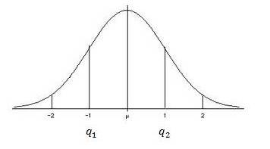

Figure 5: Normal distribution curve indicating center 50%
After determination of noise level, threshold value ${(T}_{u})$ is set by some constant multiple of noise standard deviation. For Example
(e.g.,$T=m*o$, where $m$ typically lies in the interval $2<m<5$.
There are four methods for computation of a threshold value
- The Universal Threshold
Leadbetter et al. [11] estimate the value of universal threshold by statistical theorem given. Let us consider an independent and identical distribution $N\left(0,ε\right)$of variables${ X}_{i}$, then as$N→∞$,
$P\left(\max_{i}\left|X_{i}\right|≤T_{u}\right)=1$ $(20)$
Where $T_{u}$ is given by
${ T}_{u}=σ\sqrt{2\log\left(N\right)}$ $\left(21\right)$
To understand the rationales for this threshold consider a VLF transient $"s"$ as a vector of zeros, whose transformation coefficients $\left\{D_{j,t}^{(s)}\right\}$ are a part of an independent and identical distribution Gaussian series $\left\{e_{j,t}\right\}$ with zero mean and variance$σ_{ε}^{2}$ . If $N→∞$, then
$P\left[max\left\{\left|D_{j,t}^{(s)}\right|≤T_{U}\right\}\right]≡P\left[max\left\{\left|e_{j,t}\right|≤T_{U}\right\}\right]→1$ $(22)$
Universal thresholding removes the noise therefore some time small signal coefficients are mistakenly set to zero. The value of $σ_{ε}^{2 }$ is estimated by Median Absolute Deviation (MAD) standard deviation estimate by using coefficients in $D_{1}^{(s)}$ at $N/2$ level $j=1$ $.$ So
$${\hat{σ}}_{MAD}≡\frac{median\left\{\left|D_{1,0}^{(s)}\right|,\left|D_{1,1}^{(s)}\right|,…, \left|D_{1,\frac{N}{2}-1}^{(s)}\right|\right\}}{0.6745} (23)$$To make ${\hat{σ}}_{MAD}$ suitable estimator of standard deviation for Gaussian white noise the factor $0.6745$ was rescaled. ${\hat{σ}}_{MAD}$ was estimated from the elements of $D_{1}^{(s)}$because it is noise dominated with the possible exception of the largest values.
- Steins Unbiased Risk Estimator (SURE) Threshold
Donoho and Johnstone [12] proposed a new method of threshold calculations known as SURE threshold based on the work of Stein [13].
- Hybrid Threshold
In case of signal with low energy SURE threshold $(T_{s})$ provides inaccurate results due to dominated noise, which produce inaccurate results. Therefore hybrid method threshold ${(T}_{H })$is selected among (${ T}_{u})$ and $(T_{s})$ on the basis of significant detected signal energy.
- MiniMax Threshold
Donoho and Johnstone, [10] and Bruce and Gao [14] used this principal in wavelet thresholding. In this method MiniMax threshold values were tabulated as a function of sample size.
- Wavelet Thresholding Methods
Two different methods of thresholding are generally used in denoising problem known as hard and soft threshoding.
- Hard Thresholding
The non-linear hard thresholding function $y_{hard}$ was analytically written as:
$y_{hard}=\left\{\begin{aligned} D_{j,t}^{(s)} \left|D_{j,t}^{(s)}\right|>thr thr≥0 \\ 0 \left|D_{j,t}^{(s)}\right|≤thr\end{aligned} \right. (24)$
here “thr” is the threshold estimated by user [15]. It retained all the coefficient above the threshold value and set all other to zero. Main disadvantage of this method that it removes all fine details below threshold level and produce fictitious oscillations.
B. Soft Thresholding
The non-linear hard thresholding function known as soft thresholding or “wavelet shrinkage” $y_{soft}$ is defined as:
$y_{soft}=\left\{\begin{aligned}sign\left(dD_{j,t}^{(s)}\right).\left(\left|dD_{j,t}^{(s)}\right|-thr\right) \left|D_{j,t}^{(s)}\right|>thr,thr≥0 \\ 0 \left|D_{j,t}^{(s)}\right|≤thr\end{aligned}\right.$ $(25)$
In soft thresholding method all the coefficient, whose coefficient is smaller than $y_{soft}$ were set to zero and magnitude f remaining coefficient were modified as per threshold value [10].
Translational Invariant Denoising
Wavelet denoising with DWT can occasionally produce artefacts generated due to bad alignment of signal discontinuity with wavelet [15]. Cycle Spinning (CS) denoising algorithm based on wavelet denoising technique was proposed by Coifman and Donoho [15] to get rid of these difficulties. CS algorithm was designed to suppress artefacts around the discontinuities introduced by DWT. Data is shifted for a variety of delays and its DWT is computed as a result the outcome is unshifted. In order to create a quasi-shift-invariant DWT, this process is repeated for a variety of shifts, and the results are averaged. The number of shifts that this transform produces in the input signal directly relates to how redundant it is. In terms of all circular shifts of the input signal, CS and a translation-invariant WT are equal.
Let us consider s(i) and s(i-p) represents the original and threshold signal respectively, then:
$s_{B}^{p}\left(α\right)=〈s\left(n-p\right),g_{α}\left(n\right)〉=〈s\left(n\right),g_{α}\left(n+p\right)〉 (26)$
The vectors $g_{α}\left(n+p\right)$are not in the basis$B={\left\{g_{α}\right\}}_{α∈A}$. It yields an estimate $\hat{u^{p}}$ for every translated version$s^{p}$ of the original signal:
$\hat{u^{p}}=Ds^{p }= \sum_{α∈A}{a^{p}\left(α\right)s_{B}^{p}(α)g_{α}} (27)$CS based Translation Invariant Wavelet Thresholding $(TIWT)$ was achieved by averaging these estimations after translated in inverse sense:
$$TIWT\left(s\right)= \frac{1}{\left|I\right|}\sum_{p∈I}{{\hat{u}}^{p}(i+p)} (28)$$ VI. Data Source
VLF whistlers and hiss transients signals were taken from French Micro satellite DEMETER during 2004-2010 for the mid latitude.
VII. Wavelet Based Noise Reduction
A. DWT and Universal Thresholding
The observed VLF signal consists of VLF transients with some type of atmospheric noises analytically written as:
$s=x+ε$ $(29)$ Where $x$ is a VLF transient and $ε$ represents independent and identically distributed (i.i.d) vector of dimension N (Gaussian noise).
For the purpose of denoising via thresholding Dohono and Johonstone, [10] recommended computation of partial DWT of level $J_{0}$ giving coefficient vectors $cD_{1}^{(s)},…., {cD}_{J_{0}}^{(s)}$ and${ cA}_{J_{0}}^{(s)}$. We have:
${cD}_{j,t}^{\left(s\right)}=d_{j,t}+e_{j,t}$ $(30)$
$j=1,…, j_{0}; t=0,…., N_{j}-1$
In thresholding process the coefficients of vector ${cD}_{k}^{\left(s\right)}$ are subject to change, but the coefficient of ${c A}_{J_{0}}^{\left(s\right)}$ were reamin unchanged therefore the portion of s is automatically assign to signal X. After that threshold method must be selected and chosen thresholding rule were apply on ${cD}_{j,t}^{\left(s\right)} j=1, …, J_{0}$ and $t=0,…, N_{j}-1,$to obtained the threshold coefficient $\left\{c{\hat{D}}_{j,t}^{(s)}\right\}$ to form ${\hat{ cD}}_{j}^{(s)}, j=1, …, J_{o}$. D is estimated as $\hat{X}$ obtained by inverse transformation of
$c{\hat{D}}_{1}^{(s)}, …, {\hat{cD}}_{J_{0}}^{(s)}$ and${ \hat{cA}}_{J_{0}}^{(s)}$.
VIII. Denoising Algorithm
Algorithm for signal denoising was illustrated in Figure 9.

Observed VLF Signal
Normalization of Observed VLF signal
Wavelet Decomposition of VLF signal
Wavelet Threshold
Inverse Wavelet transform of VLF signal
Denoised VLF signal

Figure 6: Denoising algorithm using Wavelet thresholding
- Noise normalizing
For Scaling of the input $N (0,1)$ noise is produced by accomplished by using Wavelab.700 toolbox [16].
- Segmenting the VLF transients
Segmentation the data in to blocks prior to processing provides the opportunity to handle large amount of stored data and allow the extension of technique. In our case Sampling frequency of VLF signal recorded by DEMETER satellite was$40 kHz$, hence $32768$ sample approximately represents $0.81 sec$ of VLF signal.
- Signal Decomposition
Selection of proper wavelet basis plays an important role in in overall performance of algorithm, but unfortunately there is no precise method to choose proper wavelet basis. Primarily it is done by comparison of results using various wavelet basis.
- Thresholding
Soft thresholding with modified universal threshold value T_{u} and level dependent the thresholding were used in this work.
- Reconstruction
Segment of each denoised signal is transformed back to the signal domain where it is weighed and overlapped to allow for smooth reconstruction.
IX. Performance Analysis of Proposed Denoising Algorithm Based on Wavelet Thresholding
In proposed noise reduction algorithm Quadratic Mirror Filters (QMF) are used to smooth the signal observed at the normalization stage. In the next stage transients are decomposed in various sub-bands with “Morlet” wavelet function with level of decomposition 5.
The value of threshold is estimated by modified universal threshold function given in equation (21). Finally this estimated value is used with the soft thresholding method to reconstruct the signal. The waveform of transients observed with their denoised version is demonstrated in Figure 7 and Figure 8 upper and lower panel respectively shows observed and denised signals.
SNR and crest factor (C.F) were used to test the performance of algorithem. The result is summarized in a Table 1 and Tables 2.
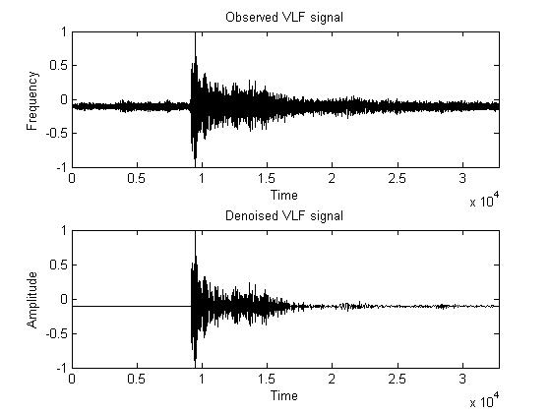
Figure 7: Observed and Denoised VLF Whistler signal
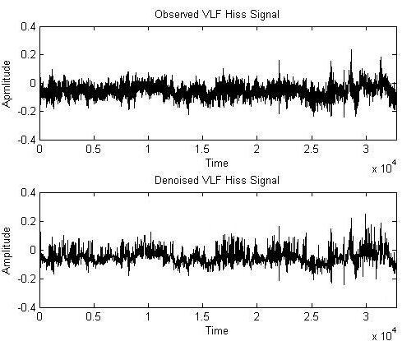

Figure 8: Observed and Denoised VLF Hiss signal
- Signal to Noise Ratio (SNR)
SNR is defined as ratio of signal power to noise and analytically it is given by:
$SNR=10\log_{10}\left(\frac{P_{signal}}{P_{noise}}\right)=P_{signal}-P_{Noise}\left(indb\right)$ $\left(31\right)$
If post SNR is higher than the pre SNR the denoising is considered to be successful [17].
- Crest Factor (CF)
It is defined as [18]:
$CF=\frac{{\left|x\right|}_{peak}}{x_{rms}}$ $(32)$
Where ${\left|x\right|}_{peak}=$amplitude of waveform
$x_{rms}=$RMS value of waveform
Table 1: Performance for VLF Whistlers
Signal | SNR (in db) | Creast Factor
Observed | 12.89 | 9.21
Denoised | 13.73 | 9.23

Table 2: Performance for VLF Hiss
Signal | SNR (in db) | Creast Factor
Observed | 23.56 | 4.35
Denoised | 26.00 | 4.21

Visual analysis
For visual inspection of observed and denoised VLF whistlers and hiss signal spectrogram were used which is illustrated in Figure 9 and Figure 10.
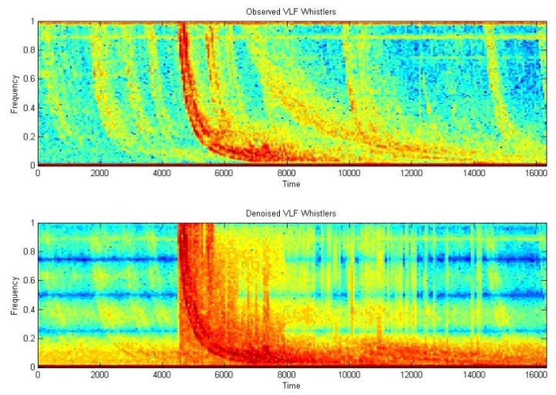
Figure 9: Spectogram of VLF Whistler
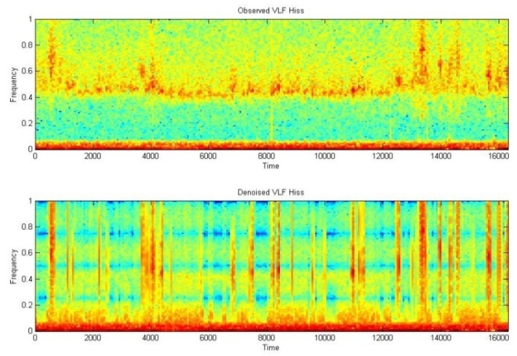
Figure 10: Spectogram of VLF Hiss
X. Noise Reduction with Wavelet Based Compression Technique
Natarajan [19] proposed a method for additive noise removal from the signal. The advantage of this method is that it does not required any information of observed signal and its frequency content. Further Natarajan [20] used piecewise linear compression technique for reduction of noise in the signal. Many researcher used compression technique in denoising processing e.g. seismic data compression [21], Kiely and Stromberg et al., use sub band coding [22] and Low bit-rate efficient compression for seismic data [23] and atmospheric data compression [24]. Various data compression techniques based on wavelet transform have been used for scientific data compression and noise reduction [26]-[33].
Level Dependent Thresholding
It is characterized by the three parameters (Birge-Massart strategy);
J = level of decomposition,
M = length of coefficients coarsest approximation
$α$ = always real and greater than 1 [34].
The strategy is such that:
- At level $J_{0}+1$ all is kept.
- The absolute value of larger coefficient $n_{J}$ for level $J$ from 1 to $J_{0}$is given by:
$${ n}_{J}=\frac{m}{{\left(J_{0}+1-J\right)}^{α}} (33)$$
The suggested value for $α$ is 1
Let us consider L represent the length of coarsest approximation coefficients for the VLF transients. On the basis of value of L three different choices scarce high, medium and low are proposed for M for which M=L, M = 1.5*L and M = 2*L respectively.
XI. Noise Reduction and Compression Using By-Level Wavelet Thresholding
The process used for signal compression is depicted in Figure 11. It involves three steps:-
- Wavelet Decomposition
- Thresholding the detail coefficient
- Reconstruction
The waveform of VLF whistler and were shown in Figure 12 and Figure 13.

Observed VLF Signal
Normalization of Observed VLF signal
Wavelet Decomposition of VLF signal
Wavelet Threshold (By-Level thresholding)
Inverse Wavelet transform of VLF signal
Output VLF signal

Figure 11: VLF signal Noise reduction and compression

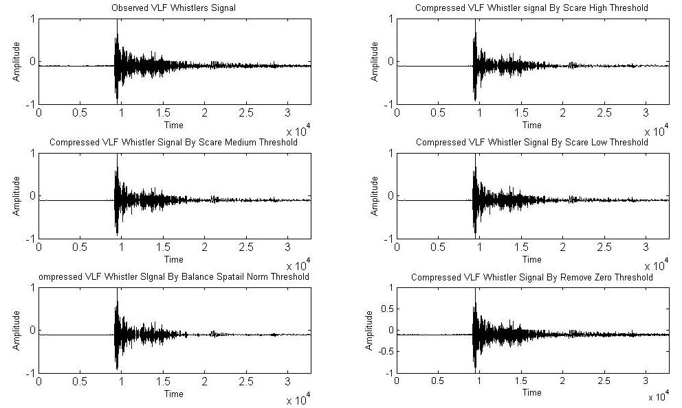
Figure 12: Observed and Compressed VLF Whistlers signal

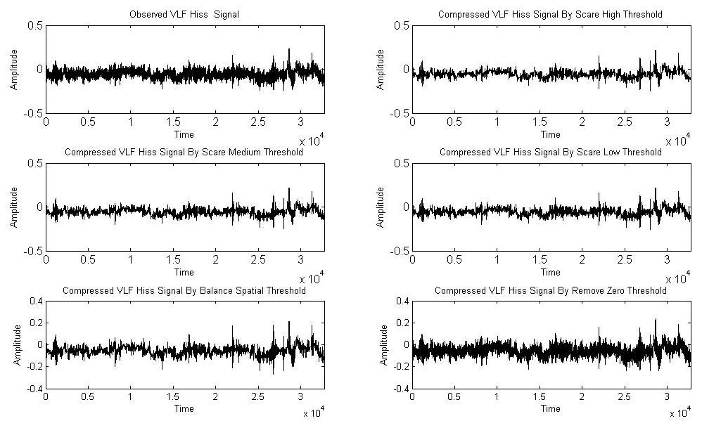

Figure 13: Observed and Compressed VLF Hiss signal
During analysis, we have tested various denoising methods such as Scare Low (SL), Scare Medium (SM), Scare high (SH), Near Zero (NZ) and Balance Spatial Norm (BSN) method. Each method produced different results for some size of signals.
XII. Performance Analysis of Proposed Noise Reduction Algorithm Based on Level Thresholding
To test the performance of proposed algorithm SNR and CF were calculated and results were summarized in Table 3 and Table 4.
Table 3: Performance of Level dependent Thresholding for VLF Whistlers signal

Signal | Thresholding Method | SNR | CF
Observed | - | 13.42 | 13.14
Reconstructed | SL | 16.03 | 15.14
Reconstructed | SM | 15.55 | 14.16
Reconstructed | SH | 15.35 | 14.25
Reconstructed | NZ | 14.79 | 13.56
Reconstructed | BSN | 13.43 | 13.01

Table 4: Performance of Level dependent Thresholding for VLF Hiss signal

Signal | Thresholding Method | SNR | CF
Observed | - | 25.39 | 5.27
Compressed | SL | 25.99 | 5.24
Compressed | SM | 25.90 | 5.22
Compressed | SH | 25.80 | 5.27
Compressed | NZ | 2.04 | 5.12
Compressed | BSN | 25.13 | 5.11
An enhanced SNR value indicate the enhancement quality of signal. The value of C.F. is approximately same in most of the cases.
XIII. Conclusion
In this chapter two different methods were proposed for denoising of VLF signal which is based on wavelet thresholding. For this purpose soft thresholding is used. To maintain the stability of representation translation invariant denoising is used in this work. Proposed denoising algorithm is depends on resolution hence to increased the resolution level chosen threshold function must be changed. The algorithm is particularly more important when signal contains the same variation pattern like VLF Hiss. It also provides more detail picture of Whistlers transients. It was concluded that wavelet based methods were efficient for denoising of VLF transients.
REFERENCES

[1] S. Umbaugh, “Computer Vision and Image Processing,” Prentice Hall, PTR, New Jersey, 1998.
[2] K. Toyamu, K. Krumm, B. Brumitt and B. Meyers, “Wallflower: Principles and practice of background maintenance”, Computer vision, The proceeding of seventh IEEE international conference, 1999.
[3] D.L. Donoho, “ Denoising by Soft Thresholding”, Technical Report no. 409, University, December 1992.
[4] J. Karam and R. Saad, “The Effect of Different Compression Schemes on Speech Signals”, International Journal of Biological and Life Sciences 1:4, 2005.
[5] S.G. Mallat and W.L. Hwang, “Singularity Detection and Processing with Wavelets”, IEEE Transactions on Information Theory, vol. 38, 1992, pp. 617–643.
[6] M.G.E. Schneiders, “Wavelets in control engineering”, Master’s thesis, Eindhoven University of Technology, 2001.
[7] G. Strang and T. Hguyen. “Wavelets and Filter Banks”, Wellesley-Cambridge Press, second edition, 1997.
[8] I. Daubechies, “Ten lectures on wavelets”, Society for industrial and Applied Mathematics , PA, 1992.
[9] P.S. Addison, “The Illustrated Wavelet Transform Handbook”, IOP Publishing Ltd, 2002.
[10] D. Donoho and I. Jonhstone, “Ideal Spatial Adaptation by Wavelet Shrinkage”, Biometrika, Journal of the American Statistical Association, Vol. 81, issue 3, 1994, pp.425-455.
[11] M. Leadbetter, G. Lindgren and H. Rootzen, “Extremes and Related properties of random sequences and Process”, Speinger-verlag, New York, 1983.
[12] D. Donoho and I. Johnstonne, “Adapting to Unknown Smoothness via Wavelet Shrinkage”, Vol. 90, 1200-1244, 1995.
[13] C. Stein, “Estimation of the Mean of a Multivariate Normal Distribution”, Annals of Statistics, vol. 9, 1981, pp. 1135-1151.
[14] A. Bruce, H. Gao and Waveshrink, “Shrinkage Functions and thresholds”, Technical Report, Statsci Division of Mathsoft, Inc, 1995.
[15] R. Coifman and D. Donoho, “Translational-Invariant Denoising”, Internal Report, Department of Statistics, Stanford University, 1995.
[16] C.S. Buckheit, D. Donoho and J. Scargle, “Wavelab.700”, http://www.wavelab/playfair.stanford.edu, 1996.
[17] S. Mallat, “A Wavelet Tour of Signal Processing: The Sparse Way”, Academic Press, 2008.
[18] P.D. Hill, B.W.V Lee, J.S. Osborne, E.L. Osman, “Palatal snoring identified by acoustic crest factor analysis", PHYSL MEAS, vol. 20, issue 2, 1999, pp. 167-174.
[19] B.K. Natarajan, “Filtering random noise via data compression”, Proceeding IEEE Data Compression Conf., Snowbird, Utah, 1993, pp. 60-69.
[20] B.K. Natarajan, “A General Technique for Filtering Random Noise”, Computer Systems Laboratory, 1994.
[21] B.P. Jefryes, “Data compression for Seismic Signal data” United States patent, patent number 593370. 3,1999.
[22] A. Kiely and F. Pollara, “Subband Coding Methods for Seismic Data Compression”, DCC, 1995.
[23] J.O. Stromberg, R. Coifman, A. Vassiliou, A.Z. Averbuch and F. Meyer, “Low bit-rate efficient compression for seismic data”, IEEE transactions on image processing, vol. 10, issue 12, 2001, pp. 1801-1814.
[24] Z. Huang, “3D Laser holographic interferometry measurements”, Phd thesis, The University of Michigan, 2006
[25] P. Hedström and J. Arbring, and J.M. Johansson, “Data Compression using Time-Frequency masking for TDOA localization of Radio Transmitters” RF Measurement Technology Conference, Gävle, Sweden, 2011.
[26] J. Chen, S. Itoh and T. Hashimoto, “ECG data compression by using wavelet transform” IEICE Trans. Inform. Syst. Vol. E76-D, issue 12, 1993, pp.1454–1461.
[27] Y. Xu, J.B. Weaver, M. Denni, J. Healy and L.U. Jian, “Wavelet Transform Domain Filters: A Spatially Selective Noise Filtration Technique”, IEEE Transactions on Image processing, vol. 3, 1994.
[28] Y.K. Sun, “Wavelet Transform and its Applications”, China Machine Press, Beijing, 1998, pp. 219-244. (in Chinese).
[29] B.A. Rajoub, An efficient coding algorithm for the compression of ECG signals using the wavelet transform. IEEE Transactions on Biomedical Engineering, vol. 49, issue 4, 2002, pp. 355–362.
[30] I.B. Ciocoiu, “ECG Signal Compression Using 2D Wavelet Foveation”, International Journal of Advanced Science and Technology, Vol. 13, 2009.
[31] S. Sunjay “High Performance Computation by Graphics Processor Unit Technology for Geophysical Seismic Signal Processing”, Search and Discovery Article, 4072, 2011.
[32] J. Jing, M. Lidong, J. Shijin, J. Lin, “A Signal Denoise Algorithm based on Wavelet transform” American Journal of Engineering and Technology Research, vol. 11, issue 9, 2011.
[33] J. Karam, “A Global Threshold Wavelet-Based Scheme for Speech Recognition”, Third International conference on Computer Science, Software Engineering Information Technology, E-Business and Applications, Cairo, Egypt, Dec. 27-29, 2004.
[34] J. Karam and R. Saad, “The Effect of Different Compression Schemes on Speech Signals”, Inter-national Journal of Biomedical Sciences, vol. 1, issue 4, 2006, pp. 230-234.

