Scope of nanomedicine and nanotechnology in the novel padnemic disease- covid 19
Zankruti Patel^{a,b,*}, Komal Paramarª
ªRofel shri GM Bilakhia college of pharmacy, Namdha road, chandor, vapi, Gujarat, India
^{b}Parul Institute of Pharmacy and Research, Parul University, Waghodia, Baroda, Gujrat, India

*Corresponding author

Zankruti Patel, M.Pharm

zankrutipatel246@gmail.com

Abstract

In December 2019, Wuhan, China, became the epicentre of the coronavirus disease 2019 (COVID-19) pandemic, which was brought on by the SARS-CoV-2 coronavirus. The virus has so far infected a certain number of people, killing around that many people worldwide. The isolation of numerous treatments from patients who were subsequently administered as a result of the person-to-person transmission of COVID-19 infection. Every significant component of our civilizations has been affected globally by the current developing COVID-19 pandemic. In this chapter, perspectives regarding the effects of COVID-19 on the employment of biosensors, vaccinations, and antiviral nano systems to battle COVID-19 are envisioned, along with a list of short-term solutions that can be used now and long-term solutions that need more research. Given brief regarding the current methods of COVID-19 resolutions.
Key words: Coronavirus, Mechanism, Global Scenario, nanoparticles, antiviral agent, diagnosis, Treatment.

Introduction

Overview on coronavrus

Coronaviruses are single-stranded RNA viruses that are spherical, enclosed, and belong to the subfamily Coronavirinae of the family Coronaviridae (order Nidovirales).¹ The aquaculture industry was where the first new coronavirus epidemics (COVID-19) were identified. From Wuhan City in China's Hubei Province, it had spread to 214 countries, territories, and locations by the middle of December 2019..^{1,2} The coronavirus is one of the major illnesses that mostly affects the human respiratory system. The large group of viruses known as coronaviruses are contagious to both people and animals. As was the case with the spherical, encapsulated, single-stranded RNA-based Middle East respiratory illness (MERS-CoV) and Severe Acute Respiratory Syndrome (SARS-CoV) viruses, animal coronaviruses can occasionally arise, infect people, and then spread to other humans.^{3,4} Over the past 20 years, it caused over 10,000 cases overall, with death rates of 10% for SARS-CoV and 37% for MERS-CoV. The infection can spread to soft tissues including the lips, eyes, and nose. The pathogen is SARS-CoV-2, a single-stranded RNA virus with a small genome of 26–32 kb and a range of diameters from 65–140 nm. Chinese experts immediately recognized the virus as the 2019 novel coronavirus (2019-nCoV). On February 11, 2020, the WHO identified the 2019 novel coronavirus (COVID-19), which sparked a coronavirus outbreak. The projected reproduction rate was somewhat around 1. (range from 2.24 to 3.58).
How coronavirus infected and damge the human body?
After extensive research to understand how the novel Coronavirus impacts people, some scientists have discovered two distinct types of cells in the human nose that serve as the site of the body's first infection.⁵
According to a study by The Indian Express, goblet cells and ciliated cells are the two types of cells where the SARS-CoV2 entrance process takes place and the virus first attacks. ⁶
According to the article, researchers from University Medical Centre Groningen, Welcome Sanger Institute (UK), University Côte d'Azur, and CNRS, Nice identified this study. To be sure, Goblet cells are located alongside the respiratory tract and are responsible for producing mucus in the nose. Contrarily, ciliated cells are hair-like cells that aid in sweeping dust or mucus to the throat.
Now, contrary to what the paper claimed, the virus actually has a lock and key effect. This particular virus contains a spike of protein on the surface of its lipid envelope. Another protein (ACE2) that resides on the human cell is unlocked by this protein.
The virus then enters the human cell after this is done. There, a different protein is used.

coronavirus

spike

Virus packaging and release

Proprotein
Convertase
Viral attachment

Cell surface

endocytosis

Lysosomal
proteases

Viral genome

Virus-producing
human cell

(A)
proteases
Virus- targeted
human cell

RBD :standing up

s1

s2

TM
IC

(B)

S1 S2

 | RBD |  |  | F P | HR1 |  | HR2 |  | TM | IC

(C)

NTD

(D)
SARS-COV-2: QTQTNSPRRARSVA 685 (PPC SIDE) SARS-COV: HTVSLL RSTS 667
Ra3367-bat: HTVSSL RSTS 668 Rat031-bat: QTQTNS RSVS 681

Fig.1 shows the how corona viruses targeted the human cell

- Various coronavirus entry stag3es at which coronavirus spike may be active by host cellular proteases.
- An schematic illustration of the coronavirus spike’s three dimensional ( 3D) Structure of coronavirus spike. S1, receptor – binding S2 membrane fusion subunit, and TM transmembrane anchor.
- A schematic illustration of the coronavirus spike’s 1D structure. N-terminal domain, or NTD. The coronavirus S2 structural components FP (fusion peptide), HR1 (heptad repeat 1), and HR2 (heptad repeat 2) are involved in membrane fusion.
- Comparison of the sequences of the spike proteins from SARS-CoV-2, SARS-CoV, and two bat coronaviruses that are similar to SARS in an area around the S1/S2 boundary. SARS-CoV-2 alone.
- A putative PPC motif—RRAR—can be found in E. spike (residues in the box).

Symptoms:
When COVID-19 illness first manifests, the most typical symptoms are fever, cough, and exhaustion. Other symptoms include sputum production, headache, hemoptysis, diarrhoea, dyspnea, lymphopenia, conjunctivitis, aches or pains, and serious symptoms include difficulty breathing or shortness of breath, chest pain or pressure, loss of speech, or inability to move.^{7–9}

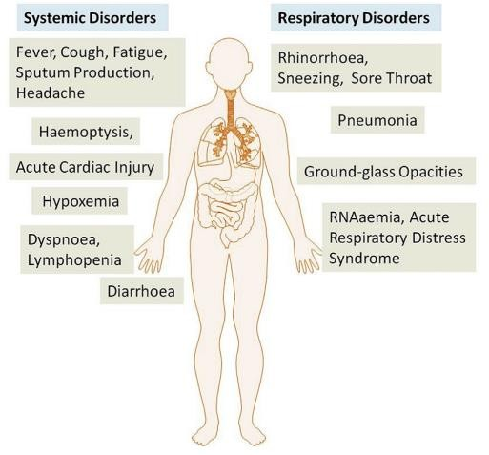

Fig 2 show the systemic and respiratory disorders of the COVID-19 ^{7–9}

Global scenario

Corona virus CoviD-19, which started only a few months ago, was first detected in Wuhan, China, in December 2019. Today, it has spread over the entire world, beginning with one case and now involving millions of cases.^{10,11}
The United States, which has 7.11 million novel coronavirus cases, is the worst-affected country, followed by India (6 million novel coronavirus cases), Brazil (more than 4 million corona cases), and Russia (more than 1 million cases of coronavirus infection). These ten countries are listed in order of worst to least affected. More than 8 lakh coronavirus cases have been recorded in Colombia, 8 lakh cases have been reported in Peru, 730,317 coronavirus cases have been verified in Mexico, 716,481 cases have been reported in Spain, and Argentina The number of deaths from COVID-19 has increased to 15,749, while South Africa has reported 670,766 coronavirus cases.¹²
The 10 nations—Palau, Micronesia, Marshall Islands, Nauru, Kiribati, Solomon Islands, Tuvalu, Samoa, Vanuatu, and Tong—with no instances of COVID-19 reported.

8000000
7000000
6000000
5000000
4000000
3000000
2000000
1000000
0
INDIA
Total cases Active cases
Recovred cases
Death cases

Fig.3 show the graphically represented the update of COVID-19 in india till october 2020
50000000
WORLD WIDE
40000000

30000000

20000000

10000000

0
Total cases Active cases Recovered deaths
cases cases

Fig.4 show the graphically reperesented the update of COVID-19 in world wide till october 2020.
Above both graph show the latest update on corona virus disease who are infected and recover with these disease.In India most five state which is highly affected with COVID-19 is Maharashtra, Tamilnadu, Andhra Pradesh, Karnataka, Uttar Pradesh.

IN INDIA
1,000,000
800,000
600,000
400,000
200,000
0
Maharashtra Andhra Tamil Nadu Karnataka Utter
Pradesh Pradesh
Active cases
Death cases
Recovery cases

Fig.5 show the graphically represented the update of COVID-19 in India with highly affected state with till October 2020

Overview on nanoparticles

A nanoparticle is a microscopic particle with a size between 1 and 100 nanometers. The physical and chemical characteristics of nanoparticles, which are invisible to the human sight, might differ dramatically from those of their bigger material counterparts. 13 Nanoparticles are tiny, but they have a high surface-to-volume ratio, which gives them amazing, unique properties. These qualities have led to the application of nanoparticles in the fields of biotechnology, medicine, drug delivery, sensors, and DNA labelling as well as their treatment as a bridge between bulk materials.¹⁴
Particularly with nucleoside analogues and delivery systems that have potential use against drug-resistant human immunodeficiency virus infection, nano methods have been frequently used to increase the distribution and efficacy of antiviral drugs. 8 With freshly created drug formulations, the several nano delivery technologies that are available can be utilised to effectively deliver medications with quicker therapeutic indices for COVID-19..

Types of nanoparticles (10)
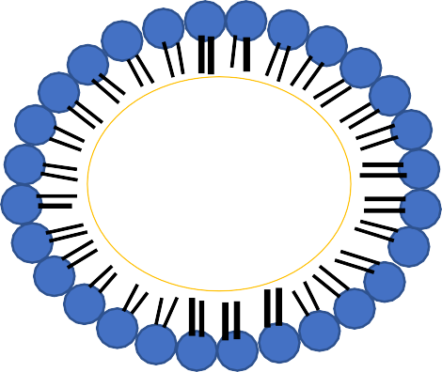
    - (B)

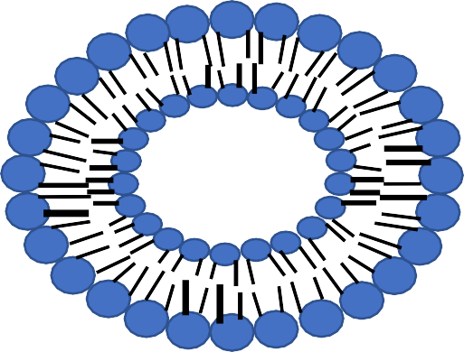
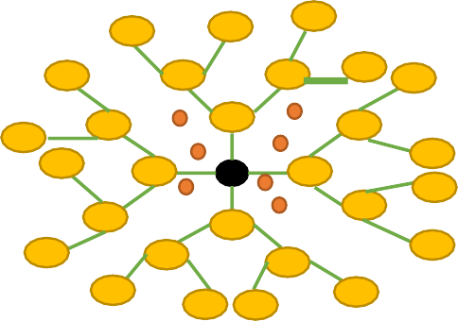
(c)

(C) (D)

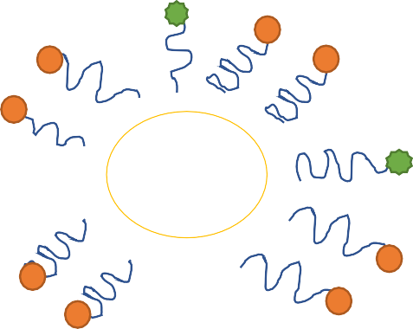
CORE
AU/AG

(E) (F)

Fig 6 show the types of nanoparticles

- Polymeric nanoparticles

- Solid lipid nanoparticles

- Liposomes

- Dendrimers

- Quantum dot

- Metallic nanoparticles

Nanoparticles reported as aantiviral drug

Due to its numerous advantages, such as controlled drug release, protection against active component degradation, and cell targeting, nanoparticles have grown in popularity as a drug delivery technology in recent years..
They have been suggested as antiviral medication carriers to raise their therapeutic index. Antiviral medication release kinetics may be altered using nanoparticulate-based systems, which may also improve bioavailability, efficacy, and reduce undesirable drug side effects and medical expenses. Additionally, they might make it possible to deliver antiviral medications to particular target sites and viral reservoirs in the body. These qualities are particularly significant in viral infections, which call for high dosages of medication and in which many active compounds have low bioavailability.. ^{15–18}
Various pathways are currently known for how nanoparticles exert their antiviral activity.
First, the distinct characteristics of nanoparticles like,^{19,20}

- particle size is tiny (which can facilitate drug delivery into anatomically privileged sites),

- large surface-to-volume ratio (allowing for the accommodating of big pharmacological payloads), and
- tunable surface charge (to allow cellular entry across the cell membrane that is negatively charged) make nanoparticles attractive tools for viral treatment.
Second, it has been demonstrated that nanoparticles can have intrinsic antiviral effects due to the presence of biomimetic characteristics. Popular examples of this are dendrimers and silver nanoparticles.
Third, by constructing a stable structure or making modifications with polymers like polyethylene glycol, it may be possible to functionalize drug encapsulation through optimal drug dosage and improved distribution.
Finally, is assumed that by designing nanoparticles with targeting moieties to increase specificity to desired cell type, target tissues or subcellular compartment, drug delivery can be greatly improved.¹⁹

HYBRID NP

DENGUE
EBOLA
POLYMER NP

THE FUTURE

POLYMER

LIPID DRUG
INFLUENZA

ZIKA

HERPES

CORONA

HIV

CARBON NP

- NANOTRAPS
- NANOROBOT
- NANOBUBBLE
- NANO FIBER
- NANODIAMOND
- MATHAMETICAL MODELING

LIPID NP
INORGANIC NP

Uncoatin g
Transcription and replication
Assembly releasing

Fig.7 shows the role of nanoparticles in the viral diseases

In the future, treatments for viral infections like influenza, dengue, Ebola, corona, HIV, herpes, and zika viruses will include nanotraps, nanorobots, nanobubbles, nanofiber, and nano Diamonds as well as mathematical modelling..

ROLE OF NANOTECHNOLOGY USED IN DIAGNOSIS OF COVID-19

By locating and isolating cases and tracing contacts, diagnostics may be crucial to the containment of COVID-19 and speed up the adoption of control measures that limit the spread (i.e. Identifying people who may have come into contact with an infected patient).^{21–23}
Nanotechnology opens up new avenues for the creation of low-cost, adaptable detection techniques, secure personal safety tools, and novel, effective medications. In patients with extremely low viral loads, nanosensors are now a reality and may detect extremely low bacterial and viral concentrations, warning clinicians even before symptoms appear. According to the joint WHO taskforce and China, 104 SARS-cov-2 virus strains were discovered and sequenced between the end of December 2019 and the middle of February 2020.. ²⁴
Different nano-based approaches for diagnosing COVID-19 have been developed, and they have benefits over molecular ones. The approaches that are being created right now are outlined below. ³
- Point-of-care testing
- Optical biosensor nanotechnology
- Nanopore target sequencing (NTS)
- Reverse transcription loop-mediated isothermal amplifies cation (RT-LAMP) coupled with a nanoparticles-based biosensor (NBS) assay

Point of care testing

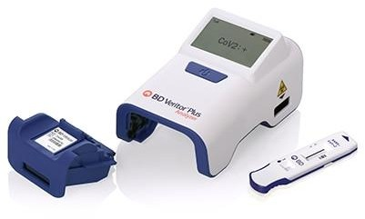

Fig 8 Instrument of piont of care testing

To treat patients without sending samples to centralized labs, point-of - care tests are used, yielding results without needing a testing network to classify infected patients. The identification of lateral flow antigen for SARS-cov-2 is a point of care considered for the diagnosis of COVID-19.
Commercial lateral flow tests are included on a membrane strip that resembles paper and is coated with two lines: one line contains gold nanoparticle antibody conjugates, while the other line collects the antibodies. The membrane is used to collect samples from patients (such as blood and urine), and then capillary action pulls the protein over the membrane. As the first line passes, the antigens bind to the gold conjugate of the nanoparticle-antibody, and the complex moves across the membrane. The trapped antibodies immobilise the complex when they join the second side, where the red or blue side is visible. Individual gold nanoparticles are red, and when they form clusters, the plasmon bands they are associated with turn the solution they are in blue. In academic labs, numerous platforms, including paper-based systems, electrochemical sensors, .^{3,25–27}

OPTICAL BIOSENSOR NANOTECHNLOGY

Thanks to a new method based on optical biosensor nanotechnology, the coronavirus may now be identified directly from patient samples in around 30 minutes without the need for centralised laboratory testing. It is now straightforward to determine whether someone has the coronavirus or the influenza virus thanks to new technology. This project will eventually be utilised to treat people for ailments other than the current pandemic. The new biosensor technology can also be used to examine other coronavirus types that are prevalent in animal reservoirs, such as bats, in order to identify and follow the possible evolution of these viruses and stop future human epidemics.. ^{3,28,29}

Nanopore target sequencing (nts)

In just 6–10 hours, the NTS system concurrently detects SARS-CoV-2 and eleven other respiratory viruses. Although it can be expanded to diagnose other viruses and disorders, it is sufficient for the current diagnosis of COVID-19. NTS is based on internal primary panels for the amplification of 11 unique gene fragments relevant to SARS-CoV-2 virulence, such as orf1ab, and nanopore platform sequencing of the amplified fragment..

This method uses a nanopore sequencing technology that can sequence long nucleic acid segments and analyse the results in real time. Within minutes of sequencing, SARS-CoV-2 infections can be confirmed by mapping the sequence reads to the SARSCoV-2 genome and examining the identity, validity, and read number of the output sequence..
For all test materials, the NTS is performed on a single Minion sequencer chip, and the sequence data is periodically examined using an internal bioinformatics algorithm. Both high identity reads were calculated by mapping output reads onto the SARS-CoV-2 genome in an effort to boost plasmid concentrations. By using only one or two areas as a reference for qPCR, NTS is unable to identify whether a sample is positive for infection; instead, data from all target regions should be included. ^{3,30,31}

Reverse transcription loop-mediated isothermal amplifies cation (rt-lamp) coupled with a nanoparticles-based biosensor (nbs) assay
People all throughout the world are concerned about the rapidly spreading and highly lethal respiratory disease COVID-19. Currently, real-time RT-PCR is used to diagnose SARS-CoV-2 using its nucleic acid (reverse transcription polymerase chain reaction). The LAMP approach is quite accurate since the target sequence is determined by six or eight different places using the RNA as a direct reference. The shift in colour macroscopically represents the outcomes of the detection.
These techniques include helicase-based, loop-controlled, and isothermal recombinase polymerase amplification. In a number of academic laboratories, the RT-LAMP assays for SARS-CoV-2 have been created and clinically validated. An easy-to-use, single-tube RT-LAMP-NBS assay has been developed for the diagnosis of COVID-19.
This approach has the advantage of being easy to use and just requiring inexpensive, basic equipment (such as a heating block or water bath) for 30 to 40 minutes to maintain a consistent temperature (63 ° C). Studies have shown that NBS, a simple and user-friendly technique, can visibly and objectively reveal the effects of RT-LAMP in comparison to previously developed COVID-19 RT-LAMP assays. As a result, there is no longer a need for time-consuming processes (like electrophoresis), specialized reagents (like pH indicators), or pricy machinery (e.g., real-time PCR).
The test phase of an isothermal process involves the simultaneous amplification and identification of two target sequences. Future studies will be able to improve the reaction's variables (such the amplification temperature) and show that COVID-19 RT-LAMP is a viable process. Characteristics of COVID-19 RTLAMP-NBS.^{3,32,33}

Role of nano medicine used in covid-19
There are numerous infectious disease treatments that use nanoparticles, both now and in the future. The focus of nanoparticle development will be on developing rapid treatments for illnesses.^{34,35} Several viral infectious problems are being treated with dendrimers and metallic nanoparticles.
All areas of medicine are impacted by nanomedicine, which is also regarded as a significant tool for developing novel vaccines, nanotherapeutics, medical imaging, and biomaterials for regenerative medicine.³⁶ The major method for soft nanoparticles is the creation of the biopharmaceutical, pharmacokinetic, and pharmacodynamic aspects of drug loading. The effectiveness and safety of the treatment may be impacted by nanoparticles' ability to promote targeted drug delivery (either passively or actively) and controlled drug release rates. In addition to soft and metal nanoparticles, nanomedicines have been used largely for their diverse antimicrobial (antibacterial, antifungal, antiparasitic, and antiviral) properties. ³⁷
In this regard, nontechnology offers a fresh approach to antiviral therapy that takes into account specific targeting. In order to prevent saras-cov-2 from entering the host cell and becoming active, the method of using nanoparticles to resist it may entail certain procedures. Since inhibiting viral surface proteins can result in virus inactivation, targeted nanoparticles made to bind to virally generated proteins may prevent viral internalisation. Metal nanoparticles have been shown to impede a virus' ability to adhere to the cell surface, which prevents viral internalisation and prevents viral proliferation after the virus enters the body. Nanoparticles have already been effective against a number of viruses, including the monkey pox virus, the hiv virus, influenza virus, herpes simplex virus, respiratory syncytial virus, and transmissible gastroenteritis virus.
The viral protein or envelope is bound to nanoparticles in the mode of action, interfering with the host cell's contact. The effectiveness of the treatment is influenced by the nanoparticles' size, shape, and surface load. However, precautions must be taken to prevent host cell cytotoxicity in terms of concentration. Organic nanoparticles have been used to deliver antiviral drugs such zidovudine, acyclovir, dipivefrine, and remdesivir in an effort to boost drug bioavailability, enable efficient drug administration, and enhance targeted antiviral action.

Due to their versatility, nanoparticles are adjustable vectors for virus targeting and targeted drug delivery. Antimicrobial drugs such chloroquine, lopinavir, ritonavir, ribavirim, and remdesivir have been tested in clinical trials for covid-19 and have shown promise against sars-cov-2. Antimicrobial drugs can be nanoencapsulated, which may result in the development of more effective treatments for covid-19 and other viral diseases.^{3,34}

Future prospective

A global health epidemic currently threatens the entire planet. The infection-to-mortality ratio of covid-19 has surpassed set thresholds, making it unique from other viral diseases. Medical experts and scientists can eliminate the threat posed by sars-cov-2 and provide the groundwork for averting any pandemics by cooperating. In the fight against COVID-19, research, technological development, and application are our most powerful weapons. It is possible to enhance nanotechnology methods to control, monitor, and halt the spread of covid-19. Nanotechnology has made a unique collection of tools available that can greatly improve our understanding of viral infections and the crucial creation of diagnostic and therapeutic platforms. By cooperating to prevent and manage any virus outbreaks in the future, we can stop the current epidemic.
In order to be employed as a first-aid remedy against unanticipated viral epidemics or pandemics, an ideal antiviral medication will need to exert a broad-spectrum activity against viruses of many families.
Sars-cov-2 is still a serious issue for people, and covid-19 is not yet medically treatable with any medications.
Nowadays, the most popular treatments for the numerous viral infection disorders are dendrimers and metallic nanoparticles.

Conclusions

The study shows that nanotechnology has enabled the development of multiple very efficient biosensors, nanovaccines, and antiviral composites for closely related viruses. The production of sars-cov-2 agents will benefit from this collection. In order to combat the COVID-19 pandemic, nanotechnology has a lot to give. In the coming months or year, the distinctive properties of nanosized sensors, vaccines, and antiviral nano nano sensors will be crucial.

References

- Campos E, V, R, Pereira A, E, S, de Oliveira J, L, Carvalho L, B, Guilger-Casagrande M,de, Lima R, Fraceto L, F, “How Can Nanotechnology Help to Combat COVID-19? Opportunities and Urgent Need” Journal of Nanobiotechnology 2020, 18 (1), 1–23.
- Novel C, P, E, R, E, “The Epidemiological Characteristics of an Outbreak of 2019 Novel Coronavirus Diseases (COVID-19) in China” Zhonghua liu xing bing xue za zhi= Zhonghua liuxingbingxue zazhi 2020, 41 (2), 145.
- Waris A, Ali, M, Khan A, U Ali, A, Baset, “A Role of Nanotechnology in Diagnosing and Treating COVID-19 during the Pandemic”.
- Ksiazek T, G, Erdman D, Goldsmith C, S, Zaki S, R, Peret T, Emery S, Tong S, Urbani C, Comer J, A, Lim W, “A Novel Coronavirus Associated with Severe Acute Respiratory Syndrome” New England journal of medicine 2003, 348 (20), 1953–1966.
- Matheson N, J, Lehner P, J, “How Does SARS-CoV-2 Cause COVID-19? Science” 2020, 369
(6503), 510–511.
- Wu J, Zha P, “Treatment Strategies for Reducing Damages to Lungs In Patients with Coronavirus and Other Infections” Available at SSRN 3533279 2020.
- Huang C, Wang Y, Li X, Ren L, Zhao J, Hu Y, Zhang L Fan, G. Xu, J, Gu, X “ Clinical Features of Patients Infected with 2019 Novel Coronavirus in Wuhan, China” The lancet 2020, 395 (10223), 497–506.
- Ren, L,L, Wang, Y,M, Wu, Z,Q, Xiang, Z, C, Guo, L, Xu, T, Jiang, Y, Z, Xiong, Y, Li, Y, J, Li, X, W, “dentification of a Novel Coronavirus Causing Severe Pneumonia in Human: A Descriptive Study” Chinese medical journal 2020.
- Zhu, N, Zhang, D, Wang, W, Li, X, Yang, B, Song, J, Zhao, X, Huang, B, Shi, W, Lu, R, “A Novel Coronavirus from Patients with Pneumonia in China, 2019” New England Journal of Medicine 2020.
- Walker, P, Whittaker, C, Watson, O, Baguelin, M, Ainslie, K, Bhatia, S, Bhatt, S, Boonyasiri, A, Boyd, O, Cattarino, L, Report 1 2, “The Global Impact of COVID-19 and Strategies for Mitigation and Suppression” 2020.
- Clark, A, Jit, M, Warren-Gash, C, Guthrie, B, Wang, H, H, X, Mercer, S, W, Sanderson, C, McKee, M, Troeger, C, Ong, K, L, “Global, Regional, and National Estimates of the Population at Increased Risk of Severe COVID-19 Due to Underlying Health Conditions in 2020, A Modelling Study” The Lancet Global Health 2020, 8 (8), e1003–e1017.
- Shadmi, E, Chen, Y Dourado, I, Faran-Perach, I, Furler, J, Hangoma, P, Hanvoravongchai, P, Obando, C, Petrosyan, V, Rao, K, D, “Health Equity and COVID-19: Global Perspectives” International journal for equity in health 2020, 19 (1), 1–16.
- Mohanraj, V, J, Chen, Y, “Nanoparticles a Review” Tropical journal of pharmaceutical research 2006, 5 (1), 561–573.

- Merisko-Liversidge, E, M, Liversidge, G, G, “Drug Nanoparticles Formulating Poorly Water- Soluble Compounds Toxicologic pathology” 2008, 36 (1), 43–48.
- Cavalli, R, Donalisio, M, Bisazza, A, Civra, A, Ranucci, E, Ferruti, P, Lembo, D, “ Enhanced Antiviral Activity of Acyclovir Loaded into Nanoparticles” In Methods in Enzymology Elsevier, 2012, Vol, 509, pp 1–19.
- Szunerits, S, Barras, A, Khanal, M, Pagneux, Q, Boukherroub, R, “Nanostructures for the Inhibition of Viral Infections Molecules” 2015, 20 (8), 14051–14081.
- Yadavalli, T, Shukla, D, “Role of Metal and Metal Oxide Nanoparticles as Diagnostic and Therapeutic Tools for Highly Prevalent Viral Infections,Nanomedicine, Nanotechnology, Biology and Medicine” 2017, 13 (1), 219–230.
- Gurunathan, S, Qasim, M, Choi, Y, Do, J, T, Park, C, Hong, K, Kim, J, H, Song, H, “Antiviral Potential of Nanoparticles Can Nanoparticles Fight Against Coronaviruses? Nanomaterials” 2020, 10 (9), 1645.
- Singh, L, Kruger, H, G, Maguire, G, E, M, Govender, T, Parboosing, R, “The Role of Nanotechnology in the Treatment of Viral Infections, Therapeutic advances in infectious disease” 2017, 4 (4), 105–131.
- Karuppusamy, C, Venkatesan, P, “Role of Nanoparticles in Drug Delivery System, A Comprehensive Review” Journal of Pharmaceutical sciences and Research 2017, 9 (3), 318.
- Vazquez Munoz, R, Lopez-Ribot, J, L, “Nanotechnology as an Alternative to Reduce the Spread of COVID-19, Challenges” 2020, 11 (2), 15.
- Vafea, M, T, Atalla, E, Georgakas, J, Shehadeh, F, Mylona, E, K, Kalligeros, M, Mylonakis, E, “Emerging Technologies for Use in the Study, Diagnosis, and Treatment of Patients with COVID-19, Cellular and molecular bioengineering “2020, 13 (4), 249–257.
- Joob, B, Wiwanitkit, V. Nanodiagnosis for Diagnosing COVID-19: A Brief Review. Lett. Appl. NanoBioSci 2020, 9, 1578–1582.
- Wu, K.; Saha, R, Su, D, Krishna, V, D, Liu, J, Cheeran, M, C, J, Wang, J, P, “Magnetic Nanosensor-Based Virus and Pathogen Detection Strategies Before and During COVID-19, ACS Applied Nano Materials” 2020.
- Nguyen, T, Duong Bang, D, Wolff, A, “2019 Novel Coronavirus Disease (COVID-19), Paving the Road for Rapid Detection and Point-of-Care Diagnostics, Micromachines” 2020, 11 (3), 306.
- Yang, T, Wang, Y, C, Shen, C, F, Cheng, C, M, “Point-of-Care RNA-Based Diagnostic Device for COVID-19” Multidisciplinary Digital Publishing Institute 2020.
- Zhu, H, Zhang, H, Ni, S, Korabečná, M, Yobas, L, Neuzil, P, “The Vision of Point-of-Care PCR Tests for the COVID-19 Pandemic and Beyond” TrAC Trends in Analytical Chemistry 2020, 115984.
- Morales-Narváez, E, Dincer, C, “The Impact of Biosensing in a Pandemic Outbreak COVID-19”
Biosensors and Bioelectronics 2020, 112274.
- Samson, R, Navale, G. R, Dharne, M, S, “Biosensors, Frontiers in Rapid Detection of COVID- 19” 3 Biotech 2020, 10 (9), 1–9.

- Moitra, P, Alafeef, M, Dighe, K, Frieman, M, Pan, D, “Selective Naked-Eye Detection of SARS- CoV-2 Mediated by N Gene Targeted Antisense Oligonucleotide Capped Plasmonic Nanoparticles” ACS nano 2020.
- Ribeiro, I, R, S, da Silva, R, F, Silveira, C, P, Galdino, F, E, Cardoso, M,B, “Nano-Targeting Lessons from the SARS-CoV-2” Nano Today 2020, 101012.
- Nie, X, “Reverse Transcription Loop-Mediated Isothermal Amplification of DNA for Detection of Potato Virus Y. Plant Disease” 2005, 89 (6), 605–610.
- Fukuta, S, Ohishi, K, Yoshida, K, Mizukami, Y, Ishida, A, Kanbe, M, “Development of Immunocapture Reverse Transcription Loop-Mediated Isothermal Amplification for the Detection of Tomato Spotted Wilt Virus from Chrysanthemum” Journal of virological methods 2004, 121 (1), 49–55.
- Mainardes, R, M, Diedrich, C, “The Potential Role of Nanomedicine on COVID-19 Therapeutics” Future Science 2020.
- Tabish, T. A, Hamblin, M, R, “Multivalent Nanomedicines to Treat COVID-19: A Slow Train Coming” Nano Today 2020, 35, 100962.
- Abd Ellah, N, H, Gad, S, F, Muhammad, K, E Batiha, G, Hetta, H, F, “Nanomedicine as a Promising Approach for Diagnosis, Treatment and Prophylaxis against COVID-19” Nanomedicine 2020, 15 (21), 2085–2102.
- Shin, M. D, Shukla, S, Chung, Y, H, Beiss, V, Chan, S. K, Ortega-Rivera, O, A, Wirth, D, M, Chen, A, Sack, M, Pokorski, J, K, “COVID-19 Vaccine Development and a Potential Nanomaterial Path Forward” Nature nanotechnology 2020, 15 (8), 646–655.

