Application of Soil Testing Sensors in Agriculture
Mudigiri Chandana^{1*} (Ph.D scholar), K. Navya¹ (Ph.D scholar), K. Bhavitha² (Ph.D scholar), G.Harshitha² (Ph.D scholar) and Y. Chaitanya² (Ph.D scholar), B. Kranthi Kumar ³
1.Ph D scholar, Dept of soil Science, PJTSAU, Hyderabad.
2. Ph D scholar, Dept of Agronomy, PJTSAU, Hyderabad.
3. Subject Matter Specalist, Dept of soil Science, Krishi vigyan Kendra, Malyal, Mahabuababd.
ABSTRACT
The soil whose main role is to provide nutrients in the process of plant growth is the foundation and an important part of agriculture. Soil testing is an important step for increasing agricultural production and raising farm income. Traditional soil testing methods are based on chemical methods carried out under laboratory conditions. An important application of sensors in agriculture is in the direct measurement of soil chemistry through tests such as pH, moisture, nutrient content, Humidity, temperature. Soil testing results are important to obtain to get high yield with good quality. ISE (Ion Selective Electrode) and ISEFT (ion-sensitive fieldeffect transistor) sensors have also been used to monitor the uptake of ions by plants.
Key woards : pH, moisture content, nutrient content, ISE, ISEFT
INTRODUCTION
Agriculture depends on the soil whose major function is to supply nutrients for plant growth. Crop growth is significantly influenced by the macro and micronutrient composition of farmland. The results of the soil testing are crucial information for determining the proper application of fertilizer and soil amendments. A solid foundation for planning the appropriate application of nutrients can be formed by combining the results of soil testing with knowledge about the nutrients that are available to different crops (Hoeft et al., 1996). A typical tets will often determine the amount of available nitrogen (N), phosphorus (P), exchangeable potassium (K), calcium (Ca), and magnesium (Mg) as well as, the cation exchange capacity(CEC), pH, and the amount of lime that is needed. Additionally, certain laboratories may do tests for nitrate, salinity and organic matter (OM), salinity, nitrate, sulphate, specific micronutrients and heavy metals (Foth and Ellis, 1988). The amount of sand , silt and clay in the soil, as well as its structure, compaction, moisture content and other physical soil attributes, have an impact on crop growth
Soil Testing in India
For boosting the agriculture productivity and profitability, soil testing is a crucial step. Traditional soil testing techniques are based on chemical procedures carried out under laboratory conditions. These methods are generally more time consuming and generally takes more time. On the other hand, the number of soil samples needed to be analyzed is large because of the small size of the land holdings in many parts of India. Consequently, even if soil samples are collected from different agricultural fields, timely testing of these samples is generally not possible and the test results often fail to reach farmers in a timely manner. Currently, there are about 1049 soil testing labs operating in the country with an annual analyzing capacity of only 10.7 million samples. Analyzing capacity of soil testing labs simply lags far behind the requirement.There is a need to repeat soil testing from time to time depending on soil types and crops. Hence, new technology has to be introduced to make soil testing-based nutrient management a reality.
Application of sensors
The direct measurement of chemical parameters such as pH, moisture, nutrient content, Humidity and temperature using sensors is significant use in agriculture. Soil testing results are crucial to obtain to get high yield with good quality. ISE (Ion Selective Electrode) and ISFET (ion-sensitive field effect transistor) sensors have also been used to monitor the uptake of ions by plants. The rate of nutrient uptake of crop determined by the soil nutrient content and also the crop growth rate. Ion-selective sensors have been developed to detect a variety of ions. ISE sensors have been developed to monitor nitrogen ions in the soil and crops. Hi-techequipments are in demand to help grow high-performance crops. Scientists are using sensors to know the response of the crops to different soils and weather conditions.
ELECTROCHEMICAL SENSORS FOR SOIL NUTRIENT DETECTION
Ion Selective Electrode (ISE) and Ion Selective Field Effect Transistor (ISFET) are two types of detectors are commonly used to know the potentiometric electrochemical sensors for soil nutrient detection.
Ion Selective Electrode (ISE)
ISE method can be analysed by using the Nernst equation as a change of an ISE’s potential, compared with a reference electrode, is linear to the change of the ionic activity (in logarithmic units) of the target ion.
ISEs were used to detect soil nitrate, ammonium and potassium. Till now , no detectors were used for analyzing the phosphorus, but several literatures presented that the PVC-based membrane ISEs could be used to measure phosphate content in biological samples.
ISEs were used for soil nutrient detection in two directions:
(1) Flow Jianhanet al. chemical analysis. To date, soil sampling is manually carried out in a field for detecting nitrogen variability of soil nutrients by visible/ ultraviolent spectroscopy. Therefore, soil nutrient 1350 Injection Analysis systems (FIA)
(2) vehicle-based soil sensing systems
Limitation:
ISEs might not be used for real-time sensing applications because they take more time.
Ion Selective Field Effect Transistor (ISFET)
ISFET is the integration of an ISE and a field effect transistor (FET). The ion selective membrane is placed on the top of the insulator layer of the FET structure, so the threshold voltage of the ISFET can be chemically modulated and the measured voltage is related with the concentrations of a dimensions, low output impedance, high signal-to-noise ratio, fast response and the ability to integrate multi -ISFETs on one chip.
ISFETs were reported to detect soil ammonium, nitrate and potassium. A successful automated system for soil pH mapping was reported to be tested under field conditions.
Limitation
However, ISFET’s high cost and inconsistent repeatability limit their use in practical system.
Both ISEs and ISFETs respond selectively to a particular ion in solution according to a logarithmic relationship between the ionic activity and electric potential.The ISEs and ISFETs require recognition elements, i.e., ion selective membranes, which are integrated with a reference electrode and enable the chemical response (ion concentration) to be converted into a signal (electric potential). Due to an increased demand for the measurement of new ions, and tremendous advances in the electronic technology required for producing multiple channel ISFETs, numerous ion-selective membranes have been developed in many areas of applied analytical chemistry.
Soil NPK estimation by optical measurements
The optical soil measurement methods in this paper can be classified into six types. Visible–infrared (Vis – IR) spectroscopy, inductively coupled plasma spectroscopy, fluorescence spectroscopy; and colorimeters are used for measuring soil nutrients.
Vis–IR spectroscopy
Vis–IR spectroscopy is a physical nondestructive, quick, repeatable and inexpensive technique that characterizes materials according to the energy absorbed by the material in the wavelength range 700 nm - 1 nm. Each soil nutrient has its own spectral length which helps in identifying the nutrients in the soil. It is a type of non liquid nutrient testing method which makes it a cutting-edge technique for soil analysis. The method is incredibly practical and actually portable because it requires little to no sample preparation. To extract quantitative information of the IR spectra it is required to use calibration curve obtained from multivariate techniques. The calibration curve is used to find unknown concentration of a solution by using the graph of intensity of spectrum versus known concentration. Thus, over other methods, spectroscopic methods for soil analysis are advantageous and easy. The only limitation of the method is the soil mapping and generation of similar database. The application of IR spectroscopy to soil is being studied from 1960 and is used extensively for determining soil Carbon and Nitrogen content. By Vis–IR spectroscopy is being studied for determining soil Phosphorus and Potassium content.
Reflectance spectroscopy
Reflectance spectra are of three types such as internal reflectance, diffuse reflectance and specular reflectance. Almost all the nutrient detection is done by using diffuse reflectance. Based on the near-infrared reflection spectroscopy, Du et al. (2019) provided a set of comprehensive guidelines and research on diffuse reflectance technique for soil nitrogen detection. They developed a portable nitrogen detector. They used a small, compact Fourier transform infrared (FTIR) coupled spectroscope with a supporting software for data acquisition and spectral analysis. They identified wavelengths for soil nitrogen as 1500- 1850 and 2000 - 2400 nm for nitrogen containing groups. Hu et al. (2016) looked at the impact of using a small region of wavelength 1100–2450 nm for sensing soil phosphorus and potassium and found that narrower sensing range is beneficial in making sensors. Mukherjee and Laskar (2019) developed a Vis–NIR diffuse reflectance spectroscopy-based sensor for measurement of NPK in soil extracts.
Raman spectroscopy
A quick method for assessing soil nutrients is Raman spectroscopy. It uses a strong beam of visible or ultraviolet light to illuminate the sample and collect the scattered Raman spectra. Based on vibrations and rotations of radiation excited molecules, Raman spectra signature can provide structural information which can be used as a key to identify a sample. The sensor is equipped to detect and measure of soil nutrients like nitrogen, phosphorus and potassium. Lararet al. (2012) studied soil phosphorus concentration using Raman spectroscopy.
Colorimetric
Soil testing kits perform a quick, on-the-spot, and approximate measurement of nutrients present in the soil (McCoy and Donohue 1979). These kits analyse the soil nutrients using the principle of colorimetric technique for analyzing the soil nutrients. The colorimetric method compares the color change of the solution with calibrated reference color charts. The shade of the color on the color chart indicates a range of concentration. By relating color of the solution to concentration of nutrients, colorimetric method measures the fertility level of nutrients (NPK) in the soil.
Optical imaging
Chen et al. (2019) studied a unique technique for detecting the nutrient status in plants. According to them analyzing images of plant leaves could help predict potassium deficiency in plants. Matrix laboratory (MATLAB) software and support-vector machines (SVM) calibration model were used together to analyze leaf image and derive potassium level from the given information. Li, Jia, and Le (2019) used 900 - 1700 nm wavelength for detecting total soil nitrogen content using a hyperspectral imaging system.
Soil moisture Sensors
The world, is currently experiencing a water deficit, which is impeding the growth of agriculture and ultimately the production of food. Judicious use of water is important and in agriculture particularly, optimum use of water is necessary (Munothet al., 2016) as there is shortage of water in most parts of India. The primary factor in determining the crops ideal water needs is soil moisture (Schroder, 2006). The various soil moisture content levels are shown below in figure 1. There are typically two methods of measuring soil moisture, which are Direct inspection (Feel and appearance method, Hand-push probe, and Gravimetric method), and indirectly with Meters and Sensors (Soil moisture blocks, TDRs, FDRs, etc.) (Evans et al.,1996). The soil moisture sensors are highly effective tools in measuring soil moisture to know crop growth (Scherer et al., 2013). Soil moisture sensors measure the amount of water content at the root zone and is useful in planning irrigation scheduling (Clarke et al., 2008), precision agriculture and hydrology (Skieruchaet al., 2010), residential gardens, landscapes, rainfall monitoring, environmental testing etc. There are various types of soil moisture sensors available in the market.
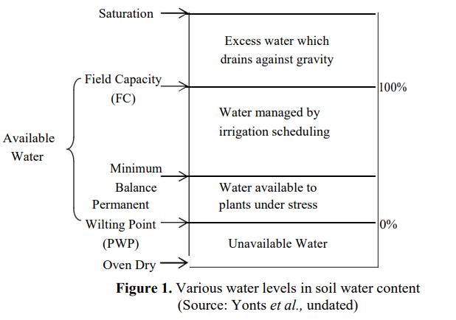

DIFFERENT TYPES OF SENSORS
Tensiometers
The porous ceramic cup is installed into the soil in such a way that soil water pressure is transmitted to the tensiometer which is read by pressure sensing devices mounted on the tensiometer. This instrument do not measure soil moisture content directly, instead it measures soil water tension (Freeman et al., 2004). Generally, the response time of a tensiometer is 2 to 3 hours (Zazuetaet al., 1994). There are tensiometers available which can be automated with the irrigation system with the help of pressure gauge.
Table 1. Variation in soil water tension for different types of soil

Soil Type | Soil moisture tension (centibars)
Sandy or loamy soils | 40-50
Sandy loam | 50-70
Loam | 60-90
Clay loam | 90-120
(Source: Hanson et al., 2002)
Advantages
a) Tensiometers are simple, rapid, inexpensive and easy to use (Enciso-Medina et al., 2007).
b) Different types of liquid like ethylene glycol solution can be used to obtain data during freezing and thawing conditions (Schmuggeet al., 1979).
c) A tensiometer is ideal for sandy loam or light textured soils.
Disadvantages
a) Periodic maintenance is required as air bubbles accumulate under normal use. (Hensley et al., 1999).
b) It is prone to damage due to freezing temperatures.
c) Several tensiometers are required for measurement because they measure soil water potential only in the vicinity of the tensiometer (Goodwin, 2009).
d) The usable range is only between 0-85 centibars of tension above which the gauge will malfunction (Werner, 2002).
Applicability
The tensiometers can be used in any horticulture crop under irrigation (Goodwin, 2009).
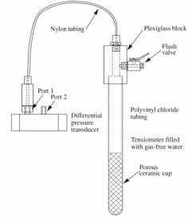
Figure 2. Soil water tensiometer (Source: Freeman et al., 2004)
Granular Matrix Sensor (GMS)
The granular matrix sensor is made of a porous ceramic external shell with an internal matrix structure containing two electrodes as shown in Figure 3. The electrodes inside the GMS are imbedded in the granular fill material above the gypsum wafer. The water conditions in the granular matrix change with variation in corresponding water conditions in the soil and these changes are continuously indicated by difference in electrical resistance between two electrodes in the sensor This resistance between the electrodes is inversely related to soil water
Advantages
a) GMS is cheaper and requires less maintenance compared to tensiometer.
b) Automation of irrigation in fields can be achieved.
c) Negligible change in sensor performance with variation in soil temperature.
Disadvantages
a) It shows different responses based on the soil types.
b) Sometimes, poor contact between the soil and the sensor occurs which could cause high m readings which is most likely to occur in heavy soils.
c) It is less responsive to small rains.
d) It is low accurate in sandy soils because of their larger particle size.

Applicability
The GMS is used for assessing soil moisture in crops like cotton, onion, potato, urbanized landscapes, corn drip irrigated vegetable crop (Thompson et al., 2005). The GMS has good accuracy in medium to fine soils because the soil particle size will be similar to that of the transmission material which has a consistency close to that of fine sand that is wrapped in porous membrane of the GMS.
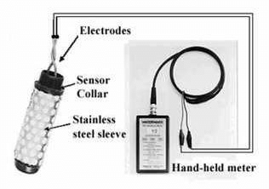
Figure 3. Granular matrix sensor (Model 200SS) (Source: Irmak et al., 2006)
Time Domain Reflectrometry (TDR)
In time domain reflectrometry, a pulse of radio frequency energy is injected into a transmission line and its velocity is measured by detecting the reflected pulse from the end of the line. This velocity depends upon the dielectric constant. The amount of moisture is measured by measuring how long it takes for the reflected pulse to come back (Cepuder et al., 2008 and Haman et al., undated). The response of a TDR is very quick (≈ 28 sec).
Advantages
a) TDR respond quickly to varying soil moistures.
b) It measures moisture quite accurately (± 2%) in any type of soil.
c) Soil moisture from multiple depths can be obtained from a single probe.
d) There is little or no disturbance to the test site during the testing process.
Disadvantages
a) They need to be carefully calibrated to precisely measure the amount of time it takes for the pulse to come back.
b) This instrument is costlier than other measuring methods
c) TDR applications are limited due to high costs.
d) TDR read soil moisture only in the vicinity of the sensor.
Applicability
TDR is mostly used in fields having mineral crops and crops grown on organic soils. Dukes et al., (2010) have listed sweet corn, green bell pepper, and the crops grown on sandy soils for which TDR can be used.
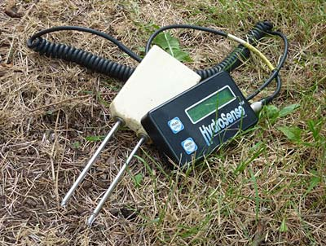
Figure 4. TDR unit (Source: labmodules.soilweb.ca)
Frequency Domain Reflectrometry (FDR)
FDR sensor is made up of two metal rings that operate as capacitors, with the soil sample servicing as the dielectric. Soil volumetric content can be measured directly using the electrical sensor capacitance. It works on a similar concept as a TDR sensor.
Advantages
a) It is very accurate (± 1%) if calibrated properly.
b) Unlike TDR, it can be used with high soil salinity.
c) With FDR, measurements to be taken simultaneously at various depths.
d) It is expensive as compared to TDR.
Disadvantages
a) It requires soil specific calibration.
b) To prevent the formation of air gaps in FDR, it is important to ensure adequate contact between soil and sensor.
c) It can sense moisture content only in the vicinity of the sensor.
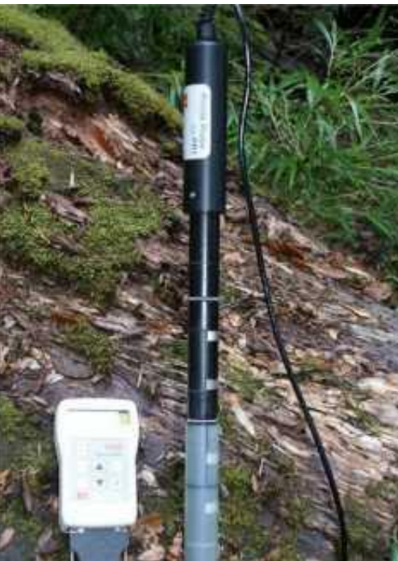
Figure 5. FDR sensor (Source: www.experimental-hydrology.net)
VH400 Soil Moisture Sensor
A resistive based soil moisture sensor called VH400 monitors the dielectric constant of soil (Salih et al., 2013). It aids in accurate, inexpensive monitoring soil water content. It has rapid response time, can take reading in under one second and is much sensitive at higher volumetric water content (Ravi et al., 2011). A horizontal location at the root level is preferred for inserting the soil moisture probe into the ground. This sensor is small in size, rugged, waterproof, and consumes less power. It is also insensitive to salinity of water, does not corrode over time, and is sensitive to even small changes in water content. This type of sensor is sensitive to temperature changes in wet conditions, thus temperature measurement would always be required (Bitellaet al., 2014). The probe is usually attached to soil moisture reading device to form a wireless sensor network, such networks are extensively used in precision agriculture and smart irrigation (Khrijiet al., 2014). One such device is soil moisture data logger which displays moisture content readings on digital screen. There are two means of communication between the system and the far user : first the readings are sent via Short Messaging Service (SMS) on GSM network, and second the readings can be stored in memory card which can be transferred to a computer for analysis logger The specifications of this sensor

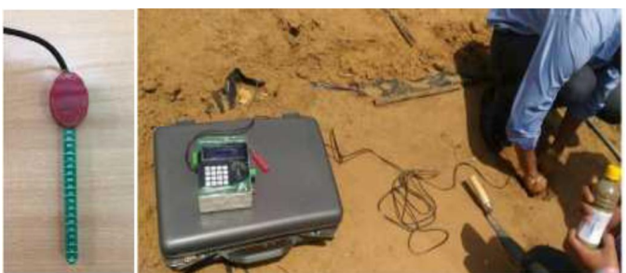
Figure 6. A VH400 sensor; its Data logger The specifications of this sensor is as follows:
Power consumption | < 7 Ma
Supply voltage | 3.5 to 20 V (DC)
Operational Temperature | -40⸰C to 85 ⸰ C
Accuracy at 25⸰ C | ± 2%
Out put | 0 to 3 V related to moisture content
Applications
Hydrology, Agronomy, Soil physics, Irrigation and Sprinkler systems, Plant physiology, Phenotyping, Root ecology, Environmental monitoring and Rain monitoring.
SOIL TEMPERATURE SENSORS
In the case of soil temperature sensor, there is no much work. For example a bent-stem soil thermometer is used to measure soil temperature between the ground surface and a depth of 20 cm underground, and has a bend between the bulb and the scale (WMO 2010).But this thermometer has many problems. Problems of this thermometer is: it is exposed to external factors like sunlight, cold etc., it requires removal of it from the installed place during harsh season. The following figure shows the different types of temperature sensors (Kedzierski 1993).
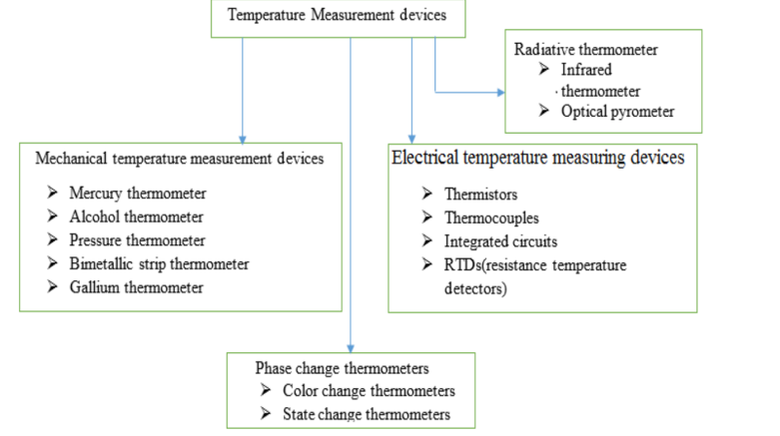
Figure 7. classification of temperature sensors
Except for IC sensors, all the temperature sensors have nonlinear transfer functions, i.e.the temperature dependence of the physical parameter under scrutiny (e.g. resistance, voltage output, etc.) is nonlinear (Feteira 2009).
Conclusion
Detection of soil nutrients depends on variations in soil and environmental factors resulting in poor detection accuracy. By applying pretreatment methods and different calibration methods will help to fix this issue. The only concern with spectroscopic methods is that typical spectrometers are bulky and expensive, and requirement of site-specific calibration. Colorimetric methods can be used to develop a portable, cost effective optical sensor for soil macronutrient detection. In general, the colorimetric technique doesn’t need expensive equipment and perfect measurement conditions or good database or sophisticated analysis techniques. Further research on colorimeter-based soil nutrient detection can be carried out for developing a cost-effective portable sensor. Research findings suggest that the solution-based soil extractant can be replaced by ion-selective membranes to make the colorimeter-based sensor more compact and convenient.The latest trend in the field of nutrient testing is the use of imaging techniques. Although much research has happened in the optical sensing field, a cost-effective portable soil NPK sensor still does not exist in the Indian market.The use of soil moisture sensors helps growers with irrigation scheduling by providing information about when to water the crops. Selection of sensor for a particular application or on the basis of type of soil can become a tiresome exercise as there are wide level of soil moisture sensors available in the market. The advantages and disadvantages of sensors must be considered as criteria for selection because the working principle behind each type of sensor varies with its application and type of soil.
References:
Hoeft, R.G., Peck, T.R., Boone, L.V., 1996. Soil testing and fertility. In: Illinois Agronomy Handbook 1995–1996, Circular 1333, Cooperative Extension Service, College of Agriculture, University of Illinois at Urbana-Champaign, Chapter 11, pp. 70–101.
Foth, H.D., Ellis, B.G., 1988. Soil fertility. Wiley, New York, New York.
Munoth P, Goyal R, Tiwari K (2016) Sensor based irrigation system: A review. International Journal of Engineering Research & Technology (IJERT), NCACE-2016 Conference Proceedings, 4 (23):86-90.
Schroder HJ (2006) Soil moisture-based irrigation for efficient use of water and nutrients and sustainability of vegetables cropped on coarse soils. A thesis presented to the Graduate School of the University of Florida.
Evans R, Cassel KD, Sneed ER (1996) Measuring soil water for irrigation scheduling: monitoring methods and devices. Publication no.AG 452-2.North Carolina Cooperative Extension Service.https://www.bae.ncsu.edu/programs/extension/evans/ag452-2.html.
Scherer FT, Franzen D, Cihacek L (2013) Soil, water and plant characteristicsimportant to irrigation. Extension Service, North Carolina State University, AE 1675 (Revised).
Clarke M, Acomb G, Philpot B (2008) Florida field guide to low impact development. Program for resource efficient communities, University of Florida.
Skierucha W, Wilczek A (2010) A FDR sensor for measuring complex soil dielectric permittivity in the 10–500 MHz frequency range. Sensors, 10: 3314-3329.
Freeman AL, Carpenter CM, Rosenberry OD, Rousseau PJ, Unger R, McLean SJ (2004) Use of submersible pressure transducers in water-resources investigations. 40-43.
Zazueta SF, Xin J (1994) Soil moisture sensors. Bulletin 292, Florida Cooperative Extension Service, Institute of Food and Agricultural Sciences, University of Florida www.experimental-hydrology.net/wiki/index.php?title=Soil moisture FDR_(profile_probe).
Enciso MJ, Porter D, Périès X (2007) Irrigation monitoring with soil water sensors. Cooperative Extension, B-6194, The Texas A&M University System.
Schmugge TJ, Jackson TJ, McKim HL(1979)Survey of methods for soil moisture determination. NASA Technical memorandum.
Hensley D, Deputy J (1999) Using tensiometers for measuring soil water and scheduling irrigation. Coopertive Extensive Service.Department of horticulture, College of tropical agriculture & human resources, University of Hawaii at Manoa. Landscape L-10.
Goodwin I (2009) How to use tensiometers?.Department of environment and primary industries, Agriculture Victoria: ISSN 1329-8062.
Feteira, A., 2009. Negative Temperature Coefficient Resistance (NTCR)Ceramic Thermistors: An Industrial Perspective. , 983.
Werner H (2002) Measuring soil moisture for irrigation water management. Cooperative Extension Services, College of Agriculture and Biological Sciences, South Dakota State.
Thompson RB, Gallardo M, Agüera T, Valdez LC, Fernández MD (2005) Evaluation of the Watermark sensor for use with drip irrigated vegetable crops. Irrig Sci (2005). DOI: 10.1007/s00271- 005-0009-5.
Du, X., J. Wang, D. Dong, and X. Zhao. 2019. Development and testing of a portable soil nitrogen detector based on near-infrared spectroscopy. In 2019 IEEE 8th joint international information technology and artificial intelligence conference (ITAIC), 822.
Hu, G., K. A. Sudduth, D. He, D. B. Myers, and M. V. Nathan. 2016. Soil phosphorus and potassium estimation by reflectance spectroscopy. Transactions of the American Society of Agricultural and Biological Engineers (ASABE) 59 (1):97–105.
Mukherjee, S., and S. Laskar. 2019. Vis–NIR-based optical sensor system for estimation of primary nutrients in soil. Journal of Optics 48 (1):87–103. doi: 10.1007/s12596-019-00517-1.
McCoy, D. E., and S. J. Donohue. 1979. Evaluation of commercial soil test kits for field use. Communications in Soil Science and Plant Analysis 10 (4):631–52. doi: 10.1080/00103627909366925.
Chen, L., S. Huang, Y. Sun, E. Zhu, and K. Wang. 2019. Rapid identification of potassium nutrition stress in rice based on machine vision and object-oriented segmentation. Journal of Spectroscopy 2019:1–8. doi: 10.1155/2019/ 4623545.
Dukes DM, Zotarelli L, Morgan TK (2010)Use of irrigation technologies for vegetable crops in Florida. Workshop, Horttechnology, ASHS Publications, 20(1).
Prichard L Terry (undated) Soil moisture measurement technology.University of California Davis. http://cecentralsierra.ucanr.org/files/96233.pdf.
Salih Md. EJ, Adom HA, Shakaff Md. YA, Shuib AM (2013) Real time wireless agricultural ecosystem monitoring for cucumus melon Cultivation in natural ventilated greenhouse. International Journal of Scientific and Research Publications, 3(11).
Ravi SK, Tapaswi K, Lokesh B, Krishna SG (2011) Smart sensor for agricultural chronology. (IJCSIT) International Journal of Computer Science and Information Technologies, 2(6):2650-2658.
Bitella G, Rossi R, Bochichhio R, Perniola M, Amato M (2014) A novel low-cost open- hardware platform for monitoring soil water content and multiple soil-air-vegetation parameters. Sensors, 14:19639-19659. DOI: 10.3390/s141019639.
Khriji S, HoussainiElD, Jmal WM, Viehweger C, Abid M, Kanoun O (2014) Precision irrigation based on wireless sensor network. IET Science, Measurement and Technology. DOI: 10.1049/ietsmt. 2013.0137.
Kedzierski,M.a.,1993. Principles and methods of temperature measurement. Experimental Thermal and Fluid Science, 6(1), p.106.

