Nanotechnology: potential applications in medicine

Manisha Ruhela¹ and Sarita Khaturia^{1*}
¹Department of Chemistry , School of Liberal Arts and Sciences, Mody University of Science and Technology, Lakshmangarh, Sikar 332311, Rajasthan, India.

Author/s email addresses: manisharuhela570@gmail.com

1. ABSTRACT
2. INTRODUCTION
3. APPLICATIONS
4. FUTURE SCOPE

ABSTRACT
Nanotechnology is a fascinating new field of study in science with numerous potential applications in medicine that focus on influencing matter at the atomic and molecular levels. There is no doubt that modern medicine will benefit greatly from it. Thus, nanomedicine has emerged as one of the most important branches. Nanomedicine is expected to be beneficial in the effort to treat unmet diseases. Nanomedicine refers to highly specific medical intervention at the molecular scale for the diagnosis, prevention and treatment of diseases. This is one of the important applications of nanotechnology. Nanotechnology has recently gained popularity as a term used to describe the core initiatives of modern science and technology. Nanotechnology is distinctive in that it encompasses a wide range of academic fields, from fundamental Material science to applications in personal care. Nanomaterials are currently undergoing clinical trials and exhibit extremely high efficacy in eliminating cancer cells. The results are so encouraging that nanomaterials might replace conventional cancer therapy, mainly because they make it possible to target cancer cells specifically and enable detailed imaging of tissues, which greatly simplifies the process of planning additional therapies. With the help of nanotechnology, drugs with a high toxic potential, such as cancer chemotherapy drugs, can be administered with a higher level of safety. Future advancements in nanomedicine could have a significant impact on both the improvement of healthy human physiology and the treatment of human diseases. In this chapter, we have attempted to provide a glimpse into the future effects of nanotechnology on medicine.

INTRODUCTION
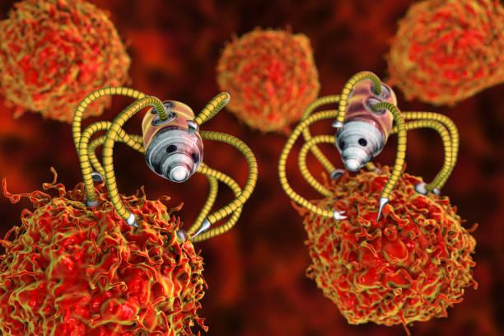
Nanotechnology a highly developed field of study that focuses on using molecular and atomic techniques to create nano-scale products that might find application in other scientific fields, has made significant strides in recent years. Although, nanoscience may appear uninteresting at first due to its small scale, it has enormous potential. Modern medicine has already benefited greatly from the application of nanoscience, largely because the variety and effectiveness of available treatment options has increased [1]. By manipulating shape and size at the nanometer scale, nanotechnology is the design, characterization, production and application of structures, devices and systems. There are many interesting things that occur in the size range between a few nanometers and 100 nm. Various physical properties change and many biological systems operate on this length scale [2].
Fig.1: Nanoparticles

A nanoparticle is any substance that has a size of less than one micron. Numerous helpful tools that can be used for the detection of biomolecules and analytes pertinent to diagnosis have been made possible by nanotechnology. Understanding nanoparticles and their distinctive properties can shed light on the odd reasons behind their use in a variety of industries [3].The nanoparticle’s small size and altered physical and chemical properties when compared to their macromolecular analogues provide many advantages for modern medicine, including improved drug delivery, non-invasive diagnostics and targeted treatment with fewer adverse and systemic effects [4]. In order to bring together the necessary collective expertise needed to develop these novel technologies, traditional sciences such as chemistry, physics, materials science and biology have come together to form the emerging field of nanotechnology, which should be understood. The combination of molecular imaging and nanotechnology offers a flexible platform for the development of novel nanoprobes that have the potential to significantly improve the sensitivity, specificity and signalling properties of various biomarkers in human diseases [5].The controlled release of agrochemicals to plants is made possible by the use of biosensors and nanoencapsulations for the delivery of nutrients and biofertilizers to plants.

APPLICATIONS

There are numerous applications for nanoparticles, nanoencapsules, nanotubes, nanospheres and nanochips in the medical industry, water treatment, agriculture, human health and environmental safety [6]. Because of its future potential to literally revolutionise each field in which it is used, nanotechnology has received unprecedented attention and enthusiasm. Nanotechnology is only now beginning to have an impact on drug delivery. The idea and capability of manipulating molecules and supramolecular structures to create devices with preprogrammed functions is crucial to the application of nanotechnology in drug delivery [7]. Numerous exciting opportunities in healthcare are being presented by the use of nanotechnology in medicine or nanomedicine [8]. Nanomedicine, which is generally regarded as the application of nanotechnology to the field of medicine, has its origins in the same fundamental ideas and principles as nanotechnology. The ability to operate at the same scale of various biological processes, cellular mechanisms and organic molecules is what drives nanotechnology’s success in the healthcare industry. As a result, medicine has viewed nanotechnology as the ideal solution for the detection and the treatment of many diseases. Drug delivery is one of the many ways that nanotechnology is used in the medical industry. Drug delivery is the market segment that dominates the nanomedicine sector, accounting for 76% of publications and 59% of patents.
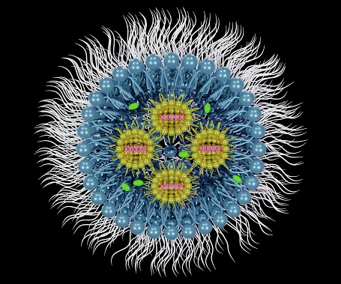
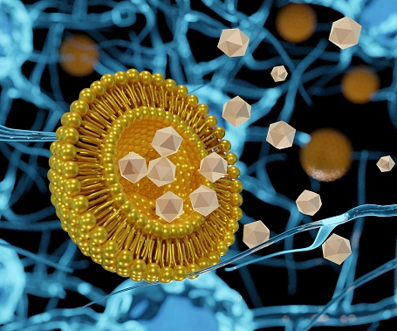
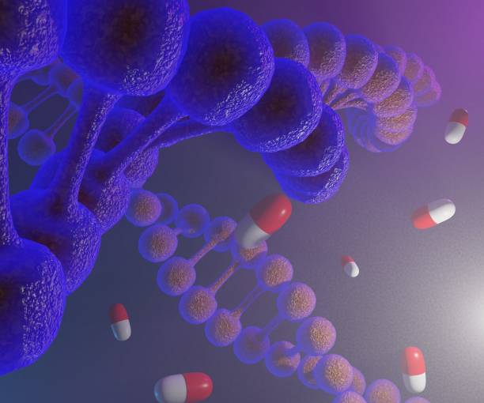
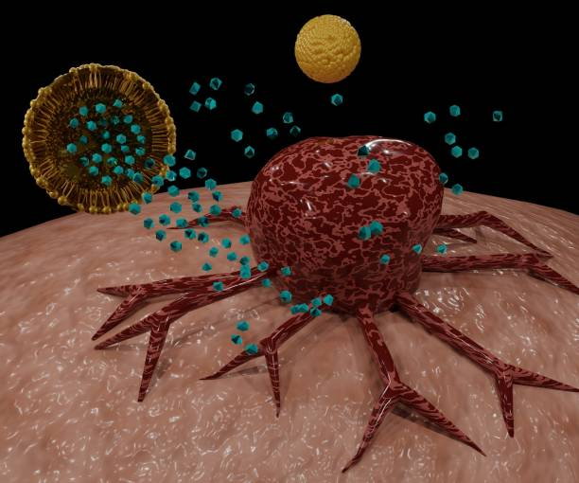

Fig.2: Nanomedicines
In vitro diagnostics is the second most important field, accounting for 11% of all publications and 14% of all patent filings [9].Among the nanoparticles used for diagnosis are paramagnetic nanoparticles, quantum dots, nanoshells and nanosomes. With the aid of nanotechnology, medications with a high potential for toxicity, such as cancer chemotherapy drugs, can be administered with a higher level of safety. Nanomedicine’s safety is not yet fully understood. However, it’s possible that nanomedicine will play a significant role in the future in both the treatment of human diseases and the improvement of physiology [10].

The science and technology of nanomedicine entails the diagnosis, treatment and prevention of diseases and traumatic injury, the easing of pain, the preservation and improvement of human health and ultimately the use of sophisticated mechanical systems and nonorobots. Nanomedicine could create instruments for in vivo diagnostics that could detect the early stages of a disease, recognise and measure toxic molecules and count tumor cells [11]. The use of several nanomaterials in vaccines has been successful. The COVID-19 mRNA vaccines from Moderna and Pfizer-BioNTech are two of the most well known examples available today. These vaccines employed a nanoparticle made of lipids or fatty acids that aids in transporting the mRNA to the location in the body where it is required to cause an immune response[12]. For cancer researchers working with anti-cancer medications that frequently have potent side effects, the potential fornanomedicine to increase a drug’s efficacy and decrease its toxicity is appealing. In fact, cancer is the primary focus of 65% of clinical trials involving nanoparticles. A multifunctional platform based on gold nanoparticles holds the promise of a ‘magic gold bullet' against cancer, with multiple receptor targeting, multimodality imaging, and multiple therapeutic entities [13].
Due to their small size, nanoparticles have the potential to pass through natural barriers, enter new sites outside of the portal of entry into the body and interact with biomolecules in the blood or within organs, tissues or cells. This interaction may be extremely advantageous for drug or gene delivery and imaging. Nanomedicine has the potential to lead to significant advancements In more efficient and affordable healthcare, which is essential for increasing access to and affordability of medications and treatments [14].

FUTURE SCOPE

Nanotechnology applications in medicine and physiology imply materials and devices that interact with the body at subcellular scales with high specificity. This has the potential to be translated into targeted cellular and tissue- specific clinical applications with the goal of achieving maximum therapeutic efficacy with the least amount of side effects [15].Natural products and herbal remedies have been used to treat diseases since the dawn of time. Herbal drug delivery methods that are nano-sized, have the potential to improve therapeutic efficacy and solve issues with plant based medicines, in future. In order to combat more chronic diseases like asthma, diabetes, cancer and others, nanocarriers must be incorporated into traditional medicine. Future research groups may become intrigued by the idea of using herbal nanoparticles to deliver cancer drugs and could produce results that are noteworthy [16].
REFERENCES
[1]Zdrojewicz Z, Waracki M, Bugaj B, Pypno D, Cabała K. Medical applications of nanotechnology. Advances in Hygiene & Experimental Medicine/Postepy Higieny i Medycyny Doswiadczalnej. 2015 Jan 1;69.
[2] Martis E, Badve R, Degwekar M. Nanotechnology based devices and applications in medicine: An overview. Chronicles of young Scientists. 2012 Jan 1;3(1):68-.
[3]Jackson TC, Patani BO, Ekpa DE. Nanotechnology in diagnosis: a review. Advances in Nanoparticles. 2017 Aug 3;6(3):93-102.
[4]Nikolova M, Slavchov R, Nikolova G. Nanotechnology in medicine. Drug discovery and evaluation: methods in clinical pharmacology. 2020:533-46.
[5]Saini R, Saini S, Sharma S. Nanotechnology: the future medicine. Journal of cutaneous and aesthetic surgery. 2010 Jan;3(1):32.
[6]Sharma PK, Dorlikar S, Rawat P, Malik V, Vats N, Sharma M, Rhyee JS, Kaushik AK. Nanotechnology and its application: a review. Nanotechnology in Cancer Management. 2021 Jan 1:1-33.
[7]Park K. Nanotechnology: What it can do for drug delivery. Journal of controlled release: official journal of the Controlled Release Society. 2007 Jul 7;120(1-2):1.
[8]Shi J, Votruba AR, Farokhzad OC, Langer R. Nanotechnology in drug delivery and tissue engineering: from discovery to applications. Nano letters. 2010 Sep 8;10(9):3223-30.
[9]Morigi V, Tocchio A, Bellavite Pellegrini C, Sakamoto JH, Arnone M, Tasciotti E. Nanotechnology in medicine: from inception to market domination. Journal of drug delivery. 2012;2012.
[10]Surendiran A, Sandhiya S, Pradhan SC, Adithan C. Novel applications of nanotechnology in medicine. Indian Journal of Medical Research. 2009 Dec 1;130(6).
[11] Patil M, Mehta DS, Guvva S. Future impact of nanotechnology on medicine and dentistry. Journal of Indian society of periodontology. 2008 May;12(2):34.
[12] Khurana A, Allawadhi P, Khurana I, Allwadhi S, Weiskirchen R, Banothu AK, Chhabra D, Joshi K, Bharani KK. Role of nanotechnology behind the success of mRNA vaccines for COVID-19. Nano Today. 2021 Jun 1;38:101142.
[13] Cai W, Gao T, Hong H, Sun J. Applications of gold nanoparticles in cancer nanotechnology. Nanotechnology, science and applications. 2008;1:17.
[14]Chang EH, Harford JB, Eaton MA, Boisseau PM, Dube A, Hayeshi R, Swai H, Lee DS. Nanomedicine: past, present and future–a global perspective. Biochemical and biophysical research communications. 2015 Dec 18;468(3):511-7.
[15]Sahoo SK, Parveen S, Panda JJ. The present and future of nanotechnology in human health care. Nanomedicine: Nanotechnology, biology and medicine. 2007 Mar 1;3(1):20-31.
[16]Ansari SH, Islam F, Sameem M. Influence of nanotechnology on herbal drugs: A Review. Journal of advanced pharmaceutical technology & research. 2012 Jul;3(3):142.

