Future of Total Knee Replacement: Artificial Intelligence and Newer Technologies
Authors: Dr. Narendra Singh Kushwaha, Dr. Mohammad Baqar Abbas, Dr. Prakash Gaurav Tiwari, Dr. Shailendra Singh
Introduction
Our improvements in the understanding of the various medical and surgical pathologies along with developments in their respective treatments has resulted in improved outcomes in patient health care. A fine example of this are the advancements made in the field of Orthopaedic surgery. Joint replacement and reconstruction is one of the most rewarding surgery done by Orthopaedic surgeons worldwide, and various researches are constantly being done to improve the outcomes of this already rewarding surgery. Total knee arthroplasty is a commonly performed surgery and has seen numerous advances in terms of implant design, surgical approaches and surgical methods over the past years. Inspite of these improvements up to 20% of TKA patients are still dissatisfied, with their functional outcomes [1]. Bonnin et al in their study reported that only 62 percent of patients in a multicenter cohort of 347 TKA patients reported being completely pain-free during gait, 35 percent reported being pain-free while ascending or descending stairs, and 40 percent reported experiencing discomfort while running [2]. Only 48% of the patients regarded their experience as "extremely satisfied". Promising new knee arthroplasty technologies have recently been developed with improvements in functional outcomes as the main aim behind these developments.
Amongst the new technologies and upcoming methods -patient-specific instrumentation (PSI), navigation, computer or robotic-assisted surgery (CAS) are promising.

Patient Specific Instrumentation
Patient specific instrumentation uses preoperative 3D model, constructed using preoperative radiographs of the lower limbs, CT scans and MRI. These 3D models are used to create disposable cutting blocks or positioning templates which are specific to the patient and take into account patient’s specific anatomical landmarks,deformities and osteophytes. These cutting blocks or pin guides are transported to the hospital in sterile packaging suitable for the operating room. This not only improves the precision of the cuts but also facilitates the surgical procedure thereby decreasing the operative time and blood loss [3][4][5]. Orthopaedic implant manufacturers like Smith & Nephew, Wright Medical Technology, DePuy, Biomet, Zimmer etc currently provide PSI systems. These manufacturers have specific algorithms on the basis of which the bone cuts, position of implants, sizes and rotations are decided. Both complete and single-compartment knee arthroplasty procedures can be performed using these systems.
For tibial cuts, the custom tibial guide is placed after appropriate exposure. Care is to be taken to not remove the osteophytes as they help in proper positioning of blocks. The advantage of using this guide is that it helps in determining the tibial bone resection level, the tibial slope and rotational alignment, thus decreasing the time otherwise consumed in conventional method for these steps. Similarly, for femur, the femoral guide is used which gives femoral alignment, cuts, size and rotation. Following the distal cuts, the remainder of the cuts are performed using the standard guide. It must be noted that these guides and blocks help is attaining, but do not replace, careful assessment of soft tissue balancing.
Although there have been studies that claim PSI improves implant location accuracy, the effects of PSI on radiologic outcomes have not been clearly demonstrated in several meta analyses [6]. Using postoperative long-leg radiographs from 569 TKAs with PSI and 155 with conventional method, Ng et al. found that there were substantially fewer HKA angle outliers with PSI than with standard instrumentation, 9 percent versus 22 percent, respectively [7]. The accuracy of alignment was studied by two meta-analyses. There was no discernible difference in the quantity of outliers in mechanical axis as well as coronal, sagittal, and axial alignment, according to Jiang et al compilation of 18 research involving 2417 individuals [8].
In a meta-analysis of 6 studies involving a total of 444 knees, Mannan et al. did identify positive femoral rotational results [9]. In contrast to conventional instrumentation, PSI did not increase the precision of femoral component rotation in TKA, according to Randelli et al randomized controlled experiment on 69 patients [10]. Other studies also described a cutting block for TKA that was patient-specific with an inadequate accuracy [11,12]. According to the technique (PSI or traditional), no investigation has found any difference in the clinical or functional outcomes [13-16]. 40 patients were randomly assigned to receive standard TKA or PSI when Abdel et al. did a gait examination on them. After three months, they found no differences in the functional or gait metrics [17].
The preoperative planning of PSI, which includes implant sizing, rotation, and femoral and tibial excision, should theoretically shorten the surgery time. However, Voleti et alrecent did meta-analysis of nine studies and 957 patients revealed a non-statistically significant trend toward shorter operating times, with a mean of just 5 minutes per patient [18]. Comparing the length of a surgical procedure using various modern technologies, such as PSI and CAS, would be intriguing and more pertinent.
In terms of functional outcome, studies have shown that there is no difference in clinical and functional outcome in short term and mid term results between patients operated using conventional methods and those using patient specific instrumentation. Goyal and colleagues [19] included five RCTs [20,21,22,23,24] involving 379 TKA in its meta-analysis. No significant improvement in short-term functional outcomes was seen after using PSI com- pared to the control in terms of PROMs or VAS. Thus, the available literature is not sufficient enough to say that PSI results in functional improvement.
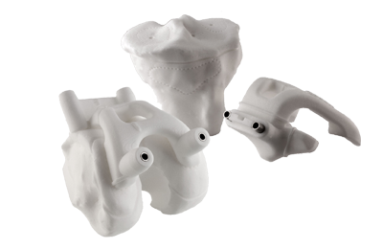
Patient specific instrumentation 3D model. (https://www.zimmerbiomet.lat/content/dam/zimmer-web/images/en-US/medical-professionals/knee/patient-specific-inst-hero.png)

Robotic assisted total knee arthroplasty
Robotic assisted TKA is another step towards improving accuracy of the surgical procedure. Along with the accurate bone cuts it also aids in assessing the soft tissues balance and appropriate positioning of the implant components. Usually a preoperative 3D image of the knee joint with femoro-tibial axis is made using CT scanning. The surgery is planned accordingly, and the robotic arm performs the accurate cuts based on the planning. Another method used is manual bone surface mapping done intraoperatively. This mapping is used to create a virtual 3 dimensional model which is used to plan the surgery. During the surgery the ligament balancing can be assessed and adjusted as per needs. Thus though the procedure does not require preoperative scans and planning, it’s cost, availability, possible errors in data entry are its associated demerits. There are 3 types of Commercially available robotic systems: autonomous, semiautonomous and passive. The autonomous and semiautonomous systems prevent removal of bone beyond the 3D plan whereas the passive system has no safeguards for bone preparation.
Studies have shown that using the robotic systems improves the positioning of implants [25,26,27,28,29,30]. Though it is a step towards improving the accuracy and thereby the overall outcome , It is yet early to say if this system provides a better long term functional outcome.
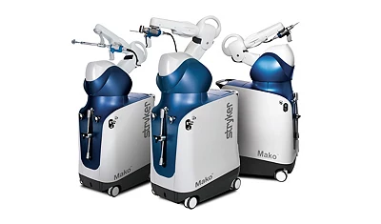
Stryker Mako Robotic Arm. (https://www.stryker.com/us/en/portfolios/orthopaedics/joint-replacement/mako-robotic-arm-assisted-surgery.html)

Sensors in total knee arthroplasty
This newer technique helps in improving a vital component of total knee arthroplasty, namely ligament balancing. Though the other technologies can assess the ligament and soft tissue tension, but still the mainstay remains the assessment by the surgeon, which relies on the BMI, the inherent laxity, joint contractures etc. The sensor, which is a wireless device, is inserted in the tibial tray. The capsule is closed by a few stitches. The leg is held in neutral position, and medial and lateral loading forces throughout the range of motion are observed. Less than differential loading of 15 pounds between the medial and lateral compartments is considered adequately balanced. A study done by Cho et al. showed that use of orthosensor improved soft tissue balancing [31].however other studies, like the one done by Song et al. showed no clinical difference between the TKAs done with or without a sensor system.
The main disadvantage of the sensors is that the reference values for normal compartment pressures is not completely understood, thus an adequately balanced tka as per the sensors might be a cause of dissatisfaction to the patient. Hence it must be kept in mind that values for normal pressures might be different with each case and patient specific. 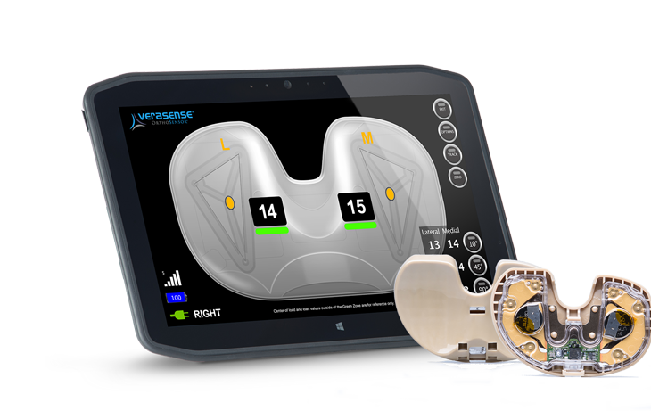
Orthosensor (https://www.orthosensor.com/wp-content/uploads/2018/07/FEATURED-IMAGE-PERSONA-POST-2-900x600.jpg)
References:
- Noble, P.C.; Conditt, M.A.; Cook, K.F.; Mathis, K.B. The John Insall Award: Patient Expectations Affect Satisfaction with Total Knee Arthroplasty. Clin. Orthop. Relat. Res. 2006, 452, 35–43.
- Bonnin, M.P.; Laurent, J.R.; Parratte, S.; Zadegan, F.; Badet, R.; Bissery, A. Can patients really do sport after TKA? Knee Surg. Sports Traumatol. Arthrosc. 2010, 18, 853–862.
- Sassoon A, Nam D, Nunley R, Barrack R. Systematic review of patient-specific instrumentation in total knee arthroplasty: new but not improved. Clin Orthop Relat Res. 2015;473(1):151–8.
- Thienpont E, Schwab PE, Fennema P. A systematic review and meta-analysis of patient-specific instrumentation for improving alignment of the components in total knee replacement. Bone Joint J. 2014;96(8):1052–61.
- Cavaignac E, Pailhe R, Laumond G, Murgier J, Reina N, Laffosse JM, Chiron P. Evaluation of the accuracy of patient-specific cutting blocks for total knee arthroplasty: a meta-analysis. Int Orthop. 2015;39(8):1541–52.

- De Vloo, R.; Pellikaan, P.; Dhollander, A.; Sloten, J.V. Three-dimensional analysis of accuracy of component positioning in total knee arthroplasty with patient specific and conventional instruments: A randomized controlled trial. Knee 2017, 24, 1469–1477.
- Ng, V.Y.; De Claire, J.H.; Berend, K.R.; Gulick, B.C.; Lombardi, A.V., Jr. Improved Accuracy of AlignmentWith Patient-specific Positioning Guides Compared With Manual Instrumentation in TKA. Clin. Orthop. Relat. Res. 2012, 470, 99–107.
- Jiang, J.; Kang, X.; Lin, Q. Accuracy of Patient-Specific Instrumentation ComparedWith Conventional Instrumentation in Total Knee Arthroplasty. Orthopedics 2015, 38, e305–e313.
- Mannan, A.; Smith, T. Favourable rotational alignment outcomes in PSI knee arthroplasty: A Level 1 systematic review and meta-analysis. Knee 2016, 23, 186–190.
- Randelli, P.S.; Menon, A.; Pasqualotto, S.; Zanini, B.; Compagnoni, R.; Cucchi, D. Patient-Specific Instrumentation Does Not Affect Rotational Alignment of the Femoral Component and Perioperative Blood Loss in Total Knee Arthroplasty: A Prospective, Randomized, Controlled Trial. J. Arthroplast. 2019, 34, 1374–1381.e137.
- Lustig, S.; Scholes, C.; Oussedik, S.I.; Kinzel, V.; Coolican, M.R.; Parker, D.A. Unsatisfactory Accuracy as Determined by Computer Navigation of VISIONAIRE Patient-Specific Instrumentation for Total Knee Arthroplasty. J. Arthroplast. 2013, 28,,469–473.
- Scholes, C.; Sahni, V.; Lustig, S.; Parker, D.A.; Coolican, M.R.J. Patient-specific instrumentation for total knee arthroplasty does not match the pre-operative plan as assessed by intra-operative computer-assisted navigation. Knee Surg. Sports Traumatol. Arthrosc. 2013, 22, 660–665.
- Abdel, M.P.; Parratte, S.; Blanc, G. No Benefit of Patient-specific Instrumentation in TKA on Functional and Gait Outcomes: A Randomized Clinical Trial. Clin. Orthop. Relat. Res. 2014, 472, 2468–2476.
- Abane, L.; Anract, P.; Boisgard, S.; Descamps, S.; Courpied, J.P.; Hamadouche, M. A comparison of patient-specific and conventional instrumentation for total knee arthroplasty: A multicentre randomised controlled trial. Bone Jt. J. 2015, 97-B, 56–63.
- Vundelinckx, B.J.; Bruckers, L.; De Mulder, K.; De Schepper, J.; Van Esbroeck, G. Functional and Radiographic Short-Term Outcome Evaluation of the Visionaire System, a Patient-Matched Instrumentation System for Total Knee Arthroplasty. J. Arthroplast. 2013, 28, 964–970.
- Chen, J.Y.; Chin, P.L.; Tay, D.K.J.; Chia, S.-L.; Lo, N.N.; Yeo, S.J. Functional Outcome and Quality of Life after Patient-Specific Instrumentation in Total Knee Arthroplasty. J. Arthroplast. 2015, 30, 1724–1728.
- Voleti, P.B.; Hamula, M.J.; Baldwin, K.D.; Lee, G.-C. Current Data Do Not Support Routine Use of Patient-Specific Instrumentation in Total Knee Arthroplasty. J. Arthroplast. 2014, 29, 1709–1712.
- Goyal T, Tripathy SK. Does patient-specific instrumentations improve short-term functional outcomes after total knee arthro- plasty? A systematic review and meta-analysis. J Arthroplasty. 2016;31(10):2173–2180.
- Vundelinckx BJ, Bruckers L, De Mulder K, et al. Functional and radiographic short-term outcome evaluation of the visionaire sys- tem, a patient-matched instrumentation system for total knee arthroplasty. J Arthroplasty. 2013;28(6):964–970.
- Kotela A, Lorkowski J, Kucharzewski M, et al. Patient-specific CT-based instrumentation versus conventional instrumentation in total knee arthroplasty: a prospective randomized controlled study on clinical outcomes and in-hospital data. Biomed Res Int. 2015;2015:165908.
- Yan CH, Chiu KY, Ng FY, et al. Comparison between patient-specific instruments and conventional instruments and computer naviga- tion in total knee arthroplasty: a randomized controlled trial. Knee Surg Sports Traumatol Arthrosc. 2015;23(12):3637–3645.
- Pietsch M, Djahani O, Zweiger C, et al. Custom-fit minimally inva- sive total knee arthroplasty: effect on blood loss and early clinical outcomes. Knee Surg Sports Traumatol Arthrosc. 2013;21 (10):2234–2240.
- Dossett HG, Estrada NA, Swartz GJ, et al. A randomised controlled trial of kinematically and mechanically aligned total knee replacements: two-year clinical results. Bone Joint J. 2014;96–B(7):907.
- Batailler, C.; White, N.; Ranaldi, F.M.; Neyret, P.; Servien, E.; Lustig, S. Improved implant position and lower revision rate with robotic-assisted unicompartmental knee arthroplasty. Knee Surg. Sports Traumatol. Arthrosc. 2019, 27, 1232–1240.
- Bell, S.W.; Anthony, I.; Jones, B.; MacLean, A.; Rowe, P.; Blyth, M.J.G. Improved Accuracy of Component Positioning with Robotic-Assisted Unicompartmental Knee Arthroplasty: Data from a Prospective, Randomized Controlled Study. J. Bone Jt. Surg.Am. Vol. 2016, 98, 627–635.
- Citak, M.; Suero, E.M.; Citak, M.; Dunbar, N.J.; Branch, S.H.; Conditt, M.A.; Banks, S.A.; Pearle, A.D. Unicompartmental knee arthroplasty: Is robotic technology more accurate than conventional technique? Knee 2013, 20, 268–271.
- Cobb, J.; Henckel, J.; Gomes, P.; Harris, S.; Jakopec, M.; Rodriguez, F.; Barrett, A.; Davies, B. Hands-on robotic unicompartmental knee replacement: A prospective, randomised controlled study of the acrobot system. J. Bone Jt. Surg. Br. Vol. 2006, 88, 188–197.
- Lonner, J.H.; Smith, J.R.; Picard, F.; Hamlin, B.; Rowe, P.J.; Riches, P.E. High Degree of Accuracy of a Novel Image-free Handheld Robot for Unicondylar Knee Arthroplasty in a Cadaveric Study. Clin. Orthop. Relat. Res. 2015, 473, 206–212.
- Herry, Y.; Batailler, C.; Lording, T.; Servien, E.; Neyret, P.; Lustig, S. Improved joint-line restitution in unicompartmental knee arthroplasty using a robotic-assisted surgical technique. Int. Orthop. 2017, 41, 2265–2271.
- Cho, K.-J.; Seon, J.-K.; Jang,W.-Y.; Park, C.-G.; Song, E.K. Objective quantification of ligament balancing using VERASENSE in measured resection and modified gap balance total knee arthroplasty. BMC Musculoskelet. Disord. 2018, 19, 266.

