SUICIDES ARE PREVENTABLE

Mrs. Debajani Sahoo
Asst. Prof. in Dept. of Psychiatric Nursing
Viswass School and College of Nursing, Khordha, Odisha
Mail Id - sahoodebajani998@gmail.com
Contact no.- 7008569668
Editor reference ID- IIPER1655891646

“Suicides Are Preventable With Timely, Evidence-Based And Also With A Low-Cost Interventions”

Introduction

Suicide is when one harm oneselve with the goal of ending the life, and loss of one’s life occured as a result. A suicide attempt is when people harm oneselve with the goal of ending the life, but no loss of one’s life occured as a result.
Each suicide is a personal tragedy which prematurely takes the life of an individual and has a continuing ripple effect, significantly affecting the lives of families, friends and communities of that individual.
How societies view suicide varies widely according to culture and religion. For example, many Western cultures, as well as mainstream Judaism, Islam, and Christianity tend to view killing oneself as quite negative. One myth about suicide that may be the result of this view is considering suicide (suicidal ideation) to always be the result of a mental illness. Some societies also treat a suicide attempt as if it were a crime. However, suicides are sometimes seen as understandable or even honorable in certain circumstances, as in protest to persecution (for example, a hunger strike), as part of battle or resistance (for example, suicide pilots of World War II, suicide bombers), or as a way of preserving the honor of a dishonored person (for example, killing oneself to preserve the honor or safety of family members).
Every year around 703 000 people take their own life and there are many more people who attempt suicide. Every suicide brings a great loss for their families, communities and entire countries and has long-lasting effects on the people left behind. Suicide occurs throughout the lifespan and was the fourth leading cause of death among 15-29 year-olds globally in 2019.
Suicide does not just occur in high-income countries, but is a global phenomenon in all regions of the world. In fact, over 77% of global suicides occurred in low- and middle-income countries in 2019.
The National Mental Health Survey (NMHS) 2015–16 found that almost 80% of those suffering from mental illnesses did not receive treatment for more than a year. The Indian government has been criticised by the media for its mental health care system, which is linked to the high suicide rate.
Actor Sushant Singh Rajput losing his life to suicide just goes to show that contrary to the popular belief, success, fame and the like are not determinants of good mental health. While success, money, achievement may increase self-worth and therefore happiness, it is not the sure shot to happiness. There’s a lot more to it than what meets the eye. No one is immune to poor mental health.

Definition

“Suicide is defined as an act in which a person intentionally causes his/her own death.”

The Government of India classifies a death as suicide if it meets the following three criteria:
- it is an unnatural death,
- the intent to die originated within the person,
- there is a reason for the person to end his or her life. The reason may have been specified in a suicide note or unspecified.
NOTE- If one of these criteria is not met, the death may be classified as death because of illness, murder or in another statistical.

Incidence and prevalence

Current global suicide rate per 100,000 population varies 0.4 in Antigua and Barbuda with male and female rate 0 : 0.8 to 72.4 in lesotho with male and female rate116 : 30.1. Where as India affected by12.7 with male and female rate 14.1 : 11.1. Which means there is no variation in gender

Previous Suicide mortality rate is the number of suicide deaths in a year per 100,000 population. Crude suicide rate (not age-adjusted).
India suicide rate for 2019 was 12.70, a 0.79% increase from 2018.
India suicide rate for 2018 was 12.60, a 5% increase from 2017.
India suicide rate for 2017 was 12.00, a 0.83% decline from 2016.
India suicide rate for 2016 was 12.10, a 1.63% decline from 2015.
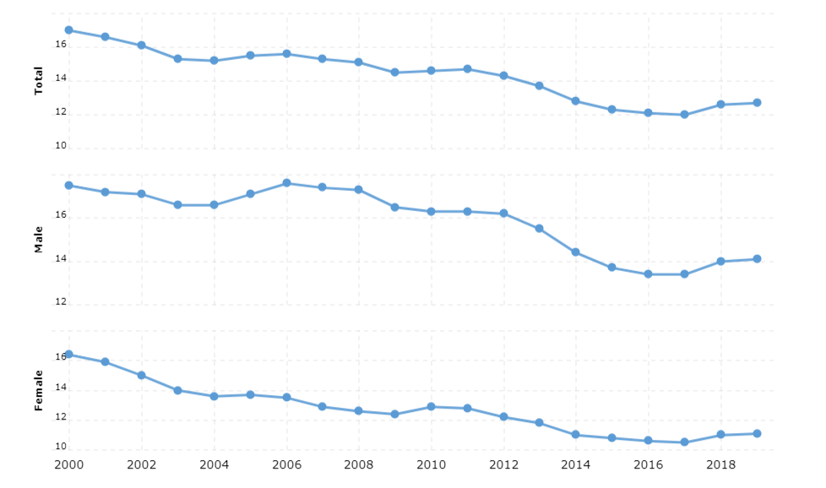
(Figure no. 1 Previous Suicide mortality rate is the number of suicide deaths in a year per 100,000 population. Crude suicide rate)

About 800,000 people die by suicide worldwide every year. 139,123 Indians committed suicide in 2019 and the national suicide rate was 10.4 (calculated per lakh of population). According to The World Health Organization, in India, suicide is an emerging and serious public health issue.

Causes

While the cause of suicide is unknown, some common risk factors include:
- major psychiatric illness - in particular, mood disorders (e.g., depression, bipolar disorder) and schizophrenia
- substance use disorder (primarily alcohol use disorder)
- family history of suicide
- long term difficulties with relationships with friends and family or any significant person of your current life
- losing hope or losing the will to live at any cost like temporary but feeling of hopelessness, worthlessness towrds own life and future with a large intensity
- significant losses in a person's life, such as the death of a loved one (e.g - spouse), loss of an important relationship, loss of employment or self-esteem due to any reason (name, fame, power)
- unbearable emotional or physical pain related to any cause like any chronic disease like cancer, HIV etc.

Table no. 1 Factors contributing to suicide in India in 2019

SL. NO. | CONTRIBUTING FACTORS | PERCENTAGE %
1 | Family problems | 32.4
2 | Illness | 17.1
3 | Drug abuse | 5.6
4 | Marriage related issues | 5.5
5 | Love affairs | 4.5
6 | Bankruptcy or indeptedness | 4.2
7 | Failure in examination | 2.0
8 | Unemployment | 2.0
9 | Professional/ career problem | 1.2
10 | Property dispute | 1.1
11 | Death of dear person | 0.9
12 | Poverty | 0.8
13 | Suspected/ illicit relation | 0.5
14 | Fall in social reputation | 0.4
15 | Impotency/infertility | 0.3
16 | Other causes | 11.1
17 | Causes not known | 10.3

Warning signs and risk factors

A person who is at risk of committing suicide usually shows signs - whether consciously or unconsciously - that something is wrong.

Keep an stare at:
- signs of clinical depression or Agitation, hyperactivity, and restlessness may indicate an underlying depression that is being concealed.
- withdrawal from friends and family, like to spend time lonely
- sadness and hopelessness
- lack of interest in previous activities, or in what is going on around them like withdrawn self from all
- physical changes, such as lack of energy, different sleep patterns, change in weight or appetite
- loss of self-esteem, negative comments about self-worth
- bringing up death or suicide in discussions or in writing
- previous suicide attempts
- getting personal affairs in order, such as giving away possessions, or having a pressing interest in personal wills or life insurance

Though many people considering suicide seem sad, some mask their feelings with excessive energy.
If you become so overwhelmed by your problems that suicide becomes a consideration, you deserve to be taken seriously.
Talking about suicide means that the potential exists to take your own life - even if you do not actually do it. Denial will not make the threat of suicide disappear and can only leave you feeling more alone and in anguish.
Sometimes professionals assess suicide risk by using an assessment scale. One such scale is called the SAD PERSONS Scale, which identifies risk factors for suicide as follows:
- Sex (male)
- Age younger than 19 or older than 45 years of age
- Depression (severe enough to be considered clinically significant)
- Previous suicide attempt or received mental health services of any kind
- Excessive alcohol or other drug use
- Rational thinking lost
- Separated, divorced, or widowed (or other ending of significant relationship)
- Organized suicide plan or serious attempt
- No or little social support
- Sickness or chronic medical illness

Methods of suicide

It is estimated that around 20% of global suicides are due to pesticide self-poisoning, most of which occur in rural agricultural areas in low- and middle-income countries. Other common methods of suicide are hanging and firearms.
Knowledge of the most commonly used suicide methods is important to devise prevention strategies which have shown to be effective, such as restriction of access to means of suicide.

Treatment to suicidal thoughts and attempt

Those who treat people who attempt suicide tend to adapt immediate treatment to the person's individual needs. Those who have a responsive and intact family, good friendships, generally good social supports, and who have a history of being hopeful and have a desire to resolve conflicts may need only a brief crisis-oriented intervention. However, those who have made previous suicide attempts, have shown a high degree of intent to kill themselves, seem to be suffering from either severe depression or other mental illness, are abusing alcohol or other drugs, have trouble controlling their impulses, or have families who are unable or unwilling to commit to counseling are at higher risk and may need psychiatric hospitalization to prevent a repeat attempt in the days following the most recent attempt by providing close monitoring (for example, suicide watch) and long-term outpatient mental health services to achieve recovery from their suicidal thoughts or actions.
Talk therapy (psychotherapy) that focuses on helping the person understand how their thoughts and behaviors affect each other (cognitive behavioral therapy) has been found to be an effective treatment for many people who struggle with thoughts of harming themselves. School intervention programs in which teens are given support and educated about the risk factors, symptoms, and ways to manage suicidal thoughts in themselves and how to engage adults when they or a peer expresses suicidal thinking have been found to decrease the number of times adolescents report attempting suicide.
Although concerns have been raised about the possibility that antidepressant medications increase the frequency of suicide attempts, mental health professionals try to put those concerns in the context of the need to treat the severe emotional problems that are usually associated with attempting suicide and the fact that the number of suicides that are completed by mentally ill individuals seems to decrease with treatment. While many youths who are treated with medication for depression may also respond to a sugar pill (placebo), this age group of individuals get better when they take an antidepressant medication, particularly when medication is combined with psychotherapy. In fact, concern has been expressed that the reduction of antidepressant prescribing since the U.S.
Food and Drug Administration required that warning labels be placed on these medications may be related to the 18.2% increase in U.S. youth suicides from 2003-2004 after a decade of steady decrease. While the use of specific antidepressants has been associated with lower suicide rates in adolescents over the long term, uncommon short-term side effects of serotonergic antidepressants (for example, fluoxetine [Prozac], sertraline [Zoloft], paroxetine [Paxil], escitalopram [Lexapro],or vortioxetine [Trintellix]) may include an increase in suicide. Therefore, most practitioners consider antidepressant medication an important part of treating depression while closely monitoring their patients' progress to prevent suicide.
Mood-stabilizing medications like lithium (Lithobid) -- as well as medications that address bizarre thinking and/or severe anxiety, like clozapine (Clozaril), risperidone (Risperdal), and aripiprazole (Abilify) -- have also been found to decrease the likelihood of individuals killing themselves.

The coping strategies for suicidal thoughts

In the effort to cope with suicidal thoughts, silence is the enemy. Suggestions for helping people survive suicidal thinking include engaging the help of a doctor or other health professional, a spiritual advisor, or by immediately calling a suicide hotline or going to the closest emergency room or mental health crisis center. In order to prevent acting on thoughts of suicide, it is often suggested that individuals who have experienced suicidal thinking keep a written or mental list of people to call in the event that suicidal thoughts come back. Other strategies include having someone hold all medications to prevent overdose, removing knives, guns, and other weapons from the home, scheduling stress-relieving activities every day, getting together with others to prevent isolation, writing down feelings, including positive ones, and avoiding the use of alcohol or other drugs.

Suicide prevention strategies

For the population at large, suicide-prevention strategies include increasing access to health care, promoting mental health, avoidance of drug use, and restricting access to means to complete suicide. Responsible media reporting to raise mental health and suicide awareness, as well as how to report suicides and other violence that occurs are other suicide-prevention strategies that are often used in general populations.
Suicide-prevention measures for individuals who have a mental health history following a psychiatric hospitalization usually involve mental health professionals trying to implement a comprehensive outpatient treatment plan prior to the individual being discharged. This is all the more important since many people fail to comply with outpatient therapy after leaving the hospital. It is often recommended that all firearms and other weapons be removed from the home, because the individual may still find access to guns and other dangerous objects stored in their home, even if locked. It is further often recommended that sharp objects and potentially lethal medications be locked up as a result of the attempt.
Vigorous treatment of the underlying psychiatric disorder is important in decreasing short-term and long-term risk. Contracting with the person against suicide has not been shown to be especially effective in preventing suicidal behavior, but the technique may still be helpful in assessing risk, since hesitation or refusal to agree to refrain from harming oneself or to fail to agree to tell a specified person may indicate an intent to harm oneself. Contracting might also help the individual identify sources of support he or she can call upon in the event that suicidal thoughts recur.

Strategies to prevent suicide

- Strengthen economic supports
Strengthen household financial security
Housing stabilization policies

- Strengthen access and delivery of suicide care
Coverage of mental health conditions in health insurance policies
Reduce provider shortages in underserved areas
Safer suicide care through systems change

- Create protective environments
Reduce access to lethal means among persons at risk of suicide
Organizational policies and culture
Community-based policies to reduce excessive alcohol use

- Promote connectedness
Peer norm programs
Community engagement activities

- Teach coping and problem-solving skills
Social-emotional learning programs
Parenting skill and family relationship programs

- Identify and support people at risk
Gatekeeper training
Crisis intervention
Treatment for people at risk of suicide
Treatment to prevent re-attempts

- Lessen harms and prevent future risk
Postvention
Safe reporting and messaging about suicide

Conclusion

Suicide is a serious public health problem that can have long-lasting effects on individuals, families, and communities. The good news is that suicide is preventable. Preventing suicide requires strategies at all levels of society. This includes prevention and protective strategies for individuals, families, and communities. Everyone can help prevent suicide by learning the warning signs, promoting prevention and resilience, and a committing to social change.

Suicide helpline number

9152987821

Suicide Prevention Helplines

Table no 2 SUICIDE PREVENTION and STRESS HELPLINES
(Updated September 2021)
Location | Organisation | Number | Hours of operation + notes
ALL-INDIA | GOVT MH Rehabilitation HELPLINE ‘KIRAN’ | 1800-5990019 | 24/7
ALL-INDIA | VANDREVALA FOUNDATION | 9999 666 555/  whatsapp- +1(256)6662141 | 24 by 7/  E: help@vandrevalafoundation.com if you don’t get through and expect a call-back
 | FORTIS HOSPITAL NATIONAL HELPLINE | 91-8376804102 | 24 by 7 / Multilingual
BANGALORE | SAHAI | 080-25497777 | Monday – Saturday 10 AM to 5:30PM
CHENNAI | SNEHA | 044 2464 0050 | Daily: 8 AM to 10 PM  E: help@snehaindia.org
DELHI | SANJIVINI SOCIETY FOR MENTAL HEALTH | 01140769002, 01141092787  01124311918, 01124318883, 01143001456 | Daily: 10 AM to 4 PM
GANGTOK | SIKKIM HELPLINE NUMBER | 1800-3453225 | 24/7
HYDERABAD | ONE LIFE | 78930 78930 | 24/7
KOLKATA | DEFEAT DEPRESSION | 9830027975 | Call: 9 AM to 10 PM
 | LIFELINE FOUNDATION | +91 9088030303, 03340447437 | Daily 10 AM to 10 PM / Caters to pan-India calls  E: contact@lifelinefoundation.in  Site: www.lifelinefoundation.in
MUMBAI | AASRA | 91-9820466726 | 24/7; Languages: English, Hindi
 | SAMARITANS | 84229 84528, 84229 84529, 84229 84530 | Daily 5 PM to 8 PM  E: talk2samaritans@gmail.com
You can call and speak anonymously and confidentially, or visit the centre for a personal meeting in Mumbai, with a prior appointment. Address:402, Jasmine, Opp Kala Kendra,
Dadasaheb Phalke Road, Dadar(E), Mumbai 400014

Suicide counselling

AASRA

Reference

- https://www.medicalnewstoday.com/articles/193026#prevention
- https://medbroadcast.com/condition/getcondition/suicide
- https://www.who.int/news-room/fact-sheets/detail/suicide
- https://www.medicinenet.com/suicide/article.htm
- https://www.cdc.gov/suicide/prevention/index.html#:~:text=Preventing%20suicide%20requires%20strategies%20at,a%20committing%20to%20social%20change.
- https://www.mayoclinic.org/diseases-conditions/suicide/symptoms-causes/syc-20378048
- https://www.medicalnewstoday.com/articles/193026
- https://ncrb.gov.in/sites/default/files/Chapter-2-Suicides_2019.pdf
- https://indianexpress.com/article/lifestyle/health/suicide-causes-signs-prevention-awareness-counselling-6460322/
- https://www.statista.com/statistics/616974/suicides-by-cause-india/
- http://www.healthcollective.in/suicide-prevention-helplines/

