Behaviour of Free-surface in Single-layer Fluid Flow Problem

Srikumar Panda

Assistant Professor

Department of Mathematics

Vidyasagar College, Kolkata, INDIA

shree.iitg.mc@gmail.com

ABSTRACT

The behavior of the free-surface in a single-layer flow over an undulated bottom is analyzed. To formulate the problem, it is considered that the fluid is incompressible as well as inviscid. The physical problem is expressed as a mixed boundary value problem using linear theory. This governing boundary value problem is solved with the help of perturbation analysis and Fourier transformation. The free-surface profile is determined mathematically. Also, the use of Fourier transform technique is highlighted in a detailed manner. The behavioral changes of the free-surface are also studied. Finally, the effect of undulated bottom profile is explained.

Keywords—Fluid flow; Linear theory; Mixed BVP; Froude number; Bottom profile

# INTRODUCTION

Many researchers considered free-surface flow problems to model diverse circumstances occurring in atmospheric science as well as in oceanography. Solutions of such fluid flow problems are helpful to analyze the mechanism of wave generation. Various challenges have been faced by the scientists to examine the free-surface flow over random bottom topography. Hence, the fluid flow problem becomes a topic of importance in mathematical as well as in physical sciences.

From the available literature, it is found that the free-surface fluid flow problems in the presence of different kind of obstacles are examined by several applied mathematicians and physicists. The consideration of the free-surface flow over arbitrary bottom has been increasing rapidly, and a considerable progress has been prepared in this direction. For instance, Forbes and Schwartz [1] studied the fluid flow problem in the presence of a semicircular obstacle attached to the bottom. They have calculated the wave resistance using a numerical approach. Vanden-Broeck [2] explained the similar problem considered in [1] numerically, and conferred the subsistence of supercritical solutions. They have shown that supercritical solutions depend on the Froude number, a physical quantity. Later on, Forbes [3] demonstrated a numerical solution for the free-surface flow in the presence of a semicircular obstacle. In the presence of surface tension, Yong [4] considered the fluid flow problem in the presence of a concave bottom, and shown the subsistence of nonlinear capillary-gravity waves. Dias and Vanden-Broeck [5] considered the fluid flow problem over a triangular obstacle, and explained the problem numerically using series truncation method. Shen *et al*. [6] studied the fluid flow problem numerically in the presence of a semielliptical bottom. Using numerical method, Dias and Vanden-Broeck [7] analyzed the steady flow problem, and confirmed the existence of supercritical flows with downstream waves only. Using a new and simpler approach, Panda *et al.* [8] solved the nonlinear flow over a random bottom. Higgins *et al.* [9] offered series method to attain the solutions of three different kinds of fluid flow problems: supercritical flow, transcritical flow and subcritical flow. It is worthy to mention here that the aforesaid studies are based on the consideration of steady flow. In case of unsteady flow of a stratified fluid, Grimshaw and Smyth [10] deliberated a theoretical aspect with the help of weak nonlinear theory. Stokes *et al*. [11] applied numerical approach to investigate the unsteady fluid flow in the presence of a submerged point sink. For the case of time dependent flow (*i.e*., the submerged obstacle is moving), Milewski and Vanden-Broeck [12] solved the time dependent problem by applying weak nonlinear theory. From the above-mentioned literature, it is clear that a specific type of bottom topography such as semi-circle [1, 2], semi-ellipse [13], a step [14], triangle [15], is considered in most of the cases due to the simplification. Hence, the flow over random bottom topography is continuing unanswered. This is because of the governing boundary value problems become mixed and coupled and therefore their explicit solutions are not possible always.

In the present study, a two-dimensional potential flow over a random bottom having a small obstruction is analyzed using linear theory. It is considered that the fluid is incompressible and inviscid. The physical problem is prepared in terms of a mixed boundary value problem (BVP). Using perturbation analysis and Fourier transform technique, the aforesaid BVP is solved to find out the analytical expression of the unknown free-surface. In addition, the role of the Fourier transform technique is highlighted. Also, the behavior of the unknown free-surface is analyzed.

# DESCRIPTION AND FORMULATION

It is considered a two-dimensional potential free-surface fluid flow in which the fluid is inviscid and incompressible. The fluid is running from the left to the right over an undulating bottom *y* = B(*x*) having a small undulation. The domain of the fluid flow is depicted in Figure 1. Let us assume that the *x*-axis is considered along the undisturbed bottom and the *y*-axis is considered vertically upward. It is also assumed that the flow is uniform with a constant velocity *c* at the far upstream. Let *H* be the upstream depth of the fluid and *ρ* be the density of fluid. Let $ϕ$ (*x*,*y*) be the velocity potential thus the velocity of the fluid, $\overline{q},$ can be written as $\overline{q}=\left(\frac{∂ϕ}{∂x}, \frac{∂ϕ}{∂y}\right)$. Let the unknown free-surface is considered as $y=η\left(x\right).$ The effect of the surface tension is neglected here and the flow is stationary. Therefore, the partial derivatives with respect to the time vanish. The consider problem is prepared non-dimensional using *H* and *c* as the length and velocity scale. Therefore, the study carries on solely with dimensionless variables.

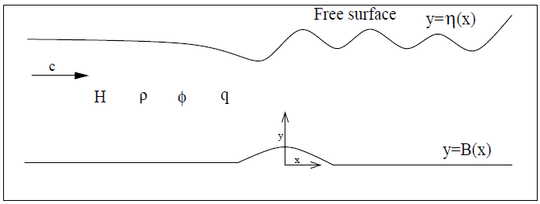

**Figure 1: The flow domain.**

Due to the aforesaid considerations, the *equation of continuity* becomes

|  |  |
| --- | --- |
|  | (1) |

As all fluid particles stick with the free surface, then the kinematic condition becomes

|  |  |
| --- | --- |
|  | (2) |

where denotes normal derivative at a point (*x*,*y*).

Applying Bernoulli’s equation, the other condition at the free surface is obtain as

|  |  |
| --- | --- |
|  | (3) |

where denotes the Froude number with acceleration of gravity *g*. Here, the subcritical flow is only considered. Hence, the Froude number is considered as small. In particular it is less than 1 i.e., *F*<1.

Since there is no incursion of fluid at the bottom, hence the bottom condition at the bottom is

|  |  |
| --- | --- |
|  | (4) |

Further, the conditions at the far upstream are

|  |  |
| --- | --- |
|  | (5) |

The objective of this study is to determine the physical parameters $ϕ$ (*x*,*y*) and $η(x)$ which are unknown at the begging. These parameters can be obtained once the governing boundary value problem (1)-(5) is solved. In the subsequent section, the aforesaid BVP is solved using the methods: perturbation analysis and Fourier transform technique.

# SOLUTION PROCEDURE

It is supposed that the undulating bottom topography is specified bywhereis a small non-dimensional quantity and represents the maximum height of the undulating bottom. As the height is small, then the solution of the boundary value problem (1)-(5) can be derived with the help of perturbation expansion. Now, the velocity potential and the free-surface profile can be stated asymptotically as

|  |  |
| --- | --- |
|  | (6) |
|  | (7) |

where and  denote the first-order velocity potential and free-surface profile, respectively. As ε is very small, the consideration upto the first-order terms are enough. Now, and can be derived once the parametersand  are evaluated. Hence, the parametersand will be determined in the following part. Using equations (6) and (7) in (1)-(4); and then relating the first-order terms of on both sides of entire system of equations, the below mixed boundary value problem is obtained:

|  |  |
| --- | --- |
|  | (8) |
|  | (9) |
|  | (10) |
|  | (11) |

where and are, respectively, the first order derivatives of *f*(*x*)and with respect to *x*.

To solve the above mixed boundary value problem (8)-(11), the first-order potential and the bottom profile *f*(*x*)are assumed such that the Fourier transforms of and *f*(*x*) exist, which are well-defined as

|  |  |
| --- | --- |
|  | (12) |

with inverse

|  |  |
| --- | --- |
|  | (13) |

and

|  |  |
| --- | --- |
|  | (14) |

where *M*(*k*) fixes the bottom profile. For the free-surface profile, let us define as

|  |  |
| --- | --- |
|  | (15) |

Using Fourier transform and its inverse; and applying the equations (14) and (15), the solution of the BVP (8)-(11) is attained as

|  |  |
| --- | --- |
|  | (16) |

where

|  |  |
| --- | --- |
|  | (17) |

with

|  |  |
| --- | --- |
|  | (18) |

It is worthy to note here that the relation

|  |  |
| --- | --- |
|  | (19) |

is called as *dispersion relation.* It can be proved (confirmed in Section IV) that the dispersion relation (19) has two real roots: one is positive root and another one is negative root having the same magnitude as that of the positive real root. It should be noted that the positive real root of the dispersion relation plays a very crucial role in the study of fluid flow problem as it indicates the wave number of the downstream waves. It can also be observed, from relations (15) and (17), that the first-order free-surface profile (hence the free-surface) depends on the profile of the bottom. Hence, it is very much important to know the shape of the bottom profile. In the present work, the below bottom profile is chosen to establish the further outcomes:

|  |  |
| --- | --- |
|  | (20) |

where *L* indicates the half length of the bottom obstacle.

Applying relations (14), (17) and (20), *a*(*k*) is derived as

|  |  |
| --- | --- |
|  | (21) |

Again, applying the value of *a*(*k*) into the relation (15), the first-order free-surface profile is derived as

|  |  |
| --- | --- |
|  | (22) |

From the relation (22), it is clear that the integrals contain a simple pole on the real axis at the zero of *E*1(*k*). Therefore, we can use the Cauchy principal value having an indentation below the singularity to determine the above integration (22). Applying the residue theorem, we have obtained the following free-surface profile:

|  |  |
| --- | --- |
|  | (23) |

where *k*0 indicates the positive and real root of the dispersion relation (19).

From the above relation (23), the following observations are made:

The free-surface represents oscillatory nature which indicates a train of waves.

At the downstream, the free-surface possesses waves whereas at the upstream there is no wave.

At the upstream, the region is free-of wave *i.e.,* wave-free region.

The amplitude of downstream wave is constant.

# RESULTS AND ILLUSTRATION

In the present section, some of the numerical results which are important for the present study are discussed. For instance, a detail discussion on the real roots (*i.e*., the wave number) of the dispersion relation (19) is provided in a tabular form. Also, effects of several physical parameters on the free-surface profile are presented.

The roots of the aforesaid dispersion relation are determined with the help of Newton’s method for several values of Froude number (*F*) for *D* = 0.7 and *γ* = 1. These roots are tabulated in Table 1. From this table, it is evident that the dispersion relation has two real roots. Out of these two roots, one is positive (indicates the wave number) and another one is negative having same magnitude. This affirms the theoretical observation reported in Section III. In addition, it is also clear (*refer* Table 1) that the wave number decreases, *i.e*., the wavelength increases with the Froude number *F*.

### **Table 1: Roots of the dispersion relation (19)**

| Parameter value | F=0.2 | F=0.3 | F=0.4 | F=0.5 | F=0.6 |
| --- | --- | --- | --- | --- | --- |
| Real roots | 24.99999,  -24.99999 | 11.11111,  -11.11111 | 6.24995, -6.24995 | 3.99730, -3.99730 | 2.75541, -2.75541 |

Figure 2 illustrates the behavior of the free-surface for two distinct Froude numbers such as *F* = 0.5 and 0.6 with =0.1 and *L*=1. From the figure, it is remarked that the nature of the free-surface is oscillatory with same peak. This phenomenon indicates that the free-surface profile represents downstream waves having constant amplitude. The wavy nature arises due to the interaction of the fluid with the undulated bottom. It is also clear (*refer* Figure 2) that the amplitude of the downstream wave increases as the Froude number increases. It is well known that the wavelength increases as the speed of the fluid increases. Again, from the relation the speed of the fluid increases as the Froude number increase. Hence, the wavelength of the downstream wave increases as the Froude number increases. This phenomenon is also observed in Figure 2.

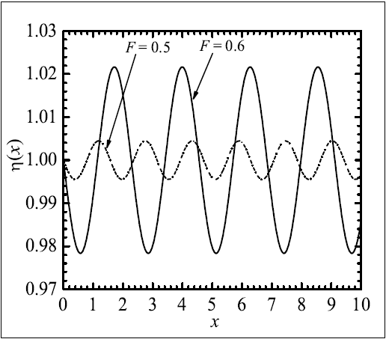

**Figure 2: Free-surface profile for =0.1, *L*=1.**

Figure 3 describes the outcome of the height of the undulated bottom on the free-surface. In the present figure, the free-surface is shown for three distinct values of the bottom height= 0.01, 0.05 and 0.1 with *F*=0.6 and *L*=1. From the physical intuition, it is obvious that the amplitude of the downstream wave increases with the growth of bottom height. This phenomenon is also noticed (*refer* Figure 3) in the present study. In this figure, we have kept the Froude number same (i.e., *F* = 0.6) for each free-surface profile (or downstream wave). And we have noticed that the wavelengths of the downstream waves are same (*refer* Figure 3). This is completely consistent with the phenomenon that the wavelength depends on the Froude number.

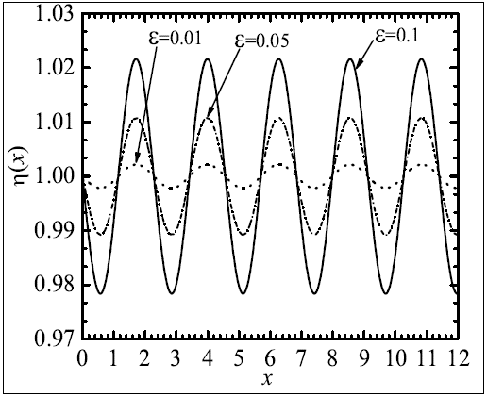

**Figure 3: Free-surface profile** **for *F*=0.6, *L*=1.**

# SUMMARY

Problem involving fluid flow in a single-layer having an undulated bottom is studied using linear theory. Perturbation analysis and Fourier transform technique is employed to solve the governing mixed boundary value problem. The behavioral changes of the free-surface are examined. It is observed that the free-surface represents downstream waves having constant amplitude. Also, the amplitude of the produced wave increases with the growth of bottom height. Further, the wavelength of downstream wave increases with Froude number.

##### REFERENCES

1. L.K. Forbes and L.W. Schwartz, “Free-surface flow over a semicircular obstruction,” J. Fluid Mech., vol. 114, pp. 299-314, 1982.
2. J.-M. Vanden-Broeck, “Free-surface flow over a semi-circular obstruction in a channel,” Phys. Fluids, vol. 30, pp. 2315-2317, 1987.
3. L.K. Forbes, “Critical free-surface flow over a semi-circular obstruction,” J. Engrg.Math., vol. 22, pp. 3-13, 1988.
4. Z. Yong, “Resonant flow of a fluid past a concave topography,” Appl. Math. Mech.-Engl. Ed., vol. 18(5), pp. 479-482, 1997.
5. F. Dias and J.-M. Vanden-Broeck, “Open channel flows with submerged obstructions,” J. Fluid Mech., vol. 206, pp. 155-170, 1989.
6. S.P. Shen, M.C. Shen, and S.M. Sun, “A model equation for steady surface wavesover a bump,” J. Engrg. Math., vol. 23, pp. 315-323, 1989.
7. F. Dias and J.-M. Vanden-Broeck, “Generalised critical free-surface flows,” J. Engrg.Math., vol. 42, pp. 291-301, 2002.
8. S. Panda, S.C. Martha, and A. Chakraborty, “An alternative approach to study nonlinear inviscid flow over arbitrary bottom topography,” Appl. Math. Comp., vol. 273, pp. 165-177, 2016.
9. P.J. Higgins, W.W. Read, and S.R. Belward, “A series-solution method for freeboundary problems arising from flow over topography,” J. Engrg. Math., vol. 54, pp. 345-358, 2006.
10. R.H.J.Grimshaw and N. Smyth, “Resonant flow of a stratified fluid over topography,” J. Fluid Mech., vol. 16, pp. 429-464, 1986.
11. T.E. Stokes, G.C. Hocking, and L.K. Forbes, “Unsteady flow induced by a withdrawalpoint beneath a free surface,” ANZIAM J., vol. 47, pp. 185-202, 2005.
12. P. Milewski and J.-M. Vanden-Broeck, “Time dependent gravity capillary flows pastan obstacle,” Wave Motion, vol. 29, pp. 63-79, 1999.
13. S.P. Shen, M.C. Shen, and S.M. Sun, “A model equation for steady surface wavesover a bump,” J. Engrg. Math., vol. 23, pp. 315-323, 1989.
14. A.C. King and M.T.G. Bloor, “Free surface flow over a step,” J. Fluid Mech., vol. 182,pp. 193-208, 1987.
15. F. Dias and J.-M. Vanden-Broeck, “Open channel flows with submerged obstructions,” J. Fluid Mech., vol. 206, pp. 155-170, 1989.