ISOLATION AND CHARACTERIZATION OF COW DUNG MICROFLORA AND ITS EFFECTIVENESS OFCitrus limon BIO-ENZYME

KRISHNAVENI.R, SATHYA I,AMEERA.S ,ARTHI.K, JANARANJANI.S
Assistant professor and Head, PG And Research Department of Microbiology.
Idhaya College for Women.Kumbakonam.
Sathya I, Ameera S ,Arthi K, Janaranjani . S, UG Student
PG And Research Department of Microbioogy. Idhaya College for Women.Kumbakonam.
Corresponding Authour;krishnavenimicro@gmail.com
ABSTRACT:
Cow manure act as a good fertilizer. It was rich in minerals like nitrogen, phosphorus and potassium. It is used to growth of beneficial microbes. When it mixed with soil it can also improve the texture of soil and help it to maintain soil moisture. Cow dung is the undigested residue of plant material which has passed through the animals gut the resultant feacal matter is rich in minerals. The present work carried out on isolation and characterization of cow dung microflora ands its effectiveness of citrus limon BIO-ENZYME

The microbes of cow dung include bacteria such as bacillus,lacto bacillus as control endospoire forming bacillus some cocci fungi and yeast such as sacromyces .Anti microbial drugs has great effect on infection disease caused by microbes.

The isolated shigella sp., shows maximum (23mm) zone of inhibition and klebsiella is sensitive to bio enzyme.the zone of inhibition ( 14mm) was observed. In proteus zone of inhibition was observed (17mm) . people in Indian villages use cow dung for cooking purpose for direct burning. Cow dung also as a co – product in agriculture, such as manure , pest repellant and source of energy. The present study concluded that use of bio-enzyme act as a potential cleansing agent in future use.

INTRODUCTION
Catle rearing used as a Agriculture trading. Since ancient period. In Auyurvedic treatment milk, gee, curd, urine, and dung from coware used As ingredients. Cow dung is used us natural nutrients for Plant and also it's resistant to insect which affect growth of plants.It induces sulphur oxidation and phosphorus solubilization and also Improve plant development. Generally cow dung consist of 80% Water, partially digested plant materials that has high amount of Nutrents and microbes. The micro organisms such as bacilli sp Lacto baccilius and coccus . Muhamed and Amusa 2003. According toWare et al ....., 1988. lower part of the gut of the cow contains various microorganisms including
Lactobacillus plantarum,Lactobacillus casei, lactobacillus acidophilus, B. Subtrita ,Enterococcus diacetylactis bifidobacterium and yeast .Commonly Saccharomyces corevisiae having probiotic activity Ware Funssin D R, Read PL et AL.,.. ( 1988 ) Generally old cow dung has more soil infectants Such as bacteria, fungi, Trichoderma and Actinimycetes Muhamed and Amusha ( 2003 ). There are many
Proofs to confirm that a fresh cow dung and cow urineare antifungal and antiseptic in nature. N ene YL . ( 2001 )Which might be due to secretion of antimicrobial metabolites by cow dung microorganisms. The microbes of cow dung Include bacteria such as bacillus, lactobacillus as control Endospore forming bacillus some cocci fungi and yeast.Such as sachromyces. ( S harma and Singh, 2015 )Antimicrobial drugs has great effect on infection diaseasecused by resistant microbes 1929 ( Fleming et.al.,., 1929 ) ( Kardosand and Demain, 2011.,( Kaarla et al.,., 2015). The bacterial resistanceis of great concern as not only increase the substantial morbidity andMortality but also the cost treatment ( Naiem et al .,., 2006 )( Sikarwar and Batra, 2011 ). ( Abo – State et al.,., 2012 )Cow dung can be referred as treasure of microorganisms thatContain 60 different bacteria species and 100 species of protozoand yeast such as
Citrobacter koseri, Enterobacter aerogenes, Escherichia coil, Klebsilla oxytoca, Klebsilla pneumonia Morgarella morganii, Pasteurella spp., and Pseudomonas spp., Nocardia, Mucor sp and Rhizopus sp . ( Nene 1999)( Sawast et al.,., 2007 ) . ( Randhawa and Kullar, 2011 ) Cow Dung has been used to prevent disease caused by microorganisms for example Antifungal agent blocking the growth of coprophilous fungi have successful been extracted from cow dung ( Muhamed and Amusha 2003) ( Dhama et al.,., 2005 ). ( Joseph and Sankerganesh 2001) ( DHAMAKA et al.,., 2013 )The extraction from cow dung has been diagnosis againstCandida sp., Escherichia coli, pseudomonas sp. And staphylococcus aureus by revealing the antimicrobial property( DAVID ODEYEMI et al.,., 2007 ) had reported a number Of antibiotic resistant strains that were isolated from the cowDung at ADO - EKITI, NIGERIA. Various biochemical test such asGram staining, spore staining, catalase test, motility, acid fastStaining, starch hydrolysis and some chemical analysis likeNitrogen, phosphorus, carbon contents and so on were carriedOut on the microbes present in the compost using cow dungas booster in the decomposition of organic material ( ADEGUNLOYE et al.,., 2007 ).Organic wastes are a valuable resource for energy, organicFertilizer, and animal feed ( V. MURALIKRISHNA et al.,., 2017 )However, inadequate organic waste management leads to aMultitude of problems such as environmental pollution, andEutrophication, esthetic damage to the urban landscape greenHouse gas emission, effects on human health, and results inloss of economic value of waste ( B. SHARMA et al.,., 2019)Compositing of organic waste is the process of conversion ofSolid waste materials into a stable product, free of pathogensAnd
plant seeds
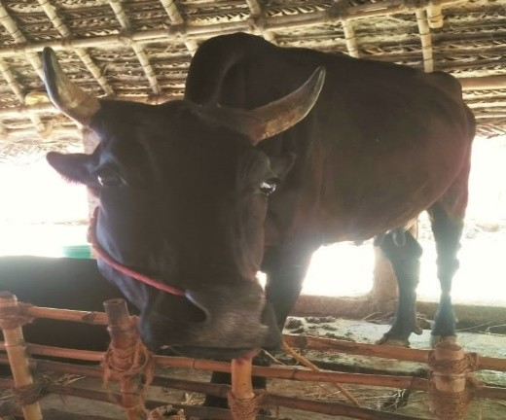

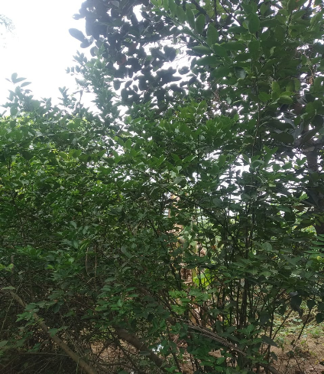
Citrus limon HerbalPlant

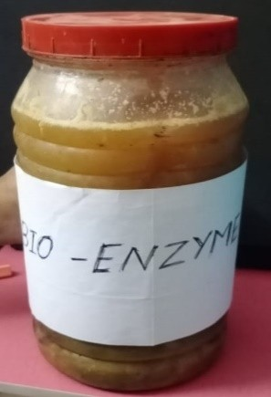
Bio Enzyme Citruslimon.,

TABLE – 1 Bio Chemical Characters of Shigella Sp.,

S.NO | BIOCHEMICAL TESTS | POSITIVE/ NEGATIVE
1. | Gram staining | Rod/negative
2. | Culture characteristics on agar slant | Thin even greyish growth
3. | Gelatin liquification | Negative
4. | Starch liquification | Negative
5. | Liquid hydrolysis | Negative
6. | Lactose | Negative
7. | Dextrose | Alkaline (A)
8. | Sucrose | Acid
9. | H₂s production | Negative
10. | No₃ reduction | Positive
11. | Indole production | Positive
12. | MR reaction | Positive
13. | VP reaction | Negative
14. | Citrate use | Negative
15. | Urease activity | Negative
16. | Catalase activity | Positive
17. | Oxidase activity | Negative

Bio Chemical Charecteristic Of Shigella Sp.,
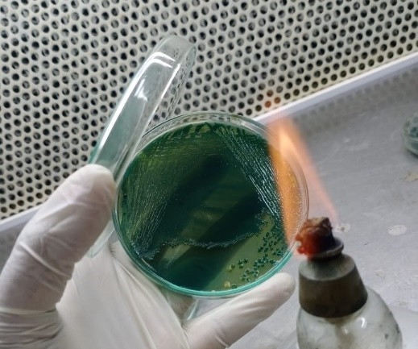
a) Shigella Sp HekteonEntricAgara

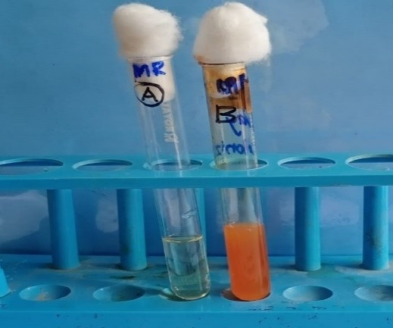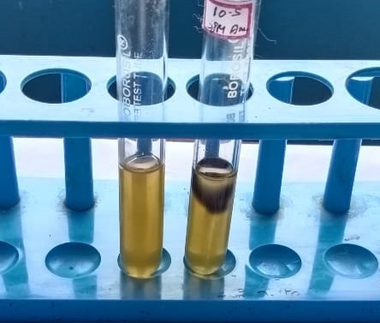b) MR -Positive b) Indole Negative

TABLE – 2 Biological Characteristics of Klebisella Pneumoniae Sp.,

S. NO | BIOCHEMICAL TESTS | POSITIVE / NEGATIVE
1. | Gram staining | Rod (Negative)
2. | Culture characteristic | Slimy, white, somewhat
 | on agar slant | translucent, raised growth
3. | Gelatin liquification | Negative
4. | Starch liquification | Negative
5. | Liquid hydrolysis | Negative
6. | Lactose | AG
7. | Dextrose | AG
8. | Sucrose | AG
9. | H₂ production | Negative
10. | NO₃ production | Positive
11. | Indole production | Negative
12. | MR reaction | Negative
13. | Vp reaction | Positive
14. | Citrate use | Positive
15. | Urease activity | Positive
16. | Catalase activity | Positive
17. | Oxidase activity | Negative

AG - Acid Gas

b)UreaseTest-Positive a)KlebisellaPneumoniaeSp
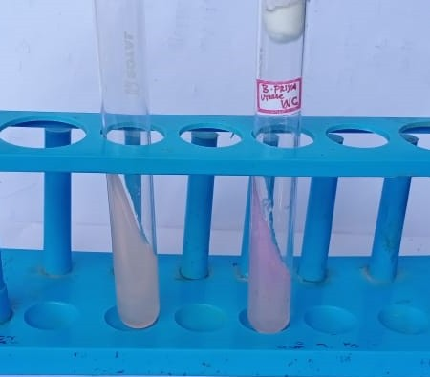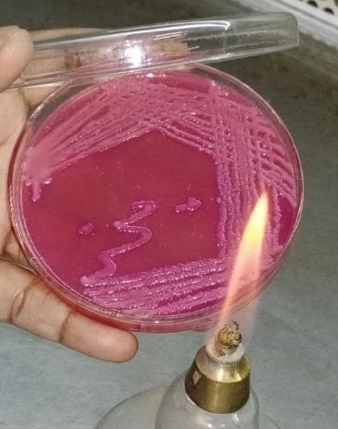

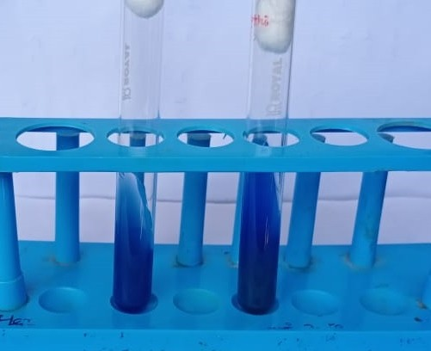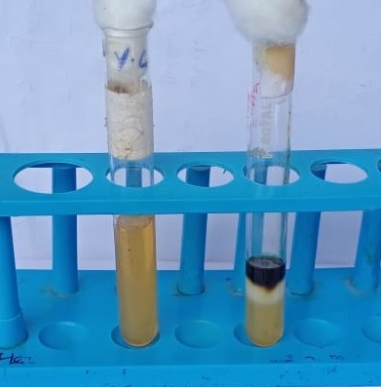 b) Indole Negative Simmon’s Citrate Test- Positive

TABLE – 3 Biochemical Characteristics of Proteus sp.,

S. | Biochemical Test | Positive/Negative
1. | Gram staining | Rod (Negative)
2. | Culture characteristic | Thin, blue, grey,
 | on agar slant | spreading growth
3. | Gelatin liquification | Positive
4. | Starch liquification | Negative
5. | Liquid liquification | Negative
6. | Lactose | Negative
7. | Dextrose | AG
8. | Sucrose | AG +
9. | H₂ Production | Positive
10. | NO₃Production | Positive
11. | Indole Production | Positive
12. | MR reaction | Negative
13. | VP reaction | + Acid gas, Curd +
14. | Citrate use | Positive
15. | Urease activity | Positive
16. | Catalase activity | Positive
17. | Oxidase activity | Negative

AG - Acid Gas

Biochemical characters of Proteus sp.
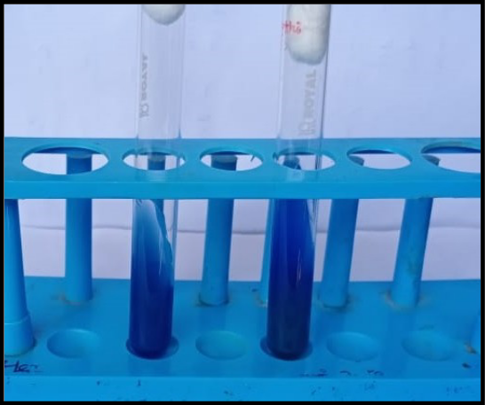
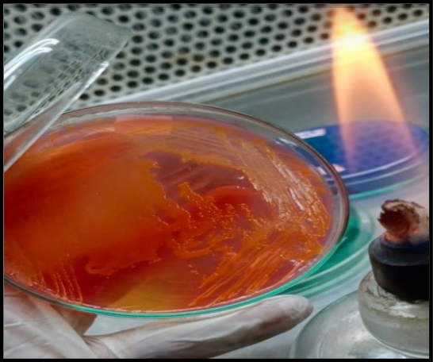

Proteus sp., Simmon’s Citrate Test - Positive

Table: 4 Testing Antimicrobial Sensitivity of Isolates Against Bio – Enzyme (Citrus Lemon)

S.NO | TESTED ORGANISM | ZONE OF INHIBITION
1. | Klebsiella sp., | 14mm
2. | Proteus sp., | 15mm
3. | Shigella sp., | 17mm

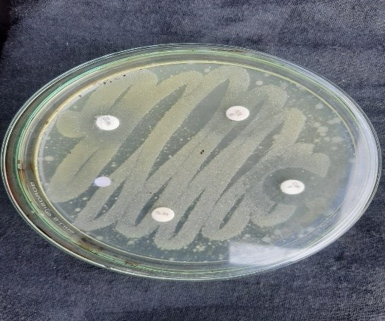Antimicrobial activity of isolated microbes
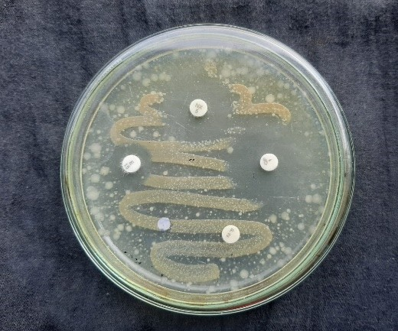KlebisellaPneumoniaeSp., Disc diffusion method- ShigellaSp.,

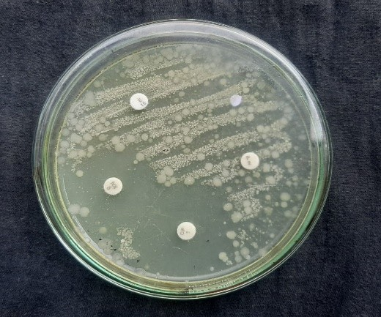Disc diffusion method- Proteussp.,

RESULT AND DISSCUSSION
In present study, the of cow Dung were collected from Thirukaliththattai locates of Kumbakonam, Thanjavur District, Tamil Nadu. They were tested for morphological and biochemical characterization. These isolated bacterial strains were further evaluated for Antimicrobial activity of against the Bio enzyme prepared by citruslimon.Bio-enzyme is a universal, Natural cleaner produced from vegetable fruit peels usually citrus or waste. It is an effective alternative to harsh chemicals such as bleach, Phenyl and other chemical solution we typically to wash our bathrooms, clean, toilets, wipe our floors, tiles and other surfaces. Chemically they are a mixture of complex organic substances such as proteins, Salts and other materials thatarebyproductsofthebacteria.Yeasthatwewillusetomakebioenzymes.These organic substances are capable of the breaking down of chemical and other organic organic waste Thus helping as in removing stains, odour, getting rid of other harmful microbes, etc. They also greatly neutralize toxins and pollutants. Citrus fruit peech are used due to their distinct properties. such as fragrance and sharp flavour, source of vitamin c and also rich in medicinal properties. Along with high acidity value the Jaggery which is added utilized by microbes, that is derived may kill the bacteria. Bio-enzyme acts as an anti-fungal, anti-bacterial and insecticidal agent. It may also use as cleaning agent. In the present study we work onproductionofbio-enzymefromCitrusfruitpeelsandtheirdifferentapplications. Cow dung can also be explored as a source of potential antimicrobial producersbecauseofitsmicrobialdiversity(sawantetal.,.,2007).Cowdunghasbeen used from ancient times in Ayurvedic Treatments, used for biogas production and increasing crop productivity. The present study was carried out to evaluate the ability of cow dung microflora for the production of antimicrobial activity against Citrus limonBioenzyme. With the work agreed with the work Desriac F, et al.,., (2013).In present study the focussed on Cow dung microbes, isolation and microbes like Klebsiella sp., Proteus sp., Shigella sp.,Since ages, Indian farmers are practicing cow dung as organic agricultural fertilizer. Addition of cow dung is known to enrich the soil nutrient satus and enhancement of plant growth parameters. But, its direct application is unsuitable for soil nutrient profile. Besides, consisting minerals, fibers and crdue protein, cow dung also consist of beneficial microflora, predominantly bacilli, lactobacilli, cocci and some identified and unidentified fungus yeast as reported by (Muhammad and Amusa , 2003).However, exploitation of microflora from cow dung for plant growth enhancement and phosphate solubilization. (Swain,M.R. and Ray,R.C,2006), Cellulase producing bacteria (Bai,S.etal.,2015)Hong-li, Z. et al.,2015). Enzymatic activities (Vijayaraghavan,P.,et al.,2016 ). Methanogenic Bacteria ( Pradha,P.andGireeshbabu, K. 2012) , Antibiotic resistant strains (David,O.M. and Odeyema, A.T, 2007 ) ,Antibiotic susceptibility (Teo, K.C and Teoh, S.M.2011) and Ammonia producing bacteria are well reported. (Radha, T. K and Rao, D.L.N. 2014). In Indian Vedas, the cow is considered the most valuable and religiousanimal of Hindus. In India, cows are a very important animal and useful inAgricultureanddairyindustry.Thecowdunghasbeenusedasorganicfertilizernd in the production of biogas. The evaporated extract of cow dung is called“Dalang”or“Dalam”innortheastNigeriaandinsomepartofNorthemCamerounandhasbeenusedassoupcondimentandinthetreatmentofinfections.Indiancow,jersey,Cowdungwasalsoputforsheddried.1000gofdifferentcowdungwascollectedandshadowdriedfor5days.Thedriedcowdungwaspowdered.Thepowderedmaterial100mlofacetoneandethanolwasaddedin10gofpowdereddifferent cow dungs (Indian cow, Jersey, Holstein and buffalo dung)in conicalflaskanditwaskeptinrotaryshakerfor3days.TheextractwasthenfilteredusingWhat man No 1 filter paper and stored in vial for future use the cow dungextraction procedure was followed by Swati H Patel, et al., 2015. Phytochemicalanalysis was performed by each cow dung extract present the flavonoids,Glycosides, tannins, saponins and phenols this result was similar to whichreportsthese phytochemical compound are present the cow urine.. In Indian Vedas, the cow is considered the most valuable and religiousanimal of Hindus. In India, cows are a very important animal and useful inAgricultureanddairyindustry.Thecowdunghasbeenusedasorganicfertilizerand in the production of biogas. The evaporated extract of cow dung is

called“Dalang”or“Dalam”innortheastNigeriaandinsomepartofNorthemCamerounandhasbeenusedassoupcondimentandinthetreatmentofinfections.Indiancow, jersey,Cowdungwasalsoputforsheddried.1000gofdifferentcowdungwascollectedandshadowdriedfor5days.Thedriedcowdungwaspowdered.Thepowderedmaterial100mlofacetoneandethanolwasaddedin10gofpowdereddifferent cow dungs (Indian cow, Jersey, Holstein and buffalo dung) in aconicalflaskanditwaskeptinrotaryshakerfor3days.TheextractwasthenfilteredusingWhat man No 1 filter paper and stored in vial for future use the cow dungextraction procedure was followed by Swati H Patel, et al., 2015. Phytochemicalanalysis was performed by each cow dung extract present the flavonoids,Glycosides, tannins, saponins and phenols this result was similar to whichreportsthese phytochemical compound are present the cow urine..The utilization of fruit peels as fermentation raw material offers benefits for being cost-effective and can provide additional revenues to food-processing industries. Various literature reports (Li et al.,. 2015; Sagar et al.,. 2018) describe fermentative production of multienzyme using fruit peels such as those of Mango (Mangifera indica), Pomegranate (Punica granatum), Apple (Malus pumila), Mosambi (Citrus limetta), Banana (Musa acuminate), and Orange (Citrus reticulata). Pakistan being sixth largest citrus fruit producer can be benefitted by thedevelopmentoffermentationprocessesbasedonfruitjuiceindustry’swaste.

SUMMARY
The present study foucessed or Isolation of Microbial population in cow Dung and testing its antimicrobial Activity against Bio-enzyme of CitrusLimon.Cow Dung host a wide variety of microorganisms varying in individual properties. Exploitation of cow dung microflora can contribute significantly in sustainable agriculture and energy
The utilization of fruit peels as fermentation raw material offers benefits for being cost-effective and can provide additional revenues to food- processing industries. Various literature reports describe fermentative production of multienzyme using fruit peels such as those of Mango (Mangifera indica), Pomegranate (Punica granatum), Apple (Malus pumila), Mosambi (Citrus limetta), Banana (Musa acuminate), and Orange (Citrusreticulata).
requirements, It is one of the bioresources of this world which is available on large scale and still not fully utilised. The understanding of the mechanisms enabling cow dung microbes to degrade hydrocarbons can promote bioremediation of environmental pollutants. With recent advances in scientific research and techniques for complete genome sequences,the genes responsible for bioremediation can be identified Another exciting area of research for future studies is developing microbial enzymes and antimicrobials. The production of enzymes by microorganisms from this cheap bioresource can find wide applications in various fields such as agriculture, Chemistry andbiotechnology. The utilization of fruit peels as fermentation raw material offers benefits for being cost-effective and can provide additional revenues to food- processing industries. Various literature reports describe fermentative production of multienzyme using fruit peels such as those of Mango (Mangifera indica), Pomegranate (Punica granatum), Apple (Malus pumila), Mosambi (Citrus limetta), Banana (Musa acuminate), and Orange (Citrusreticulata).It is concluded that the enzymes are biological catalysts ie. Biocatalysthenceknownasbioenzymeswhichspeedupbiochemicalreactionin
living organisms, useful in a wide range of commercially imported processes. Thus, the bioenzymes an be used for various purpose since it is organic it won’t have any side effects Bioenzyme helps us to reduce some waste & turn into a useful substance to the society which is economical and cheaply available and theend product can be completelyuseful. The present work foccussed on characterization of microbes from cow urine and testing its antimicrobial activity against citrus limonBio-enzyme.The isolated shigella sp., shows maximum (23mm) zone of inhibition and Klebsiella is sensitive to bioenzyme. The zone of inhibition (14mm) was observed. In Proteus zone of inhibition was observed (17mm).People in Indian villages use cow dung for cooking purpose for direct burning. Cow dung also as a co-product in Agriculture, such as Mannure, pest repellent and source of energy. The present study concluded that use of Bio- Enzyme act as a potential cleansing agent in futureuse.
REFERENCES
Abo-State MA, Mahdy HM, Ezzat SM, Abd El Shakour EH and ElBahnasawy MA. (2012). Antimicrobial resistance profiles of Enterobacteriaceae isolated from rosettabranchofriverNile,Egypt.WorldAppliedSciencesJournal.19:1234-1243.

Adegunloye DV, Adetuyi FC, Akinyosoye FA, Doyeni MO (2007). Microbial AnalysisofCompostUsingCowDungasBooster.Pak.J.Nutri.6(5):506-510.

David OM, Odeyemi AT (2007). Antibiotic resistant pattern of environmental isolates of Listeria monocytogenes from Ado-Ekiti, Nigeria. Afr. J. Biotechnol. 6(18):2135-2139

Dhama K, Chakraborty S and Tiwari R. (2013). Panchgavya therapy (Cowpathy) in safeguarding health of animals and humans-a review. Res OpinAnim Vet Sci. 3:170-178.

Fleming A. (1929). On the antibacterial action of cultures of a penicillium, with special reference to their use in the isolation of B. influenzae. Br. J. Exp. Pathol. 10:226–236.

Joseph B and Sankarganesh P. (2011). Antifungal efficacy ofpanchgavya.
International Journal of PharmTech Research. 3:585-588.

Kardos N and Demain AL. (2011). Penicillin: the medicine with the greatest impact on therapeutic outcomes. Appl. Microbiol. Biotechnol. 92:677–687.

Muhammad S and Amusa NA. (2003). Invitro inhibition of growth of some seedling blight inducing pathogens by compost-inhabiting microbes. Afr. J. Biotechnol.2:161-164.

Muralikrishna.V., V. Manickam, I. V. Muralikrishna, V. Manickam,Solid
Waste Management, Environ. Manage. (2017) 431– 462. https://doi.org/10.1016
/B9 78-0-12-811989-1.00016-6.

NaiemiAlN, Heddema ER, Bart A, EdeJonge CM, Grauls V, Savelkoul PH and Duim B. (2006). Emergence of multidrugresistant gram-negative bacteria during selective decontamination of the digestive tract on an intensive care unit. Journal of Antimicrobial Chemotherapy.58:853-856.

Nene YL (1999) Utilizing traditional knowledge in agriculture. Traditional knowledge system of India and Sri Lanka, pp32–38

Randhawa GK, Kullar JS (2011) Bioremediation of pharmaceuticals,pesticides,
and petrochemicals with gomeya/cow dung. ISRN Pharmacol.
doi:10.5402/2011/362459

SawantAA,HegdeNV,StraleyBA,DonaldsonSC,LoveBC,KnabelSJ,Jayarao
BM (2007) Antimicrobial-resistant enteric bacteria from dairy cattle. Appl Environ
Microbiol 73:156–163

Sharma, B. and Singh, M. (2015). Isolation and charactreization of bacteria from cow dung of desi cow breed on different morpho-biochemical parameters in Dehradun. International journal of Advances in Pharmacy, Biology and Chemistry, Vol:4(2).

B. Sharma, B. Vaish, Monika, U.K. Singh, P. Singh, R.P. Singh, Recycling of Organic Wastes in Agriculture: An Environmental Perspective, Int. J. Environ. Res. 13 (2019) 409–429.https://doi.org/10.1007/s41742-019-00175-y

Sikarwar AS and Batra HV. (2011). Prevalence of antimicrobial drug resistance of Klebsiellapneumoniae in India. International Journal of Bioscience, Biochemistry and Bioinformatics.1:211-215.
Ware Fungsin, D.R., Read, P.L., Mantredi, E.T. (1988). Lactation performance of two large dairy herds fed Lactobacillus acidophilus strain BT 1386. J. Dairy Sci, 71:219-222.

