A look on the Importance Of Cloud Computing security in E-commerce from Zombie Attack
S M Firdaus Zaki Rizviª , Amar Nath Chatterjee^{b,*}

ªDepartment of Mathematics and IT, Magadh University, Bodh-Gaya, Bihar–824234(India)
^{b}Department of Mathematics, K.L.S. College, Nawada, Magadh University, Bodh-Gaya, Bihar – 805110 (India)

∗ Corresponding author.
E-mail address: anchaterji@gmail.com (A.N. Chatterjee).

Abstract
Cloud Computing has totally changes the world of computing as well as business, now a days it is very hot and popular topic of discussion. It was already announced by Google in 2007.Cloud computing is a channel through which the deliverance of services and resources using the internet medium is possible easily. The Cloud computing is useful for small as well as big business and organization. Many E-commerce (online ) businesses are running over cloud server. Cloud provides different services, using cloud computing we can get many benefits than traditional computing system , it provides many facilities such as large mobile storage, cost saving on large scale, well-built and superior protection, access from everywhere, power saving and environment friendly, these are basic benefits of cloud computing. Now it is very important for an organization or individual to reallocate from customary computing to cloud computing because they get advantage to it. Recently, various types of cloud computing facilities are available at a very flexible rate models, such as, monthly or yearly subscription and rent based cost models services for illustration, Remote Desktop Session Host (RDSH) available for cloud Terminal, Software as a Service (SaaS) provide facility to utilize software services on rent. Platform as a Service (PaaS) Provide facility to utilize computing equipments with infrastructure on rent on minimum monthly or yearly cost. The Storage as a Service (SaaS) provide facility to use huge memory space on rent at a minimum cost and Security as a Service (SaaS) provides a strong cloud based application for security. Likewise, the Infrastructure as a Service (IaaS) provide cloud facility to take computing infrastructure on rent that reduces the buildup cost for any individual or organization. By means of facilities, cloud computing architecture offers more advantages than conventional computing. But the data and authorization security over the cloud computing is also most important. Attackers always make their eyes on cloud to steal important data. Attackers in various forms, some are detect easily but some are silent and sweet killer they treat as a normal authorize user but they do their work very smartly to attack on the cloud network to steal data, it is not easy to detect them. These attackers are called zombie. It very important to detect and isolate them for the security of client and server over the Cloud network.

Keywords:- E-commerce; Security; Threats; Cloud Computing; Host and Client ; Online Business Model: IT Industry; Data science.
1. Introduction
Cloud computing structure is completely based on Internet and over the internet there are always needs security from unauthorized attacks . Every time on the internet attackers are try to hack the system or damage the data [1]. As It Google announced in 2007 that the Cloud Computing has get a lot of attraction of the technologist of IT industry and business man because Cloud computing is very speedily developed from logical concept to real Application [2]. So the attackers are also attracted to cloud network to perform their illegal activities. Zombies are one of type of attackers or hackers, they login on the cloud in an illegal way but show themselves on the network as an authorize client or user, because Cloud computing is a group of technologies for keeping and retrieving of data and computing services over the internet. In cloud computing system data doesn't store on client computer. So the most of the time Zombies targeted the server [3]. They work very slowly to steal the important data of the client from their server. The cloud computer services is available on demanded such as servers for data, locations for data storage, networking, databases, etc [4]. The chief goal of cloud computing is to offer access permission to data centers (centralized virtual server) to many users. And the users can also access data from a remote server which connected to a centralized. It is a structure of application-based software which keep data on remote servers and it can be retrieve by the internet [5]. The cloud computing jobs , can be divided into two parts front-end and backend. The user access data stored in the cloud through front-end using an internet browser or a cloud computing software. The responsible of primary component of cloud computing is to securely storing data and information at the backend. It includes data storage servers, computers, databases, and central servers [6]. And it is possible by cloud computing that a user can use many different gadgets such as laptop, personal computers, smart phones and other computing machines which connect virtually to the cloud [7]. And the user also called client is able to use and make changes to the data stored on cloud by himself with a minimum rent cost charges by cloud owner. Client need not buy or pay extra for hardware because it’s a shared resource facility over the internet [8]. Now a day’s cloud computing demand of every sectors such as business world and other firms are changing the of traditional way of record keeping to cloud based infrastructure format, because its very beneficial and easy to retrieve data in case of disaster on local server or machine. Data can be access and updated from anywhere at any time [9,10]. E- Commerce is such an industry which is get birth by the features of Cloud Computing. Here in this paper we are going to discuss the impact of cloud computing on traditional E-Commerce completely in respect of technology, service and industry sequence, and will advice our suggestion to develop E-Commerce business in the era of cloud computing [10].

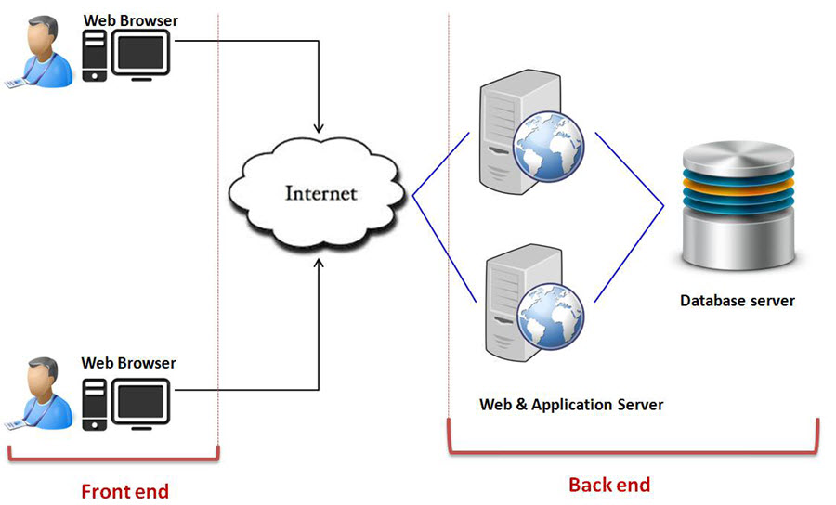

Cloud computing provides shared resources software and information to the various computers and devices on demand because cloud computing is an internet based.
2. Cloud Computing Service Models.
Manly there are three various service models for cloud computing are as follows:
i. Software as a service (SaaS).
In this model cloud vendor hosted software which running on a cloud based structure (internet) and obtainable to various user’s devices via a thin UI such as a Web browser. Benefit of this model is that instead of purchasing the software subscribe it for monthly rental on internet, even a particular piece of software can be subscribe.
ii. Platform as a service (PaaS).
In this cloud infrastructure can customized applications with the help of programming languages and tools supported by the provider ( java, python, .Net)
iii. Infrastructure as a service (IaaS)
It allow access to the infrastructure and computing resources such as storage, networks, and other fundamental computing resources in a virtualized manner where the customer is able to establish and run any software, which can consist of operating system and applications. It is a cost reduces internet based IT infrastructure
The main motto of cloud computing is to recognize the entire network as a very high performance computer that is to authorize the cloud customer to keep their all records and services, and data information on the cloud storage and get access of all types of service facility from cloud only through the remote login or remote terminal tools after connected to the internet. When the user used cloud system services, they observe that it’s a virtual view and the records and services are really give out to various locations on the cloud. The tendency that data and all facilities will be transformed to web network is to be projected to apply more services and to store more information on the cloud network. It is already known that the services of Cloud computing are completely built on Web Services and all the Web Services are built on the Internet network. On the Internet there are various types of security issues due to its free and open services and the chance of attacks and threats are always high. And the cloud computing network services will have to face always a high range of security risk. In recent days there are many various kinds of security software technologies for Web Services are came in picture, so this is big implication for us to solve security related problems of cloud service using the existing security information system. The Cloud system architecture provides suitable and on-requirement based cloud computing network access to a general collection of assembled computing resources such as internet, websites, applications software, grids, clients, servers, storage, and the facilities that can be fast provisioned and get feel free with least management effort or communications with cloud service provider. These cloud models are used to improve availability and these are made up of four deployment models, five major uniqueness along with three models of service.

3. Important features of Cloud Computing
Here I am discussing some important features of the cloud computing that generated by cloud characteristics.

3. 1 . Resources Pooling
Resources pooling is most significant features of the cloud computing because through this uniqueness the cloud computing service provider can distribute resources between many users and providing each user with a different set of facilities and services as per the requirements. In cloud computing resource pooling is multi-client strategy system which is applied for data storage, data processing and bandwidth-provided services. And in this whole process the real time administration that allocating resources does not clash with the client services.

3. 2 On-Demand Self-Service
This is also an important and necessary features of Cloud Computing. It enable the client to all the time supervise the servers uptime, caliber, and selected network storage. It is a basic features of Cloud computing, and a client be able to similarly manage the computing abilities as per his necessity..

3. 3. Easy Maintenance
It is the best features of cloud that the servers can be easily maintain and the downtime is very low and even in some situations, there is no downtime. Cloud Computing comes up with bring up to date every time by steadily building it better.
The updates are well-matched with the devices and execute faster than previous along with the bugs which are predetermined.

3.4. Scalability and Rapid flexibility
It is a main important attribute and advantage of cloud computing and it is its fast scalability. This cloud element enables the operation on low cost for workloads that need a vast number of servers but only for a short period of time. Many clients have such workloads, which can be run on very less cost because of the fast scalability of Cloud Computing.

3. 5. Large Network Access
The consumer can also use the stored data of the cloud or upload the data over the cloud from any place in the world just with the support of a computing machine and an internet link. These capability are accessible all over the world via net and can access through the internet connection.

3. 6. Availability
The working capabilities of the Cloud can be customize as per the use or requirements and also can be extend as per the need . It survey the use of storage and authorize the user to buy more Cloud storage if required for a little amount.

3. 7. Automation System
This a special features of Cloud computing that it can automatically examine the data required and favor a measuring caliber at a few phases of services. We can easily watch, control, and report the usage of data and the clients activity over the cloud network . It will provide transparency for the host and the customer.

3. 8. Inexpensive
This cloud computing features help us to reduce the IT infrastructure expenditure of individual or organization level. It is a one-time investment over the IT assets as the Organization or individual (host) has to buy the storage over the cloud and a minute division of it can be distributed to the numerous Organizations or individuals that save the host from the paying of heavy monthly or yearly costs. Only they have to pay that amount which is used up on the basic maintenance and a few more expenditure that are very less.

3. 9. Safety
Safety of data over the cloud is one of the key features of Cloud computing.. It build a copy or print of the data stored to prevent the stored data from damage or los even if one of the servers gets smashed.
The data are stored in the huge storage capacity devices that is extremely secure and which cannot be hacked or unauthorized utilized by any other person. The storage service is very rapid and reliable.

3. 10. Payment as per requirements.
The Payment system of cloud computing is totally depend upon user requirements. The user has to pay only for that service or the space they are using. There is no any hidden or extra charges that is to be paid by user. The facility is available on low-cost and mostly few spaces are allotted for free.

3. 11. Calculated Service
This is a major Cloud computing features that are utilized to monitor and control the entire system and the organization uses it for recording. This resource consumption is calculated by supporting charge-per-use of capabilities.
It means that the utilized resources are virtual server instances that are consecutively in the cloud are getting watched and measured and reported by the service provider. Finally we can say that a user has to as per the utilization to manufacturer organization as it happen in cellular company.
4. Litrature review:
As the paper completely concentrate on how the impact of cloud computing make changes in E-Commerce business.
As it appears that the impact of cloud computing has been discussed by different Articles or literatures in last decades. Pravin S Rotkar and Gayatri Butey [1] finding the factors that the lack of technical training and technical resources it preventing the educational information in remote area of India. Most of the rural India is unskilled and unaware with these technologies. Finally it concluded that the cloud computing can easily solve these problems. This paper conclude the possible advantages to get educational information by cloud computing from anywhere. It is important and meaningful for cloud computing Applications that all the possible advantages of cloud computing can be only discussed after a deep study on it. Kashefi F, at al [2] Analyzes that the it should present a new methodology of cloud computing to improve it. The paper define the positive impact of cloud computing on e-commerce industry based on the case study of big companies and organizations such as Amazon and Fipkart, now a days these e-commerce sites are reached remote areas and the people are facilitates from it.
4. E-Commerce technical Architecture:
The main working process of ecommerce is that the exchange of products and services by internet. Generally e-commerce architecture is composed of two layers. First layer is technical architecture that is combination of physical devices (hardware) and logical applications (software) and the second layer is business model through which transaction is possible that is based on technical architecture. According to Laudon[3] the base layer of E-commerce is Technical Architecture. All marketing and business strategies of E-commerce can be realize on the basis of Technical Architecture, because technical architecture is main premises of online products in addition to security and exchange services.
Basically cloud computing is not very new mode of computing it is only the transformation of traditional distributed and grid computing mode to cloud architecture.
5. Zombies and their attacks method:
Zombies are the hackers who they connected to the cloud network as an authorize user but they do only malicious work. They develop malware and install it to the cloud network to control the over all authorization of the entire system and they also make slow the performance of the network. They generally choose a website or a particular system of an organization and make it their target, they degrade the performance targeted website instead of blocking that’s why it is not an easy task to detect them.
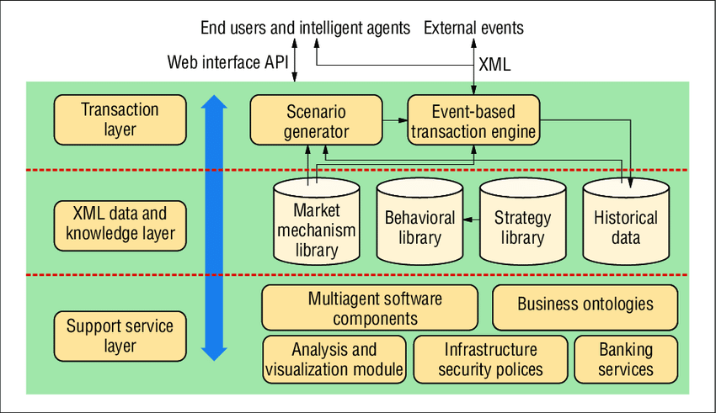
E-Commerce Technical Architecture

Conclusion
The interaction of cloud computing is producing new ecosystem that will encapsulate all the facilities and resources of E-commerce in the new service modes. These are the Companies who control and maintain the servers, maintain the activeness of the server and take care over all security and tasks of it. The association also buys the software and the licenses for the action of their business. All these things protect by the monthly fee that they are expecting from the organizations they are serving. They are listening cautiously on providing ranked service as if they not succeed to do so they will be at the back in the contest. This web-based system can be only utilize by the internet.

Cloud Computing have different types of advantages that are serving hosts and the individual client or organization. A host also construct of a range of profit that provide benefit to the cloud clients. There are a countless of safety element that is a hopeful point next to with it the implementation time is very low and the clients can upload and download data easily and quickly. The organization these days demanding huge amount of the data storage capability and the Large Data companies offer them very easily.

To detect the zombies over the cloud network, network administrator should always watch the activities of the each and every user of cloud network. Here its need a strong algorithm to detect and isolate these silent attackers of cloud network. A very highly strong authorization system should be implement to login into the cloud network.

Declaration of Competing Interest
The authors declare it that they have no known competing financial interests or personal relationships that could have appeared to influence the work reported in this paper.

References

[1] Pravin S Roatkar and Gayatri Butey(Feb-2021). Impact of cloud computing in India on E-commerce,
Reseaechgate.
[2] Daping Wang, (2013), Influences of cloud computing on E-Commerce Business and Industry. Journal of
Engineering and Applications,6p.
[3] F. Kashefi, M. Majd, M. Darbandi, H. Purhosein, K. Alizadeh and O. Atae, “Perusal about Influences of Cloud
Computing on the Processes of These Days and Presenting New Ideas about Its Security,” The Proceedings of
the 5th International Conference on Application of Information and Communication Technologies (AICT),
Baku, 12-14 October 2011,
[4] Sagar Choudhary1, Garima Pundir2, Yashveer Singh3. International Research Journal of
Engineering and Technology (IRJET) e-ISSN: 2395-0056 Volume: 07 Issue: 01 | Jan 2020.
[5] Manish Kumar- Bhagwant Institute of Technology, Muzaffarnagar, UP. Shivani Chauhan
Assistant Professor Bhagwant Institute of Technology, Muzaffarnagar, UP. Ajay Singh
Assistant Professor Bhagwant Institute of Technology, Muzaffarnagar, UP, International
Journal of Computer Science and Mobile Computing, Vol.8 Issue.1, January- 2019.
[6] Sunil Kumar and Maninder Singh, Department of Computer Science, Punjabi University,
Patiala. Article Published : 12 Apr 2017
[7] T. Karnwal, S. Thandapanii, A. Gnanasekaran, “A filter tree approach to protect Cloud
Computing against Xml DDoS and http DDoS Attack”. In: Intelligent Informatics, pp. 459–
469. Springer, 2013.
[8] A.R.Khan, “Access Control in Cloud Computing Environment,” ARPN Journal of
Engineering and Applied Sciences, vol 7, no 5, MAY 2012.
[9] B. Sevak, “Security against Side Channel Attack in Cloud Computing” International Journal
of Engineering and Advanced Technology (IJEAT), 2(2), December 2012.
[10] Anurag Singh Tomar. Energy studies, and Shashi Kant Shankar. to detect and isolate
zombie attack in cloud computing; 2017.

