On some theoretic aspects of fuzzy subsets

Sisir Kumar Rajbongshi*a**,** Prasanta Gogoi*b

*aDepartment of Computer Science, Pandit Deendayal Upadhyaya Adarsha Mahavidyalaya, Amjonga, Goalpara , Assam, India, Pin: 783124, email: sisirrajbongshi@gmail.com*

*bDepartment of Chemistry, Pandit Deendayal Upadhyaya Adarsha Mahavidyalaya, Amjonga, Goalpara , Assam, India, Pin: 783124, email: prasantagogoi799@gmail.com*

**Abstract**

This article proposes some important theoretic aspects of fuzzy subsets. Here, we take a non-empty finite set and an ordered subset of the closed interval, then the set of mappings from to denoted by is defined as special fuzzy Boolean algebra. This article defines the subalgebra of a special fuzzy Boolean algebra. Some characteristics of the subalgebra are discussed.

**Keywords: fuzzy subsets, Special Fuzzy Boolean algebra, Subalgebra,**

**1. Introduction**

The concept of fuzzy sets was introduced by Zadeh1 is applied to many mathematical branches. This concept was adapted by Goguen2 and Sarchez3 to define and study fuzzy relations. -fuzzy sets are the generalization of fuzzy sets was first considered in 1967 by Joseph Goguen. Since then studies on -fuzzy sets have been carried out by many researchers. Rosenfeld4 inspired the fuzzification of algebraic structures and introduced the notion of fuzzy subgroups.

Algebraic structures play an important role in mathematics with wide ranging applications in many disciplines such as computer science, information technology, coding theory and so on. There are many researches which had given emphasis on the algebraic structures of the fuzzy sets5,6,7,8.

The set of all fuzzy subsets of is called the fuzzy power set of and denoted by . Since there is infinite numbers of values in , the fuzzy power set also have infinite numbers of fuzzy subsets or elements.That is why, in this article we take a non-empty finite set and an ordered subset  of such that , where is any positive integer greater than 1. Then the set of all fuzzy subsets obtained from the mappings from to is defined as special fuzzy Boolean algebra 8. It is denoted by. The total numbers of elements or fuzzy subsets in =.For better identification we denote the fuzzy subsets of as 0,1,2…. as follows:

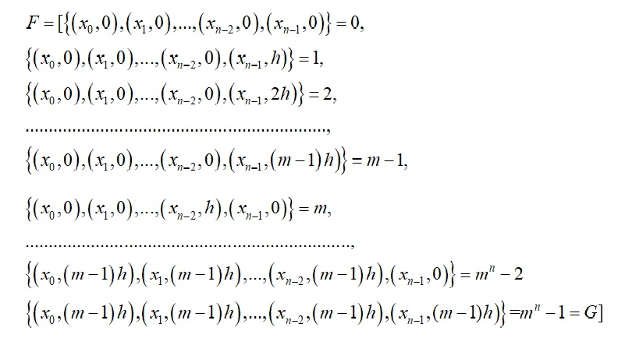

In mathematics, subalgebra is a subset of an algebra, closed under all its operations, and carrying the included operations. As are studying the different aspects of special fuzzy Boolean algebra, it is like a duty to study its subalgebra. This chapter defines the subalgebra of a special fuzzy Boolean algebra. Some characteristics of the subalgebra are discussed.

**2 Special fuzzy Boolean Subalgebra**

Let,  is a special fuzzy Boolean algebra with  and  represents two binary

operations fuzzy intersection and fuzzy union respectively, ‘/’ represents a unary operation complementation and two distinct elements empty fuzzy subset ‘’ (***bottom element***) and the universal fuzzy subset ‘’ (***top element***).

Now, if  is a non-empty subset of containing  and ; and is closed under the same operations, then  is a **special fuzzy Boolean subalgebra** of . Therefore a special fuzzy Boolean subalgebra of a special fuzzy Boolean algebra  is a subset of  and itself a special fuzzy Boolean algebra.

Every special fuzzy Boolean algebra  has a special fuzzy Boolean subalgebra namely which is called the **improper subalgebra**; all the other special fuzzy Boolean subalgebras are called as **proper**.

Every special fuzzy Boolean algebra  has a **trivial subalgebra** containing the empty fuzzy subset  and the universal fuzzy subset  only; all other subalgebras of  are called **non-trivial**.

**Example 2.1** Considering the special fuzzy Boolean algebra  of example 4.1, where



The fuzzy union the elements of  are listed in the following table 2.1:

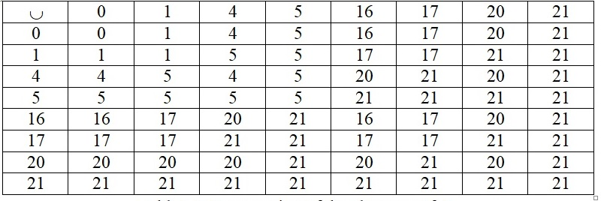

Table 2.1: Fuzzy Union of the elements of 

The fuzzy intersection of the elements of  are listed in the following table 2.2:

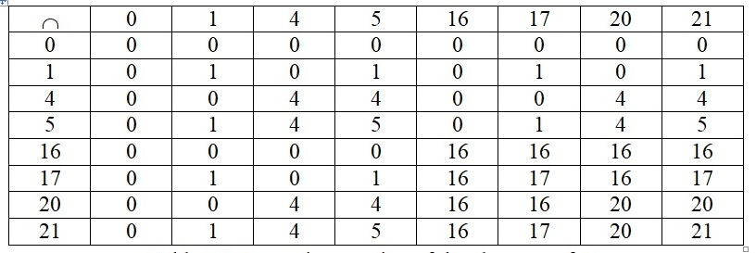

Table 2.2: Fuzzy Intersection of the elements of 

And the fuzzy complements the elements of  are listed in the following table 2.3:

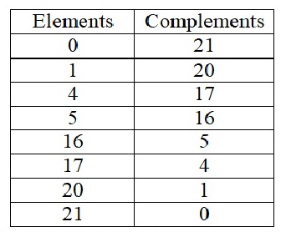

Fig: Fuzzy Complement of the elements of 

Observing the three tables some special fuzzy Boolean subalgebras of  are:

 improper special fuzzy Boolean subalgebra,

 trivial special fuzzy Boolean subalgebra,

,



****etc. are special fuzzy Boolean subalgebras of .

**3. Some Characteristics of special fuzzy Boolean subalgebra**

**Theorem 3.1**

To be a special fuzzy Boolean subalgebra  of a special fuzzy Boolean algebra ;  must contain the empty fuzzy subset and the universal fuzzy subset  of .

*Proof* Since, the complementation is an essential part of the structure of a special fuzzy Boolean algebra; the presence of the empty fuzzy subset ’ and the universal fuzzy subset  in every special fuzzy Boolean subalgebra is necessary since  and .

Since, a special fuzzy Boolean subalgebra contains an element with its complement . The fuzzy union or join is always the universal fuzzy subset  and the fuzzy intersection  is always . Hence, the special fuzzy Boolean subalgebra must have  and .

**Remark 3.1**

Every special fuzzy Boolean subalgebra of a special fuzzy Boolean algebra contains elements but the reverse is not always true. If a subset of a special fuzzy Boolean algebra does not contain elements then it is never become a special fuzzy Boolean subalgebra, for some 

For example, observing the tables as shown in above, the subset of the special fuzzy Boolean algebra  of example 7.1 is not a special fuzzy Boolean subalgebra, because.

**Remark 3.2**

Every special fuzzy Boolean algebra can be expressed by the special fuzzy power set of its universal fuzzy subset  which is discussed in the section 3.9, but a proper special fuzzy Boolean subalgebra cannot be expressed as the special power set of  .

**Theorem 3.2**

If  ; where  are some special fuzzy Boolean subalgebras of a special fuzzy Boolean algebra , then is also a special fuzzy Boolean subalgebra of .*Proof* Let,  and be two fuzzy subsets of . This implies that:

 ( is a special fuzzy Boolean subalgebra) (1)

 ( is a special fuzzy Boolean subalgebra) (2)

………………………….

 ( is a special fuzzy Boolean subalgebra) (3)

From (1), (2) and (3) it implies that :



 is closed with respect to fuzzy intersection .

Similarly, we can show that:



 is closed with respect to fuzzy union .

Again, let 

 (as are subalgebras)

Also, 

  ,

So,  is closed with respect to fuzzy complementation.

Again,  and .

Hence,  is a special fuzzy Boolean subalgebra.

**Remark 3.3**

If  is a special fuzzy Boolean algebra and  be the set of all the special fuzzy Boolean subalgebras of .

Then the union of all the subalgebras is the special fuzzy Boolean algebra  itself which is called the improper subalgebra, that is:



On, the other hand, the intersection of all the subalgebras is the trivial subalgebra, that is:

.

**Theorem** **3.3**

The relation  of one special fuzzy Boolean algebra being a special fuzzy Boolean subalgebra of another is a partial order on the set of all special fuzzy Boolean subalgebras of a special fuzzy Boolean algebra.

*Proof*  Let  be the set of all special fuzzy Boolean subalgebras of a special fuzzy Boolean algebra 

**Reflexivity**: Here, , so the relation  is reflexive on .

**Antisymmetry**: If . Hence, the relation  is antisymmetric on .

two special fuzzy Boolean algebras are special fuzzy Boolean subalgebra of one another, then they are equal.

**Transitivity**: For any three special fuzzy Boolean algebras  and if  is a special fuzzy Boolean subalgebra of  and  is a special fuzzy Boolean subalgebra of  then  is a special fuzzy Boolean subalgebra of  which follows that the relation  is transitive.

Therefore, the relation  is a partial order relation on  as it is reflexive, antisymmetric and transitive. Therefore  is a poset.

**References and Notes**

1. A. Goguen, L-fuzzy sets, *J. Math. Anal. Appl.*, **1967**, *18*, pp. 145-174.
2. A. Rosenfeld, Fuzzy Groups, *J Math Anal Appl*., **1971**, *35*, pp. 512-517.
3. A. Tepavacevic; G. Trajkovski, L-fuzzy lattices: an introduction, *Fuzzy Sets Syst*., **2001**, 1*23*,

pp. 209-216.

1. E. Sanchez, Resolution of Composite fuzzy relation equation, *Infor. And Control*, **1976**, *30*,

*International Conference on Frontiers in Mathematics, Gauhati University, Guwahati,*

*Assam, India*, **2015**, *1*, pp. 26-28.

1. K. R. Bhutani, Fuzzy Sets, Fuzzy Relations and Fuzzy Groups: some interrelations, *Inform.*

*Sci.,* **1993***, 73*, pp. 107-115*.*

1. L. Zadeh, Fuzzy sets*, Infor. And Control*, **1965**, *8*, pp. 338-353.
2. M. Atif; A. Mishref, On the free product, *Fuzzy Sets and Systems*, **1996**, *81*, pp. 287-289.
3. S. K. Rajbongshi; D. Talukdar, An Introduction to a family of fuzzy subsets forming Boolean algebra, *International Journal of Computer Applications,* **2013**, *68(24),* pp. 0975-8887.
4. S. K. Rajbongshi; D. Talukdar, Some aspects of Special fuzzy Boolean algebra, *Proceeding of*

*Sci*., **1993**, *73*, pp. 107-115.