Next Generation Computing – Its Technologies, Platform and Infrastructure That Will Lead the Computing World

Ravi Kumar¹ Santosh Kumar²
Project Manager Assistant Prof.
HCL Technologies Dept. of Computer Applications
New Delhi. KLS College, Nawada – Bihar
ravi.mca2006@gmail.com sano.kms99@gmail.com

Abstract:
The ever changing field of Information Technology opened up several different eras of computing that has changed the way we work, extended great easiness, promoted various process automations, streamlined several industrial activities. During the development, the entire IT technologies, Information processing tools, techniques and cost factors also changes. At every ten to twenty years, the computing technologies changes its gears and reshuffle the whole computing industry. Some of the previous technologies proved very beneficial and also cuts down cost of computing with higher sophistication, such as Client Server techniques, Virtualization, Distributed computing, Cloud Computing, Grid Computing, Computer Vision, AI and ML, Fog computing and many mere.
The development seems to be very fast in some cases while some technologies have faced a number of complications and difficulties. Some others are still facing acute problems in architectural design and their implementation.
In the following chapter, we are going to introduce such computing techniques and cutting edge technologies that will definitely grow, succeed and eventually will rule the Computing World.

Keyword: Quantum Computing, HPC, Artificial Intelligence, Social Computing, Nano-computing, Neuromorphic computing CNN

- Introduction

In spite of the fact that computers have changed and improved nearly every aspect of our lives over the past 50 years, they still operate on the same basic computational principles that Alan Turing and Neumann first envisioned. Digital Computers built on silicon and using conventional design are reaching the fundamental physical constraints and encountering reliability and cost-related problems as the demands on computation, storage, and communication increase. As a result, certain types of issues in fields like quantum computing, HPC, forecasting the weather,, quantum chemistry, bioinformatics, robotics, nature inspired computing and autonomous systems are constrained by the traditional computer paradigm.

Research and business are investigating cutting-edge new computing paradigms, such as quantum computing, computing inspired by biology, nanocomputing, and optical computing, which all have the potential to lead to a wide range of difficult new applications. We will be able to direct the future of computing by comprehending, learning, and putting these new, creative techniques to use.. The ability of our innovations to run on computers, whose performance and cost-performance have enhanced many-fold over the last three decades, has contributed to how computing has revolutionized our world. This has been fueled in part by doubling the number of transistors on each chip repeatedly. Emulation of the mind or brain is not appropriate for the Von Neumann architecture. To effectively manage the complex behaviours required for cognitive systems, a completely different form of parallel and multitasking architecture is required. For the kind of access to data we want, serial-access file systems are incredibly inefficient. I don't think human brains, for instance, undertake pure serial searches. Therefore, we need to have better matched bulk memory systems if we want to mimic our brains.
In light of this, a new generation—not the only one that may exist—would include entirely novel kinds of hardware. Our existing silicon technology is just not suitable for creating minds, as I have stated elsewhere. It's comparable to attempting to create the Internet with telegraphs and steam engines. Added: Elixir, which is descended from Prolog and Erlang, may now be one of the best approaches to solve the multiprogramming challenges for programming languages operating on traditional hardware. At least it seems a good match to constructing multi-module distributed systems even if there is no optimal hardware.
Computing has developed into "almost always on" web-based moving computing-devices over time. We can anticipate hardware becoming a commodity in the not-too-distant future, with the value lying in the software used to operate it and the data that it produces. An infrastructure that can move and store data will be needed, as well as computing systems that can analyze and value-extract data in real-time. It has been argued that the computing industry will gradually split into huge, powerful units that will be needed to analyze massive amounts of data in real time, and smaller, application-specific computing units that connect to provide system services.

- Prospective Next-Gen Technologies
There are hundreds of emerging tools, software and hardware. Some of them have started operating commercially, some other are under development. However, some computing technologies still facing critical problems in architectural design and implementation. We are providing below brief description of some most prominent next-gen computing technologies.

  - Quantum Computing: A system that uses quantum mechanics to compute outputs is referred to as "quantum computing." In physics, a quantum is the smallest distinct unit of any corporeal (Physical) characteristic. Most frequently, it makes reference to the properties of atomic or subatomic particles like photons, electrons, neutrinos, etc. Quantum computing makes use of quantum bits, or qubits. It makes use of the unique ability of subatomic particles to simultaneously exist in many states, such as 1 and 0. The goal of quantum computing research is to develop new computational techniques that take advantage of quantum physics phenomena. Quantum computing is based on qubits. A qubit can be either I or 0 or a superposition of the two. Quantum computers are significantly faster than supercomputers and traditional computers. Superposition and entanglement, two features of quantum physics, are the foundations of supercomputers. Due to this, quantum computers can perform operations at rates that are exponentially faster than those of conventional computers while using a fraction of the energy.

In some circumstances, machines that exploit the quantum-mechanical properties of superposition and the entanglement can solve computational problems that are beyond the capabilities of contemporary classical computers. Using this method, we can create gadgets that are more powerful than any traditional computer. Researchers and industry have recently expressed a lot of interest in quantum algorithms, devices, encryption and quantum approaches. In fact, commercially viable quantum technologies for generating random numbers and safely encrypting communication already exist.

It sounds seductive and has a pretty intriguing appearance. There are a few apparent fundamental questions to address before we start looking at the concepts and foundations of quantum computing, as well as its mystique and future. The great advancements being made in the creation of conventional computers seem to have no end in sight. The design of quantum computers also seems to be highly speculative and almost probably quite expensive. All classical computers and computer models are based on classical physics, despite the fact that this is rarely explicitly stated, rendering them unsuitable for high-performance computing. Although traditional computers are effective, it doesn't seem to fully exploit the physical world's capacity for information processing.

Opportunities:
- In the coming years, it will alter industries like healthcare, medicines, transportation, finance and artificial intelligence. To preserve a competitive advantage, organizations must remain active.

- By being able to simulate quantum encounters that are challenging to simulate precisely on classical computers or to run quantum-enhanced AI to extract correlations in information, businesses in the pharmaceutical and information sciences will speed up the discovery of new organic compounds and molecules.

- Quantum computing having potential to solve many complex and unsolved equations of physical and mathematical science.

- While fault-tolerant quantum computers are undoubtedly 10 to 20 years away, the time is now to develop good quantum algorithms that can function on noisy quantum computers.

- Processing speed will increase exponentially.

Challenges:

- Although quantum computing has the immense potential to fundamentally alter the way that problems are solved in the real world, there are still many challenging engineering obstacles that must be overcome before it can be employed in the workplace.

  - HPC (High-Performance-Computing): The capacity to process data and carry out intricate calculations quickly is known as high performance computing (HPC). For comparison, a computer with a 4 GHz microprocessor can complete about 4 billion calculations in a second. Even though that is far faster than what a human can do, HPC solutions that have the capacity to process quadrillions of computations per second are much faster.
Applications in robotics, weather forecast, aerospace, industrial automotive processes, automotive, manufacturing, NLP and AI need processing capability similar to that of supercomputers some years back, however, with integrated application-specific restrictions on size, power consumption, and guaranteed reaction time. This is a chance to capitalize on the already strong computing industries base and create a family of cutting-edge, scalable technologies that will power everything from embedded micro-servers to massive data centers.
Computer servers are networked collectively into a cluster in order to construct an HPC computing architecture. Algorithms and software applications are run concurrently on the cluster's servers. To capture the output, the cluster is internetworked with the data storage. These parts work flawlessly together to finish a variety of tasks.

Opportunities: In order to grow and handle more heavy workloads, future HPC systems will include more powerful computing nodes, utilize more cores and accelerators, and make use of innovative memory technology and cloud-based novel I/O technologies.

Challenges: Higher costs for HPC on the cloud compared to on-premises The costs of acquiring and maintaining a well- premeditated local cluster are less than those associated with cloud computing. Depending on the kind of cloud instances you employ to build your HPC Cluster, the price of hosting an HPC Cluster over the cloud may vary greatly.

  - Molecular Computing: A subset of computing known as "molecular computing" replaces conventional silicon-based computer technologies with hardware based on DNA, biochemistry, and molecular biology. R&D in this field focuses on molecular computing theory, experimentation, and applications. The study of molecular computing involves creating computer programs from individual molecules. Due to worries about the limits of miniaturization—a genuine and important issue that concerns the future development of computers. Some scientists worldwide are currently attempting to execute software on liquids, living cells, test tubes, etc. instead of silicon chips.

Research in molecular computing has been sparked by the hunt for radically novel algorithms and physical implementation to handle computational problems more effectively, efficiently, and quickly than with conventional computers. Through consideration of information density, parallelism, and energy efficiency, this paradigm has the potential to revolutionize conventional processing. There are millions of different types of molecules, and each one has its own 3D atomic structure and different characteristics including its form, its size, color as well. In addition to the 0s and 1s of the present logic-based, digital architectures, this richness offers a wide design area for investigating unique and multi-value ways to encode and handle data.

Recently developed molecular storage ideas, like those based on DNA sequences, reflect assurance for recording digital data as a method that uses incredibly little physical space. The initiative will need a multidisciplinary, cooperative community of researchers from disciplines like mathematical science, computers and IT, chemical science, electrical engineering, etc. to fulfill its goals. The goal of the Molecular Informatics program is to identify and describe prospects to use molecules in storing information and their processing by tackling mathematical and computational issues that push the boundaries of our existing understanding.

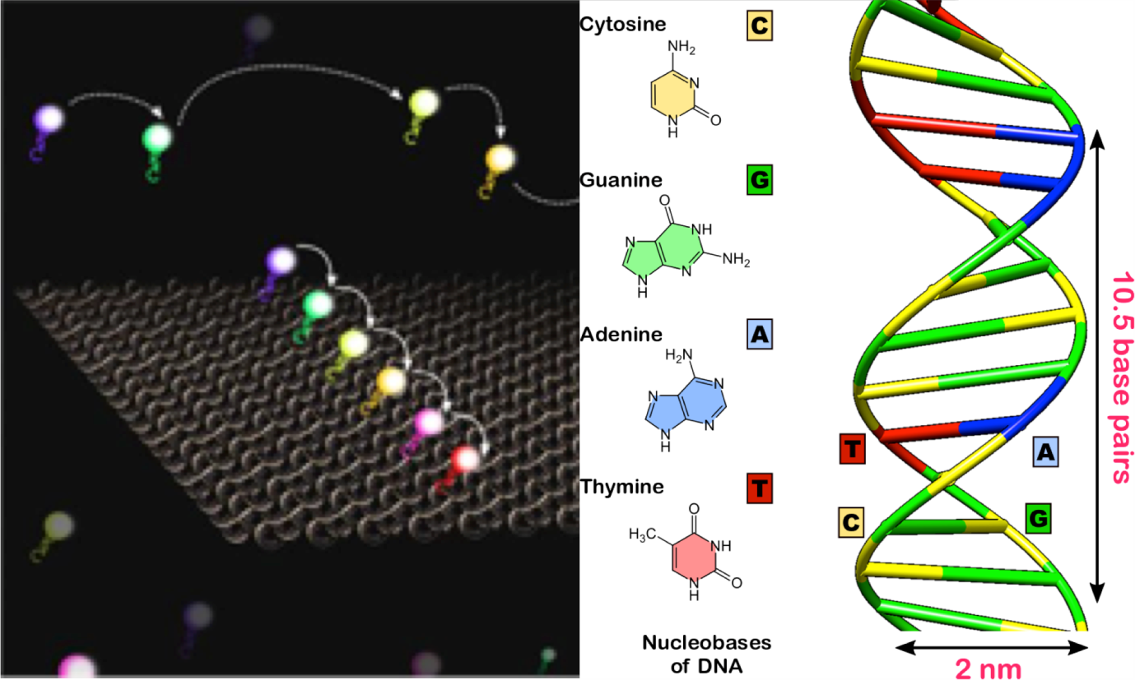

Fig. 1: Bio-Inspired Molecular Computing
Source: “https://engineering.catholic.edu/research-and-faculty/faculty-profiles/eecs/hieu-bui/research_v0/index.html”

Opportunities: The fundamental advantage of molecular computing is its ability to cheaply and tightly pack much more circuitry onto a microchip than silicon could. Due to the fact that molecules are only a few nanometers in size, it is conceivable to create chips with billions or even trillions of switches and other components.

Challenges: The reliability, effectiveness, and scalability of molecular computing are the three most pressing problems. The degree to which a laboratory experiment offers a genuine solution to the posed problem is the dependability of a protocol, or a DNA computation.

  - Nature-Inspired Computing: A relatively recent field of study called "nature inspired computing" aims to create novel computer methods by studying how complicated issues are resolved in various natural environments. This has led to ground-breaking research that has given rise to new fields like artificial immune systems, swarm intelligence, neural networks, and evolutionary computation. Engineering, Physics, biological science, economics, management, etc., all apply NIC approaches.

Numerous creative approaches to problem-solving and optimization are influenced by nature. In reality, machine learning, optimization tasks, multi-objective functionalities and extremely challenging design issues fall into a category where nature-inspired algorithms excel. They advocate for continued study in a few particular areas to progress this field further in order to address a wide variety of real-world application-based difficulties. Big data, computer science, and computational analytics all made advancements that helped to create nature-based computing. Scientists and researchers investigate how biological communities, such as ant colonies, bee hives, and bird flocks, respond to stimuli, process data, and make decisions.

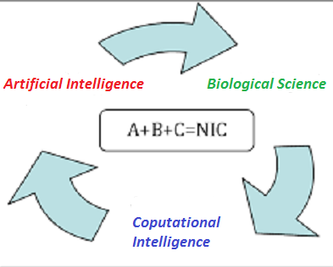
Fig. 2: Ingredients of NIC
Opportunities:
- Nearly every field of science, engineering, and business now uses computation that is inspired by nature, from image analysis and vision systems to industrial applications, from data mining processes to optimization techniques. Computational intelligence and signal processing also have many applications derived from nature-inspired computing.
Challenges:
- Regardless of its effectiveness and popularity of nature-inspired algorithms, there are still numerous difficult problems with these algorithms, especially from theoretical views. Although academics are aware of the fundamental principles underlying how these algorithms operate in reality, it is unclear why they function and under what specific circumstances. are aware of the fundamental principles underlying how these algorithms operate in reality, it is unclear why they function and under what specific circumstances.

- The accomplishment of the algorithm under dialogue can be impacted by the values of the algorithm-dependent parameters that are present in all nature-inspired algorithms. Though, the optimal settings or numbers to use or how to adjust these parameters to get the best performance are unclear.

  - Cognitive Computing: Using computerized models to imitate human mental processes in complex circumstances where the solutions may be vague and uncertain is known as cognitive computing. Although computers are quicker than people in processing and performing calculations, they are still not yet adept at certain activities, such comprehending spoken language and identifying items in an image. The goal of cognitive computing is to have computers function similarly to the human brain. Cognitive computing uses various underlying technology to do this. The underlying technologies include AI, NLP (Natural Language Processing), neural networks, object & speech recognition, robotics, expert system etc. To teach computing systems, cognitive computing combines these techniques with auto-detective algorithms, pattern recognition and various data analysis. The learning system can be used for face detection, speech recognition,, risk assessments, sentiment analysis, , and many more. Additionally, it is especially beneficial in industries like medicine, finance healthcare, banking, retail and manufacturing.

Machine learning algorithms need to be fed enormous amounts of organized and unstructured data in order to tackle the kinds of problems that humans are generally entrusted with solving. Cognitive systems can improve their ability to recognize patterns and to handle data over time. They develop the ability to model potential solutions and anticipate future issues.
An AI system can be trained to recognize images of vehicles, for instance, by keeping thousands of images of various vehicles in a database. A system is able to learn more and become more accurate over time the more data it is exposed to. A typical cognitive system shown in fig. 3 below.

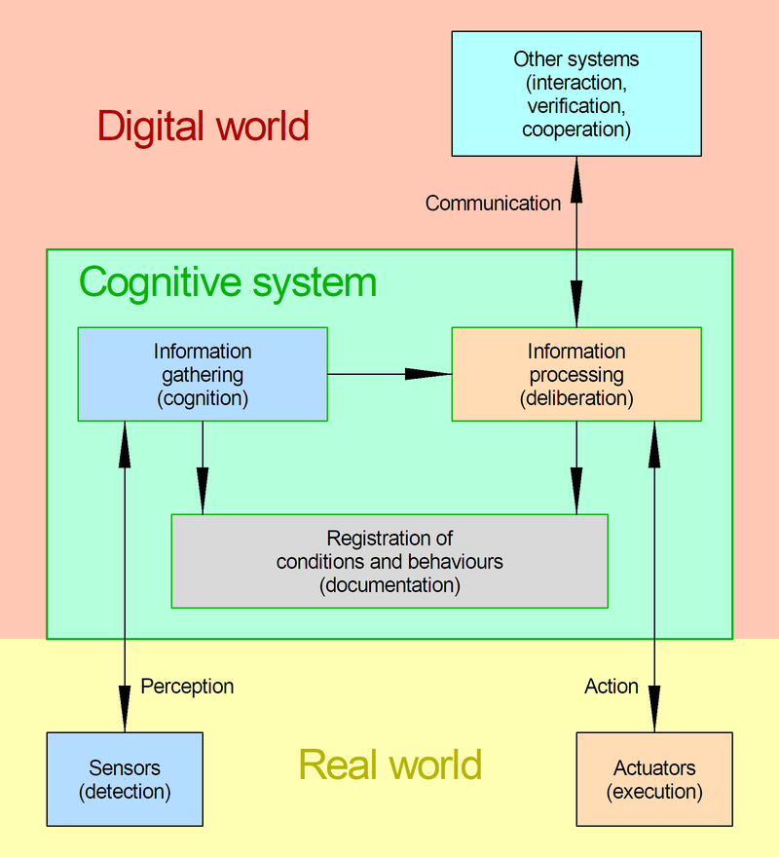
Fig. 3: A Cognitive System
Source: By Bautsch - Own work, CC0, https://commons.wikimedia.org/w/index.php?curid=114473125
Opportunities:
- Healthcare is one of the key industries that cognitive computing will primarily benefit. The technology will make it possible to quickly and easily compile patient data and recommend treatments in real time.

- Applications of cognitive computing have enormous potential to improve human workflows in a variety of industries, such as education, law, finance, and others, that require processing massive amounts of complicated information.
Challenges:
- Without human intellect, cognitive computing cannot succeed because we are the source of intelligence for the systems

  - Nanocomputing: Utilizing very small objects at the atomic or molecular level, nanotechnology creates systems, structures, and gadgets. It encompasses the study of matter with dimensions ranging from one to one hundred nanometers in both science and engineering. A computer with circuitry so tiny they can only be seen under a microscope is referred to as a nanocomputer. Nanocomputers truly function by saving data as quantum dots or as spins, and our present devices are composed of semiconductors that are smaller than 100 nanometers long.

Opportunities:
- Due to this reduction, the circuit's functionality can be increased exponentially, and the device's processing power can increase by up to a million times. Since less electricity is consumed as a result, the efficiency is significantly higher.

- Nanocomputers can execute calculations that other microcomputers are unable to complete and are also substantially faster than other microcomputers. They may be included into smaller, lighter, and more portable gadgets thanks to their compact size, which is an added benefit. Additionally, they develop an immunity to disruptions like noise.

Challenges:
- Since scaling down devices to a tiny level necessitates a level of sophistication and experience that can only be attained by investing millions of dollar. Manufacturing gadgets that operate on the basis of nanotechnology is exceedingly difficult and expensive.
- The fact that nanocomputers are small and almost undetectable would also be a drawback.

  - Social Computing: Social computing refers to cooperative and interactive online behavior. Personal computing is entirely individual activity since it is typically controlled by a single user. The Internet enables social computing by enabling user interaction through a variety of media such as social sites, micro-Blog, IMS, online games, open-source development & deployment, etc. Using computer systems for social reasons is referred to as social computing. Computers were mostly utilized before the Internet as tools to boost productivity. The social aspect of the Internet allowed people to network, exchange hobbies, post personal insights, and do more with their computers than just do tasks more quickly.

Opportunities:
- Even if social computing is employed for commercial objectives, it can still be advantageous to enterprises. Products may be marketed and customer relations can be improved with the help of social computing.

- Social computing has given rise to two different forms of promotional advertising, i.e., online and viral marketing.
Challenges:
- The complexity of features that cross many disciplines and the broad application of social computing in various sectors present new difficulties for social computing researchers.

- Since social computing is in its infancy state today, its theoretical foundations are rudimentary and lack precise standards.

- Platforms and Tools: Many innovative tools and computing platforms are available today for research and development. Many of them are free while some others charges very nominal amount to use. Some of the most prominent tools and platforms are briefly elaborated below:

  - Kubernetes: Using either private or public cloud platforms, the kubernetes system simplifies the deployment and administration of cloud native applications. It automates the requirements for dynamic container networking and distributes application workloads throughout a Kubernetes cluster. Additionally, Kubernetes allows automatic scalability, allocates storage and unrelenting volumes to the running containers, continuously maintains the intended state of applications, and offers resilience.

  - Jenkins: An open source server for automation is called Jenkins. It assists in automating software development processes related to development, testing, and deployment, enabling continuous integration and continuous delivery. It aids in spreading out the work over many devices and platforms. It serves as the projects' ongoing delivery hub.

  - Docker: An open source platform for creating, distributing, and running programs is Docker. You may divide your apps from your infrastructure with the help of Docker, allowing for rapid software delivery. We can manage our infrastructure using Docker in the same manner that we manage our applications. Developers may drastically shorten the time between writing code and executing it in production by utilizing Docker's methodology for shipment, testing, and deployment of code quickly.

  - TensorFlow: An AI and ML software library called TensorFlow is free and open-source. It is applicable to a variety of applications but is especially focused on deep neural network training and inference. For numerical computing and extensive machine learning, there is a free package called TensorFlow. With the use of common programmatic metaphors, TensorFlow collects a variety of deep learning and machine learning models and algorithms (also known as CNN ) and makes them applicable. It offers an easy front-end API for constructing apps using Python or JavaScript, and high-performance C++ is used to run those programs.

  - OpenStack: A cloud operating system called OpenStack manages enormous pools of computing, storage, and network tools & resources spread throughout a datacenter. These resources are all provisioned and managed using APIs using standard authentication techniques. Additionally, a dashboard is offered, allowing administrators command while enabling end users to provision various resources via a web interface. OpenStack is divided into services so that you can plug and play different components based on your need.

  - PyTorch: PyTorch is a Torch and Python-based Deep-Learning tensor library that is mostly utilized in CPU and GPU applications. Since PyTorch uses dynamic computation graphs and is entirely Pythonic, it is preferred over other DL frameworks such as TensorFlow and Keras. It enables real-time testing and execution of certain sections of code by researchers, programmers, and neural network debuggers. Hence users can therefore check whether a portion of the completed code module works or not without having to wait for the implementation of the complete program.

  - Full-Stack Framework: Full stack, in the context of computers, refers to the entire collection of software tools and techniques used to create a platform, website, or application. Full-stack development combines the client-side and server-side of every application or tools or website development project. A full-stack framework is made to be used repeatedly by developers to create apps instead of doing it manually and starting from scratch each time. Simply described, they are prewritten chunks of code that programmers utilize to create apps by applying the Java language. Ex. Spring Boot, React, Angular, Bootstrap, Django, Flask, Node JS, etc.

- Conclusion
The potential for a wide range of difficult new applications is being explored by research and business in relation to radical new computing paradigms like molecular and quantum computing, nature-inspired computing, nanocomputing, optical computing, etc. We will be able to steer the future of computers by comprehending, grasping, and putting these kinds of cutting-edge, new approaches into practice. However, some of the computing technologies requires a lot of research and investment to realize its real power to the society.

- References:
[1] Hager G. D., Hill M. D., & Yelick K. (2015). Opportunities and Challenges for Next Generation Computing: A white paper prepared for the Computing Community Consortium committee of the Computing Research Association. http://cra.org/ccc/resources/ccc-led-whitepapers/

[2] Ng, Lik Yin & Chong, Fah Keen & Chemmangattuvalappil, Nishanth. (2015). Challenges and opportunities in computer-aided molecular design. Computers & Chemical Engineering. 81. 10.1016/j.compchemeng. 2015.03.009.

[3] El-Seoud, Samir & Mohamed, Reham & Ghoniemy, Samy. (2017). DNA Computing: Challenges and Application. International Journal of Interactive Mobile Technologies (iJIM). 11. 74. 10.3991/ijim.v11i2.6564.

[4] Xin-She Yang, Nature-Inspired Optimization Algorithms: Challenges and Open Problems, Journal of Computational Science, Article 101104, (2020). https://doi.org/10.1016/j.jocs.2020.101104

[5] https://engineering.catholic.edu/research-and-faculty/faculty-profiles/eecs/hieu-bui/research_v0/index.html

[6] Bharti, Vandana & Biswas, Bhaskar & Shukla, Kaushal. (2020). Recent Trends in Nature Inspired Computation with Applications to Deep Learning. 294-299.

